SYSTEMS AND METHODS FOR DETECTING COORDINATE-STRUCTURE DIVERGENCE IN LEARNED AND DYNAMICAL SYSTEMS
PROVISIONAL PATENT APPLICATION
Applicant | Forma Substrate Inc.
Inventor(s) | Mark White
Prepared | July 10, 2026
Application Type | U.S. Provisional Application under 35 U.S.C. 111(b)
Status | Filed

1. Technical Field
The present disclosure relates to computer-implemented monitoring, diagnosis, validation, and control of learned systems, autonomous systems, state-space systems, and other dynamical systems. More particularly, the disclosure relates to separately measuring point-level or coordinate-space change and relational or structural change among system states, determining divergence between the two, detecting regime transitions or unsupported operating conditions, and optionally controlling prediction, extrapolation, or action in response.

2. Background
High-dimensional systems are often monitored by observing the movement or distribution of individual state representations. In learned systems, these representations may be feature vectors, hidden states, embeddings, or latent vectors. In physical or engineered systems, the representations may be sensor vectors, estimated states, operating parameters, or fused observations.
Point-centric monitoring can reveal significant drift, but the inventors recognized that individual coordinates and the organization among states are different observables. A collection of states can move materially while preserving neighborhood relations, basin structure, transition accessibility, pathway organization, or other relational properties. Conversely, the coordinates can move only modestly while the relationships, admissible transitions, bottlenecks, basins, and transport pathways reorganize substantially.
A consequential system transition may therefore be hidden from or understated by coordinate-level metrics. The present disclosure addresses this problem by computing at least one point-level change measure and at least one structural change measure, comparing them, and determining a regime or operational condition from the relationship.

3. Summary of the Disclosure
In one aspect, a computer-implemented method receives system states associated with at least first and second conditions; computes a coordinate-change measure; constructs relational structural representations for the conditions; computes a structural-change measure; determines a divergence condition from a relationship between the coordinate-change measure and the structural-change measure; determines a system condition; and optionally causes an operational response.
In another aspect, the method operates across a temporal sequence or perturbation sweep and identifies a breakpoint at which structural organization changes disproportionately relative to coordinate displacement. The breakpoint may define a robustness boundary, safe operating envelope, validated prediction regime, or intervention threshold.
In another aspect, the divergence determination is used as a structural entitlement gate that permits, restricts, suppresses, modifies, or conditions prediction or action. The gate may cause abstention, confidence adjustment, model switching, controller switching, acquisition of additional data, escalation to a human operator, safe-mode entry, or another response.
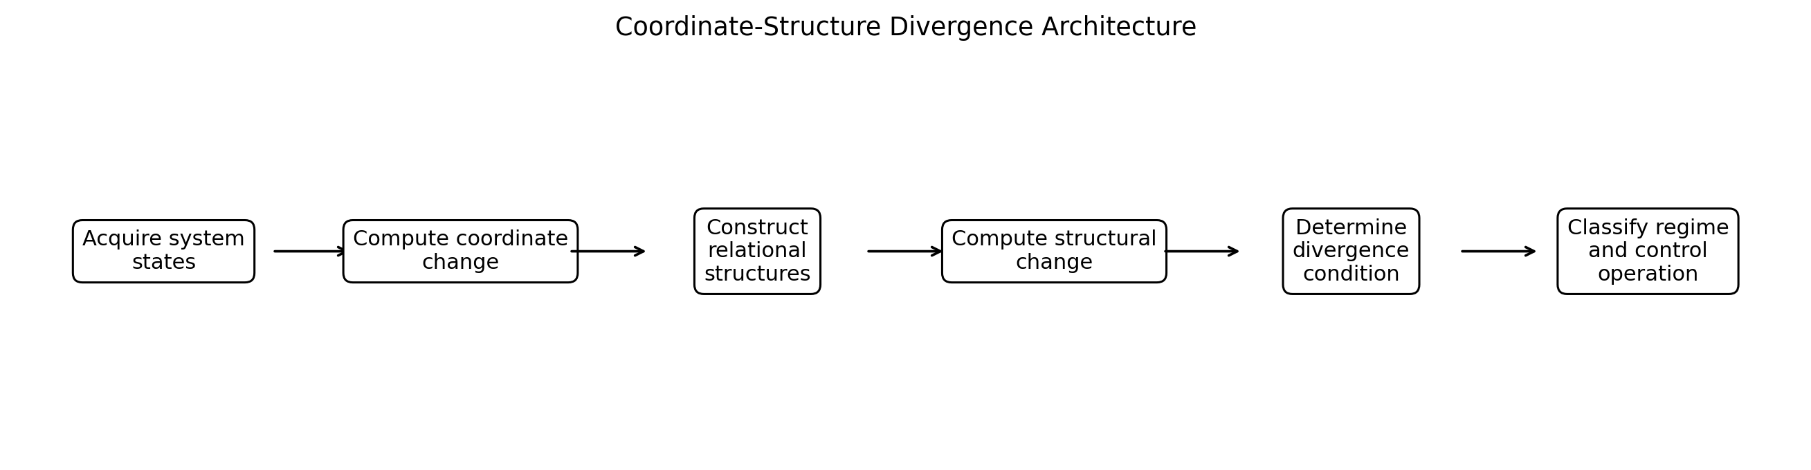
FIG. 1 - Example coordinate-structure divergence architecture.

4. Brief Description of the Drawings
FIG. 1 illustrates an example architecture for coordinate-structure divergence detection.
FIG. 2 illustrates representative divergence classes based on relative coordinate and structural change.
FIG. 3 illustrates a perturbation-sweep embodiment for structural breakpoint detection.
FIG. 4 illustrates an operational entitlement embodiment.
FIG. 5 illustrates a recursive multiscale structural analysis embodiment.
FIG. 6 illustrates an example world-model embodiment.

5. Definitions and Interpretive Conventions
State: Any representation of a system condition, including raw observation, measurement, symbolic state, feature vector, embedding, latent vector, hidden state, estimated physical state, control state, market state, biological state, or machine operating state.
Coordinate or point-level representation: A representation in which individual system states are treated as points, vectors, symbols, measurements, or feature collections, whether or not the representation is Euclidean.
Coordinate change: A measure primarily directed to movement, difference, or distributional change of individual state representations. Examples include Euclidean, cosine, geodesic, Mahalanobis, Wasserstein, divergence, centroid, covariance, density, velocity, or trajectory measures.
Relational structural representation: A representation constructed from relationships among states, which may include neighborhoods, graphs, hypergraphs, basin assignments, transition networks, transport networks, path systems, recursive abstractions, multiscale structures, or combinations thereof.
Structural change: A change in one or more relational properties, including neighborhood stability, edge persistence, basin organization, transition probabilities, pathway availability or use, bottlenecks, spectral cohesion, curvature, path fidelity, path information, transport drift, or recursive stability.
Divergence condition: Any classification, score, statistic, boundary, or decision derived from the relationship between point-level change and structural change.
Regime: A condition or class of system organization characterized by one or more coordinate, relational, structural, behavioral, temporal, or operational properties.
Structural entitlement: A determination that a prediction, extrapolation, control action, or autonomous operation is or is not sufficiently supported by the system structural condition under a defined policy or criterion.

6. System Architecture
The disclosed methods may be implemented by one or more processors executing instructions stored in non-transitory computer-readable memory. The processors may be local, distributed, cloud-based, edge-based, embedded, neuromorphic, analog-assisted, or hybrid. Data may be received in batches, streams, windows, episodes, trajectories, asynchronous event sequences, or combinations thereof. Unless expressly stated otherwise, steps may be reordered, combined, omitted, repeated, or performed concurrently. A reference to a 'module' denotes functional organization and does not require a physically separate hardware component.
An example system includes a state acquisition interface, point-level change engine, relational construction engine, structural comparison engine, divergence decision engine, regime classifier, policy engine, and output or control interface. These functions may be implemented within a single program or distributed across multiple components.
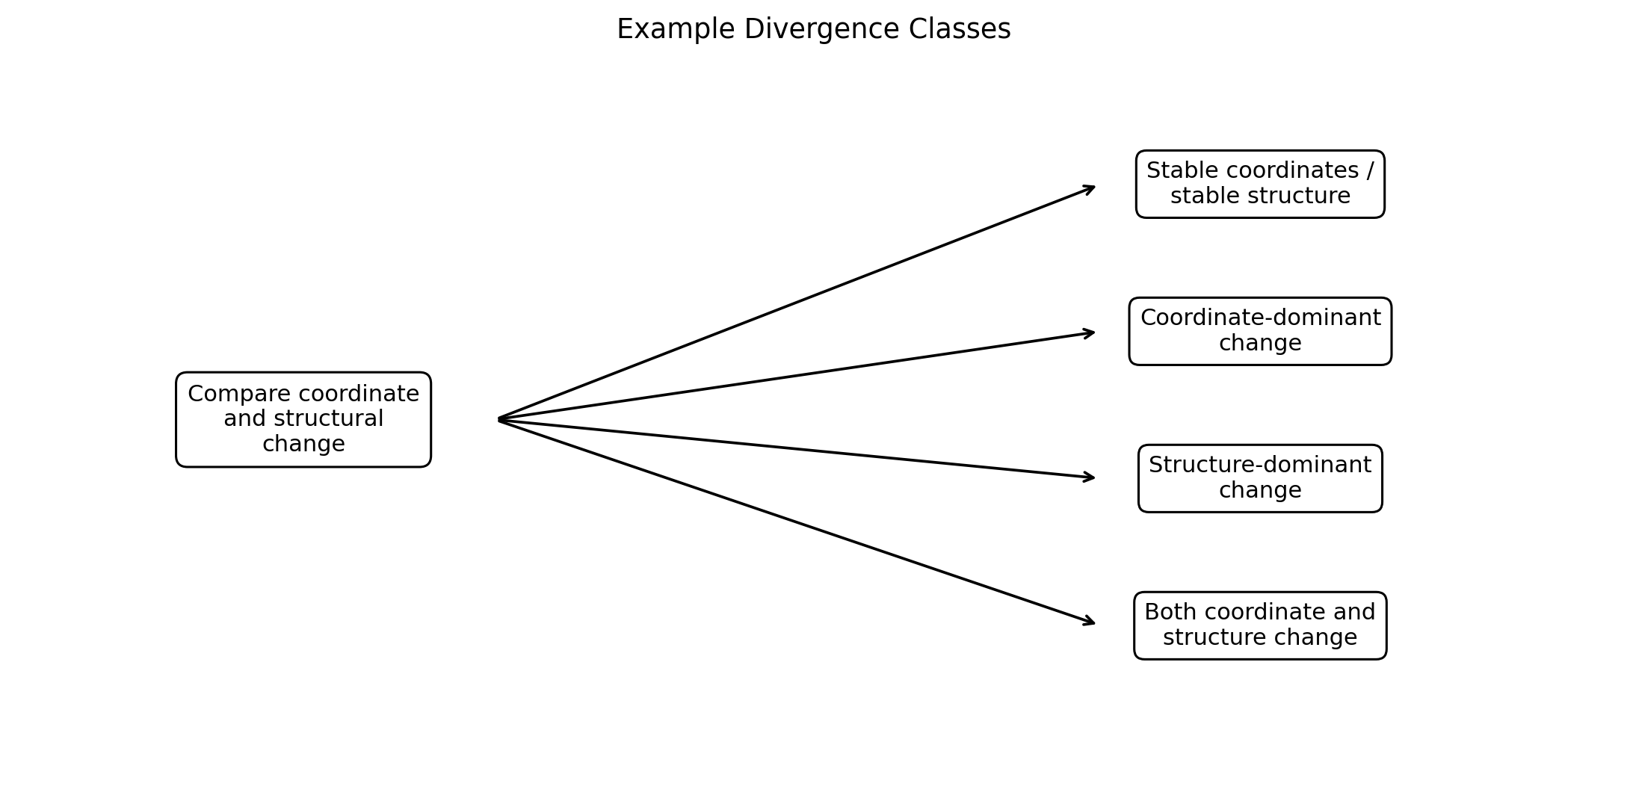
FIG. 2 - Representative divergence classes.

7. General Method
- Obtain a first collection of system states associated with a reference or first condition.
- Obtain a second collection of system states associated with a current, later, perturbed, or comparison condition.
- Compute one or more point-level change quantities between or within the state collections.
- Construct one or more relational structural representations from the state collections.
- Compute one or more structural change quantities between the structural representations.
- Determine a divergence condition from a relationship between point-level change and structural change.
- Determine a regime, risk, support, or operational condition from the divergence condition.
- Optionally cause an operational action in response.

8. Coordinate-Change Measurement
Coordinate change may be calculated globally, locally, conditionally, per state, per trajectory, per region, or at multiple scales. The coordinate measure need not correspond to literal Cartesian coordinates. It may be any state-level metric or distributional comparison that does not itself require the relational organization used for the structural measure.
- Pointwise displacement averaged over matched states or trajectories.
- Distributional divergence between reference and current state populations.
- Neighborhood-independent latent displacement.
- Trajectory velocity, acceleration, or curvature in a coordinate representation.
- Differences in centroid, covariance, density, or higher-order moments.
- Learned state-level similarity or anomaly scores.

9. Relational Structure Construction
A relational structure may be built from spatial proximity, semantic similarity, observed transitions, counterfactual transitions, admissibility rules, control reachability, temporal co-occurrence, recursive indexing, or combinations thereof. The structure may be directed or undirected, weighted or unweighted, static or temporal, single-scale or multiscale.
In one preferred embodiment, states are assigned to local neighborhoods; relationships are transformed according to one or more constraints; the transformed representation is recursively abstracted; and the resulting structure is analyzed for locality, basin organization, pathways, transport, bottlenecks, entropy, or stability.

10. Structural-Change Measurement
Structural change may be scalar or vector-valued. A multi-metric embodiment forms a structural change vector $D_{s}=\left[D_{N},D_{B},D_{T},D_{P},D_{H},D_{R}\right]$, where components may represent neighborhood, basin, transition, pathway, path-information, and recursive-stability change. Other components may be added or substituted.
- Neighborhood overlap loss or reassignment rate.
- Edge birth, death, persistence, or weight change.
- Reference-basin occupancy, purity, locality, fragmentation, or merging.
- Transition-matrix, route, or pathway change.
- Top-k pathway concentration or effective path count.
- Path entropy, transition entropy, or another information measure.
- Bottleneck density, dominance, or relocation.
- Spectral or curvature changes.
- Transport drift or path-fidelity change.
- Instability across recursive or multiscale levels.

11. Divergence Functions and Decision Rules
The divergence relationship may be represented as $Q=F\left(D_{x},D_{s}\right)$. F may be a difference, ratio, normalized ratio, weighted sum, likelihood, statistical test, learned classifier, temporal model, change-point statistic, Bayesian posterior, conformal score, or other function. The invention is not limited to a particular formula.
Example conditions include: (a) both changes below reference bounds; (b) coordinate-dominant change; (c) structure-dominant change; (d) both coordinate and structure change; (e) discordant local and global change; and (f) persistent or oscillatory divergence over time.

12. Reference Regimes and Baselines
A reference may be defined from training data, successful trajectories, nominal operation, expert specification, historical stability, a prior time window, or automatically discovered stable structural classes. A reference may be a single structure, ensemble, distribution, confidence region, time-varying model, or set of multiple valid regimes.

13. Perturbation-Sweep and Breakpoint Embodiment
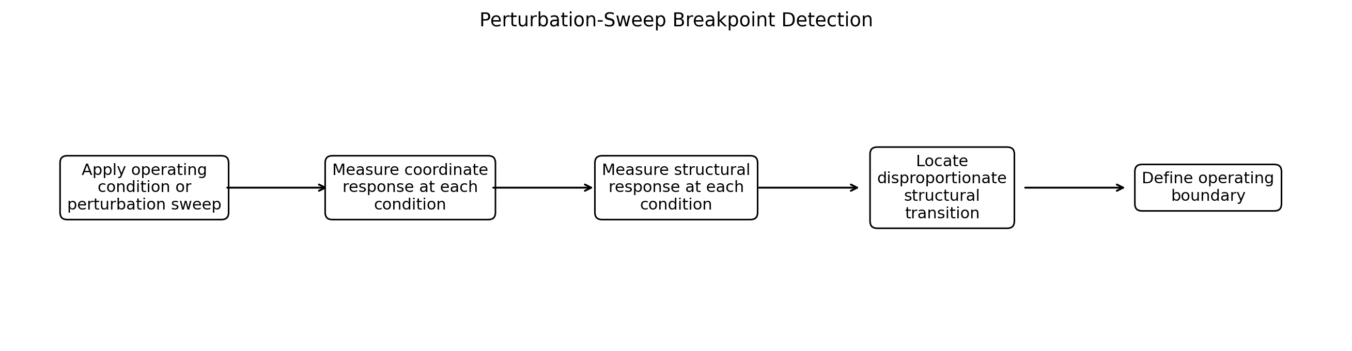
FIG. 3 - Perturbation-sweep breakpoint detection.
In one embodiment, the system is evaluated at conditions $λ0$ through $λn$. At each condition, coordinate change $D_{x}\left(λi\right)$ and structural change $D_{s}\left(λi\right)$ are computed. A breakpoint is identified where the structural response changes materially, nonlinearly, discontinuously, or disproportionately relative to coordinate response. The breakpoint may be used to define a validated operating boundary or trigger additional testing.

14. Temporal and Streaming Embodiment
For a streaming system, $D_{x}\left(t\right)$ and $D_{s}\left(t\right)$ are computed continuously or periodically. The system may identify divergence onset, peak divergence, duration, slope, oscillation, hysteresis, or return toward a reference condition. Windows may overlap and may be fixed or adaptive. Structural reference models may update under controlled policies while retaining protected validation anchors.

15. Recursive and Multiscale Embodiments
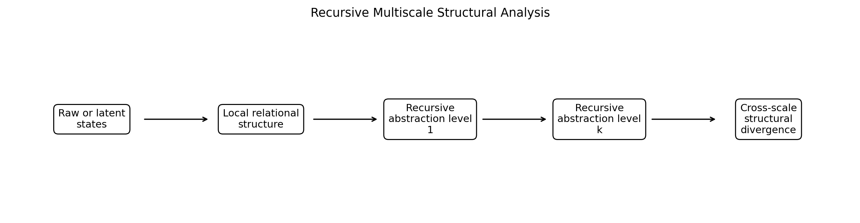
FIG. 5 - Recursive multiscale structural analysis.
A starting representation I_A may be transformed to $I_{C}^{\left(1\right)}=T\left(I_{A};C^{\left(1\right)}\right)$ and recursively to $I_{C}^{\left(k\right)}=T\left(I_{C}^{\left(k-1\right)};C^{\left(k\right)}\right)$. Structural measurements may be calculated at one level, multiple levels, a stable recursion level, or an adaptively selected level. A divergence condition may be based on instability appearing first at a local scale, propagating across scales, or appearing globally while pointwise measures remain modest.

16. Structural Entitlement and Operational Control
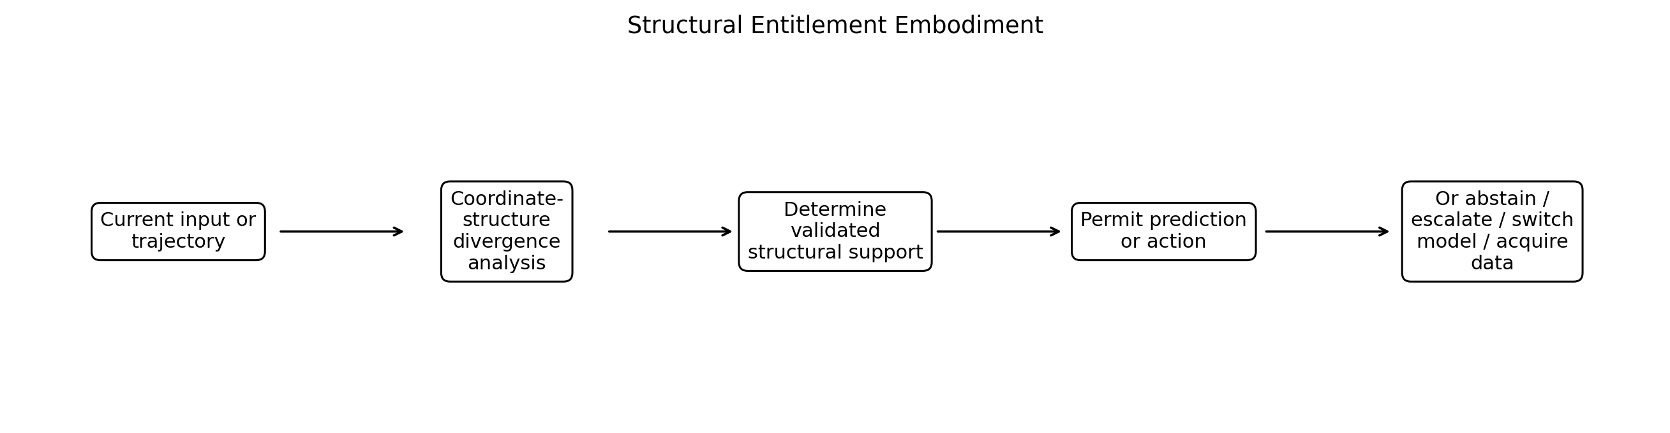
FIG. 4 - Structural entitlement embodiment.
The divergence detector may act as a pre-prediction, pre-extrapolation, or pre-action validation layer. A policy engine receives the divergence condition, reference-regime similarity, evidence strength, or other structural diagnostics and selects an action.
- Permit prediction or action under normal operating authority.
- Permit action with reduced confidence or bounded authority.
- Abstain from prediction or suppress an autonomous action.
- Acquire additional observations or experimental data.
- Switch to another model, controller, or inference path.
- Escalate to a human or higher-assurance system.
- Enter a safe state or terminate a sequence.
- Initiate recalibration, validation, or retraining.
The entitlement policy may be deterministic, probabilistic, learned, risk-weighted, domain-specific, or subject to external compliance rules. Structural entitlement is distinct from mere prediction confidence because a highly confident model may nevertheless operate within a structurally unsupported regime.

17. World-Model Experimental Embodiment
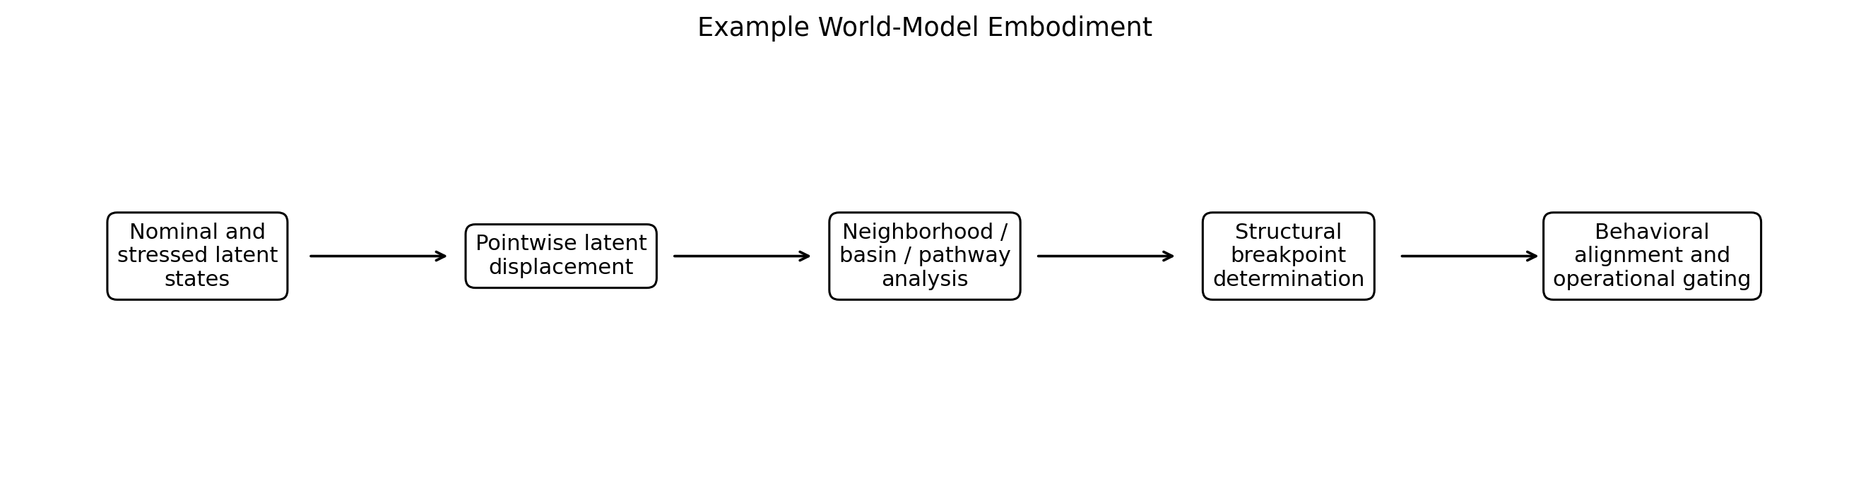
FIG. 6 - Example world-model embodiment.
In an example embodiment, a pretrained world model operating in a closed-loop behavioral environment is subjected to controlled observation stress. Latent states are collected under multiple stress conditions. Pointwise latent displacement is measured separately from neighborhood organization, fixed-reference basin organization, transition pathways, pathway concentration, pathway entropy, and recursive stability.
A structural breakpoint may be localized across a stress interval where the world model reorganizes structurally. Closed-loop success or another behavioral outcome may be compared with the structural transition. The structural analysis may be performed offline, online, or in a hybrid configuration. The example is illustrative and does not limit the invention to world models.

18. Domain Embodiments
Robotics and autonomous systems: Monitor internal state organization, reachability, control neighborhoods, or pathway accessibility; restrict control when relational structure departs from validated regimes.
Pharmaceutical and scientific AI: Determine whether a predictive system remains within structurally supported regions of chemical, biological, clinical, manufacturing, or experimental state space.
Industrial systems: Detect process or equipment transitions where variable ranges appear ordinary but relationships among operating states or transition routes reorganize.
Financial systems: Detect structural market regime changes where familiar feature levels coexist with changed transition, pathway, bottleneck, or coupling organization.
Biological systems: Detect pathway or trajectory reorganization without relying solely on biomarker magnitude or individual-state displacement.
Cyber-physical and networked systems: Detect hidden reorganization in routing, accessibility, dependency, or failure propagation structure.

19. Alternative Implementations
- Matched-state and unmatched-distribution comparisons.
- Supervised, unsupervised, and self-supervised regime models.
- Fixed, adaptive, and multi-reference baselines.
- Deterministic and stochastic transition structures.
- Observed transitions and simulated or counterfactual transitions.
- Graphs, hypergraphs, simplicial complexes, transport maps, Markov representations, or custom relational structures.
- Batch, streaming, online, edge, distributed, or federated operation.
- Human-in-the-loop and fully autonomous control policies.

20. Illustrative Algorithm
INPUT: reference states X_ref, current states X_cur, coordinate metric d_x, structural constructor T, structural metric d_s, decision function F, policy π.
1. Compute D_x = d_x(X_ref, X_cur).
2. Construct S_ref = T(X_ref) and S_cur = T(X_cur).
3. Compute D_s = d_s(S_ref, S_cur).
4. Compute Q = F(D_x, D_s).
5. Determine regime label Z and evidence score C from Q and optional historical context.
6. Select operation A = π(Z, C).
7. Return Q, Z, C, and A; optionally execute A.

21. Advantages and Technical Effects
- Detects relational reorganization not adequately represented by point-level drift.
- Separates harmless coordinate motion from consequential structural transition.
- Supports robust operating-boundary identification.
- Provides a mechanism for action gating based on structural support rather than confidence alone.
- Supports recursive, multiscale, and trajectory-level monitoring.
- Can reduce unnecessary interventions when coordinates move but structure remains stable, while increasing sensitivity when structure reorganizes with little coordinate movement.

22. Illustrative Claim-Like Statements for Later Drafting
- A computer-implemented method comprising receiving state representations for first and second system conditions; computing a point-level change measure; constructing first and second relational structural representations; computing a structural-change measure; determining a divergence condition from a relationship between the point-level and structural-change measures; and generating a system-state determination based at least in part on the divergence condition.
- The method of the preceding statement, wherein the structural-change measure includes change in at least one of neighborhood organization, basin organization, transition pathways, pathway entropy, bottleneck organization, transport drift, or recursive stability.
- The method of any preceding statement, further comprising controlling prediction or action based on the system-state determination.
- The method of any preceding statement, wherein a breakpoint is detected across a plurality of perturbation or operating conditions.
- The method of any preceding statement, wherein coordinate displacement remains within a reference bound while structural change exceeds a structural criterion.
- A system comprising one or more processors and memory storing instructions that cause the system to perform any of the disclosed methods.
- A non-transitory computer-readable medium storing instructions that cause one or more processors to perform any of the disclosed methods.

23. Experimental and Implementation Materials to Incorporate Before Filing
- Phase 4 structural breakpoint figures and tables.
- Exact neighborhood construction and fixed-reference basin procedures used in experiments.
- Pathway entropy computation details and parameter ranges.
- Coordinate displacement baseline methods.
- Example pseudocode for the RIX structural constructor and recursive levels.
- At least one numerical example showing a structure-dominant divergence condition.
- Alternative thresholds and reference-regime construction procedures.

24. Scope and Reservation of Alternatives
The examples and embodiments described herein are illustrative rather than limiting. Features described in connection with one embodiment may be combined with features of another embodiment. Numerical values, thresholds, window sizes, graph construction rules, recursion depths, metrics, and model classes are examples and may be selected adaptively, learned from data, defined by a user, or determined from reference distributions. The invention is not limited to RIX implementations, although recursive indexing and constraint-preserving structural abstraction are preferred embodiments.

25. Abstract
Systems and methods are disclosed for detecting divergence between point-level change and relational structural change in learned and dynamical systems. A system obtains state representations for at least two conditions, computes a coordinate or point-level change measure, constructs relational structural representations, computes a structural-change measure, and determines a divergence condition from the relationship between the measures. The divergence condition may identify hidden regime transition, structural instability, unsupported extrapolation, or another system condition even where coordinate displacement is modest. The method may operate over time, across perturbation sweeps, or at multiple recursive scales. The resulting structural condition may control prediction or action, including permitting operation, modifying confidence or control authority, abstaining, acquiring additional data, switching models or controllers, escalating to human review, or entering a safe mode.

