SYSTEMS AND METHODS FOR DETECTING STRUCTURAL EXCURSION, RECOVERY, AND REENTRY IN LEARNED AND DYNAMICAL SYSTEMS
PROVISIONAL PATENT APPLICATION
Applicant | Forma Substrate Inc.
Inventor(s) | Mark White
Prepared | July 10, 2026
Application Type | U.S. Provisional Application under 35 U.S.C. 111(b)
Status | Filed

1. Technical Field
The present disclosure relates to computer-implemented monitoring, diagnosis, validation, and control of learned systems and other dynamical systems. More particularly, the disclosure concerns establishment of one or more reference structural regimes, trajectory-level detection of structural excursion, persistence, recovery, and reentry, and control of prediction or action according to structural status and evidence strength.

2. Background
A disrupted system does not necessarily fail immediately, and a system that ultimately succeeds may experience material structural disruption before recovery. Conventional outcome labeling often compresses a trajectory into a final success or failure designation. That approach can obscure whether a system remained stable, departed temporarily and recovered, oscillated between regimes, stabilized in an alternative regime, or remained in persistent structural excursion.
The inventors recognized that recovery is a trajectory-level structural process. A system can be monitored relative to one or more validated relational regimes, allowing detection of departure, duration and magnitude of excursion, partial or repeated reentry, alternative-regime stabilization, and evidence-aware restoration of operational authority.

3. Summary of the Disclosure
In one aspect, a computer-implemented method establishes a reference structural regime; receives a sequence of system states; constructs a sequence of relational structural representations; compares the sequence with the reference regime; detects structural excursion; determines persistence or reentry; classifies recovery; and optionally causes an operational action.
In another aspect, multiple validated reference regimes are maintained. A trajectory may reenter its original regime, enter a different validated regime, remain outside validated regimes, or occupy an indeterminate region. The operational response may depend on this classification.
In another aspect, the method performs sequential or adaptive evidence accumulation. The system may abstain from early outcome prediction, continue monitoring, restrict operation upon excursion detection, conditionally restore operation during reentry, and fully restore operation after sustained structural stability.
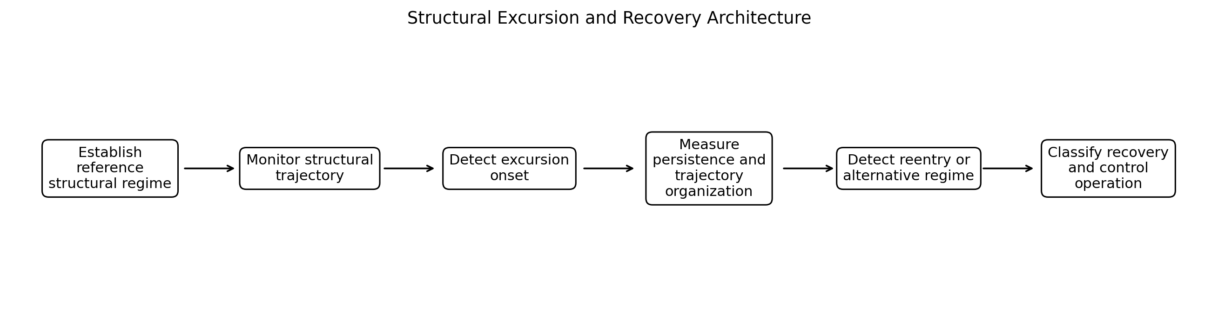
FIG. 1 - Example structural excursion and recovery architecture.

4. Brief Description of the Drawings
FIG. 1 illustrates an example structural excursion and recovery architecture.
FIG. 2 illustrates representative trajectory classes relative to a reference regime.
FIG. 3 illustrates adaptive evidence accumulation and operational entitlement.
FIG. 4 illustrates a multi-reference regime embodiment.
FIG. 5 illustrates a multiscale recovery embodiment.
FIG. 6 illustrates an example world-model recovery embodiment.

5. Definitions and Interpretive Conventions
Reference structural regime: A relational organization associated with a validated, nominal, successful, safe, lawful, or otherwise selected system condition. A reference may be fixed, adaptive, probabilistic, ensemble-based, or one of multiple permissible regimes.
Structural trajectory: A temporally ordered sequence of relational structural representations constructed from system states or windows of system states.
Structural excursion: A departure of a structural trajectory from a reference regime according to one or more structural criteria.
Persistence: Continuation, accumulation, duration, or repeated recurrence of structural excursion according to a selected criterion.
Reentry: Return to, restoration of, or renewed satisfaction of a structural relationship with a reference regime. Reentry does not require return to identical coordinates.
Partial reentry: Restoration of a subset of structural properties or scales without full restoration of all reference properties.
Alternative-regime entry: Stabilization relative to another validated or discovered structural regime distinct from the original reference.
Recovery classification: A trajectory-level determination such as stable, transient excursion, rapid recovery, delayed recovery, partial recovery, repeated reentry, persistent excursion, alternative stabilization, unknown, or insufficient evidence.
Structural entitlement: A policy determination governing whether prediction or action should be permitted, restricted, deferred, or restored according to structural status and optionally evidence strength.

6. System Architecture
The disclosed methods may be implemented by one or more processors executing instructions stored in non-transitory computer-readable memory. The processors may be local, distributed, cloud-based, edge-based, embedded, neuromorphic, analog-assisted, or hybrid. Data may be received in batches, streams, windows, episodes, trajectories, asynchronous event sequences, or combinations thereof. Unless expressly stated otherwise, steps may be reordered, combined, omitted, repeated, or performed concurrently. A reference to a 'module' denotes functional organization and does not require a physically separate hardware component.
An example system includes a reference-regime builder, structural trajectory constructor, excursion detector, persistence analyzer, reentry detector, recovery classifier, evidence accumulator, policy engine, and output or control interface. One component may perform multiple functions, and functions may be distributed.
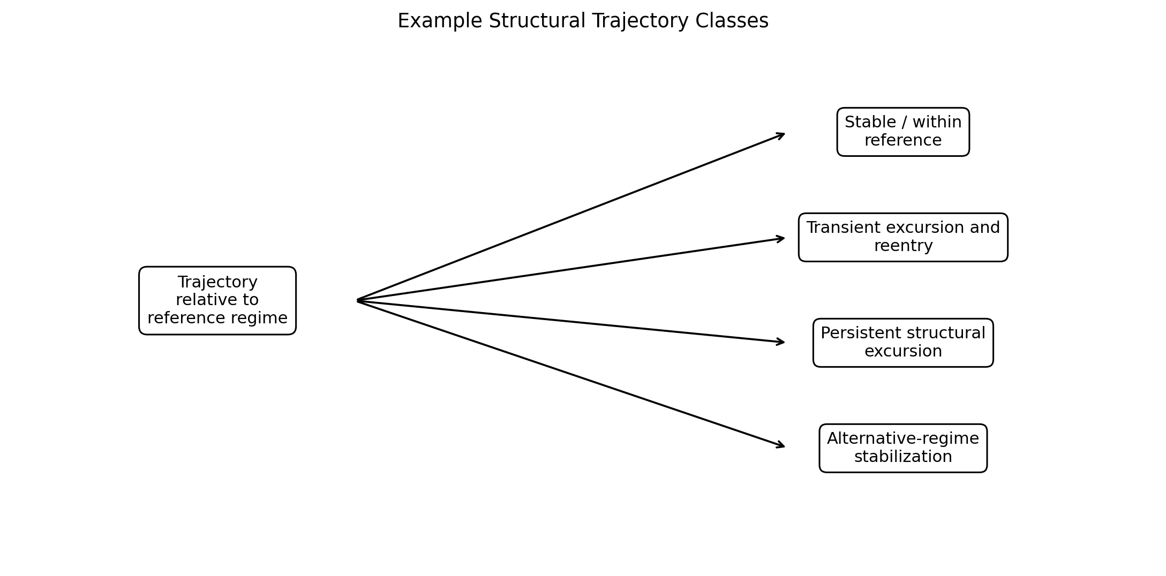
FIG. 2 - Representative structural trajectory classes.

7. General Method
- Obtain states associated with one or more reference operating conditions.
- Construct one or more reference relational structural representations or distributions.
- Receive a trajectory or stream of current system states.
- Construct structural representations for successive trajectory segments, windows, events, or time points.
- Compare the structural trajectory with one or more reference regimes.
- Detect excursion onset and optionally measure excursion magnitude, rate, duration, or accumulated burden.
- Determine whether excursion is transient, persistent, oscillatory, partially recovering, reentering, recovered, or stabilizing in an alternative regime.
- Generate a recovery or structural-status classification and evidence score.
- Optionally cause an operational response or adjust system authority.

8. Construction of Reference Structural Regimes
A reference regime may be constructed from successful trajectories, validated operation, training conditions, expert specification, safe-mode data, historical stability, automatically discovered clusters of structural states, or combinations thereof. A regime may be represented by a centroid structure, prototype, ensemble, probability distribution, confidence set, temporal model, or learned classifier.
Reference regimes may be protected from uncontrolled adaptation. In one embodiment, a current model can update only within a validation policy while an immutable anchor reference is retained for comparison. In another embodiment, multiple references correspond to lawful operating modes.

9. Structural Trajectory Construction
The structural trajectory may be constructed from raw observations, embeddings, latent states, hidden model states, symbolic states, sensor measurements, or recursively indexed states. The trajectory may use per-time-step structures, sliding windows, event-triggered windows, episode segments, or multiscale intervals.
- Neighborhood organization and neighbor persistence.
- Reference-basin assignments and basin transitions.
- Transition networks and route accessibility.
- Pathway frequencies, concentration, and entropy.
- Bottleneck appearance, dominance, and relocation.
- Transport drift and path fidelity.
- Spectral or curvature properties.
- Recursive structural stability and cross-scale consistency.
- Coordinate-structure divergence as a supplementary feature.

10. Excursion Detection
Let $S_{R}$ denote a reference structural regime and $S_{t}$ denote a structural representation at trajectory time t. A structural relationship $d_{t}=D\left(S_{t},S_{R}\right)$ may be calculated. Excursion may be identified by a threshold, confidence region, likelihood, classifier, change-point detector, conformal region, or other rule.
Excursion magnitude may be represented by maximum distance, integrated distance, multivariate burden, departure slope, structural change rate, or another quantity. In a multivariate embodiment, excursion is represented by $E_{t}=\left[E_{N},E_{B},E_{P},E_{H},E_{T},E_{R}\right]$, for example neighborhood, basin, pathway, path-information, transport, and recursive-stability excursion components.

11. Persistence Analysis
Persistence is not limited to uninterrupted time above a fixed threshold. It may include cumulative burden, proportion of trajectory outside a reference region, repeated failed reentry attempts, worsening structural disorganization, or stable occupancy of an unsupported region.
- Duration above an excursion criterion.
- Accumulated or integrated structural distance.
- Fraction of windows classified outside validated regimes.
- Increasing trend in structural distance or path-information change.
- Continued basin fragmentation or pathway loss.
- Repeated excursion after transient reentry.
- Failure to achieve sustained reentry for a selected dwell period.

12. Structural Reentry
Reentry occurs when a trajectory that has undergone excursion again satisfies a selected structural relationship with a reference regime. Reentry may be exact, functionally equivalent, partial, transient, sustained, or scale-dependent. Coordinate return is not required.
For example, a trajectory can occupy new coordinate locations while restoring neighborhood roles, basin organization, admissible pathways, transition organization, or transport structure. This allows the method to distinguish structural recovery from literal coordinate retracing.

13. Recovery Classification
- Stable: remains within or sufficiently near a validated reference regime.
- Transient excursion with rapid recovery.
- Transient excursion with delayed recovery.
- Partial recovery: some structural properties recover while others remain displaced.
- Repeated excursion and reentry.
- Persistent structural excursion.
- Alternative-regime stabilization.
- Unknown or insufficient evidence.
The classification can be multiclass, multilabel, hierarchical, continuous, probabilistic, or evidence-bounded. The system may preserve uncertainty rather than forcing an early binary outcome.

14. Adaptive Evidence Accumulation
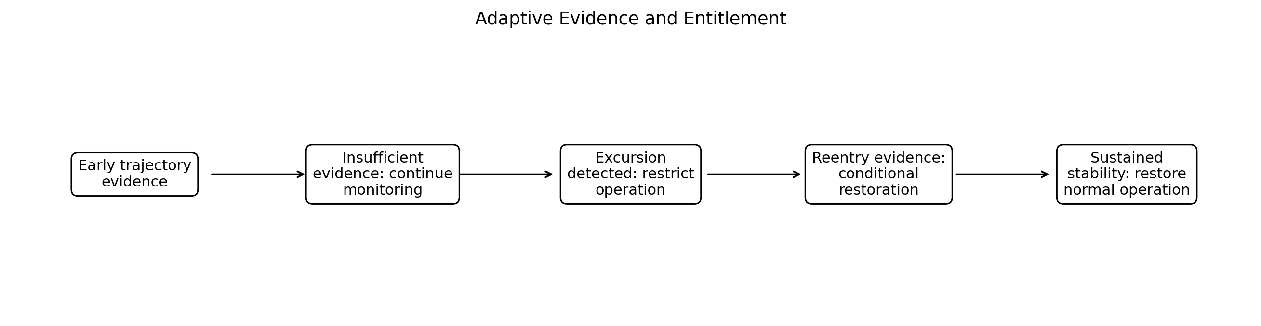
FIG. 3 - Adaptive evidence and entitlement.
Early trajectory prefixes may contain insufficient information for reliable outcome prediction. In one embodiment, the system explicitly represents insufficient evidence and continues monitoring. As evidence accumulates, it may detect excursion, persistence, reentry, and sustained recovery. Operational authority can be adjusted incrementally rather than by a one-time binary prediction.
An example sequence is: early evidence insufficient; continue monitoring; excursion detected; restrict operation; reentry evidence detected; allow conditional restoration; sustained stability demonstrated; restore normal operation.

15. Operational Entitlement Embodiment
A structural status $Z_{t}$ may belong to a set such as {reference, excursion, persistent, reentering, recovered, alternative, unknown}. An evidence score $4C_{t}$ may indicate reliability. A policy $A_{t}=π\left(Z_{t},C_{t}\right)$ selects the operational response.
- Reference: permit normal prediction or action.
- Excursion: reduce confidence, limit authority, increase monitoring, or acquire more data.
- Persistent excursion: abstain, switch model or controller, enter safe mode, or escalate.
- Reentering: restore operation gradually or conditionally and require dwell time.
- Recovered: restore normal authority.
- Alternative validated regime: switch to regime-specific policy or model.
- Unknown: abstain, defer, or request additional evidence.

16. Multi-Reference Regime Embodiment
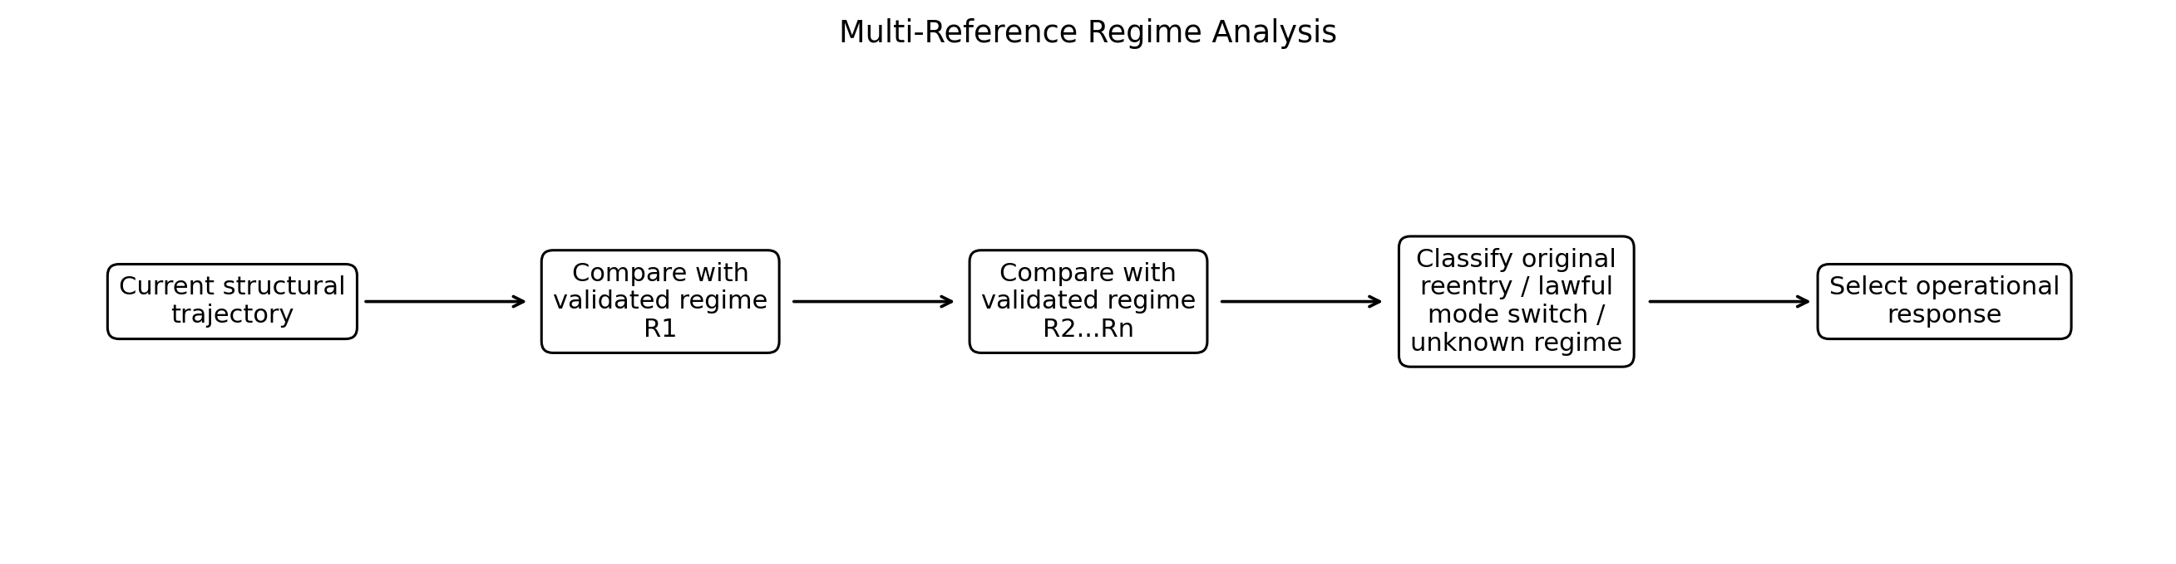
FIG. 4 - Multi-reference regime analysis.
A system may have multiple validated operating regimes $S_{R}1$ through $S_{R}n$. A trajectory departing $R1$ may return to $R1$, enter $R2$, enter another validated regime, remain between regimes, or occupy an unvalidated regime. The system distinguishes recovery from lawful mode switching and unsupported transition.

17. Multiscale and Recursive Recovery Embodiment
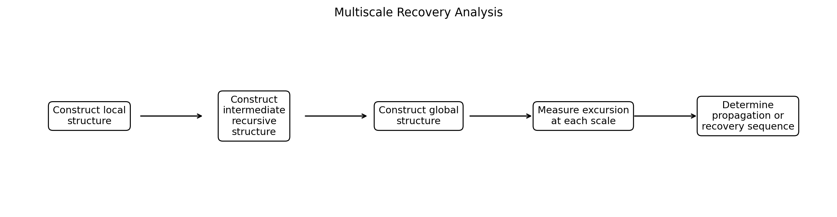
FIG. 5 - Multiscale recovery analysis.
Structural excursion may emerge at one scale before another. The system may construct local, intermediate, and global structures, including recursively indexed structures. It may detect local excursion with global stability, global excursion despite local stability, propagation of disruption across scales, or recovery that begins at one scale and propagates to another.
A recovery classifier may use the order of scale recovery as a feature. For example, local neighborhood restoration may precede basin reentry, which may precede pathway and global transport restoration.

18. Integration with Coordinate-Structure Divergence
In one embodiment, a structural trajectory is accompanied by point-level displacement $D_{x}\left(t\right)$ and structural displacement $D_{s}\left(t\right)$. Excursion may be detected when structural displacement is large relative to point-level displacement. Recovery may be detected when structural organization returns toward a validated regime even though coordinates do not return to prior locations.
This combination supports detection of hidden structural disruption and functional recovery without requiring coordinate retracing.

19. World-Model Experimental Embodiment
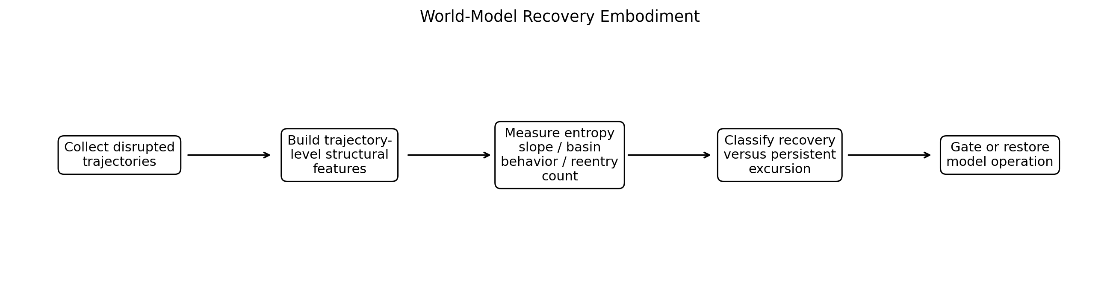
FIG. 6 - Example world-model recovery embodiment.
In an example embodiment, a pretrained world model is operated under controlled observation stress. Trajectories are collected under a condition exhibiting mixed behavioral outcomes. A reference structural regime is constructed from nominal and/or successful behavior. Trajectory-level structural features are computed, including one or more of neighborhood organization, basin behavior, pathway dynamics, path-information slope, structural reentry count, transport organization, and recursive stability.
The system distinguishes trajectories that undergo excursion and recovery from trajectories that remain in persistent structural excursion. Early-prefix analysis may be used for evidence accumulation while avoiding forced prediction when evidence is weak. Operational gating may restrict or restore model action according to the evolving structural status.

20. Domain Embodiments
Robotics: Monitor whether a robot returns to a validated internal structural regime after sensor corruption, disturbance, contact, or environmental change; slow, replan, switch controller, request help, or stop according to status.
Autonomous systems: Track structural excursion after environment shift and restore authority only after sustained reentry.
Pharmaceutical and scientific AI: Monitor whether a predictive model remains within or returns to validated structural regimes; abstain or acquire evidence during persistent excursion.
Industrial control: Differentiate temporary process disturbance from persistent regime change and condition restart or escalation on structural recovery.
Financial systems: Classify temporary structural dislocation, persistent transition, repeated reentry, or stabilization in a new regime without requiring directional price prediction.
Biological systems: Characterize recovery trajectories, pathway reorganization, and return to functional structural regimes after perturbation or treatment.

21. Alternative Embodiments and Variants
- Single or multiple reference regimes.
- Fixed or adaptive references.
- Deterministic thresholds or learned probabilistic boundaries.
- Exact, functional, partial, transient, and sustained reentry definitions.
- Continuous, periodic, or event-triggered monitoring.
- Trajectory windows of fixed or adaptive duration.
- Supervised or unsupervised recovery classification.
- Observed, simulated, or counterfactual structural trajectories.
- Batch, streaming, distributed, federated, edge, or embedded execution.
- Human-in-the-loop or autonomous policy execution.

22. Illustrative Algorithm
INPUT: reference regime model R, incoming state trajectory X_1...X_T, structural constructor T_s, distance or relation function D, persistence rule P, reentry rule G, classifier C, policy π.
For each evaluation time t:
1. Build structural representation S_t = T_s(X_{window(t)}).
2. Compute relation vector r_t = D(S_t, R).
3. Update excursion state and accumulated burden.
4. Evaluate persistence P and reentry G.
5. Update recovery class Z_t and evidence score q_t = C(history of r, excursion, persistence, reentry).
6. Select operational response A_t = π(Z_t, q_t).
7. Output and optionally execute A_t.
Continue until termination or sustained recovery.

23. Advantages and Technical Effects
- Represents recovery as a dynamic structural process rather than only a final outcome.
- Differentiates transient disturbance from persistent structural disruption.
- Detects reentry without requiring identical coordinate return.
- Supports partial, repeated, and scale-dependent recovery.
- Supports multiple lawful operating regimes.
- Provides evidence-aware abstention and gradual restoration of autonomy.
- Separates early prediction from ongoing recovery monitoring.
- Can integrate with coordinate-structure divergence to detect hidden excursion and functional recovery.

24. Illustrative Claim-Like Statements for Later Drafting
- A computer-implemented method comprising establishing a reference relational structural regime from system states; receiving a trajectory of system states; constructing a sequence of relational structural representations from the trajectory; comparing the sequence with the reference regime; determining that the trajectory has undergone structural excursion; determining whether the trajectory satisfies a structural reentry criterion; and generating a recovery classification based at least in part on the excursion and reentry determinations.
- The method of the preceding statement, further comprising measuring persistence of structural excursion using duration, accumulated burden, fraction of trajectory, repeated failed reentry, or another persistence criterion.
- The method of any preceding statement, wherein reentry is determined from restoration of neighborhood, basin, pathway, transport, path-information, or recursive-stability properties and does not require return to prior coordinates.
- The method of any preceding statement, further comprising maintaining multiple validated reference regimes and distinguishing original-regime reentry, lawful mode switching, and occupancy of an unvalidated regime.
- The method of any preceding statement, further comprising determining a structural entitlement condition and controlling prediction or action in response.
- The method of any preceding statement, wherein the system abstains from early classification when evidence is insufficient and updates the recovery classification as additional trajectory states become available.
- A system comprising one or more processors and memory storing instructions that cause the system to perform any of the disclosed methods.
- A non-transitory computer-readable medium storing instructions that cause one or more processors to perform any of the disclosed methods.

25. Experimental and Implementation Materials to Incorporate Before Filing
- Paper 2 figures distinguishing recovery and persistent excursion trajectories.
- Definitions and code-level computation of reentry count, entropy slope, basin features, and trajectory windows.
- Example reference-regime construction from nominal or successful trajectories.
- At least one worked example of transient excursion, reentry, and persistent excursion.
- Prefix availability and evidence-abstention examples.
- Alternative multi-reference and multiscale examples.
- Operational policy examples for prediction gating and restoration.

26. Scope and Reservation of Alternatives
The examples and embodiments described herein are illustrative rather than limiting. Features described in connection with one embodiment may be combined with features of another embodiment. Numerical values, thresholds, window sizes, graph construction rules, recursion depths, metrics, and model classes are examples and may be selected adaptively, learned from data, defined by a user, or determined from reference distributions. The invention is not limited to RIX implementations, although recursive indexing and constraint-preserving structural abstraction are preferred embodiments.

27. Abstract
Systems and methods are disclosed for trajectory-level detection of structural excursion, persistence, recovery, and reentry in learned and dynamical systems. One or more reference structural regimes are established from validated, nominal, successful, or otherwise selected states. A monitored trajectory is converted into a sequence of relational structural representations and compared with the reference regime or regimes. The system detects excursion, measures persistence or accumulated burden, determines exact, functional, partial, transient, or sustained reentry, and generates a recovery classification. The system may represent insufficient evidence and update classification as trajectory data accumulates. Structural status and evidence strength may control prediction or action, including normal operation, restricted authority, abstention, additional data acquisition, model or controller switching, escalation, safe-mode entry, conditional restoration, and full restoration after sustained stability.

