How Safe Is Air Travel?

Scott Breitbach  
04-February-2022

As months turn into years of being cooped up in our homes and we slowly run out of creative ways to keep ourselves entertained, the desire to travel grows evermore at the forefront of our minds. And then we see terrible accidents happening on the news, like the recent and very public incidents in Indonesia and Pakistan, where dozens of people were killed in unfortunate airline crashes.

When we travel, we want to know that our families are going to be safe from harm and so we want to make the safest available choices when selecting not just our destinations, but also our means of travel. What if I told you that flying is the safest choice you can make?

# Safest Mode of Transport

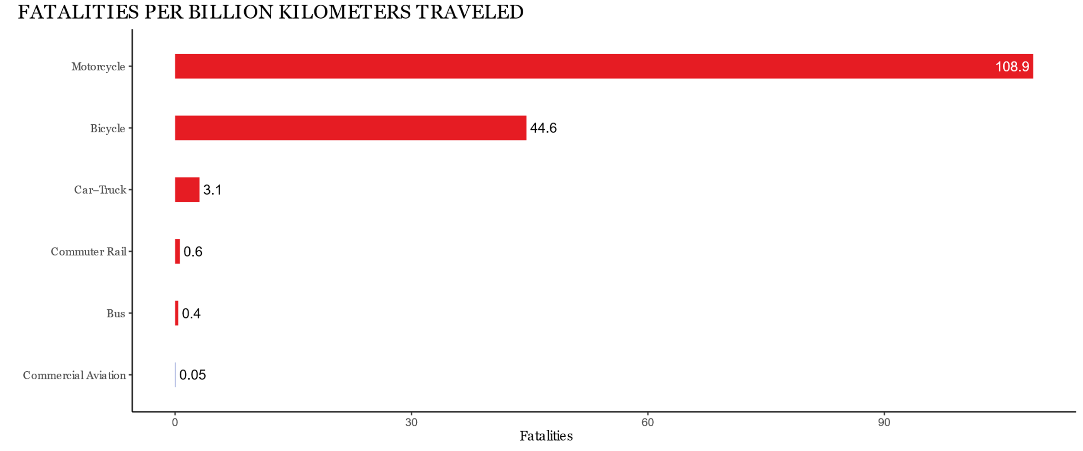

Compared to other modes of transport, commercial airlines are not just one of the safest, but the safest means of travel. When we take a bus we don’t worry about whether or not we’re going to make it to our destination safely, but mile-for-mile air travel is almost an order of magnitude safer than traveling by bus.

# Ever Declining Number of Accidents

In the last 50 years we have not only seen airline accidents decrease almost continuously on average, but this is in spite of the fact that the number of flights has been steadily increasing at an almost exponential rate. This is of course with the exception of the dramatic decrease we see starting in 2020 as a result of the COVID-19 pandemic.

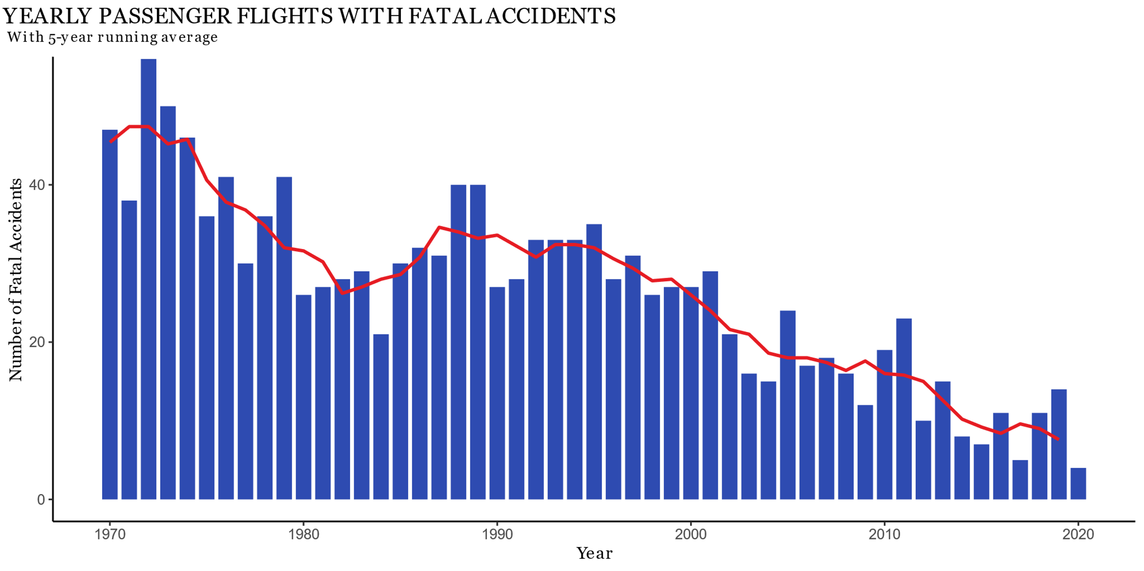



Couple the continually decreasing overall number of accidents with the ever increasing number of flights and we get a very low ratio of accidents to flights.

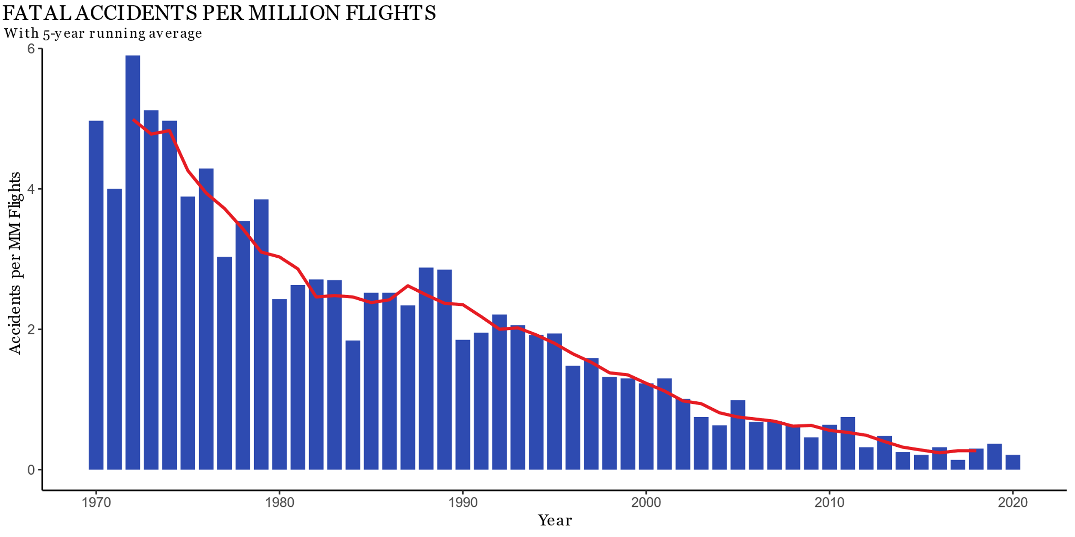

So not only is flying safer than it’s ever been, but the risk continues to decrease as we progress.

# Sources

Beck, L. F., et al. “Motor Vehicle Crash Injury Rates by Mode of Travel, United States: Using Exposure-Based Methods to Quantify Differences.” *American Journal of Epidemiology*, vol. 166, no. 2, 2007, pp. 212–218., https://doi.org/10.1093/aje/kwm064.

Ranter, Harro. “Aviation Accident Database.” Aviation Safety Network, 20 Nov. 2021, http://aviation-safety.net/.

Vodden, Gregory. “Which Mode of Transportation Is the Safest?” *Bus.com*, 28 July 2020, https://www.bus.com/blog/safest-mode-of-transportation/.