Descriptive, not injunctive, social norms caused increases in mask wearing throughout the COVID-19 pandemic

Samantha L. Heiman1, Scott Claessens2, Jessica D. Ayers3, Diego Guevara Beltran3, Andrew Van Horn4, Edward R. Hirt1, Athena Aktipis3, & Peter M. Todd1,5

1 Department of Psychological and Brain Sciences, Indiana University Bloomington, United States

2 School of Psychology, University of Auckland, New Zealand

3 Department of Psychology, Arizona State University, United States

4 Department of Anthropology, Rutgers University - New Brunswick, United States

5 Cognitive Science Program, Indiana University Bloomington, United States

This working paper has not yet been peer-reviewed. This study was funded by the Interdisciplinary Cooperation Initiative, ASU President’s Office, the Cooperation Science Network, the Institute for Mental Health Research, the University of New Mexico, the Indiana University College of Arts & Sciences, the Rutgers University Center for Human Evolutionary Studies, the Charles Koch Foundation, and the John Templeton Foundation.

Author note

Correspondence concerning this article should be addressed to Samantha L. Heiman, 1101 E 10th St, Bloomington, IN 47405, United States. E-mail: [slheiman@iu.edu](mailto:slheiman@iu.edu)

Abstract

Social norms allow humans to coordinate and cooperate in the face of existential threats. In particular, injunctive social norms prescribe what people *ought* to do, whereas descriptive social norms inform what people *actually* do. While previous experimental work has revealed people’s sensitivity to normative influence, several open questions remain about the natural emergence of injunctive and descriptive social norms within populations and their causal influences on cooperative behavior over time. To understand how social norms emerge and shape behavior in a non-experimental setting, we studied mask wearing during the COVID-19 pandemic. Leveraging two years of longitudinal data from a representative sample of adults in the United States (18 time points; *n* = 915), we tracked people’s reported mask wearing behavior and their perceived injunctive and descriptive mask wearing norms as the pandemic unfolded. Longitudinal trends of norm perceptions and self-reported mask wearing suggested that norms and behavior were tightly coupled and both changed quickly in response to recommendations from public health authorities. In addition, a random-intercept cross-lagged panel model revealed that descriptive norms, but not injunctive norms, caused future increases in mask wearing behavior. These findings underline the relative importance of descriptive social norms in shaping cooperative behavior during uncertain times.

*Keywords:* descriptive norms; injunctive norms; longitudinal; COVID-19; mask wearing; cooperation

*Word count:* 4683 words

Descriptive, not injunctive, social norms caused increases in mask wearing throughout the COVID-19 pandemic

Social norms are a key aspect of human sociality. Broadly defined as commonly known behavioral guidelines enforced by groups of people, social norms have attracted the attention of behavioral scientists for decades (1–5). Since Asch’s early studies of normative conformity (6), evidence has accrued that humans are particularly attuned to social norms (7). From a young age, children begin to adhere to and enforce group-wide social norms (8–10) and both children and adults rely on normative emotions, such as shame and guilt, to determine when they or others have violated social norms (11, 12). This uniquely human sensitivity to social norms allows groups of unrelated people to cooperate and coordinate in the face of existential threats, such as resource scarcity, natural disasters, and infectious diseases (13, 14).

Previous research has distinguished between two primary kinds of social norms: injunctive norms and descriptive norms (1, 2, 15). Injunctive social norms indicate what others in the group tend to approve or disapprove of and often involve social sanctions if violated. By contrast, descriptive norms are situational, simply describing what most people are doing in a given situation. Though these two kinds of social norms tend to align, they can also be in conflict with one another. For example, there may be an injunctive norm that cleaning up litter at a picnic site is the right thing to do: one *ought* to behave this way. However, if an individual observes that most people are leaving their litter behind at the site, the descriptive norm is to not clean up. It is thus possible for injunctive and descriptive norms to have independent effects on behavior (16).

Despite decades of research on the causes and consequences of injunctive and descriptive norms (1, 2, 16–18), social norms have remained an elusive concept in the behavioral sciences and several open questions remain (3–5). In the current work, we focus on two such questions. First, how do injunctive and descriptive norms emerge naturally over time within a population? Second, how do evolving injunctive and descriptive norms causally influence behavior over time?

With regards to norm emergence, research in cultural evolution and behavioral economics have begun to illuminate how social norms emerge over time. In the longer term, cultural evolutionary models show that injunctive social norms can be vertically transmitted down through generations via imitation or teaching, or horizontally diffused from neighboring human populations (14, 19). For example, cultural phylogenetic studies have revealed patterns of vertical cultural inheritance across societies for a variety of injunctive social norms, such as norms governing land ownership (20) and post-marital residence (21). However, much less is known about how social norms arise endogenously within populations in the shorter term. Recent experimental work in behavioral economics suggests that social norms of public good provisioning develop in tandem with cooperative behavior through repeated interactions (22) and require peer enforcement to become stable (23). But it remains unclear to what extent these findings generalize beyond the laboratory to real human populations.

With regards to normative influences on behavior, there is a wealth of cross-sectional evidence demonstrating the behavioral impact of social norms. For example, field experiments have demonstrated the positive effects of descriptive norms on a variety of cooperative behaviors, including recycling (24), paying taxes (25), and sustainably reusing towels in hotels (26). Evidence also suggests that any potentially deleterious effects of descriptive social norms (e.g., choosing to litter at a picnic site that already contains visible signs of littering) can be counteracted by instead focusing individuals’ attention on injunctive norms (16). However, these cross-sectional studies have two main limitations. First, studies have not adequately controlled for other potential non-social influences on behavior, such as factual beliefs and personal normative beliefs (27). For example, social norms might only affect cooperative behavior indirectly by influencing perceptions of the effectiveness of the behavior (i.e., factual beliefs) or individuals’ moral preferences (i.e., personal normative beliefs). Second, cross-sectional studies have tended to follow experimental designs in which perceptions of social norms are manipulated by the researchers at a single time point, and thus do not allow cooperative social norms to emerge and affect behavior naturally over time within a population. An alternative way to identify causality, whilst retaining ecological validity, is to follow perceptions of social norms and cooperative behavior over time amidst a real, unfolding social dilemma. This is particularly important because social norms are not static: they change dynamically over time through processes of deliberation and social interaction (28).

To understand how novel injunctive and descriptive social norms emerge over time and shape cooperative behavior in a non-experimental setting, we studied mask wearing behavior during the COVID-19 pandemic. Before the pandemic, mask wearing was not a common behavior in the United States. In April 2020, two months into the pandemic, mask wearing was officially recommended by the Centers for Disease Control and Prevention (CDC) as a cooperative behavior that people should adopt to minimize the spread of COVID-19 (29). Mask wearing has individual benefits, but the CDC emphasized the cooperative aspects of mask wearing as a tool for reducing community spread (30). Indeed, mask wearing posed a social dilemma to individuals, in that it imposed personal costs (e.g., difficulty breathing, disrupted social interaction) for the benefit of the wider community (e.g., “flattening the curve” to protect at-risk individuals). Thus, the evolution of mask wearing in the United States throughout the COVID-19 pandemic allows us to study, on a short timescale within a single population, the emergence of novel injunctive and descriptive social norms and the causal effects of these norms on cooperative behavior.

Recent research has found positive relationships between perceptions of social norms and protective COVID-19 behaviors. In the United States, one cross-sectional study found that perceptions of injunctive norms positively predicted intentions to stay at home to minimize exposure (31), and another vignette study found that experimentally-manipulated descriptive norms increased personal mask wearing intentions (32). In Germany, a two-wave study found that perceptions of descriptive norms positively predicted future protective behaviors, such as physical distancing (33). These studies are telling, but since they are experimental, cross-sectional, or only minimally longitudinal, they are unable to distinguish between within-person and between-person change over time (34), nor do they have the temporal granularity to capture fluctuating changes in norm strength and norm adherence across the entire pandemic. These studies also do not adequately distinguish between the effects of social norms and the effects of other non-social beliefs that are also predicted to shape behavior, such as factual beliefs and personal normative beliefs (27).

Here, we use two years of longitudinal data from a representative sample of adults in the United States (18 time points; *n* = 916) to track the development of descriptive and injunctive mask wearing norms and mask wearing behavior over the course of the COVID-19 pandemic. Between September 2020 and October 2022, we asked participants to report their frequency of mask wearing during in-person interactions, as well as their perceptions of descriptive and injunctive mask wearing norms. We used these data to answer two main research questions. First, how do descriptive and injunctive mask wearing norms emerge and evolve over time in the United States population? Second, how do descriptive and injunctive mask wearing norms causally influence mask wearing behavior over time?

# Results

To understand how mask wearing social norms emerged and fluctuated over the course of the COVID-19 pandemic, we first visualized the average descriptive trends of self-reported norm perceptions across the entire study duration. Figure 1 plots self-reported mask wearing behavior and perceptions of descriptive and injunctive mask wearing norms alongside relevant pandemic-related events in the United States, such as CDC public health recommendations and COVID-19 case numbers. These events were obtained from the CDC Museum’s COVID-19 Timeline (29) and are included here based on their direct relevance to protective behaviors (e.g., changing CDC guidance on mask wearing, vaccination access, etc.).

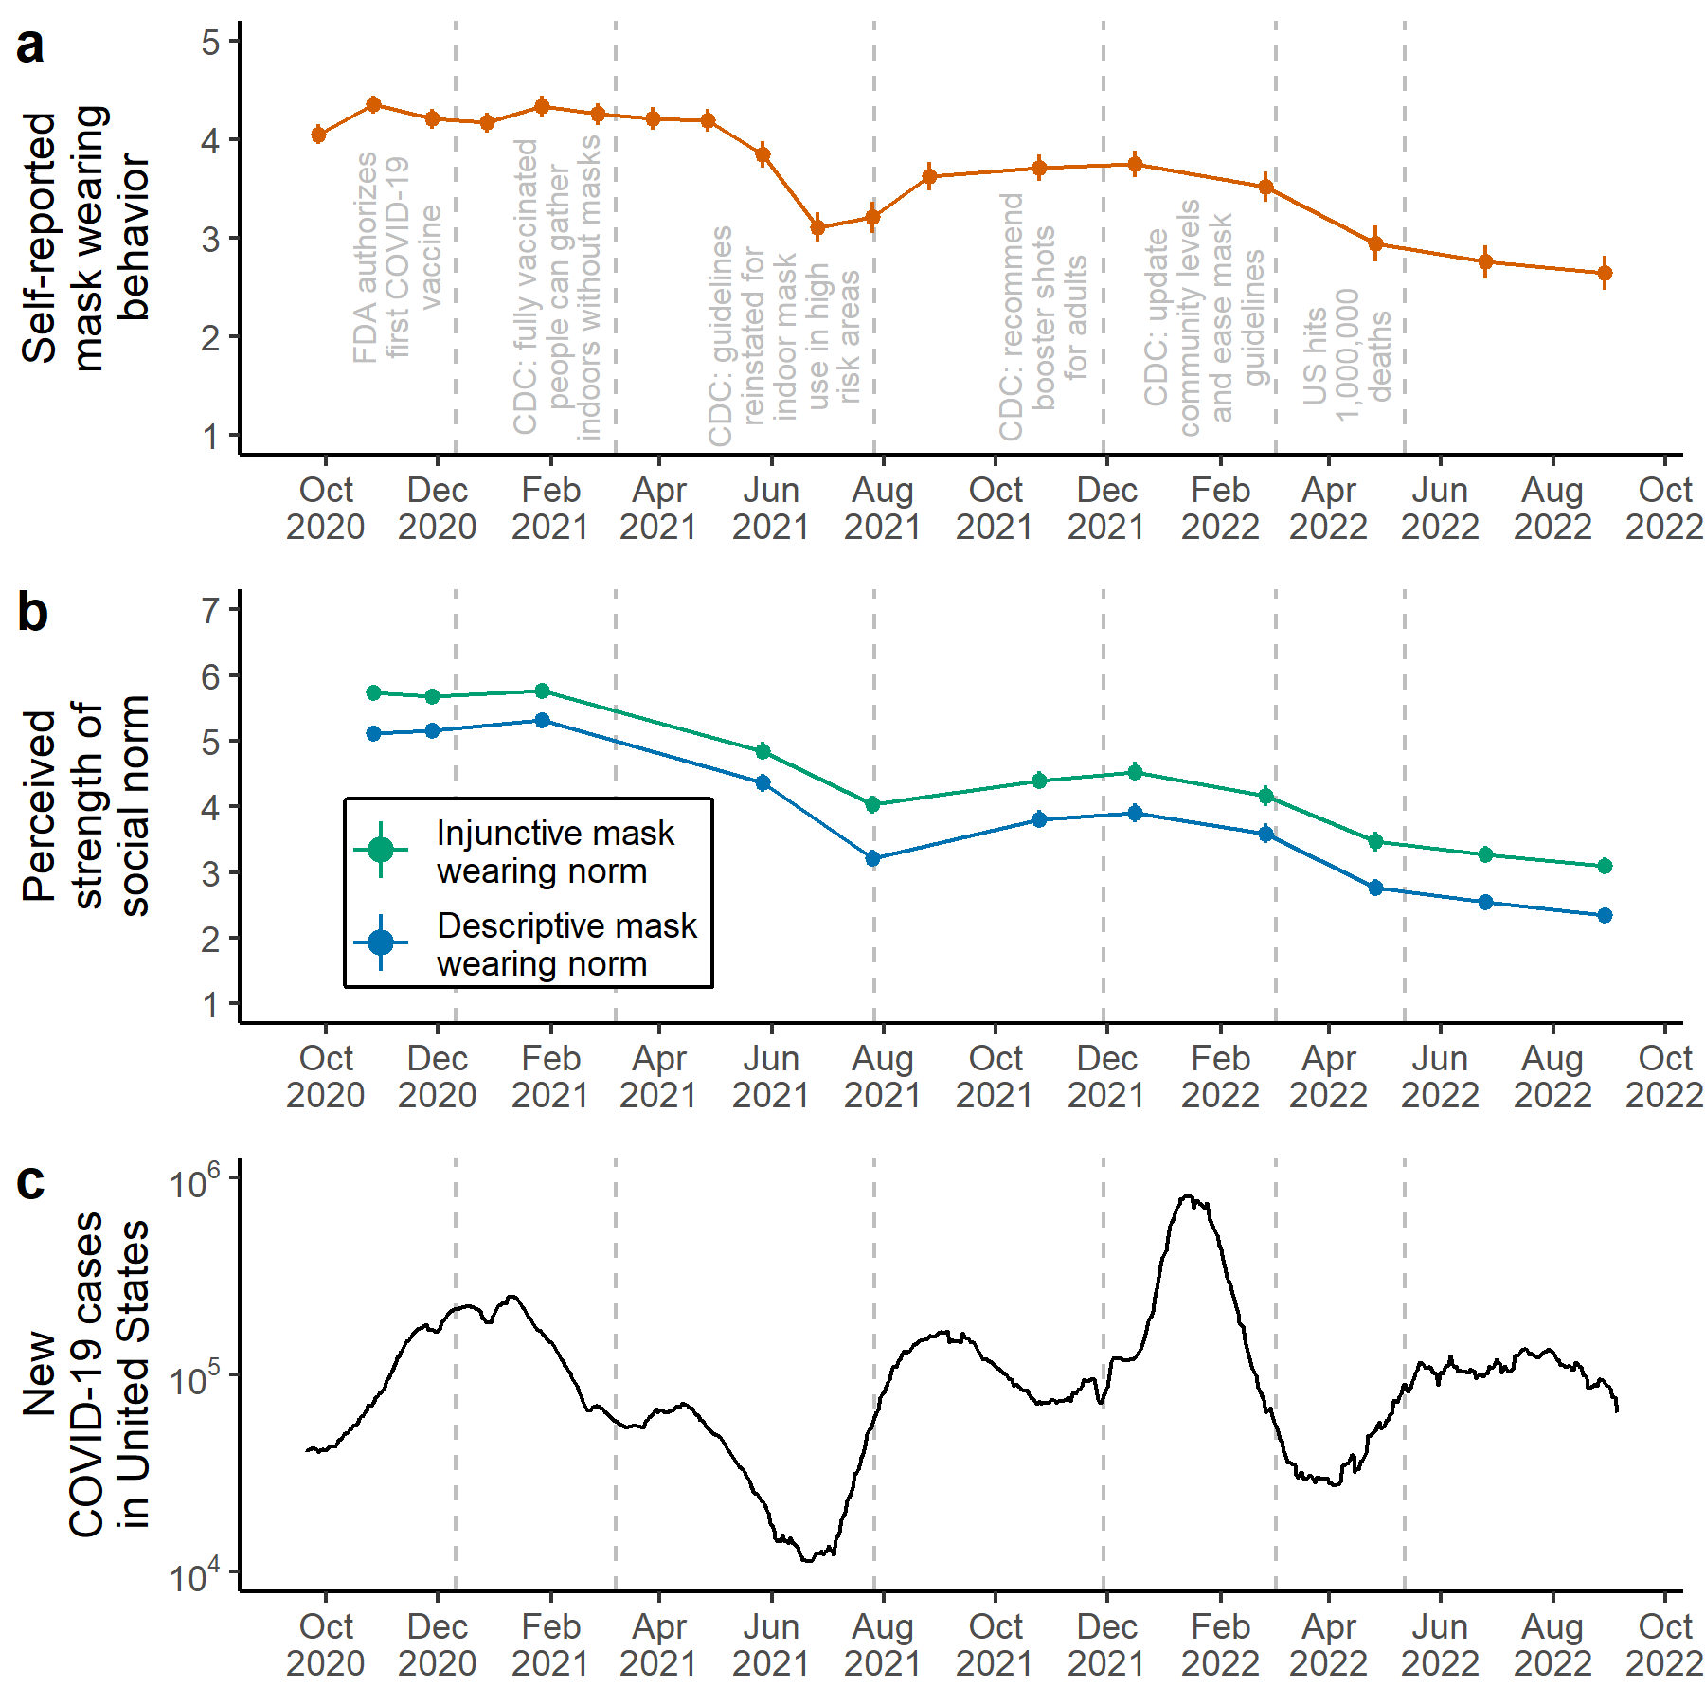

*Figure* *1.*  *Timeline of self-reported mask wearing behavior and perceived social norms in the United States throughout the COVID-19 pandemic.* (a) Points and line ranges indicate mean averages and standard errors for the self-reported mask wearing item. This item was measured across all eighteen time points on a 5-point Likert scale, with higher values indicating increased frequency of personal mask wearing during in-person interactions. (b) Points and line ranges indicate mean averages and standard errors for perceived injunctive mask wearing norms (green) and perceived descriptive mask wearing norms (blue). These items were measured across eleven time points on a 7-point Likert scale, with higher values indicating stronger perceived social norms. (c) Smoothed data for new COVID-19 cases in the United States, displayed on the log scale (data retrieved from Our World in Data; <https://ourworldindata.org/>). Across all panels, gray dashed lines represent significant pandemic-related events in the United States, such as vaccine approval from the Food and Drug Administration (FDA) and public health recommendations from the Centers for Disease Control and Prevention (CDC).

Two main observations can be made about the emergence and stability of social norms from these visualizations. First, social norms and behavior were tightly coupled over time. Although social norms are measured on fewer occasions than mask wearing behavior, we can see that as mask wearing behavior decreased in the summer of 2021, so too did perceived descriptive and injunctive mask wearing norms. Subsequently, the steep rise in COVID-19 case numbers in the fall of 2021 saw concomitant increases in both mask wearing behavior and perceived social norms, before declining again in 2022. In line with these patterns, multilevel regression models revealed positive correlations between mask wearing behavior and perceived descriptive mask wearing norms (*b* = 0.29, 95% confidence interval [0.23 0.35], *p* < .001) and between mask wearing behavior and perceived injunctive mask wearing norms (*b* = 0.26, 95% CI [0.22 0.30], *p* < .001) across individuals and time points (Supplementary Figure 3; Supplementary Table 1).

Second, fluctuations in mask wearing behavior and perceived social norms are in line with recommendations broadcasted by the CDC, the main national public health agency of the United States. We do not have data for the very start of the pandemic in early 2020, but the high levels of mask wearing and strong perceived social norms at the start of our observation window likely emerged after the initial mask wearing recommendation from the CDC in April 2020. Perceived social norms and mask wearing behavior subsequently declined after the CDC rescinded their mask wearing recommendation following widespread vaccine availability in March 2021, and then increased again after the CDC updated their guidelines for indoor mask use in high risk areas in August 2021. Finally, perceived social norms and mask wearing declined again after the CDC eased mask wearing guidelines in March 2022. Impressively, shifts in mask wearing behavior and norms happened on the timescale of weeks. These trends were confirmed by a series of multilevel regression models with change points aligning with changes in CDC mask wearing recommendations (Supplementary Figure 4; Supplementary Table 2).

Sample averages can provide informative trends, but they do not allow us to estimate within-person changes in mask wearing behavior and perceived social norms over time. To determine whether within-person changes in social norms temporally preceded within-person changes in mask wearing behavior, we fitted a ten-wave unconstrained random-intercept cross-lagged panel model to the longitudinal data. This structural equation model separately estimated stable trait-like between-person individual differences and within-person fluctuations from trait levels for our main variables (self-reported mask wearing behavior, perceived descriptive mask wearing norms, and perceived injunctive mask wearing norms) and time-variant control variables (factual beliefs and personal normative beliefs). In line with our proposed causal model (Supplementary Figure 5), we also included political orientation as an exogenous time-invariant control. According to established fit statistics, this model fitted the data well (root mean square error of approximation = 0.030, 95% CI [0.028 0.033]; standardized root mean squared residual = 0.087; comparative fit index = 0.957). Since we are primarily interested in the causal effects of social norms on behavior, in what follows we focus on the results for mask wearing behavior, perceived descriptive norms, and perceived injunctive norms (but see Supplementary Table 3 for full list of estimated autoregressive and cross-lagged effects).

Regarding between-person individual differences, the covariances between the random intercepts in the model revealed positive correlations between stable trait levels of mask wearing behavior and perceived social norms. On average across the whole study, participants who more frequently wore masks during in-person interactions also perceived stronger descriptive mask wearing norms (*r* = 0.19, 95% CI [0.04 0.33], *p* = .019) and stronger injunctive mask wearing norms (*r* = 0.27, 95% CI [0.14 0.40], *p* < .001). Stable trait perceptions of descriptive and injunctive mask wearing norms were also highly positively correlated (*r* = 0.71, 95% CI [0.65 0.78], *p* < .001).

Regarding within-person dynamics over time, Figure 2 displays autoregressive and cross-lagged effects for perceived descriptive norms, perceived injunctive norms, and mask wearing behavior across the study duration, controlling for non-social beliefs and political orientation. In random intercept cross-lagged panel models, autoregressive effects represent “persistence” or “inertia” in within-person fluctuations from stable trait levels. In other words, a positive autoregressive effect indicates that being higher than average on one measure predicts being higher than average on that same measure in the following time point (this is not to be confused with the “stability” of the measure over time, which is captured by the random intercepts in our model). By contrast, and most relevant for the current study, cross-lagged effects represent the effect of a within-person fluctuation in one measure on future within-person fluctuations in other measures. In other words, a positive cross-lagged effect indicates that being higher than average on one measure predicts being higher than average on *another* measure in the following time point. Cross-lagged effects are thus used to infer within-person causal influences over time.

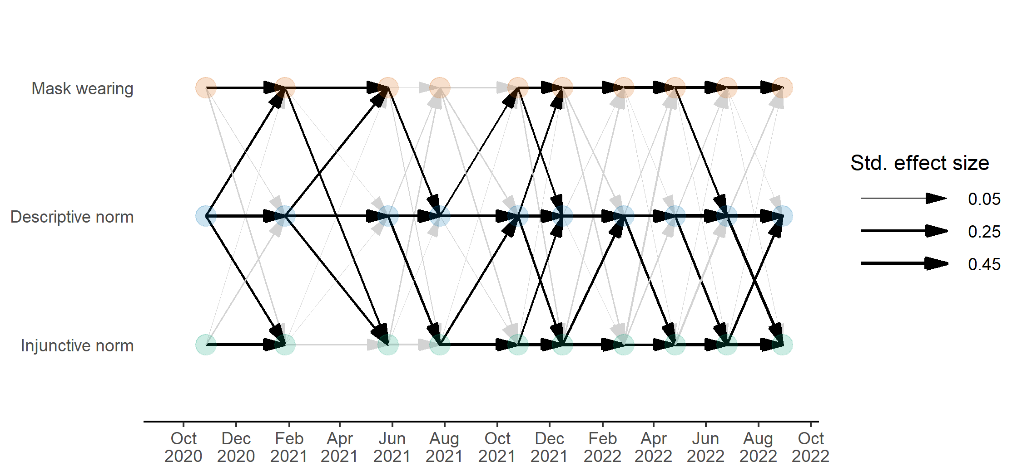

*Figure* *2.*  *Results of ten-wave unconstrained random-intercept cross-lagged panel model.* Arrows represent within-person autoregressive and cross-lagged effects for mask wearing behavior and perceived descriptive and injunctive norms, partitioning out stable between-person individual differences and controlling for factual beliefs, personal normative beliefs, and political orientation. Arrow thickness is scaled according to standardized effect size. Bolded arrows indicate significantly positive parameters, *p* < 0.05. Gray arrows indicate non-significant parameters.

In late 2020 and throughout 2021, we see several cross-lagged effects from perceived descriptive norms to future mask wearing behavior. On four occasions, within-person increases in perceived descriptive norms predicted future within-person increases in mask wearing behavior. According to recent effect size guidelines for cross-lagged panel models (35), the standardized beta coefficients for these cross-lagged effects were large (Time 2, $β$ = 0.17, 95% CI [0.06 0.28], *p* = .002; Time 5, $β$ = 0.21, 95% CI [0.08 0.34], *p* = .001; Time 11, $β$ = 0.15, 95% CI [0.01 0.30], *p* = .041; Time 13, $β$ = 0.16, 95% CI [0.02 0.29], *p* = .023). In 2022, these cross-lagged effects from descriptive norms to mask wearing behavior diminished. We also find some evidence for a reciprocal effect, whereby within-person increases in mask wearing behavior predicted future within-person increases in perceived descriptive norms. Moreover, several cross-lagged effects emerged between perceived descriptive and injunctive norms, demonstrating reciprocal within-person causal effects between these variables.

However, the model reveals that, after controlling for perceived descriptive norms, non-social beliefs, and political orientation, within-person changes in perceived injunctive norms did not predict future within-person changes in mask wearing behavior across the entire pandemic. All cross-lagged effects from perceived injunctive norms to mask wearing behavior are non-significant. Any causal effect that perceived injunctive norms might have had on future mask wearing behavior appears to be fully mediated by perceived descriptive norms. For example, between August 2021 and December 2021, perceived injunctive norms predicted future perceived descriptive norms, which themselves predicted future mask wearing behavior. But aside from these indirect effects, perceived injunctive norms did not have a direct causal effect on mask wearing behavior over time within individuals.

# Discussion

Using longitudinal data from the United States across the entire COVID-19 pandemic, we aimed to understand how descriptive and injunctive mask wearing norms emerge and influence behavior in response to a naturally unfolding social dilemma. The trends of norm perceptions and self-reported mask wearing over time suggest that norms and behavior are tightly coupled, and both change quickly in response to recommendations from public health authorities. The results of our structural equation model also indicate that descriptive norms caused future increases in mask wearing behavior at the beginning of the pandemic. By contrast, injunctive norms were not directly causally related to future mask wearing behavior over the course of the pandemic.

Our finding that social norms and mask wearing behavior are tightly coupled over time provides real-world support for experimental evidence that social norms and cooperative behavior develop synergistically within groups via processes of social interaction (22). Moreover, the role of authorities, like the CDC, in shaping social norms and behavior supports the idea that institutions are part of the process by which culture and one’s own behaviors are mutually constructed (36). The CDC explicitly releases guidelines for the benefit of public health, one of many situations in which the function of authorities is to coordinate behavior on large scales. However, even when institutions do not intend to coordinate behavior, they still may introduce influential social norms into the population (e.g., through business practices or products produced).

In our longitudinal analysis, we found that descriptive norms, not injunctive norms, predicted future increases in mask wearing across multiple time points. These cross-lagged effects were independent of the effects of non-social beliefs and political orientation. In line with this finding, descriptive norms have also been shown to predict future increases in physical distancing and prosocial behaviors (e.g., neighborhood help, charitable donations) throughout the COVID-19 pandemic, though this previous work did not adequately disentangle between-person and within-person effects (33). Similarly, experimental work has revealed that people in the United States are more likely to report intentions to wear a mask if they are told that others are wearing masks (32). Why this specific effect of descriptive norms on mask wearing? Descriptive norms are particularly useful for fast changing, threatening situations with a high degree of uncertainty, such as the COVID-19 pandemic (37). During times of uncertainty, people look to others to quickly coordinate their behavior, and attempt to alleviate uncertainty-related stress by identifying with their group and its social norms (38, 39). Supporting this situational-uncertainty explanation, our model revealed that descriptive norms predicted future mask wearing at the beginning of the pandemic, when uncertainty was likely at its peak. Unsure of how to respond to a novel threatening situation, people began to look to their neighbors and adapted their mask wearing behavior accordingly. However, as the uncertainty surrounding the pandemic lessened in 2022, reliance on descriptive norms appeared to decrease.

Our finding that injunctive norms do not predict future mask wearing behavior is at odds with cross-sectional evidence showing that perceived injunctive norms are positively correlated with intentions to stay indoors during the pandemic among older adults (31). One possible explanation for these conflicting findings is that, unlike previous work, our model systematically controlled for non-social beliefs, such as factual beliefs and personal normative beliefs, which could potentially have driven previous correlations. Another possible explanation is that, due to the increased opportunities to observe mask wearing in public, descriptive norms of mask wearing behavior were made more salient than injunctive norms throughout the pandemic, and therefore had a greater influence on behavior (2). By contrast, for more private behaviors like remaining indoors, it would have been less possible to observe other people’s behaviors, increasing the relative salience of injunctive norms. To test this idea, future research should expand our longitudinal cross-lagged approach to protective behaviors beyond mask wearing, including both public behaviors (e.g., physical distancing) and private behaviors (e.g., hand washing and home isolation). It is also possible that since injunctive norm perceptions did influence later descriptive norm perceptions, people use injunctive norm information as a signal that aids in interpreting or perceiving other people’s behavior as a descriptive norm. Future studies could also manipulate injunctive norm presence and determine the effect of these norms on how people interpret behavioral information.

We are limited in generalizing these findings due to the constraints of our sample and the variables considered. While our sample began as representative of the United States, there was significant attrition over the course of the study (Supplementary Figure 6). This attrition did not leave us with enough data to test the robustness of our results within different identity groups, such as different genders, different ethnicities, or those with different political ideologies. Since injunctive norm strength varies based on which group is seen as the source of the norm (40), it would be interesting to learn whether different groups have different patterns of norm emergence over time. In particular, future analyses with larger samples should consider political ideology as a group identity, due to the political polarization of COVID-19 protective behaviors (41). Our sample was predominantly White, and so future larger samples should be intentionally more diverse, answering calls to avoid generalizing White samples as representative of human behavior at large (42). Our results also might not generalize to all social norms, behaviors, and social dilemmas. Norms governing sustainability in response to climate change, for example, might take longer to emerge, since the threat of climate change is more abstract and remote than the COVID-19 pandemic. For more distant social dilemmas that do not cause immediate day-to-day uncertainty, descriptive social norms may not necessarily drive cooperative behavior.

Regardless, in the case of mask wearing in the United States over the COVID-19 pandemic, we have shown that social norms developed rapidly in the population and responded to both recommendations from authorities and current levels of cooperative behavior. Moreover, we found that descriptive norms, rather than injunctive norms, were the main driver for future mask wearing. Importantly, this key finding slices both ways. Not only does it imply that high local levels of mask wearing encouraged future personal mask use, but it also implies that *low* local levels of mask wearing *discouraged* future personal mask use. This echoes recent reports of people in the United States not wanting to be “singled out” by being the only one wearing a mask in their community (43). Our work thus underscores the importance of consistent, visible community adherence for encouraging personal protective behaviors in response to global pandemics like COVID-19.

# Materials and Methods

## Ethical approval

This project was granted exemption from the Institutional Review Board of Arizona State University (STUDY00011678). All participants in this study provided informed consent.

## Participants and sampling

Using the platform Prolific (<https://www.prolific.co/>), we distributed surveys to a representative sample of adults from the United States (*n* = 915, *M*age = 46 years, 75% White, 52% Women; see Supplementary Figure 7 for geographic distribution). From September 2020 to October 2022, we asked participants to complete regular surveys of COVID-19 related attitudes and behaviors. This resulted in 18 unique time points of data collection throughout the pandemic. The first 12 time points were distributed monthly, while the remaining six time points were distributed every two months. 634 of the initial 915 participants returned to complete the survey at Time 2, while 347 participants continued through to Time 18 (see Supplementary Figure 6 for attrition rates across all time points).

## Measures

### Self-reported mask wearing behavior.

At every time point, participants were asked about the number of in-person interactions they had in the last week. Following this question, participants self-reported their mask wearing behavior by answering: “*During these in-person interactions, if you were closer than 6 feet (2 meters) from the person(s) did you wear a face mask?*” Participants responded on a 5-point Likert scale, from Never (1) to Always (5).

### Perceived descriptive and injunctive social norms.

In 11 of the 18 time points (Time 2, 3, 5, 9, 11, 13, 14, 15, 16, 17, and 18), we asked questions about perceived descriptive and injunctive mask wearing norms.

Descriptive social norms were operationalized as the proportion of individuals in participants’ local areas wearing masks in routine and recreational settings. We measured perceived descriptive social norms as the mean average of the following two items: “*What proportion of people in your area wear a mask while doing routine activities indoors (e.g., running errands, shopping, going to work)?*” and “*What proportion of people in your area wear a mask while doing recreational/social activities indoors (e.g., going to the gym, eating at a restaurant, attending a party)?*” These perceived descriptive social norm items were measured on 7-point Likert scales, from None (1) to All (7).

Injunctive social norms were operationalized as respected individuals wearing masks and community encouragement of mask wearing rules to emphasize the perceived social approval of the behavior from group leaders and the community at large. We measured perceived injunctive social norms as the mean average of the following two items: “*In general, how often do you see people that you respect and trust wearing a mask (e.g., on tv, news, etc.)?*” and “*How much are mask-wearing rules encouraged in your area (e.g., by local or state government officials, businesses, etc.)?*” These perceived injunctive social norm items were measured on 7-point Likert scales, from Never/Rarely (1) to Very Often (7) for the first item, and from Strongly Discouraged (1) to Strongly Encouraged (7) for the second item.

To check the construct validity of these measures, at time point 7 we asked participants about their interpretations of the social norm items. We asked participants whether each of the four items informed them about what people *are* doing or what people *should* be doing (i.e., giving descriptive or injunctive information). Participants were able to correctly distinguish between the two sets of items, suggesting that they are valid measures of perceived descriptive and injunctive social norms (see Supplementary Results and Supplementary Table 4).

### Additional control variables.

To identify direct causal effects in our longitudinal analysis, we constructed a directed acyclic causal graph outlining the expected causal relationships between our variables (see Supplementary Figure 5). In this causal model, we included two kinds of non-social beliefs highlighted by previous research (27): factual beliefs (i.e., beliefs about the effectiveness or consequences of mask wearing) and personal normative beliefs (i.e., personal beliefs about whether mask wearing is the morally right thing to do). These variables were included as potential mediators of the effects of descriptive and injunctive social norms on mask wearing behavior. In addition, we also included political orientation as a common cause of all other variables. This is justified by evidence showing that mask wearing was heavily politicized in the United States throughout the pandemic (41). Given this causal graph, it is necessary to control for factual beliefs, personal normative beliefs, and political orientation in order to estimate the direct causal effects of descriptive and injunctive norms on mask wearing behavior over time.

Non-social beliefs were measured in 12 of the 18 time points (Time 2, 4, 5, 7, 9, 11, 13, 14, 15, 16, 17, and 18). Factual beliefs were measured as the mean average of the following two items: “*I wear a face mask when going out in public to keep myself from getting sick*” and “*I wear a face mask when going out in public to prevent others from getting sick in case I may be infected but don’t know it yet*”. Personal normative beliefs were measured with a single item: “*Wearing a face mask when going out in public is the right thing to do*”. These non-social belief items were measured on 7-point Likert scales, from Strongly Disagree (1) to Strongly Agree (7).

Political orientation was measured in the first time point only. We measured political orientation as the mean average of the following two items: “*How would you describe your political orientation with regard to social issues?*” and “*How would you describe your political orientation with regard to economic issues?*”. These items were measured on 7-point Likert scales, from Very Liberal (1) to Very Conservative (7).

## Statistical analysis

To analyze average trends in self-reported mask wearing behavior and perceived social norms, we fitted several multilevel regression models. First, to determine whether mask wearing behavior and social norms were coupled over time, we regressed mask wearing behavior on perceived descriptive and injunctive norms separately, including random intercepts and slopes for participants and time points. Second, to analyze whether changes over time were related to recommendations from the CDC, we regressed mask wearing behavior and perceived social norms onto a continuous time predictor. These models included random intercepts and slopes for participants, as well as change points aligning with changes in CDC mask wearing recommendations. We estimated these multilevel regression models using the *lme4* R package (44) and dealt with missing data via listwise deletion.

To quantify the within-person relationships between our variables over time, we fitted a random-intercept cross-lagged panel model to our longitudinal data (34). This structural equation model distinguishes between stable between-person trait levels and within-person fluctuations from trait levels. Positive cross-lagged effects from this model indicate that being above average on one variable at timet-1 predicts being above average in another variable at timet. These models are considered the gold standard for identifying Granger causality in longitudinal datasets (34, 45).

We estimated the random-intercept cross-lagged panel model using the *lavaan* R package (46). In line with our directed acyclic graph (see Supplementary Figure 5), we included three main variables (self-reported mask wearing behavior, perceived descriptive norms, and perceived injunctive norms) and two time-variant control variables (factual beliefs and personal normative beliefs) in the model. For each of these variables, the model estimated a stable between-person trait level (random intercept) and time-specific within-person fluctuations from this trait level. We modelled autoregressive and cross-lagged effects between all five variables, and included political orientation as a time-invariant covariate. We restricted the analysis to the ten time points with available data for all five variables. Full information maximum likelihood estimation was used to deal with missing data.

All analyses were conducted in R v4.1.1 (47). Visualizations were generated using the *cowplot* (48) and *ggplot2* (49) packages. The manuscript was reproducibly generated using the *targets* (50) and *papaja* (51) packages.

# Acknowledgements

This study was funded by the Interdisciplinary Cooperation Initiative, ASU President’s Office, the Cooperation Science Network, the Institute for Mental Health Research, the University of New Mexico, the Indiana University College of Arts & Sciences, the Rutgers University Center for Human Evolutionary Studies, the Charles Koch Foundation, and the John Templeton Foundation.

# Author Contributions

SLH, JDA, DGB, AVH, ERH, AA, and PMT conceptualized the study. SLH, SC, JDA, DGB, and AVH oversaw the data curation, investigation, and methodology of the study. SLH and SC wrote the first draft of the paper. SC conducted the formal analysis and created all visualisations. ERH, AA, and PMT provided funding and supervision for the study. All authors reviewed and edited the final draft of the paper.

# Conflicts of Interest

There are no conflicts of interest to declare.

# Research Transparency and Reproducibility

All data and code to reproduce the statistical analyses in this manuscript can be found on GitHub: <https://github.com/ScottClaessens/covidMaskWearing>

# References

1. C. Bicchieri, E. Xiao, [Do the right thing: But only if others do so](https://doi.org/10.1002/bdm.621). *Journal of Behavioral Decision Making* **22**, 191–208 (2009).

2. R. B. Cialdini, C. A. Kallgren, R. R. Reno, “[A focus theory of normative conduct: A theoretical refinement and reevaluation of the role of norms in human behavior](https://doi.org/10.1016/S0065-2601(08)60330-5)” in Advances in experimental social psychology., M. P. Zanna, Ed. (Academic Press, 1991), pp. 201–234.

3. E. Fehr, I. Schurtenberger, [Normative foundations of human cooperation](https://doi.org/10.1038/s41562-018-0385-5). *Nature Human Behaviour* **2**, 458–468 (2018).

4. S. Legros, B. Cislaghi, [Mapping the social-norms literature: An overview of reviews](https://doi.org/10.1177/1745691619866455). *Perspectives on Psychological Science* **15**, 62–80 (2020).

5. G. A. van Kleef, M. J. Gelfand, J. Jetten, [The dynamic nature of social norms: New perspectives on norm development, impact, violation, and enforcement](https://doi.org/10.1016/j.jesp.2019.05.002). *Journal of Experimental Social Psychology* **84**, 103814 (2019).

6. S. E. Asch, [Studies of independence and conformity: I. A minority of one against a unanimous majority](https://doi.org/10.1037/h0093718). *Psychological Monographs: General and Applied* **70**, 1 (1956).

7. M. Tomasello, [The ultra-social animal](https://doi.org/10.1002/ejsp.2015). *European Journal of Social Psychology* **44**, 187–194 (2014).

8. K. Jensen, A. Vaish, M. F. H. Schmidt, [The emergence of human prosociality: Aligning with others through feelings, concerns, and norms](https://doi.org/10.3389/fpsyg.2014.00822). *Frontiers in Psychology* **5**, 822 (2014).

9. H. Rakoczy, M. F. H. Schmidt, [The early ontogeny of social norms](https://doi.org/10.1111/cdep.12010). *Child Development Perspectives* **7**, 17–21 (2013).

10. M. F. H. Schmidt, M. Tomasello, [Young children enforce social norms](https://doi.org/10.1177/0963721412448659). *Current Directions in Psychological Science* **21**, 232–236 (2012).

11. A. Vaish, M. Carpenter, M. Tomasello, [Young children’s responses to guilt displays](https://doi.org/10.1037/a0024462). *Developmental Psychology* **47**, 1248–1262 (2011).

12. R. L. Schaumberg, S. E. Skowronek, [Shame broadcasts social norms: The positive social effects of shame on norm acquisition and normative behavior](https://doi.org/10.1177/09567976221075303). *Psychological Science*, 09567976221075303 (2022).

13. M. J. Gelfand, *et al.*, [Differences between tight and loose cultures: A 33-nation study](https://doi.org/10.1126/science.1197754). *Science* **332**, 1100–1104 (2011).

14. J. Henrich, *The secret of our success: How culture is driving human evolution, domesticating our species, and making us smarter* (Princeton University Press, 2015).

15. M. Deutsch, H. B. Gerard, [A study of normative and informational social influences upon individual judgment](https://doi.org/10.1037/h0046408). *The Journal of Abnormal and Social Psychology* **51**, 629–636 (1955).

16. P. W. Schultz, J. M. Nolan, R. B. Cialdini, N. J. Goldstein, V. Griskevicius, [The constructive, destructive, and reconstructive power of social norms](https://doi.org/10.1111/j.1467-9280.2007.01917.x). *Psychological Science* **18**, 429–434 (2007).

17. R. B. Cialdini, [Descriptive social norms as underappreciated sources of social control](https://doi.org/10.1007/s11336-006-1560-6). *Psychometrika* **72**, 263–268 (2007).

18. R. B. Cialdini, R. P. Jacobson, [Influences of social norms on climate change-related behaviors](https://doi.org/10.1016/j.cobeha.2021.01.005). *Current Opinion in Behavioral Sciences* **42**, 1–8 (2021).

19. R. Boyd, P. J. Richerson, *Culture and the evolutionary process* (University of Chicago Press, 1985).

20. G. Kushnick, R. D. Gray, F. M. Jordan, [The sequential evolution of land tenure norms](https://doi.org/10.1016/j.evolhumbehav.2014.03.001). *Evolution and Human Behavior* **35**, 309–318 (2014).

21. F. M. Jordan, R. D. Gray, S. J. Greenhill, R. Mace, [Matrilocal residence is ancestral in Austronesian societies](https://doi.org/10.1098/rspb.2009.0088). *Proceedings of the Royal Society B: Biological Sciences* **276**, 1957–1964 (2009).

22. K. Titlestad, T. A. B. Snijders, K. Durrheim, M. Quayle, T. Postmes, [The dynamic emergence of cooperative norms in a social dilemma](https://doi.org/10.1016/j.jesp.2019.03.010). *Journal of Experimental Social Psychology* **84**, 103799 (2019).

23. E. Fehr, I. Schurtenberger, “The dynamics of norm formation and norm decay” (Department of Economics 278, University of Zurich, 2018) https:/doi.org/[10.5167/uzh-147925](https://doi.org/10.5167/uzh-147925).

24. D. Nigbur, E. Lyons, D. Uzzell, [Attitudes, norms, identity and environmental behaviour: Using an expanded theory of planned behaviour to predict participation in a kerbside recycling programme](https://doi.org/10.1348/014466609X449395). *British Journal of Social Psychology* **49**, 259–284 (2010).

25. C. Larkin, M. Sanders, I. Andresen, F. Algate, “Testing local descriptive norms and salience of enforcement action: A field experiment to increase tax collection” (2018) https:/doi.org/[10.2139/ssrn.3167575](https://doi.org/10.2139/ssrn.3167575).

26. N. J. Goldstein, R. B. Cialdini, V. Griskevicius, [A room with a viewpoint: Using social norms to motivate environmental conservation in hotels](https://doi.org/10.1086/586910). *Journal of Consumer Research* **35**, 472–482 (2008).

27. C. Bicchieri, J. W. Lindemans, T. Jiang, [A structured approach to a diagnostic of collective practices](https://doi.org/10.3389/fpsyg.2014.01418). *Frontiers in Psychology* **5**, 1418 (2014).

28. L. G. E. Smith, E. F. Thomas, C. McGarty, ["We must be the change we want to see in the world": Integrating norms and identities through social interaction](https://doi.org/10.1111/pops.12180). *Political Psychology* **36**, 543–557 (2015).

29. Centers for Disease Control and Prevention, [CDC Museum COVID-19 Timeline](https://www.cdc.gov/museum/timeline/covid19.html) (2022).

30. Centers for Disease Control and Prevention, [CDC calls on Americans to wear masks to prevent COVID-19 spread](https://www.cdc.gov/media/releases/2020/p0714-americans-to-wear-masks.html) (2020).

31. J. T. Macy, C. Owens, K. Mullis, S. E. Middlestadt, [The role of self-efficacy and injunctive norms in helping older adults decide to stay home during the COVID-19 pandemic](https://doi.org/10.3389/fpubh.2021.660813). *Frontiers in Public Health* **9**, 660813 (2021).

32. S. E. Bokemper, *et al.*, [Experimental evidence that changing beliefs about mask efficacy and social norms increase mask wearing for COVID-19 risk reduction: Results from the United States and Italy](https://doi.org/10.1371/journal.pone.0258282). *PLOS ONE* **16**, e0258282 (2021).

33. S. C. Rudert, S. Janke, [Following the crowd in times of crisis: Descriptive norms predict physical distancing, stockpiling, and prosocial behavior during the COVID-19 pandemic](https://doi.org/10.1177/13684302211023562). *Group Processes & Intergroup Relations*, 13684302211023562 (2021).

34. E. L. Hamaker, R. M. Kuiper, R. P. P. P. Grasman, [A critique of the cross-lagged panel model](https://doi.org/10.1037/a0038889). *Psychological Methods* **20**, 102 (2015).

35. U. Orth, *et al.*, Effect size guidelines for cross-lagged effects. *Psychological Methods* (2022) https:/doi.org/[10.1037/met0000499](https://doi.org/10.1037/met0000499).

36. H. R. Markus, S. Kitayama, [Cultures and selves: A cycle of mutual constitution](https://doi.org/10.1177/1745691610375557). *Perspectives on Psychological Science* **5**, 420–430 (2010).

37. M. J. Gelfand, J. R. Harrington, [The motivational force of descriptive norms: For whom and when are descriptive norms most predictive of behavior?](https://doi.org/10.1177/0022022115600796) *Journal of Cross-Cultural Psychology* **46**, 1273–1278 (2015).

38. M. A. Hogg, Z. P. Hohman, J. E. Rivera, [Why do people join groups? Three motivational accounts from social psychology](https://doi.org/10.1111/j.1751-9004.2008.00099.x). *Social and Personality Psychology Compass* **2**, 1269–1280 (2008).

39. J. M. Wellen, M. A. Hogg, D. J. Terry, [Group norms and attitude-behavior consistency: The role of group salience and mood](https://doi.org/10.1037/1089-2699.2.1.48). *Group Dynamics: Theory, Research, and Practice* **2**, 48–56 (1998).

40. C. Neighbors, *et al.*, [The relative impact of injunctive norms on college student drinking: The role of reference group.](https://doi.org/10.1037/a0013043) *Psychology of Addictive Behaviors* **22**, 576–581 (2008).

41. R. Baxter-King, J. R. Brown, R. D. Enos, A. Naeim, L. Vavreck, [How local partisan context conditions prosocial behaviors: Mask wearing during COVID-19](https://doi.org/10.1073/pnas.2116311119). *Proceedings of the National Academy of Sciences* **119**, e2116311119 (2022).

42. J. D. Remedios, [Psychology must grapple with whiteness](https://doi.org/10.1038/s44159-022-00024-4). *Nature Reviews Psychology* **1**, 125–126 (2022).

43. H. Natanson, [Peer pressure is ending mask usage in schools](https://www.washingtonpost.com/education/2022/02/25/peer-pressure-mask-optional-schools/). *The Washingston Post* (2022) (August 18, 2022).

44. D. Bates, M. Mächler, B. Bolker, S. Walker, [Fitting linear mixed-effects models using lme4](https://doi.org/10.18637/jss.v067.i01). *Journal of Statistical Software* **67**, 1–48 (2015).

45. C. W. J. Granger, [Investigating causal relations by econometric models and cross-spectral methods](https://doi.org/10.2307/1912791). *Econometrica* **37**, 424–438 (1969).

46. Y. Rosseel, [lavaan: An R package for structural equation modeling](https://doi.org/10.18637/jss.v048.i02). *Journal of Statistical Software* **48**, 1–36 (2012).

47. R Core Team, [*R: A language and environment for statistical computing*](https://www.R-project.org/) (R Foundation for Statistical Computing, 2022).

48. C. O. Wilke, [*cowplot: Streamlined plot theme and plot annotations for ’ggplot2’*](https://CRAN.R-project.org/package=cowplot) (2020).

49. H. Wickham, [*ggplot2: Elegant graphics for data analysis*](https://ggplot2.tidyverse.org) (Springer-Verlag New York, 2016).

50. W. M. Landau, [The targets R package: A dynamic Make-like function-oriented pipeline toolkit for reproducibility and high-performance computing](https://doi.org/10.21105/joss.02959). *Journal of Open Source Software* **6**, 2959 (2021).

51. F. Aust, M. Barth, [*papaja: Prepare reproducible APA journal articles with R Markdown*](https://github.com/crsh/papaja) (2022).

# Appendix

## Supplementary Results

### Construct validity for measures of perceived descriptive and injunctive norms.

To evaluate the construct validity of our measures of perceived descriptive and injunctive norms, at Time 7 we asked participants to rate the extent to which each perceived norm item provided descriptive and injunctive information. For each item, participants were asked whether the item provided information about what people *are* doing, and whether the item provided information about what people *should* be doing. Participants responded on a 7-point Likert scale, from (1) Not At All to (7) Very Strongly. For a full list of questions, see Supplementary Table 4.

Results showed that participants did differentiate the perceived norm items as expected. Participants rated the perceived descriptive norm items as providing more descriptive information than the perceived injunctive norm items, *t*(442) = -7.28, *p* < .001 (mean descriptive items = 4.75; mean injunctive items = 4.25). By contrast, participants rated the perceived injunctive norm items as providing more injunctive information than the perceived descriptive norm items, *t*(444) = 7.15, *p* < .001 (mean descriptive items = 5.11; mean injunctive items = 5.54).

## Supplementary Figures

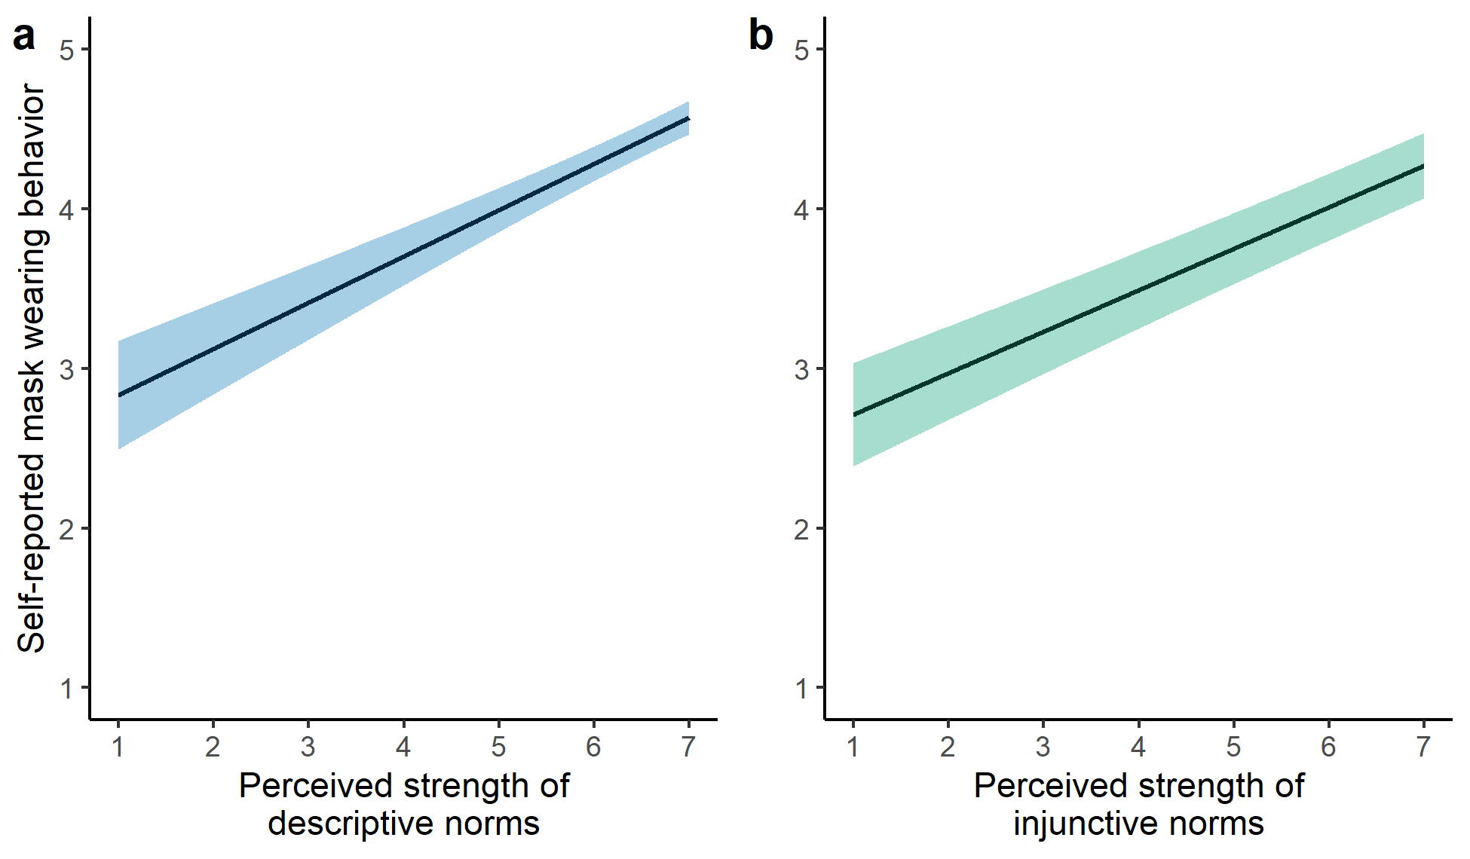

*Figure* *3.*  *Predictions from multilevel models with self-reported mask wearing behavior as the outcome variable and (a) perceived strength of descriptive norms and (b) perceived strength of injunctive norms as independent predictor variables.* Models contain random intercepts for participants and time points. Lines are fixed effect regression lines from multilevel models, shaded areas are 95% confidence intervals.

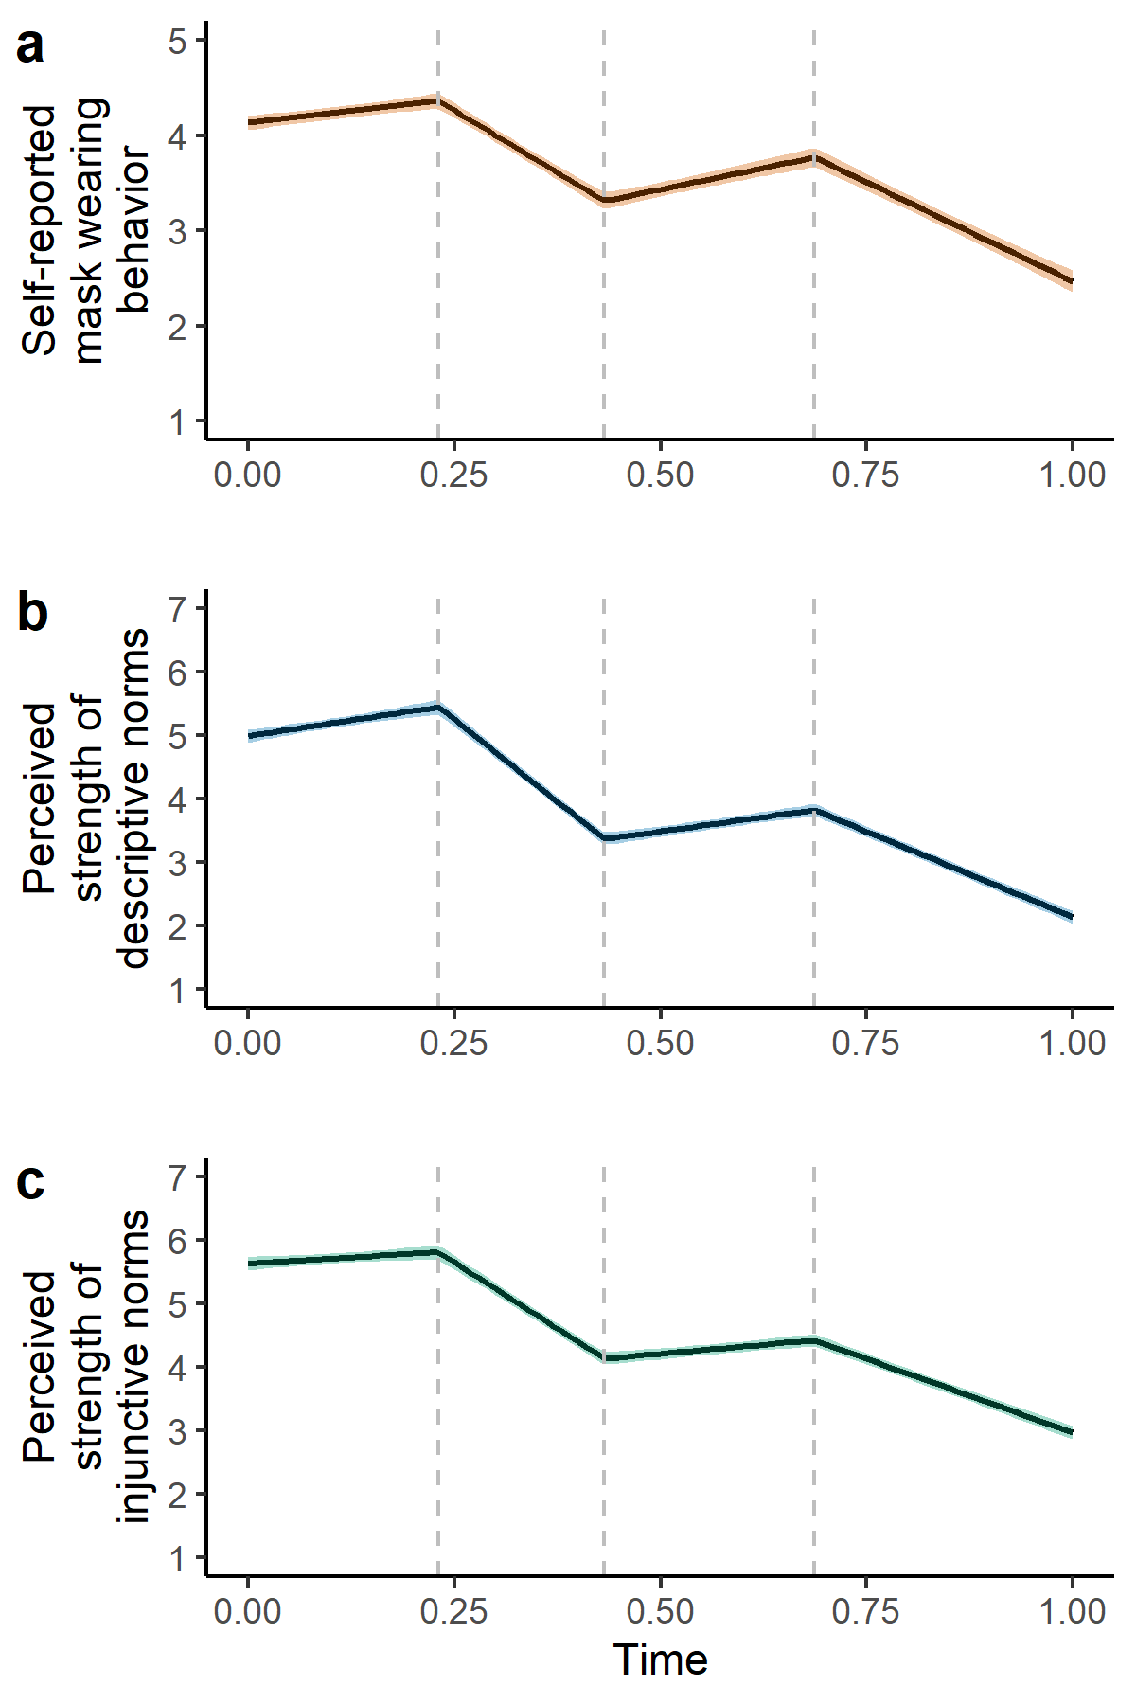

*Figure* *4.*  *Predictions from multilevel models with change points in line with changes in CDC mask wearing recommendations.* These models track temporal changes in (a) self-reported mask wearing behavior, (b) perceived strength of descriptive norms, and (c) perceived strength of injunctive norms. Time is included as a continuous linear predictor, scaled between 0 and 1, with three forced change points (dashed lines). From the left, the first dashed line indicates when the CDC relaxed their mask wearing recommendations in March 2021, the second dashed line indicates when the CDC strengthened their mask wearing recommendations in July 2021, and the third dashed line indicates when the CDC updated their community levels and relaxed their mask wearing recommendations in March 2022. This results in the estimation of five fixed effect parameters: the initial intercept, the slope in the first window, the slope in the second window, the slope in the third window, and the slope is the fourth window. Bolded lines and shaded areas represent fixed effect regression lines from multilevel models and 95% confidence intervals, respectively.

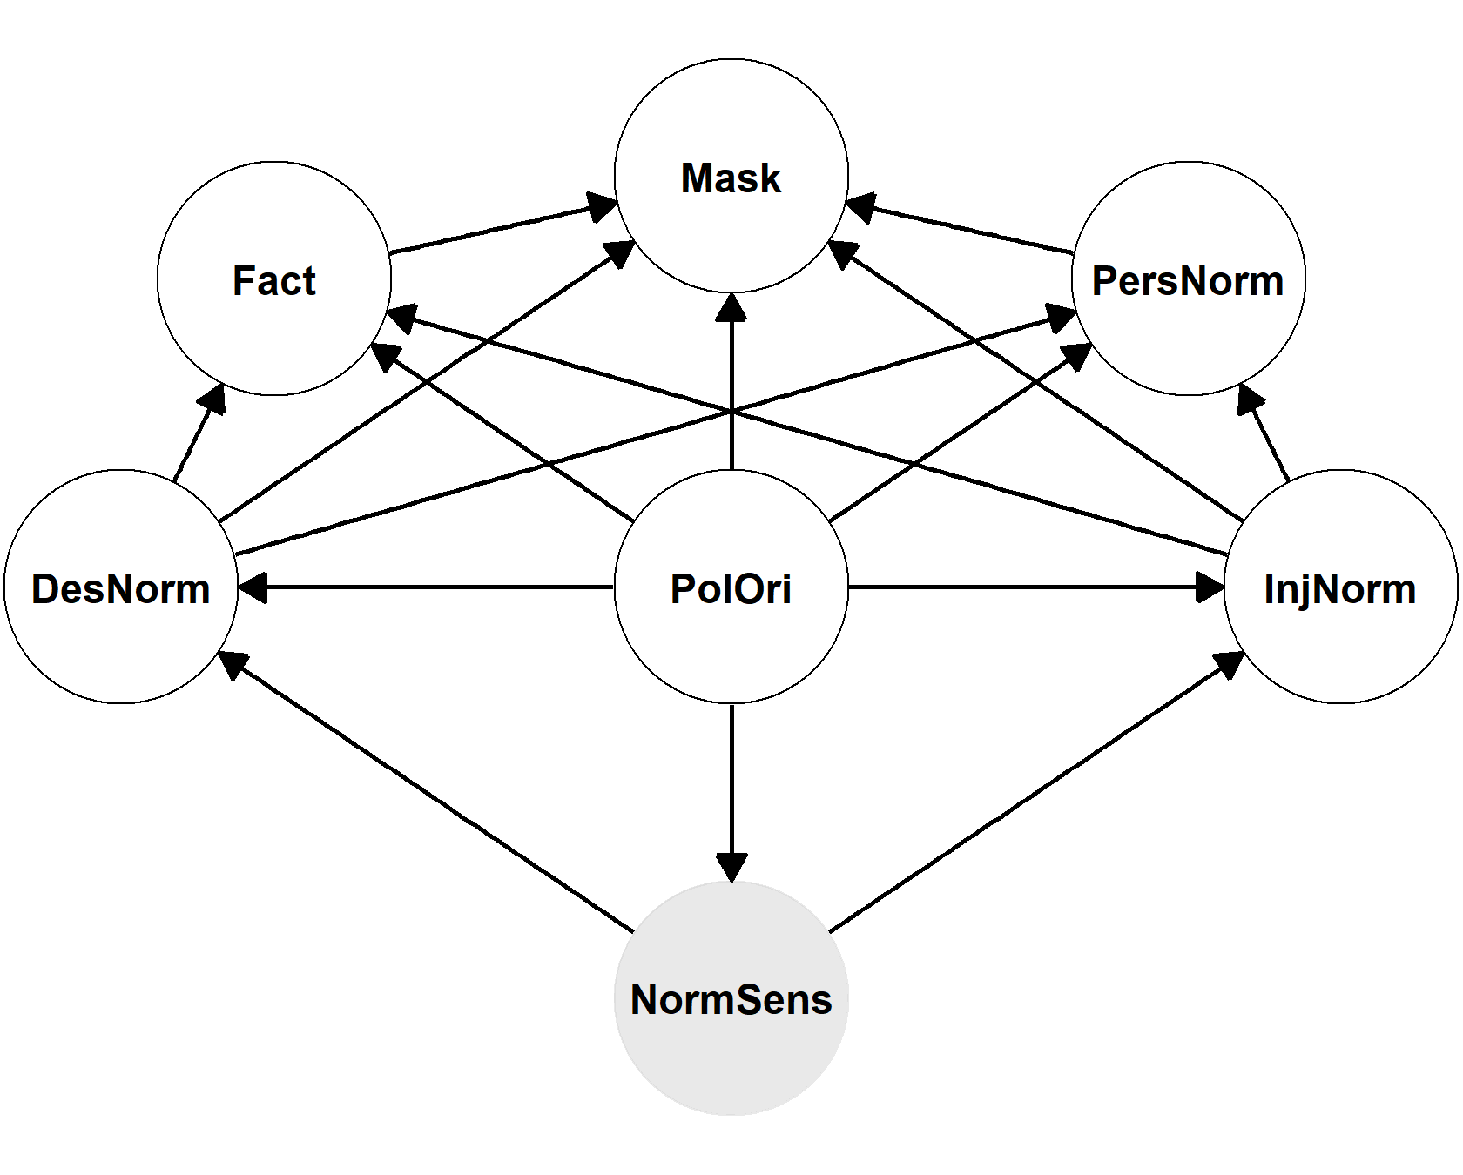

*Figure* *5.*  *Directed acyclic graph reflecting causal assumptions.* In this model, a general unobserved sensitivity to social norms (NormSens) causes perceptions of descriptive social norms (DesNorm) and perceptions of injunctive social norms (InjNorm), and perceptions of descriptive and injunctive norms directly cause mask wearing behavior (Mask). Perceptions of descriptive and injunctive norms also indirectly cause mask wearing behavior through non-social beliefs, specifically factual beliefs (Fact) and personal normative beliefs (PersNorm). Finally, political orientation (PolOri) is an exogenous variable that is a common cause of all other variables. Using the backdoor criterion (Pearl, 1995), this causal model implies that it is necessary to control for perceptions of injunctive norms, factual beliefs, personal normative beliefs, and political orientation to estimate the direct causal effect of perceived descriptive norms on mask wearing. Similarly, it is necessary to control for perceptions of descriptive norms, factual beliefs, personal normative beliefs, and political orientation to estimate the direct causal effect of perceived injunctive norms on mask wearing.

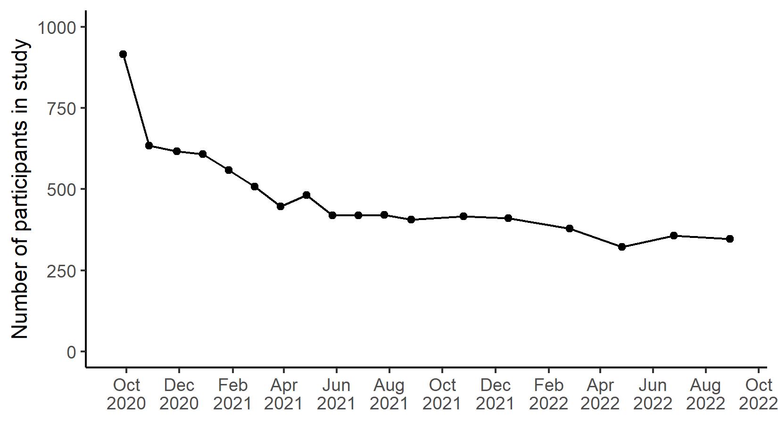

*Figure* *6.*  *Attrition across the course of the study.*

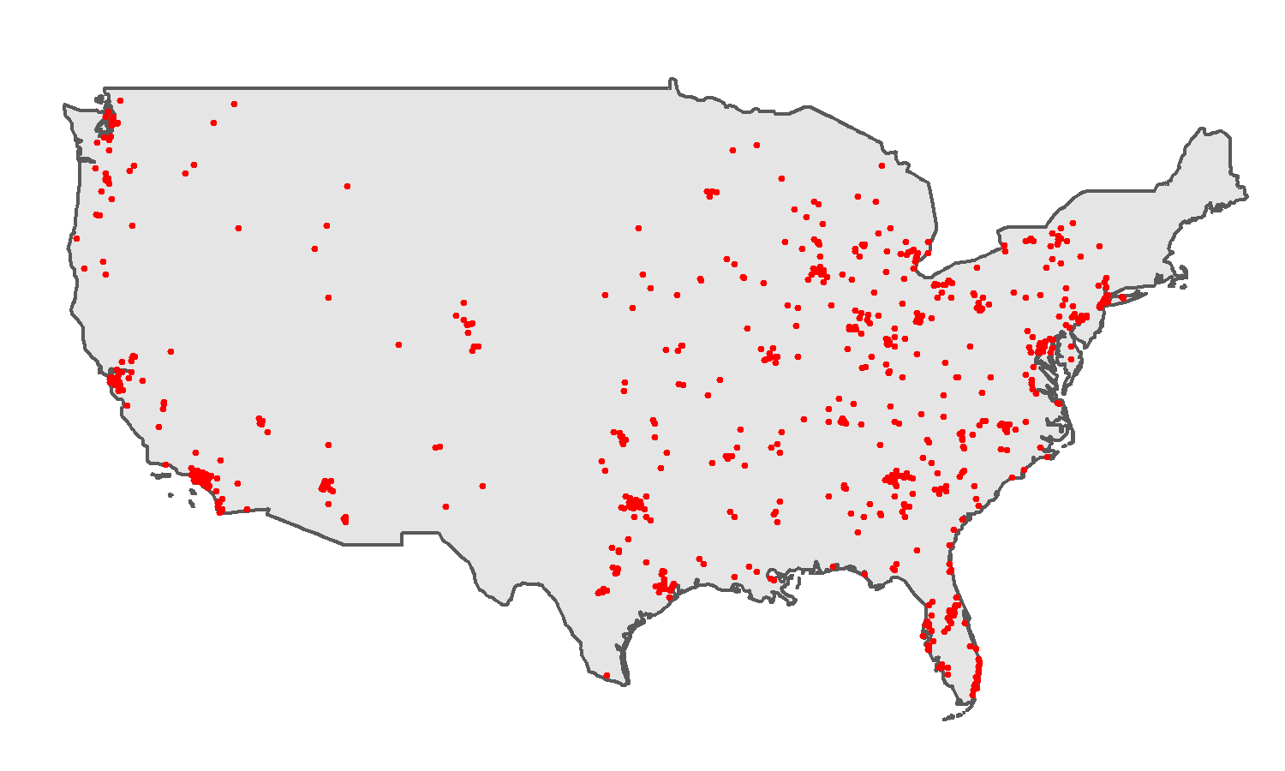

*Figure* *7.*  *Map of the United States with participant zip code locations.*

## Supplementary Tables

Table 1: Unstandardized fixed effect parameters from multilevel models: perceptions of social norm strength predicting self-reported mask wearing. _Standard errors are included in brackets._

|  |  |  |
| --- | --- | --- |
|  | Model 1 | Model 2 |
| Intercept | 2.54 | 2.45 |
|  | (0.20) | (0.18) |
| Descriptive norms | 0.29 |  |
|  | (0.03) |  |
| Injunctive norms |  | 0.26 |
|  |  | (0.02) |
| N | 4785 | 4798 |
| N (id) | 783 | 783 |
| N (time) | 11 | 11 |
| AIC | 15309.62 | 15411.28 |
| BIC | 15367.88 | 15469.57 |
| R2 (fixed) | 0.10 | 0.08 |
| R2 (total) | 0.47 | 0.47 |

Table 2:

*Unstandardized fixed effect parameters from multilevel models: trends over time with change points at CDC events.*

|  | Mask wearing | Descriptive norms | Injunctive norms |
| --- | --- | --- | --- |
| Intercept | 4.13, 95% CI [4.06 4.21] | 5.00, 95% CI [4.89 5.10] | 5.64, 95% CI [5.53 5.75] |
| Slope1 | 0.99, 95% CI [0.56 1.43] | 1.96, 95% CI [1.23 2.72] | 0.78, 95% CI [0.07 1.50] |
| Slope2 | -5.24, 95% CI [-5.78 -4.70] | -10.37, 95% CI [-11.08 -9.67] | -8.34, 95% CI [-9.02 -7.66] |
| Slope3 | 1.81, 95% CI [1.31 2.28] | 1.82, 95% CI [1.36 2.27] | 1.14, 95% CI [0.69 1.59] |
| Slope4 | -4.17, 95% CI [-4.62 -3.70] | -5.41, 95% CI [-5.79 -5.01] | -4.66, 95% CI [-5.05 -4.26] |
| N | 8505 | 4851 | 4861 |
| R2 (fixed) | 0.11 | 0.4 | 0.34 |
| R2 (total) | 0.38 | 0.68 | 0.67 |

(ref:rightArrow) →

Table 3:

*Standardised autoregressive and cross-lagged parameters from random-intercept cross-lagged panel model. Variable name prefixes: Mask = mask wearing, Des = perceived descriptive norms, Inj = perceived injunctive norms, Fact = factual beliefs, Pers = personal normative beliefs. Variable name suffixes indicate time points. Arrows indicate the direction of prediction.*

| Parameter | Estimate | SE | 2.5% | 97.5% |
| --- | --- | --- | --- | --- |
| Des_02 (ref:rightArrow) Mask_05 | 0.17 | 0.05 | 0.06 | 0.28 |
| Des_02 (ref:rightArrow) Inj_05 | 0.17 | 0.06 | 0.06 | 0.28 |
| Des_02 (ref:rightArrow) Des_05 | 0.37 | 0.05 | 0.26 | 0.47 |
| Des_02 (ref:rightArrow) Fact_05 | 0.09 | 0.06 | -0.04 | 0.21 |
| Des_02 (ref:rightArrow) Pers_05 | 0.04 | 0.06 | -0.08 | 0.17 |
| Des_05 (ref:rightArrow) Mask_09 | 0.21 | 0.06 | 0.08 | 0.34 |
| Des_05 (ref:rightArrow) Inj_09 | 0.23 | 0.07 | 0.10 | 0.36 |
| Des_05 (ref:rightArrow) Des_09 | 0.26 | 0.06 | 0.14 | 0.39 |
| Des_05 (ref:rightArrow) Fact_09 | 0.16 | 0.07 | 0.02 | 0.30 |
| Des_05 (ref:rightArrow) Pers_09 | 0.27 | 0.07 | 0.12 | 0.42 |
| Des_09 (ref:rightArrow) Mask_11 | 0.04 | 0.07 | -0.09 | 0.18 |
| Des_09 (ref:rightArrow) Inj_11 | 0.20 | 0.07 | 0.07 | 0.33 |
| Des_09 (ref:rightArrow) Des_11 | 0.26 | 0.07 | 0.13 | 0.39 |
| Des_09 (ref:rightArrow) Fact_11 | 0.03 | 0.06 | -0.09 | 0.16 |
| Des_09 (ref:rightArrow) Pers_11 | 0.07 | 0.07 | -0.06 | 0.20 |
| Des_11 (ref:rightArrow) Mask_13 | 0.15 | 0.07 | 0.01 | 0.30 |
| Des_11 (ref:rightArrow) Inj_13 | 0.03 | 0.07 | -0.12 | 0.17 |
| Des_11 (ref:rightArrow) Des_13 | 0.27 | 0.07 | 0.14 | 0.41 |
| Des_11 (ref:rightArrow) Fact_13 | 0.07 | 0.07 | -0.07 | 0.21 |
| Des_11 (ref:rightArrow) Pers_13 | 0.06 | 0.07 | -0.08 | 0.20 |
| Des_13 (ref:rightArrow) Mask_14 | 0.16 | 0.07 | 0.02 | 0.29 |
| Des_13 (ref:rightArrow) Inj_14 | 0.21 | 0.06 | 0.09 | 0.33 |
| Des_13 (ref:rightArrow) Des_14 | 0.40 | 0.06 | 0.28 | 0.51 |
| Des_13 (ref:rightArrow) Fact_14 | 0.03 | 0.06 | -0.09 | 0.14 |
| Des_13 (ref:rightArrow) Pers_14 | 0.01 | 0.06 | -0.11 | 0.12 |
| Des_14 (ref:rightArrow) Mask_15 | 0.05 | 0.08 | -0.09 | 0.20 |
| Des_14 (ref:rightArrow) Inj_15 | -0.01 | 0.07 | -0.16 | 0.13 |
| Des_14 (ref:rightArrow) Des_15 | 0.34 | 0.06 | 0.22 | 0.46 |
| Des_14 (ref:rightArrow) Fact_15 | 0.12 | 0.07 | -0.01 | 0.25 |
| Des_14 (ref:rightArrow) Pers_15 | 0.09 | 0.07 | -0.05 | 0.23 |
| Des_15 (ref:rightArrow) Mask_16 | 0.03 | 0.07 | -0.11 | 0.18 |
| Des_15 (ref:rightArrow) Inj_16 | 0.23 | 0.08 | 0.08 | 0.38 |
| Des_15 (ref:rightArrow) Des_16 | 0.30 | 0.07 | 0.15 | 0.45 |
| Des_15 (ref:rightArrow) Fact_16 | 0.13 | 0.07 | 0.00 | 0.26 |
| Des_15 (ref:rightArrow) Pers_16 | 0.01 | 0.07 | -0.12 | 0.14 |
| Des_16 (ref:rightArrow) Mask_17 | 0.06 | 0.08 | -0.10 | 0.21 |
| Des_16 (ref:rightArrow) Inj_17 | 0.24 | 0.08 | 0.08 | 0.39 |
| Des_16 (ref:rightArrow) Des_17 | 0.53 | 0.07 | 0.40 | 0.66 |
| Des_16 (ref:rightArrow) Fact_17 | 0.06 | 0.07 | -0.08 | 0.20 |
| Des_16 (ref:rightArrow) Pers_17 | 0.03 | 0.07 | -0.10 | 0.16 |
| Des_17 (ref:rightArrow) Mask_18 | 0.08 | 0.07 | -0.06 | 0.21 |
| Des_17 (ref:rightArrow) Inj_18 | 0.30 | 0.07 | 0.17 | 0.43 |
| Des_17 (ref:rightArrow) Des_18 | 0.46 | 0.06 | 0.34 | 0.58 |
| Des_17 (ref:rightArrow) Fact_18 | 0.12 | 0.06 | 0.00 | 0.24 |
| Des_17 (ref:rightArrow) Pers_18 | 0.07 | 0.06 | -0.05 | 0.20 |
| Fact_02 (ref:rightArrow) Mask_05 | 0.06 | 0.07 | -0.08 | 0.19 |
| Fact_02 (ref:rightArrow) Inj_05 | -0.10 | 0.07 | -0.24 | 0.03 |
| Fact_02 (ref:rightArrow) Des_05 | -0.02 | 0.07 | -0.15 | 0.12 |
| Fact_02 (ref:rightArrow) Fact_05 | 0.22 | 0.08 | 0.07 | 0.38 |
| Fact_02 (ref:rightArrow) Pers_05 | -0.08 | 0.08 | -0.23 | 0.08 |
| Fact_05 (ref:rightArrow) Mask_09 | 0.15 | 0.08 | -0.01 | 0.31 |
| Fact_05 (ref:rightArrow) Inj_09 | -0.07 | 0.08 | -0.23 | 0.09 |
| Fact_05 (ref:rightArrow) Des_09 | -0.05 | 0.08 | -0.20 | 0.11 |
| Fact_05 (ref:rightArrow) Fact_09 | 0.07 | 0.09 | -0.10 | 0.25 |
| Fact_05 (ref:rightArrow) Pers_09 | -0.03 | 0.09 | -0.20 | 0.15 |
| Fact_09 (ref:rightArrow) Mask_11 | 0.15 | 0.08 | -0.01 | 0.30 |
| Fact_09 (ref:rightArrow) Inj_11 | 0.03 | 0.08 | -0.12 | 0.18 |
| Fact_09 (ref:rightArrow) Des_11 | 0.10 | 0.08 | -0.05 | 0.24 |
| Fact_09 (ref:rightArrow) Fact_11 | 0.26 | 0.07 | 0.12 | 0.40 |
| Fact_09 (ref:rightArrow) Pers_11 | 0.14 | 0.07 | -0.01 | 0.28 |
| Fact_11 (ref:rightArrow) Mask_13 | 0.18 | 0.09 | 0.00 | 0.35 |
| Fact_11 (ref:rightArrow) Inj_13 | 0.05 | 0.09 | -0.13 | 0.22 |
| Fact_11 (ref:rightArrow) Des_13 | -0.12 | 0.08 | -0.28 | 0.04 |
| Fact_11 (ref:rightArrow) Fact_13 | 0.19 | 0.08 | 0.03 | 0.36 |
| Fact_11 (ref:rightArrow) Pers_13 | 0.16 | 0.08 | 0.00 | 0.33 |
| Fact_13 (ref:rightArrow) Mask_14 | 0.05 | 0.08 | -0.12 | 0.21 |
| Fact_13 (ref:rightArrow) Inj_14 | 0.04 | 0.07 | -0.11 | 0.18 |
| Fact_13 (ref:rightArrow) Des_14 | 0.01 | 0.08 | -0.14 | 0.16 |
| Fact_13 (ref:rightArrow) Fact_14 | 0.25 | 0.07 | 0.11 | 0.39 |
| Fact_13 (ref:rightArrow) Pers_14 | 0.19 | 0.07 | 0.06 | 0.33 |
| Fact_14 (ref:rightArrow) Mask_15 | 0.32 | 0.08 | 0.16 | 0.48 |
| Fact_14 (ref:rightArrow) Inj_15 | -0.06 | 0.08 | -0.22 | 0.10 |
| Fact_14 (ref:rightArrow) Des_15 | 0.15 | 0.07 | 0.01 | 0.29 |
| Fact_14 (ref:rightArrow) Fact_15 | 0.47 | 0.07 | 0.33 | 0.60 |
| Fact_14 (ref:rightArrow) Pers_15 | 0.31 | 0.08 | 0.16 | 0.47 |
| Fact_15 (ref:rightArrow) Mask_16 | 0.10 | 0.09 | -0.08 | 0.28 |
| Fact_15 (ref:rightArrow) Inj_16 | 0.08 | 0.10 | -0.11 | 0.27 |
| Fact_15 (ref:rightArrow) Des_16 | 0.10 | 0.10 | -0.09 | 0.29 |
| Fact_15 (ref:rightArrow) Fact_16 | 0.39 | 0.08 | 0.23 | 0.55 |
| Fact_15 (ref:rightArrow) Pers_16 | 0.10 | 0.08 | -0.06 | 0.27 |
| Fact_16 (ref:rightArrow) Mask_17 | 0.21 | 0.09 | 0.03 | 0.39 |
| Fact_16 (ref:rightArrow) Inj_17 | -0.01 | 0.09 | -0.19 | 0.18 |
| Fact_16 (ref:rightArrow) Des_17 | -0.05 | 0.09 | -0.22 | 0.12 |
| Fact_16 (ref:rightArrow) Fact_17 | 0.22 | 0.08 | 0.06 | 0.39 |
| Fact_16 (ref:rightArrow) Pers_17 | 0.06 | 0.08 | -0.10 | 0.22 |
| Fact_17 (ref:rightArrow) Mask_18 | 0.10 | 0.09 | -0.08 | 0.28 |
| Fact_17 (ref:rightArrow) Inj_18 | -0.10 | 0.09 | -0.28 | 0.08 |
| Fact_17 (ref:rightArrow) Des_18 | 0.08 | 0.09 | -0.10 | 0.25 |
| Fact_17 (ref:rightArrow) Fact_18 | 0.37 | 0.08 | 0.21 | 0.53 |
| Fact_17 (ref:rightArrow) Pers_18 | 0.48 | 0.08 | 0.32 | 0.64 |
| Inj_02 (ref:rightArrow) Mask_05 | 0.01 | 0.05 | -0.10 | 0.11 |
| Inj_02 (ref:rightArrow) Inj_05 | 0.28 | 0.05 | 0.17 | 0.38 |
| Inj_02 (ref:rightArrow) Des_05 | 0.07 | 0.05 | -0.03 | 0.18 |
| Inj_02 (ref:rightArrow) Fact_05 | 0.05 | 0.06 | -0.08 | 0.17 |
| Inj_02 (ref:rightArrow) Pers_05 | -0.01 | 0.06 | -0.13 | 0.11 |
| Inj_05 (ref:rightArrow) Mask_09 | -0.07 | 0.06 | -0.19 | 0.05 |
| Inj_05 (ref:rightArrow) Inj_09 | 0.08 | 0.06 | -0.04 | 0.21 |
| Inj_05 (ref:rightArrow) Des_09 | -0.02 | 0.06 | -0.14 | 0.11 |
| Inj_05 (ref:rightArrow) Fact_09 | 0.02 | 0.07 | -0.11 | 0.16 |
| Inj_05 (ref:rightArrow) Pers_09 | -0.04 | 0.07 | -0.18 | 0.10 |
| Inj_09 (ref:rightArrow) Mask_11 | 0.08 | 0.08 | -0.07 | 0.23 |
| Inj_09 (ref:rightArrow) Inj_11 | 0.11 | 0.07 | -0.03 | 0.26 |
| Inj_09 (ref:rightArrow) Des_11 | -0.03 | 0.07 | -0.17 | 0.11 |
| Inj_09 (ref:rightArrow) Fact_11 | 0.01 | 0.07 | -0.12 | 0.15 |
| Inj_09 (ref:rightArrow) Pers_11 | 0.05 | 0.07 | -0.08 | 0.19 |
| Inj_11 (ref:rightArrow) Mask_13 | -0.01 | 0.07 | -0.15 | 0.13 |
| Inj_11 (ref:rightArrow) Inj_13 | 0.29 | 0.07 | 0.15 | 0.43 |
| Inj_11 (ref:rightArrow) Des_13 | 0.21 | 0.07 | 0.08 | 0.34 |
| Inj_11 (ref:rightArrow) Fact_13 | 0.12 | 0.07 | -0.01 | 0.26 |
| Inj_11 (ref:rightArrow) Pers_13 | 0.09 | 0.07 | -0.04 | 0.23 |
| Inj_13 (ref:rightArrow) Mask_14 | -0.05 | 0.07 | -0.19 | 0.08 |
| Inj_13 (ref:rightArrow) Inj_14 | 0.40 | 0.06 | 0.28 | 0.52 |
| Inj_13 (ref:rightArrow) Des_14 | 0.15 | 0.07 | 0.03 | 0.28 |
| Inj_13 (ref:rightArrow) Fact_14 | 0.02 | 0.06 | -0.10 | 0.14 |
| Inj_13 (ref:rightArrow) Pers_14 | 0.09 | 0.06 | -0.02 | 0.21 |
| Inj_14 (ref:rightArrow) Mask_15 | 0.08 | 0.07 | -0.06 | 0.22 |
| Inj_14 (ref:rightArrow) Inj_15 | 0.45 | 0.07 | 0.32 | 0.58 |
| Inj_14 (ref:rightArrow) Des_15 | 0.29 | 0.06 | 0.16 | 0.41 |
| Inj_14 (ref:rightArrow) Fact_15 | 0.10 | 0.06 | -0.02 | 0.22 |
| Inj_14 (ref:rightArrow) Pers_15 | 0.06 | 0.07 | -0.07 | 0.20 |
| Inj_15 (ref:rightArrow) Mask_16 | 0.14 | 0.07 | 0.00 | 0.28 |
| Inj_15 (ref:rightArrow) Inj_16 | 0.21 | 0.07 | 0.06 | 0.35 |
| Inj_15 (ref:rightArrow) Des_16 | 0.06 | 0.07 | -0.08 | 0.21 |
| Inj_15 (ref:rightArrow) Fact_16 | 0.01 | 0.06 | -0.12 | 0.13 |
| Inj_15 (ref:rightArrow) Pers_16 | 0.10 | 0.06 | -0.03 | 0.22 |
| Inj_16 (ref:rightArrow) Mask_17 | -0.01 | 0.07 | -0.15 | 0.13 |
| Inj_16 (ref:rightArrow) Inj_17 | 0.38 | 0.07 | 0.23 | 0.52 |
| Inj_16 (ref:rightArrow) Des_17 | 0.13 | 0.07 | 0.00 | 0.27 |
| Inj_16 (ref:rightArrow) Fact_17 | 0.00 | 0.07 | -0.14 | 0.13 |
| Inj_16 (ref:rightArrow) Pers_17 | -0.03 | 0.06 | -0.16 | 0.09 |
| Inj_17 (ref:rightArrow) Mask_18 | -0.02 | 0.07 | -0.15 | 0.11 |
| Inj_17 (ref:rightArrow) Inj_18 | 0.45 | 0.06 | 0.33 | 0.57 |
| Inj_17 (ref:rightArrow) Des_18 | 0.19 | 0.06 | 0.07 | 0.32 |
| Inj_17 (ref:rightArrow) Fact_18 | 0.01 | 0.06 | -0.11 | 0.13 |
| Inj_17 (ref:rightArrow) Pers_18 | 0.01 | 0.06 | -0.11 | 0.13 |
| Mask_02 (ref:rightArrow) Mask_05 | 0.21 | 0.05 | 0.11 | 0.31 |
| Mask_02 (ref:rightArrow) Inj_05 | 0.09 | 0.05 | -0.01 | 0.20 |
| Mask_02 (ref:rightArrow) Des_05 | 0.04 | 0.05 | -0.07 | 0.14 |
| Mask_02 (ref:rightArrow) Fact_05 | -0.05 | 0.06 | -0.17 | 0.07 |
| Mask_02 (ref:rightArrow) Pers_05 | -0.05 | 0.06 | -0.17 | 0.06 |
| Mask_05 (ref:rightArrow) Mask_09 | 0.19 | 0.06 | 0.07 | 0.30 |
| Mask_05 (ref:rightArrow) Inj_09 | 0.13 | 0.06 | 0.01 | 0.26 |
| Mask_05 (ref:rightArrow) Des_09 | 0.02 | 0.06 | -0.10 | 0.14 |
| Mask_05 (ref:rightArrow) Fact_09 | 0.14 | 0.07 | 0.01 | 0.27 |
| Mask_05 (ref:rightArrow) Pers_09 | 0.06 | 0.07 | -0.07 | 0.20 |
| Mask_09 (ref:rightArrow) Mask_11 | -0.01 | 0.07 | -0.14 | 0.12 |
| Mask_09 (ref:rightArrow) Inj_11 | 0.06 | 0.06 | -0.07 | 0.18 |
| Mask_09 (ref:rightArrow) Des_11 | 0.16 | 0.06 | 0.04 | 0.28 |
| Mask_09 (ref:rightArrow) Fact_11 | 0.19 | 0.06 | 0.08 | 0.31 |
| Mask_09 (ref:rightArrow) Pers_11 | 0.16 | 0.06 | 0.05 | 0.28 |
| Mask_11 (ref:rightArrow) Mask_13 | 0.07 | 0.07 | -0.06 | 0.21 |
| Mask_11 (ref:rightArrow) Inj_13 | 0.06 | 0.07 | -0.07 | 0.19 |
| Mask_11 (ref:rightArrow) Des_13 | 0.07 | 0.06 | -0.06 | 0.19 |
| Mask_11 (ref:rightArrow) Fact_13 | 0.04 | 0.06 | -0.09 | 0.16 |
| Mask_11 (ref:rightArrow) Pers_13 | 0.03 | 0.07 | -0.10 | 0.16 |
| Mask_13 (ref:rightArrow) Mask_14 | 0.19 | 0.06 | 0.08 | 0.31 |
| Mask_13 (ref:rightArrow) Inj_14 | 0.07 | 0.05 | -0.03 | 0.18 |
| Mask_13 (ref:rightArrow) Des_14 | 0.12 | 0.06 | 0.01 | 0.23 |
| Mask_13 (ref:rightArrow) Fact_14 | 0.07 | 0.05 | -0.03 | 0.17 |
| Mask_13 (ref:rightArrow) Pers_14 | 0.01 | 0.05 | -0.09 | 0.11 |
| Mask_14 (ref:rightArrow) Mask_15 | 0.21 | 0.06 | 0.09 | 0.33 |
| Mask_14 (ref:rightArrow) Inj_15 | 0.06 | 0.06 | -0.06 | 0.18 |
| Mask_14 (ref:rightArrow) Des_15 | 0.08 | 0.05 | -0.02 | 0.18 |
| Mask_14 (ref:rightArrow) Fact_15 | 0.05 | 0.05 | -0.06 | 0.15 |
| Mask_14 (ref:rightArrow) Pers_15 | -0.05 | 0.06 | -0.17 | 0.06 |
| Mask_15 (ref:rightArrow) Mask_16 | 0.25 | 0.07 | 0.12 | 0.39 |
| Mask_15 (ref:rightArrow) Inj_16 | 0.02 | 0.07 | -0.12 | 0.16 |
| Mask_15 (ref:rightArrow) Des_16 | 0.01 | 0.07 | -0.13 | 0.15 |
| Mask_15 (ref:rightArrow) Fact_16 | 0.10 | 0.06 | -0.03 | 0.22 |
| Mask_15 (ref:rightArrow) Pers_16 | 0.09 | 0.06 | -0.03 | 0.22 |
| Mask_16 (ref:rightArrow) Mask_17 | 0.33 | 0.07 | 0.20 | 0.46 |
| Mask_16 (ref:rightArrow) Inj_17 | -0.04 | 0.07 | -0.18 | 0.10 |
| Mask_16 (ref:rightArrow) Des_17 | 0.16 | 0.06 | 0.03 | 0.28 |
| Mask_16 (ref:rightArrow) Fact_17 | 0.22 | 0.06 | 0.09 | 0.34 |
| Mask_16 (ref:rightArrow) Pers_17 | 0.12 | 0.06 | 0.01 | 0.24 |
| Mask_17 (ref:rightArrow) Mask_18 | 0.39 | 0.06 | 0.27 | 0.51 |
| Mask_17 (ref:rightArrow) Inj_18 | -0.05 | 0.06 | -0.17 | 0.07 |
| Mask_17 (ref:rightArrow) Des_18 | 0.02 | 0.06 | -0.10 | 0.13 |
| Mask_17 (ref:rightArrow) Fact_18 | 0.13 | 0.06 | 0.02 | 0.24 |
| Mask_17 (ref:rightArrow) Pers_18 | 0.04 | 0.06 | -0.07 | 0.16 |
| Pers_02 (ref:rightArrow) Mask_05 | 0.05 | 0.07 | -0.09 | 0.18 |
| Pers_02 (ref:rightArrow) Inj_05 | 0.09 | 0.07 | -0.05 | 0.22 |
| Pers_02 (ref:rightArrow) Des_05 | 0.03 | 0.07 | -0.10 | 0.17 |
| Pers_02 (ref:rightArrow) Fact_05 | 0.06 | 0.08 | -0.09 | 0.22 |
| Pers_02 (ref:rightArrow) Pers_05 | 0.36 | 0.07 | 0.21 | 0.50 |
| Pers_05 (ref:rightArrow) Mask_09 | -0.27 | 0.08 | -0.42 | -0.12 |
| Pers_05 (ref:rightArrow) Inj_09 | -0.16 | 0.08 | -0.31 | 0.00 |
| Pers_05 (ref:rightArrow) Des_09 | -0.06 | 0.08 | -0.21 | 0.10 |
| Pers_05 (ref:rightArrow) Fact_09 | -0.21 | 0.08 | -0.37 | -0.05 |
| Pers_05 (ref:rightArrow) Pers_09 | -0.21 | 0.09 | -0.38 | -0.04 |
| Pers_09 (ref:rightArrow) Mask_11 | 0.04 | 0.08 | -0.11 | 0.20 |
| Pers_09 (ref:rightArrow) Inj_11 | 0.08 | 0.08 | -0.07 | 0.23 |
| Pers_09 (ref:rightArrow) Des_11 | 0.04 | 0.07 | -0.10 | 0.19 |
| Pers_09 (ref:rightArrow) Fact_11 | 0.06 | 0.07 | -0.08 | 0.20 |
| Pers_09 (ref:rightArrow) Pers_11 | 0.16 | 0.07 | 0.02 | 0.31 |
| Pers_11 (ref:rightArrow) Mask_13 | 0.08 | 0.08 | -0.08 | 0.24 |
| Pers_11 (ref:rightArrow) Inj_13 | 0.09 | 0.08 | -0.07 | 0.24 |
| Pers_11 (ref:rightArrow) Des_13 | 0.12 | 0.08 | -0.03 | 0.27 |
| Pers_11 (ref:rightArrow) Fact_13 | 0.18 | 0.08 | 0.03 | 0.33 |
| Pers_11 (ref:rightArrow) Pers_13 | 0.20 | 0.08 | 0.05 | 0.35 |
| Pers_13 (ref:rightArrow) Mask_14 | 0.24 | 0.08 | 0.08 | 0.40 |
| Pers_13 (ref:rightArrow) Inj_14 | -0.07 | 0.07 | -0.21 | 0.07 |
| Pers_13 (ref:rightArrow) Des_14 | -0.03 | 0.08 | -0.18 | 0.12 |
| Pers_13 (ref:rightArrow) Fact_14 | 0.34 | 0.07 | 0.21 | 0.48 |
| Pers_13 (ref:rightArrow) Pers_14 | 0.41 | 0.07 | 0.29 | 0.54 |
| Pers_14 (ref:rightArrow) Mask_15 | -0.05 | 0.08 | -0.22 | 0.11 |
| Pers_14 (ref:rightArrow) Inj_15 | 0.15 | 0.08 | -0.02 | 0.31 |
| Pers_14 (ref:rightArrow) Des_15 | -0.07 | 0.07 | -0.21 | 0.07 |
| Pers_14 (ref:rightArrow) Fact_15 | 0.02 | 0.07 | -0.13 | 0.16 |
| Pers_14 (ref:rightArrow) Pers_15 | 0.14 | 0.08 | -0.02 | 0.30 |
| Pers_15 (ref:rightArrow) Mask_16 | 0.11 | 0.09 | -0.05 | 0.28 |
| Pers_15 (ref:rightArrow) Inj_16 | 0.08 | 0.09 | -0.10 | 0.25 |
| Pers_15 (ref:rightArrow) Des_16 | 0.17 | 0.09 | 0.00 | 0.35 |
| Pers_15 (ref:rightArrow) Fact_16 | 0.11 | 0.08 | -0.05 | 0.26 |
| Pers_15 (ref:rightArrow) Pers_16 | 0.41 | 0.08 | 0.27 | 0.56 |
| Pers_16 (ref:rightArrow) Mask_17 | 0.00 | 0.08 | -0.17 | 0.17 |
| Pers_16 (ref:rightArrow) Inj_17 | 0.05 | 0.09 | -0.12 | 0.23 |
| Pers_16 (ref:rightArrow) Des_17 | -0.02 | 0.08 | -0.18 | 0.14 |
| Pers_16 (ref:rightArrow) Fact_17 | 0.26 | 0.08 | 0.11 | 0.41 |
| Pers_16 (ref:rightArrow) Pers_17 | 0.56 | 0.07 | 0.42 | 0.69 |
| Pers_17 (ref:rightArrow) Mask_18 | 0.09 | 0.09 | -0.08 | 0.26 |
| Pers_17 (ref:rightArrow) Inj_18 | -0.01 | 0.08 | -0.17 | 0.15 |
| Pers_17 (ref:rightArrow) Des_18 | -0.02 | 0.08 | -0.18 | 0.14 |
| Pers_17 (ref:rightArrow) Fact_18 | 0.16 | 0.08 | 0.01 | 0.31 |
| Pers_17 (ref:rightArrow) Pers_18 | 0.12 | 0.08 | -0.03 | 0.27 |

Table 4:

*List of norm interpretation questions asked at Time 7. These questions were preceded by the following text: “There may or may not be a difference between what people around you are doing and what they should be doing. You can learn about what people are doing and what they should be doing in different ways. For each of the following information sources, we want to know if you can learn from it what people are doing, what people should be doing, or both”. Participants answered all questions on a 7-point Likert scale, from (1) Not At All to (7) Very Strongly.*

| Interpretation | Perceived norm item | Question |
| --- | --- | --- |
| Provides descriptive information | Descriptive | Does noticing the proportion of people in your area that wear a mask while doing recreational/social activities indoors (e.g., going to the gym, eating at a restaurant, attending a party) tell you what everyone is doing? |
|  |  | Does noticing the proportion of people in your area that wear a mask while doing routine activities indoors (e.g., running errands, shopping, going to work) tell you what everyone is doing? |
|  | Injunctive | Do mask-wearing rules encouraged in your area (e.g., by local or state government officials, businesses, etc.) tell you what everyone is doing? |
|  |  | Does how often you see people that you respect and trust wearing a mask (e.g., on tv, news, etc.) tell you what everyone is doing? |
| Provides injunctive information | Descriptive | Does noticing the proportion of people in your area that wear a mask while doing recreational/social activities indoors (e.g., going to the gym, eating at a restaurant, attending a party) tell you what everyone should be doing? |
|  |  | Does noticing the proportion of people in your area that wear a mask while doing routine activities indoors (e.g., running errands, shopping, going to work) tell you what everyone should be doing? |
|  | Injunctive | Do mask-wearing rules encouraged in your area (e.g., by local or state government officials, businesses, etc.) tell you what everyone should be doing? |
|  |  | Does how often you see people that you respect and trust wearing a mask (e.g., on tv, news, etc.) tell you what everyone should be doing? |

## Supplementary References

Pearl, J. (1995). Causal diagrams for empirical research. *Biometrika*, *82*(4), 669–688, <https://doi.org/10.1093/biomet/82.4.669>