# Why Do People Punish? Evidence for a Range of Strategic Concerns

Scott Claessens1,2, Quentin D Atkinson2, and Nichola J Raihani2,3

1School of Psychology, University of Kent

2School of Psychology, University of Auckland

3Department of Experimental Psychology, University College London

# Author Note

Scott Claessens  <https://orcid.org/0000-0002-3562-6981>

Quentin D Atkinson  <https://orcid.org/0000-0002-8499-7535>

Nichola J Raihani  <https://orcid.org/0000-0003-2339-9889>

This manuscript was published as a pre-print on PsyArXiv under a CC BY 4.0 license: <https://doi.org/10.31234/osf.io/ys6rm> Word count (excluding abstract, figures, tables, and references) = 6065 words.

Author roles were classified using the Contributor Role Taxonomy (CRediT; https://credit.niso.org/) as follows: *Scott Claessens***:** conceptualization, data curation, formal analysis, investigation, methodology, visualization, writing – original draft, and writing – review & editing. *Quentin D Atkinson***:** conceptualization, funding acquisition, methodology, supervision, writing – original draft, and writing – review & editing. *Nichola J Raihani***:** conceptualization, funding acquisition, investigation, methodology, supervision, writing – original draft, and writing – review & editing

Correspondence concerning this article should be addressed to Scott Claessens, School of Psychology, University of Kent, Canterbury, United Kingdom, Email: [scott.claessens@gmail.com](mailto:scott.claessens@gmail.com)

# Abstract

Costly punishment is thought to be a key mechanism sustaining human cooperation. However, the motives for punitive behaviour remain unclear. Although often assumed to be motivated by a desire to convert cheats into cooperators, punishment is also consistent with other functions, such as levelling payoffs or improving one’s relative position. We used six economic games to tease apart different motives for punishment and to explore whether different punishment strategies were associated with personality variables, political ideology, and religiosity. We used representative samples from the United Kingdom and the United States (N = 2010) to estimate the frequency of different punishment strategies in the population. The most common strategy was to never punish: prosocial individuals and those scoring high in honesty-humility were among the least punitive in our sample, while religious individuals and those scoring high for right-wing authoritarianism and social dominance orientation were more punitive. For people who did punish, strategy use was more consistent with egalitarian motives than behaviour-change motives. Nevertheless, different punishment strategies were also associated with personality, social preferences, political ideology, and religiosity. Self-reports of behaviour in the games suggested that people have some insight into their punishment strategy. These findings highlight the multipurpose nature of human punishment and show how the different motives underpinning punishment decisions are linked with core character traits.

*Keywords*: punishment, cooperation, economic games

# Why Do People Punish? Evidence for a Range of Strategic Concerns

Humans cooperate on a scale that is unparalleled in the animal kingdom. One mechanism thought to sustain this level of cooperation is costly punishment, whereby individuals harm others at a personal cost1, ostensibly encouraging cooperative behaviour from the target or bystanders2–4. Punishment offers a route to maintaining or increasing cooperation by changing the payoff structure of social interactions such that it no longer pays to cheat or exploit social partners1,5. Yet, despite its theoretical importance, the question of why people choose to punish others is still hotly contested6. In this study, we use a battery of economic games to disentangle the different motives underpinning punishment and explore how these motives vary across individuals.

In humans, punishment is often studied in laboratory settings using economic games6–15. In some of these games, participants are given a sum of money that they can use to invest in collective action or to help others; conversely, they can ‘cheat’ by keeping the money for themselves or by exploiting the contributions of others. In other games, participants are endowed with sums of money and can then ‘cheat’ by destroying a partner’s payoffs or stealing from them16,17. Punishment is introduced into such games by giving participants the option to pay a small ‘fee’ to impose a greater ‘fine’ on their co-players. Several lines of experimental evidence indicate that people use this punishment option13, that they enjoy punishing18, and that they frequently, though not always19, punish those who cheat, free-ride, or steal11,12.

Evidence from these experiments suggests that the threat of costly punishment plays an important role in promoting human cooperation. People tend to cooperate more in games where punishment is possible compared to those where it is not6–8. Similarly, people make higher offers in the Ultimatum Game (where punishment is possible) compared to the structurally-similar Dictator Game (where it is not)20. This cooperation-enhancing effect of punishment has also been observed across societies8, leading some to suggest that costly punishment has played a key role in the cultural evolution of cooperation in humans21–24.

Nevertheless, it remains unclear whether individuals playing economic games use punishment as a behaviour-change tool to enforce cooperation or to achieve other ends. Some have argued that punishment is primarily used to shape behaviour, either to deter personal harm3,10,25 or to uphold normative standards of cooperative behaviour22,23,26–29. But while the *threat* of punishment can have a cooperation-enhancing effect, the *enactment* of this punishment does not consistently deter targets from cheating in the future6. This calls into question whether punishment primarily operates as a behaviour-change tool or whether it is used to achieve other goals.

Beyond behaviour shaping concerns, there are other reasons why people punish in economic games. Punishers might be motivated by a desire for retribution rather than deterrence, punishing in proportion to the amount of harm that was personally caused30. Punishment might be driven by concerns about relative payoffs, such as disadvantageous inequity aversion (i.e., avoiding having less than others)6,17 and/or general egalitarian preferences (i.e., wanting all participants to receive the same payoffs)31. Such concerns about relative payoffs may be activated when participants earn less than cheats in economic games or when there are income disparities in these settings. People might also use punishment for competitive purposes, seeking advantageous inequity for themselves (i.e., having more than others) and/or improving their relative position6.

Common economic game designs have been unable to tease apart these different motives for punishment because participants who interact with cheats in these games experience both losses *and* lower relative payoffs. The typical 1:3 fee-fine ratio of punishment in economic games compounds this issue. With this setup, people can simultaneously use punishment to reciprocate losses, to deter others from cheating, and to reduce or reverse disparities in payoffs between themselves and targets. To add to this complexity, it is evident that people use punishment in seemingly disparate ways: punishing when no behaviour change is possible, such as in one-shot games13,17,32,33, on the very last round of repeated games34, or in games where the target never learns about the punishment35; punishing those who did not cheat or who over-contributed to collective action (sometimes called ‘antisocial punishment’)19,36; punishing in scenarios where they were not personally harmed (third-party punishment)37; and punishing in scenarios where disparities in payoffs did not arise from participants’ actions31,38,39.

The general conclusion from this research is that there is no one unifying function of costly punishment in humans. Instead, punishment should be thought of as a flexible behavioural tool that serves a variety of functions that are not mutually exclusive6. Due to its multipurpose nature, we should therefore expect variation in punishment strategies in the population, much like the observed variation in social learning strategies40. Some individuals may use punishment as a behaviour shaping tool, for example, while others may use it to reduce or reverse payoff differentials.

This insight raises several underexplored questions. First, which punishment strategies are more frequent in human populations? Second, what traits predict adherence to a particular strategy? Previous work has reported that personality is related to cooperative behaviour41 and demographics, political ideology, and religiosity are related to punitive behaviour42, but no research has related these variables to specific punishment strategies. Third, do people have insight into their own punishment strategy? Previous work has argued that people are often unaware of the underlying function of their punitive behaviour, yet they feel compelled to enact it anyway30,43.

Here, we aim to delineate nine possible punishment strategies by asking whether people punish in a manner consistent with a specific strategy and, if so, what other characteristics (personality, social preferences, political orientation, religious views) predict the use of different punishment strategies. Table 1 summarises the potential functions for costly punishment in the economic games that we considered, and the behavioural strategies they predict. Note that Table 1 is not an exhaustive list of all possible punishment strategies: we do not include reputational functions of punishment in this table, such as signalling trustworthiness4,44–47, because our focus is on punishment strategies in anonymous economic games without reputational incentives (but see ref48).

Building on previous designs that have used one-shot economic games to explore behaviour-shaping and egalitarian motives for punishment17,32,35,49,50, we employ a suite of one-shot economic games where individuals are given the opportunity to punish targets at a personal cost (Figure 1). In each game, targets either steal from another individual or do nothing. Representative samples of participants from the United Kingdom (*n* = 1014) and the United States (*n* = 996) completed all six games on the online platform Prolific. We designed the suite of games to tease apart the proposed punishment strategies in Table 1, such that each strategy predicts a different pattern of behaviour across all the games (see Methods for more detail about the six games). We use the resulting behavioural patterns to discern which punishment strategy participants are employing. We then combine these behavioural patterns with data on demographics, personality, social preferences, political ideology, religiosity, and self-reported strategy usage.

Figure 1

Visual summary of the six economic games.

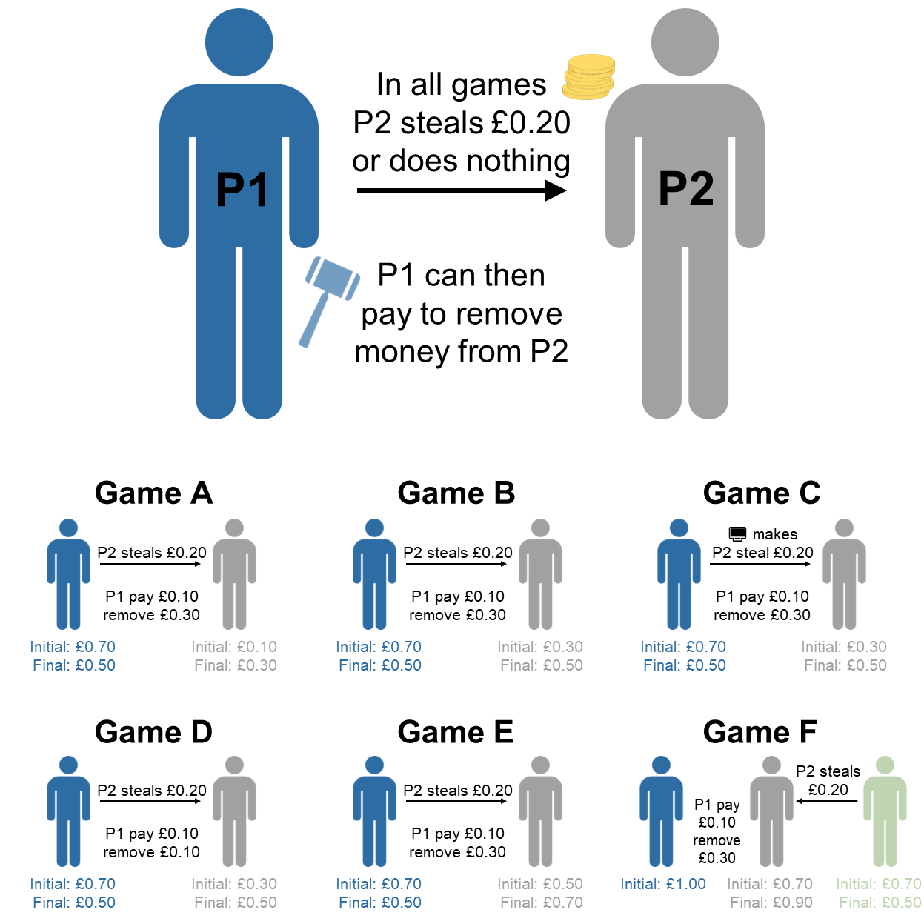

*Note*. In the games, Player 2 either steals £0.20 from Player 1 (the focal player) or does nothing. Player 1 is then given the option to punish by paying a certain amount of money to remove money from Player 2 (this money is destroyed). The six games are variants on this general setup, creating situations where (A) Player 2 is still worse off after stealing, (B) Player 2 creates equality by stealing, (C) the computer ‘decides’ whether Player 2 steals, (D) the fee-fine ratio is 1:1, (E) Player 2 is better off after stealing, and (F) Player 2 steals instead from a third-party.

Table 1

Summary of the different functions for punishment and the behavioural strategies they predict.

|  | | Game A   (AI)   70-10 | | Game B   (Equal)   70-30 | | Game C   (Computer)   70-30 | | Game D   (1:1 Fee Fine)   70-30 | | Game E   (DI)   70-50 | | Game F   (Third Party)   70-70 [100] | |
| --- | --- | --- | --- | --- | --- | --- | --- | --- | --- | --- | --- | --- | --- |
| Function | Behavioural strategy | Steal   50-30 | No steal   70-10 | Steal   50-50 | No steal   70-30 | Steal   50-50 | No steal   70-30 | Steal   50-50 | No steal   70-30 | Steal   50-70 | No steal   70-50 | Steal   50-90 [100] | No steal   70-70 [100] |
| Deterrent | Punish to deter another who has harmed you from harming you again in the future | ✓ | x | ✓ | x | x | x | ✓ | x | ✓ | x | x | x |
| Norm-enforcing | Punish to enforce a shared anti-harm norm and encourage future norm compliance, even amongst third parties | ✓ | x | ✓ | x | x | x | ✓ | x | ✓ | x | ✓ | x |
| Retributive | Punish if doing so harms another who has harmed you | ✓ | x | ✓ | x | ✓ | x | ✓ | x | ✓ | x | x | x |
| Avoid DI | Punish if doing so avoids disadvantageous inequity for self | x | x | x | x | x | x | x | x | ✓ | x | x | x |
| Egalitarian | Punish if doing so makes payoffs for all more equal | x | x | x | x | x | x | x | x | ✓ | x | ✓ | x |
| Seek AI | Punish if doing so produces advantageous inequity for self | x | x | ✓ | x | ✓ | x | x | x | x | x | x | x |
| Competitive | Punish if doing so improves your relative position | ✓ | ✓ | ✓ | ✓ | ✓ | ✓ | x | x | ✓ | ✓ | ✓ | ✓ |
| Antisocial | Punish exclusively those who do not cause harm | x | ✓ | x | ✓ | x | ✓ | x | ✓ | x | ✓ | x | ✓ |
| Never punish | Never punish others | x | x | x | x | x | x | x | x | x | x | x | x |

*Note*. Games A-F are the games employed in the current study (see Methods for more details). In each of the six games, participants are given the opportunity to punish players who ‘steal’ and those who do not, meaning that participants make twelve punishment decisions in total. Each behavioural strategy implies a unique pattern of punishment across all decisions (see Methods for detailed explanation of strategies). Ticks reflect decisions to punish, crosses reflect decisions to not punish. In column headers, payoffs at the first stage (above) and the second stage (below) are denoted as P1-P2 (or P2-P3 [P1] for Game F) where participants take the role of P1 and P2 is the target of punishment. AI = advantageous inequity, DI = disadvantageous inequity.

# Results

The overall pattern of punitive behaviour in the six economic games was very similar across both countries (Figure 2). Participants were generally more likely to punish targets who stole compared to targets who did not steal (multilevel logistic regression; *b* = 1.93, standard error = 0.27, *p* < .001). Participants were also more likely to punish when targets’ stealing behaviour generated inequalities, specifically in Games E and F (*b* = 2.42, SE = 0.44, *p* < .001).

Figure 2

Overall pattern of punitive behaviour across all six economic games, split by country.

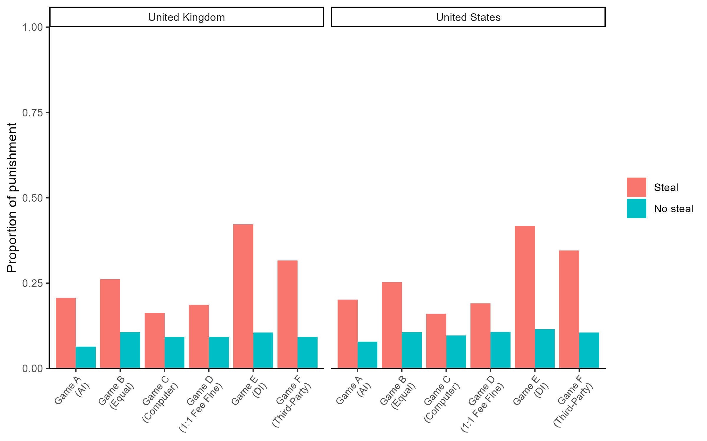

*Note*. AI = advantageous inequity, DI = disadvantageous inequity.

We classified participants into a particular strategy if their behaviour across all twelve decisions matched our behavioural predictions shown in Table 1 exactly. Table 2 shows the proportion of participants following each strategy, with N/A used to represent participants who did not fit exactly into any particular strategy type. Overall, 59% of our participants could be classified exactly into one of the strategies. The most common strategy in both countries was to never punish across any of the games. The next most common strategies were those that care about minimising payoff differences (avoid disadvantageous inequity, egalitarian). Less common were the behaviour shaping strategies (deterrent, norm-enforcing), the retributive strategy, and the competitive strategies (seek advantageous inequity, competitive). Although participants often punished targets who did not steal in the six games (Figure 2), no participants followed the antisocial strategy by exclusively punishing targets who did not steal across *all* games.

Table 2

Counts and proportions of participants following each punishment strategy exactly, split by country.

|  | United Kingdom (N = 1014) | | United States (N = 996) | |
| --- | --- | --- | --- | --- |
| Strategy | N | Prop | N | Prop |
| Deterrent | 9 | 0.009 | 6 | 0.006 |
| Norm-enforcing | 8 | 0.008 | 16 | 0.016 |
| Retributive | 6 | 0.006 | 5 | 0.005 |
| Avoid DI | 67 | 0.066 | 62 | 0.062 |
| Egalitarian | 65 | 0.064 | 71 | 0.071 |
| Seek AI | 2 | 0.002 | 0 | 0.000 |
| Competitive | 3 | 0.003 | 1 | 0.001 |
| Antisocial | 0 | 0.000 | 0 | 0.000 |
| Never punish | 426 | 0.420 | 447 | 0.449 |
| N/A | 428 | 0.422 | 388 | 0.390 |

*Note*. N/A implies that participants were unable to be classified exactly into any of the punishment strategies. AI = advantageous inequity, DI = disadvantageous inequity.

To further investigate the strategies that participants were following, we examined the most common patterns of punitive behaviour across all twelve decisions. Supplementary Table 1 shows the proportion of participants following the 25 most common behavioural patterns, including, where appropriate, the predetermined strategies from Table 1. In both countries, a common pattern of behaviour not captured by any of the strategies was punishing only when the target stole in the third-party game (Game F). Punishment in this game is consistent with an egalitarian motive, as stealing produces unequal outcomes, but third-party punishment here is also consistent with norm-enforcing and competitive motives (see Table 1). Other common behavioural patterns not captured by our strategies included punishing whenever the target stole across all games and always punishing in every game irrespective of the targets’ behaviour.

While it is useful to look at exact patterns of behaviour, participants may not have implemented their chosen punishment strategy with exact precision. In reality, strategies may have been implemented probabilistically for each punishment decision. There is also the possibility of implementation errors, whereby participants occasionally “slip up” and make decisions that are incongruent with a particular strategy. This may explain why some participants were unable to be classified exactly into a single punishment strategy.

To deal with this complexity and include all observed data in our frequency estimates, we fitted a Bayesian latent state model to the data. This model assumes that the nine strategies in Table 1 (plus a “random choice” strategy that chooses randomly for each decision) are the only latent strategies and that these are instantiated into observed behaviour according to the logic in Table 1 with some probability of implementation error (i.e., an intention to punish is implemented as non-punishment and vice versa). Averaging over all strategies and incorporating the possibility of implementation errors, the model estimates the probability of participants following any particular strategy, given the observed data.

The posterior estimates from the model are presented in Figure 3. The posterior probabilities for each strategy did not differ between the two countries. In both countries, the never punish strategy had the highest probability, followed by the egalitarian strategy. The norm-enforcing and seek advantageous inequity strategies were the next most likely, with higher posterior estimates than the competitive and antisocial strategies. None of the other strategies differed in their posterior estimates. The same general pattern emerged when we analysed the full dataset without pre-registered exclusions (Supplementary Figure 1).

Figure 3

Posterior estimates of the probabilities of following different punishment strategies from the Bayesian latent state model.

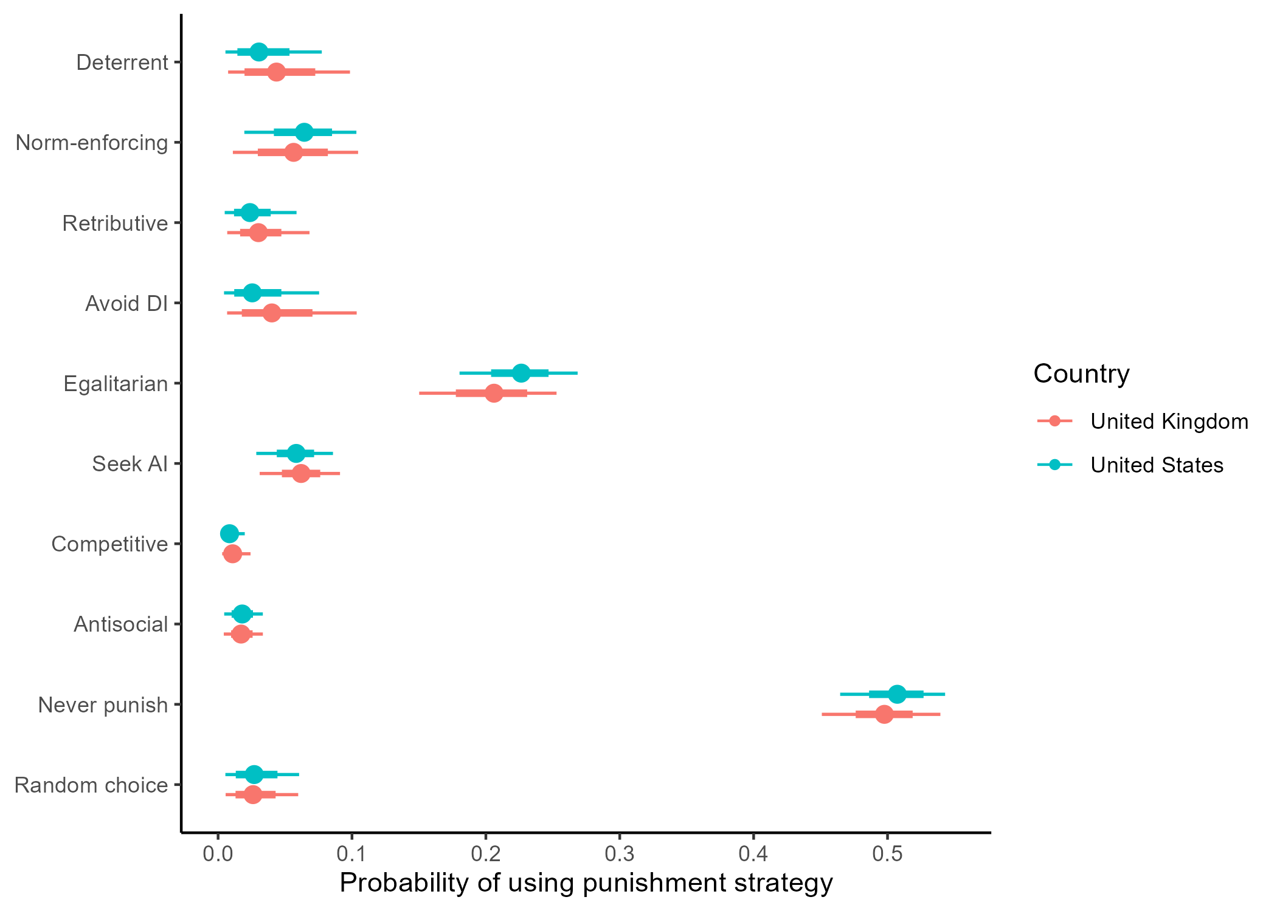

*Note*. The model assumes an implementation error rate of 5%. Points represent posterior medians, line ranges represent 50% and 95% credible intervals. AI = advantageous inequity, DI = disadvantageous inequity.

Next, we explored which traits predicted adherence to different punishment strategies. To answer this question, we included variables capturing demographics, personality, social preferences, political views, and religious views as predictors in our Bayesian latent state model. We included each variable in a separate model, predicting all ten punishment strategies (the nine from Table 1, plus the ‘random choice’ strategy) simultaneously.

Demographic variables tended to be unrelated to strategy usage: age and gender did not predict adherence to a particular punishment strategy (Supplementary Figures 2 and 3). In the United States, the never punish strategy was slightly more common among participants lower in socio-economic status (median posterior slope = -0.20, 95% CI [-0.38 -0.03]) but this effect was small.

Conversely, personality and social preferences were linked to variation in punishment strategies. When including the Big-6 personality dimensions and Social Value Orientation (SVO) in the model, we found associations with the egalitarian, never punish, and random choice strategies, with small-to-medium effect sizes (Figure 4). More prosocial participants (those with higher SVO scores) were more likely to follow the egalitarian and the never punish strategies, while those with lower SVO scores were more likely to enact the random choice strategy. The personality dimensions of honesty-humility and openness to experience were both positively associated with following the never punish strategy, while extraversion negatively predicted this strategy. The effects were mostly similar across countries, but occasionally differed: for example, in the United States, but not in the United Kingdom, honesty-humility was positively associated with following the egalitarian strategy and negatively associated with following the random choice strategy. Overall, the same pattern of results emerged when analysing the full dataset without exclusions (Supplementary Figure 4).

Figure 4

Posterior slopes from Bayesian latent state models including Big-6 personality dimensions and Social Value Orientation.

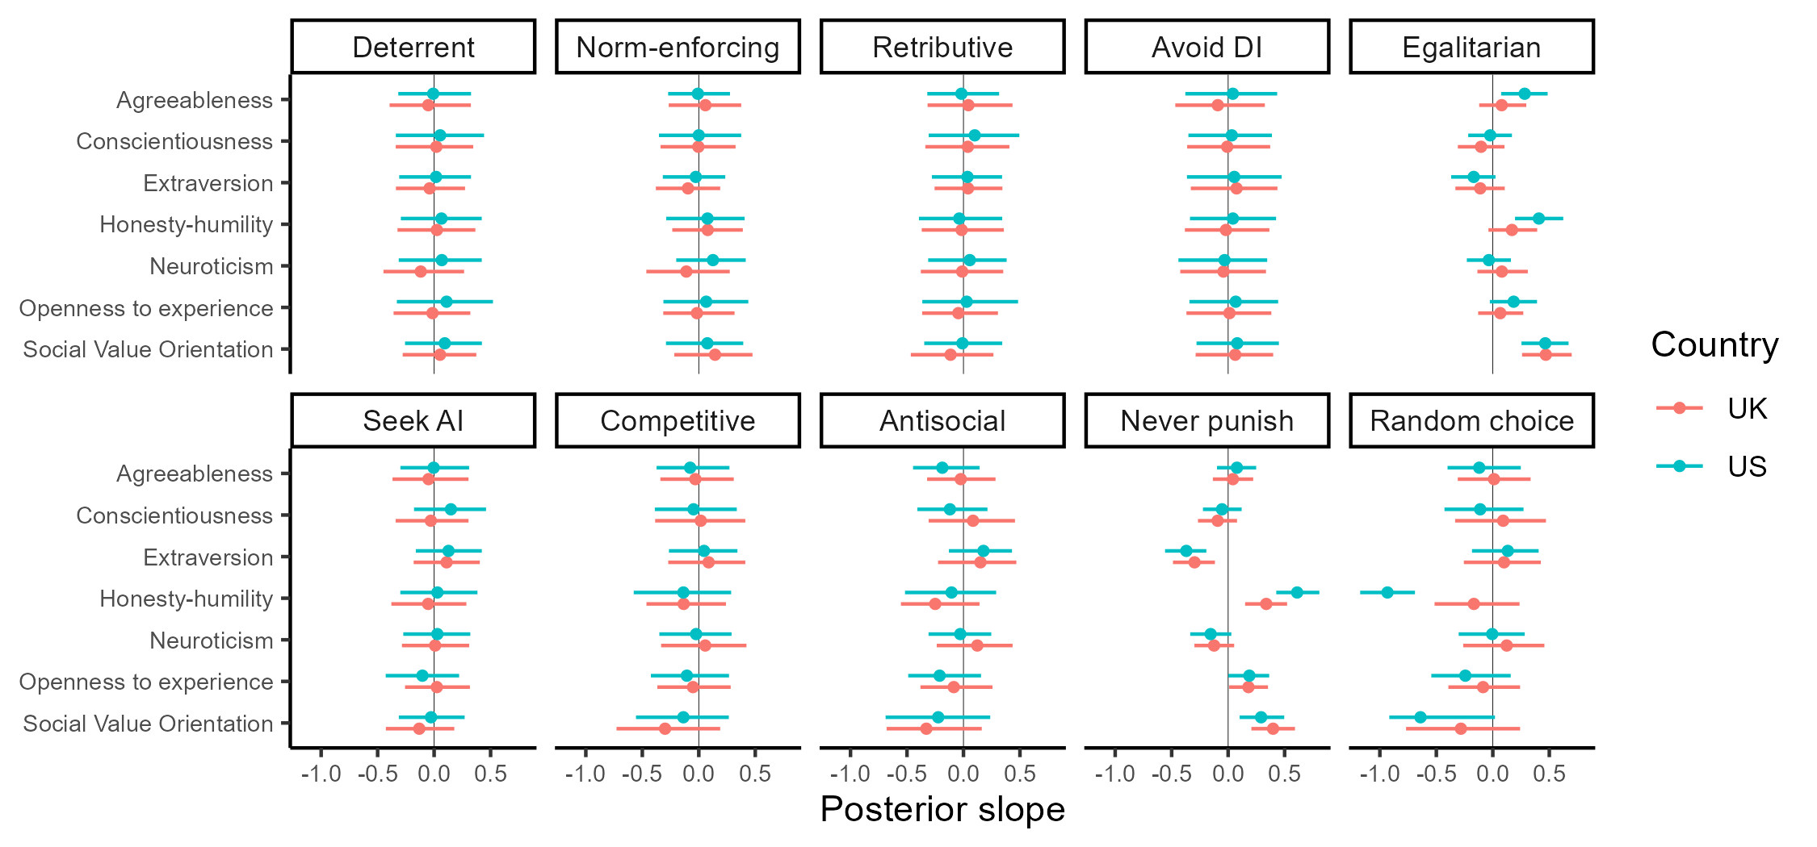

*Note*. Each row represents a separate model. All models assume an implementation error rate of 5%. Points represent posterior medians, line ranges represent 95% credible intervals. AI = advantageous inequity, DI = disadvantageous inequity.

Political and religious variables were also associated with punishment strategy (Figure 5). These effects were small-to-medium in size and tended to be more pronounced in the United States. Controlling for Social Dominance Orientation, American participants higher in Right Wing Authoritarianism were more likely to follow the strategies avoiding disadvantageous inequity and seeking advantageous inequity. Participants who stated that they would like to “bring those below them [on the socio-economic status ladder] up a peg” were more likely to follow the egalitarian strategy, while American participants higher in Social Dominance Orientation, Right Wing Authoritarianism, and believing that God controls events in the world were less likely to follow the egalitarian strategy. In general, religious and conservative participants were less likely to follow the never punish strategy. This general pattern of results was replicated with the full dataset (Supplementary Figure 5).

Figure 5

Posterior slopes from Bayesian latent state models including political ideology, views about social inequality, and religiosity.

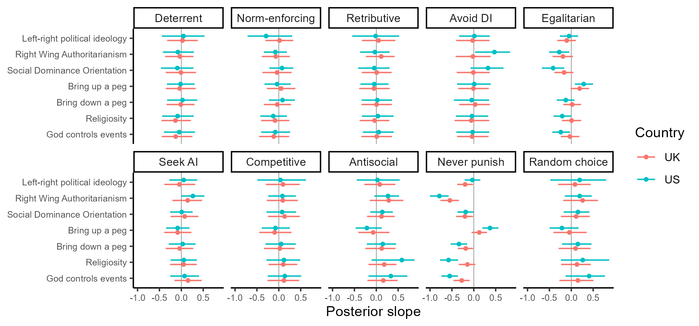

*Note*. Each row represents a separate model aside from Social Dominance Orientation and Right Wing Authoritarianism, which control for one another within the same model. All models assume an implementation error rate of 5%. Points represent posterior medians, line ranges represent 95% credible intervals. AI = advantageous inequity, DI = disadvantageous inequity.

Finally, we asked whether participants had insight into their own punishment strategy. In other words, could participants self-report the strategy that they were following during the games? To answer this question, we included participants’ responses to post-game questions about their strategy as predictors in the model. As before, each predictor was included in a separate model, predicting all ten strategies simultaneously.

In general, we found that self-reported strategy usage was positively associated with the behavioural strategy that participants employed, with effects ranging from small to large in size (see Supplementary Figures 6 and 7 for the distribution of responses to self-report questions). Figure 6 shows the relationships between self-report questions and the different punishment strategies, highlighting the combinations where the question matched the behavioural strategy. We found positive relationships between the self-report questions and strategy usage for the norm-enforcing, egalitarian, seek advantageous inequity, never punish, and random choice strategies. The 95% credible intervals for other estimates included zero, though these estimates often trended in a positive direction. The same pattern of results was found when analysing the full dataset without exclusions (Supplementary Figure 8).

Figure 6

Posterior slopes from models including self-reported strategy usage.

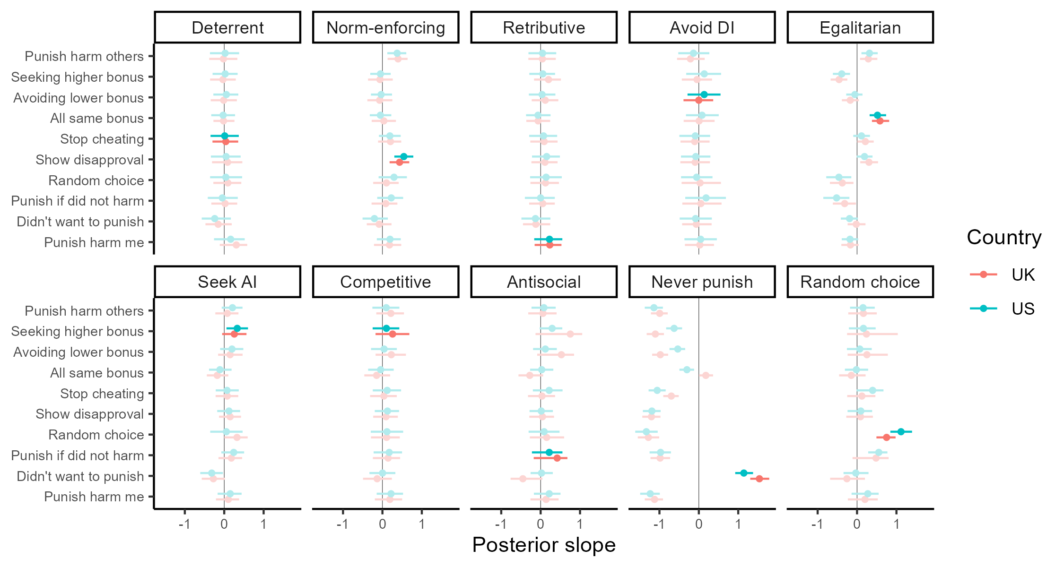

*Note*. Each row represents a separate model. All models assume an implementation error rate of 5%. Highlighted estimates represent combinations where the self-report question matched the behavioural strategy. Points represent posterior medians, line ranges represent 95% credible intervals. AI = advantageous inequity, DI = disadvantageous inequity.

# Discussion

Using a suite of economic games measuring punishment in different situations, we have shown that punishment does not serve just one function, but instead is a flexible tool that can be and is used for different purposes6. While some use punishment to enforce norms of cooperation, others use it to reduce or even create inequality between individuals. We found that people’s punishment strategy can, to some extent, be predicted by individual differences in personality, social preferences, and political and religious views. Moreover, contrary to the view that people are often unable to articulate the reasons for their punitive behaviour30, people seem to have some degree of insight into the strategy they are using. Despite small differences, these general patterns replicated in samples from both the United Kingdom and the United States, providing further confidence in the results.

Among the punitive strategies, the most common were particularly sensitive to inequality in payoffs, either from a self-referential perspective (i.e., avoid disadvantageous inequity) or more generally (i.e., egalitarian). This is in line with previous studies which have highlighted inequity aversion as an important motivation for punishment in economic games17,31,32,38,49,51. Personality, social preferences, and political and religious views were related to these strategies. Traits associated with other-regarding concern, such as SVO and honesty-humility, predicted following the egalitarian strategy. By contrast, religious and conservative individuals, including individuals higher in SDO and RWA, were less likely to follow the egalitarian strategy and more likely to follow the avoid disadvantageous inequity strategy, especially in the United States. Authoritarian participants in the United States were also more likely to actively seek advantageous inequity with their punishment. These findings provide insight into the motives that may have driven higher levels of peer punishment among conservatives in previous work42.

Behaviour shaping strategies, such as deterrence and norm-enforcement, were less common than strategies sensitive to inequality in our set of games. This was reflected both in participants’ elicited punishment behaviour (Figure 3) and in their self-reports of their own strategy (Supplementary Figures 6 and 7). Although our design did not explicitly allow for behaviour shaping as the interactions were all one-shot, we did manipulate whether the target’s stealing behaviour was intentional or not (Game C), an approach which has been used in previous vignette studies to identify behaviour shaping motives30. The lower prevalence of behaviour shaping strategies in our study is consistent with prior work showing that punishment often continues to be used when behaviour shaping is impossible, such as when the target will never find out that they have been punished35 or on the last round of repeated interactions34. We found that demographic, personality, political, and religious variables tended to be unrelated to behaviour shaping strategies, though this could reflect low power to detect such associations given the low prevalence of these strategies in our sample. We also found that participants accurately reported using the norm-enforcing strategy, but not the deterrent strategy. This finding is in line with previous research showing that people struggle to accurately report the deterrent motivations for their punitive behaviour30.

We defined antisocial punishment as occurring when a participant exclusively punished those who did not steal. There were no participants in our sample who followed this strategy, although some players did punish non-stealing co-players. Harming non-stealing individuals was also consistent with the competitive strategies, which did appear in our sample albeit at low frequencies. The fact that no participants in our sample punished non-stealing across all games suggests that the antisocial punishment that has been observed in other studies19,52 is not aimed at harming cooperators specifically, as has been previously suggested19. Instead, antisocial punishment is more likely to be motivated by improving one’s relative position, which is in line with work showing that antisocial punishment disappears when relative payoffs cannot be changed (e.g., when punishment is only available with a 1:1 fee-fine ratio)36.

The fact that people use punishment for many different reasons poses problems for the way that punishment is operationalised in classic behavioural economic game studies. In these studies, a common assumption is that participants punish to change the behaviour of cheats11,12. But in reality, people may be choosing the punishment option to achieve a variety of different goals. This has implications for how people respond to being targeted by punishers in these games. Targets of punishment in these studies may know that punishment reflects different motives and can respond accordingly. For example, if targets interpret punishment as serving a competitive motive, it may elicit retaliation rather than encourage cooperation6,10,53. As punishers’ motives must be inferred (and such inferences likely depend on character traits of the target, as well as the context in which punishment occurs), there is likely to be some variation and error in attributing motives to punishers. To the extent that inferred motives affect target responses, this might help to explain the mixed findings in the field as to whether punishment actually motivates cheating targets to subsequently cooperate6.

It is striking that the most common strategy in our dataset was to never punish. This is partly because punishment in these games imposes an economic cost for no tangible benefit. If the fee-fine ratio had been lower, such that it was cheaper to punish, we may have seen more punishment from participants. Indeed, 72% of participants following the never punish strategy positively stated that they didn’t want to pay to reduce anyone’s bonus but would have done so if it were free. But the frequency of the never punish strategy perhaps also reflects a more general aversion to peer punishment, an aversion that has been highlighted in both WEIRD (Western, educated, industrialised, rich, and democratic) samples54,55 and in small-scale societies56. One reason that people may be averse to peer punishment is that, because it is a fundamentally harmful act, punishment can reflect badly on the punisher and people might therefore refrain from punishing others to avoid reputational damage4. People frequently avoid taking actions that could harm their reputation, even when they don’t know if reputation is at stake (as in the one-shot anonymous settings used here). Another reason that people may be averse to peer punishment is that it can trigger retaliation6. This may be especially likely in situations that lack clear institutional norms to legitimise punishment, such as our economic games. As with reputation damage, people might abstain from peer punishment to avoid retaliation, regardless of whether retaliation is actually possible. By contrast, institutionalised punishment in small-scale societies often functions to compensate victims while limiting the potential for feuds and cycles of retaliation57,58. Future research should uncover whether people are more willing to punish in these conventionalised contexts (e.g., see ref59).

One potential limitation with our design is that some strategies required more punishment than others, meaning that some strategies were more “expensive” to implement. For example, the competitive strategy required punishment in ten of twelve decisions, compared to the avoid disadvantageous inequity strategy which required only one instance of punishment (Table 1). We employed the strategy method to deal with this, calculating participant payoffs from a randomly chosen game instead of accumulating the costs across all games. This mitigates the concern that the total cost is the most salient feature determining participants’ decisions. But even accounting for this, one could still argue that the difference in overall costs explains why, for example, the competitive strategy is less common in our dataset than the avoid disadvantageous inequity strategy. We do not think this feature of our design is a concern, however, for a number of reasons. First, we are interested in measuring strategies underlying *costly* punishment. Some of these strategies, by their very nature, will be more costly to implement than others. This is reflected in our design. It would not make theoretical sense to use an alternative design where more or less punitive strategies are manipulated to cost participants the same amount. Second, when we asked participants whether they would have punished if it were free to do so, we found low agreement with this statement (Supplementary Figure 6), suggesting that participants were not particularly sensitive to the costs of punishment. In line with this, when we plot the frequencies of different strategies against their expected costs, we find that cost is not a perfect predictor of strategy frequency: many “cheap” strategies are rare in our data and some “expensive” strategies are quite common (e.g., always punish; Supplementary Figure 9). Third, this argument implies that the high frequency of the never punish strategy is merely an artefact of our design, since it is the only strategy that does not cost anything to implement. But as we have discussed, many other studies have found similar aversions to costly punishment in the lab17,32,34,45,49 and in the real world54–56 suggesting that this result is not an artefact of our design.

In sum, we have shown that while many people choose not to punish peers, those who do are motivated by a variety of different concerns, including behaviour shaping, egalitarianism, and competition. Much like the observed variation in human social learning strategies40, humans thus also exhibit variation in their punishment strategies. These individual differences map onto personality dimensions, social preferences, political and religious views, and self-reports of behaviour. We hope that future work will continue to unpack the multifaceted nature of human punishment.

# Methods

## Ethical approval

This research was approved by the UCL Department of Psychology Ethics Committee (project: 3720/002) and ratified by the University of Auckland Human Participants Ethics Committee. The study was performed in accordance with all the relevant guidelines and regulations. Informed consent was obtained from all participants prior to the study and participation was voluntary.

## Pre-registration

We pre-registered the study on the Open Science Framework before collecting data in the United Kingdom (11th November 2022; <https://osf.io/k75fc>). We submitted another pre-registration before collecting data in the United States (20th June 2023; <https://osf.io/q4hdy>). In the pre-registrations, we outlined our study design, exclusion criteria, and analysis plan. As the study was exploratory, we did not pre-register any explicit hypotheses. We did not deviate from the pre-registrations.

## Exclusion criteria

We pre-registered that we would exclude participants who failed any of the attention checks, sped through the surveys (i.e., two standard deviations below the median duration), or flatlined (i.e., provided identical responses to matrix questions). We also stated that we would exclude data for particular games if participants failed the comprehension question for that game. We followed our pre-registered plan of conducting analyses with and without these exclusions (analyses without exclusions are reported in the Supplementary Material).

## Participants

We collected a representative sample of 1019 participants from the United Kingdom through the online platform Prolific (<https://www.prolific.com/>). All of these participants completed the economic games and 973 returned to complete the follow-up survey a week later (95% retention rate). After exclusions, we were left with 1014 participants overall (see Supplementary Figure 10).

We later collected a representative sample of 1005 participants from the United States through Prolific. All of these participants completed the economic games and 957 returned to complete the follow-up survey (95% retention rate). After exclusions, we were left with 996 participants overall (see Supplementary Figure 11 for sample characteristics).

## Materials

### Economic games

In the first part of the study, participants completed six economic games, each with slight variations. In all games, there are multiple players and the participant takes the role of P1. P2 either (a) steals £0.20 from another player and adds it to their payoff or (b) does nothing. For each of these cases, participants are asked whether they would like to pay money to reduce P2’s payoff. Games A-E have two players and Game F has three players.

The six games are as follows (variations bolded; see Figure 1 for a visual representation of the games):

1. *Game A (Advantageous Inequity)*. P1 starts with £0.70 and P2 starts with £0.10. P2 is given the option to either steal £0.20 from P1 or do nothing. P1 can then pay £0.10 to reduce P2’s payoff by £0.30.
2. *Game B (Equal)*. P1 starts with £0.70 and P2 starts with **£0.30**. P2 is given the option to either steal £0.20 from P1 or do nothing. P1 can then pay £0.10 to reduce P2’s payoff by £0.30.
3. *Game C (Computer)*. P1 starts with £0.70 and P2 starts with £0.30. Participants are told that **“the computer will decide”** whether P2 steals £0.20 from P1 or does nothing. P1 can then pay £0.10 to reduce P2’s payoff by £0.30.
4. *Game D (1:1 Fee-Fine)*. P1 starts with £0.70 and P2 starts with £0.30. P2 is given the option to either steal £0.20 from P1 or do nothing. P1 can then pay £0.10 to reduce P2’s payoff by **£0.10**.
5. *Game E (Disadvantageous Inequity)*. P1 starts with £0.70 and P2 starts with **£0.50**. P2 is given the option to either steal £0.20 from P1 or do nothing. P1 can then pay £0.10 to reduce P2’s payoff by £0.30.
6. *Game F (Third-Party)*. P1 starts with £1.00, P2 and P3 start with £0.70. P2 is given the option to either steal £0.20 **from P3** or do nothing. P1 can then pay £0.10 to reduce P2’s payoff by £0.30.

We delineate nine punishment strategies that can be isolated based on players’ decisions across the six economic games (Table 1). In existing literature, it is often unclear whether punishment decisions are sensitive to the previous actions of others or to payoff sensitivity. This is because (*i*) players’ decisions typically introduce payoff differentials in economic games and (*ii*) where fine > fee, punishment tools can be used to harm co-players and to change relative payoffs6. Of the nine strategies we define, *deterrent*, *norm-enforcing*, *retributive* and *antisocial* are strategies that are only sensitive to the actions of others. Conversely, *avoid disadvantageous inequity*, *egalitarian*, *seek advantageous inequity* and *competitive* are strategies that are sensitive to payoffs. *Never punish* is an unconditional strategy (i.e., no sensitivity to actions or payoffs).

Our strategy definitions sometimes differ from how these strategies are defined and discussed in the literature (e.g., antisocial punishment). This is essential because previous definitions permit many possible motives, while we are aiming to isolate punishment motives. We define our strategies as follows:

* *Deterrent*: Deter others who have harmed you from harming you again in the future (when the target steals in Games A, B, D, and E). We note that while no behaviour change is possible in our one-shot games, deterrent motives can be isolated from retributive motives by asking whether participants are sensitive to the intentionality behind cheating, as in previous work30.
* *Norm-enforcing*: Punish to enforce a shared anti-harm norm and encourage future norm compliance (when the target steals in Games A, B, D, E and F). Though we cannot measure future norm compliance in our one-shot games, these non-repeated (and ‘stranger design’) games have been used to identify norm-enforcing motives in many previous studies11,12.
* *Retributive*: Punish if doing so harms another who harmed you (when the target steals in Games A-E). We note that retribution is also sometimes used to describe punishment of those who harmed others30. We require this tighter definition because our aim is to precisely identify punishment strategies, and sensitivity to whether self or others were harmed may be an important factor affecting the decision to punish (e.g., ref60).
* *Avoid disadvantageous inequity*: Punish if doing so avoids disadvantageous inequity for the self (when the target steals in Game E).
* *Egalitarian*: Punish if doing so makes payoffs for all more equal (when the target steals in Games E and F) (c.f. ref31).
* *Seek advantageous inequity*: Punish if doing so produces advantageous inequity for the self (when the target steals in Games B and C). This is one possible motive underlying what others have previously called ‘antisocial punishment’ or ‘spite’; here we isolate it.
* *Competitive*: Punish if doing so improves your relative position (all games except Game D).
* *Antisocial*: Punish exclusively those who do not cause harm (punish non-stealing target in all games). This definition differs from some previous definitions of antisocial punishment, but this is essential to isolate the full range of motives that could be driving punishment and which are not typically disentangled in other settings.
* *Never punish*: A person who never incurs a personal cost to punish a co-player (does not punish in any game).

For each game, participants saw the game instructions and answered a comprehension question before providing their decisions. After completing all the games, participants were asked to give an open-ended response explaining their behaviour in the games, and then responded to several slider questions capturing the different reasons for their decisions (for full wordings, see Supplementary Table 2).

### Survey questions

In a follow-up survey, we collected the following data on participants (for wordings of all questions, see Supplementary Table 3):

* *Demographics*. In the survey, we collected information on participants’ education level and self-reported socio-economic status (MacArthur ladder61). We also collected additional demographic data from Prolific (e.g., age, gender, student status).
* *Personality*. We used the Mini-IPIP scale62 to measure the Big 6 personality dimensions of agreeableness ( = 0.83), conscientiousness ( = 0.75), extraversion ( = 0.83), honesty-humility ( = 0.77), openness to experience ( = 0.79), and neuroticism ( = 0.79). Four items were used for each personality dimension.
* *Social Value Orientation*. We used the Social Value Orientation Slider Measure to measure other-regarding preferences63. Across fifteen items, participants made decisions on how to allocate different amounts of money between themselves and another anonymous individual. From these decisions, we calculated participants’ Social Value Orientation “angle” as a measure of their other-regarding preference, following the steps outlined in ref63.
* *Political ideology*. We included several measures of political ideology, including left-right conservatism, Social Dominance Orientation64 ( = 0.91; eight items), and Right Wing Authoritarianism65 ( = 0.82; six items). We also probed participants’ views on social inequality by asking them whether they would like to bring people above (below) them on the MacArthur socio-economic status ladder down (up) a peg or two.
* *Religious views*. We asked participants how religious they consider themselves and whether they believe that God or another spiritual non-human entity controls the events in the world66.

## Procedure

We began data collection in the United Kingdom on 28th November 2022, with participants returning to complete the follow-up survey on 5th December 2022. We then ran a second wave of data collection in the United States on 20th June 2023, with participants returning to complete the follow-up survey on 27th June 2023. Our surveys were designed through the online survey platform Qualtrics (<https://www.qualtrics.com/>).

In the initial games survey, participants completed all six economic games in a random order, with punishment decisions (whether to punish a stealing target and whether to punish a target who did nothing) randomised within games. Responses to comprehension questions suggested that participants understood the six economic games (Supplementary Table 4). In order to partially mitigate the fact that some punishment strategies predict more punishment than others and are thus more “expensive” to implement (Table 1), we used the strategy method to incentivise the economic games, choosing a random game to determine bonus payments rather than summing participants’ earnings across all games. After all games, 62% of participants stated that they believed that their decisions had real consequences for others.

In the follow-up survey, participants completed blocks of questions on demographics, personality, Social Value Orientation, political ideology, and religious views in a random order, with questions randomised within blocks. A random decision from the Social Value Orientation Slider Measure was chosen to determine bonus payment.

Participants were paid £1.80 for completing the games survey, plus a bonus payment from the six economic games (between £0.40 – £0.70 depending on their decisions). Participants were paid £1.50 for completing the follow-up survey, plus a bonus payment from the Social Value Orientation Slider Measure (between £0.50 – £0.85 depending on their decisions).

## Statistical analysis

We pre-registered that we would use a Bayesian latent state model to infer unobserved punishment strategies from the observed data (for a similar version of this model, see ref67). In this model, participants in countries make binary punishment decisions across twelve decisions . We assume that the probability of the observed data is the weighted average of the probability of the observed data conditional on each of the ten punishment strategies . From this logic, the model estimates the probability of each strategy . The full model is as follows:

The conditional probabilities are hard coded in the model as outlined in Table 1. We incorporate an implementation error rate into these conditional probabilities by coding ticks in Table 1 with a conditional probability of and coding crosses with a conditional probability of . We set to 0.05 in all models, which is similar to its value when we estimate it as a free parameter in an additional model (median posterior = 0.03, 95% CI [0.00 0.06]; Supplementary Figure 12). The random choice strategy is consistently coded with a conditional probability of ½ across all decisions.

To include a categorical predictor in the model, we estimate a different for each categorical level. To include a continuous predictor in the model, we include a slope in the linear model for :

These models control for multiple comparisons across strategies by estimating the effects of the predictor on all strategies simultaneously.

We estimated the posterior distributions of these models using Hamiltonian Monte Carlo as implemented in Stan version 2.32.268. We ran each model for 2000 samples, with 1000 warmup samples. R-hat values and effective sample sizes suggested that all models converged normally. Trace plots are reported in Supplementary Figure 13.

We validated the model by simulating observed data (*n* = 100) from a known frequency of strategies. The model was successfully able to recover the known frequency of strategies from the simulated data (Supplementary Figure 14).

## Reproducibility

All data and code are accessible on GitHub: <https://github.com/ScottClaessens/punishStrategies>. All analyses were conducted in R version 4.4.269. Visualisations were created with the *ggplot2*70 and *cowplot*71 R packages. We used the *targets*72 R package and *quarto*73 to reproducibly generate the manuscript.

# Acknowledgements

This work was supported by a Royal Society of New Zealand Catalyst Leaders Grant to Q.D.A and N.R. (ref: ILFUOA2002).

# Competing Interests

The authors declare no competing interests.

# Data Availability

All data used in this study are publicly available on GitHub: <https://github.com/ScottClaessens/punishStrategies>

# Code Availability

All code to reproduce the analyses in this study are publicly available on GitHub: <https://github.com/ScottClaessens/punishStrategies>

# References

1. Clutton-Brock, T. H. & Parker, G. A. [Punishment in animal societies](https://doi.org/10.1038/373209a0). *Nature* **373**, 209–216 (1995).

2. dos Santos, M., Rankin, D. J. & Wedekind, C. [The evolution of punishment through reputation](https://doi.org/10.1098/rspb.2010.1275). *Proceedings of the Royal Society B: Biological Sciences* **278**, 371–377 (2011).

3. dos Santos, M., Rankin, D. J. & Wedekind, C. [Human cooperation based on punishment reputation](https://www.jstor.org/stable/24032701). *Evolution* **67**, 2446–2450 (2013).

4. Raihani, N. J. & Bshary, R. [The reputation of punishers](https://doi.org/10.1016/j.tree.2014.12.003). *Trends in Ecology & Evolution* **30**, 98–103 (2015).

5. Ostrom, E. *Governing the commons: The evolution of institutions for collective action*. (Cambridge University Press, 1990).

6. Raihani, N. J. & Bshary, R. [Punishment: One tool, many uses](https://doi.org/10.1017/ehs.2019.12). *Evolutionary Human Sciences* **1**, e12 (2019).

7. Balliet, D., Mulder, L. B. & Van Lange, P. A. M. [Reward, punishment, and cooperation: A meta-analysis](https://doi.org/10.1037/a0023489). *Psychological Bulletin* **137**, 594–615 (2011).

8. Balliet, D. & Lange, P. A. M. V. [Trust, punishment, and cooperation across 18 societies: A meta-analysis](https://doi.org/10.1177/1745691613488533). *Perspectives on Psychological Science* **8**, 363–379 (2013).

9. Chaudhuri, A. [Sustaining cooperation in laboratory public goods experiments: A selective survey of the literature](https://doi.org/10.1007/s10683-010-9257-1). *Experimental Economics* **14**, 47–83 (2011).

10. Dreber, A., Rand, D. G., Fudenberg, D. & Nowak, M. A. [Winners don’t punish](https://doi.org/10.1038/nature06723). *Nature* **452**, 348–351 (2008).

11. Fehr, E. & Gächter, S. [Cooperation and punishment in public goods experiments](https://www.jstor.org/stable/117319). *American Economic Review* **90**, 980–994 (2000).

12. Fehr, E. & Gächter, S. [Altruistic punishment in humans](https://doi.org/10.1038/415137a). *Nature* **415**, 137–140 (2002).

13. Henrich, J. *et al.* [Costly punishment across human societies](https://doi.org/10.1126/science.1127333). *Science* **312**, 1767–1770 (2006).

14. Nikiforakis, N. & Normann, H.-T. [A comparative statics analysis of punishment in public-good experiments](https://doi.org/10.1007/s10683-007-9171-3). *Experimental Economics* **11**, 358–369 (2008).

15. Raihani, N. J., Thornton, A. & Bshary, R. [Punishment and cooperation in nature](https://doi.org/10.1016/j.tree.2011.12.004). *Trends in Ecology & Evolution* **27**, 288–295 (2012).

16. Abbink, K. & Sadrieh, A. [The pleasure of being nasty](https://doi.org/10.1016/j.econlet.2009.08.024). *Economics letters* **105**, 306–308 (2009).

17. Raihani, N. J. & McAuliffe, K. [Human punishment is motivated by inequity aversion, not a desire for reciprocity](https://doi.org/10.1098/rsbl.2012.0470). *Biology Letters* **8**, 802–804 (2012).

18. de Quervain, D. J.-F. *et al.* [The neural basis of altruistic punishment](https://doi.org/10.1126/science.1100735). *Science* **305**, 1254–1258 (2004).

19. Herrmann, B., Thöni, C. & Gächter, S. [Antisocial punishment across societies](https://doi.org/10.1126/science.1153808). *Science* **319**, 1362–1367 (2008).

20. Camerer, C. F. *Behavioral game theory: Experiments in strategic interaction*. (Russell Sage Foundation, 2003).

21. Bowles, S. & Gintis, H. *A cooperative species: Human reciprocity and its evolution*. (Princeton University Press, 2013).

22. Boyd, R., Gintis, H., Bowles, S. & Richerson, P. J. [The evolution of altruistic punishment](https://doi.org/10.1073/pnas.0630443100). *Proceedings of the National Academy of Sciences* **100**, 3531–3535 (2003).

23. Chudek, M. & Henrich, J. [Culture-gene coevolution, norm-psychology and the emergence of human prosociality](https://doi.org/10.1016/j.tics.2011.03.003). *Trends in Cognitive Sciences* **15**, 218–226 (2011).

24. Henrich, J. *The secret of our success: How culture is driving human evolution, domesticating our species, and making us smarter*. (Princeton University Press, 2017).

25. Delton, A. W. & Krasnow, M. M. [The psychology of deterrence explains why group membership matters for third-party punishment](https://doi.org/10.1016/j.evolhumbehav.2017.07.003). *Evolution and Human Behavior* **38**, 734–743 (2017).

26. Fehr, E. & Schurtenberger, I. [Normative foundations of human cooperation](https://doi.org/10.1038/s41562-018-0385-5). *Nature Human Behaviour* **2**, 458–468 (2018).

27. Mathew, S. & Boyd, R. [Punishment sustains large-scale cooperation in prestate warfare](https://doi.org/10.1073/pnas.1105604108). *Proceedings of the National Academy of Sciences* **108**, 11375–11380 (2011).

28. Mathew, S. & Boyd, R. [The cost of cowardice: Punitive sentiments towards free riders in Turkana raids](https://doi.org/10.1016/j.evolhumbehav.2013.10.001). *Evolution and Human Behavior* **35**, 58–64 (2014).

29. Richerson, P. *et al.* [Cultural group selection plays an essential role in explaining human cooperation: A sketch of the evidence](https://doi.org/10.1017/S0140525X1400106X). *Behavioral and Brain Sciences* **39**, e30 (2016).

30. Carlsmith, K. M., Darley, J. M. & Robinson, P. H. [Why do we punish? Deterrence and just deserts as motives for punishment](https://doi.org/10.1037/0022-3514.83.2.284). *Journal of Personality and Social Psychology* **83**, 284–299 (2002).

31. Dawes, C. T., Fowler, J. H., Johnson, T., McElreath, R. & Smirnov, O. [Egalitarian motives in humans](https://doi.org/10.1038/nature05651). *Nature* **446**, 794–796 (2007).

32. Bone, J. E. & Raihani, N. J. [Human punishment is motivated by both a desire for revenge and a desire for equality](https://doi.org/10.1016/j.evolhumbehav.2015.02.002). *Evolution and Human Behavior* **36**, 323–330 (2015).

33. Walker, J. M. & Halloran, M. A. [Rewards and sanctions and the provision of public goods in one-shot settings](https://doi.org/10.1023/B:EXEC.0000040559.08652.51). *Experimental Economics* **7**, 235–247 (2004).

34. Barclay, P. & Raihani, N. [Partner choice versus punishment in human prisoner’s dilemmas](https://doi.org/10.1016/j.evolhumbehav.2015.12.004). *Evolution and Human Behavior* **37**, 263–271 (2016).

35. Crockett, M. J., Özdemir, Y. & Fehr, E. [The value of vengeance and the demand for deterrence](https://doi.org/10.1037/xge0000018). *Journal of Experimental Psychology: General* **143**, 2279–2286 (2014).

36. Sylwester, K., Herrmann, B. & Bryson, J. J. [Homo homini lupus? Explaining antisocial punishment](https://doi.org/10.1037/npe0000009). *Journal of Neuroscience, Psychology, and Economics* **6**, 167–188 (2013).

37. Fehr, E. & Fischbacher, U. [Third-party punishment and social norms](https://doi.org/10.1016/S1090-5138(04)00005-4). *Evolution and Human Behavior* **25**, 63–87 (2004).

38. Johnson, T., Dawes, C. T., Fowler, J. H., McElreath, R. & Smirnov, O. [The role of egalitarian motives in altruistic punishment](https://doi.org/10.1016/j.econlet.2009.01.003). *Economics Letters* **102**, 192–194 (2009).

39. Fowler, J. H., Johnson, T. & Smirnov, O. [Egalitarian motive and altruistic punishment](https://doi.org/10.1038/nature03256). *Nature* **433**, E1 (2005).

40. Molleman, L., Van den Berg, P. & Weissing, F. J. [Consistent individual differences in human social learning strategies](https://doi.org/10.1038/ncomms4570). *Nature Communications* **5**, 3570 (2014).

41. Thielmann, I., Spadaro, G. & Balliet, D. [Personality and prosocial behavior: A theoretical framework and meta-analysis.](https://doi.org/10.1037/bul0000217) *Psychological Bulletin* **146**, 30–90 (2020).

42. Hofmann, W., Brandt, M. J., Wisneski, D. C., Rockenbach, B. & Skitka, L. J. [Moral punishment in everyday life](https://doi.org/10.1177/0146167218775075). *Personality and Social Psychology Bulletin* **44**, 1697–1711 (2018).

43. Nisbett, R. E. & Wilson, T. D. [Telling more than we can know: Verbal reports on mental processes](https://doi.org/10.1037/0033-295X.84.3.231). *Psychological Review* **84**, 231–259 (1977).

44. Barclay, P. [Reputational benefits for altruistic punishment](https://doi.org/10.1016/j.evolhumbehav.2006.01.003). *Evolution and Human Behavior* **27**, 325–344 (2006).

45. Batistoni, T., Barclay, P. & Raihani, N. J. [Third-party punishers do not compete to be chosen as partners in an experimental game](https://doi.org/10.1098/rspb.2021.1773). *Proceedings of the Royal Society B* **289**, 20211773 (2022).

46. Jordan, J. J., Hoffman, M., Bloom, P. & Rand, D. G. [Third-party punishment as a costly signal of trustworthiness](https://doi.org/10.1038/nature16981). *Nature* **530**, 473–476 (2016).

47. Jordan, J. J. & Rand, D. G. [Third-party punishment as a costly signal of high continuation probabilities in repeated games](https://doi.org/10.1016/j.jtbi.2017.04.004). *Journal of Theoretical Biology* **421**, 189–202 (2017).

48. Jordan, J. J. & Rand, D. G. [Signaling when no one is watching: A reputation heuristics account of outrage and punishment in one-shot anonymous interactions](https://doi.org/10.1037/pspi0000186). *Journal of Personality and Social Psychology* **118**, 57–88 (2020).

49. Deutchman, P., Bračič, M., Raihani, N. J. & McAuliffe, K. [Punishment is strongly motivated by revenge and weakly motivated by inequity aversion](https://doi.org/10.1016/j.evolhumbehav.2020.06.001). *Evolution and Human Behavior* **42**, 12–20 (2021).

50. Marczyk, J. [Human punishment is not primarily motivated by inequality](https://doi.org/10.1371/journal.pone.0171298). *PLoS ONE* **12**, e0171298 (2017).

51. Bone, J. E., McAuliffe, K. & Raihani, N. J. [Exploring the motivations for punishment: Framing and country-level effects](https://doi.org/10.1371/journal.pone.0159769). *PLoS One* **11**, e0159769 (2016).

52. Pleasant, A. & Barclay, P. [Why hate the good guy? Antisocial punishment of high cooperators is greater when people compete to be chosen](https://doi.org/10.1177/0956797617752642). *Psychological Science* **29**, 868–876 (2018).

53. Nikiforakis, N. [Punishment and counter-punishment in public good games: Can we really govern ourselves?](https://doi.org/10.1016/j.jpubeco.2007.04.008) *Journal of Public Economics* **92**, 91–112 (2008).

54. Balafoutas, L., Nikiforakis, N. & Rockenbach, B. [Direct and indirect punishment among strangers in the field](https://doi.org/10.1073/pnas.1413170111). *Proceedings of the National Academy of Sciences* **111**, 15924–15927 (2014).

55. Balafoutas, L., Nikiforakis, N. & Rockenbach, B. [Altruistic punishment does not increase with the severity of norm violations in the field](https://doi.org/10.1038/ncomms13327). *Nature Communications* **7**, 13327 (2016).

56. Baumard, N. [Has punishment played a role in the evolution of cooperation? A critical review](https://doi.org/10.1007/s11299-010-0079-9). *Mind & Society* **9**, 171–192 (2010).

57. Fitouchi, L. & Singh, M. [Punitive justice serves to restore reciprocal cooperation in three small-scale societies](https://doi.org/10.1016/j.evolhumbehav.2023.03.001). *Evolution and Human Behavior* **44**, 502–514 (2023).

58. Singh, M. & Garfield, Z. H. [Evidence for third-party mediation but not punishment in Mentawai justice](https://doi.org/10.1038/s41562-022-01341-7). *Nature Human Behaviour* **6**, 930–940 (2022).

59. Molleman, L., Kölle, F., Starmer, C. & Gächter, S. [People prefer coordinated punishment in cooperative interactions](https://doi.org/10.1038/s41562-019-0707-2). *Nature Human Behaviour* **3**, 1145–1153 (2019).

60. FeldmanHall, O., Sokol-Hessner, P., Van Bavel, J. J. & Phelps, E. A. [Fairness violations elicit greater punishment on behalf of another than for oneself](https://doi.org/10.1038/ncomms6306). *Nature Communications* **5**, 5306 (2014).

61. Adler, N. E., Epel, E. S., Castellazzo, G. & Ickovics, J. R. [Relationship of subjective and objective social status with psychological and physiological functioning: Preliminary data in healthy, White women](https://doi.org/10.1037/0278-6133.19.6.586). *Health Psychology* **19**, 586–592 (2000).

62. Sibley, C. G. *et al.* The Mini-IPIP6: Validation and extension of a short measure of the Big-Six factors of personality in New Zealand. *New Zealand Journal of Psychology (Online)* **40**, 142 (2011).

63. Murphy, R. O., Ackermann, K. A. & Handgraaf, M. J. J. [Measuring social value orientation](https://doi.org/10.1017/S1930297500004204). *Judgment and Decision Making* **6**, 771–781 (2011).

64. Ho, A. K. *et al.* [The nature of social dominance orientation: Theorizing and measuring preferences for intergroup inequality using the new SDO7 scale](https://doi.org/10.1037/pspi0000033). *Journal of Personality and Social Psychology* **109**, 1003 (2015).

65. Bizumic, B. & Duckitt, J. [Investigating right wing authoritarianism with a Very Short Authoritarianism Scale](https://doi.org/10.5964/jspp.v6i1.835). *Journal of Social and Political Psychology* **6**, 129–150 (2018).

66. Laurin, K., Shariff, A. F., Henrich, J. & Kay, A. C. [Outsourcing punishment to God: Beliefs in divine control reduce earthly punishment](https://doi.org/10.1098/rspb.2012.0615). *Proceedings of the Royal Society B: Biological Sciences* **279**, 3272–3281 (2012).

67. McElreath, R. [*Statistical rethinking: A Bayesian course with examples in R and Stan, 2nd edition*](http://xcelab.net/rm/statistical-rethinking/). (CRC Press, 2020).

68. Stan Development Team. [RStan: The R interface to Stan](http://mc-stan.org/). (2020).

69. R Core Team. [*R: A language and environment for statistical computing*](https://www.R-project.org/). (R Foundation for Statistical Computing, 2022).

70. Wickham, H. [*ggplot2: Elegant graphics for data analysis*](https://ggplot2.tidyverse.org). (Springer-Verlag New York, 2016).

71. Wilke, C. O. [*cowplot: Streamlined plot theme and plot annotations for ’ggplot2’*](https://CRAN.R-project.org/package=cowplot). (2020).

72. Landau, W. M. [The targets R package: A dynamic Make-like function-oriented pipeline toolkit for reproducibility and high-performance computing](https://doi.org/10.21105/joss.02959). *Journal of Open Source Software* **6**, 2959 (2021).

73. Allaire, J. J. *et al.* Quarto. (2024) doi:[10.5281/zenodo.5960048](https://doi.org/10.5281/zenodo.5960048).

# Supplementary Materials

## Supplementary Figures

|  |
| --- |
| Supplementary Figure 1: Posterior estimates of the probabilities of following different punishment strategies from the Bayesian latent state model fitted to the full dataset without pre-registered exclusions. The model assumes an implementation error rate of 5%. Figure 3 in the main text shows the same result, but from a model fitted to the reduced dataset with pre-registered exclusions. Points represent posterior medians, line ranges represent 50% and 95% credible intervals. AI = advantageous inequity, DI = disadvantageous inequity. |

|  |
| --- |
| Supplementary Figure 2: Posterior slopes from models including age, socio-economic status, gender, and student status, fitted to the subsetted dataset with pre-registered exclusions. Each row represents a separate model. Points represent posterior medians, line ranges represent 95% credible intervals. AI = advantageous inequity, DI = disadvantageous inequity. |

|  |
| --- |
| Supplementary Figure 3: Posterior slopes from models including age, socio-economic status, gender, and student status, fitted to the full dataset without pre-registered exclusions. Each row represents a separate model. Points represent posterior medians, line ranges represent 95% credible intervals. AI = advantageous inequity, DI = disadvantageous inequity. |

|  |
| --- |
| Supplementary Figure 4: Posterior slopes from models including Big-6 personality dimensions and Social Value Orientation, fitted to the full dataset without pre-registered exclusions. Each row represents a separate model. Figure 4 in the main text shows the same results, but from models fitted to the reduced dataset with pre-registered exclusions. Points represent posterior medians, line ranges represent 95% credible intervals. AI = advantageous inequity, DI = disadvantageous inequity. |

|  |
| --- |
| Supplementary Figure 5: Posterior slopes from models including political ideology, views about social inequality, and religiosity, fitted to the full dataset without pre-registered exclusions. Each row represents a separate model aside from Social Dominance Orientation and Right Wing Authoritarianism, which control for one another within the same model. Figure 5 in the main text shows the same results, but from models fitted to the reduced dataset with pre-registered exclusions. Points represent posterior medians, line ranges represent 95% credible intervals. AI = advantageous inequity, DI = disadvantageous inequity. |

|  |
| --- |
| Supplementary Figure 6: Boxplots showing the distribution of responses to each self-report question about the reasons for participants’ behaviour in the games. Boxplots represent medians and interquartile ranges. |

|  |
| --- |
| Supplementary Figure 7: Boxplots showing the distribution of responses to each self-report question about the reasons for participants’ behaviour in the games, presented as deviations from participants’ average rating across all questions. Boxplots represent medians and interquartile ranges. |

|  |
| --- |
| Supplementary Figure 8: Posterior slopes from models including self-reported strategy usage, fitted to the full dataset without pre-registered exclusions. Each row represents a separate model. Highlighted estimates represent combinations where the self-report slider matched the behavioural strategy. Figure 6 in the main text shows the same results, but from models fitted to the reduced dataset with pre-registered exclusions. Points represent posterior medians, line ranges represent 95% credible intervals. AI = advantageous inequity, DI = disadvantageous inequity. |

|  |
| --- |
| Supplementary Figure 9: The relationships between strategy frequencies and the overall costs of strategies across all twelve punishment decisions, in both countries. Each point is a unique strategy that appears in our dataset at least once (for ease of presentation, the “never punish” strategy is excluded). Lines and shaded areas represent posterior predictions from splines fitted to the trend in each country separately. |

|  |
| --- |
| Supplementary Figure 10: Sample characteristics in the United Kingdom. |

|  |
| --- |
| Supplementary Figure 11: Sample characteristics in the United States. |

|  |
| --- |
| Supplementary Figure 12: Posterior estimates of the probabilities of following different punishment strategies from the Bayesian latent state model that estimates the implementation error rate as a free parameter. The model estimated the implementation error rate to be 0.03 (95% CI [0.00 0.06]). Points represent posterior medians, line ranges represent 50% and 95% credible intervals. AI = advantageous inequity, DI = disadvantageous inequity. |

|  |
| --- |
| Supplementary Figure 13: MCMC trace plots for parameter values from the Bayesian latent state model fitted to data with exclusions. These trace plots suggest that the different chains mixed well and the model converged normally. |

|  |
| --- |
| Supplementary Figure 14: Results of Bayesian latent state model fitted to simulated data (n = 100) with known strategy frequencies in the population. Blue points represent known strategy frequencies, grey densities represent posterior estimates of strategy frequencies. AI = advantageous inequity, DI = disadvantageous inequity. |

## Supplementary Tables

|  |  |  |  |  |  |  |  |  |  |  |  |  |  |  |  |  |  |  |  |  |  |  |  |  |  |  |  |  |  |  |  |  |  |  |  |  |  |  |  |  |  |  |  |  |  |  |  |  |  |  |  |  |  |  |  |  |  |  |  |  |  |  |  |  |  |  |  |  |  |  |  |  |  |  |  |  |  |  |  |  |  |  |  |  |  |  |  |  |  |  |  |  |  |  |  |  |  |  |  |  |  |  |  |  |  |  |  |  |  |  |  |  |  |  |  |  |  |  |  |  |  |  |  |  |  |  |  |  |  |  |  |  |  |  |  |  |  |  |  |  |  |  |  |  |  |  |  |  |  |  |  |  |  |  |  |  |  |  |  |  |  |  |
| --- | --- | --- | --- | --- | --- | --- | --- | --- | --- | --- | --- | --- | --- | --- | --- | --- | --- | --- | --- | --- | --- | --- | --- | --- | --- | --- | --- | --- | --- | --- | --- | --- | --- | --- | --- | --- | --- | --- | --- | --- | --- | --- | --- | --- | --- | --- | --- | --- | --- | --- | --- | --- | --- | --- | --- | --- | --- | --- | --- | --- | --- | --- | --- | --- | --- | --- | --- | --- | --- | --- | --- | --- | --- | --- | --- | --- | --- | --- | --- | --- | --- | --- | --- | --- | --- | --- | --- | --- | --- | --- | --- | --- | --- | --- | --- | --- | --- | --- | --- | --- | --- | --- | --- | --- | --- | --- | --- | --- | --- | --- | --- | --- | --- | --- | --- | --- | --- | --- | --- | --- | --- | --- | --- | --- | --- | --- | --- | --- | --- | --- | --- | --- | --- | --- | --- | --- | --- | --- | --- | --- | --- | --- | --- | --- | --- | --- | --- | --- | --- | --- | --- | --- | --- | --- | --- | --- | --- | --- | --- | --- | --- | --- |
| |  | | United Kingdom (N = 1014) | | United States (N = 996) | | | --- | --- | --- | --- | --- | --- | | Pattern | Explanation | N | Prop | N | Prop | | 000000000000 | Never punish strategy (exact) | 426 | 0.420 | 447 | 0.449 | | 000000001000 | Avoid DI strategy (exact) | 67 | 0.066 | 62 | 0.062 | | 000000001010 | Egalitarian strategy (exact) | 65 | 0.064 | 71 | 0.071 | | 000000000010 | Punish when steal in Game F | 55 | 0.054 | 49 | 0.049 | | 001000001000 | Punish when steal in Games B and E | 14 | 0.014 | 11 | 0.011 | | 101000001010 | Punish when steal in Games A, B, E, and F | 11 | 0.011 | 4 | 0.004 | | 100000000000 | Punish when steal in Game A | 10 | 0.010 | 2 | 0.002 | | 000000100000 | Punish when steal in Game D | 9 | 0.009 | 3 | 0.003 | | 001000001010 | Punish when steal in Games B, E, and F | 9 | 0.009 | 17 | 0.017 | | 101000101000 | Deterrent strategy (exact) | 9 | 0.009 | 6 | 0.006 | | 101010101010 | Punish when steal in all games | 9 | 0.009 | 15 | 0.015 | | 101000101010 | Norm-enforcing strategy (exact) | 8 | 0.008 | 16 | 0.016 | | 001000000000 | Punish when steal in Game B | 7 | 0.007 | 4 | 0.004 | | 001010101000 | Punish when steal in Games B, C, D, and E | 7 | 0.007 | 0 | 0.000 | | 100000001000 | Punish when steal in Games A and E | 6 | 0.006 | 5 | 0.005 | | 101000001000 | Punish when steal in Games A, B, and E | 6 | 0.006 | 7 | 0.007 | | 101010101000 | Retributive strategy (exact) | 6 | 0.006 | 5 | 0.005 | | 111111111111 | Always punish | 6 | 0.006 | 16 | 0.016 | | 000000101000 | Punish when steal in Games D and E | 5 | 0.005 | 2 | 0.002 | | 000000101010 | Punish when steal in Games D, E, and F | 5 | 0.005 | 3 | 0.003 | | 101010001010 | Punish when steal in all games except Game D | 5 | 0.005 | 2 | 0.002 | | 001000101000 | Punish when steal in Games B, D, and E | 4 | 0.004 | 2 | 0.002 | | 001000101010 | Punish when steal in Games B, D, E, and F | 4 | 0.004 | 6 | 0.006 | | 101000000000 | Punish when steal in Games A and B | 4 | 0.004 | 2 | 0.002 | | 101010001000 | Punish when steal in Games A, B, C, and E | 4 | 0.004 | 0 | 0.000 | |

Supplementary Table 1: Counts and proportions of the 25 most common patterns of punitive behaviour across all twelve decisions, split by country. Binary strings represent punishment (1) or no punishment (0) in each decision, aligning with the order of game decision columns in Table 1.

|  |  |  |  |  |  |  |  |  |  |  |  |  |  |  |  |  |  |  |  |  |  |  |  |  |
| --- | --- | --- | --- | --- | --- | --- | --- | --- | --- | --- | --- | --- | --- | --- | --- | --- | --- | --- | --- | --- | --- | --- | --- | --- |
| | Slider | Wording | | --- | --- | | 1 | I wanted to punish people who harmed others | | 2 | I wanted to have a higher final bonus than others | | 3 | I wanted to avoid having a lower final bonus than others | | 4 | I wanted all players to have the same final bonus | | 5 | I wanted to stop others from cheating | | 6 | I wanted to show that I disapproved of others' actions | | 7 | I made decisions at random | | 8 | I wanted to punish people who DID NOT harm me or others | | 9 | I didn't want to reduce anyone's bonus, no matter what they did | | 10 | I didn't want to PAY to reduce anyone's bonus but I would have done so if it were free | | 11 | I wanted to punish people if they harmed me but not if they harmed others | |

Supplementary Table 2: Wordings for 11 self-report slider questions asking participants to report the reasons for their behaviour in the six games. Participants were prompted with the following text: “We would now like you to answer a few questions about your main motivation in the games. Please answer truthfully - there is no right or wrong answer and your first answer is probably best. Please rate the extent to which the following statements apply to your decisions to reduce or not to reduce other players’ bonuses in the games.”

|  |  |  |  |  |  |  |  |  |  |  |  |  |  |  |  |  |  |  |  |  |  |  |  |  |  |  |  |  |  |  |  |  |  |  |  |  |  |  |  |  |  |  |  |  |  |  |  |  |  |  |  |  |  |  |  |  |  |  |  |  |  |  |  |  |  |  |  |  |  |  |  |  |  |  |  |  |  |  |  |  |  |  |  |  |  |  |  |  |  |  |  |  |  |  |  |  |  |  |  |  |  |  |  |  |  |  |  |  |  |  |  |  |  |  |  |  |  |  |  |  |  |  |  |  |  |  |  |  |  |  |  |  |  |  |  |  |  |  |  |  |  |  |  |  |
| --- | --- | --- | --- | --- | --- | --- | --- | --- | --- | --- | --- | --- | --- | --- | --- | --- | --- | --- | --- | --- | --- | --- | --- | --- | --- | --- | --- | --- | --- | --- | --- | --- | --- | --- | --- | --- | --- | --- | --- | --- | --- | --- | --- | --- | --- | --- | --- | --- | --- | --- | --- | --- | --- | --- | --- | --- | --- | --- | --- | --- | --- | --- | --- | --- | --- | --- | --- | --- | --- | --- | --- | --- | --- | --- | --- | --- | --- | --- | --- | --- | --- | --- | --- | --- | --- | --- | --- | --- | --- | --- | --- | --- | --- | --- | --- | --- | --- | --- | --- | --- | --- | --- | --- | --- | --- | --- | --- | --- | --- | --- | --- | --- | --- | --- | --- | --- | --- | --- | --- | --- | --- | --- | --- | --- | --- | --- | --- | --- | --- | --- | --- | --- | --- | --- | --- | --- | --- | --- | --- | --- | --- | --- | --- | --- |
| | Measure | Wording | Scale | | --- | --- | --- | | Demographics | What is your highest level of education? |  | |  | Where would you place yourself on this ladder? Please indicate which number on the rung best represents where you stand at this time in your life, relative to other people in your country |  | |  | Please could you tell us roughly how many years have you lived in your current country of residence? |  | | Big 6 Extraversion | I am the life of the party | 1-7 | |  | I don't talk a lot (reversed) | 1-7 | |  | I keep in the background (reversed) | 1-7 | |  | I talk to a lot of different people at parties | 1-7 | | Big 6 Agreeableness | I sympathise with others' feelings | 1-7 | |  | I am not interested in other people's problems (reversed) | 1-7 | |  | I feel others' emotions | 1-7 | |  | I am not really interested in others (reversed) | 1-7 | | Big 6 Conscientiousness | I get chores done right away | 1-7 | |  | I like order | 1-7 | |  | I make a mess of things (reversed) | 1-7 | |  | I often forget to put things back in their proper place (reversed) | 1-7 | | Big 6 Neuroticism | I have frequent mood swings | 1-7 | |  | I am relaxed most of the time (reversed) | 1-7 | |  | I get upset easily | 1-7 | |  | I seldom feel blue (reversed) | 1-7 | | Big 6 Openness to experience | I have a vivid imagination | 1-7 | |  | I have difficulty understanding abstract ideas | 1-7 | |  | I do not have a good imagination (reversed) | 1-7 | |  | I am not interested in abstract ideas (reversed) | 1-7 | | Big 6 Honesty-humility | I feel entitled to more of everything (reversed) | 1-7 | |  | I deserve more things in life (reversed) | 1-7 | |  | I would like to be seen driving around in a very expensive car (reversed) | 1-7 | |  | I would get a lot of pleasure from owning expensive luxury goods (reversed) | 1-7 | | Social Value Orientation | Please indicate how you would like to distribute money between yourself and the other player | 9 choices | | Left-right political ideology | Political views are often organised on a single scale from left to right. For example, in the United States, the Democratic Party is described as more to the left and the Republican Party is described as more to the right. If you had to place your political views on this left-right scale, generally speaking, where would you put yourself? | 0-100 slider | | Social Dominance Orientation | An ideal society requires some groups to be on top and others to be on the bottom | 1-7 | |  | Some groups of people are simply inferior to other groups | 1-7 | |  | No one group should dominate in society (reversed) | 1-7 | |  | Groups at the bottom are just as deserving as groups at the top (reversed) | 1-7 | |  | Group equality should not be our primary goal | 1-7 | |  | It is unjust to try to make groups equal | 1-7 | |  | We should do what we can to equalize conditions for different groups (reversed) | 1-7 | |  | We should work to give all groups an equal chance to succeed (reversed) | 1-7 | | Right Wing Authoritarianism | It's great that many young people today are prepared to defy authority (reversed) | 1-9 | |  | What our country needs most is discipline, with everyone following our leaders in unity | 1-9 | |  | God's laws about abortion, pornography, and marriage must be strictly followed before it is too late | 1-9 | |  | There is nothing wrong with premarital sexual intercourse (reversed) | 1-9 | |  | Our society does NOT need tougher government and stricter laws (reversed) | 1-9 | |  | The facts on crime and the recent public disorders show we have to crack down harder on troublemakers, if we are going to preserve law and order | 1-9 | | Views on social inequality | I would like to bring the people above me on the ladder down a peg or two | 1-7 | |  | I would like to bring the people below me on the ladder up a peg or two | 1-7 | | Religious views | How religious are you? | 1-5 | |  | It is likely that God, or some other type of spiritual non-human entity, controls the events in the world | 1-7 | |

Supplementary Table 3: Wordings for survey questions in the study.

|  |  |  |  |  |  |  |  |  |  |  |  |  |  |  |  |  |  |  |  |  |  |
| --- | --- | --- | --- | --- | --- | --- | --- | --- | --- | --- | --- | --- | --- | --- | --- | --- | --- | --- | --- | --- | --- |
| | Game | United Kingdom | United States | | --- | --- | --- | | Game A (AI) | 0.96 | 0.94 | | Game B (Equal) | 0.95 | 0.93 | | Game C (Computer) | 0.95 | 0.95 | | Game D (1:1 Fee-Fine) | 0.95 | 0.94 | | Game E (DI) | 0.96 | 0.94 | | Game F (Third-Party) | 0.95 | 0.94 | |

Supplementary Table 4: Proportions of correct answers to comprehension questions for all six economic games, split by country.