**COVID-19 Impact on Household Water System Debt across California**

Analysis of Water Board Data by UCLA Luskin Center for Innovation

Gregory Pierce, Peter Roquemore and Jacquelyn Adams (contact: gspierce@ucla.edu)

**Motivation and Background**

Policies to maintain access to water at home was a critical step in the response to the Covid-19 pandemic. As places of business, schools, and many government buildings closed and millions of Californians were compelled to stay at home, access to in-home water for hand-washing, cooking, bathing, and drinking became even more critical than in normal times. As the pandemic’s impact on the economy worsened and unemployment rose across the state, more and more households became unable to pay regular utility bills. In April 2020, through executive order N-42-20, Governor Newsom placed a moratorium on water system shutoffs which applies to the approximate 2,800 regulated systems in the state. This ensured access to critical water resources at home even for those households unable to pay. While this step was critical, the moratoria did not wipe away water bill balances in the past or present, and thus accrued household debt continues to rise. Rising customer debt has financial implications for water systems and both financial and broader welfare impacts on customers.

To understand the scope and impact of utility revenue shortfalls and household debt accrual, in Fall 2020, the State Water Resources Control Board attempted to elicit responses to its Drinking Water COVID-19 Financial Impacts Survey from a representative sample of both large and small community water systems in the state. The surveys asked for both system-level and zip-code level data. Results below are entirely-derived from analysis of this data, except with respect to zip-code level trends that draw on sociodemographic data from the 2018 American Community Survey, a product of the U.S. Census.

**Key Findings**

*Statewide Estimates*

* Using system-level estimates to project statewide, there appears to be around $1 billion in accrued debt which residential households owe on their drinking water bill accounts in California:
  + 30-40% of debt may be due to non-drinking water related charges on bills, and
  + Over 90% of debt comes from households in water systems serving 10,000 connections or more.
* Using both system-level and zip code-level data to project statewide, we estimate that there are between 1.6-2.2 million residential accounts deemed “delinquent” by their water system.
  + In other words, 12-17% of all of the state’s households have some level of past due bill debt.
* Using both system-level and zip code-level data to project statewide, for households who are currently delinquent the average debt level falls between $400-500:
  + If the debt were evenly spread over all households in California, this would equate to around $75 per household
* There are nearly 150,000 residential accounts which are more than $1,000 in debt, and a large percentage of total debt (more than half) is concentrated among these households.

*Zip Code Trends*

* Having a higher % Hispanic and Black households in a zip code is statistically-significantly, positively associated with and in some cases is the largest factor in having:
  + A higher percentage of households with some level of debt,
  + A higher average level of debt,
  + A higher percentage of households with very high levels of debt (above $600 and $1,000),
  + These relationships hold true even after controlling for income, poverty level and housing type (which also play a role in the prevalence and levels of debt in zip codes)
* In zip-codes that are predominately Hispanic or Black, the majority of debt is concentrated in “DAC” and “SDAC” zip-codes.
  + Overall, 47% of household debt comes from DAC zip-codes. However, in zip-codes with over 60% Hispanic or Black populations, those that are also DAC represent 77% and 97% of debt respectively.
  + In predominately Hispanic or Black zip-codes, the average debt per delinquent household increases as average incomes decrease.

**Brief summary of Methods & Data**  
  
Two separate surveys were sent out by the Water Board, one for community water systems with fewer than 10,000 service connections, and one for community water systems with 10,000 service connections or more. In turn, systems were asked in the surveys to report both system-level and zip code level customer debt estimates. Among returned surveys, data quality was fairly high, leading to exclusion of relatively few erroneous entries or questionable outliers. The system level data covers about three-fifths of the state’s population whereas the zip code level data contain three-fourths of the state's population, from which basis statewide estimated were derived.

Analysis of the survey data points allows for the calculation of statewide debt prevalence and level estimations, identifies zip codes with high prevalence and levels of debt, and identifies relationships between debt and socio-economic data at the zip code level. We provide details regarding our estimates and associated assumptions in an appendix below.

Statewide projections for debt and analysis of trends along socio-economic status lines were found using zip-code level 2018 American Community Survey data for population, race, economic, and housing characteristics, provided to us by the UCLA Center for Neighborhood Knowledge, and joined to zip code level debt estimates by zip code ID (ZCTA).

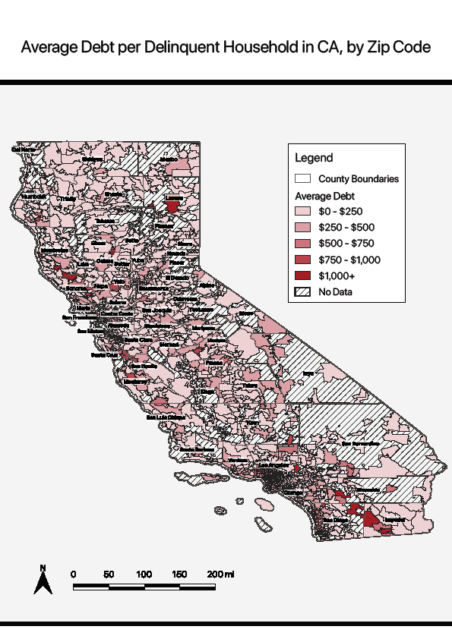

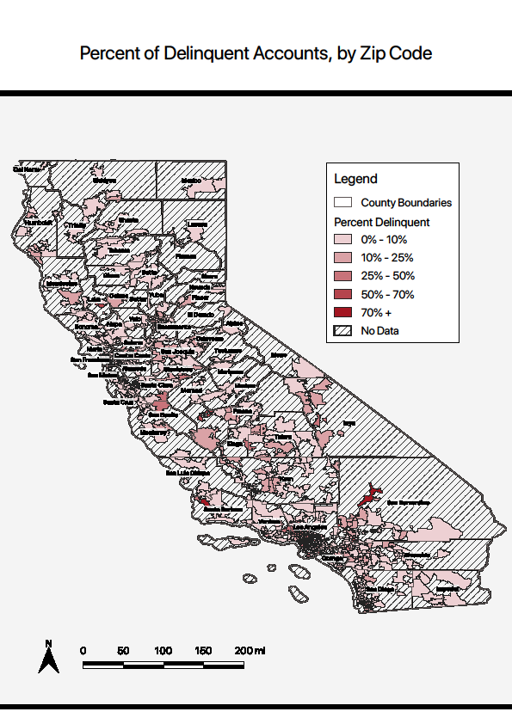

**Appendix: Additional Detailed Results, Methodology and Assumptions**

The survey contacted 500 Small/Medium CWS (under 10,000 service connections) and 150 Large CWS (over 10,000 service connections) and received responses from 398 Small/Medium CWS and 121 Large CWS. After filtering Small/Medium CWS to remove systems that reported a $0 debt figure or removing outlier systems that indicated debt levels reported were not due to the Covid pandemic, the total small/medium CWS number analyzed was 281 CWS. In total CWS analyzed in the survey data serve 60% of CWS service connections across the state. To project debt levels statewide the calculated debt level per account found in survey data for Small/Medium and Large CWS was multiplied across total service connection numbers in the state. Below we provide additional summary data tables and figures to illustrate our calculations and different ways of analyzing the data.

*Water System Connections in Survey*

|  |  |
| --- | --- |
| Water System Characteristics | Totals |
| Large CWS Survey Accounts (n = 121) | 5,011,934.00 |
| Small/Medium CWS Survey Accounts  (n = 281) | 856,477.00 |
| Total | 5,868,411.00 |

*Delinquent Accounts in Survey*

|  |  |
| --- | --- |
| Water System Characteristics | Totals |
| Large CWS Delinquent Accounts (n = 121) | 1,294,340 |
| Small/Medium CWS Delinquent Accounts  (n = 281) | 82,951.00 |
| Total | 1,377,291 |
| Percent of Large CWS Accounts Delinquent | 26% |
| Percent of Small/Medium CWS Accounts Delinquent | 10% |

*Debt Calculated in Survey*

|  |  |
| --- | --- |
| Water System Characteristics | Totals |
| Large CWS Survey Accounts (n = 121) | 642,531,810.16 |
| Small/Medium CWS Survey Accounts  (n = 281) | 29,815,392.00 |
| Debt per Delinquent Account – Large CWS | $ 496.42 |
| Debt per Delinquent Account – Small/Medium CWS | $ 359.43 |

*Primary Debt Projection across California*

|  |  |
| --- | --- |
| Water System Characteristics | Totals |
| Large CWS | $ 995,859,987.62 |
| Small/Medium CWS | $ 67,178,579.99 |
| Total | $1,063,038,567.61 |

*Very Large Water Systems (+100,000 connections) Debt per Delinquent Account*

*Figure X: Large Water Systems (10,000 – 99,000 connections) Debt per Delinquent Account*

*Small/Medium Water Systems Debt per Delinquent Accounts*

Survey data also provided debt figures at the zip code level, reported by participating CWS, for 1051 of California’s 1763 zip codes. Zip codes in the data contain 75- 80% of the state’s population and indicate there are at least 1.2 million delinquent accounts, before projecting figures statewide. Zip codes reporting debt data were not notably different than those not reporting debt, except that they tended to be slightly more urban, and thus dense and diverse.   
  
Debt data at the zip code level was provided in debt “buckets” in $100 increments from ‘Under $100’, “$100 - $200”…up to “Over $1000”. Each bucket was assigned a number of accounts in that zip code that hold a debt level within that bucket. To calculate debt level with this data each bucket is reassigned a midpoint value and multiplied by the number of accounts that fall within the bucket. For example, if there are 100 accounts in a “$100 - $200” bucket debt is calculated by multiplying 100 * $150 for a total of $15,000. Additionally, all debt over $1000 is assumed to be “$1050. This limits the accuracy of the projections and likely skews overall projections low. There are approximately 150,000 accounts with over $1000 in debt that could contribute a considerable amount of debt to statewide totals.   
  
*Distribution of Delinquent Accounts* *across Debt Levels*

Analysis of debt trends across socio-economic status factors was enabled by matching American Community Survey zip code tabulation area (ZCTA) data to corresponding zip codes. Three overarching questions were examined. Which, if any, socioeconomic factors help explain:

* The % of households in a zip code with any level of debt?
* The average level of debt in a zip code?
* The % of households in a zip code with very high levels of debt?

Multivariate regression analysis of relationships between debt and other zip code characteristics (n=808) was performed in the statistical analysis software program Stata 16.1. It is important to undertake multivariate regression to assess which, if any, socioeconomic factors were most strongly associated with debt.

Factors assessed for their relationship to debt prevalence and levels at the zip code level were:

* Race-ethnicity: the % of the zip code’s households reported as Non-Hispanic White, Hispanic, Black and Asian
* Economic status: Median household income & % of households in poverty
* Housing status: % of households living in rental units

In brief we found the following relationships between different and socioeconomic factors, with “+” indicating a positive, statistically significant relationship and (#) indicating the relative influence of the factor in explaining the debt outcome.

*Reduced form Regression Models of Zip Code Level Debt Outcomes*

|  |  |  |  |  |  |
| --- | --- | --- | --- | --- | --- |
| Outcome modeled | % of households in debt | Average debt level | Average debt level across all households above $100 | % of households above $600 debt | % of households above $1000 debt |
| % Black Households | + (2) | + (2) | + (1) | + (2) | + (2) |
| % Hispanic households | + (1) | + (1) | + (3) | + (1) | + (1) |
| Median Income |  |  |  | + (4) | + (4) |
| % households in poverty |  |  |  |  |  |
| % of households renting housing unit | + (3) | + (3) | + (2) | + (3) | + (3) |
| Total Variation in Outcome Explained (Adjusted or Pseudo R2) | 10% | 12% | 10% | 9% | 7% |

*Zip-Code Debt in Predominately Minority Zip-Codes*

|  |  |  |  |  |  |
| --- | --- | --- | --- | --- | --- |
|  | All Zip Codes | Non-Hispanic White | Hispanic | Black | Asian |
| Total Debt | $ 439,084,875.84 | $ 72,163,432.00 | $ 135,292,300.00 | $ 8,014,000.00 | $ 3,465,550.00 |
| DAC Debt | $ 208,789,800.00 | $ 6,464,950.00 | $ 104,217,650.00 | $ 7,838,975.00 | $ 533,117.00 |
| SDAC Debt | $ 106,970,000.00 | $ 1,332,400.00 | $ 74,625,900.00 | $ 3,280,500.00 | NA |

*Zip-Code Debt per Delinquent Household in Predominately Minority Zip-Codes*

|  |  |  |  |  |  |
| --- | --- | --- | --- | --- | --- |
|  | All Zip Codes | Non-Hispanic White | Hispanic | Black | Asian |
| Total Debt per D HH | $ 362.48 | $ 380.86 | $ 377.76 | $ 485.52 | $ 249.27 |
| DAC Debt per D HH | $ 366.68 | $ 292.12 | $ 386.57 | $ 496.99 | $ 234.75 |
| SDAC Debt per D HH | $ 374.96 | $ 204.67 | $ 397.87 | $ 422.85 | NA |