Supplemenatry information

Effect of land use on microplastic pollution in a major boundary waterway: The Arvand River

Table S1. Location of water and sediment sampling sites with different land uses in the Arvand River.

1. Sediment physicochemical properties
The characterisation of the 24 sediment samples from the Arvand are summarized in Table S2. The mean pH values in the four land uses are slightly similar ranging from 6.59 to 8.21. The sediment sample collected near Khorramshahr wastewater effluent (sample No. N4) is the most acidic sample (pH: 6.59), while sample No. N7 collected from agricultural area proved to be the most alkaline (pH: 8.21) due to the use of fertilizers. Significant differences in pH values among samples collected from different land uses were determined (Kruskal-Wallis test, p < 0.05). The electrical conductivity (EC) ranged from 1.09 to 1265 mS/cm. The highest EC values occurred in mixed zone (estuarine) of the Arvand River water with the Persian Gulf in natural area. Mean organic matter (OM) content of the sediments in urban, industrial, agricultural and natural areas were 8.29, 5.75, 7.95, and 9.08%, respectively. The EC, CEC, OM and CaCO₃ contents did not exhibit significant variations spatially (p > 0.05). Based on the US Department of Agriculture (USDA) and the method proposed by Buol et al. (2011), sediment samples demonstrated various texture as follows: at urban sites the samples were classified as silty clay and clay. At industrial sites, samples fell in the category of sandy clay loam, silty clay loam and clay. Samples collected at agricultural area were classified as sandy loam, silty clay, clay loam and clay. In natural area, the sediments showed clay loam, silty clay loam and loam texture. There were significant differences between clay, silt and sand contents in sediment samples from different land uses (p < 0.05). A rich variety of sediment texture in the Arvand River was found to be associated with freshwater and sediment inputs from specific rivers in the area such as Tigris River from Iraq and Karoon River from Iran. Moreover, local coastal erosion of the Persian Gulf is responsible for downstream sedimentation result in high variation of sediment texture.

Table S2. Characterisation of sediment samples from sites with different land uses in the Arvand River.

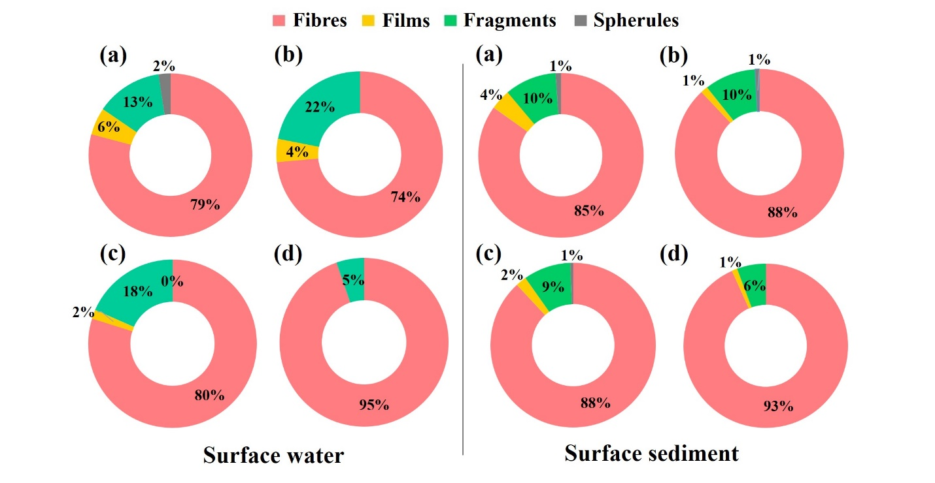
Fig. S1. Comparison of the proportion of main MP shapes found in surface water and sediment samples from (a) urban (b) industrial (c) agricultural and (d) natural areas of the Arvand River. MPs were characterized from 24 sampling sites.
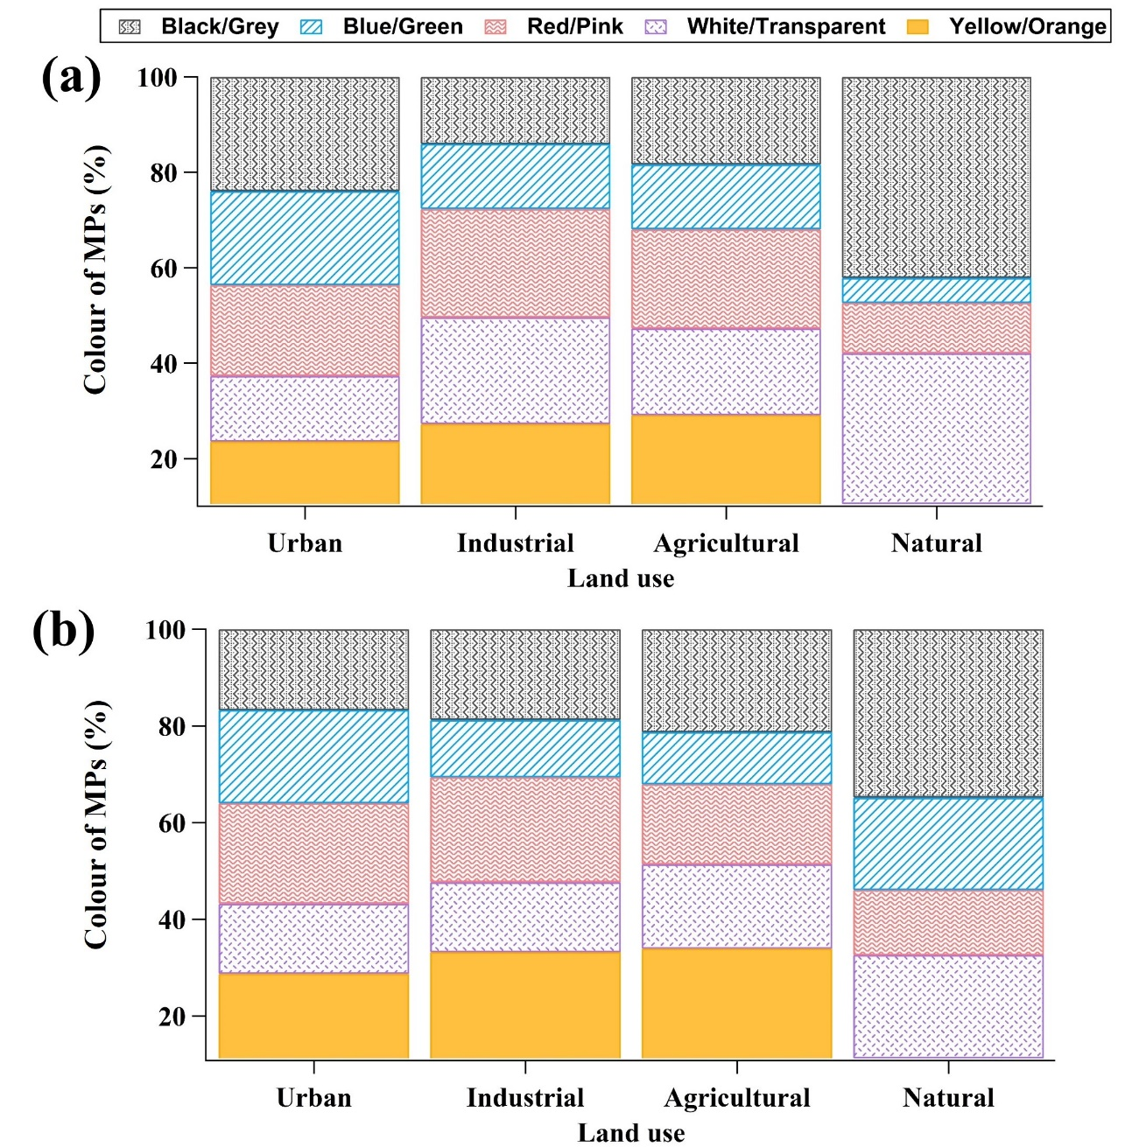
Fig. S2. Colour comparison among the MPs isolated from (a) surface water and (b) surface sediments in sampling sites (total of 24) with different land uses in the Arvand River.

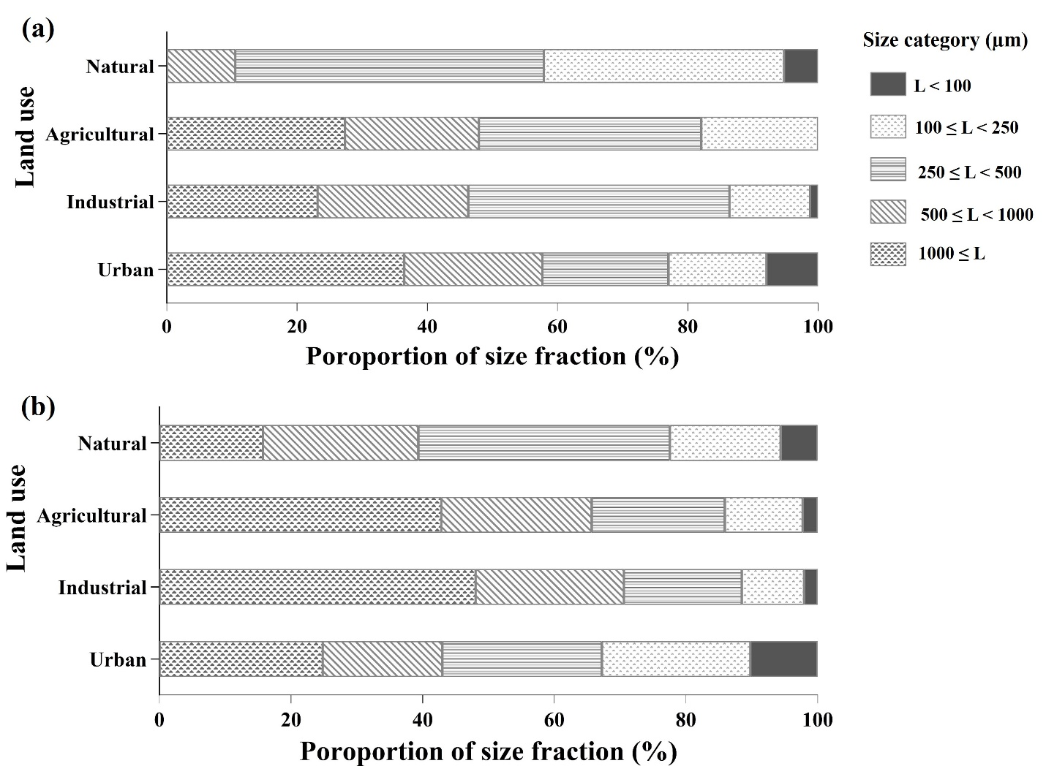
Fig. S3. Distribution of MPs according to their size in a) surface water and b) surface sediment sampling sites with different land uses in the Arvand River.

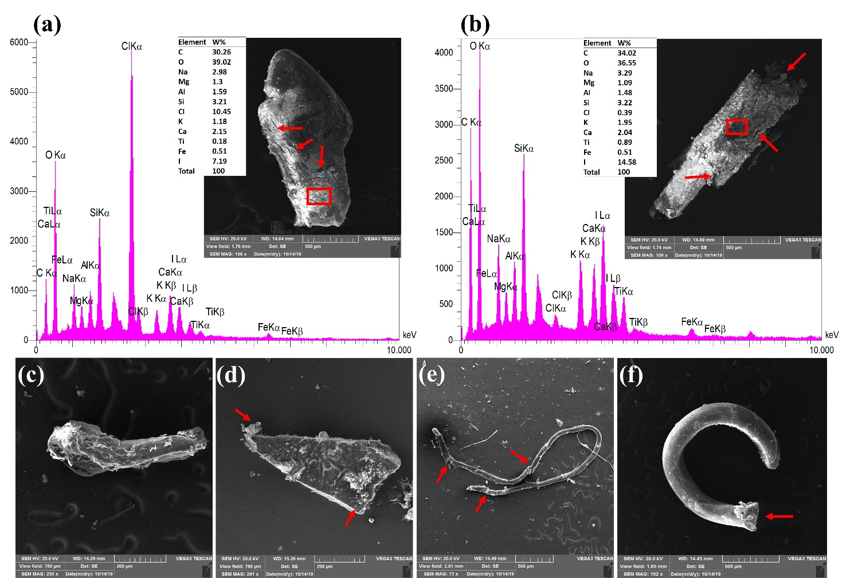
Fig. S4. SEM micrographs of MPs showing surface morphology features that could have been caused by weathering from sediment samples of the Arvand River with EDX spectra showing the elemental composition of weathered MPs. (a) SEM image showing a net of cracks and grooves on its surface of a fragment particle that could be from the separation of other plastic layers, some of which could be caused by weathering; (b) SEM image showing a broken edge and small cavities and pores on its surface with its related EDX; (c) adhered materials onto a fragment particle; (d) broken and angular edges of a fragment particle; (e) broken edges in a fibre; and (f) broken edge of a horseshoe-shaped particle. The polymer composition of these particles was confirmed by SEM-EDX and Raman microscopy.

Table S3. Chemical compositions of the examined MPs particles.

Reference
Buol, S.W., Southard, R.J., Graham, R.C., McDaniel, P.A., 2011. Soil genesis and classification. John Wiley & Sons.

