ToMEx 2.0 microplastic properties - 240425

All summaries done

## do all of this on whole ToMEx2.0 data + again for only the data that is used for the pSSDs (RDS file after filtering on github)

Number of samples per polymer type
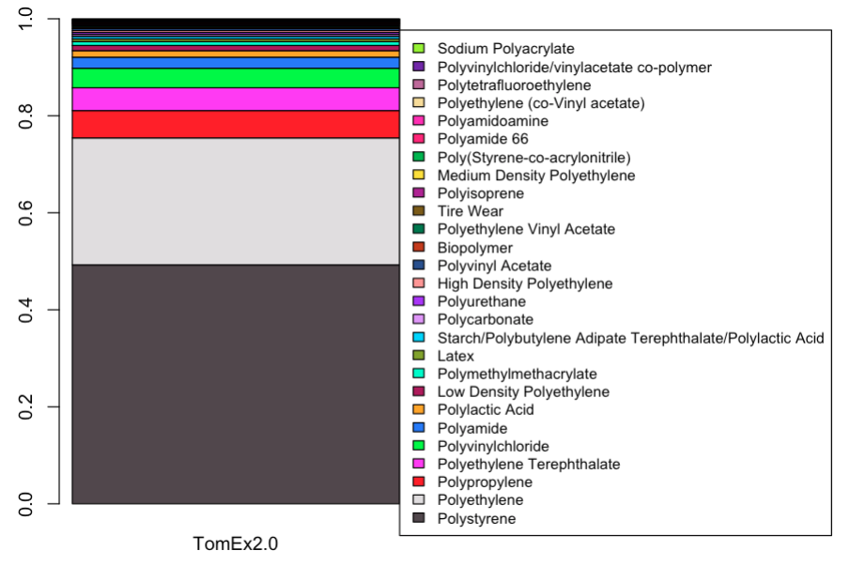

Which polymers to be lumped together to have better overview?

Data in other papers presented in the same way. Could extract proportions from plots of these studies, but should we replicate them here?

collapse to categories that can be identified by spectroscopy
>> openspecy – Win shares classes: https://link.springer.com/article/10.1007/s00216-018-1156-x

tire particles usually not recognized in environmental samples >> maybe remove tire wear for these comparisons

polymer types only descriptive – broken down in freshwater

average density of polymers >> this goes into the alignments
shape: would need corey shape factor, other would be length; better power law data out there?

Particle size – comparison with data from Kooi et al. 2019
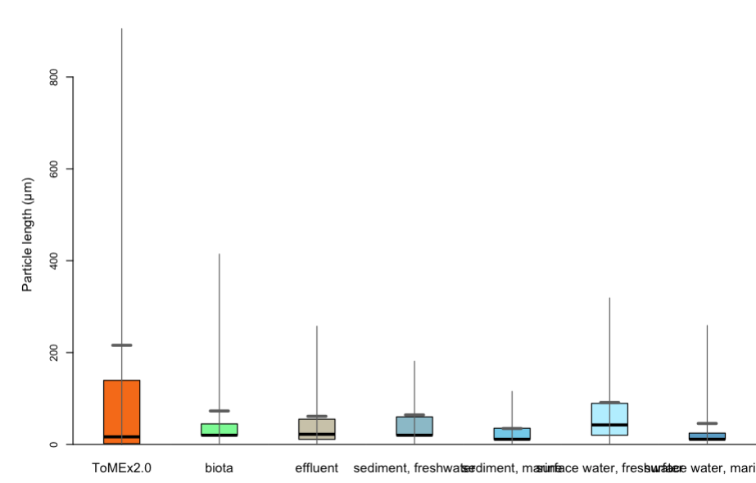
(boxplots for environmental samples dran from quantile info)

Problem with these comparisons:
- there’s a lower detection limit depending on the measurement methods
- studies used different sieves,i.e. upper particle size limits.

How can we compare size distributions, if measurement limits are different?

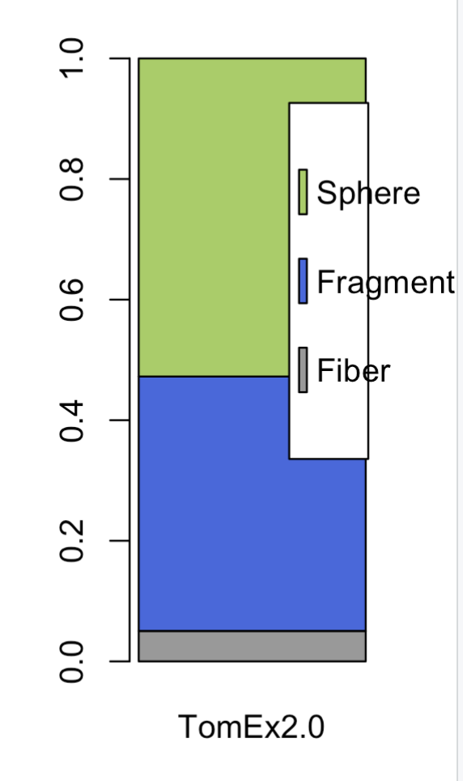

We have datasets to which we can compare these frequencies
>> Do this as stacked bars? or unstacked?

General question
- Should we discriminate between freshwater and marine ecosystems? in both ToMEx and environemntal samples? > two different comparisons
Are pSSDs planned separately for marine and freshwater?
>> yes separately! Maybe there are not enough species for the freshwater environment

- @Scott&Win: in which form would you need the data for data alignments?
- no environmental data on: charge, zeta potential,

