Supplementary Information:
A Probabilistic Risk Framework for Microplastics Integrating Uncertainty Across Toxicological and Environmental Variability: Development and Application to Marine and Freshwater Ecosystems
Scott Coffin¹, Lidwina Bertrand², Kazi Towsif Ahmed³, Luan de Souza Leite⁴, Win Cowger⁵, Mariella Siña⁶, Andrew Barrick⁷, Anna Kukkola⁸, Bethanie Carney Almroth⁹, Ezra Miller¹⁰, Andrew Yeh¹¹, Stephanie Kennedy¹², Magdalena M. Mair¹³˒¹⁴
¹ California Office of Environmental Health Hazard Assessment, 1001 I St., Sacramento, CA 95814, USA
² Laboratorio de Investigaciones en Contaminación Acuática y Ecotoxicología (LICAE), Centro de Investigaciones en Bioquímica Clínica e Inmunología - CIBICI, Facultad de Ciencias Químicas, CONICET, Universidad Nacional de Córdoba, Medina Allende esq. Haya de la Torre, Ciudad Universitaria, 5000 Córdoba, Argentina
³ Bangladesh Agricultural University, Mymensingh, Bangladesh
⁴ Environmental Chemistry Laboratory, Institute of Chemistry, University of Campinas, Cidade Universitária Zeferino Vaz, 13083-970, Campinas, SP, Brazil
⁵ Moore Institute for Plastic Pollution Research, 120 N Marina Dr., Long Beach, CA 90803, USA
⁶ National Taiwan University, No.1, Sec. 4, Roosevelt Road, Taipei, Taiwan
⁷ Auburn University, School of Fisheries, Aquaculture, and Aquatic Sciences, Auburn, AL, USA
⁸ University of Birmingham, School of Geography, Earth and Environmental Sciences, Edgbaston, Birmingham B15 2TT, United Kingdom
⁹ University of Gothenburg, Department of Biological and Environmental Sciences, Medicinaregatan 7B, 41390 Göteborg, Sweden
¹⁰ San Francisco Estuary Institute, 4911 Central Ave, Richmond, CA 94804, USA
¹¹ Gradient Corporation, 600 Stewart Street, Suite 1900, Seattle, WA 98101, USA
¹² ToxStrategies, LLC, 31 College Place, Suite B118, Asheville, NC, USA
¹³ Statistical Ecotoxicology, University of Bayreuth, Universitätsstrasse 30, 95440 Bayreuth, Germany
¹⁴ Bayreuth Center for Ecology and Environmental Research (BayCEER), Bayreuth, Germany
Journal of Hazardous Materials

Table of Contents
Text 6
Extended Methods and Analyses 6
Additional details regarding threshold derivation 6
Technical changes and analyses relating to the PSSD++ code 8
MP characteristics covered in the ToMEx 2.0 dataset 9
Intra-Species Variability 10
Sensitivity Analysis of Thresholds Based on Quality Filters 10
Tables 12
Table S1: Summary statistics of aquatic toxicity data in ToMEx 2.0, separated by environment and whether data was included in threshold derivation (and for which tier) 12
Table S2: Information from freshwater organisms introduced into the pSSD model based on Taxa. Data is broken down by level of biological organization. 20
Table S3: Information from marine organisms introduced into the pSSD model based on Taxa. Data is broken down by level of biological organization. 26
Table S4. Environmental Distribution parameters used to align data to ERMs from Kooi et al. (2021) 36
Table S5. Percent relative standard deviations (based on Monte Carlo modeling) of proposed tiered SSD-based ecotoxicological microplastics thresholds for freshwater and marine environments based on food dilution and tissue translocation-mediated effects ERMs. 37
Table S6. Percentage of threshold values with z-scores > ±3 in the Monte Carlo analysis grouped by environment/tier/ERM 38
Table S7. Freshwater and Marine species/alignment sensitivity analysis 39
Table S8. Summary statistics for PSSD++ derived thresholds 40
Table S9. Summary Statistics for Coefficients of Variation (CoV) for individual toxicity data points in alignment Monte Carlo simulations for marine and freshwater environments and food dilution and tissue translocation ERMs 41
Table S10. Relative Confidence Intervals of Thresholds based on Different Methods 42
Table S11. Environmental particle distribution data 43
Figures 71
Figure S1. Example coefficient of variation. 71
Figure S2. Coefficients of Variation. 72
Figure S3. Coefficient of variation scatterplots. 73
Figure S4. MC-SSD Violin Plots (particles/L) 74
Figure S5. MC-SSD Violin Plots (mass) 75
Figure S6. PSSD++ for Tissue Translocation (Marine). 76
Figure S7. PSSD++ for Tissue Translocation (Freshwater). 77
Figure S8. PSSD++ for Food Dilution (Freshwater). 78
Figure S9. PSSD++ for Food Dilution (Marine). 79
Figure S10. Leave-One-Out Quality. 80
Figure S11. Comparison of Monte-Carlo and Deterministic Thresholds. 81
Figure S12. Characteristics of microplastic particles (MP) represented in the filtered ToMEx 2.0 dataset used to derive thresholds. 82
Figure S13. Comparison of PNEC distributions (particles/L; aligned to 1 to 5,000 µm) for Tier 3 for Marine (left) and Freshwater (right) environments for food dilution and tissue translocation ERM calculated using either; A) the original PSSD+ trapezoidal step-wise function from Wigger et al. (2021) or; B) the modified log-normal distribution-based approach for computing species NOEC distributions when n > 2. 83

Text

Extended Methods and Analyses

Additional details regarding threshold derivation
To derive ecotoxicological MP thresholds for aquatic environments, we applied the approach described in Thornton-Hampton et al. (2025) which was slightly adapted from Mehinto et al. (2022). This approach utilizes SSDs to summarize ecotoxicological data for species and taxa relevant to the chosen environments (e.g., freshwater, marine, etc.). The SSD method compares interspecies sensitivity to a specific contaminant and is often used to develop water quality criteria (Belanger et al. 2016). This method integrates a large set of toxicity data for all species exposed to a contaminant of interest (e.g., microplastics), providing a pragmatic method for deriving hazard concentration (HC) levels protective at an ecological community level, and is often used to develop water quality criteria (Posthuma and de Zwart 2012). Just as in Mehinto et al. (2022), SSDs here were derived using effect concentrations from laboratory studies aligned to one of two ERMs (i.e., food dilution and tissue translocation-mediated effects) using particle size and shape distributions measured in environmental samples based on the methods by Koelmans et al. (2020) and Kooi et al. (2021). As in Mehinto et al. (2022), SSDs were derived using the ssdtools R package (version 0.3.7) by fitting a series of parametric distributions to the data (i.e., log-normal, log-logistic, Gamma, log-Gumbel), with Akaike’s Information Criteria calculated for each distribution to determine their goodness-of-fit (Thorley and Schwarz 2018; Fox et al. 2021). The HC value (e.g., HC5, HC10) is then determined using a weighted model averaging approach, and confidence intervals are determined using bootstrapping (n = 10 bootstraps), as described in Thorley and Schwarz (2018). Testing revealed insignifcant (<2%) differences when larger bootrap iterations are used with the filtered dataset, while requiring significantly more computational energy and processing time. Accordingly, the minimum bootstrap iteration of 10 was used throughout this assessment.
A series of four threshold values was derived for each of two hypothesized effect mechanisms (food dilution and tissue translocation-mediated effects) for both marine and freshwater aquatic environments using SSDs. A four-tiered “protective-to-predictive” management framework previously developed by an expert workgroup was utilized to populate a suite of SSD parameters representing increased confidence in ERMs (Mehinto et al. 2022). These parameters included: the method in which data were summarized for each species; modeled percentage of species affected - also referred to as “hazard concentration” (HC), model point estimate (e.g., median, 5% confidence interval, etc.); and the level of biological organization of endpoints included in the SSD (e.g., molecular, organismal, population, etc.). For the two lower “protective” thresholds, endpoints at all levels of biological organization were used, with the 1st quartile of summarized species data chosen to populate the SSD. For the two higher “predictive” thresholds, only organismal and population-level endpoints were used, with the median species concentration utilized. The lower three thresholds all used the HC5, while Threshold 4 used the HC10. The median model output value was used in all thresholds except for Threshold 1, in which the lower 5th percentile confidence interval value was used.
As in Thornton-Hampton et al. (2025, we slightly modified the approach in Mehinto et al. (2022) by separating freshwater and marine environments to improve fidelity. Mehinto et al. (2022) merged ecotoxicity data for both freshwater and marine species into a single SSD based on the rationale that some environments contain both organism types (e.g., estuaries), and, due to the pragmatic limitation in which insufficient quality-screened data were available in the ToMEx 1.0 database to derive thresholds for freshwater (a minimum of six species is required to derive an SSD, with just five species available in ToMEx 1.0 which passed minimum criteria). In our assessment, however, sufficient quality-screened toxicity data were available to derive thresholds separately for freshwater and marine environments; so we derived thresholds for each - a practice which is in line with common water quality guideline protocol (Canadian Council of Ministers of the Environment, 2007; European Chemicals Agency, 2011). Alignments were performed using environment-specific (i.e., freshwater parameters with freshwater species, and marine parameters with marine species) particle-based distribution parameters, which were obtained from Kooi et al. (2021), and include: power law alpha values for particle length, mass, volume, and surface area; particle length to width ratios, and particle height to width ratios. Note that since the height of particles is not typically measured due to limitations of using Fourier-Transform Infrared Spectroscopy (FTIR) imaging techniques (Primpke et al. 2022), we assumed that the height-to-width ratio distributions were equivalent to the length-to-width ratio distributions, as was done in Kooi et al. (2021).
For determining the bioaccessibility of particles, the approach first described in Koelmans et al. (2020) and used in Mehinto et al. (2022) was utilized, with a slight modification to account for partially bioavailable polydisperse exposure mixtures. In the case of the food dilution ERM, each species ’maximum ingestible plastic particle size (i.e., particle length) was estimated using the allometric animal-plastic size relationship model derived in Jâms et al. (2020). Each species’ body length data was obtained previously (Mehinto et al. 2022) in addition to various sources (see supplementary information). In the case of the tissue translocation ERM, particles deemed too large to be displaced through tissue were considered biologically unavailable (Koelmans et al. 2021), with the 50th percentile probability of tissue translocation size limit derived in this paper used in analyses. For monodisperse particle exposures, if the particle length was greater than the bioaccessibility limit, the data were excluded from threshold derivation. In the case of polydisperse particle exposures, if only part of the particle distribution was bioaccessible, then the non-bioaccessible particles were excluded from the alignment by re-assigning the upper size of the particle distribution to be the maximum bioavailable (ingestible or translocatable) size; and re-calculating the bioaccessible effect concentration by multiplying the effect concentration by the bioaccessible correction factor (CF_{bio frac}), which was determined using equation 1 (Koelmans et al. 2020):
$${CF}_{bio frac} = \frac{x_{Bio.}^{1 - a} - x_{Poly, min}^{1 - a}}{x_{Poly, max}^{1 - a} - x_{Poly, min}^{1 - a}}$$
In which x_{bio} is the bioaccessibility limit (i.e., species’ mouth size, or tissue translocation limit), x_{Poly, min} is the polydisperse particle mixture’s smallest particle length, and x_{Poly, max} is the polydisperse particle mixture’s largest particle length, and a is the particle length power law. Ideally, the power law value for the laboratory polydisperse exposure mixture would be used to make this correction, however such data was not reported in any of the surface water exposure studies using in this assessment, therefore the value used in the environment to which the data is being aligned (freshwater, marine) from Kooi et al. (2021) was used. Note that CF_{bio frac} is always a unitless fraction.
Following Mehinto et al. (2022), NOECs for chronic exposures were used for threshold derivations. LOECs and EC50/LC50 values were converted using uncertainty factors of 2 and 10, respectively, and acute data were converted to chronic data using an uncertainty factor of 10 (Wigger et al., 2019). Data were aligned and rescaled to a default size range of 1 – 5,000 μm based on the two ecologically relevant metrics (ERMs) utilized by Mehinto et al. (2022) and first described by Koelmans et al. (2020) and Kooi et al. (2021) - which are food dilution and tissue translocation-mediated effects. Only studies using particles with lengths within this default size range were used in the derivation of thresholds. Alignment of toxicity data through this approach involved the conversion of effect concentrations (typically reported in particles/volume of media) to total particle volume/volume of media for food dilution, and total particle surface area/volume of media for tissue translocation-mediated effects. Particle bioavailability was accounted for as in Mehinto et al. (2022), by restricting the aligned particle distributions to those that can be ingested by the specific organism (species- and life-stage-specific) in the case of food dilution (based on the allometric relationship between ingested plastic and body length derived in Jâms et al. 2022, with body length data from ToMEx 2.0), and translocatable lengths of particles in the case of tissue translocation-mediated effects.
Approximately 90% of the data in ToMEx 2.0 could not be used in ERA modelling simply due to being an effect metric that is either an intermediary exposure concentration (10,792 data points out of 12,798 total) or was a HONEC (705 data points). Of the remaining ~10% of usable data, the most abundant effect metrics were either NOECs or LOECs for both marine and freshwater species, with a significantly greater amount of LC50 data for freshwater species (n = 39) than marine (n = 3) (Table S1). LOECs comprised the majority of data points used for modelling for both marine and freshwater species, therefore necessitating an uncertainty factor adjustment of 2. Specifically, for threshold tiers 1&2, marine species consisted of 83 NOECs, 149 LOECs, 2 EC50s, and 1 IC50; and freshwater species consisted of 51 NOECs, 60 LOECs, 19 LC50s, 8 EC50s, and 2 EC10s (Table S1).

Technical changes and analyses relating to the PSSD++ code
To address a computational bottleneck in the original PSSD++ framework (Wigger et al., 2020), we evaluated two approaches for simulating species-specific NOEC distributions when there are more than three datapoints for a single species. The original method developed by Wigger et al., (2020) generates an empirical step-function distribution based on observed NOEC values using a piecewise trapezoidal approximation. While this method is robust for capturing distributional nuances from limited empirical data, it becomes computationally expensive when applied within a MC simulation framework - like the one that we applied here for environmental particle distributions of ERMs - where each species may be represented by tens to hundreds of thousands of particle-specific NOECs. This is a scale far exceeding that used in the original implementation, resulting in prohibitively long runtimes due to iterative trapezoidal sampling across many unique values. To overcome this limitation, we implemented a simplified log-normal approximation. For species with three or more NOEC values, we applied a base-10 logarithmic transformation to the data, calculated the mean and standard deviation, and sampled from a normal distribution in log space. The resulting values were exponentiated and multiplied by a uniformly sampled uncertainty factor that captured species-specific variability (including experimental error and inter-species uncertainty). This approach aligns with the assumption that toxicological data often follow a log-normal distribution (e.g., Beaudouin et al., 2012; Newman et al., 2000). Compared to the original step-wise trapezoidal method provided in Wigger et al., (2021), this shortcut reduced runtime from ~90 hours to ~5 hours, while producing nearly identical summary statistics (e.g., medians, quartiles; Figure S13). Despite similarities in summary statistics, the PNEC distributions differ in shape, with the log-normal approach yielding relatively smooth, normal distributions, while the step-wise approach yielding multimodal, non-normal distributions - especially for freshwater tissue translocation; Figure S13. Nonetheless, the similarities in summary values demonstrate that the log-normal simplification may be used as a more efficient alternative for large-scale MC-SSD applications.
We modified the original PSSD+ code to enable differences in HCx values when local species data were sparse. Specifically, the original PSSD+ code used "type 1" in R's quantile() function (stats library) to determine hazard concentration (HCx, e.g., HC5, HC10) distributions, which selects the smallest discrete value that meets the probability (e.g., 5th percentile for HC5) without interpolation, relying on abundant data near the HC value. This limitation led to identical HC5 and HC10 values for the freshwater environment due to sparse data at the lower end of the distribution. To fix this, we changed the `quantile()` function to use "type 8," which employs linear interpolation for the median-unbiased estimate to determine the values (i - 3/8) / (n + ¼; where i is the rank, and n is the number of observations). This ensures that distinct values are produced for every HCx (e.g., HC5, HC10), even with limited data.

MP characteristics covered in the ToMEx 2.0 dataset
The ToMEx 2.0 dataset reveals a clear predominance of the use of polystyrene (PS) particles, reaching percentages of 42 % and 63 % in the freshwater and marine species toxicity test, respectively (Fig. S12A). Polyethylene (PE) particles were the second most commonly used, reaching a percentage of 36 and 26% in freshwater and marine studies, respectively. Other polymers, such as PVC, PA, and PP, were represented in less than six percent of the studies. Regarding the particle shape, spheres were used in 48 and 72% of studies involving freshwater and marine organisms, followed by fragments, which were used in a higher percentage of studies with freshwater species (37 %) than with marine ones (19 %) (Fig. S12B). Surprisingly, fibers were used in only a few studies (eight in total), even though they are considered to be one of the most abundant shapes in the environment. The average particle lengths were 64.1 ± 100.8 µm (mean ± standard deviation (SD); range: 0.02 - 400 ) and 28.8 ± 69.3 µm (mean ± SD; range: 0.03 - 312.5) while the average particle widths were 36.6 ± 82.6 µm (mean ± SD; range: 0.02 - 350) and 8.5 ± 31.9 µm (mean ± SD; range: 0.03 - 203.8), for freshwater and marine organisms, respectively (Fig. S12C and D). A large proportion of studies did not report the presence of sodium azide in MPs particles used for toxicity tests, especially in studies using marine species (Fig. S12E). Moreover, the presence of dissolved organic matter, either in the exposure medium or as a biofilm on MPs, was not reported in most toxicity tests involving freshwater species. In contrast, it was considered in tests with marine species (Fig. S12F). Finally, surface charges and the presence of functional chemical groups on the particle surface were considered in approximately 30 and 10% of the toxicity tests using marine and freshwater species, respectively. (Fig. S12G and H).

Intra-Species Variability
The variability underlying the uncertainty intervals for the MC+SSD-derived thresholds, and part of the uncertainty intervals for the PSSD++-derived thresholds was due to the variability in aligned toxicity values (incorporating both intra-species variability and uncertainty involved in alignments) - described for each toxicity value by their coefficient of variation (‘CoV’ = standard deviation ÷ mean). CoV values varied according to species, particle traits in exposures, and ERMs, with strong consistencies observed between environments (Figures S1 and S2). The distribution of CoV values was wider for food dilution than for tissue translocation, ranging from 0.2 to 2.7 (median 1.7±0.6) and 0.08 to 1 (median 0.5±0.2), respectively (Figure S2; Table S9). CoV distributions for individual toxicity data points followed roughly normal distributions with limited skewness and kurtosis (Figure S2). The lowest CoV for both food dilution and tissue translocation was observed for a toxicity test that exposed the marine Oryzias melastigma fish to 10 µm long particles, with CoV values of 0.01 and 0.08, respectively (Figure S1). The highest CoV values were observed in a toxicity test with the Cnidaria Hydra attenuata that was exposed to 200 µm long particles, with CoV values of 2.77 and 0.96, respectively (Figure S1). Mouth size opening was determined to be a significant predictor of CoV, with a positive association with food dilution (Spearman's rank coefficient = 0.21; p<0.001) and a negative association with tissue translocation (Spearman's rank coefficient = -0.12; p=0.049) (Figure S3).

Sensitivity Analysis of Thresholds Based on Quality Filters
The leave-one-out sensitivity analysis on quality filters revealed relatively limited to zero influence on the resulting thresholds for Tiers 3 and 4, with limited to moderate influence for Tiers 1 and 2 for tissue translocation and food dilution ERMs for both marine and freshwater environments. For Tiers 1 and 2, freshwater thresholds decreased slightly with the addition of studies not meeting minimum quality criteria, with a 0.5-fold and 0.3-fold decrease in the food dilution thresholds, respectively, and a 0.3-fold and 0.2-fold decrease in the tissue translocation thresholds, respectively (Figure 8). When no quality filters were applied, there were 12 and 11 species included in the tissue translocation and food dilution thresholds datasets (respectively), compared with 9 and 8 species, respectively, when risk applicability and technical criteria filters were applied. Regardless of whether quality filters were applied or not, the studies with the most sensitive species in the dataset were always included due to their meeting minimum criteria, which for food dilution was Kim and Rhee (2021) (Moina macrocopa crustacea), and for tissue translocation was Ziajahromi et al. (2017) (Ceriodaphnia dubia crustacea). In the case of Tiers 3 and 4, freshwater threshold values for food dilution were identical, while tissue translocation thresholds were 1.1-fold higher when no screening criteria were applied.
In contrast to the freshwater thresholds, for the marine environment, the removal of quality filters resulted in a slight increase in thresholds, with a fold-change of 11 and 15 for food dilution for Tiers 1 and 2, and 3 for tissue translocation thresholds for both Tiers 1 and 2, respectively (Figure sx). As with the freshwater thresholds, Tiers 3 and 4 were robust to quality filters, with food dilution thresholds being 1.3-fold higher, and no changes in the tissue translocation thresholds. When no quality filters were applied, there were 17 and 18 species included in the tissue translocation and food dilution thresholds datasets, respectively, compared with 16 and 15 species, respectively, when risk applicability and technical criteria were applied. As was the case with the freshwater environment, regardless of whether quality filters were applied or not, the studies with the most sensitive species in the dataset were always included due to their meeting minimum criteria, for both food dilution and tissue translocation (Capolupo et al., 2021) (Mytilus galloprovencialis mollusc).

Tables

Table S1: Summary statistics of aquatic toxicity data in ToMEx 2.0, separated by environment and whether data was included in threshold derivation (and for which tier)

 | Freshwater  (All Data) | Freshwater (Tier 1/2) | Freshwater (Tier 3/4) | Marine  (All Data) | Marine (Tier 1/2) | Marine (Tier 3/4)
Number of Data Points | 6,555 | 140 | 107 | 6,243 | 235 | 41
Number of Studies | 144 | 16 | 13 | 149 | 16 | 12
Number of Species | 63 | 10 | 7 | 101 | 17 | 14
% Chronic | 42% | 36% | 28% | 37% | 76% | 27%
Effect Metrics
NOEC | 191 | 51 | 39 | 237 | 83 | 15
LOEC | 365 | 60 | 39 | 412 | 149 | 23
HONEC | 327 | 0 | 0 | 378 | 0 | 0
EC10 | 4 | 2 | 2 | 3 | 0 | 0
EC20 | 1 | 0 | 0 | 0 | 0 | 0
EC50 | 30 | 8 | 8 | 11 | 2 | 2
LC20 | 0 | 0 | 0 | 4 | 0 | 0
LC50 | 39 | 19 | 19 | 3 | 0 | 0
IC50 | 0 | 0 | 0 | 1 | 1 | 1
Intermediary exposure concentration | 5,598 | 0 | 0 | 5,194 | 0 | 0
Combined Uncertainty Factors (Effect Metrics - > NOEC; Acute -> Chronic)
UF: NA;  Intermediary exposure concentration  (data not used) | 4,569 | 0 | 0 | 3,944 | 0 | 0
UF:1 | 571 | 22 | 12 | 550 | 68 | 4
UF:2 | 298 | 25 | 14 | 215 | 111 | 7
UF:10 | 691 | 35 | 33 | 962 | 15 | 11
UF:20 | 365 | 35 | 25 | 557 | 38 | 16
UF:100 | 61 | 23 | 23 | 15 | 3 | 3
Organismal Group
Mollusca | 104 | 0 | 0 | 1,903 | 17 | 7
Fish | 3,529 | 22 | 3 | 1,859 | 170 | 5
Crustacea | 1,363 | 109 | 102 | 816 | 17 | 8
Annelida | 200 | 0 | 0 | 503 | 0 | 0
Echinoderm | 0 | 0 | 0 | 313 | 12 | 6
Cnidaria | 0 | 0 | 0 | 301 | 7 | 7
Algae | 518 | 9 | 2 | 183 | 5 | 1
Dinoflagellate | 0 | 0 | 0 | 154 | 0 | 0
Rotifera | 72 | 0 | 0 | 124 | 3 | 3
Bacterium | 149 | 0 | 0 | 40 | 0 | 0
Ciliophora | 0 | 0 | 0 | 27 | 4 | 4
Mixed | 108 | 0 | 0 | 20 | 0 | 0
Insect | 181 | 0 | 0 | 0 | 0 | 0
Plant | 303 | 0 | 0 | 0 | 0 | 0
Cyanobacteria | 28 | 0 | 0 | 0 | 0 | 0
Particle Characteristics
% Polydisperse | 50% | 70% | 64% | 50% | 16% | 49%
1nm < 100nm | 883 | 0 | 0 | 724 | 0 | 0
100nm < 1µm | 780 | 0 | 0 | 422 | 0 | 0
1µm < 100µm | 2,736 | 133 | 100 | 3,328 | 228 | 34
100µm < 1mm | 1,741 | 7 | 7 | 1,448 | 7 | 7
1mm < 5mm | 121 | 0 | 0 | 164 | 0 | 0
Size Not Reported | 294 | 0 | 0 | 157 | 0 | 0
Shape
Sphere | 3,288 | 55 | 34 | 2,886 | 219 | 25
Fragment | 1,987 | 79 | 67 | 1,830 | 16 | 16
Fiber | 261 | 6 | 6 | 267 | 0 | 0
Shape Not Reported | 1,019 | 0 | 0 | 1,260 | 0 | 0
Polymer
Polystyrene | 3,795 | 28 | 18 | 3,094 | 203 | 20
Polyethylene | 1,380 | 76 | 59 | 1,565 | 25 | 18
Polyvinylchloride | 285 | 5 | 5 | 445 | 5 | 1
Polypropylene | 183 | 6 | 6 | 281 | 0 | 0
Polyethylene Terephthalate | 238 | 3 | 3 | 167 | 2 | 2
Mixture | 85 | 6 | 0 | 109 | 0 | 0
Polyamide | 86 | 0 | 0 | 102 | 0 | 0
Low Density Polyethylene | 26 | 0 | 0 | 78 | 0 | 0
High Density Polyethylene | 94 | 0 | 0 | 56 | 0 | 0
Polyethylene vinyl acetate | 6 | 0 | 0 | 56 | 0 | 0
Polylactic Acid | 37 | 6 | 6 | 39 | 0 | 0
Polymethylmethacrylate | 48 | 0 | 0 | 28 | 0 | 0
Polyvinyl Acetate | 10 | 0 | 0 | 20 | 0 | 0
Polycarbonate | 12 | 0 | 0 | 16 | 0 | 0
Polytetrafluoroethylene | 0 | 0 | 0 | 3 | 0 | 0
Biopolymer | 3 | 0 | 0 | 2 | 0 | 0
Starch/  Polybutylene Adipate Terephthalate/  Polylactic Acid | 20 | 0 | 0 | 2 | 0 | 0
Polyurethane | 44 | 4 | 4 | 1 | 0 | 0
Polyisoprene | 0 | 0 | 0 | 1 | 0 | 0
Latex | 4 | 0 | 0 | 0 | 0 | 0
Medium Density Polyethylene | 6 | 0 | 0 | 0 | 0 | 0
Poly(Styrene-co-acrylonitrile) | 6 | 0 | 0 | 0 | 0 | 0
Polyethylene Vinyl Acetate | 7 | 0 | 0 | 0 | 0 | 0
Polyoxymethylene | 4 | 0 | 0 | 0 | 0 | 0
Polyvinylchloride/  vinylacetate co-polymer | 6 | 0 | 0 | 0 | 0 | 0
Sodium Polyacrylate | 6 | 0 | 0 | 0 | 0 | 0
Tire Wear | 21 | 6 | 6 | 0 | 0 | 0
Polymer Not Reported | 143 | 0 | 0 | 178 | 0 | 0

Table S2: Information from freshwater organisms introduced into the pSSD model based on Taxa. Data is broken down by level of biological organization.
Taxa | Genus | Level of Biological Organization
 |  | Population | Organism | Tissue | Cell | SubCell | Total
Algae | Chlamydomonas |  | 7 |  |  | 18 | 25
Algae | Chlorella |  | 12 | 14 | 231 | 34 | 291
Algae | Heterocapsa |  | 2 |  |  |  | 2
Algae | Microcystis |  |  |  | 48 | 12 | 60
Algae | Raphidocelis |  |  | 4 | 28 | 19 | 51
Algae | Scenedesmus | 5 | 4 |  | 12 | 7 | 28
Algae | Spirulina |  | 2 |  | 12 |  | 14
Algae | Tetraselmis |  | 14 |  |  |  | 14
Algae | Tisochrysis |  | 2 |  |  |  | 2
Annelida | Lumbribulus |  | 54 |  |  | 108 | 162
Annelida | Tubifex |  | 14 |  |  |  | 14
Bacterium | Microcystis |  | 4 | 16 | 62 | 40 | 122
Crustacea | Artemia |  | 43 |  |  | 12 | 55
Crustacea | Asellus |  |  | 14 |  |  | 14
Crustacea | Ceriodaphnia |  | 124 |  |  |  | 124
Crustacea | Daphnia | 9 | 600 |  | 3 | 125 | 737
Crustacea | Diaphanosoma |  | 15 |  |  | 141 | 156
Crustacea | Eriocheir |  | 12 | 4 |  | 72 | 88
Crustacea | Gammarus |  | 104 |  |  | 20 | 124
Crustacea | Hyalella |  | 44 |  |  |  | 44
Crustacea | Moina |  | 144 |  |  |  | 144
Crustacea | Neocaridina |  | 40 |  |  |  | 40
Crustacea | Procambarus |  |  |  | 1 | 3 | 4
Cyanobacteria | Anabaena |  | 4 |  | 8 | 12 | 24
Fish | Barbodes |  |  | 1 |  | 6 | 7
Fish | Carassius |  | 30 | 35 |  | 68 | 133
Fish | Clarias |  |  | 8 |  | 131 | 139
Fish | Cyprinus |  |  | 6 |  | 78 | 84
Fish | Danio |  | 545 | 367 | 5 | 1185 | 2102
Fish | Hypophthalmichthys |  |  | 4 |  | 12 | 16
Fish | Letalurus |  |  |  |  | 72 | 72
Fish | Oncorhynchus |  | 71 | 18 | 60 | 414 | 563
Fish | Oreochromis |  | 11 |  |  | 45 | 56
Fish | Oryzias |  | 34 | 73 | 4 | 117 | 228
Fish | Perca |  | 33 | 32 | 8 | 40 | 113
Fish | Pimephales |  | 2 |  | 24 |  | 26
Fish | Zacco |  | 2 | 1 |  | 1 | 4
Insect | Aphylla |  |  |  |  | 8 | 8
Insect | Chironomus | 18 | 57 | 3 |  |  | 78
Insect | Hydropsyche |  | 3 |  |  | 12 | 15
Multiple | Mixed | 108 |  |  |  |  | 108
Mollusca | Anodonta |  |  |  |  | 8 | 8
Mollusca | Dreissena |  | 20 |  |  | 48 | 68
Mollusca | Sphaerium |  | 14 |  |  |  | 14
Plant | Hydrilla |  | 4 | 28 | 8 | 24 | 64
Plant | Lemna |  | 30 |  | 6 | 7 | 43
Plant | Myriophyllum | 6 |  | 24 |  | 54 | 84
Plant | Potamogeton |  |  | 5 | 10 | 35 | 50
Plant | Vallisneria |  | 4 | 5 | 6 | 47 | 62
Rotifera | Brachionus | 24 | 48 |  |  |  | 72
Total |  | 170 | 2153 | 662 | 536 | 3035 | 6556

Table S3: Information from marine organisms introduced into the pSSD model based on Taxa. Data is broken down by level of biological organization.

Taxa | Genus | Level of Biological Organization
 |  | Population | Organism | Tissue | Cell | SubCell | Total
Algae | Chaetoceros |  | 6 |  | 4 | 6 | 16
Algae | Diatoms |  | 9 |  |  |  | 9
Algae | Dunaliella |  |  |  | 92 | 15 | 107
Algae | Karenia |  | 8 |  | 8 | 8 | 24
Algae | Macroalgae |  | 4 |  |  | 9 | 13
Algae | Skeletonema |  |  |  | 8 | 4 | 12
Algae | Thalassiosira |  |  |  |  | 2 | 2
Annelida | Arenicola |  | 56 |  | 8 | 7 | 71
Annelida | Hediste |  | 173 |  | 12 | 215 | 400
Annelida | Perinereis |  | 8 |  |  |  | 8
Bacterium | Aliivibrio |  |  |  | 4 |  | 4
Bacterium | Cyanobacteria |  | 9 |  |  |  | 9
Bacterium | Halomonas |  |  |  | 21 | 6 | 27
Ciliophora | Strombidium | 9 | 18 |  |  |  | 27
Cnidaria | Acropora |  | 11 |  | 12 | 1 | 24
Cnidaria | Aurelia |  | 128 |  |  |  | 128
Cnidaria | Heliopora |  | 11 |  |  | 1 | 12
Cnidaria | Hydra |  | 13 |  |  |  | 13
Cnidaria | Lophelia |  | 3 |  |  |  | 3
Cnidaria | Montastraea |  | 1 |  |  |  | 1
Cnidaria | Orbicella |  | 1 |  |  |  | 1
Cnidaria | Pocillopora |  | 12 |  |  | 7 | 19
Cnidaria | Porites |  | 11 |  |  | 1 | 12
Cnidaria | Protopalythoa |  | 6 |  |  | 30 | 36
Cnidaria | Seriatopora |  |  |  | 12 |  | 12
Cnidaria | Tubastrea |  |  |  |  | 40 | 40
Crustacea | Acartia |  | 16 |  |  |  | 16
Crustacea | Amphibalanus |  | 10 |  |  | 12 | 22
Crustacea | Artemia |  | 57 | 28 |  |  | 85
Crustacea | Calanus |  | 7 |  |  |  | 7
Crustacea | Carcinus |  | 50 |  |  | 20 | 70
Crustacea | Charybdis |  |  |  |  | 15 | 15
Crustacea | Echinogammarus |  | 9 |  |  |  | 9
Crustacea | Idotea |  | 21 |  |  | 5 | 26
Crustacea | Litopenaeus |  | 10 | 5 |  |  | 15
Crustacea | Neomysis |  | 35 |  |  | 5 | 40
Crustacea | Nephrops |  | 2 | 1 |  | 3 | 6
Crustacea | Nitocra |  | 22 |  |  |  | 22
Crustacea | Palaemonetes |  | 11 |  |  |  | 11
Crustacea | Paracylopina |  | 36 |  |  | 18 | 54
Crustacea | Parvocalanus | 1 | 4 |  |  | 2 | 7
Crustacea | Tigriopus | 25 | 168 |  |  |  | 193
Echinoderm | Amphiura |  | 3 |  |  |  | 3
Echinoderm | Apostichopus |  | 18 | 1 |  | 60 | 79
Echinoderm | Lytechinus |  | 2 |  |  |  | 2
Echinoderm | Parcentrotus |  | 124 | 3 | 24 | 27 | 178
Echinoderm | Psammechinus |  | 7 | 3 |  |  | 10
Echinoderm | Psuedechinus |  | 6 |  |  | 15 | 21
Echinoderm | Scaphechinus |  |  |  | 6 | 6 | 12
Echinoderm | Tripneustes |  | 8 |  |  |  | 8
Fish | Acanthochromis |  | 24 | 4 |  |  | 28
Fish | Acanthurus |  | 2 |  |  |  | 2
Fish | Acipenser |  | 24 | 16 |  | 16 | 56
Fish | Bathygobius |  | 2 |  |  |  | 2
Fish | Centropristis |  | 12 |  | 12 |  | 24
Fish | Cyprinondon |  | 8 |  |  | 40 | 48
Fish | Dicentrarchus |  | 30 | 4 |  | 88 | 122
Fish | Gasterosteus |  | 4 |  |  |  | 4
Fish | Lates |  | 8 | 20 |  | 2 | 30
Fish | Oryzias |  | 183 | 156 | 3 | 688 | 1030
Fish | Pomatoschistus |  | 73 |  |  | 84 | 157
Fish | Sebastes |  | 22 | 17 |  | 20 | 59
Fish | Sparus |  | 41 | 62 | 14 | 180 | 297
Mixed | Multiple | 20 |  |  |  |  | 20
Mollusca | Abra |  | 27 |  |  | 36 | 63
Mollusca | Atactodea |  | 6 |  |  |  | 6
Mollusca | Choromytilus |  | 12 |  |  | 2 | 14
Mollusca | Corbicula |  | 16 | 8 |  | 16 | 40
Mollusca | Crassostrea | 1 | 139 | 12 | 73 | 229 | 454
Mollusca | Cerepidula |  | 8 |  |  |  | 8
Mollusca | Ennucula |  | 27 |  |  | 36 | 63
Mollusca | Mactra |  |  |  |  | 18 | 18
Mollusca | Meretrix |  | 36 | 24 | 17 | 6 | 83
Mollusca | Mytilus | 18 | 172 |  | 81 | 592 | 863
Mollusca | Ostrea |  | 20 |  |  |  | 20
Mollusca | Perna |  | 6 |  |  |  | 6
Mollusca | Pinctada |  | 79 | 6 |  |  | 85
Mollusca | Potamopyrgus |  | 125 |  |  |  | 125
Mollusca | Scobicularia |  | 2 |  |  | 12 | 14
Marine | Brachionus | 16 | 72 |  |  | 42 | 130
Total |  | 90 | 2294 | 370 | 411 | 2647 | 5812

Table S4. Environmental Distribution parameters used to align data to ERMs from Kooi et al. (2021)

Parameter | Mean | Standard Deviation | Median | 5th Percentile | 95th Percentile
Length-width ratio (freshwater) (unitless) | 0.671 | 0.28 | 0.671 | 0.12 | 1.22
Length-width ratio (marine) (unitless) | 0.769 | 0.289 | 0.768 | 0.206 | 1.34
Length power law exponent (freshwater) (unitless) | 2.64 | 0.01 | 2.64 | 2.62 | 2.66
Length power law exponent (marine) (unitless) | 2.07 | 0.03 | 2.07 | 2.01 | 2.13
Mass power law exponent (freshwater) (unitless) | 1.65 | 0.071 | 1.65 | 1.51 | 1.79
Mass power law exponent (marine) (unitless) | 1.32 | 0.00901 | 1.32 | 1.3 | 1.34
Surface Area power law exponent (freshwater) (unitless) | 2 | 0.0651 | 2 | 1.87 | 2.13
Surface Area power law exponent (marine) (unitless) | 1.5 | 0.00902 | 1.5 | 1.48 | 1.52
Volume power law exponent (freshwater) (unitless) | 1.68 | 0.0808 | 1.68 | 1.52 | 1.84
Volume power law exponent (marine) (unitless) | 1.48 | 0.0627 | 1.48 | 1.36 | 1.6
Ingestible particle model body length beta coefficent (unitless) | 0.934 | 0.137 | 0.934 | 0.664 | 1.2
Ingestible particle model body length intercept (unitless) | 1.12 | 0.323 | 1.12 | 0.484 | 1.75
50th percentile tissue translocation particle length (µm) | 179 | 5.62E+03 | 88.5 | 29.8 | 468

Table S5. Percent relative standard deviations (based on Monte Carlo modeling) of proposed tiered SSD-based ecotoxicological microplastics thresholds for freshwater and marine environments based on food dilution and tissue translocation-mediated effects ERMs.
Environment | Freshwater |  | Marine
ERM | Food Dilution | Tissue Trans. | Food Dilution | Tissue Trans.
Tier1 | 160% | 40.5% | 145% | 53.6%
Tier2 | 142% | 25.8% | 144% | 49.8%
Tier3 | 119% | 31.2% | 135% | 58.5%
Tier4 | 115% | 31.3% | 129% | 56.7%

Overall uncertainty due to ERM alignments was assessed using Monte Carlo simulations and probability distributions of alignment parameters. The percent relative standard deviations of derived thresholds ranged from 26% to 160% (Table S5), with tissue translocation thresholds having lower variability than food dilution thresholds (Table S5). Freshwater thresholds had lower variability than marine thresholds for all ERMs/threshold tiers. No apparent trend was observed for variability with respect to threshold tiers (Table S5).

Table S6. Percentage of threshold values with z-scores > ±3 in the Monte Carlo analysis grouped by environment/tier/ERM
 | Freshwater |  | Marine
Tier↓ ERM → | Food Dilution | Tissue Translocation | Food Dilution | Tissue Translocation
Tier 1 | 0.01% | 0.01% | 1.2% | 0.01%
Tier 2 | 0.01% | 0.01% | 1.2% | 0.01%
Tier 3 | 2.1% | 0.01% | 1.5% | 0.54%
Tier 4 | 2.0% | 0.02% | 1.6% | 0.51%

Table S7. Freshwater and Marine species/alignment sensitivity analysis
Tier | Food Dilution (Freshwater Sp., marine params) | Tissue Translocation (Freshwater Sp., marine params) | Food Dilution (Freshwater sp., freshwater params) | Tissue Translocation (Freshwater sp., freshwater params) | Food Dilution (Marine Sp., freshwater params) | Tissue Translocation (Marine Sp., freshwater params) | Food Dilution (Marine sp., marine params) | Tissue Translocation(Marine sp.,  marine params)
Tier1 | 0.014  (NA) | 15  (NA) | 0.1  (NA) | 93  (NA) | 0.01  (NA) | 8  (NA) | 4.7x10⁻⁵  (NA) | 0.82  (NA)
Tier2 | 0.11  (0.01 to 8) | 120  (15 to 4,000) | 4.9  (0.1 to 150) | 720  (93 to 23,000) | 0.25  (0.01 to 40) | 110  (8 to 2,900) | 2.6x10⁻³  (4.7x10⁻⁵ to 1.1) | 13  (0.82 to 380)
Tier3 | 1.2  (0.56 to 210) | 1,100 (560 to 52,000) | 42  (28 to 2,400) | 4,800 (1,900 to 54,000) | 22  (2.9 to 320) | 4,500 (1,200 to 46,000) | 0.3  (0.03 to 7.3) | 490  (140 to 5,300)
Tier4 | 6.4  (1.5 to 670) | 2,100 (890 to 67,000) | 140  (63 to 7,000) | 9,500 (3,200 to 120,000) | 86  (16 to 1,400) | 15,000 (3,200 to 130,000) | 1.5  (0.22 to 44) | 1,600  (430 to 16,000)

Table S8. Summary statistics for PSSD++ derived thresholds
Tier | Environment | ERM | Min | Q5 | Q25 | Mean | Median | Mode | Q75 | Q95 | Max
Tier3 | Marine | Food Dilution | 0.0000892 | 0.137 | 2.85 | 333 | 30.5 | 78.5 | 291 | 1,490 | 70,300
Tier4 | Marine | Food Dilution | 0.0122 | 6.32 | 45.2 | 449 | 137 | 58.1 | 451 | 1780 | 72,200
Tier3 | Marine | Tissue Translocation | 0.765 | 167 | 642 | 8,360 | 2,150 | 584 | 10,700 | 3,8000 | 11,9000
Tier4 | Marine | Tissue Translocation | 22.7 | 423 | 2,500 | 1,4100 | 6,390 | 1,540 | 14400 | 5,5200 | 50,3000
Tier3 | Freshwater | Food Dilution | 0.000315 | 0.0146 | 0.0555 | 0.323 | 0.142 | 0.0747 | 0.355 | 1.22 | 34.6
Tier4 | Freshwater | Food Dilution | 0.0054 | 0.0805 | 0.268 | 1.36 | 0.638 | 0.196 | 1.48 | 5.02 | 112
Tier3 | Freshwater | Tissue Translocation | 18.9 | 74 | 153 | 465 | 321 | 116 | 595 | 1,380 | 7,210
Tier4 | Freshwater | Tissue Translocation | 46 | 192 | 405 | 949 | 711 | 322 | 1,230 | 2,490 | 14,900

Table S9. Summary Statistics for Coefficients of Variation (CoV) for individual toxicity data points in alignment Monte Carlo simulations for marine and freshwater environments and food dilution and tissue translocation ERMs
Environment | ERM | Min | Max | Median | Standard Deviation
Freshwater | Food Dilution | 0.43 | 2.6 | 1.6 | 0.55
Marine | Food Dilution | 0.22 | 2.7 | 1.7 | 0.63
Freshwater | Tissue Translocation | 0.26 | 0.74 | 0.47 | 0.14
Marine | Tissue Translocation | 0.077 | 0.97 | 0.43 | 0.21

Table S10. Relative Confidence Intervals of Thresholds based on Different Methods
 | Environment→ | Marine |  | Freshwater
Tier ↓ | ERM →  Method ↓ | Food Dilution | Tissue Translocation | Food Dilution | Tissue Translocation
Tier1  (95% CI) | SSDª | NA | NA | NA | NA
Tier1  (95% CI) | MC+SSD^{b} | 9.0 | 2.00 | 4.05 | 1.15
Tier2  (95% CI) | SSDª | 423 | 30.4 | 29.2 | 31.2
Tier2  (95% CI) | MC+SSD^{b} | 8.15 | 9.15 | 1.84 | 0.837
Tier3  (95% CI) | SSDª | 24.2 | 56.7 | 10.5 | 10.7
Tier3  (95% CI) | MC+SSD^{b} | 7.64 | 6.88 | 2.17 | 1.03
Tier3  (95% CI) | PSSD++^{c} | 8.51 | 48.8 | 4.07 | 17.6
Tier4  (95% CI) | SSDª | 29.9 | 50.3 | 9.72 | 12.7
Tier4  (95% CI) | MC+SSD^{b} | 7.0 | 6.21 | 2.07 | 1.04
Tier4  (95% CI) | PSSD++^{c} | 7.74 | 12.9 | 3.23 | 8.55
ª95% confidence intervals for SSD-based thresholds are the bootstrap uncertainties of distributions fit to the species data at the HC5 for Tiers 2 and 3, and HC10 for Tier 4. Because Tier 1 is the lower 95% confidence interval of the SSD at the HC5, no further uncertainty estimates can be provided for that tier and this approach.
^{b}95% confidence intervals for MC+SSD-based thresholds represent the distribution values at those percentiles for the HC5/HC10 SSD values for the corresponding tier.

Table S11. Environmental particle distribution data
DOI | sample.source | Environment | PE_PET_Polyester | PP_prop | PS_prop | PA_prop | PUR_prop | PVC | PTFE | other | Fragments proportion | Spheres proportion | Fibers proportion | Length mean (µm) | Lengthmedian(µm) | Width mean (µm) | Width median (µm) | Denstiy mean (g/cm³) | Area mean (µm²) | comment
10.1016/j.watres.2021.117429 | Kooi et al. 2021, freshwater surface | freshwater | 0.319 | 0.129 | NA | 0.087 | 0.003 | 0 | NA | 0.409 | NA | NA | NA | 91.17 | 42.43 | 44.95 | 20 | 1.04 | 45300 | PU and acrylates not separated in dataset: divided by 2; proportions of polymer types extracted from Fig. 3 via metaDigitise
10.1016/j.watres.2021.117429 | Kooi et al. 2021, marine surface | marine | 0.25 | 0.116 | NA | 0.314 | 0.054 | 0.018 | NA | 0.36 | NA | NA | NA | 45.64 | 11.14 | 25.04 | 11.03 | 1.1 | 48300 | PU and acrylates not separated in dataset: divided by 2; proportions of polymer types extracted from Fig. 3 via metaDigitise
10.1016/j.watres.2021.117429 | Kooi et al. 2021, freshwater sediment | freshwater | 0.1 | 0.054 | NA | 0 | 0.324 | 0.075 | NA | 1.101 | NA | NA | NA | 64.25 | 20 | 28.08 | 20 | 1.15 | 11500 | PU and acrylates not separated in dataset: divided by 2; proportions of polymer types extracted from Fig. 3 via metaDigitise
10.1016/j.watres.2021.117429 | Kooi et al. 2021, marine sediment | marine | 0.201 | 0.1 | NA | 0.103 | 0.057 | 0.108 | NA | 0.547 | NA | NA | NA | 34.69 | 11.14 | 17.59 | 11.14 | 1.16 | 3520 | PU and acrylates not separated in dataset: divided by 2; proportions of polymer types extracted from Fig. 3 via metaDigitise
10.1038/s43247-021-00091-0 | Yakushev et al. 2021, inner plume, surface | marine | 0.667 | 0.167 | 0 | 0.167 | 0 | 0 | 0 | 0 | 0.33 | 0 | 0.67 | NA | NA | NA | NA | NA | 1320000 | no lengths or widths reported
10.1038/s43247-021-00091-0 | Yakushev et al. 2021, outer plume, surface | marine | 0.375 | 0 | 0 | 0.125 | 0.292 | 0.208 | 0 | 0 | 0.875 | 0 | 0.125 | NA | NA | NA | NA | NA | 2170000 | no lengths or widths reported
10.1038/s43247-021-00091-0 | Yakushev et al. 2021, Atlantic surface | marine | 0.727 | 0 | 0.182 | 0 | 0 | 0.091 | 0 | 0 | 0.91 | 0 | 0.09 | NA | NA | NA | NA | NA | 6140000 | no lengths or widths reported
10.1038/s43247-021-00091-0 | Yakushev et al. 2021, inner plume, subsurface | marine | 0.571 | 0 | 0 | 0 | 0 | 0 | 0 | 1.287 | 0 | 0 | 1 | 1297 | 636 | NA | NA | 1.3 | 19461 | width only reported for fragments, not fibers
10.1038/s43247-021-00091-0 | Yakushev et al. 2021, outer plume, subsurface | marine | 0.417 | 0.083 | 0.056 | 0.056 | 0 | 0 | 0.028 | 0.917 | 0.25 | 0 | 0.75 | 662 | 436 | 136 | 121 | 1.25 | 23816 | width only reported for fragments, not fibers
10.1038/s43247-021-00091-0 | Yakushev et al. 2021, Atlantic subsurface | marine | 0.5 | 0.042 | 0.042 | 0.042 | 0.083 | 0.083 | 0.042 | 0.417 | 0.54 | 0 | 0.46 | 708 | 422 | 185 | 121 | 1.28 | 83125 | width only reported for fragments, not fibers
10.1038/s43247-021-00091-0 | Yakushev et al. 2021, polar subsurface | marine | 0.432 | 0.054 | 0.081 | 0.027 | 0.027 | 0 | 0.108 | 0.432 | 0.51 | 0 | 0.49 | 696 | 481 | 162 | 142 | 1.33 | 37829 | width only reported for fragments, not fibers
10.1371/journal.pone.0080466 | Reisser et al. 2014, 1 | marine | 0.2 | 0 | NA | NA | NA | NA | NA | 0.8 | NA | NA | NA | 2533 | 2500 | NA | NA | NA | NA
10.1371/journal.pone.0080466 | Reisser et al. 2014, 2 | marine | 0.23 | 0.02 | NA | NA | NA | NA | NA | 0.75 | NA | NA | NA | 3215 | 3300 | NA | NA | NA | NA
10.1371/journal.pone.0080466 | Reisser et al. 2014, 3 | marine | 0.21 | 0.05 | NA | NA | NA | NA | NA | 0.74 | NA | NA | NA | 2338 | 21240 | NA | NA | NA | NA
10.1371/journal.pone.0080466 | Reisser et al. 2014, 4 | marine | 0.25 | 0.1 | NA | NA | NA | NA | NA | 0.65 | NA | NA | NA | 2573 | 2500 | NA | NA | NA | NA
10.1371/journal.pone.0080466 | Reisser et al. 2014, 5 | marine | 0.12 | 0.08 | NA | NA | NA | NA | NA | 0.82 | NA | NA | NA | 2577 | 2500 | NA | NA | NA | NA
10.1371/journal.pone.0080466 | Reisser et al. 2014, 6 | marine | 0.14 | 0.07 | NA | NA | NA | NA | NA | 0.79 | NA | NA | NA | 2196 | 2000 | NA | NA | NA | NA
10.1371/journal.pone.0080466 | Reisser et al. 2014, 7 | marine | 0.1 | 0.12 | NA | NA | NA | NA | NA | 0.78 | NA | NA | NA | 2280 | 2170 | NA | NA | NA | NA
10.5281/zenodo.10629004 | Soininen et al. 2023, S01 | freshwater | 1 | 0 | 0 | 0 | NA | NA | NA | 0 | NA | NA | NA | 98.8 | 83.2 | 47.5 | 30.1 | NA | NA
10.5281/zenodo.10629004 | Soininen et al. 2023, S02 | freshwater | 0.42 | 0.47 | 0.04 | 0 | NA | NA | NA | 0.07 | NA | NA | NA | 78.4 | 61.6 | 33.1 | 28 | NA | NA
10.5281/zenodo.10629004 | Soininen et al. 2023, S03 | freshwater | 0.55 | 0.36 | 0.09 | 0 | NA | NA | NA | 0 | NA | NA | NA | 132 | 134.5 | 58 | 60.3 | NA | NA
10.5281/zenodo.10629004 | Soininen et al. 2023, S04 | freshwater | 0.33 | 0.33 | 0.07 | 0 | NA | NA | NA | 0.07 | NA | NA | NA | 119.2 | 79.6 | 43.5 | 31.4 | NA | NA
10.5281/zenodo.10629004 | Soininen et al. 2023, S05 | freshwater | 0.12 | 0.83 | 0.04 | 0 | NA | NA | NA | 0 | NA | NA | NA | 87.2 | 62.6 | 39.1 | 32.6 | NA | NA
10.5281/zenodo.10629004 | Soininen et al. 2023, S06 | freshwater | 0.21 | 0.67 | 0.04 | 0 | NA | NA | NA | 0.08 | NA | NA | NA | 103.3 | 93.3 | 46.4 | 41.3 | NA | NA
10.5281/zenodo.10629004 | Soininen et al. 2023, S07 | freshwater | 0.49 | 0.51 | 0 | 0 | NA | NA | NA | 0 | NA | NA | NA | 116.7 | 95.8 | 50.5 | 44.4 | NA | NA
10.5281/zenodo.10629004 | Soininen et al. 2023, S08 | freshwater | 0.56 | 0.39 | 0 | 0 | NA | NA | NA | 0.06 | NA | NA | NA | 115.4 | 94.25 | 46.69 | 35.7 | NA | NA
10.5281/zenodo.10629004 | Soininen et al. 2023, S09 | freshwater | 0.24 | 0.68 | 0.05 | 0 | NA | NA | NA | 0.03 | NA | NA | NA | 89.2 | 55.5 | 39.3 | 34.2 | NA | NA
10.5281/zenodo.10629004 | Soininen et al. 2023, S10 | freshwater | 0.22 | 0.67 | 0.11 | 0 | NA | NA | NA | 0 | NA | NA | NA | 87.1 | 74.1 | 31.6 | 35.7 | NA | NA
10.5281/zenodo.10629004 | Soininen et al. 2023, S11 | freshwater | 0.14 | 0.79 | 0.04 | 0.04 | NA | NA | NA | 0 | NA | NA | NA | 95.9 | 56.1 | 35.3 | 28.8 | NA | NA
10.5281/zenodo.10629004 | Soininen et al. 2023, S12 | freshwater | 0.19 | 0.62 | 0.14 | 0 | NA | NA | NA | 0.05 | NA | NA | NA | 117.3 | 88.5 | 42.6 | 38.8 | NA | NA
10.5281/zenodo.10629004 | Soininen et al. 2023, S13 | freshwater | 0.24 | 0.52 | 0.05 | 0 | NA | NA | NA | 0.19 | NA | NA | NA | 89.3 | 66.1 | 39.4 | 34.4 | NA | NA
10.5281/zenodo.10629004 | Soininen et al. 2023, S14 | freshwater | 0.17 | 0.8 | 0.02 | 0 | NA | NA | NA | 0 | NA | NA | NA | 121.8 | 105.9 | 48.1 | 44.1 | NA | NA
10.5281/zenodo.10629004 | Soininen et al. 2023, S15 | freshwater | 0.19 | 0.73 | 0 | 0.03 | NA | NA | NA | 0.05 | NA | NA | NA | 118.7 | 103.1 | 48 | 38.5 | NA | NA
10.5281/zenodo.10629004 | Soininen et al. 2023, S16 | freshwater | 0.11 | 0.33 | 0.56 | 0 | NA | NA | NA | 0 | NA | NA | NA | 57.2 | 44.2 | 28.5 | 25.3 | NA | NA
10.5281/zenodo.10629004 | Soininen et al. 2023, S17 | marine | 0.33 | 0.53 | 0 | 0 | NA | NA | NA | 0.13 | NA | NA | NA | 117.8 | 96.8 | 57.1 | 56.7 | NA | NA
10.5281/zenodo.10629004 | Soininen et al. 2023, S18 | marine | 0.62 | 0.38 | 0 | 0 | NA | NA | NA | 0 | NA | NA | NA | 118.4 | 105.7 | 51.1 | 47.4 | NA | NA
10.5281/zenodo.10629004 | Soininen et al. 2023, S19 | freshwater | 0.31 | 0.63 | 0 | 0 | NA | NA | NA | 0.05 | NA | NA | NA | 137.2 | 89.3 | 49.8 | 36.5 | NA | NA
10.5281/zenodo.10629004 | Soininen et al. 2023, S20 | freshwater | 0.27 | 0.71 | 0.01 | 0 | NA | NA | NA | 0 | NA | NA | NA | 156.9 | 74.1 | 56.2 | 40.9 | NA | NA
10.5281/zenodo.10629004 | Soininen et al. 2023, S21 | freshwater | 0.42 | 0.55 | 0.02 | 0 | NA | NA | NA | 0.02 | NA | NA | NA | 178.5 | 123.3 | 70.2 | 51.3 | NA | NA
10.5281/zenodo.10629004 | Soininen et al. 2023, S22 | freshwater | 0.43 | 0.4 | 0.09 | 0.01 | NA | NA | NA | 0.07 | NA | NA | NA | 154.5 | 118.5 | 57.5 | 50.4 | NA | NA
10.5281/zenodo.10629004 | Soininen et al. 2023, S23 | freshwater | 0.2 | 0.64 | 0.03 | 0 | NA | NA | NA | 0.13 | NA | NA | NA | 141.37 | 116.5 | 60.2 | 46.7 | NA | NA
10.5281/zenodo.10629004 | Soininen et al. 2023, S24 | freshwater | 0.28 | 0.69 | 0 | 0.03 | NA | NA | NA | 0 | NA | NA | NA | 99 | 73.2 | 45.5 | 36.8 | NA | NA
10.5281/zenodo.10629004 | Soininen et al. 2023, S25 | freshwater | 0.36 | 0.62 | 0.03 | 0 | NA | NA | NA | 0 | NA | NA | NA | 108.5 | 88.5 | 49.14 | 45.3 | NA | NA
10.5281/zenodo.4892875 | Uurasjaervi et al 2021, N1 | marine | 0.87 | 0.13 | 0 | 0 | NA | NA | NA | 0 | NA | NA | NA | 114.1 | 62.5 | 32.2 | 27.7 | NA | 4736
10.5281/zenodo.4892875 | Uurasjaervi et al 2021, N2 | marine | 0.85 | 0.14 | 0 | 0 | NA | NA | NA | 0 | NA | NA | NA | 121.2 | 76.8 | 29.8 | 26.9 | NA | 3509
10.5281/zenodo.4892875 | Uurasjaervi et al 2021, N3 | marine | 0.64 | 0.35 | 0 | 0 | NA | NA | NA | 0 | NA | NA | NA | 158.3 | 112.8 | 36.9 | 27.2 | NA | 8260
10.5281/zenodo.4892875 | Uurasjaervi et al 2021, N5 | marine | 0.86 | 0.13 | 0 | 0 | NA | NA | NA | 0 | NA | NA | NA | 116.3 | 100 | 34.3 | 30.4 | NA | 3615
10.5281/zenodo.4892875 | Uurasjaervi et al 2021, N6 | marine | 0.51 | 0.38 | 0 | 0.13 | NA | NA | NA | 0 | NA | NA | NA | 79.5 | 65.6 | 27.2 | 23.8 | NA | 2030
10.5281/zenodo.4892875 | Uurasjaervi et al 2021, N7 | marine | 0.73 | 0.24 | 0 | 0 | NA | NA | NA | 0.02 | NA | NA | NA | 98.4 | 68.9 | 31.3 | 27 | NA | 2908
10.5281/zenodo.4892875 | Uurasjaervi et al 2021, N8 | marine | 0.875 | 0 | 0 | 0.13 | NA | NA | NA | 0 | NA | NA | NA | 73.4 | 55.9 | 28.8 | 28 | NA | 1891
10.5281/zenodo.4892875 | Uurasjaervi et al 2021, N9 | marine | 0.97 | 0.03 | 0 | 0 | NA | NA | NA | 0 | NA | NA | NA | 68.3 | 43.4 | 26.4 | 22.9 | NA | 1674
10.5281/zenodo.4892875 | Uurasjaervi et al 2021, N10 | marine | 0.66 | 0.33 | 0 | 0 | NA | NA | NA | 0 | NA | NA | NA | 103.3 | 119.6 | 31.9 | 29.6 | NA | 2954
10.5281/zenodo.4892875 | Uurasjaervi et al 2021, N11 | marine | 0.43 | 0.43 | 0.14 | 0 | NA | NA | NA | 0 | NA | NA | NA | 112.4 | 102.3 | 38.6 | 36.9 | NA | 3673
10.5281/zenodo.4892875 | Uurasjaervi et al 2021, N12 | marine | 0.4 | 0.6 | 0 | 0 | NA | NA | NA | 0 | NA | NA | NA | 57.2 | 41.6 | 23 | 20.5 | NA | 1222
10.5281/zenodo.4892875 | Uurasjaervi et al 2021, N13 | marine | 1.01 | 0 | 0 | 0 | NA | NA | NA | 0 | NA | NA | NA | 145.6 | 119.4 | 52.1 | 28.4 | NA | 9672
10.5281/zenodo.4892875 | Uurasjaervi et al 2021, N14 | marine | 0.6 | 0.4 | 0 | 0 | NA | NA | NA | 0 | NA | NA | NA | 68.6 | 53.8 | 27.2 | 23.9 | NA | 1838
10.5281/zenodo.4892875 | Uurasjaervi et al 2021, N15 | marine | 0.26 | 0.67 | 0 | 0.07 | NA | NA | NA | 0 | NA | NA | NA | 717.2 | 155.1 | 61.8 | 45.6 | NA | 44878
10.5281/zenodo.4892875 | Uurasjaervi et al 2021, N16 | marine | 0.77 | 0.15 | 0.08 | 0 | NA | NA | NA | 0 | NA | NA | NA | 136.1 | 113.5 | 62.2 | 43.3 | NA | 9540
10.5281/zenodo.4892875 | Uurasjaervi et al 2021, N17 | marine | 0.5 | 0.5 | 0 | 0 | NA | NA | NA | 0 | NA | NA | NA | 87.7 | 76.6 | 35.1 | 40 | NA | 2737
10.5281/zenodo.4892875 | Uurasjaervi et al 2021, N18 | marine | 0.59 | 0.29 | 0.06 | 0.06 | NA | NA | NA | 0 | NA | NA | NA | 123.3 | 67.1 | 31.9 | 26.3 | NA | 3944
10.1038/s41598-019-51741-5 | Frei et al. 2019; freshwater sediment | freshwater | 0.21 | 0.43 | 0.06 | 0.01 | NA | 0.27 | NA | 0.01 | 0.94 | 0 | 0.06 | 35 | NA | NA | NA | NA | NA | particle length taken as mean of smallest size range 20-50µm; This size range was reported as most frequent in the main text; proportions of shapes and polymer types taken from Figure 4 B (for 1 core sample).
10.1016/j.marpolbul.2022.113534 | Devereux et al 2020, 191229 | freshwater | 0.14 | 0.06 | 0.21 | NA | NA | 0.22 | 0 | 0.36 | 0.03 | 0.01 | 0.95 | 683 | NA | NA | NA | NA | NA | extracted from Figure 4 with metaDigitise
10.1016/j.marpolbul.2022.113534 | Devereux et al 2020, 191230 | freshwater | 0.28 | 0.06 | 0.11 | NA | NA | 0.23 | 0.02 | 0.29 | 0 | 0 | 1 | 1310 | NA | NA | NA | NA | NA | extracted from Figure 4 with metaDigitise
10.1016/j.marpolbul.2022.113534 | Devereux et al 2020, 191231 | freshwater | 0.23 | 0.03 | 0.07 | NA | NA | 0.23 | 0.03 | 0.4 | 0.01 | 0 | 0.99 | 879 | NA | NA | NA | NA | NA | extracted from Figure 4 with metaDigitise
10.1016/j.marpolbul.2022.113534 | Devereux et al 2020, 200101 | freshwater | 0.23 | 0.08 | 0.12 | NA | NA | 0.17 | 0 | 0.4 | 0.01 | 0 | 0.99 | 1350 | NA | NA | NA | NA | NA | extracted from Figure 4 with metaDigitise
10.1016/j.marpolbul.2022.113534 | Devereux et al 2020, 200102 | freshwater | 0.19 | 0 | 0.08 | NA | NA | 0.27 | 0 | 0.46 | 0.05 | 0 | 0.95 | 1180 | NA | NA | NA | NA | NA | extracted from Figure 4 with metaDigitise
10.1016/j.marpolbul.2022.113534 | Devereux et al 2020, 200103 | freshwater | 0.52 | 0.04 | 0 | NA | NA | 0.23 | 0 | 0.2 | 0.05 | 0 | 0.95 | 1130 | NA | NA | NA | NA | NA | extracted from Figure 4 with metaDigitise
10.1016/j.marpolbul.2022.113534 | Devereux et al 2020, 200104 | freshwater | 0.2 | 0.08 | 0.2 | NA | NA | 0.25 | 0 | 0.28 | 0.01 | 0 | 0.99 | 839 | NA | NA | NA | NA | NA | extracted from Figure 4 with metaDigitise
10.1016/j.marpolbul.2022.113534 | Devereux et al 2020, 200105 | freshwater | 0.31 | 0.04 | 0.26 | NA | NA | 0.05 | 0 | 0.34 | 0.01 | 0 | 0.99 | 1440 | NA | NA | NA | NA | NA | extracted from Figure 4 with metaDigitise
10.1016/j.marpolbul.2022.113534 | Devereux et al 2020, 200123 | freshwater | 0.26 | 0.04 | 0.25 | NA | NA | 0.04 | 0 | 0.41 | 0.01 | 0 | 0.99 | 940 | NA | NA | NA | NA | NA | extracted from Figure 4 with metaDigitise
10.1016/j.scitotenv.2022.155141 | Rolf et al. 2022, transect 1, 0-5cm | freshwater | 0.64 | 0.12 | 0.08 | 0 | 0.08 | NA | NA | 0.08 | 0.88 | 0.04 | 0.08 | 1693 | 1373 | 1004 | 755 | NA | NA | calculated from raw data
10.1016/j.scitotenv.2022.155141 | Rolf et al. 2022, transect 2, 0-5cm | freshwater | 0.54 | 0.06 | 0.27 | 0 | 0 | 0.02 | 0 | 0.12 | 0.6 | 0.29 | 0.12 | 1548 | 1038 | 722.5 | 592 | NA | NA | calculated from raw data
10.1016/j.scitotenv.2022.155141 | Rolf et al. 2022, transect 3, 0-5cm | freshwater | 0.53 | 0.12 | 0.29 | 0.06 | 0 | 0 | 0 | 0 | 0.47 | 0.29 | 0.24 | 834.1 | 680.5 | 279.7 | 207 | NA | NA | calculated from raw data
10.1016/j.scitotenv.2022.155141 | Rolf et al. 2022, transect 1, 5-20 cm | freshwater | 0.71 | 0.14 | 0 | 0 | 0 | 0 | 0 | 0.14 | 0.86 | 0.14 | 0 | 1859 | 1355 | 1003.1 | 919 | NA | NA | calculated from raw data
10.1016/j.scitotenv.2022.155141 | Rolf et al. 2022, transect 2, 5-20 cm | freshwater | 0.15 | 0 | 0.69 | 0 | 0 | 0.08 | 0 | 0.08 | 0.23 | 0.77 | 0 | 912.5 | 786 | 755.8 | 666 | NA | NA | calculated from raw data
10.1016/j.scitotenv.2022.155141 | Rolf et al. 2022, transect 3, 5-20 cm | freshwater | 0.25 | 0 | 0.13 | 0 | 0 | 0 | 0 | 0.63 | 0.25 | 0.75 | 0 | 755.9 | 705 | 668.4 | 658.5 | NA | NA | calculated from raw data
10.1038/srep17988 | Mani et al. 2016 | freshwater | 0.29 | 0.17 | 0.37 | NA | NA | 0.02 | NA | 0.16 | 0.51 | 0.33 | 0.16 | NA | NA | NA | NA | NA | NA | extracted from Figure S1
10.1021/acs.est.9b04896 | Corcoran et al. 2020 | freshwater | 0.51 | 0.08 | 0 | 0.1 | 0.02 | 0.07 | 0 | 0.24 | 0.57 | 0 | 0.43 | NA | NA | NA | NA | NA | NA | extracted from Fig. 4
10.1016/j.scitotenv.2021.145591 | Li et al. 2020 | freshwater | 0.36 | 0.31 | 0.25 | NA | NA | 0.02 | NA | 0.06 | 0.41 | 0 | 0.59 | 411.3 | NA | NA | NA | NA | NA | extracted from Fig.3 and Fig.8; block, foam and film considered as fragments
10.1016/j.scitotenv.2022.154728 | Soltani et al. 2022, surface, urban | freshwater | 0.38 | 0.08 | 0.31 | 0.16 | NA | NA | NA | NA | 0.19 | 0.02 | 0.79 | 625 | NA | NA | NA | NA | NA | extracted from Fig. 6, Fig. S1 and Fig. S3; film considered as fragments
10.1016/j.scitotenv.2022.154728 | Soltani et al. 2022, surface, industrial | freshwater | 0.44 | 0.1 | 0.23 | 0.22 | NA | NA | NA | NA | 0.26 | 0 | 0.74 | 578 | NA | NA | NA | NA | NA | extracted from Fig. 6, Fig. S1 and Fig. S3; film considered as fragments
10.1016/j.scitotenv.2022.154728 | Soltani et al. 2022, surface, agricultural | freshwater | 0.08 | 0.41 | 0.17 | 0.25 | NA | NA | NA | NA | 0.2 | 0 | 0.8 | 587 | NA | NA | NA | NA | NA | extracted from Fig. 6, Fig. S1 and Fig. S3; film considered as fragments
10.1016/j.scitotenv.2022.154728 | Soltani et al. 2022, surface, natural | freshwater | 0 | 0.74 | 0.13 | 0.13 | NA | NA | NA | NA | 0.05 | 0 | 0.95 | 326 | NA | NA | NA | NA | NA | extracted from Fig. 6, Fig. S1 and Fig. S3; film considered as fragments
10.1016/j.scitotenv.2022.154728 | Soltani et al. 2022, sediment, urban | freshwater | 0.43 | 0.06 | 0.27 | 0.17 | NA | NA | NA | NA | 0.14 | 0.01 | 0.85 | 522 | NA | NA | NA | NA | NA | extracted from Fig. 6, Fig. S1 and Fig. S3; film considered as fragments
10.1016/j.scitotenv.2022.154728 | Soltani et al. 2022, sediment, industrial | freshwater | 0.56 | 0.05 | 0.22 | 0.11 | NA | NA | NA | NA | 0.11 | 0.01 | 0.88 | 733 | NA | NA | NA | NA | NA | extracted from Fig. 6, Fig. S1 and Fig. S3; film considered as fragments
10.1016/j.scitotenv.2022.154728 | Soltani et al. 2022, sediment, agricultural | freshwater | 0.36 | 0.27 | 0.27 | 0.09 | NA | NA | NA | NA | 0.11 | 0.01 | 0.88 | 695 | NA | NA | NA | NA | NA | extracted from Fig. 6, Fig. S1 and Fig. S3; film considered as fragments
10.1016/j.scitotenv.2022.154728 | Soltani et al. 2022, sediment, natural | freshwater | 0.22 | 0.57 | 0 | 0.12 | NA | NA | NA | NA | 0.07 | 0 | 0.93 | 509 | NA | NA | NA | NA | NA | extracted from Fig. 6, Fig. S1 and Fig. S3; film considered as fragments

Figures
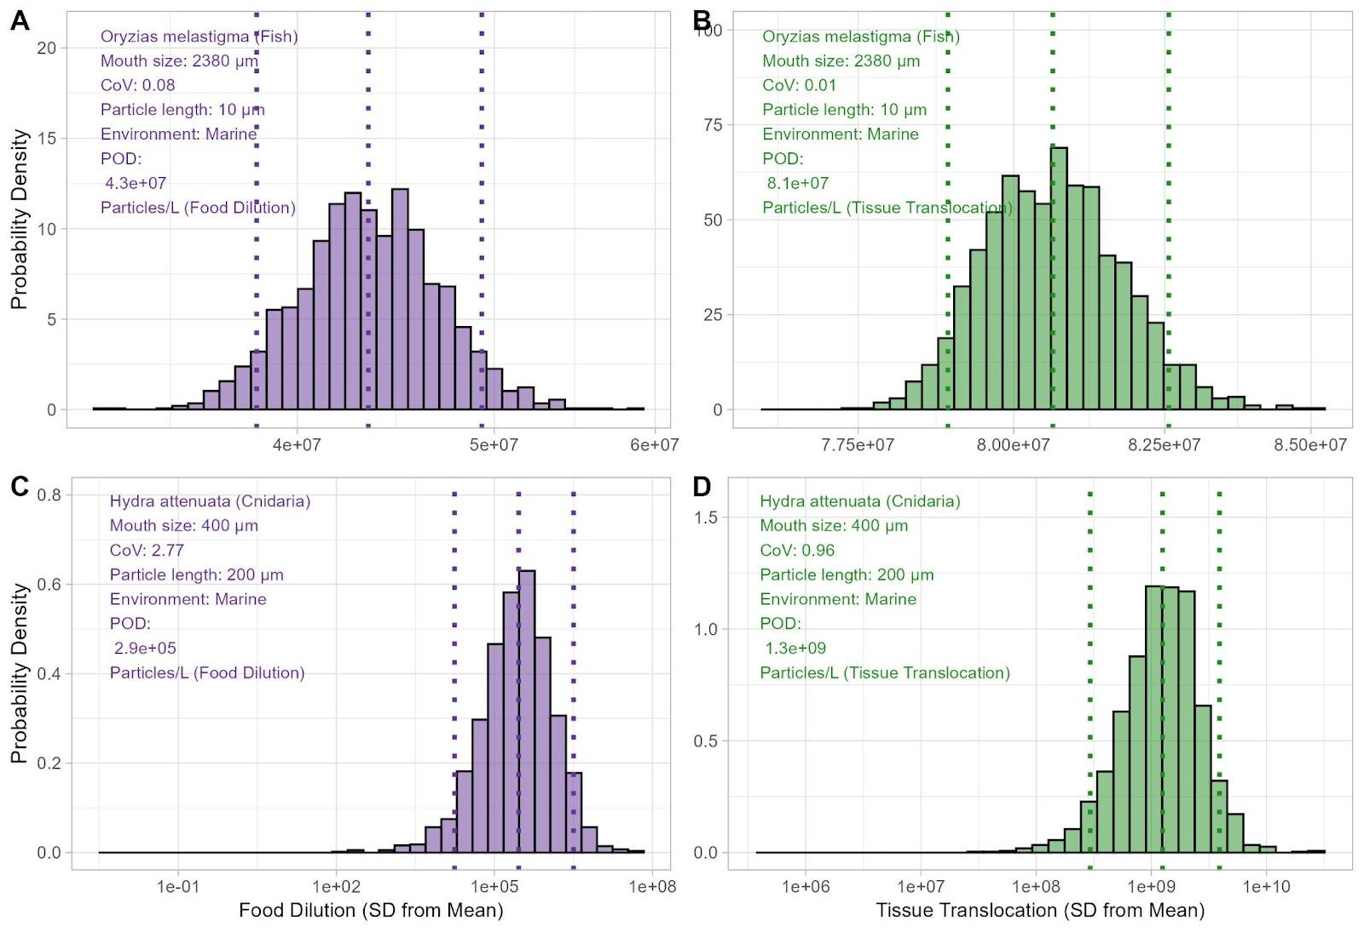

Figure S1. Example coefficient of variation.
Histograms of Monte-Carlo simulated toxicity effect concentrations (‘EC’; particles/L aligned to 1 to 5,000 µm environmentally-realistic distributions) for data points (defined as a unique combination of species/study/effect metric/endpoint/ERM) with the lowest coefficient of variation (top row - i.e., A, B) and highest coefficient of variation (bottom row - i.e., C, D) for two different ERMs - food dilution (left column - A, C), and tissue translocation-mediated effects (right column - B, D). Dotted vertical lines represent the 5th percentile, mean, and 95th percentile values of the Monte-Carlo derived toxicity effect concentration distributions. Text inserts in the top-left corner of each plot lists additional details about the data shown. Note that axes differ between plots. Y-axes denote relative probability density.
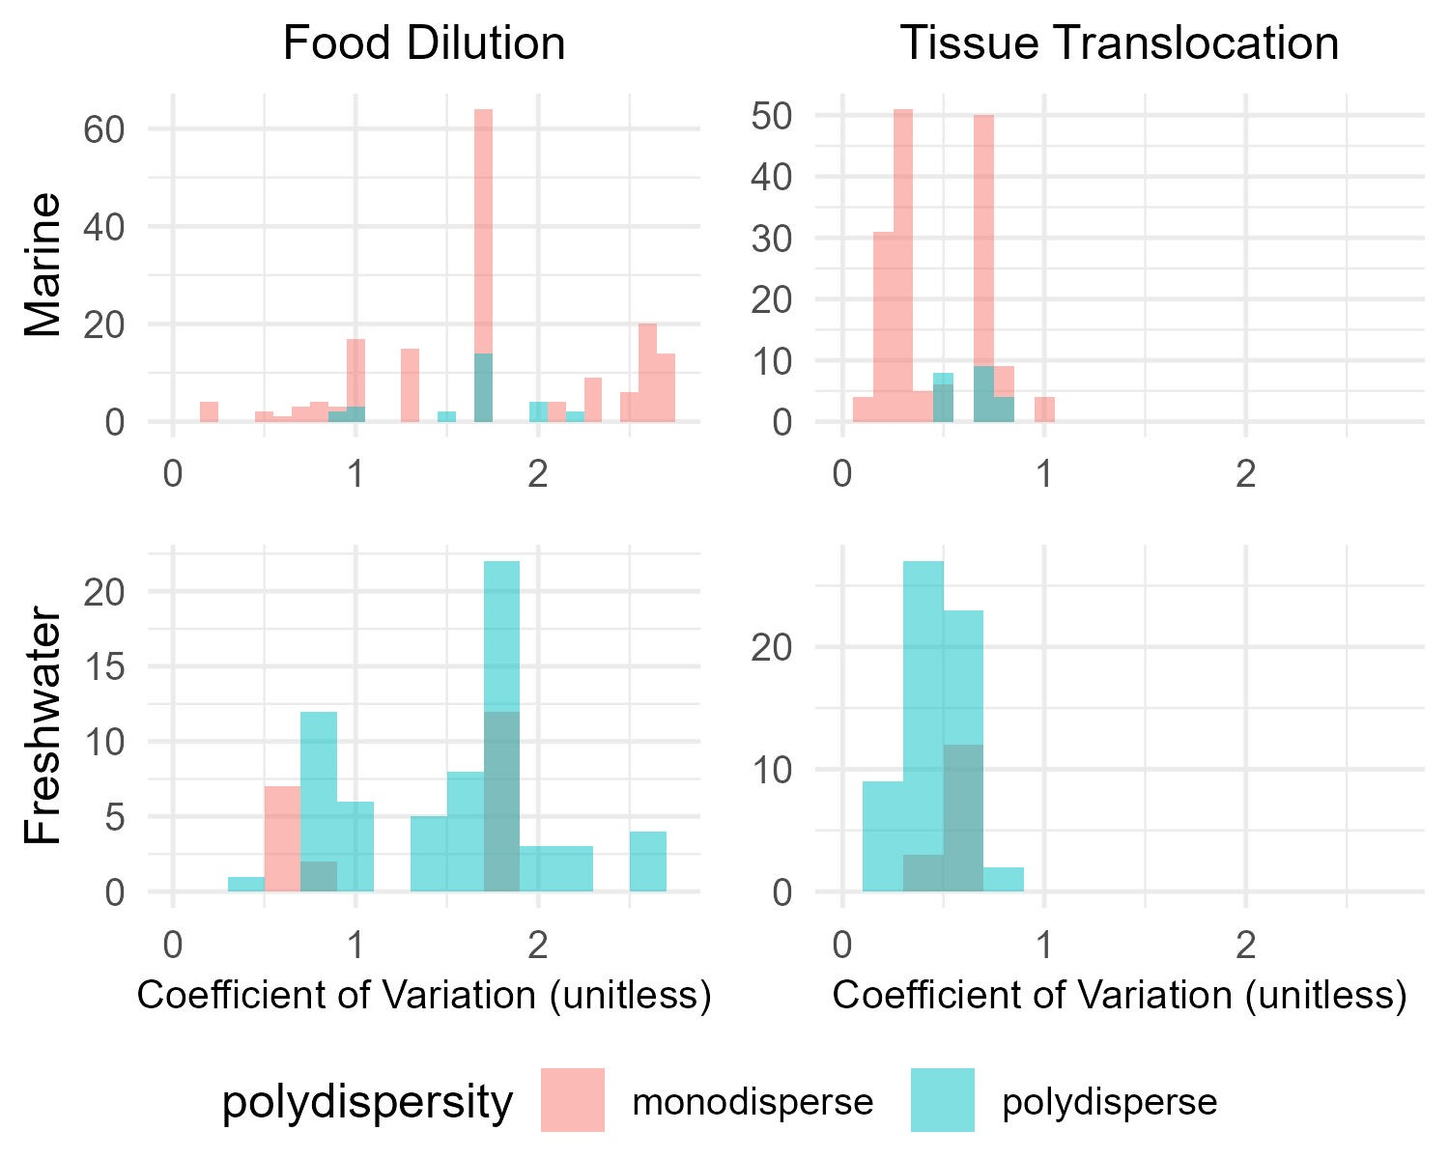

Figure S2. Coefficients of Variation.
Histograms of coefficient of variations (unitless) of toxicity datapoints used to derive predicted no effect concentrations (PNECs) in the pSSD based on Monte-Carlo simulations of rescaling and alignments to ecologically relevant metrics (i.e., Food Dilution - left column, Tissue Translocation-Mediated effects - right column) for marine (top row), and freshwater (bottom row) environments. Note the different x-axis scales between the ERMs - indicating significant uncertainty involved in alignments/rescaling for food dilution relative to tissue translocation-mediated impacts.
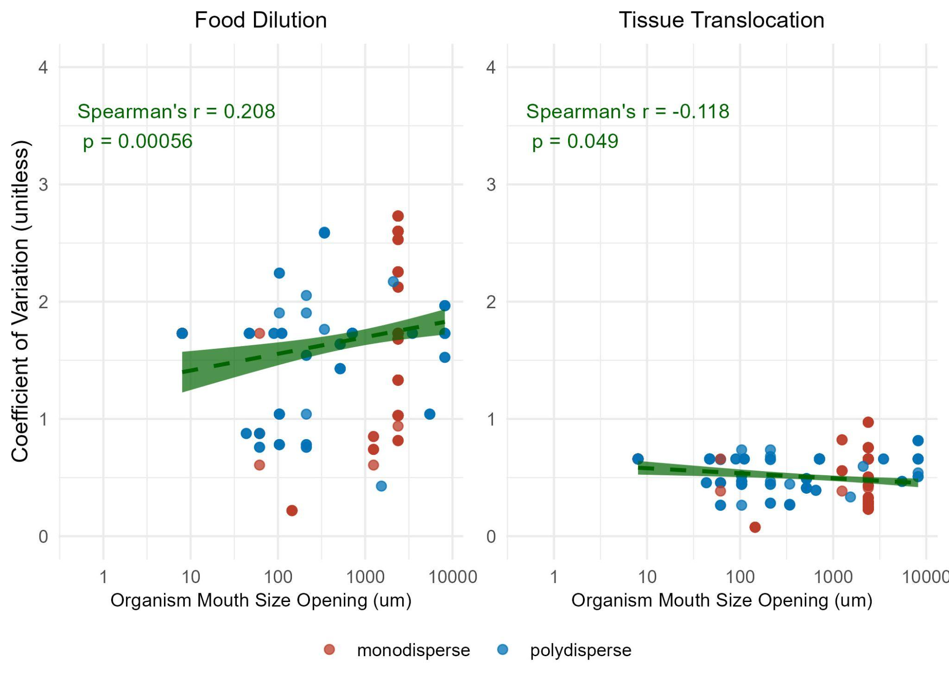

Figure S3. Coefficient of variation scatterplots.
Scatterplots and fitted linear regression lines of coefficients of variations (based on rescaling and alignment Monte Carlo simulations) versus organism mouth size opening (µm) for microplastics toxicity data points (e.g., NOECs, LOECs, etc.) used to derive PNECs for the food dilution ecologically-relevant metric (left), and tissue translocation-mediated impacts (right). Data points are colored according to whether the particles used were monodisperse (red) or polydisperse (blue). Spearman’s rank correlation r and p-values are annotated for each plot. This non-parametric test was chosen due to the data failing to meet the Shapiro-Wilk test for being normally distributed for both food dilution and tissue translocation-mediated ERM-aligned endpoints (p <2x10⁻¹⁶)
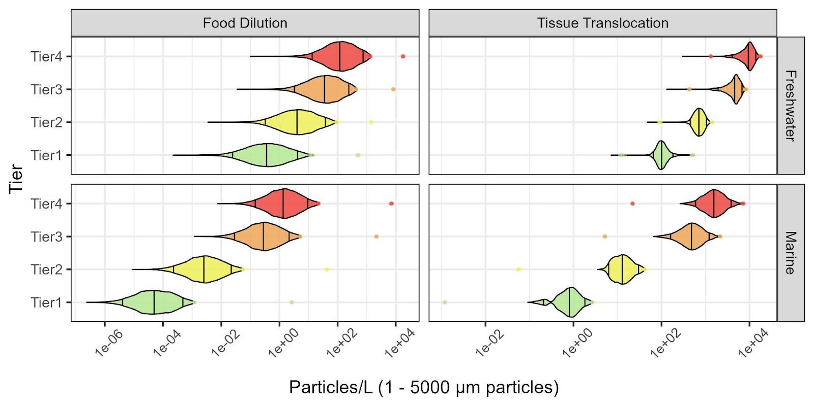

Figure S4. MC-SSD Violin Plots (particles/L)
Violin plots of the four-tiered thresholds for microplastics derived using the MC+SSD approach. Threshold values are presented as particle number (i.e., particles/L) aligned to respective ERMs for the 1 to 5,000 µm size range. Tiers range from protective (Tier 1 - “Investigative Monitoring”) to predictive (Tier 4 - “Source Control”), as defined in Mehinto et al. (2022). Thresholds are aligned based on specific environments, including freshwater (top) and marine (bottom), for two ERMs - food dilution (left) and tissue translocation-mediated effects (right), using a species sensitivity distribution-based approach. Ecologically-relevant metric alignments were performed using a Monte-Carlo simulation (n = 10,000). The center vertical line of each violin represents the median value obtained through the Monte Carlo simulation, with the outer two vertical lines representing the 5th and 95th percentile values. The data points outside of the violins are outlier values (i.e., outside the 1 - 99th percentile range).

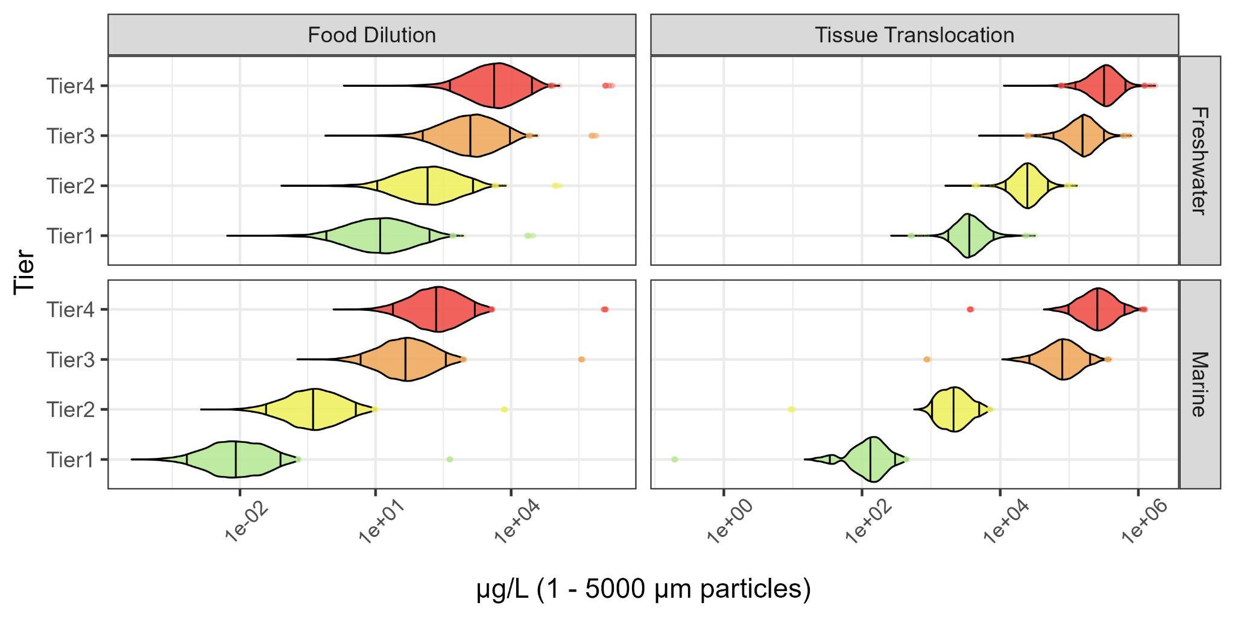

Figure S5. MC-SSD Violin Plots (mass)
Violin plots of the four-tiered thresholds for microplastics derived using species sensitivity distributions and Monte Carlo simulation. Threshold values are presented as mass (i.e., µg/L), for particles aligned to their respective ERMs in the 1 to 5,000 µm size range. Tiers range from protective (Tier 1 - “Investigative Monitoring”) to predictive (Tier 4 - “Source Control”), as defined in Mehinto et al. (2022). Thresholds are aligned based on specific environments, including freshwater (top) and marine (bottom) for two ERMs - food dilution (left); and tissue translocation-mediated effects (right); using a species sensitivity distribution-based approach. Ecologically-relevant metric alignments were performed using a Monte-Carlo simulation (n = 10,000). The center vertical line of each violin represents the median value obtained through the Monte Carlo simulation, with the outer two vertical lines representing the 5th and 95th percentile values. The data points outside of the violins are outlier values (i.e., outside the 1 - 99th percentile range).

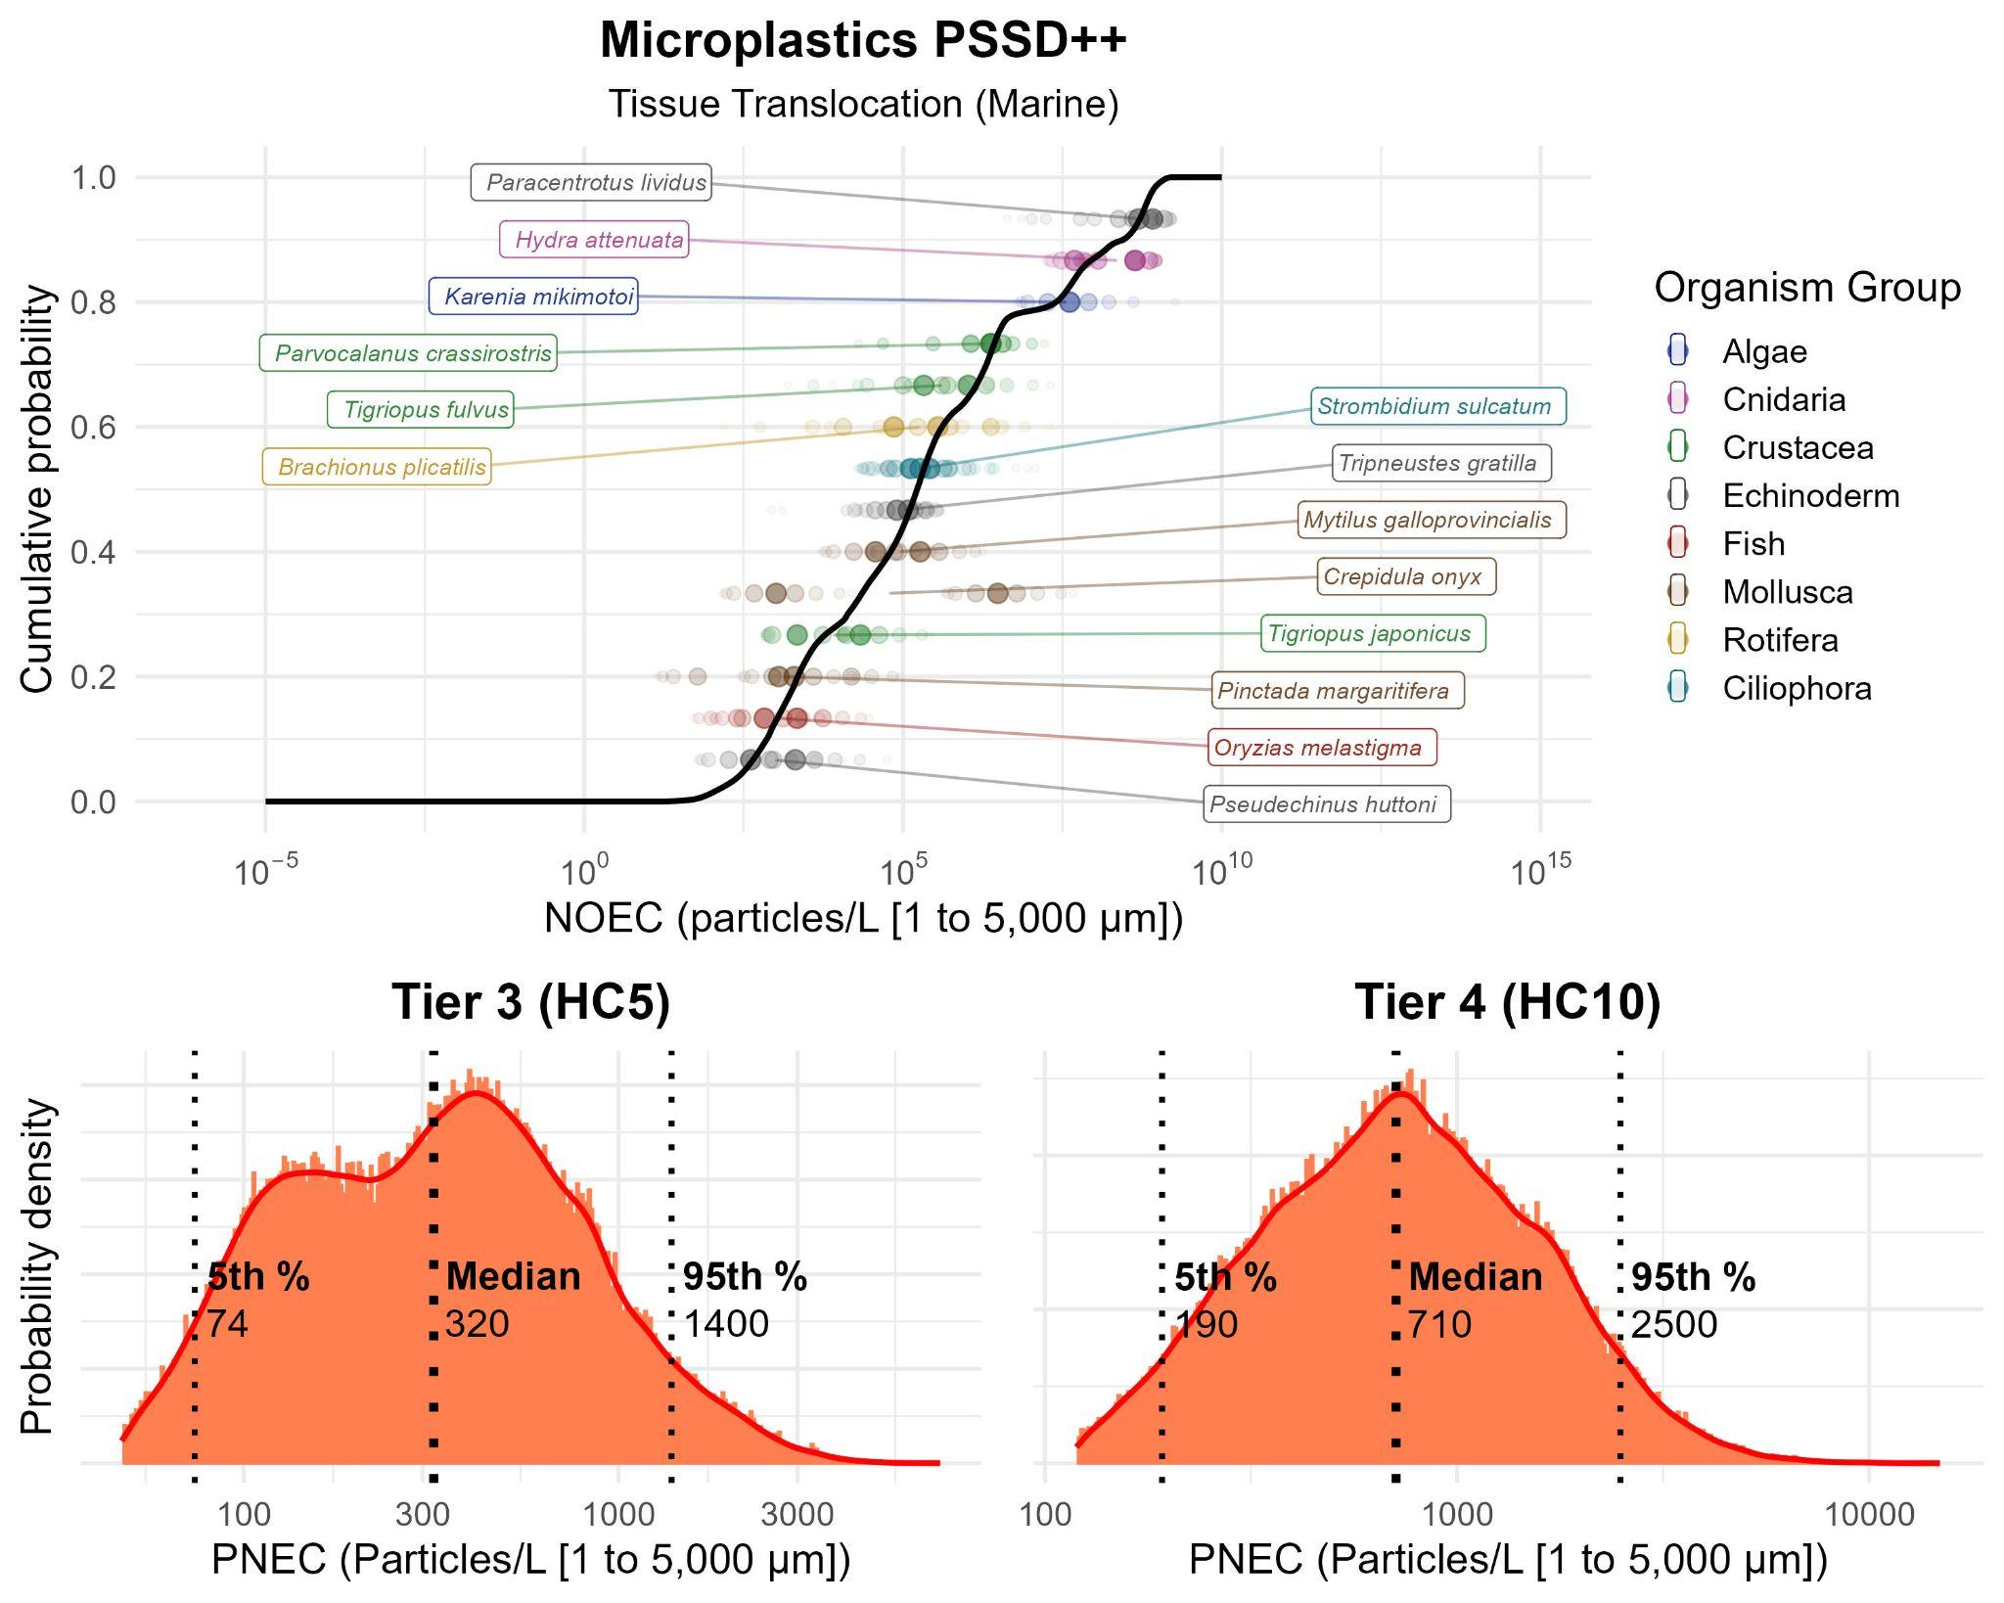

Figure S6. PSSD++ for Tissue Translocation (Marine).
Modified Probabilistic Species Sensitivity Distribution (PSSD++) of MPs for tissue translocation-mediated effects for marine ecosystems on the top row, with PNEC distributions for the corresponding HC5 (“Tier 3”) and HC10 (“Tier 4”) values on the bottom row. X-axes are PNEC (i.e., harmonized to chronic NOECs) in particles/L (aligned to the 1 to 5,000 µm size range for respective ERMs). Y-axes are cumulative probability (top row) and relative probability (bottom row). Labels and colored points on the PSSD++ denote individual species with colors corresponding to their organismal group. The probabilistic distribution for each PSSD++ is shown with a red line, with uncertainty bounds denoted with red shading. On the bottom row, a histogram of data points at the corresponding HC5/HC10 values are shown, with a smoothed fitted curve plotted. Vertical dotted lines represent the 5th, 50th, and 95th percentile values of the distributions.

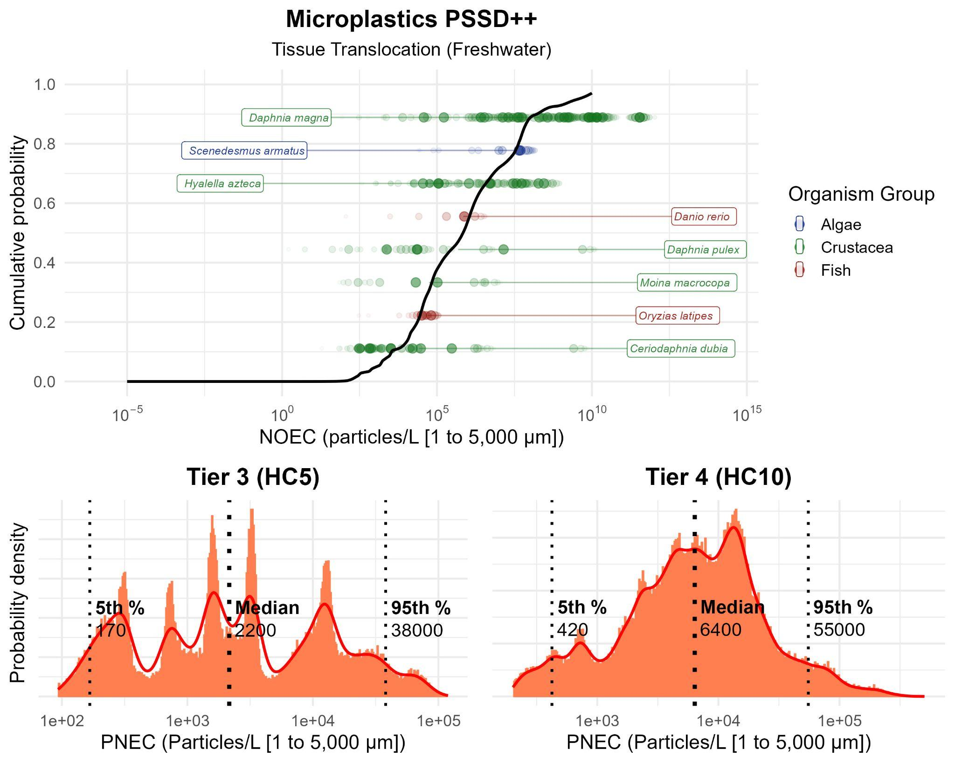

Figure S7. PSSD++ for Tissue Translocation (Freshwater).
Modified Probabilistic Species Sensitivity Distribution (PSSD++) of MPs for tissue translocation-mediated effects for freshwater ecosystems on the top row, with PNEC distributions for the corresponding HC5 (“Tier 3”) and HC10 (“Tier 4”) values on the bottom row. X-axes are PNEC (i.e., harmonized to chronic NOECs) in particles/L (aligned to the 1 to 5,000 µm size range for respective ERMs). Y-axes are cumulative probability (top row) and relative probability (bottom row). Labels and colored points on the PSSD++ denote individual species with colors corresponding to their organismal group. The probabilistic distribution for each PSSD++ is shown with a red line, with uncertainty bounds denoted with red shading. On the bottom row, a histogram of data points at the corresponding HC5/HC10 values are shown, with a smoothed fitted curve plotted. Vertical dotted lines represent the 5th, 50th, and 95th percentile values of the distributions.

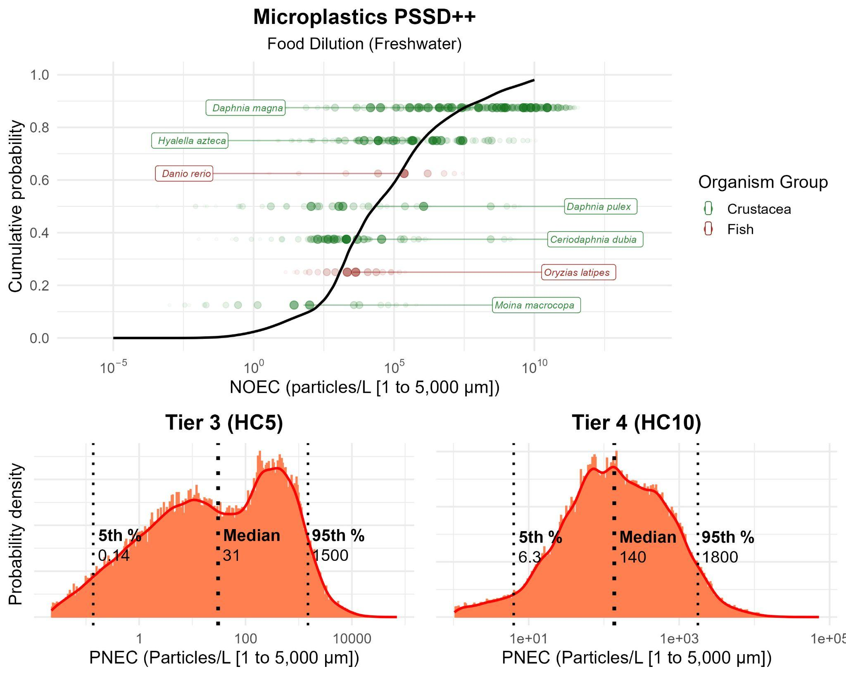

Figure S8. PSSD++ for Food Dilution (Freshwater).
Modified Probabilistic Species Sensitivity Distribution (PSSD++) of MPs for food dilution for freshwater ecosystems on the top row, with PNEC distributions for the corresponding HC5 (“Tier 3”) and HC10 (“Tier 4”) values on the bottom row. X-axes are PNEC (i.e., harmonized to chronic NOECs) in particles/L (aligned to the 1 to 5,000 µm size range for respective ERMs). Y-axes are cumulative probability (top row) and relative probability (bottom row). Labels and colored points on the PSSD++ denote individual species with colors corresponding to their organismal group. The probabilistic distribution for each PSSD++ is shown with a red line, with uncertainty bounds denoted with red shading. On the bottom row, a histogram of data points at the corresponding HC5/HC10 values are shown, with a smoothed fitted curve plotted. Vertical dotted lines represent the 5th, 50th, and 95th percentile values of the distributions.
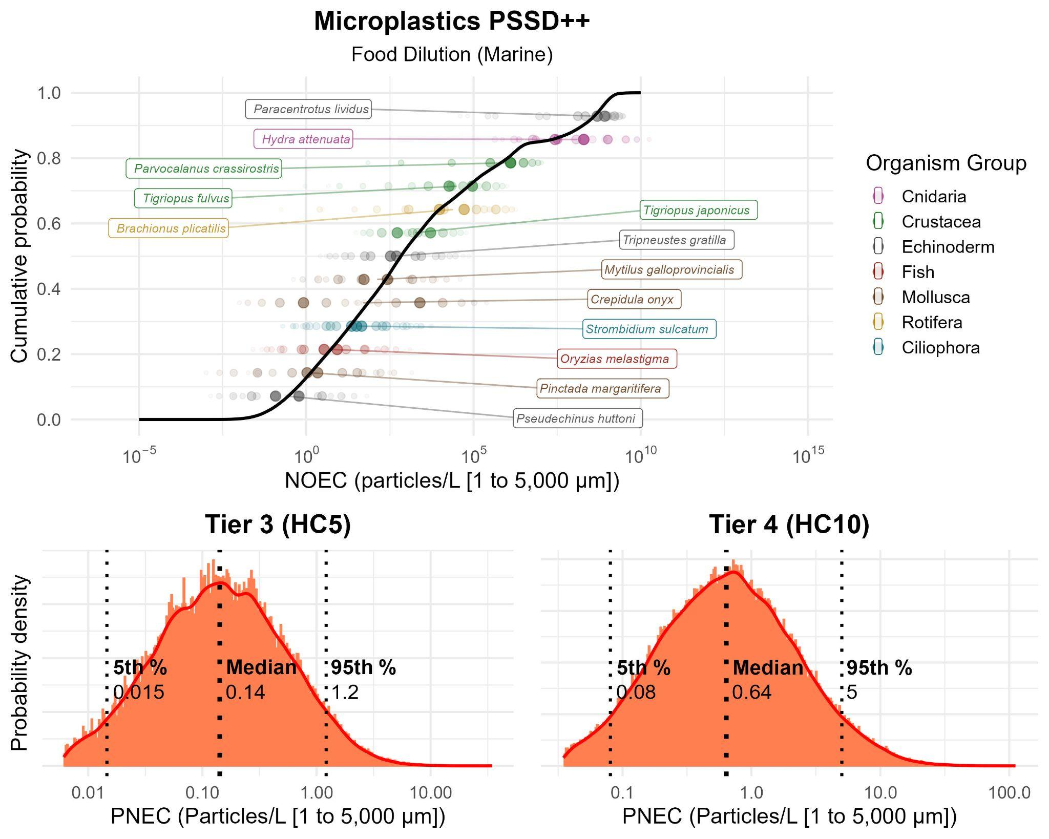

Figure S9. PSSD++ for Food Dilution (Marine).
Modified Probabilistic Species Sensitivity Distribution (PSSD++) of MPs for food dilution for marine ecosystems on the top row, with PNEC distributions for the corresponding HC5 (“Tier 3”) and HC10 (“Tier 4”) values on the bottom row. X-axes are PNEC (i.e., harmonized to chronic NOECs) in particles/L (aligned to the 1 to 5,000 µm size range for respective ERMs). Y-axes are cumulative probability (top row) and relative probability (bottom row). Labels and colored points on the PSSD++ denote individual species with colors corresponding to their organismal group. The probabilistic distribution for each PSSD++ is shown with a red line, with uncertainty bounds denoted with red shading. On the bottom row, a histogram of data points at the corresponding HC5/HC10 values are shown, with a smoothed fitted curve plotted. Vertical dotted lines represent the 5th, 50th, and 95th percentile values of the distributions.

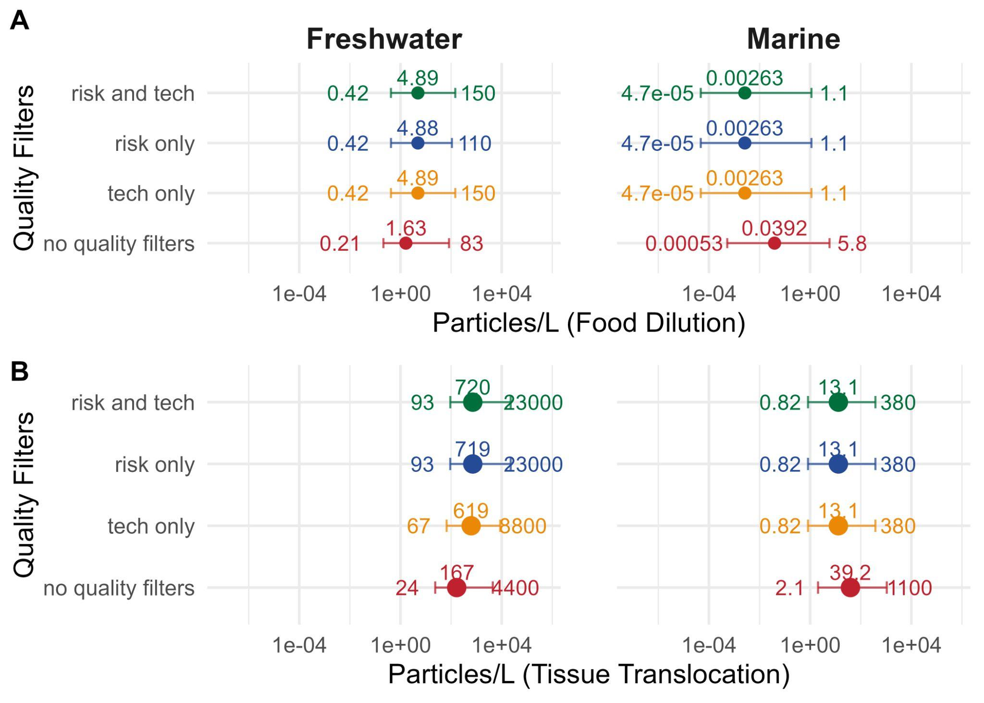

Figure S10. Leave-One-Out Quality.
Sensitivity analysis for thresholds for a representative tier (i.e., “Tier 2” as defined in Mehinto et al. (2022)) based on categories of quality filters for toxicological studies as originally defined in De Ruijter et al. (2020) and adapted in Mehinto et al. (2022). Categories include: applicability for risk assessment and technical criteria. X-axes are PNEC (i.e., harmonized to chronic NOECs) in particles/L (aligned to the 1 to 5,000 µm size range for respective ERMs). Points represent the median estimate from the SSD for threshold 2 (i.e., HC5 value), with error bars representing the 5th and 95th percentile bounds of the distribution of the SSD. The top row in each plot (green) is the ‘default’ filtering of quality criteria for applicability for risk assessment and technical criteria, the second row (blue) is filtering just for applicability for risk assessment criteria, the third row (orange) is filtering just for technical criteria, and the fourth row (red) is using all data in ToMEx regardless of whether or not it meets any quality criteria. Thresholds derived for the Food Dilution ERM (A) and Tissue Translocation-Mediated Effects ERM (B) are separated, for both freshwater (left column) and marine (right column) environments. All threshold values are aligned to the default MP size distribution of 1 to 5,000 µm.
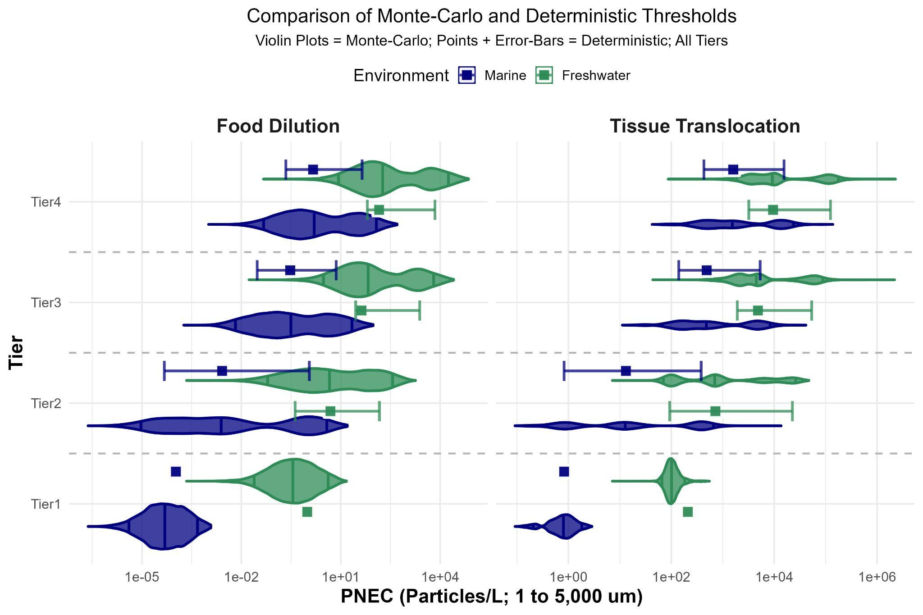

Figure S11. Comparison of Monte-Carlo and Deterministic Thresholds.
Violin plots represent Monte-Carlo + SSD derived thresholds, with vertical lines representing the 5th, 50th, and 95th percentile threshold values, compared points and error-bar that represent the deterministically-SSD derived thresholds, with points representing the median HC5 estimates from the SSD, and error bars representing the 5th and 95th percentile estimates. The left plot is for Tier 2, and the right plot is Tier 3. The top row are freshwater thresholds, and the bottom row are marine. Food dilution thresholds are blue, and tissue translocation thresholds are green.
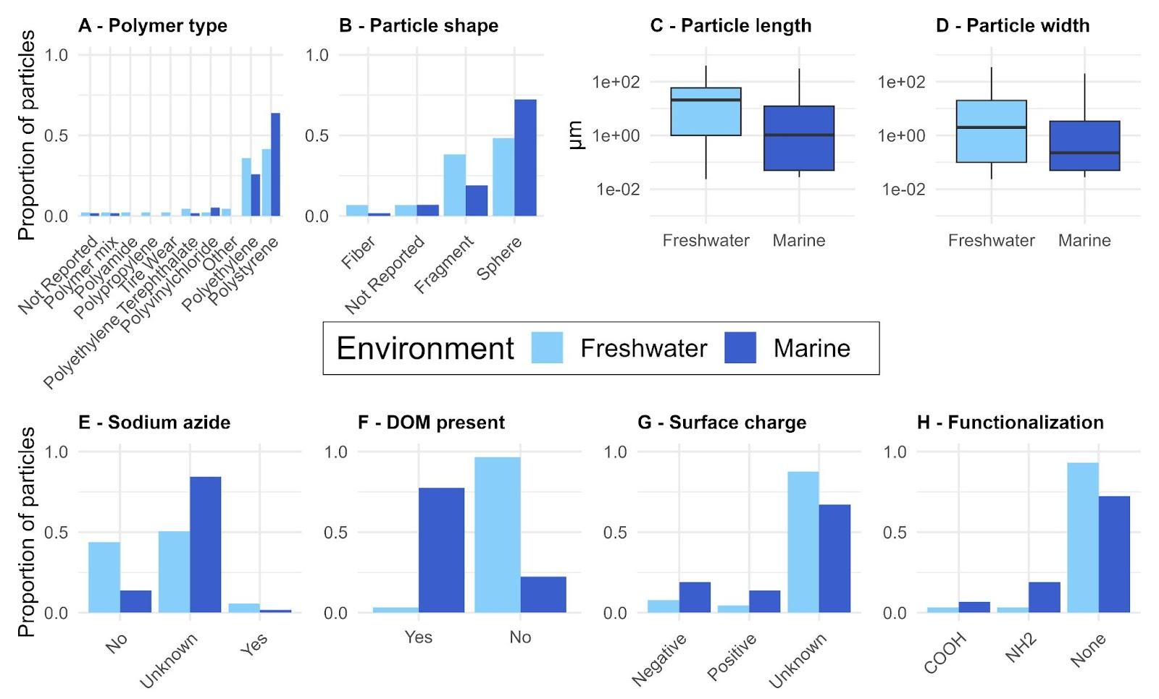

Figure S12. Characteristics of microplastic particles (MP) represented in the filtered ToMEx 2.0 dataset used to derive thresholds.
(A) Proportion of MP made of different polymer types. (B) Proportion of different shapes. (C) Average particle length (µm). (D) Average particle width (µm). (E) Proportion of MP with sodium azide present, absent, or unknown (not reported). (F) Proportion of treatments where dissolved organic matter was present (either in the exposure medium or as a biofilm or eco-corona on the MP). (G) Proportion of MP with positive or negative surface charge. (I) Proportion of MP with functional chemical groups on the particle surface. Light blue: MP used in studies with freshwater species, dark blue: MP used in studies with marine species. COOH: Carboxyl group functionalization, NH2: Amino group functionalization.

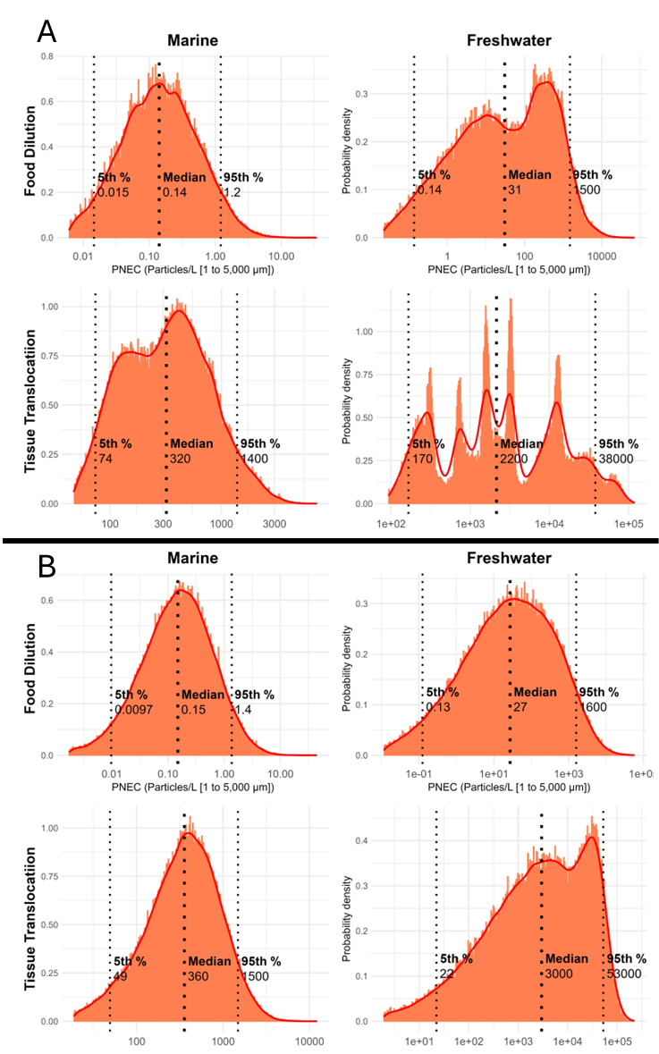
Figure S13. Comparison of PNEC distributions (particles/L; aligned to 1 to 5,000 µm) for Tier 3 for Marine (left) and Freshwater (right) environments for food dilution and tissue translocation ERM calculated using either; A) the original PSSD+ trapezoidal step-wise function from Wigger et al. (2021) or; B) the modified log-normal distribution-based approach for computing species NOEC distributions when n > 2.

