Supporting Information

Characterizing the multidimensionality of microplastics across environmental compartments
Merel Kooi^{1*}, Sebastian Primpke², Svenja M. Mintenig¹, Claudia Lorenz³, Gunnar Gerdts², Albert A. Koelmans¹

¹Aquatic Ecology and Water Quality Management Group, Wageningen University & Research, The Netherlands
²Shelf Seas Systems Ecology, Alfred Wegener Institute Helmholtz Centre for Polar and Marine Research
³Department of The Built Environment, Aalborg University, Thomas Manns Vej 23, 9220 Aalborg Øst, Denmark

*Corresponding author: merel.kooi@wur.nl; P.O. box 47 – 6700 AA Wageningen – The Netherlands

Section S1. Extrapolation of subsample analyses (Supporting section 2.2. of the main manuscript)
Since most studies analyzed only a part of their samples and/or filter areas, data were extrapolated to represent the full sample. However, different subsample fractions have been analyzed for different size classes. For most samples, the bigger particles (i.e. >300 or 500 µm) were measured in 100% of the sample. However, for the smaller particles, this percentage ranged from only 1.2 to 100% of the total sample volume. Since we are interested in the whole size range, all subsamples needed to be extrapolated to 100%, which assumes particle characteristics detected for the subsample would apply to the whole sample as well. Since in reality two microplastic particles are never identical, this is a critical assumption. We therefore performed a theoretical test to see how subsampling and subsequent extrapolation influences the parameters of PDFs for particle size. We set two quality criteria, based on the minimum number of particles in a sample (criterium 1) and the subsample percentage of the sample or filter (criterium 2) that would suffice to adequately capture the size distribution of a full sample. In order to be able to include a sample in the further data analyzes, at least one of the criteria had to be met.
The test comprised three main steps. First, datasets were generated with virtual particles that satisfy a power law distribution for particle size (Cózar et al., 2014; Kaandorp et al., 2021; Kooi and Koelmans, 2019) and represent a full sample, i.e. 100%. This was done for five power law exponents (1.5, 2.0, 2.5, 3.0 and 3.5), and for particles with a length between 20 and 5000 µm.
A virtual ‘measured’ dataset was then simulated by randomly selecting a number of particles from the original dataset, given a subsample percentage that is comparable to the actual subsample percentages used in the different studies (Table S1). Hence, for criterium 1, we distinguished between three size classes; 20 – 100 µm, 100 – 300 µm and >300 µm (Mintenig et al., 2020). Total particle numbers per dataset varied between 50 and 10,000 particles. For these smaller two size classes three subsample percentages were applied; 10, 30 and 50% for the 20 – 100 µm size class, and 30, 50 and 70% for the 100 – 300 µm size class, while for >300 µm particles no subsampling was assumed (i.e. 100% of particles analyzed). For criterium 2, we only distinguished between two size classes, i.e. <500 µm and ≥500 µm. For these analyses, subsample percentages ranged between 1 and 90%, with a step size of 10%. Here, total particle numbers varied between 50 and 400 particles (given criterium 1, see results, section 3.1). For both criteria, random subsampling of each unique combination of the three parameters (i.e. power law exponent, number of particles and subsample percentage) was replicated 10 times. Subsequently, the virtual ‘measured’ datasets were extrapolated to 100%. We calculated correction factors (CFs) based on the subsample percentages, where CF = 1/subsample percentage. CFs were rounded to the nearest integer. Each particle in the measured dataset was cloned CF times after which the datasets of the different size ranges were combined.
To test the effect of this extrapolation, we calculated power law exponents for the size distributions of the simulated original, ‘full sample’ datasets and the simulated ‘subsampled, measured and extrapolated’ datasets, using the MLE-method (section 2.3.1) (Clauset et al., 2009; Newman, 2005; White et al., 2008). This makes it possible to quantify the extent to which actual power law exponents derived from data for a full sample can still be represented by data for a sub-sampled and subsequently extrapolated sample. Only power law exponents based on data for 10 or more particles were included. Agreement between the original and fitted power law exponents was evaluated using linear regression. Additionally, the ratio between the two exponents was calculated. We set as an acceptance criterion that power law exponents of the extrapolated dataset may deviate up to 10% from the exponents of the original dataset. Based on visual inspection of the regressions and the ratio histograms, we decided on a minimum number of particles (criterium 1) and a minimum subsample percentage (criterium 2). The environmental samples were extrapolated to 100% of the sample volume, given the calculated CFs. Environmental samples that did not meet the quality criteria were deemed of insufficient quality to be used for further analyses in this study, and were therefore omitted.
For data analyses on the environmental compartment level, we combined all samples per compartment. This is only valid when all sample sizes are the same, since otherwise large samples could dominate the distributions. Therefore, a second, sample size dependent, correction factor (CF_{samp}) was used, which was defined as 1 divided by the ratio between the actual sample size and the maximum sample size for the specific aquatic compartment. The individual observations in all samples were repeated CF_{samp} times.

Section S2. Average of a power law distribution
A power law probability distribution is defined as:
$P\left(x\right)=Cx^{-α}$ [S1]
To calculate the mean of a section of the power law regime, we have to make sure the total probability equals 1, between a lower and upper limit (LL and UL, respectively):
$\int_{LL}^{UL}{P\left(x\right)dx=1}$ [S2]
Therefore, $C$ has to equate to:
$C=\frac{1}{\int_{LL}^{UL}{x^{-α}dx}}=\frac{1-α}{UL^{1-α}-LL^{1-α}}$ [S3]
The average $(μ$) of any continuous probability distribution is calculated as:
$μ_{x}= \int_{LL}^{UL}{xP\left(x\right)dx }$ [S4]
For our power law distribution, we therefore have
$μ_{x}=\frac{C}{2-α}\left(UL^{2-α}-LL^{2-α}\right)$ [S5]
Combining equations S5 and S3, yields the equation for the average of the power law distribution (in case $α$ ≠ {1,2}):
$μ_{x}=\frac{1-α}{2-α}\frac{x_{UL}^{2-α}-x_{LL}^{2-α}}{x_{UL}^{1-α}-x_{LL}^{1-α}}$ [S6]
Equation S6 is not valid when $α$ =1 or $α$ =2. In case $α$ =1, the equation for the average of the power law distribution is:
$μ_{x}=\frac{x_{UL}-x_{LL}}{ln\left(\frac{x_{UL}}{x_{LL}}\right)}$ [S7]
And for $α$ =2 the equation for the average of the power law distribution is:
$μ_{x}=\frac{ln\left(\frac{x_{UL}}{x_{LL}}\right)}{x_{LL}^{-1}-x_{UL}^{-1}}$ [S8]

Section S3. Example calculation alignment exposure and effect concentrations using power law slopes.
To illustrate how exposure and effect threshold concentrations can be aligned using Equations 1 to 5, we provide a numerical example. Equation numbers relate to those in the main manuscript. The problem definition is whether a risk is to be expected for marine benthic invertebrates.
Available exposure data. In the marine environment, an environmental concentration of $C_{meas}$ = 100 particles L⁻¹ is measured using an accurate method which targets all particles between 20 µm and 5000 µm.
Available threshold effect data. In the laboratory, for same marine benthic invertebrates a threshold effect concentration of $EC_{mono}$ = 100 particles L⁻¹ is found from standardized laboratory experiments using monodisperse spherical particles of 100 μm in diameter. Toxicological research has concluded that the ecologically relevant dose metric (ERM) is particle surface area. Given the mouth opening of the organism, only particles between 1 and 20 µm in width are ingestible.
Rescaling the measured exposure concentration. With a default size range of 1 to 5000, a measured range of 20 to 5000 µm, and $α_{L}$ for marine sediment is 1.89 (Table S4), Equation 1 becomes:
$${CF}_{meas}=\frac{{5000}^{1-1.89}-1^{1-1.89}}{{5000}^{1-1.89}-{20}^{1-1.89}}=14.48$$
The rescaled exposure concentration thus is $C_{ env}$ = 100 × 14.48 = 1448 particles L⁻¹
Rescaling the threshold effect concentration. We first calculate the correction factor for bioavailability, that is, the factor by which the threshold effect concentration for ingestible particles needs to be multiplied, to get the threshold effect concentration in terms of the 1 to 5000 µm size range, using the same power law slope $α_{L}$ (see Equation 2, main manuscript).
$${CF}_{bio}=\frac{{5000}^{1-1.89}-1^{1-1.89}}{{20}^{1-1.89}-1^{1-1.89}}=1.07$$
Subsequently, $EC_{poly}$ (Equation 3, main manuscript) is calculated. First, using the surface of a sphere, the average surface area per particle used in the laboratory is $μ_{x,mono}$ = 3.1×10⁴ µm². To calculate $μ_{x,poly}$ we need Equation 4 (main manuscript, again with $α_{L}$ is 1.89):
$$μ_{x,poly}=\frac{1-α_{x}}{2-α_{x}}×\frac{x_{UL}^{2-α_{x}}-x_{LL}^{2-α_{x}}}{x_{UL}^{1-α_{x}}-x_{LL}^{1-α_{x}}}$$
As $x$ in this example is area, in this case $x_{UL}$ and $x_{LL}$ are the upper and lower limit for the area of the ingestible particles, which thus requires an assumption on the shape of the particles. As explained, an ellipsoid shape was assumed to be able to approximate all actual microplastic shapes. The surface area of an ellipsoid is:
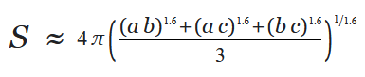
With a, b, c being equal to 0.5×length, 0.5×width and 0.5×height, respectively. Ingestibility is defined as width being smaller than the mouth opening, assuming a particle still can be ingested along its longest dimension (Koelmans et al. 2020). This means that the ranges for length, width and height are 1 to 5000 µm, 1 to 20 µm and 0.67 × (1 to 20) µm, respectively. The minimum ingestible particle area thus is calculated from the dimensions (a, b, c): 0.5, 0.5, and 0.335 µm, and the maximum ingestible particle area is calculated from the dimensions 2500, 10 and 6.7 µm. Using the above equation for the surface area (S) of an ellipsoid this results in a maximum ingestible particle area of 2.06 × 10⁵ µm² and a minimum ingestible particle area of 2.48 µm². Substitution of these $x_{UL}$ and $x_{LL}$values in Equation 4 results in the average surface area of ingestible particles, i.e. particles with a width between 1 and 20 µm: $μ_{x,poly}$ = 49.7 µm².
The polydisperse effect concentration therefore is $EC_{poly}$ = 100 × 3.1×10⁴/49.7 = 6.32×10⁴ particles L⁻¹. Now the environmental effect concentration $EC_{env}$ is calculated using Equation 2 (main manuscript) as 1.07 × 6.32×10⁴ = 6.79 ×10⁴ particles L⁻¹.
Finally, we can conclude that $C_{ env}$ = 1448 particles L⁻¹ is 47 times lower than the threshold concentration $EC_{env}$ = 6.79 ×10⁴ particles L⁻¹, which would imply low or absence of risk.
Note that this calculation is an example and does not provide information about the true risks of microplastic in marine systems.

Table S1. Characteristics per study. The (-n) refers to a decrease in number of samples since these samples did not contain any polymers, whereas [-n] refers to the number of samples removed because they did not meet the quality criteria for sample extrapolation.
 | (Lorenz et al., 2019) |  | (Mintenig et al., 2020) |  | (Mani et al., 2019) | (Pan et al., n.d.) |  | (Primpke et al., 2019)
Sample type | Marine sediment | Marine water | Fresh water | Effluent | Fresh sediment | Fresh sediment | Fresh biota | Effluent
Location | North Sea | North Sea | Meuse & Dommel, NL | Meuse & Dommel, NL | Rhine, Germany | Dommel, NL | Dommel, NL | WWTP, Germany
Nr. Of samples | 23 [-10] | 23[-14] | 29 [-8] | 3 [0] | 10 [-6] | 7 | 31 (-3) [0] | 6 [-1]
Nr. Of blanks | 4 | 2 | 8 |  | 3 | 3 (-1) | 3 (-1) | 1
Minimum mesh (µm) | 20 | 100 | 20 | 20 | 20 | 20 | 20 | 20
µFTIR D.L. | 11 | 11 | 20 | 20 | 11 | 20 | 20 | 11
ATR-FTIR size (µm) | ≥500 | ≥500 | ≥300 | ≥300 | ≥500 | ≥500 | ≥500 | N.A.
Sample size* | 1.3 – 1.8 kg d.w. | 16 – 51 m³ | 0.03 – 1.00 m³ | 0.06 – 0.20 m³ | 0.06 kg | 0.3 kg | 2 – 190 individuals | 0.19 – 0.53 m³
Sample size* | 1.3 – 1.8 kg d.w. | 16 – 51 m³ | 1.70 – 7.99 m³ | 1.52 – 2.83 m³
% subsample on filter µFTIR | 10.8 – 75.4 | 1.2-73.2 | 100 | 100 | 7.5 - 100 | 100 | 100 | 10.2 – 59.8
% of filter analyzed µFTIR* | 100 | 100 | 30 – 62 | 60-67 | 100 | 100 | 100 | 100
% of filter analyzed µFTIR* | 100 | 100 | 64 – 69 | 60-67

* Mintenig et al. report different sample volumes and filter area percentages analyzed for two different size fractions (Mintenig et al., 2020). In the table, the cells are split, where the upper cell refers to the 20 – 100 µm size range, and the lower cell refers to the 100 – 300 µm size range.

Table S2. Polymer types and associated densities (Primpke et al., 2018).

Polymer | Density (g cm⁻³)
Polyethylene high-density | 0.91
Polyethylene | 0.91
Polyethylene-oxidized | 0.91
Polyethylene-chlorinated | 0.91
Polypropylene | 0.92
Polystyrene | 1.04
Polycarbonate | 1.21
Polyamide | 1.22
Polyvinylchloride | 1.38
Cellophane | 1.2
Cellulose chemical modified | 1.2
Nitrile rubber | 1
Polyester | 1.35
Acrylates/polyurethanes/varnish | 1.2
Ethylene methacrylic acid | 1.2
Polymethyl methacylate | 1.2
Polysulfone | 1.24
Polyetheretherketone | 1.32
Polychloroprene | 1.23
Polyisoprene-chlorinated | 0.91
Polyactic acid | 1.3
Polycaprolactone | 1.15
Ethylene-vinyl-acetate | 0.94
Polyimide | 1.6
Polyoxymethylene | 1.41
Acrylonitrile-butadiene | 1.2
Rubber Type 1 | 1.03
Rubber Type 2 | 1.03
Rubber Type 3 | 1.1
Polyphenylene ether | 1.1
Polytetrafluorethylene | 2.2
Urea-formaldehyde | 1.5

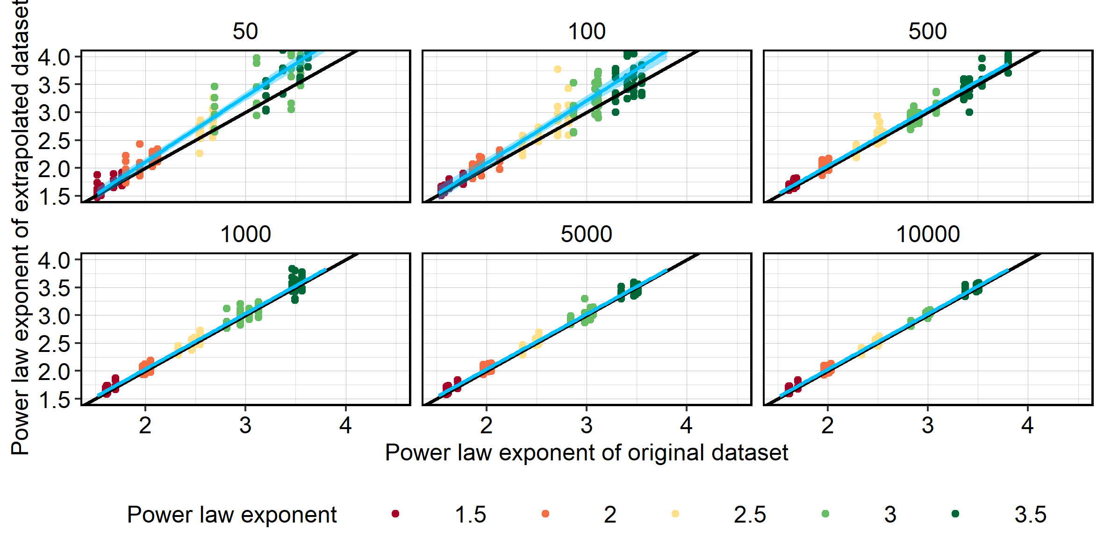

Figure S1. Regression of power law exponents of the original datasets versus the extrapolated datasets, testing criterium 1. Colors indicate the different power law exponents used to generate the original datasets. The black line is the 1:1 line, the blue line is the fitted linear regression, with the 99% confidence interval. The different panels refer to the different number of particles in the original datasets. Datasets needed ≥10 particles for the calculation of the exponent. The threshold for criterium 1 was set at 500 particles.

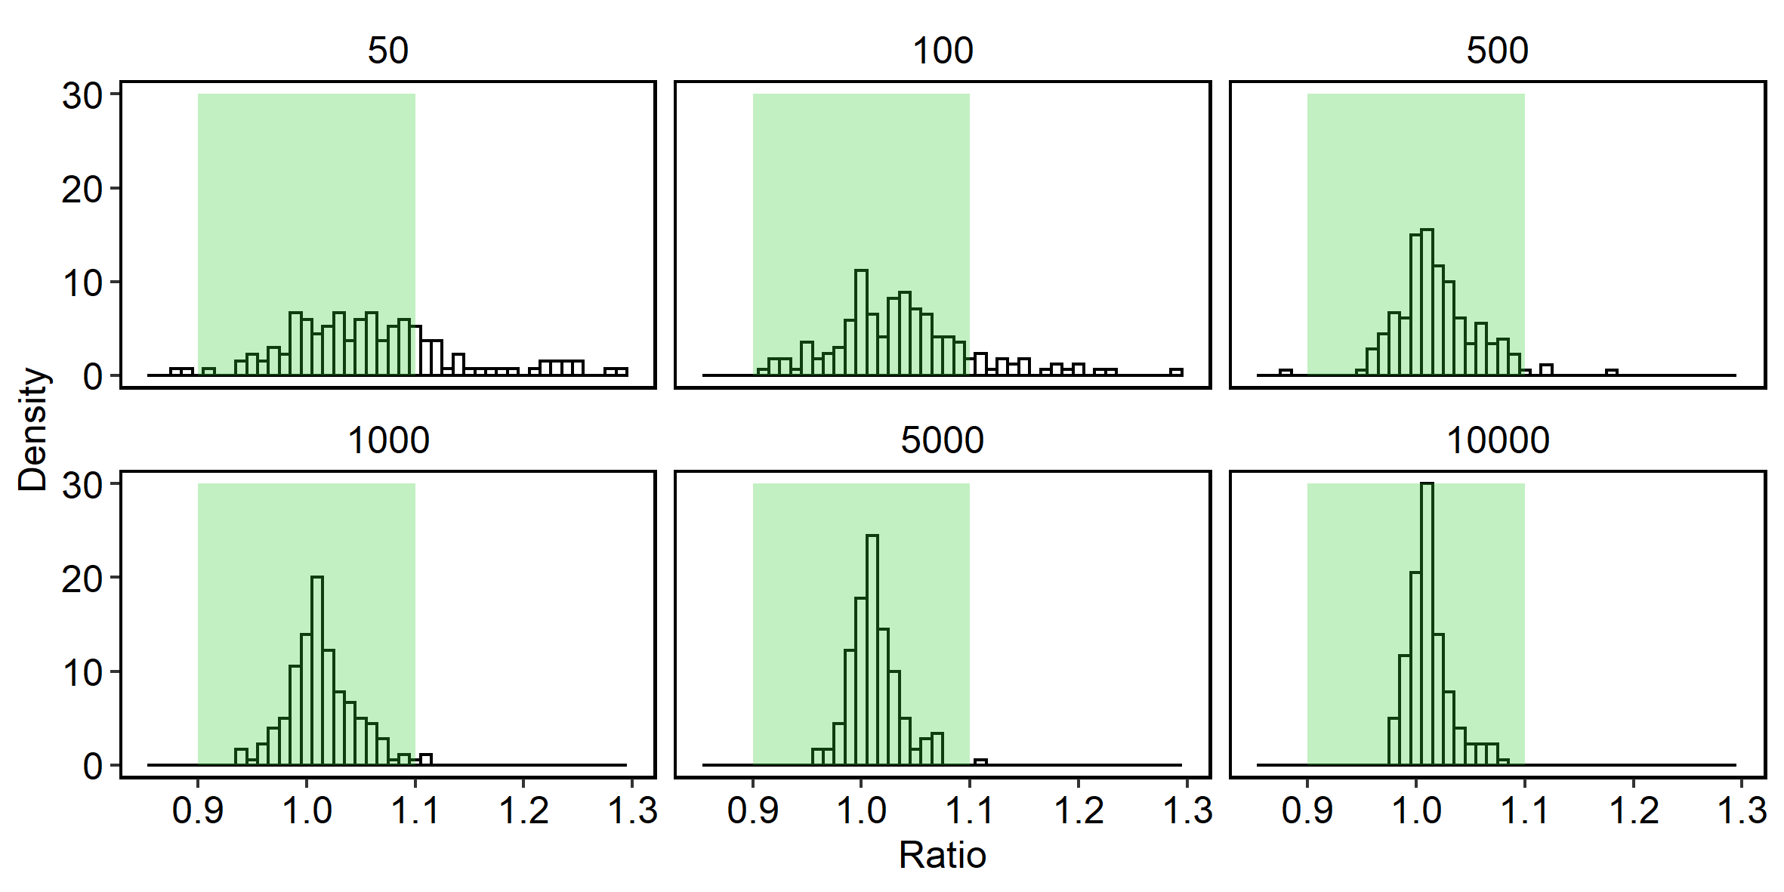

Figure S2. Ratios between the extrapolated and original power law exponent datapoints as presented in Figure S1. In the present study, we set a threshold of 10% variance from the perfect fit (i.e. ratio = 1), shown as the shaded green area. Panels refer to the number of observations in the original dataset. Based on visual inspection, we need at least 500 observations in the original dataset for a dataset to be included. Please note that ratios can be as high as 1.4 (50 observations) and 2.5 (100 observations), which is not shown in the graph.

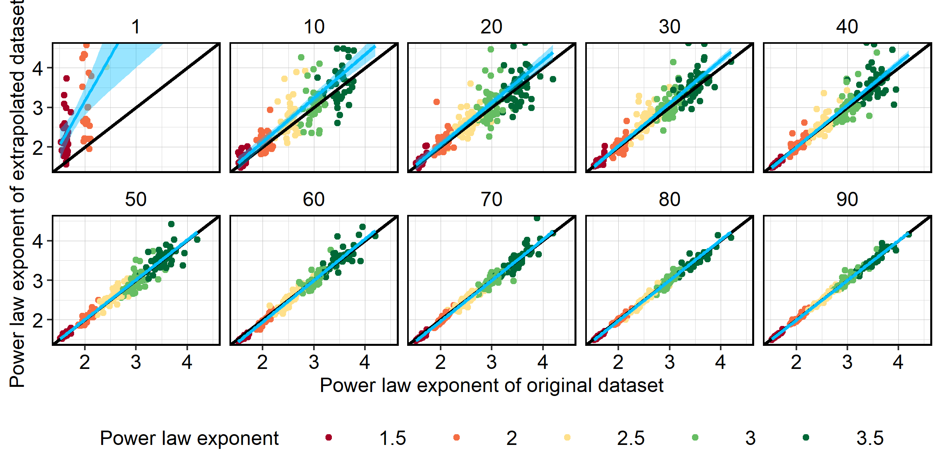
Figure S3. Regression of power law exponents of the original datasets versus the extrapolated datasets, testing criterium 2. Colors indicate the different power law exponents used to generate the original datasets. The black line is the 1:1 line, the blue line is the fitted linear regression, with the 99% confidence interval. The different panels refer to the subsample percentages, of either the sample volume or the filter area. Datasets needed ≥10 observations for the calculation of the exponent. Here, data are included of 10, 50, 100, 200, 300 or 400 observations, and 10 replicates per unique combination of alpha, nr of observations and subsample percentages. The different number of observations (10 – 400) each occur 10 times per panel per power law exponent. The threshold for criterium 2 was set at 60%.

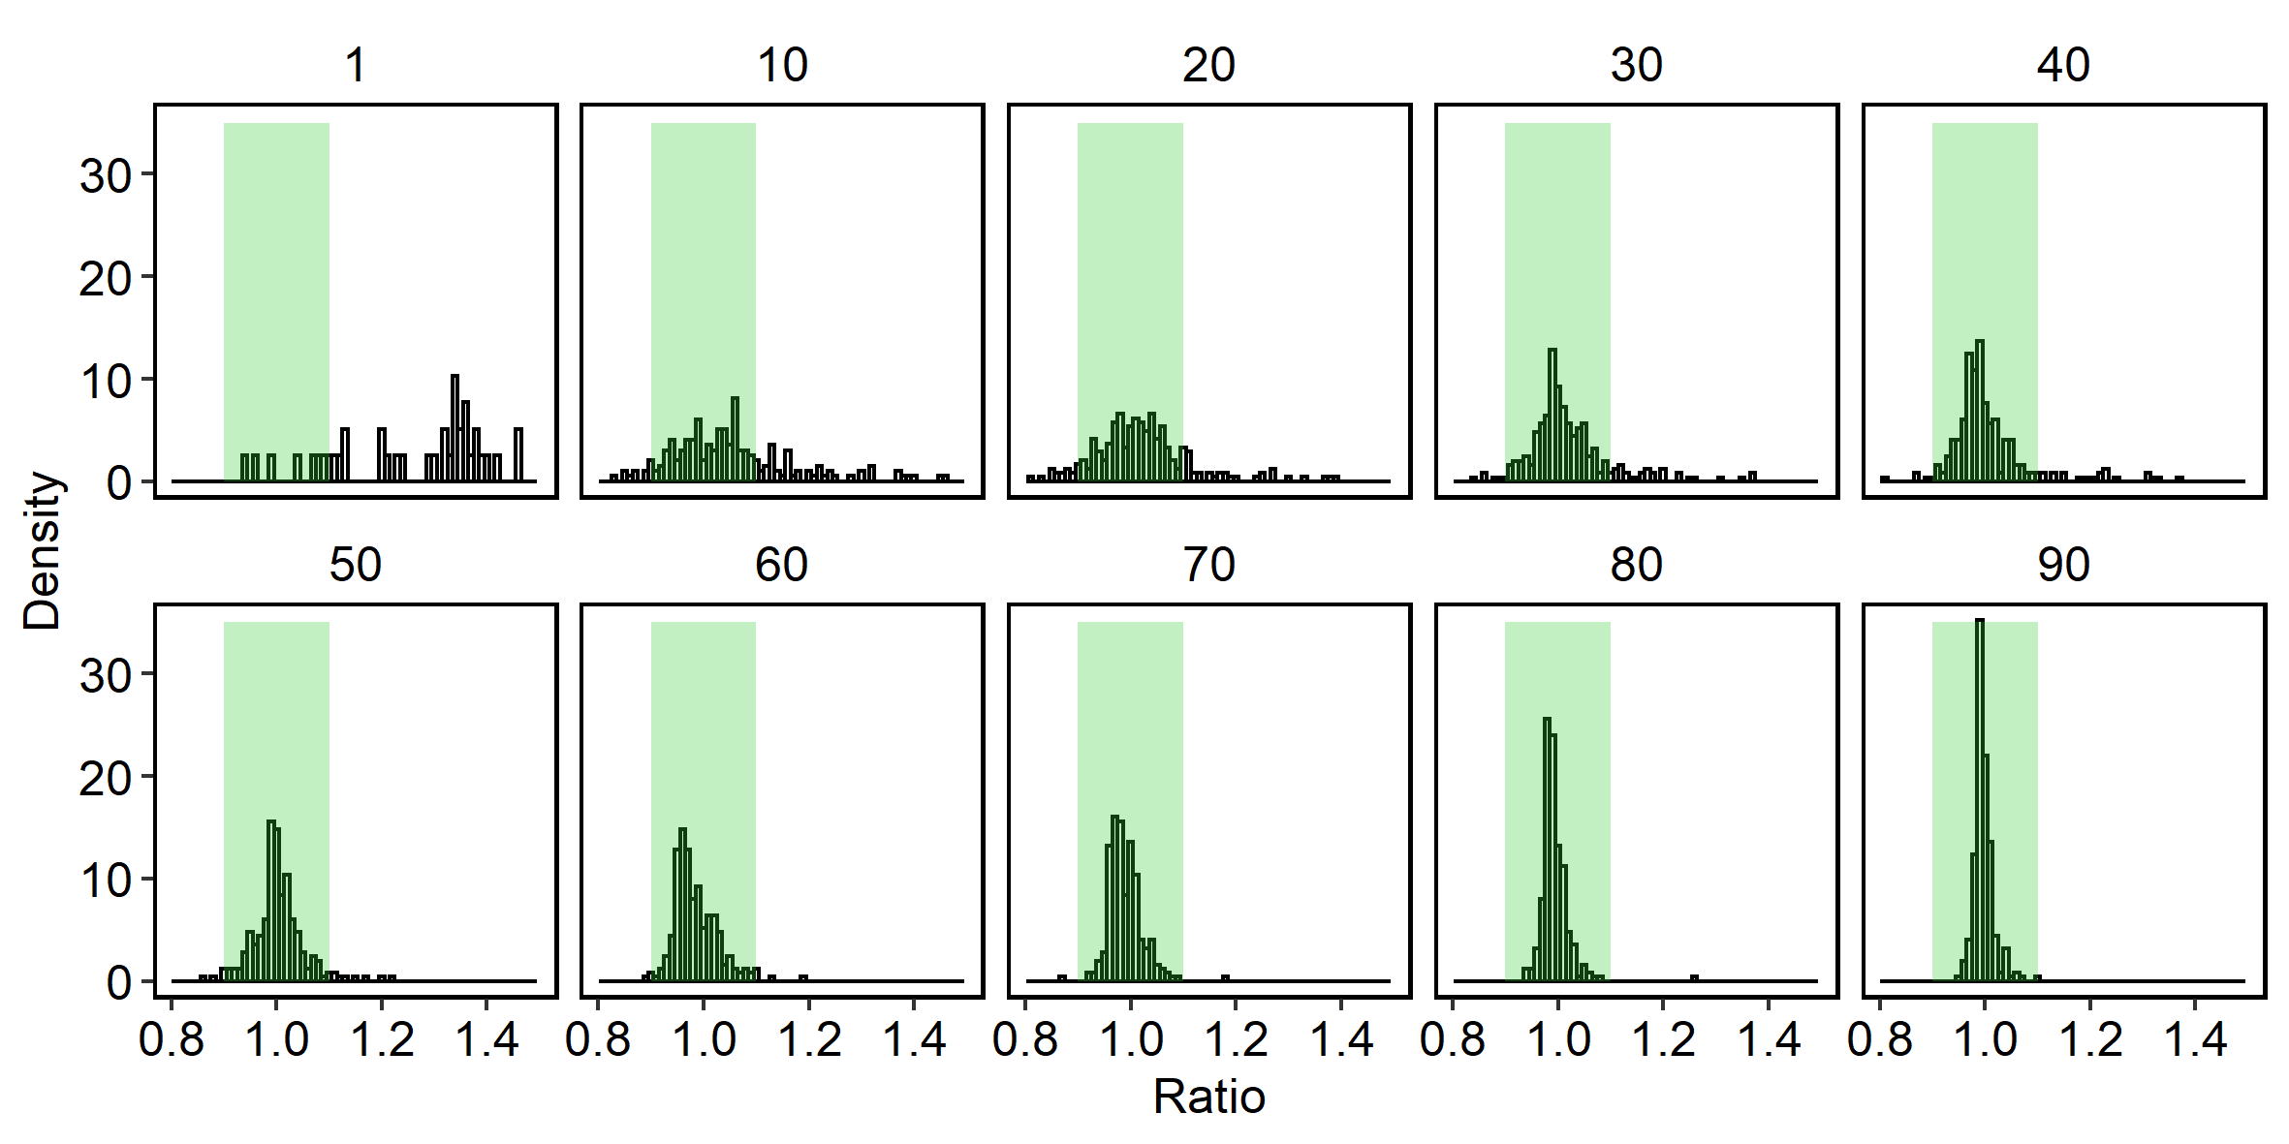
Figure S4. Ratios between the extrapolated and original power law exponent datapoints as presented in Figure S1. In the present study, we set a threshold of 10% variance from the perfect fit (i.e. ratio = 1), shown as the shaded green area. Panels refer to the subsample percentages, of either the sample volume or the filter area. Based on visual inspection, 60% would provide good extrapolation results, so we set criterium 2 at 60% of the original sample (or filter) to be analyzed for a dataset to be included, when less than 500 particles are available in the extrapolated datasets.

Table S3. Particle properties for different aquatic compartments.
water type | median | lower quantile | upper quantile | average | std
 | Length (µm)
biota | 20.00 | 20.00 | 44.72 | 72.86 | 341.58
effluent | 22.06 | 11.03 | 55.00 | 61.26 | 196.19
sediment, freshwater | 20.00 | 20.00 | 60.00 | 64.25 | 116.81
sediment, marine | 11.14 | 11.14 | 35.23 | 34.69 | 80.73
surface water, freshwater | 42.43 | 20.00 | 89.44 | 91.17 | 227.65
surface water, marine | 11.14 | 11.03 | 24.66 | 45.64 | 213.23
 | Width (µm)
biota | 20.00 | 20.00 | 20.00 | 35.80 | 266.05
effluent | 11.03 | 11.03 | 19.49 | 27.80 | 66.12
sediment, freshwater | 20.00 | 15.00 | 20.00 | 28.08 | 43.00
sediment, marine | 11.14 | 11.03 | 11.45 | 17.59 | 22.95
surface water, freshwater | 20.00 | 20.00 | 41.21 | 44.95 | 93.73
surface water, marine | 11.03 | 11.03 | 11.14 | 25.04 | 113.97
 | Width to Length ratio (-)
biota | 1.00 | 0.50 | 1.00 | 0.77 | 0.31
effluent | 0.64 | 0.45 | 1.00 | 0.69 | 0.30
sediment, freshwater | 0.89 | 0.46 | 1.00 | 0.70 | 0.33
sediment, marine | 1.00 | 0.50 | 1.00 | 0.75 | 0.30
surface water, freshwater | 0.60 | 0.50 | 1.00 | 0.67 | 0.28
surface water, marine | 1.00 | 0.50 | 1.00 | 0.77 | 0.29
 | Area (µm²)
biota | 9.93E+02 | 9.93E+02 | 1.77E+03 | 2.06E+05 | 9.88E+06
effluent | 5.37E+02 | 3.02E+02 | 2.42E+03 | 2.46E+04 | 4.22E+05
sediment, freshwater | 9.93E+02 | 9.93E+02 | 2.57E+03 | 1.15E+04 | 1.23E+05
sediment, marine | 3.08E+02 | 3.08E+02 | 9.89E+02 | 3.52E+03 | 1.84E+04
surface water, freshwater | 2.23E+03 | 9.93E+02 | 7.45E+03 | 4.53E+04 | 7.46E+05
surface water, marine | 3.08E+02 | 3.02E+02 | 5.48E+02 | 4.83E+04 | 8.62E+05
 | Volume (µm³)
biota | 2.81E+03 | 2.81E+03 | 5.63E+03 | 3.74E+08 | 2.03E+10
effluent | 9.44E+02 | 4.72E+02 | 6.96E+03 | 3.24E+06 | 1.74E+08
sediment, freshwater | 2.81E+03 | 2.81E+03 | 8.44E+03 | 6.94E+05 | 2.04E+07
sediment, marine | 4.86E+02 | 4.86E+02 | 1.89E+03 | 6.81E+04 | 7.38E+05
surface water, freshwater | 7.96E+03 | 2.81E+03 | 4.39E+04 | 9.07E+06 | 3.74E+08
surface water, marine | 4.86E+02 | 4.72E+02 | 9.72E+02 | 1.32E+07 | 4.34E+08
 | Mass (µg)
biota | 3.09E-03 | 2.56E-03 | 6.19E-03 | 4.11E+02 | 2.23E+04
effluent | 1.13E-03 | 5.66E-04 | 7.73E-03 | 2.98E+00 | 1.60E+02
sediment, freshwater | 3.38E-03 | 3.09E-03 | 1.01E-02 | 7.79E-01 | 1.93E+01
sediment, marine | 5.98E-04 | 5.76E-04 | 2.17E-03 | 7.42E-02 | 7.10E-01
surface water, freshwater | 8.64E-03 | 3.23E-03 | 4.47E-02 | 8.38E+00 | 3.46E+02
surface water, marine | 5.93E-04 | 5.19E-04 | 1.15E-03 | 1.21E+01 | 3.95E+02
 | Specific surface area (µm²/µg)
biota | 3.45E+05 | 3.21E+05 | 3.88E+05 | 3.24E+05 | 9.06E+04
effluent | 4.87E+05 | 3.12E+05 | 5.82E+05 | 4.41E+05 | 1.97E+05
sediment, freshwater | 2.94E+05 | 2.62E+05 | 3.40E+05 | 3.12E+05 | 1.36E+05
sediment, marine | 5.15E+05 | 4.12E+05 | 5.33E+05 | 4.75E+05 | 1.77E+05
surface water, freshwater | 2.85E+05 | 1.53E+05 | 3.53E+05 | 2.53E+05 | 1.17E+05
surface water, marine | 5.25E+05 | 4.74E+05 | 6.19E+05 | 5.22E+05 | 1.72E+05
 | Density (g/cm⁻³)
biota | 1.10 | 0.91 | 1.10 | 1.02 | 0.10
effluent | 1.10 | 0.92 | 1.20 | 1.09 | 0.14
sediment, freshwater | 1.20 | 1.10 | 1.20 | 1.15 | 0.13
sediment, marine | 1.22 | 1.00 | 1.23 | 1.16 | 0.16
surface water, freshwater | 1.00 | 0.92 | 1.10 | 1.04 | 0.12
surface water, marine | 1.10 | 0.92 | 1.22 | 1.10 | 0.14

Table S4. Fitted minimum values (‘min’) and power law exponents ($α$) (mean ± standard deviation) for particle length (L), width (W), volume (V), mass (M), area (A) and specific surface area (SSA)¹⁾.
 | Length |  | Width
 | L_{min} (µm) | $$α_{L}$$ | W_{min} (µm) | $$α_{W}$$
Biota | 290 ± 25 | 2.59 ± 0.04 | 127.0 ± 13.0 | 2.52 ± 0.07
Effluent | 160 ± 5.2 | 2.54 ± 0.01 | 89.4 ± 3.0 | 2.55 ± 0.015
Freshwater sediment | 354 ± 86 | 3.25 ± 0.19 | 93.7 ± 26.2 | 2.87 ± 0.167
Marine sediment | 56 ± 21 | 2.57 ± 0.20 | 21.3 ± 4.7 | 2.51 ± 0.091
Freshwater surface water | 113 ± 0.0 | 2.64 ± 0.01 | 65.9 ± 0.3 | 2.70 ± 0.008
Marine surface water | 75 ± 17 | 2.07 ± 0.03 | 21.9 ± 3.8 | 1.96 ± 0.026

 | Volume |  | Mass
 | V_{min} (µm³) | $$α_{V}$$ | M_{min} (µg) | $$α_{M}$$
Biota | 1.76E4 ± 1.49E3 | 1.40 ± 0.004 | 3.84E-1 ± 5.19E-1 | 1.41 ± 0.060
Effluent | 1.67E4 ± 4.17E3 | 1.45 ± 0.004 | 3.65E-3 ± 6.99E-5 | 1.40 ± 0.002
Freshwater sediment | 1.96E4 ± 9.66E3 | 1.53 ± 0.013 | 3.99E-1 ± 3.73E-1 | 1.56 ± 0.077
Marine sediment | 5.04E3 ± 2.41E3 | 1.50 ± 0.023 | 7.14E-3 ± 3.98E-3 | 1.50 ± 0.026
Freshwater surface water | 2.79E7 ± 1.92E7 | 1.68 ± 0.081 | 1.82E1 ± 1.52E1 | 1.65 ± 0.071
Marine surface water | 5.19E4 ± 4.31E4 | 1.48 ± 0.063 | 2.92E-2 ± 4.51E-2 | 1.32 ± 0.009

 | Area |  | Specific surface area¹⁾
 | A_{min} (µm²) | $$α_{A}$$ |  | [1/SSA_{min}] (g/m²) | $$α_{A}$$
Biota | 2.09E4 ± 5.54E3 | 1.69 ± 0.023 |  | 19.23 ± 3.12 | 2.46 ± 0.092
Effluent | 1.42E4 ± 6.79E2 | 1.73 ± 0.005 |  | 12.45 ± 0.12 | 2.58 ± 0.013
Freshwater sediment | 2.02E4 ± 1.39E4 | 1.89 ± 0.055 |  | 16.80 ± 3.75 | 2.82 ± 0.096
Marine sediment | 1.68E3 ± 7.97E2 | 1.75 ± 0.050 |  | 4.41 ± 0.61 | 2.54 ± 0.082
Freshwater surface water | 4.82E5 ± 1.90E5 | 2.00 ± 0.065 |  | 10.53 ± 0.13 | 2.71 ± 0.009
Marine surface water | 2.38E3 ± 3.98E3 | 1.50 ± 0.009 |  | 4.05 ± 16.10 | 1.98 ± 0.297
¹⁾ The power law for SSA (m²/g) was fitted to 1/SSA

Figure S5. Particle width distributions for the different compartments. The blue vertical segments indicate the minimum size for which the fitted power law is valid. The brown slopes present the fitted power law distributions. The mean (solid line) and standard deviation (shaded area) are based on n = 100 bootstraps. The dotted line shows the continuation of the fitted slope beyond the minimum size. Here, the deviation of the particles from this line is apparent.
Figure S6. Particle area distributions for the different compartments. The blue vertical segments indicate the minimum size for which the fitted power law is valid. The brown slopes present the fitted power law distributions. The mean (solid line) and standard deviation (shaded area) are based on n = 100 bootstraps. The dotted line shows the continuation of the fitted slope beyond the minimum size. Here, the deviation of the particles from this line is apparent.
Figure S7. Particle volume distributions for the different compartments. The blue vertical segments indicate the minimum size for which the fitted power law is valid. The brown slopes present the fitted power law distributions. The mean (solid line) and standard deviation (shaded area) are based on n = 100 bootstraps. The dotted line shows the continuation of the fitted slope beyond the minimum size. Here, the deviation of the particles from this line is apparent.
Figure S8. Particle mass distributions for the different compartments. The blue vertical segments indicate the minimum size for which the fitted power law is valid. The brown slopes present the fitted power law distributions. The mean (solid line) and standard deviation (shaded area) are based on n = 100 bootstraps. The dotted line shows the continuation of the fitted slope beyond the minimum size. Here, the deviation of the particles from this line is apparent.
Figure S9. Specific surface area (SSA) distributions for the different compartments. Please note that 1/SSA is plotted here! The blue vertical segments indicate the minimum size for which the fitted power law is valid. The brown slopes present the fitted power law distributions. The mean (solid line) and standard deviation (shaded area) are based on n = 100 bootstraps. The dotted line shows the continuation of the fitted slope beyond the minimum size. Here, the deviation of the particles from this line is apparent.
Table S5. Spearman’s rank correlation coefficients when found to be significant (p < 0.05).
Polymer 1 | Polymer 2 | n.obs | p-value | rho
Cellulose chemically modified | Polyethylene | 11 | 0.025 | 0.682
Cellulose chemically modified | Polyvinylchloride | 6 | 0.033 | 0.886
Cellulose chemically modified | Acrylates | 12 | 0.049 | 0.587
Ethylene-vinyl-acetate | Polyethylene | 12 | 0.017 | -0.685
Polyamide | Polyethylene-chlorinated | 23 | 0.007 | 0.556
Polyester | Rubber Type 3 | 15 | 0.031 | -0.564
Polyethylene-chlorinated | Nitrile rubber | 21 | 0.010 | 0.555
Polystyrene | Ethylene-vinyl-acetate | 9 | 0.003 | 0.883
Polyvinylchloride | Polypropylene | 20 | 0.038 | -0.471

Figure S10. Spearman ‘s correlation plots for significant correlations (p < 0.05). Colors indicate the environmental compartments, where green = biota; yellow = effluent; orange = freshwater sediment, brown = marine sediment, light blue = freshwater surface water and dark blue = marine surface water. No clear pattern for the different environmental compartments is visible. With Cellulose we refer to chemically modified cellulose.
References
Clauset, A., Shalizi, C.R., Newman, M.E.J., 2009. Power-law distributions in empirical data. SIAM Rev. 51, 661–703.
Cózar, A., Echevarría, F., González-Gordillo, J.I., Irigoien, X., Ubeda, B., Hernández-León, S., Palma, A.T., Navarro, S., García-de-Lomas, J., Ruiz, A., Fernández-de-Puelles, M.L., Duarte, C.M., 2014. Plastic debris in the open ocean. Proc. Natl. Acad. Sci. U. S. A. 111, 10239–10244. https://doi.org/10.1073/pnas.1314705111
Kaandorp, M.L.A., Dijkstra, H.A., van Sebille, E., 2021. Modelling size distributions of marine plastics under the influence of continuous cascading fragmentation. Environ. Res. Lett. https://doi.org/10.1088/1748-9326/abe9ea
Kooi, M., Koelmans, A.A., 2019. Simplifying Microplastic via Continuous Probability Distributions for Size, Shape, and Density. Environ. Sci. Technol. Lett. 6, 551–557.
Lorenz, C., Roscher, L., Meyer, M.S., Hildebrandt, L., Prume, J., Löder, M.G.J., Primpke, S., Gerdts, G., 2019. Spatial distribution of microplastics in sediments and surface waters of the southern North Sea. Environ. Pollut. 252, 1719–1729.
Mani, T., Primpke, S., Lorenz, C., Gerdts, G., Burkhardt-Holm, P., 2019. Microplastic pollution in benthic midstream sediments of the Rhine River. Environ. Sci. Technol. 53, 6053–6062.
Mintenig, S.M., Kooi, M., Erich, M.W., Primpke, S., Redondo Hasselerharm, P.E., Dekker, S.C., Koelmans, A.A., van Wezel, A.P., 2020. A systems approach to understand microplastic occurrence and variability in Dutch riverine surface waters. Water Res. 176, 115723.
Newman, M.E.J., 2005. Power laws, Pareto distributions and Zipf’s law. Contemp. Phys. 46, 323–351.
Pan, C.-G., Mintenig, S.M., Redondo-Hasselerharm, P.E., Neijenhuis, P., Yu, K., Wang, Y., Koelmans, A.A., n.d. Automated uFTIR imaging demonstrates taxon-specific and selective uptake of microplastic by freshwater invertebrates. Environ. Sci. Technol.
Primpke, S., Dias, P.A., Gerdts, G., 2019. Automated identification and quantification of microfibres and microplastics. Anal. Methods 11, 2138–2147.
Primpke, S., Wirth, M., Lorenz, C., Gerdts, G., 2018. Reference database design for the automated analysis of microplastic samples based on Fourier transform infrared (FTIR) spectroscopy. Anal. Bioanal. Chem. 410, 5131–5141.
White, E.P., Enquist, B.J., Green, J.L., 2008. On estimating the exponent of power-law frequency distributions. Ecology 89, 905–912.

