This will become the README file for the git repo.

While poking around, as I do, I found it hard to see business intelligence in action with and without AI.

**10 Great Portfolio Projects for Business Analysis**

<https://www.dataquest.io/blog/10-great-portfolio-projects-for-business-analysis/>

Sounds good! Here are some ideas on how we could showcase these airline BI use cases in the demo app:

**Revenue Management**

- Use simulated booking data with passenger count, ticket prices, demand forecasts etc. Build dashboard showing revenue metrics and pricing analytics.

- Implement demand forecasting model in Python to predict ticket demand at future dates. Allow adjusting prices and seeing impact on revenue.

**Route Planning**

- Ingest flight schedule, route and cost data. Build route profitability dashboard showing metrics like revenue per route, aircraft utilization etc.

- Develop network optimization model that recommends optimal routes based on constraints like demand, aircraft type, operating costs. Show model results.

**Customer Intelligence**

- Include customer demographic, travel history, satisfaction data. Build customer segmentation model in Python and profile different clusters.

- Implement sentiment analysis on sample customer feedback comments to identify pain points and improvement areas. Visualize results.

**Equipment Maintenance**

- Simulate aircraft sensor timeseries data with real-world failure patterns. Detect anomalies using timeseries forecasting and ML models.

- Predict expected maintenance needs by applying regression models on aircraft usage and sensor data. Show maintenance schedules.

For each use case, we can provide relevant sample data, analysis code, and custom visualizations tailored to airline operations. Let me know if you have any preferences on which 1-2 use cases to focus on for the initial demo app. I'm happy to provide more details and code snippets.

Demonstrating:

## 1. Sales Data Analysis

## 2. Customer Churn Rate Prediction

## 3. Customer Review Sentiment Analysis

## 4. Market Basket Analysis

## **5. Price Optimization**

## **6. Stock Market Data Analysis**

## **7. Customer Segmentation**

## **8. Fraud Detection**

## **9. Life Expectancy Analysis**

## **10. Building a BI App**

# 10 best sales forecasting tools (+ features and benefits)

<https://www.zendesk.com/sell/features/sales-forecasting-software/>

Salesforce - Trailblazers

# 8 Best AI-Powered Data Forecasting and Prediction Tools for Businesses

#### Demand Forecasting

#### Growth Forecasting

### AI in Data Predictions and Business Forecasting: Use Cases

Here are some industry-based use cases of AI forecasting:

#### Finance

#### Government

#### Manufacturing

#### Healthcare

#### Insurance

#### Sales

#### Telecommunication

#### Product

#### Operations

### **AI planning and forecasting**

#### [What is AI planning and forecasting?](https://www.domo.com/glossary/what-is-ai-planning-and-forecasting#WhatisAIplanningandforecasting)

#### [Artificial intelligence vs. augmented intelligence](https://www.domo.com/glossary/what-is-ai-planning-and-forecasting#Artificialintelligencevsaugmentedintelligence)

#### [Why is AI planning important for your business?](https://www.domo.com/glossary/what-is-ai-planning-and-forecasting#WhyisAIplanningimportantforyourbusiness)

#### [What are the approaches for AI planning?](https://www.domo.com/glossary/what-is-ai-planning-and-forecasting#WhataretheapproachesforAIplanning)

#### [How do different industries use AI planning and forecasting?](https://www.domo.com/glossary/what-is-ai-planning-and-forecasting#HowdodifferentindustriesuseAIplanningandforecasting)

#### [What should I look for in AI forecasting tools?](https://www.domo.com/glossary/what-is-ai-planning-and-forecasting#WhatshouldIlookforinAIforecastingtools)

#### [How will AI forecasting affect the future?](https://www.domo.com/glossary/what-is-ai-planning-and-forecasting#HowwillAIforecastingaffectthefuture)

### What are the approaches for AI planning?

Three approaches dominate artificial intelligence today, including models and methods for types of AI planning and forecasting in business:

#### **Bayesian Networks**

#### **Evolutionary Algorithms**

#### **Deep Learning**

**Here are a few examples of machine learning in action:**

#### **Protecting finances.**

#### **Increasing retention.**

#### **Texting better.**

#### **Improving healthcare.**

#### **Supporting education.**

#### **Fueling facial recognition.**

#### **Making product recommendations.**

# 9 Ways Modern BI for All Differs from Traditional BI

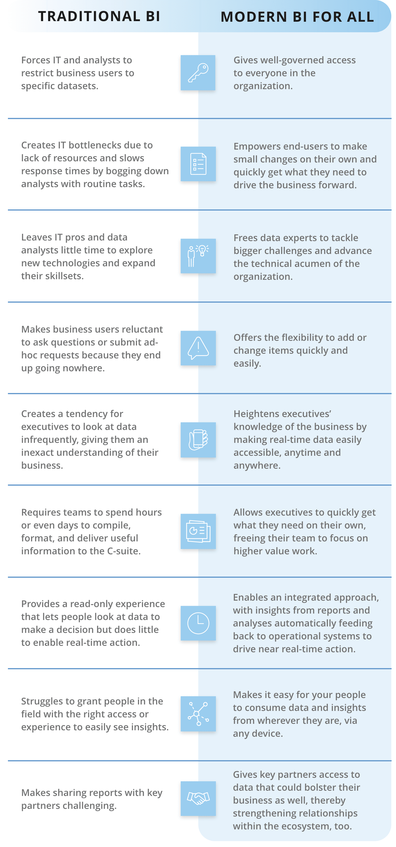

You're right, we can enhance the demo by creating more visualizations and charts to provide additional business insights. Here are some ideas:

**Revenue Dashboard**

- Add charts for revenue over time, revenue by month/day of week, distribution of ticket prices.

- Include key revenue metrics like average/total revenue per passenger, revenue per flight etc.

- Plot revenue vs demand forecast to show accuracy of predictions.

**Passenger Analytics**

- Breakdown passengers by new vs returning. See trends over time.

- Visualize passenger volume by flight route. Identify most popular routes.

- Plot passenger demographics like age groups, gender, travel purpose (business vs leisure).

**Pricing Analysis**

- Show price trends and seasonality using time series charts.

- Plot price vs passenger demand scatterplot. Add regression line to quantify relationship.

- Display interactive distribution of ticket prices - mean, percentiles, outliers etc.

**Operational Metrics**

- Add flight delay/cancellation rates, aircraft downtime, fuel consumption metrics.

- Visualize operational data like capacity, loads, yield to spot utilization issues.

Let me know if any particular chart ideas seem useful, and I can add sample code to generate more insightful visualizations in the demo notebook. The key is turning the data into relevant insights for revenue management and airline operations.