**Part 2**

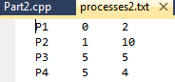

Using this file containing process info:

I obtain these results.

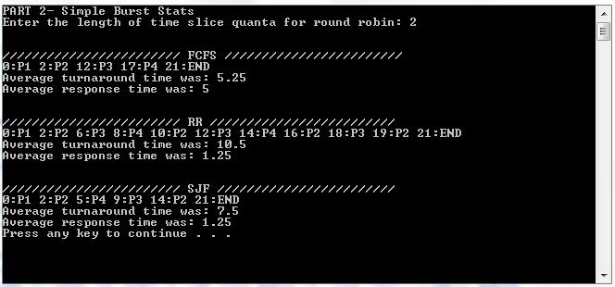

a) Looking at the image, FCFS turnaround time 5.25 is much better than RR 10.5. The conditions for FCFS to have better turnaround time are that the time slice for quanta is shorter than the run time of the processes. If processes run longer than the length of quanta, then they will start in RR and not be able to finish right away. FCFS processes always finish after they start though, so FCFS will have better turnaround when quanta lengths are shorter than burst lengths.

b) I don’t think this is actually possible. For the situation where only one CPU burst occurs at a time, FCFS will always have an advantage for turnaround time because a process will always start, run its burst duration, and finish in the shortest amount of time. For RR, best case scenario is that a process can start at the same time as a new quanta, giving turnaround time equal to FCFS. But outside of the best case scenario, a process will start, run for a bit, pause while other processes run, and then finish, making its turnaround time worse.

c) Looking at the image again, SJF has a response time much better than FCFS because when a new, shorter process arrives, it starts immediately. My example also shows SJF giving an even response time to RR. RR is also better than FCFS in terms of response time because the intermittent switching of processes encourages processes to start sooner rather than later.

**Part 3**

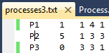

1. Using this file,

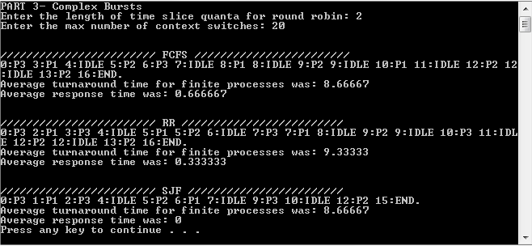I obtained these results.

If you compare FCFS with SJF, you can see that at time 1 for SJF, there is an extra context switch not made for FCFS. This shows that SJF has been implemented to be pre-emptive; whenever a shorter CPU burst becomes available than the currently running one, the shorter burst will become active and will run.



1. 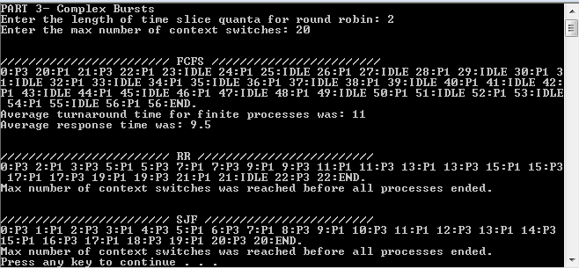Using this input file,

I obtained these results.

As you can see, The SJF scheduler said that “Max number of context switches was reached before all processes ended.” Because there are only two processes in this input, and one of the processes is infinite, that means that the other process (P3) was unable to finish according to the criteria for outputting turnaround and response time. That means that P3 starved during this schedule because it was unable to finish in the given 20 context switches. P3 ended up starving because it had one main CPU burst that was long, and the competing P1 had very short CPU and IO bursts in infinite sequence. While P1 was busy running and restarting, P3 was hardly able to get through.

1. If you will look back to my images from part a, you will see that FCFS and RR were able to finish without starvation. FCFS is quite likely to be able to avoid starvation because of the way it lets processes run for as long as they need to at once. For RR, it is a little less likely. You can see this by comparing my images from part a (RR finishes without starvation) and part b (RR finished with starvation). For RR, avoiding starvation is less likely based on the value given not only for number of context switches but also for quanta. If quanta is really low with respect to the CPU bursts of processes, then it is much more likely that starvation will occur in a dataset where a proportionally small number of context switches is allowed.

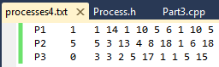**Part 4**

1. Using this file for input,

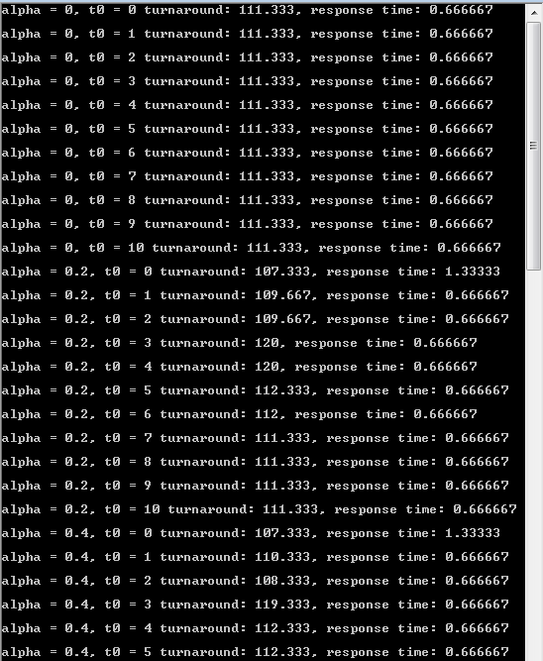I was able to get output like this

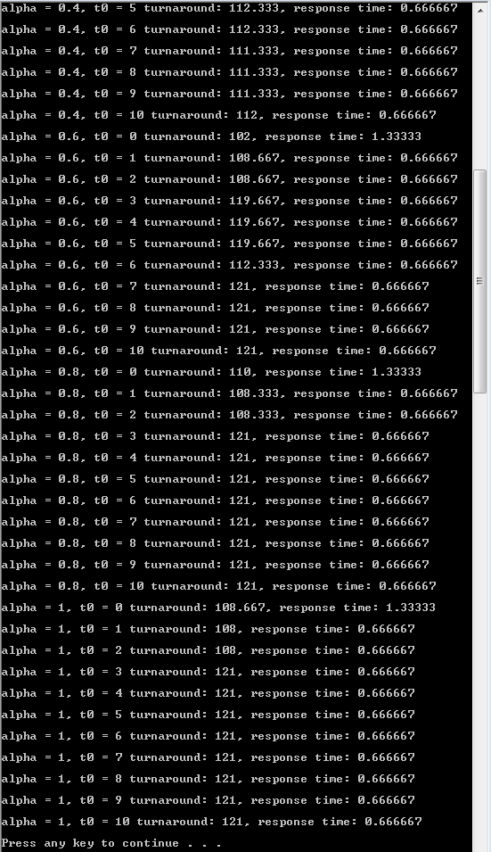

Some interesting things showed up! First, the very best turnaround time was found by using an initial t0 guess of 0 and an alpha value of 0.5 (102) and the best response time was a result of many of the runs (0.666667). Some trends I noticed with varying alpha and t0 include that for both low alpha and low t0, turnaround and response time both seem good. On the contrary, having both high alpha and high t0 led to the highest turnaround in this survey (121). Another trend I found was that usually, very small t0 values (0, 1, 2) all yielded significantly better turnaround than higher t0 values with the same value of alpha.

1. I think that my approximation is fairly good. In my input data set, I never used values that seem totally unreasonable, so TAU(n+1) was never too much bigger than TAU(n). Because of this, the results were generally smooth. Granted, if you could know the actual run time of each burst, you could essentially run a perfect SJF. I went ahead and tried a SJF with this input file and found a turnaround time of 90 and response time of 0. This is pretty noticeable already… If I call the average of my SRTF results turnaround of 115 and response of 0.75 approximately, (115/90) is a 27% variation for run time and obviously a response time of 0 for SJF is the absolute best, so SRTF can’t even compare in that department. With 0 response time, any other response time greater than 0 will be an infinite number of times larger. In terms of actual values, 0.75 is not a huge margin different than 0 in most respects, but it might be just enough to frustrate a user if their program is not snappy to start when it should. For turnaround, 27% difference in runtime is not insignificant… For the question of “How good is this approximation”, I’m initially inclined to say that it’s not that good at 27% variation. However, thinking about this in the real world, SJF is an idealized version that isn’t necessarily truly possible. For our crude implementation, I think that our approximation does a fair job at coming closer to the ideal and optimal situation of SJF.

*Note: For the above runs, 400 context switches were allowed.

**Part 5**

1. 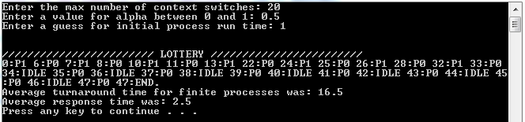Using the same input file for part 3 b, I am comparing this lottery result to the result of the SJF run that ended in starvation. For the lottery, I got this output

If you look at time 32, you will see the last instance of process P1 running. Using this lottery, P1 was actually able to finish and not starve! If you recall from part 3, the schedule ended after reaching the max number of context switches before P1 could finish. In this system, P1 must have gotten lucky enough to get chosen to run during the context switches enough times within the same number of context switches to complete. P1 was able to finish in the lottery because there was no guarantee that P0 would be able to jump back in just because it had a shorter CPU burst as was the case in part 3. This can easily be seen if you look at time 13 where P1 is able to run uninterrupted by context switches for 9 seconds before P0 jumps back in. I did help P1 out by setting t0 to 1 knowing that P0’s average would approach 1. So me setting P1’s t0 to 1 helped P1 be able to compete at what ends up being a 50% chance of running. You would not need to fix all situations to avoid starvation, but for the processes I did in part 3, this made it easy to show without running lots of times that starvation actually can be avoided.

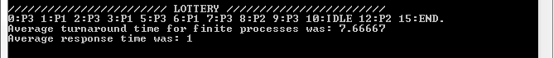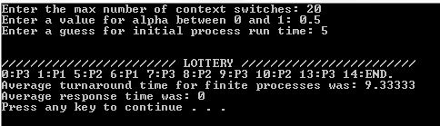

1. Recall from part 3 a that FCFS had turnaround time of 8.66667 and response time of 0.66667 and RR had turnaround time of 9.33333 and response time of 0.33333. Let’s compare that to some of the best results I found using this lottery after running it hundreds of times. The first image shows one of many runs that had a response time of 0. The turnaround time was nothing to write home about, but it outperformed both FCFS and RR in terms of response time. The second image shows the run that yielded the best turnaround time that I saw. 7.66667. That’s pretty impressive to me. Compared to 8.66667, that is a 13% better turnaround, and compared to 9.33333, that is a 22% better turnaround. I also think it is interesting that the schedule with a better run time ended in real time 1 second before the schedule that had the improved turnaround time (14 vs 15).
2. The biggest drawback I could see to this lottery-style approach is that there is always going to be some chance that a process will run, regardless of its priority. As long as processes have even one ticket, they have some chance to be run at the next context switch. That being said, this is quite favorable to avoid starvation, but I could easily think of a scenario when that would not be ideal. For one example, if you think about trying to stream a video while leaving your Digits-Of-Pi-Counter program running, letting your side program always jump in would interfere with bandwidth and video quality. Instead, you would want your pi counter to “pseudo-starve” until you are not actively trying to do something else. Another example where you would not want programs unnecessarily taking CPU time would be if you are trying to do displaced real time communication with someone. If you are (for example) trying to synchronize your watch to the second with your friend in Australia that you are chatting with on Hangouts, having side programs jump in could easily slow down the process just enough to throw time-critical information out of sync.

Another problem I could foresee would be deriving an optimal algorithm for splitting up tickets at context switches. How do you know which processes to give how many tickets to? This could probably be settled in an arbitrary manner, but could still be a problem.

This fair share lottery style seems like it would be good when you are trying to run multiple long processes that don’t have time critical information. For this situation, it would be good to give every process some breathing time so it doesn’t actually starve as long as nothing would be thrown off by the unimportant processes getting some run time.