Dev Log

taper-web

# 1/11/18 : 1900

## Initiate Project

### Github Setup

* create new repo called taper-web; keep it empty - no readme, ignore, license

### Create React App

Open Ubuntu shell

* cd /mnt/c/dev/src
* create-react-app taper-web

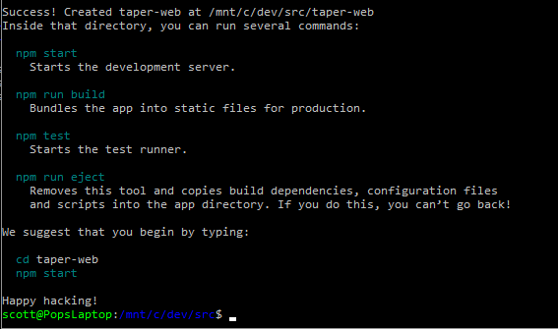

### Serve React App Locally

* cd taper-web
* npm start

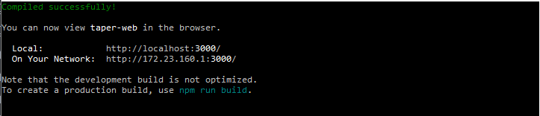

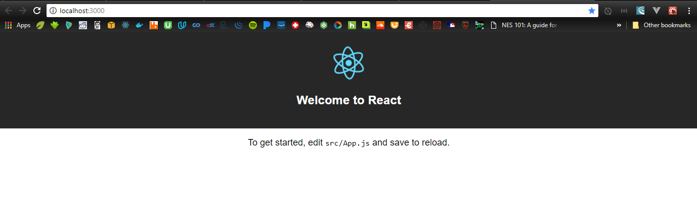

### Git Setup

Open a new Ubuntu shell

* cd taper-web
* mv README.md CreateReactApp-readme.md

(That readme is huge; it’s the one on create-react-app’s github repo. Make one for THIS project.)

* vi README.md
  + cut/paste the npm start, npm run, etc instructions into the readme
* git init
* git add .
* git commit –m “Initial commit: create-react-app scaffolding”

### Sync Git and Github

* git remote add origin <https://github.com/ScottHensen/taper-web.git>
* git push –u origin master

