# **Python Workshop – Setup Instructions**

# Overview of Tools

The tools we will be using during this course are the industry standard tools below:

**GIT**

**Python 3.6.1**

**Atom** (or preferred code editor)

# Installing Atom

Atom is a text editor used to write code. You could just use notepad, but there are a lot of advantages to using a more advanced editor. If you already have another preferred text editor, feel free to use that.

<https://atom.io/>

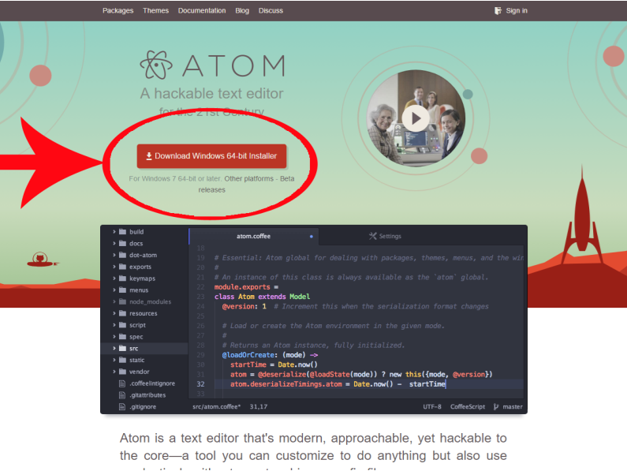

# Installing Python

Note that there are two version of Python. There are some pretty big differences between the two as we will look at. See details of how to install below.

<https://www.python.org/downloads/>

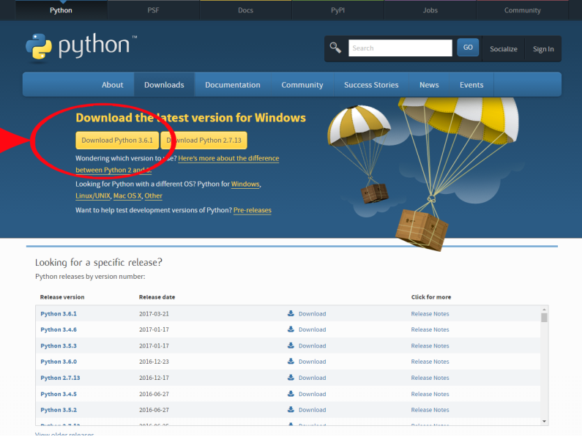

Download the python installer for version 3.6.1 as seen above.

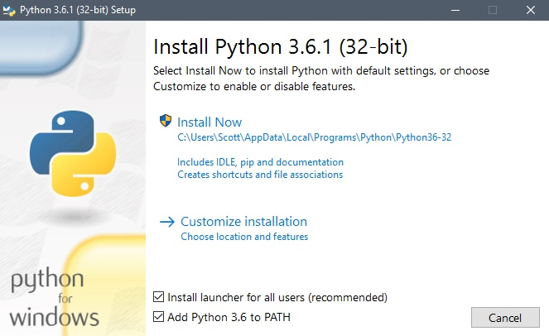

Make sure you have this checkbox selected so that your GitBash/CMD are able to use Python

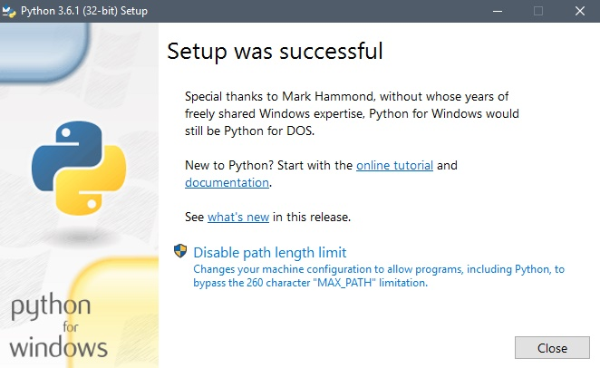

# Check Python Installation

Open Command Prompt (cmd.exe) and enter the following:

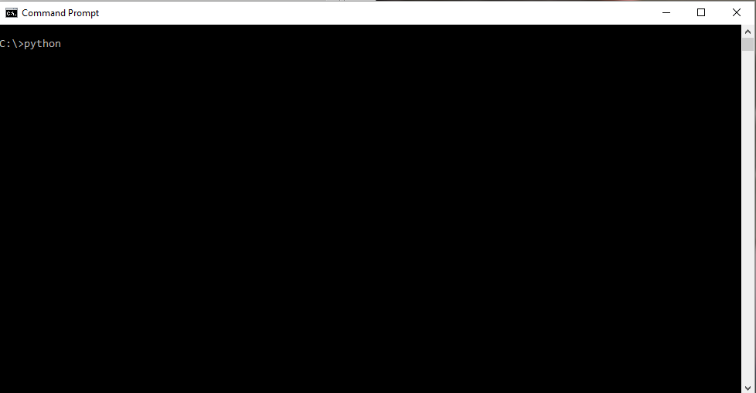

If python has installed correctly and added itself to your environment, then you should see the following:

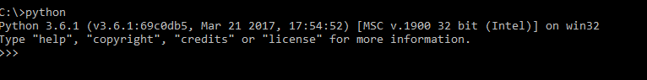

If you do not see this, then don’t worry. We will be able to have a look during the first session.

Installing GIT

Go to the following link: <https://git-scm.com/downloads>

Use the windows installer.

# 

# Accessing the GIT repository material

Open gitbash.exe and enter the following (change the path to where you would like to add the git repo. Mine is C:/Users/George/Documents). This points gitbash at the target directory:

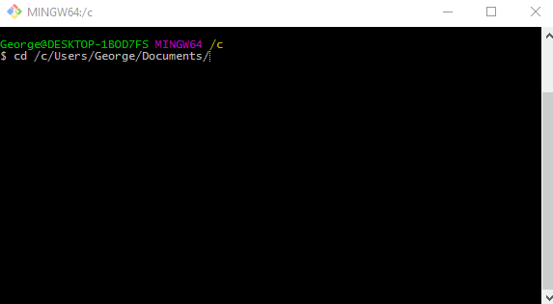

Make a new directory in which to add the git repo:



Change into that directory:



Initialise this directory as a git repository:



Add our Python repo as a remote:

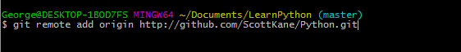

Pull the material from the remote repository:



You should see something like this:

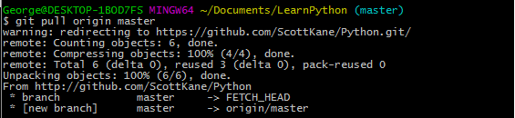

**NOTE:** The “pull” command above is how to pull down the newly added material each week.