Supplementary Materials
S.1 Lab Testing Standard Operating Procedure
Purpose:
This SOP outlines the process for testing a thermal camera in a controlled environment to ensure accurate temperature measurements across a range of known target temperatures and ambient conditions.
Equipment:
- Thermal camera
  - We do not recommend the use of cameras with manufacturer-reported accuracy exceeding ±5 °C or thermal sensitivity (noise equivalent temperature difference, NETD) exceeding 50mK, as their measurements may not be suitable for ecological applications that rely on fine-scale temperature gradients.
- Blackbody calibrator with adjustable temperature and known emissivity (e.g., Omega BB701 model)
- Chem wipes (e.g., Kimwipes® Low-Lint Wipers)
- Data collection software
  - This can be done in MATLAB or Python or with the camera’s proprietary software (e.g., ResearchIR)
- Handheld infrared thermometer (e.g., Fluke 64 MAX IR Thermometer)
- Air temperature and humidity reader (e.g., Aranet4 HOME)
- Tape measure
Procedure:
- Preparation:
  - Start the camera and allow it to stabilize for at least 30 minutes.
  - Set up the blackbody on a stable surface and allow it to reach the desired ambient temperature.
  - Clean the camera lens with a chem wipe to remove any dust or debris.
  - Measure the distance between camera lens and blackbody aperture. Make sure the camera is not closer than the minimum focus distance of the lens.
- Software Settings:
  - Minimize internal camera corrections.
    - Set emissivity to 1
    - Set atmospheric transmission to 1
      - If you can’t set this - set the distance to less than 1 meter
- Testing Environment:
  - Turn off air conditioners and fans to minimize air circulation.
  - Remove warm objects like computers or people from the camera's field of view.
  - Set up camera to have blackbody fill whole FOV
    - Make sure the camera is not closer than the minimum focus distance of the lens
    - When testing on a table and unable to position the camera close enough for the blackbody to fill the full FOV, place a non-reflective material (e.g., paper towels or black cloth) over the table in front of the camera to reduce background effects.
- Data Collection:
  - Record the ambient air temperature and relative humidity with the reader.
  - Record the wall temperature (as a proxy for sky temperature) using the handheld infrared thermometer.
  - For each temperature increment:
    - Allow the blackbody temperature to stabilize (wait 30 seconds).
    - Capture one image of the blackbody using the thermal camera.
    - If applicable, using the software, record one temperature point measurement at the center of the blackbody image.
  - Repeat steps 4a-4c for all desired blackbody target temperatures:
    - Work sequentially through temperature range at 5-degree increments. We recommend temperature range encompassing at least 25° above and below ambient temperature. Add increments of 2.5 degrees at ±5 °C ambient temperature.
    - For example if ambient temperature is 20°C, the samples should be at -5 °C, 0 °C, 5 °C, 10 °C, 15 °C, 17.5 °C, 20°C, 22.5°C, 25°C, 30 °C, 35 °C, 40 °C, 45 °C
  - Repeat as a second run with target temperatures starting at the high end (i.e., 45°C)
  - Repeat procedure in three different rooms, each with a different ambient temperature if possible.
    - Hot room (ideally 30-40ºC)
    - Ambient room (20-25ºC)
    - Cold room (10-15ºC)
- Data Recording:
  - Save all captured images and temperature measurements (point and additional) in spreadsheet with appropriate labeling. Include photos of the setup for reference.
____________________________________________________________________________
Lab Testing Notes:
- In temperature measurement collection software, the user needs to be able to override default emissivity and transmission. We want all defaults to be set to 1 to ensure the software is not doing an unknown correction (see step 2 of the procedure).
- All testing should be done in actual housing.
- If a blackbody calibrator is not available, we recommend using a heated water bath as a reference temperature source. For best results, ensure the water is well-mixed to maintain uniform temperature (e.g., using an immersion circulator such as an ANOVA cooker). To minimize evaporative cooling, cover the water surface with aluminum foil. Since most water bath containers are opaque to thermal infrared radiation, use a first surface mirror angled above the bath to reflect the water surface toward the thermal camera’s FOV. See Figure S.2 for an example setup schematic.
- Record tier of lab testing done (Table 1).
Interpretation of Results:
Both image and point data collected during lab testing should be post-processed through the “mechanistic” method we recommend (see more in Section VI.B.). If lab testing results are within manufacturer specifications indicating its calibration accuracy, the camera is cleared to be deployed in the field.

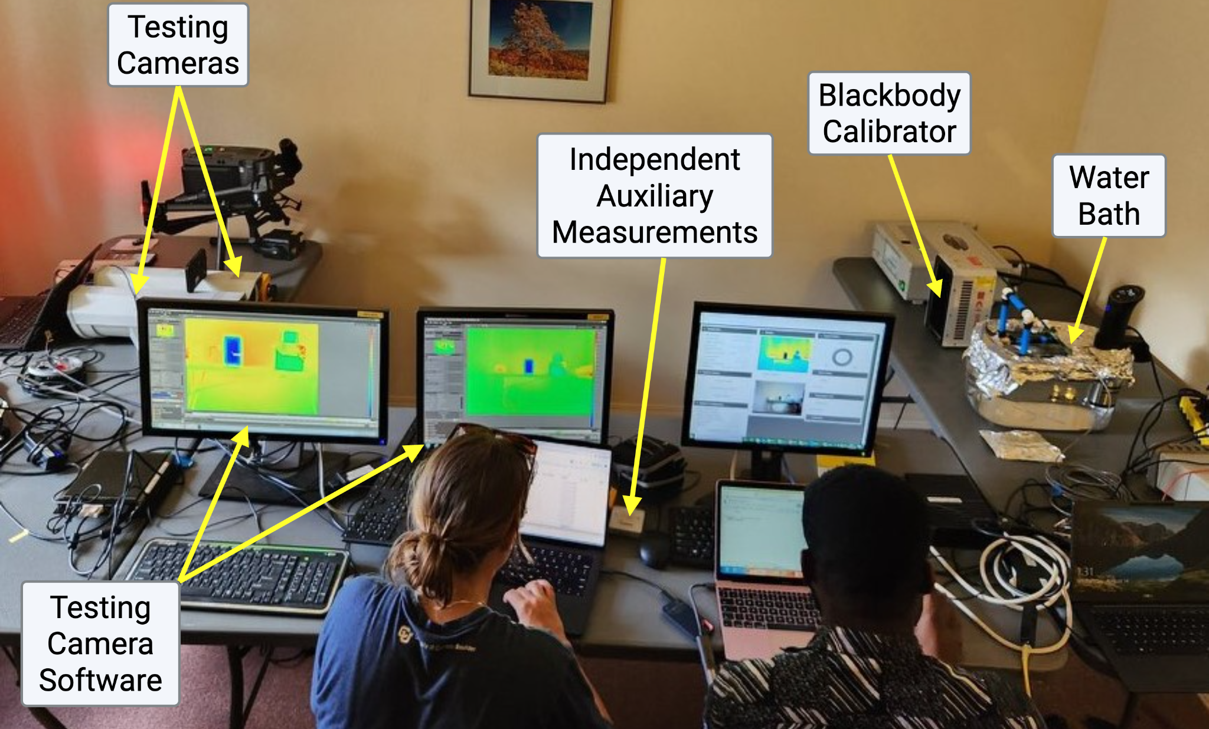
Figure S1. Example lab testing set-up.
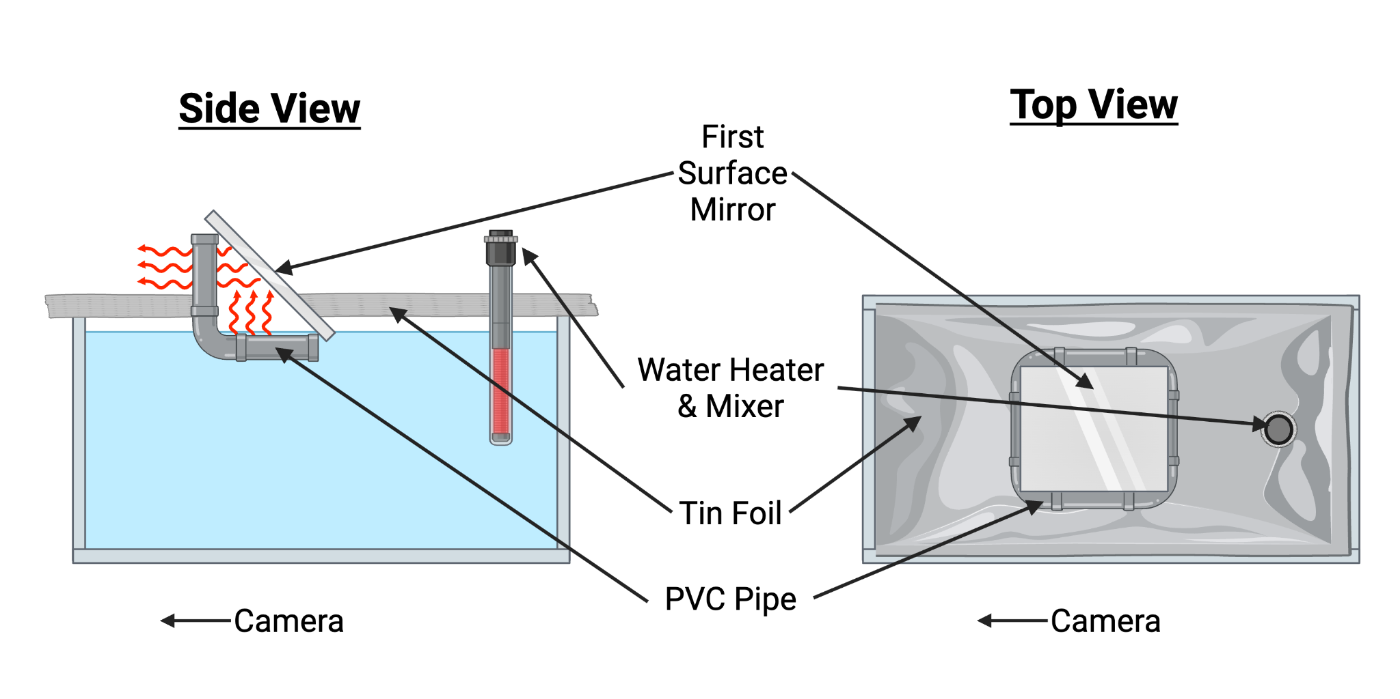
Figure S.2 Waterbath testing schematic. If the camera cannot securely view the bath from above, a first-surface mirror positioned above this opening can be used to reflect thermal energy from the water surface toward the camera like shown in Figure S.1 where simultaneous recordings across multiple instruments was needed. Created in BioRender. Diehl, J. (2026) https://BioRender.com/y51fpfe
S.2 Reflective Plate
Conceptual framework: sky vs. surrounding contributions
Background reflected radiation can be decomposed into contributions from the sky and from surrounding surfaces (e.g., vegetation, soil, infrastructure) (Johnston et al., 2021). The relative importance of these components depends on the exposure of the ROI. If any portion of the ROI is sunlit or directly exposed to the sky, then the target receives a non-negligible contribution from sky radiance. In these cases, the reflected component should be partitioned into sky and surrounding contributions, with the sky component estimated independently (e.g., using an infrared thermometer or sky-view pixels) and combined with the surrounding component using a view factor derived from the ROI field of view (see Figure S3). For fully sunlit, top-of-canopy ROIs with an unobstructed view of the sky, reflected radiation may be dominated by the sky contribution. On the other hand, ROIs contained within the canopy (e.g., shaded leaves with no direct line of sight to the sky), the sky contribution may be minimal and the surrounding component dominates.

Measurement using a reflective plate
Reflected radiation from surrounding surfaces can be estimated using a low-emissivity, highly reflective plate (e.g., Infragold® or crinkled aluminum foil) placed within the camera field of view (Garcia-Santos et al., 2013; Göttsche et al., 2017; Muller et al., 2021; Salisbury, 1998; Yong Zhang et al., 2007). The plate must be oriented toward the camera to be observed, which typically requires a near-vertical placement (i.e., perpendicular to the camera viewing direction). Because of this orientation, the plate does not sample the full hemispheric radiative environment seen by the canopy. Instead, it primarily captures radiation from surrounding (non-sky) surfaces and underrepresents the sky contribution. As such, the reflective plate is used here to estimate the surrounding component of reflected radiation. Highly reflective materials such as Infragold® and crinkled aluminum have reflectance values of approximately 97% in the thermal infrared (Göttsche et al., 2017). Because absorptivity and emissivity are approximately equal in the thermal infrared (Kirchhoff’s law), this high reflectance implies low emissivity (ε ≈ 0.03) (Vollmer & Möllmann, 2018). As a result, the measured radiance from the plate is dominated by reflected environmental radiation, with only a small contribution from emission by the plate itself. Despite this, the emitted component should still be accounted for to obtain the most accurate estimate of reflected radiation.
To correct for plate emission, the plate temperature must be measured independently. This can be achieved by attaching a fine-wire thermocouple or thermistor to the backside of the plate, ensuring good thermal contact while minimizing disturbance to the reflective surface. Temperature measurements should be recorded at regular intervals and aligned with thermal image acquisition (see Section IV.A.1.a). The plate emissivity must also be specified; for example, Infragold® coatings on aluminum have a reported emissivity of 0.023 (Muller et al., 2021).
The surrounding reflected component (ɸ_{refl}) can be estimated as:
$$ϕ_{refl}=\frac{ϕ_{total}-τ_{air}τ_{win}ϕ_{plate}-τ_{win}(1-τ_{air})ϕ_{atm}-(1-τ_{win})ϕ_{win}}{τ_{air}τ_{win}(1-ϵ_{plate})}$$
Eq. S1
$ϕ_{total}$ is the total radiance measured by the thermal camera from the reflective plate; $ϕ_{plate}$ is the emitted radiance of the reflective plate, calculated from an independently measured plate temperature: $ϕ_{plate}=σT_{plate}^{4}$ where $T_{plate}$​ is measured using a thermocouple or thermistor attached to the backside of the plate; $ϵ_{plate}$ is the emissivity of the reflective plate; $τ_{air}$ is the atmospheric transmittance between the plate and the camera; $ϕ_{atm}$is the atmospheric emitted radiance along the sensor-target path; $τ_{win}$ is the transmittance of the camera window or enclosure (if present); $ϕ_{win}$ is the radiance emitted by the camera window/enclosure (if present).
Infragold® coatings on aluminium provide high reflectance and low emissivity but have several practical limitations: large plates can be heavy and are relatively expensive (Salisbury, 1998). Crinkled aluminum foil provides a lower-cost alternative but may introduce additional uncertainty due to variability in surface properties and durability. Both options are susceptible to contamination from windblown dust or corrosion and should be cleaned semi-regualrly (Still et al., 2019). Size of reflective plate can be established similar to reference panel using Python code in S.3 (see also Section IV.A.2.a for details).
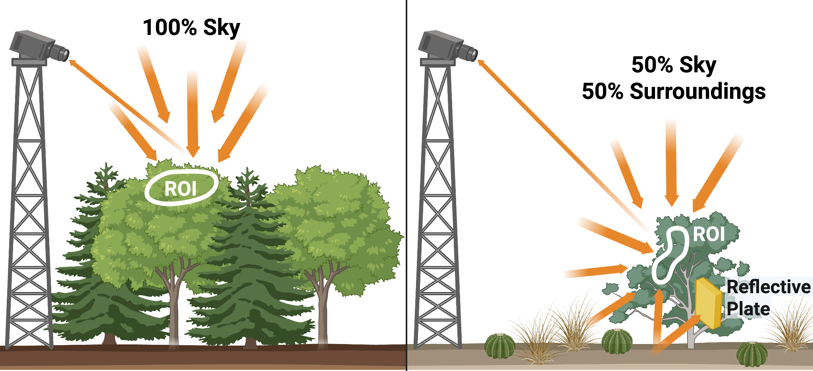
Figure S.3 Conceptual illustration of background (reflected) thermal radiation contributions across different canopy structures. Left: In closed-canopy systems, a thermal camera viewing a sunlit, top-of-canopy ROI primarily receives reflected radiation from the colder sky. Right: In open-canopy or dryland systems, reflected radiation arises from a combination of sky and surrounding surfaces (e.g., bare ground and nearby vegetation). A gold, reflective plate is shown to estimate the surrounding components. Created in BioRender. Diehl, J. (2026) https://BioRender.com/0mex54q

S.3 Panel Size Code (in Python)

import math

def calculate_panel_size(resolution_width, resolution_height, hFOV_deg, distance_m, buffer_cm, num_pixels):
"""
Estimate the physical size (in cm) of a reference panel required to cover a specified
number of pixels in a thermal camera image, including a buffer around the panel.

Parameters:
resolution_width (int): Horizontal resolution of the thermal camera in pixels
resolution_height (int): Vertical resolution of the thermal camera in pixels
hFOV_deg (float): Horizontal field of view of the camera in degrees
distance_m (float): Distance between camera and panel in meters
buffer_cm (float): Buffer space added around the panel in centimeters
num_pixels (int): Minimum number of pixels desired to cover the panel

Returns:
(float, float): Panel width and height in centimeters, including buffer
"""
# Convert distance to centimeters
distance_cm = distance_m * 100

# Convert horizontal field of view to radians
hFOV_rad = math.radians(hFOV_deg)

# Calculate view width at given distance
view_width_cm = 2 * distance_cm * math.tan(hFOV_rad / 2)

# Estimate vertical FOV based on aspect ratio
vFOV_rad = hFOV_rad * (resolution_height / resolution_width)
view_height_cm = 2 * distance_cm * math.tan(vFOV_rad / 2)

# Determine physical size of one pixel
pixel_width_cm = view_width_cm / resolution_width
pixel_height_cm = view_height_cm / resolution_height

# Estimate side length of pixel grid
pixel_grid_size = math.sqrt(num_pixels)
min_width_cm = pixel_grid_size * pixel_width_cm
min_height_cm = pixel_grid_size * pixel_height_cm

# Add buffer to both sides
total_width_cm = min_width_cm + 2 * buffer_cm
total_height_cm = min_height_cm + 2 * buffer_cm

return total_width_cm, total_height_cm

# Example usage:
panel_width_cm, panel_height_cm = calculate_panel_size(
resolution_width=320,
resolution_height=240,
hFOV_deg=34.0,
distance_m=15,
buffer_cm=3, #1 inch buffer is 2.54 cm
num_pixels=100 #minimum number of pixels
)

print(f"Panel size needed: {panel_width_cm:.1f} cm × {panel_height_cm:.1f} cm")

Output: Panel size needed: 34.7 cm x 34.3 cm

Figure S.4 Reference Panel Schematic
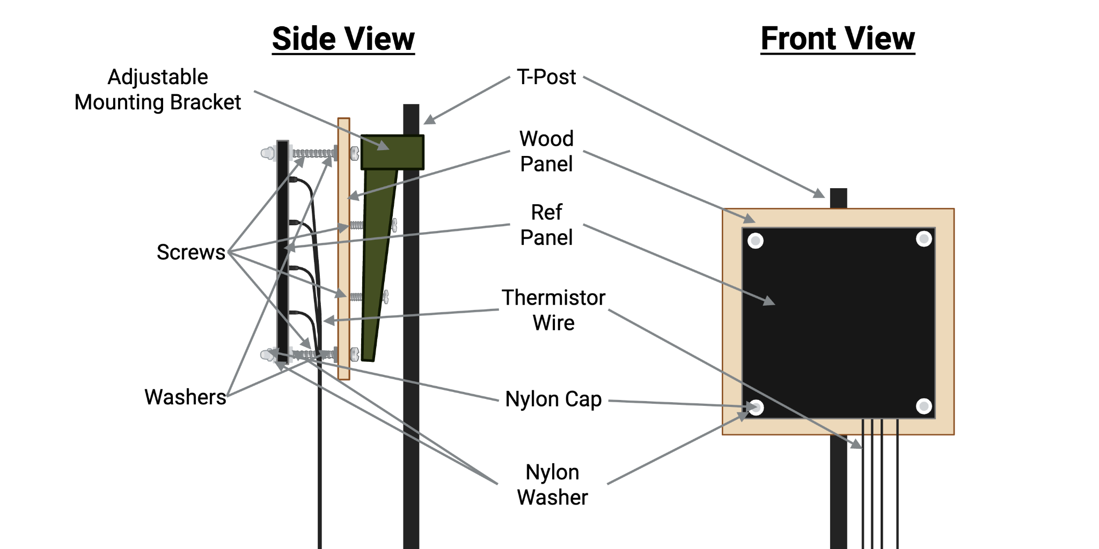
The number of mounting screws and thermistors may vary depending on panel dimensions. A wood backing is used to insulate the panel and reduce thermal influence from the post and surrounding structures. Screws were inserted from the wood board side through the panel, with an air gap maintained between the panel and the wood. To minimize thermal interference, we used nylon washers on both sides of the panel and a nylon screw cap on the side facing the camera. A standard metal washer was placed on the wood board side for structural support. Additionally, the portion of the screw passing through the panel was wrapped in teflon tape to reduce thermal conduction. The wood board was then securely attached to the adjustable mounting bracket using as many screws as needed to ensure stability. We recommend using an adjustable mounting bracket to allow for panel angle adjustments (e.g., a solar panel brackets like this one or this one). Created in BioRender. Diehl, J. (2026) https://BioRender.com/bs4nm9y

Figure S.5 Reference Panel in Field
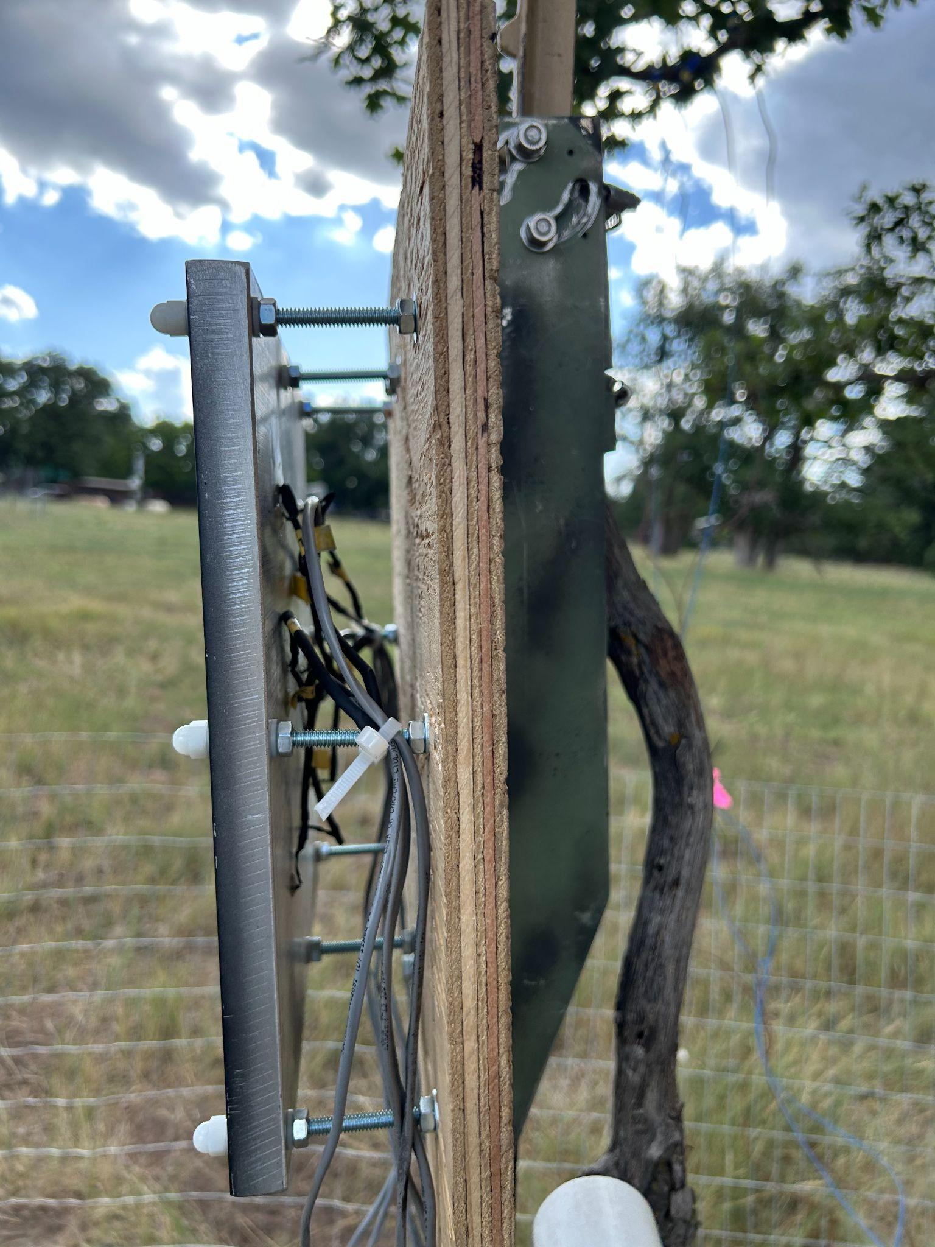
Example reference panel mounting for a 30cm x 30cm, 2cm deep panel deployed in the field. Eight screws were used to attach the panel to the wood backing, positioned ~1 cm from the edges. Nine thermistors were evenly spaced across the panel, approximately 7.6 cm from the edges and 7.6 cm apart from each other. The thermistor wire was zip-tied to one of the mounting screws for strain relief.

Table S.1 Metadata file format

Label | Format / Type | Description
siteID | string | A short, unique name using only letters and numbers (no spaces or special characters). Example: harvbarn for Harvard Forest Barn Tower.
siteName | string | A descriptive name for your site, including location and context. Example: Harvard Forest Barn Tower.
hasEC | dropdown (Yes/No) | Select “Yes” if the site is co-located with an eddy covariance (EC) tower.
ecID | string | EC tower ID matching AmeriFlux/ICOS ID (e.g., US-Ha1).
ecLink | URL | Link to EC data (e.g., AmeriFlux or ICOS portal).
siteStatus | dropdown (Active/Inactive) | Indicate whether the site is currently collecting data. If inactive, provide end date.
startDate | date (YYYY-MM-DD) | Site start date.
endDate | date (YYYY-MM-DD) | Site end date (leave blank if ongoing).
contactName[] | array[string] | Name(s) of site contact(s).
contactEmail[] | array[string] | Email(s) of site contact(s).
lat | float | Latitude in decimal degrees (negative for Southern Hemisphere).
long | float | Longitude in decimal degrees (negative for Western Hemisphere).
elev | float | Elevation at base of tower (meters above sea level).
timezone | int | UTC offset (standard time only, e.g., -7 for MST).
MAT_site | float | Mean Annual Temperature (°C).
MAP_site | float | Mean Annual Precipitation (cm).
PFT | dropdown | Dominant CLM Plant Functional Type (see CLM Table 2.2.1).
species_common[] | array[string] | Dominant species near measurement area (common names).
species_scientific[] | array[string] | Dominant species near measurement area (scientific names).
brand_model | string | Brand and model of instrument (e.g., FLIR A655sc).
pixelWidth | int | Native image width in pixels.
pixelHeight | int | Native image height in pixels.
lastCalibrationDate | date (YYYY-MM) | Date of last factory calibration.
purchaseDate | date (YYYY-MM) | Date of purchase (used if calibration date is unknown).
tempErrorMin | float | Lower bound of manufacturer-reported temperature error (°C).
tempErrorMax | float | Upper bound of manufacturer-reported temperature error (°C).
NETD | float | Manufacturer-reported thermal sensitivity (noise equivalent temperature difference, NETD; in mK).
hasEnclosureWindow | dropdown (Yes/No) | Select "No" if instrument lens was not enclosed.
enclosureTransmittance | float (0–1) | Transmittance of enclosure window, if applicable.
fovAngle | float | Camera’s field of view (FOV) angle in degrees.
cameraMountAngle | float | Mount angle relative to horizontal (0° = horizontal, 90° = nadir).
cameraOrientation | dropdown | Cardinal direction the camera is facing (e.g., N, NE, E, etc.).
cameraZenith | float | Camera viewing zenith
cameraAzimuth | float | Camera viewing azimuth
cameraHeight | float | Height of camera above ground (m).
samplingInterval | int | Time between image captures (minutes).
softwareOverride | boolean | Were camera settings (emissivity, distance, etc.) overridden?
software_emissivity | float (0–1) | Emissivity used in software (if override not available).
software_transmittance | float (0–1) | Transmittance used in software.
software_distance | float | Distance used in software (meters).
pd_tier | string | Pre-deployment Testing tier.
corrM_tier | string | Correction Measurement tier.
rp_tier | string | Reference Panel tier.
ref_panel_id[] | array[string] | Unique IDs for reference panels. Allow for multiple panel inputs.
ref_panel_width[] | array[float] | Width of each panel (cm).
ref_panel_height[] | array[float] | Height of each panel (cm).
ref_panel_thickness[] | array[float] | Thickness of each panel (cm).
ref_panel_material[] | array[string] | Panel material (e.g., Copper).
ref_panel_emissivity[] | array[float (0–1)] | Emissivity of each panel.
ref_panel_distance[] | array[float] | Distance from camera to each panel (m).
ref_panel_angle[] | array[float] | Mount angle of each panel (degrees from horizontal).
ref_panel_independent_contact[] | array[dropdown (Yes/No)] | Whether panels were independently instrumented.
ref_panel_independent_contact_typ[] | array[string] | Reference panel measurement sensor type and placement method.
ref_interval[] | array[int] | Measurement frequency for panels (minutes).
RGB_tier | string | RGB camera tier.
conM_tier | string | Contact Measurement tier.
conM_typ | string | Contact measurement sensor type and placement method, if applicable.
emiss_tier | string | Emissivity value tier.
has_rois | dropdown (Yes/No) | Optional: Have regions of interest (ROIs) been defined? Allow for multiple ROI inputs.
roi_id[] | array[string] | Optional: Unique identifiers for ROIs.
roi_species_common[] | array[string] | Optional: Dominant species (common name) in ROI.
roi_species_scientific[] | array[string] | Optional: Dominant species (scientific name) in ROI.
roi_emissivity[] | array[float (0–1)] | Optional: Emissivity of each ROI.
roi_distance[] | array[float] | Optional: Distance from camera to ROI (m).
camera_shift | dropdown (Yes/No) | Known camera shifts
camera_shift_date | date (YYYY-MM-DD) | Date of known camera shift

Table S.2 Reference panels estimated emissivity values

The follow material emissivity’s were measured with a Fourier-transform infrared spectrometer (Nicolet iS10) following (Richardson et al., 2021).

Material | Emissivity
ESLI black velvet | 0.99
Gambel oak (Quercus gambelii) bark | 0.98
Western wheatgrass (Pascopyrum smithii) | 0.98
SJ C 3 royalty black velvet fabric | 0.97
Silver maple (Acer saccharinum) bark | 0.97
D25C16 | 0.97
BIC white out (3 coats on 1.27mm thick aluminum metal tree tag) | 0.96
Dried out western wheatgrass (Pascopyrum smithii) | 0.96
Aeroglaze Z306 | 0.96
Krylon flat black spray paint (3 coats on 1.27mm thick aluminum metal tree tag) | 0.96
Silver maple (Acer saccharinum) leaf | 0.96
Gambel oak (Quercus gambelii) leaf | 0.96
Black electrical tape (1 layer on 1.27mm thick aluminum metal tree tag) | 0.95
Krylon ultra flat black spray paint model number: K04290000 (3 coats on 1.27mm thick aluminum metal tree tag) | 0.94
Rustoleum satin spray paint (3 coats on 1.27mm thick aluminum metal tree tag) | 0.94
Krylon matte black spray paint (3 coats on 1.27mm thick aluminum metal tree tag) | 0.94
Wood block | 0.94
Rustoleum flat spray paint (3 coats on 1.27mm thick aluminum metal tree tag) | 0.94
Aluminum alloy 6061 panel 1.27cm thick (3 coats Krylon matte black spray paint) | 0.94
Aluminum alloy 6061 panel 1.9cm thick (3 coats Krylon matte black spray paint) | 0.94
Aluminum alloy 6061 panel 2.54cm thick (3 coats Krylon matte black spray paint) | 0.94
Glidden Max-Flex black spray paint (3 coats on 1.27mm thick aluminum metal tree tag) | 0.93
Aluminum alloy 6061 panel 0.635cm thick (3 coats Krylon matte black spray paint) | 0.93
Stove Bright high temperature black stove paint (3 coats on 1.27mm thick aluminum metal tree tag) | 0.91
Black acrylic paint (3 coats on 1.27mm thick aluminum metal tree tag) | 0.91
Styrofroam | 0.71
Rustoleum metallic spray paint (3 coats on 1.27mm thick aluminum metal tree tag) | 0.54
Metal tree tag (1.27mm thick, aluminum) | 0.13
6061 T651 aluminum sheet metal (1.524mm thick) | 0.09
Reynolds wrap aluminum foil hammered down flat | 0.07
Pure copper anode sheet (99.95% purity copper, 1mm thick) | 0.06
Reynolds wrap aluminum foil crinkled | 0.06

References

Garcia-Santos, V., Valor, E., Caselles, V., Mira, M., Galve, J. M., & Coll, C. (2013). Evaluation of Different Methods to Retrieve the Hemispherical Downwelling Irradiance in the Thermal Infrared Region for Field Measurements. IEEE Transactions on Geoscience and Remote Sensing, 51(4), 2155–2165. https://doi.org/10.1109/TGRS.2012.2209891
Göttsche, F., Olesen, F. S., Hoyer, J. L., Wimmer, W., & Nightingale, T. (2017). Fiducial Reference Measurements for Validation of Surface Temperature from Satellites (FRM4STS) Technical Report TR-3: A framework to verify the field performance of TIR FRM. (Reference OFE-D-120-V1-Iss-3-Ver-1-ISSUED.).
Johnston, M. R., Andreu, A., Verfaillie, J., Baldocchi, D., González-Dugo, M. P., & Moorcroft, P. R. (2021). Measuring surface temperatures in a woodland savanna: Opportunities and challenges of thermal imaging in an open-canopy ecosystem. Agricultural and Forest Meteorology, 310, 108484. https://doi.org/10.1016/j.agrformet.2021.108484
Muller, J. D., Rotenberg, E., Tatarinov, F., Vishnevetsky, I., Dingjan, T., Kribus, A., & Yakir, D. (2021). ‘Dual‐reference’ method for high‐precision infrared measurement of leaf surface temperature under field conditions. New Phytologist, 232(6), 2535–2546. https://doi.org/10.1111/nph.17720
Richardson, A. D., Aubrecht, D. M., Basler, D., Hufkens, K., Muir, C. D., & Hanssen, L. (2021). Developmental changes in the reflectance spectra of temperate deciduous tree leaves and implications for thermal emissivity and leaf temperature. NEW PHYTOLOGIST, 229(2), 791–804. (WOS:000593650300001). https://doi.org/10.1111/nph.16909
Salisbury, J. W. (1998). Spectral Measurements Field Guide (Published by the Defense Technology Information Center as Report No. ADA362372). Earth Satellite Corporation.
Still, C., Powell, R., Aubrecht, D., Kim, Y., Helliker, B., Roberts, D., Richardson, A. D., & Goulden, M. (2019). Thermal imaging in plant and ecosystem ecology: Applications and challenges. Ecosphere, 10(6). https://doi.org/10.1002/ecs2.2768
Vollmer, M., & Möllmann, K.-P. (2018). Infrared Thermal Imaging: Fundamentals, Research and Applications (second edition). Wiley-VCH Verlag GmbH & Co. KGaA. https://doi.org/10.1002/9783527693306
Yong Zhang, Zhiguo Rong, Xiuqing Hu, Jingjing Liu, Lijun Zhang, Yuan Li, & Xingying Zhang. (2007). Field measurement of Gobi surface emissivity using CE312 and Infragold Board at Dunhuang calibration site of China. 2007 IEEE International Geoscience and Remote Sensing Symposium, 358–360. https://doi.org/10.1109/IGARSS.2007.4422804

