Assignment 1 Report

Name: Scott Mitchell
Student Number: 20116523
Course: Computer Science
Group: W3

Introduction:
The goal of this assignment is to make a 3–5-page Personal Website, including information such as, a page about myself, a page for my hobbies and another for my interests, along with an introduction page outlining why this website was made and the information that is available on the website.
- Brief introduction
- A page about myself and my experience with html and css
- Hobbies: Gaming, TV, Sports… etc.
- Page on my interest in skateboarding
Wireframes:
Some of the webpages have a very similar layout the only page with major changes is the hobbies page.
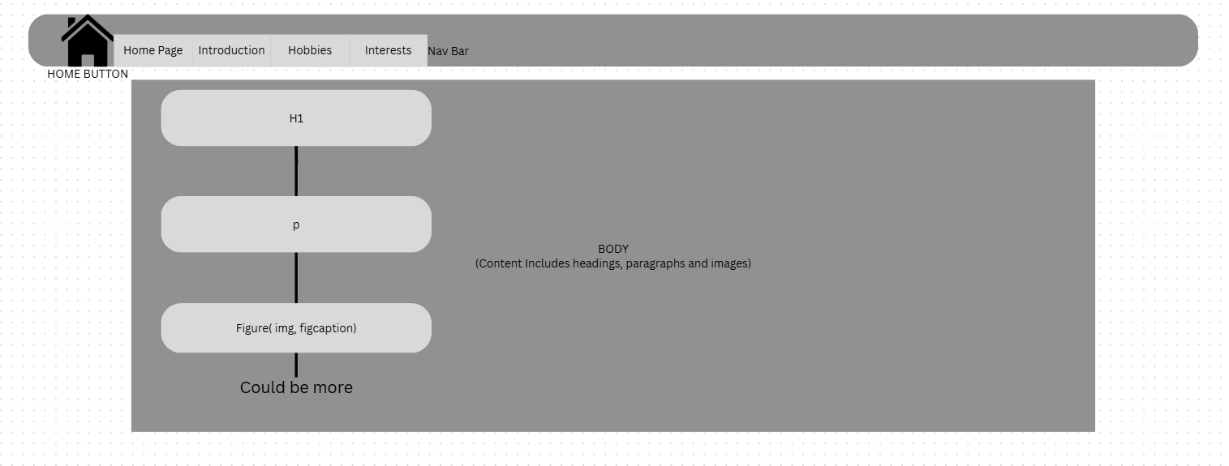
Most of the webpages have a format very similar if not the same as the wireframe above. The only distinct webpage is the Hobbies page as it has a table in its body adding another element into the mix.
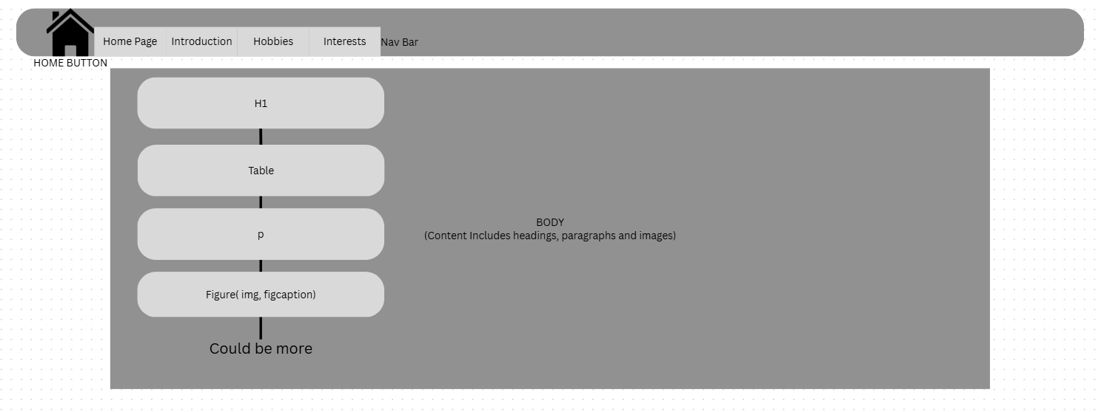
Visual Design:
For my website I want a nice cool colour background where no colours are clashing together, and everything smelts together. I ended up using the times new roman font for my website, in my opinion it is one of the most professional fonts that can be used.
I want everything to be evenly spaced, and no information can be blocking or obscuring another element in the code.
I plan to change design slightly during the time of completing this assignment, such as slightly changing colour schemes and maybe using different fonts for specific elements.

