Running a Data Set Visualization and Graphing in PyCharm Edu

Scott Miner

Colorado State University – Global Campus

#BEGIN  
  
#########################################################################  
#Python Statistical Data Visualization - Plotting data for presentation  
#########################################################################  
#Pandas use for data structures and data analysis  
# Import the necessary libraries  
  
*import* matplotlib.pyplot *as* plt  
*import* pandas *as* pd  
*import* seaborn *as* sns  
  
# Create Data_Frame from Array. This could also be a data file loaded  
# Three ways to load files  
# cvs read,  
df = pd.DataFrame({  
 'name':['john','mary','peter','jeff','bill','lisa','jose'],  
 'age':[23,78,22,19,45,33,20],  
 'gender':['M','F','M','F','M','F','M'],  
 'state':['CA','DC','CA','DC','VA','NY','NY'],  
 'num_children':[2,0,0,3,2,1,4],  
 'num_pets':[5,1,0,5,2,2,3]  
})  
  
#1 Generate a scatter plot comparing num_children and num_pets  
df.plot(kind='scatter',x='num_children',y='num_pets',color='red')  
plt.show()  
  
#2 Generate a simple bar graph  
df.plot(kind='bar',x='name',y='age')  
plt.show()  
  
#3 Generate Line plot with multiple columns  
ax = plt.gca()  
df.plot(kind='line',x='name',y='num_children',ax=ax)  
df.plot(kind='line',x='name',y='num_pets', color='red', ax=ax)  
plt.show()  
  
#4 Generate Stacked bar plot with two-level group by  
df.groupby(['state','gender'])['name'].size().unstack().plot(kind='bar',stacked=*True*)  
df.sample(n=3)  
plt.show()  
  
#5 Generate a Plot with count of people by gender, spliting by state:  
df.groupby(['gender','state'])['age'].size().unstack().plot(kind='bar',stacked=*True*)  
plt.show()  
  
#6 Generate a violinplot  
fig, ax = plt.subplots()  
ax.violinplot(df["age"], vert=*False*)  
plt.show()  
  
#7 Generate a Plot of the distribution of faculty children  
num_bins = 10  
plt.hist(df['num_children'], num_bins, density=1, facecolor='blue', alpha=0.5)  
plt.show()  
  
#8 Use Seaborn Library to construct a pet plot  
sns.set()  
# Set context to `"paper"`  
sns.set_context("paper")  
# Construct pets plot  
sns.swarmplot(x="num_pets", y="age", data=df)  
  
#9 Save last plot to a file with Permanent link  
# the plot gets saved to 'graphoutput.png' image file  
plt.savefig('graphoutput.png')  
  
# Show plot  
plt.show()  
END

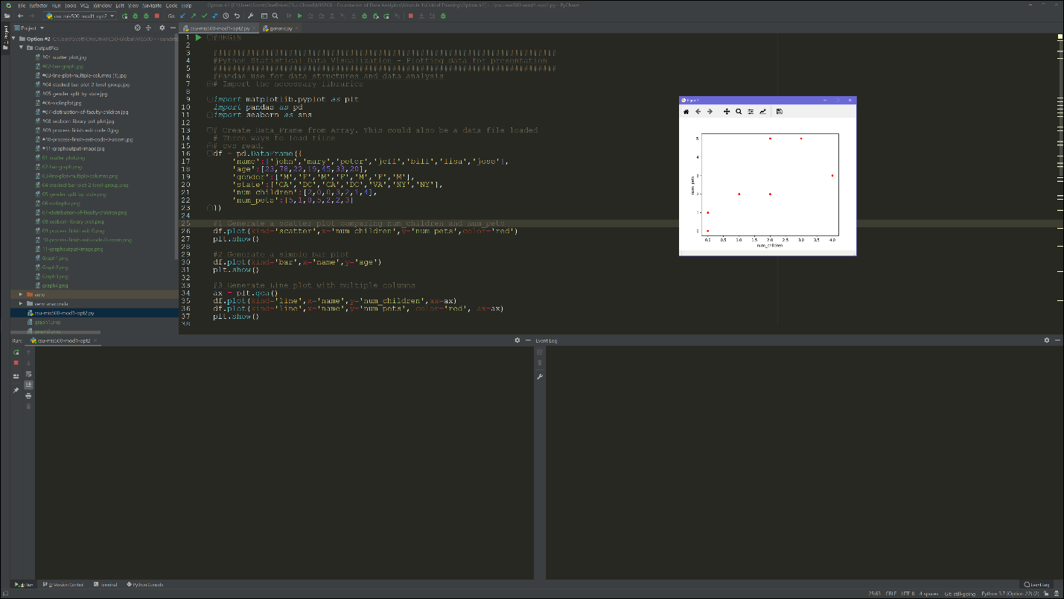

Figure . Scatter Plot

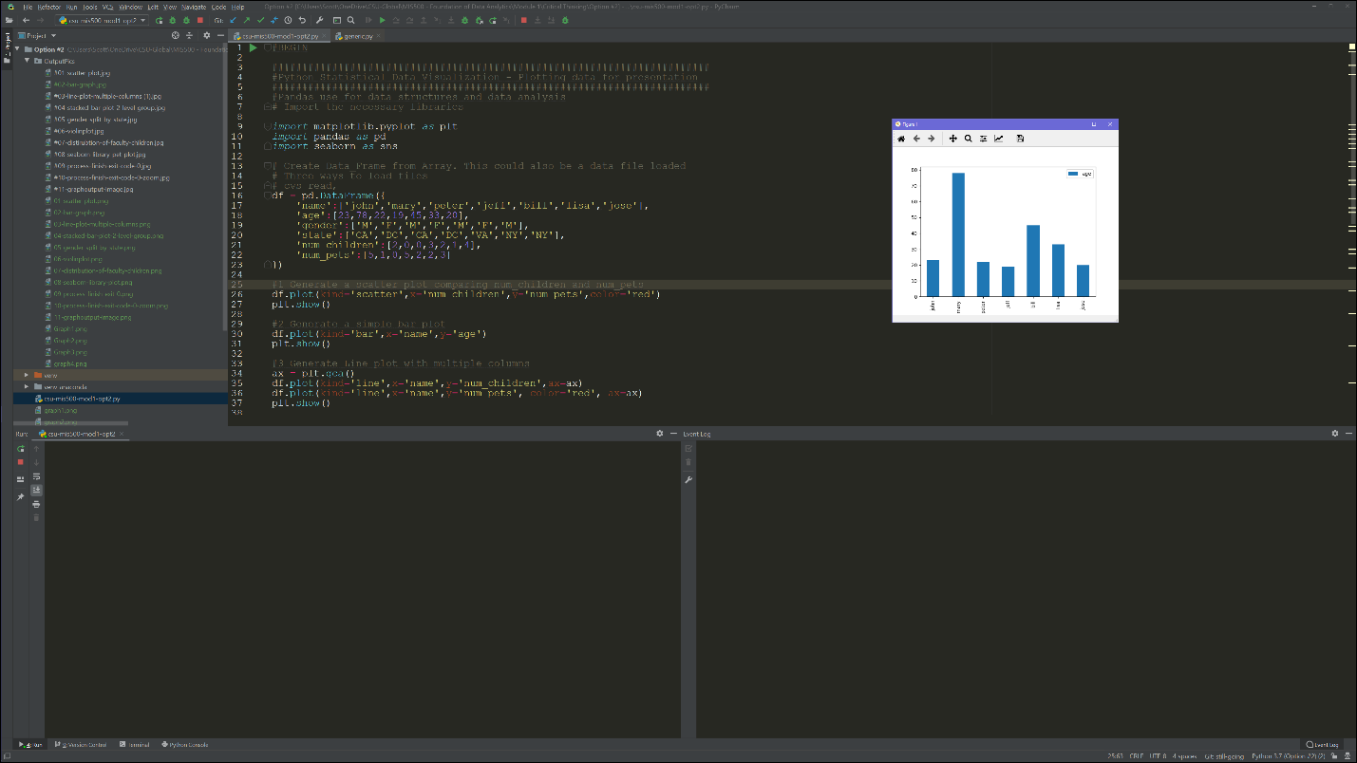

Figure . Bar Graph

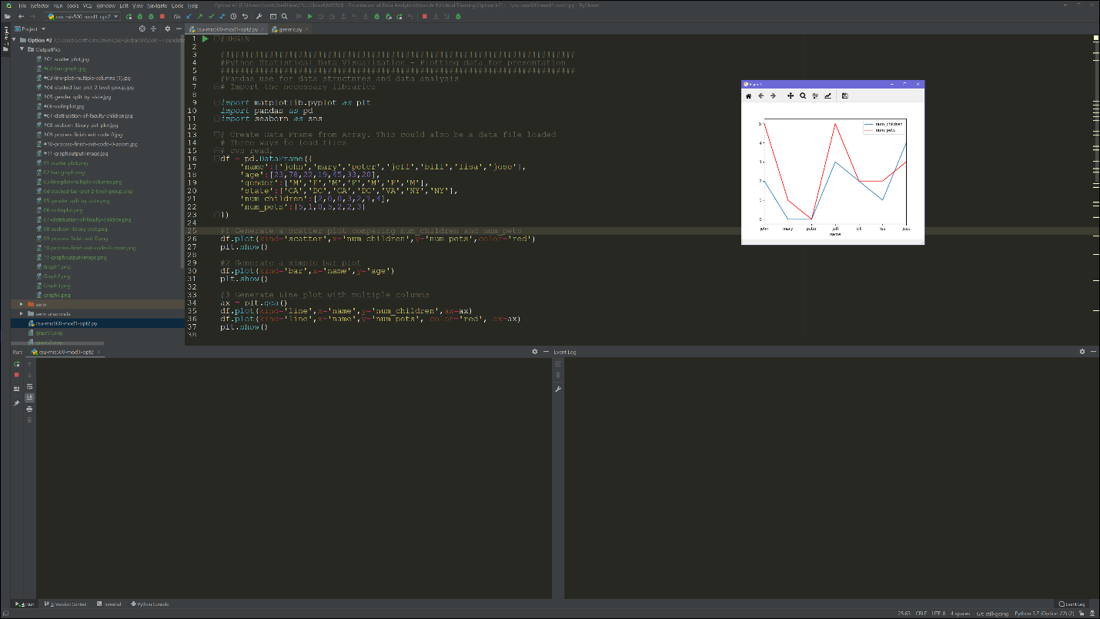

Figure . Line Plot with Multiple Columns

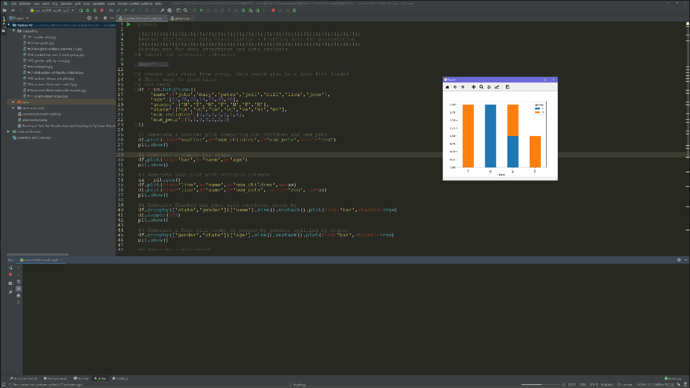

Figure . Stacked Bar Plot with 2 Level Grouping

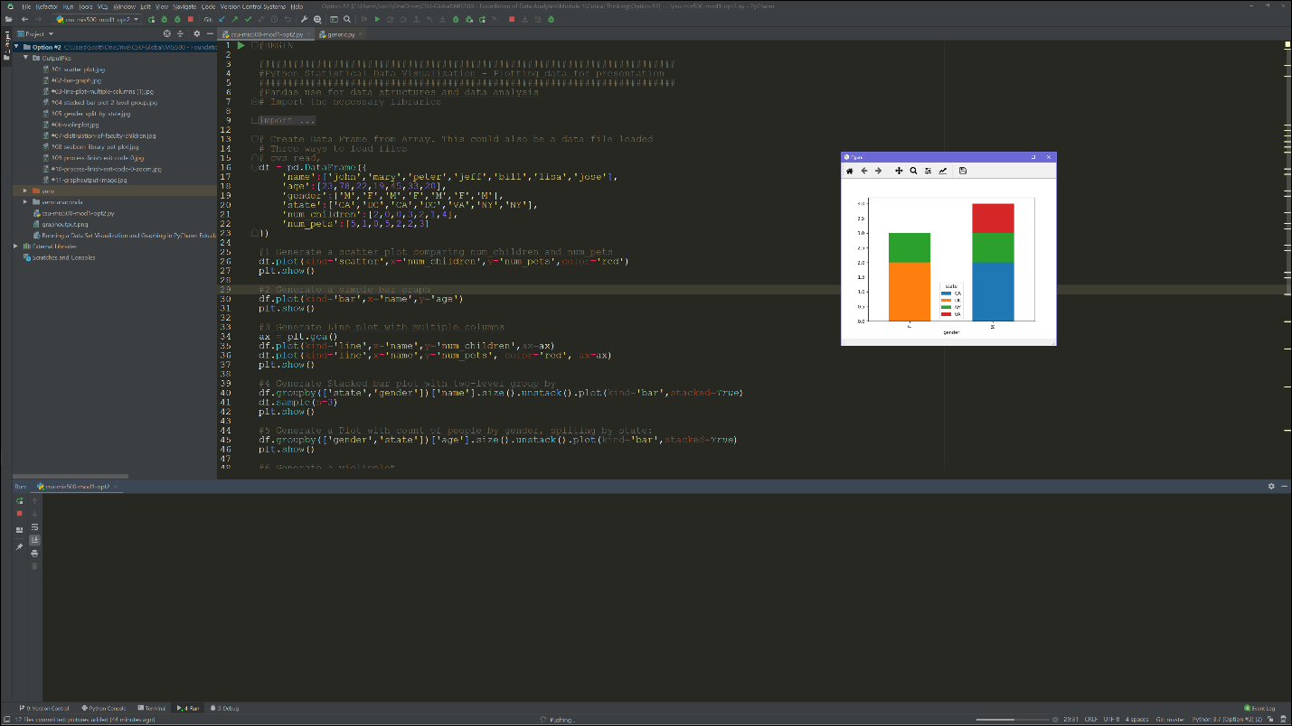

Figure . Count of People by Gender, Split by State

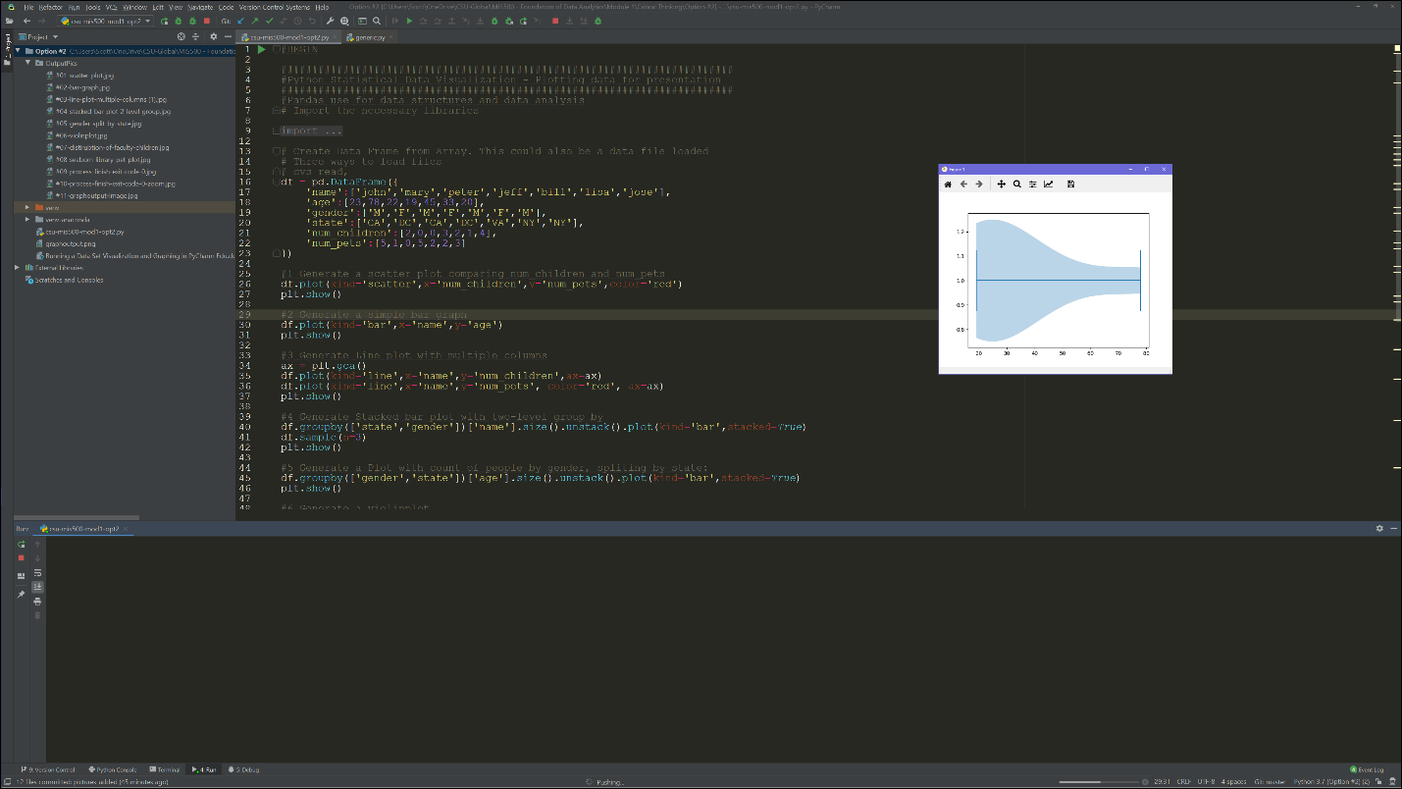

Figure . Violin Plot

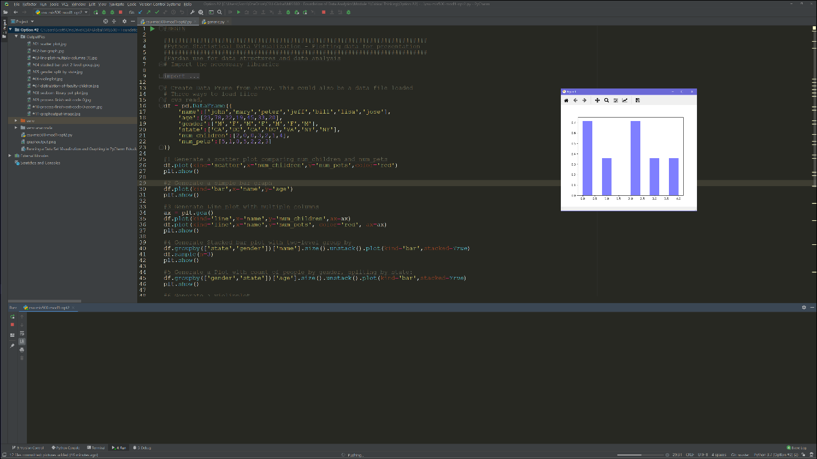

Figure . Distribution of Faculty Children (Bar Graph)

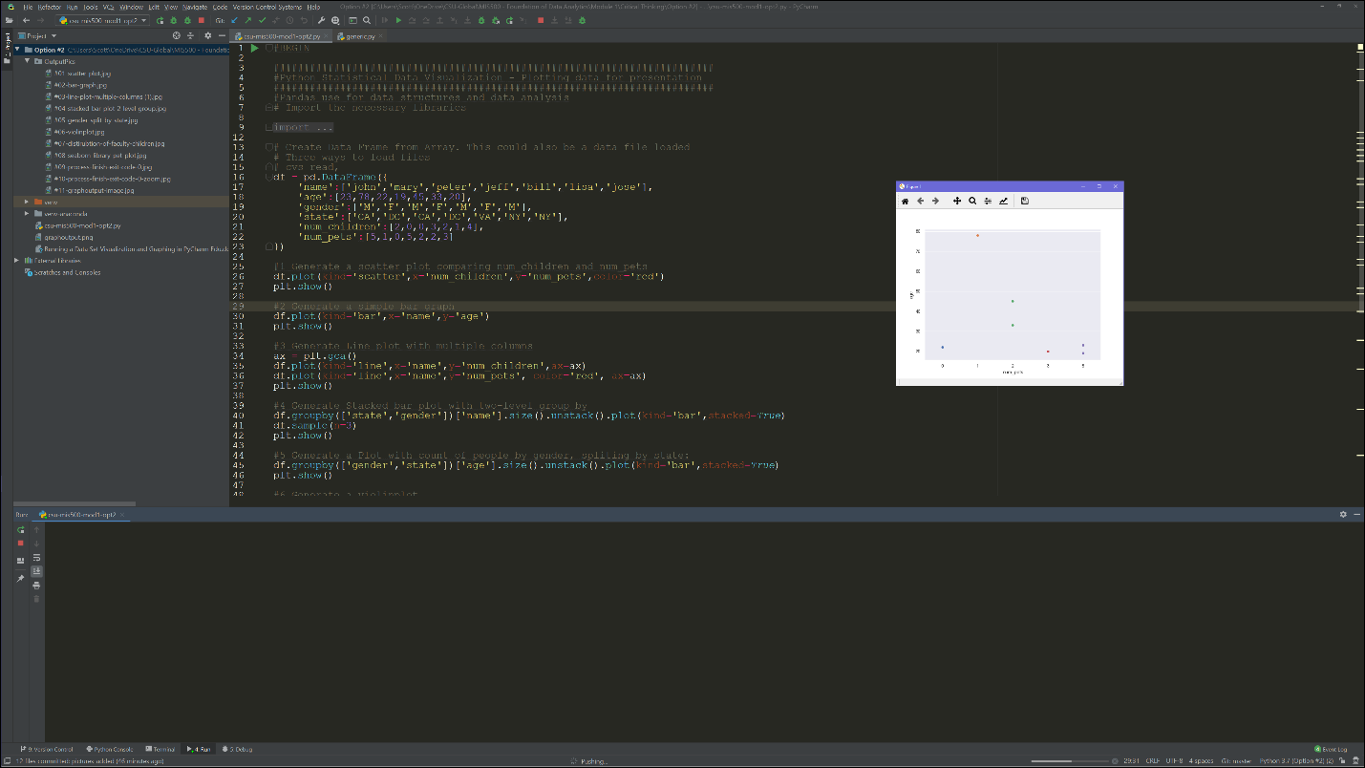

Figure . Seaborn Library Pet Plot

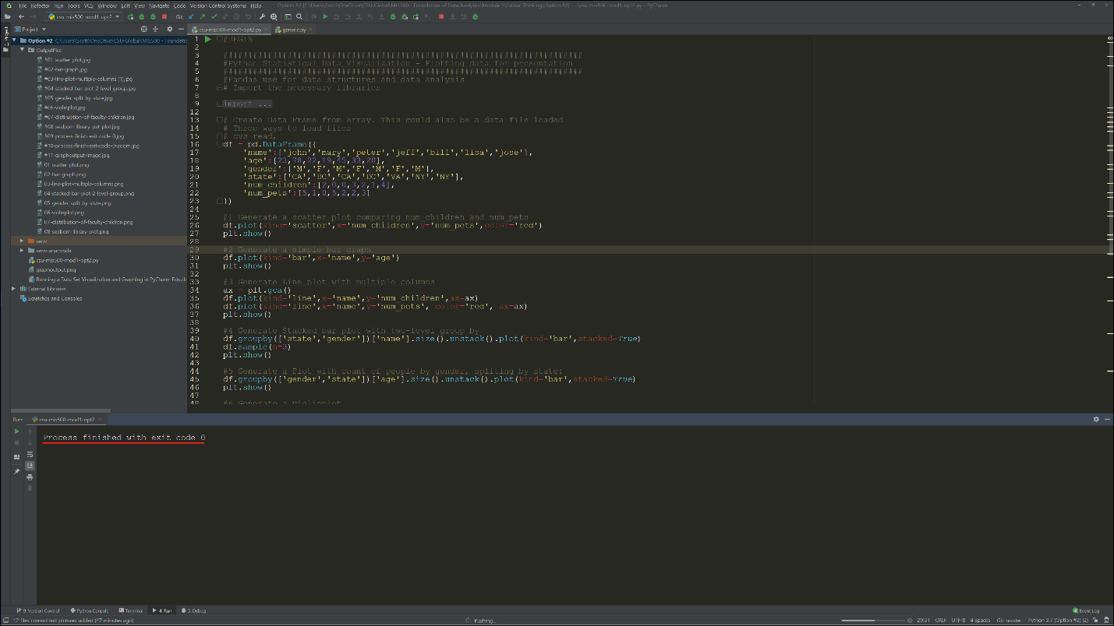

Figure . Program Output (Process finished with exit code 0)

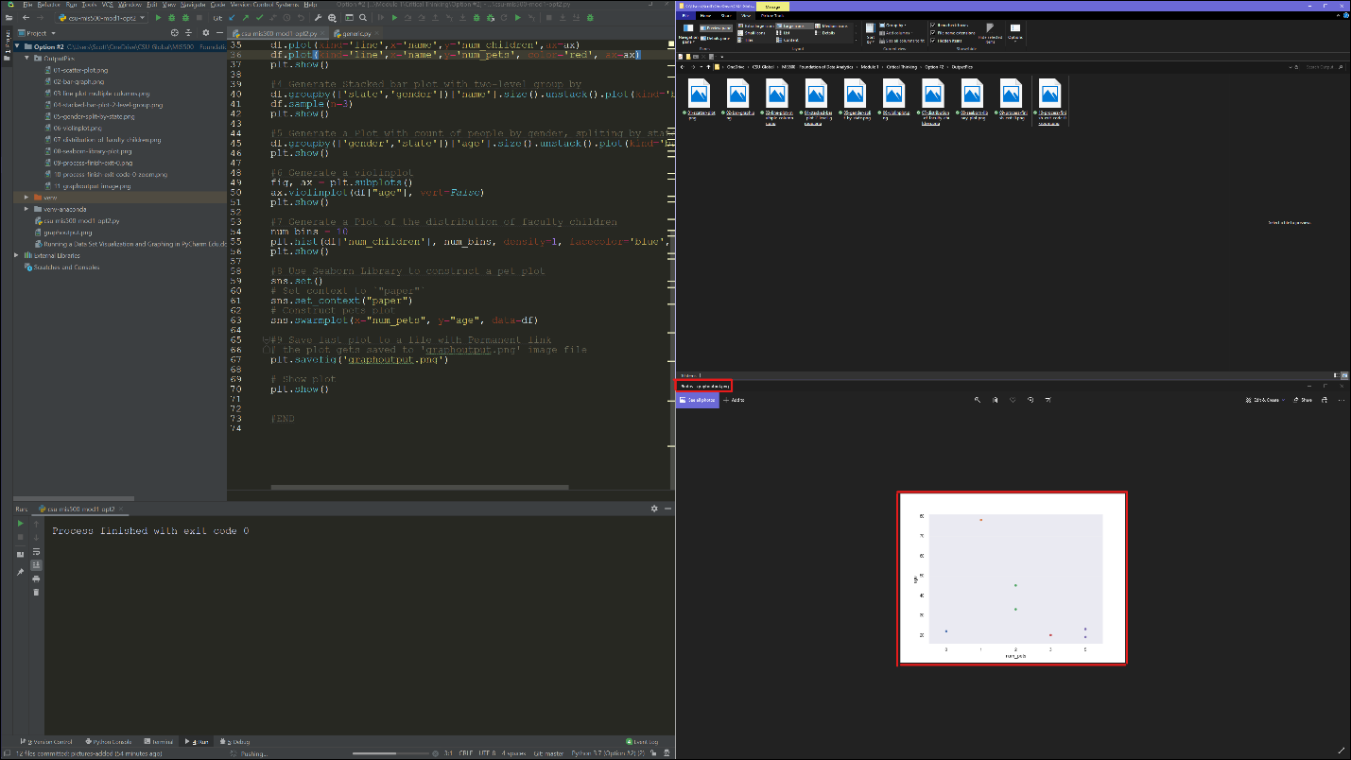

Figure . Graphoutput.png Image Displayed