Implementing SAS Hypothesis Testing

Scott Miner

Colorado State University – Global Campus

**SAS Code**

data TestScores;

input TScore_before TScore_after @@;

datalines;

123 133 135 136 129 135 117 137

120 142 138 135 140 121 145 147

136 168 140 152 146 129 137 145

;

run;

proc print data=TestScores;

run;

ods graphics on;

proc ttest;

paired TScore_before*TScore_after;

run;

ods graphics off;

**Output Screenshots**

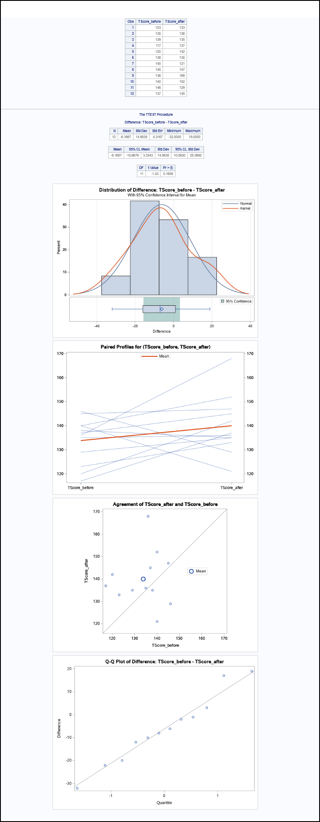

Figure 1. Overview of RESULTS Tab

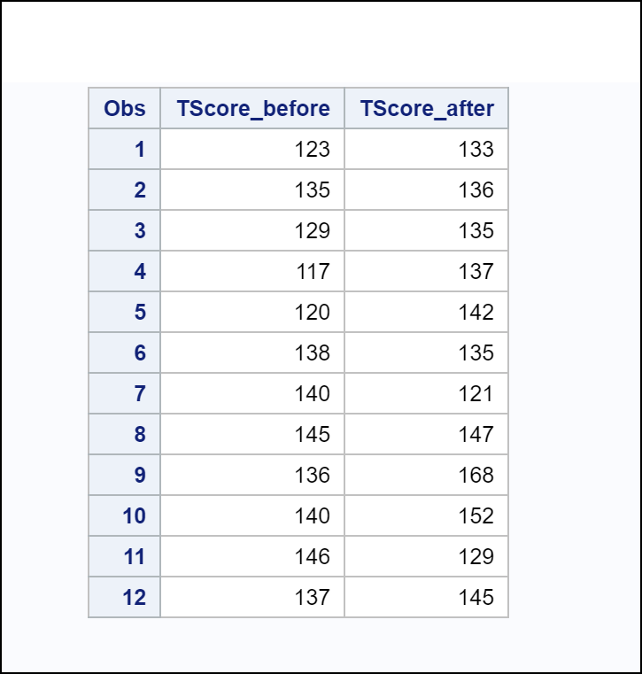

Figure 2. WORK.TESTSCORES Data Set

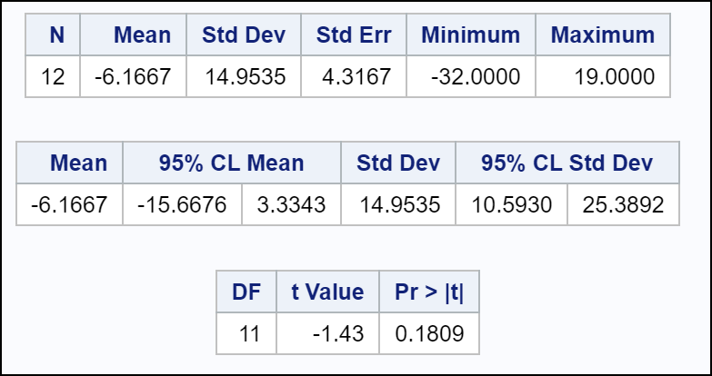

Figure 3. Statistics, Confidence Limits, & T-Tests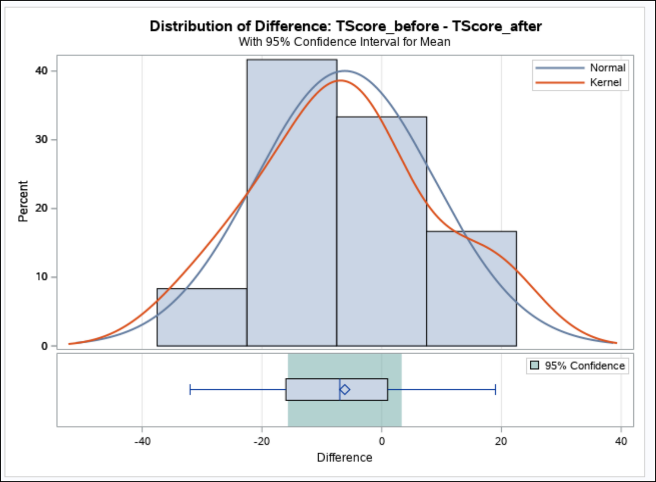

Figure 4. Summary Panel

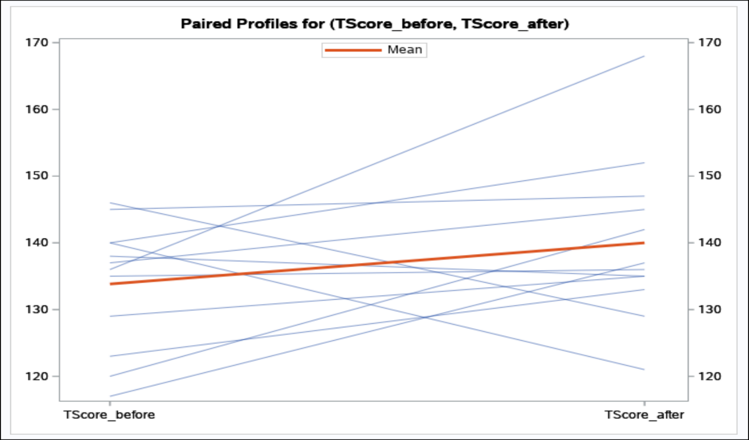

Figure 5. Profiles Plot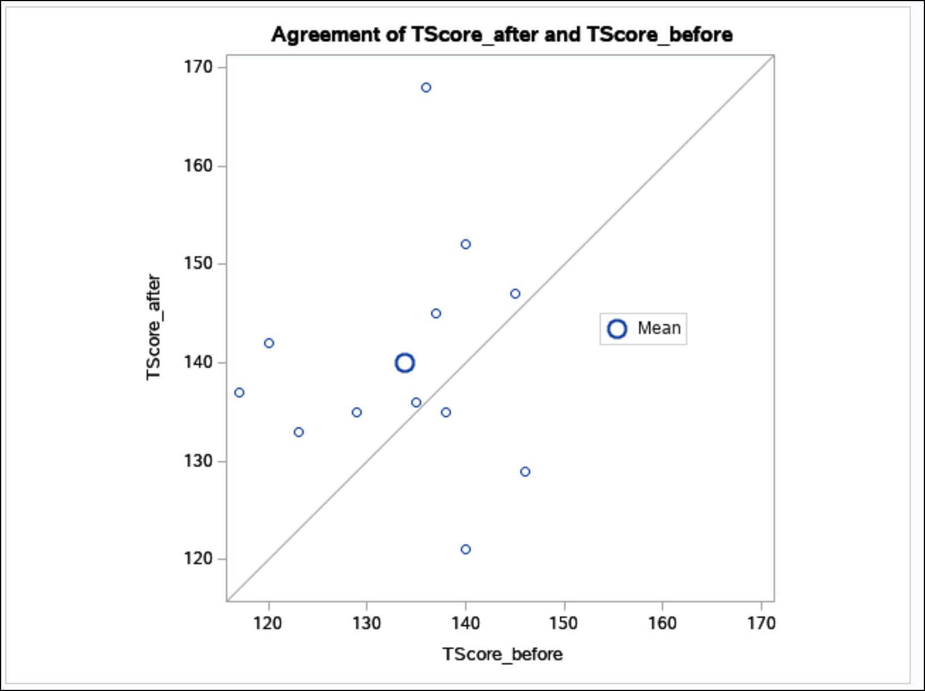

Figure 6. Agreement Plot

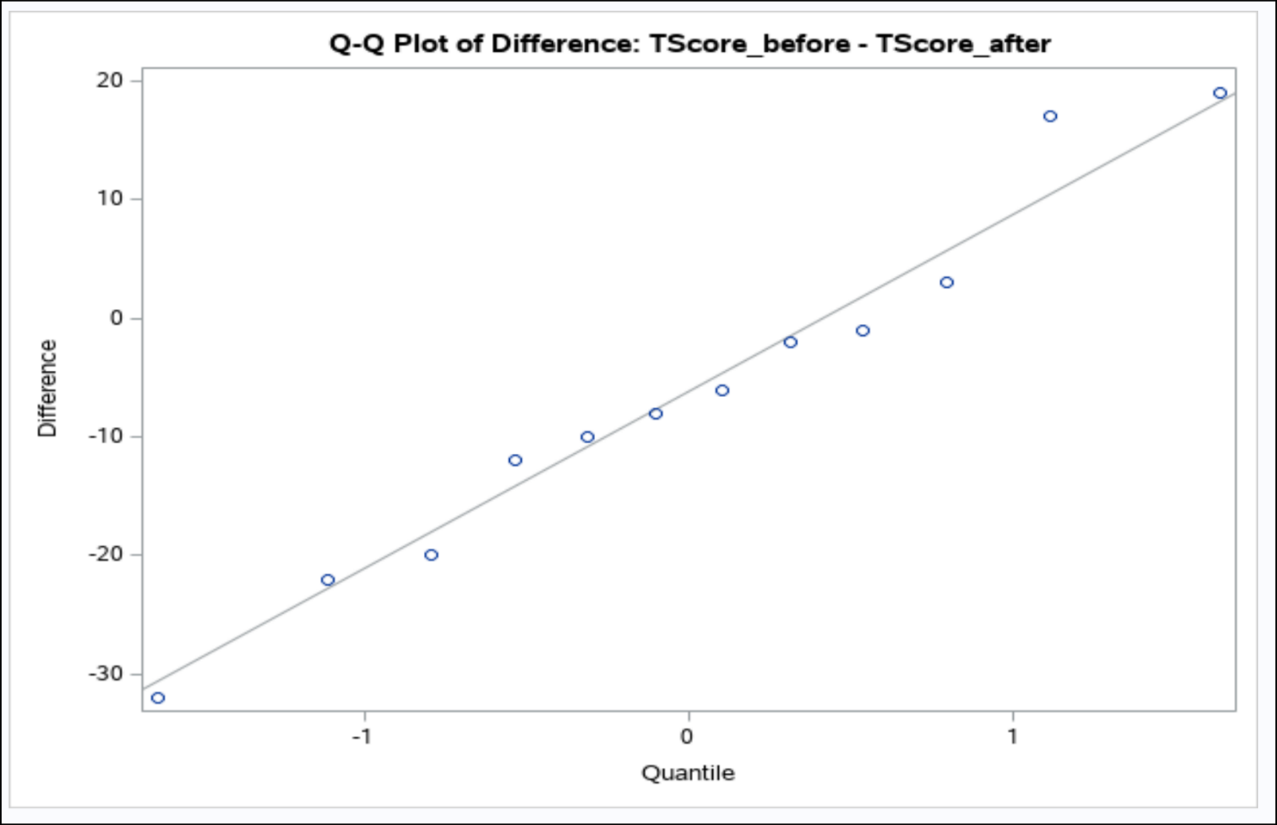

Figure 7. Q-Q Plot

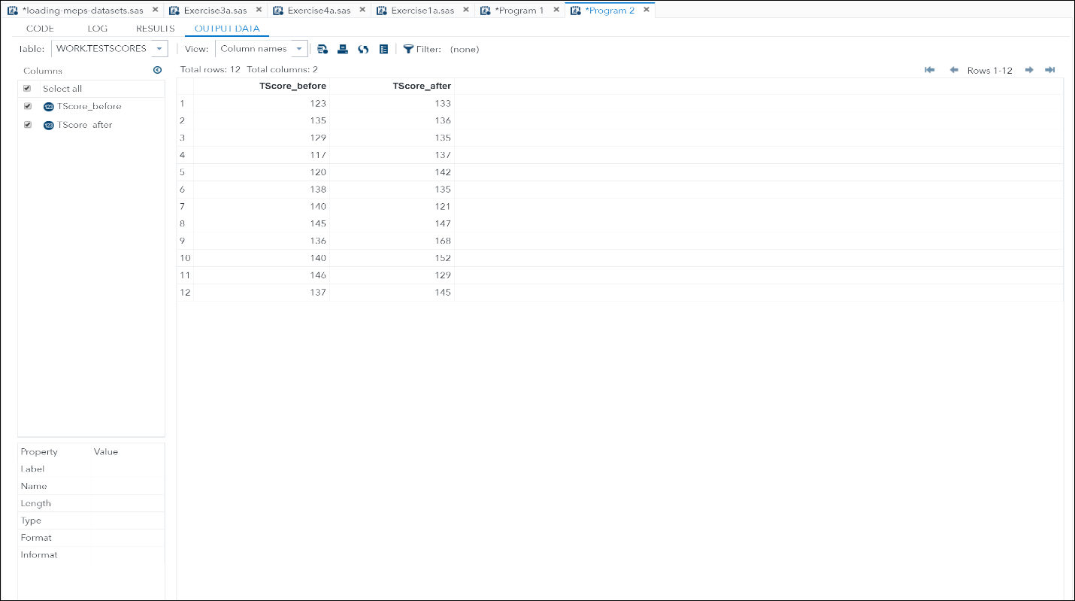

Figure 8. OUTPUT DATA Tab

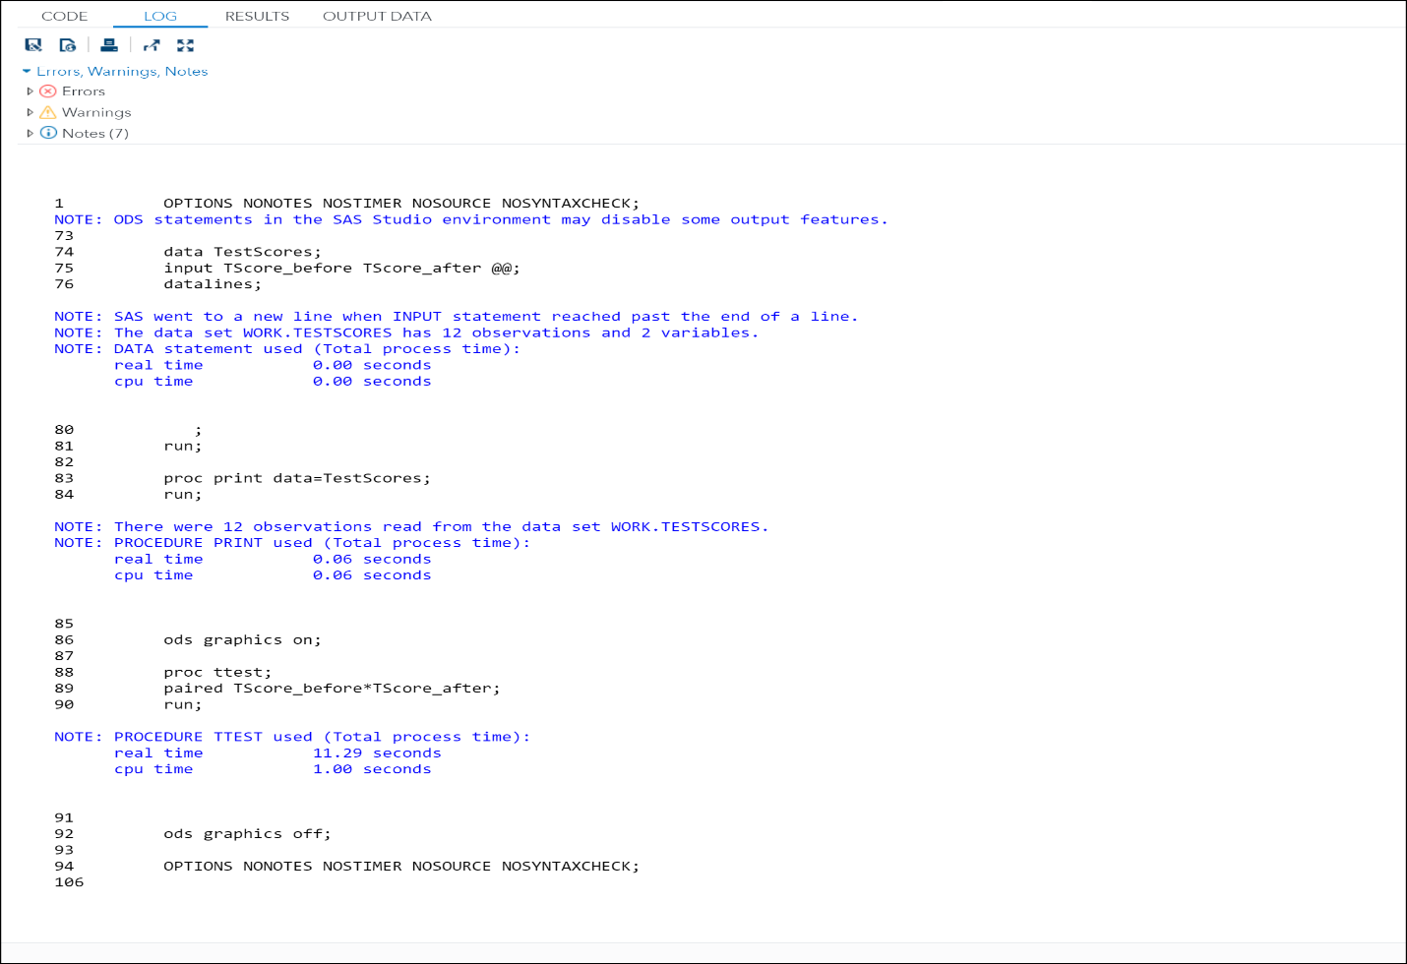

Figure 9. Log Output