Visualizing Earthquake Data in Tableau

Scott Miner

Colorado State University – Global Campus

**Visualizing Earthquake Data in Tableau**

The author used Tableau to create a dashboard for a dataset found on the Tableau Public Resources website. The dataset is an Excel (.xlsx) file and comes from the United States Geological Survey (USGS). The dataset contains all recorded earthquakes between 1900 and 2013 with a magnitude of 6 or greater. In all, the dataset contains over 8,000 records with longitude and latitude information making it ideal for plotting on a geographical map (“Resources | Tableau Public,” n.d.).

The author used a dashboard in Tableau to visualize this dataset. Dashboards combine different worksheets and views into a single, conglomerated view – making a large amount of data available at the touch of a button. Dashboards enable users to effectively filter views based on a common dataset via interactive, intuitive actions. A click on a single plot or line can simultaneously activate a filter on an adjacent map, enabling users to quickly and easily drill-down into subsets of data. In studying dashboards, the author watched three videos available on the Tableau Public Resources website:

* Video 14: Combining Sheets on a Dashboard (5:27)
* Video 15: Adding Interactivity to Dashboards (4:30)
* Video 16: Dashboard Formatting (4:05) (“Resources | Tableau Public,” n.d.)

The following screenshots show some typical use cases for the Earthquake Dashboard as well as focus on some of the elements that comprise it.

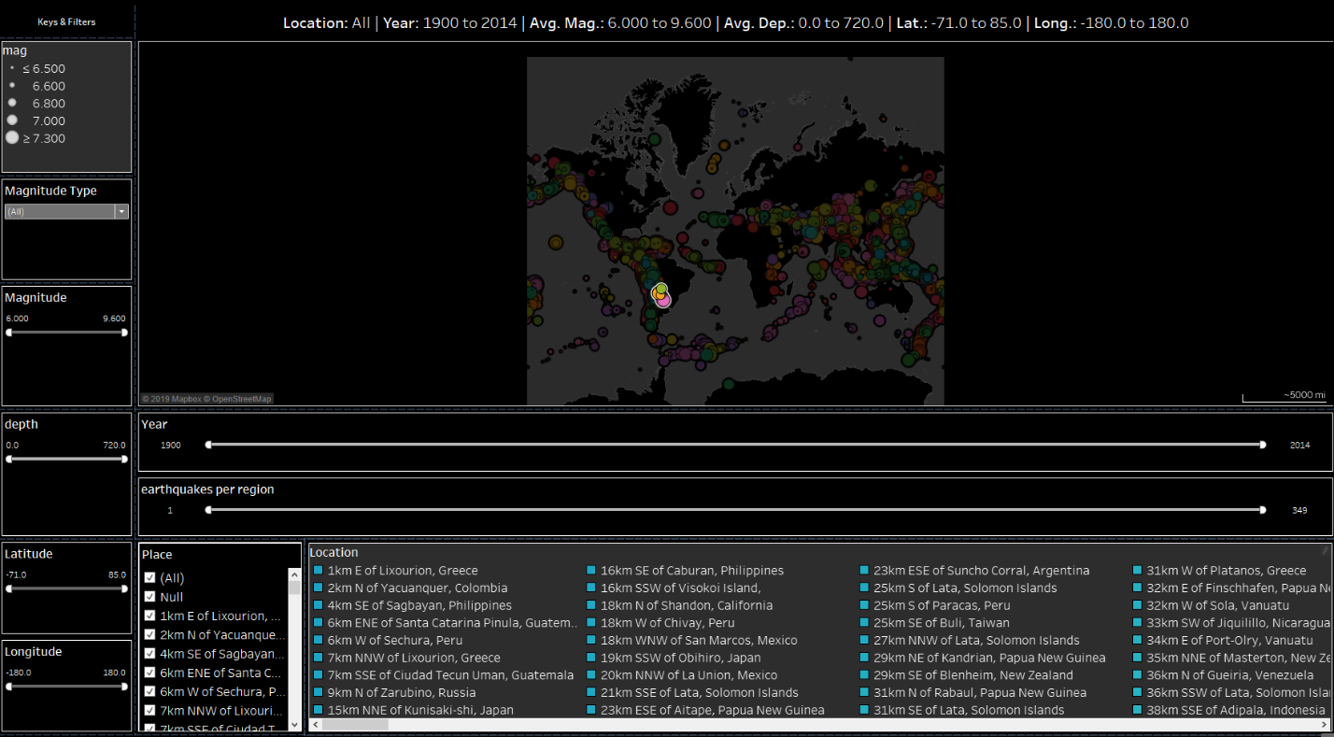

Figure . Primary Investigative Map

Figure 1 displays the **Primary Investigative Map.** The Primary Investigative Map presents users with a high-level overview of all the magnitude 6+ earthquakes that have occurred in the world between 1900 and 2013. Plots on the map are colored by location. When an earthquake occurs, it receives specific latitude and longitude points, as well as general location information, such as “Los Angeles” or “North of the Baltic Sea.” Earthquakes are colored based on their location, enabling users to quickly and easily identify a subset of earthquakes for analysis.

Additionally, users can zoom in on specific regions and filter data using a wide variety of filters, including magnitude type, magnitude size, depth, latitude and longitude, year, and even the number of earthquakes per location. The plots vary by size, which corresponds to the magnitude of the earthquake. A legend in the upper left-hand corner of the dashboard displays this information. The title bar of the view displays relevant location information. Figure 2 presents the results of filtering by a specific magnitude type: “mj” or the Japanese Meteorological Agency magnitude scale (“Seismic magnitude scales,” 2019).

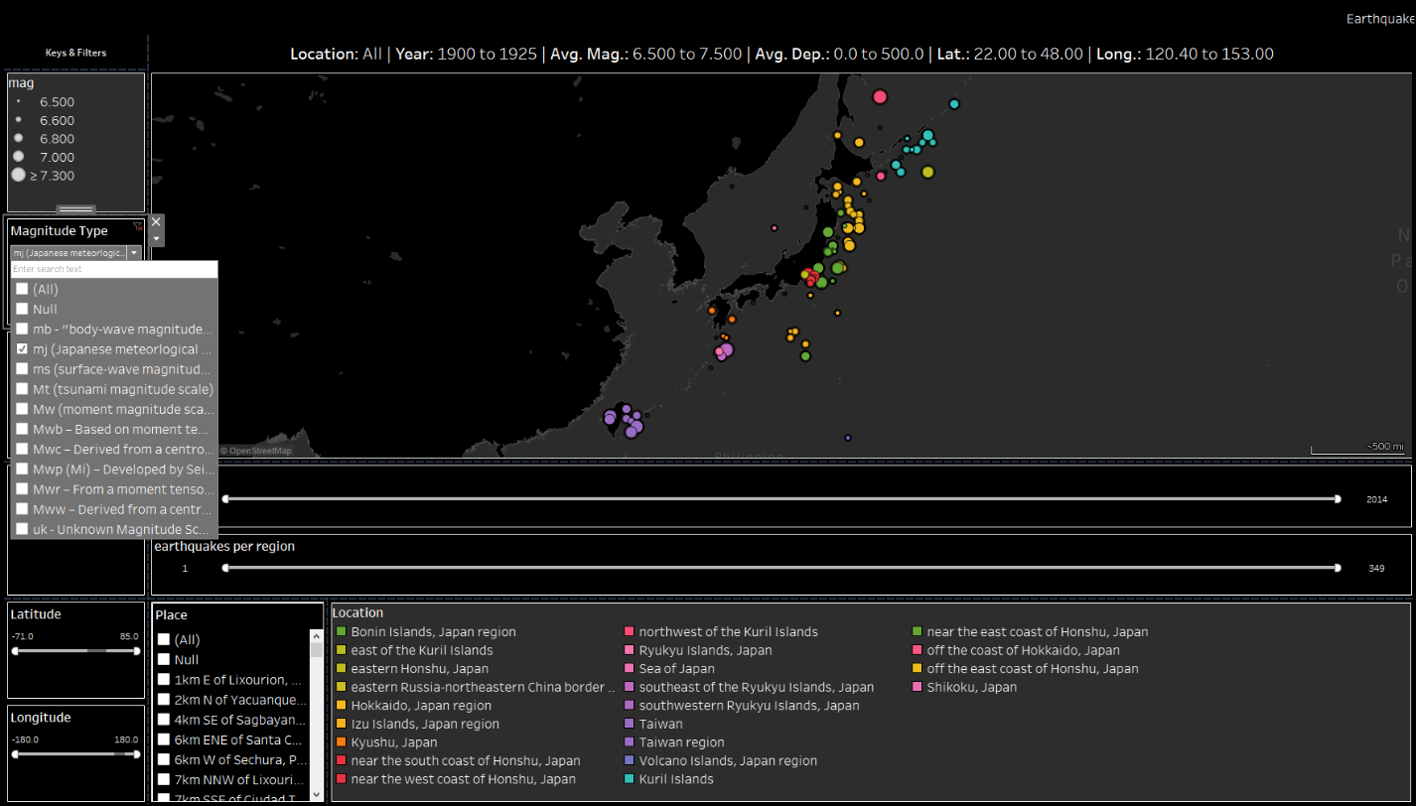

Figure . Filtering by the Japanese Meteorological Agency magnitude scale

In Figure 2, we see the Primary Investigative Map has pinpointed our specified location. Additionally, the location filter has been updated to display the corresponding color scheme. Similarly, Figure 3 presents the results of filtering by latitude and longitude dimensions.

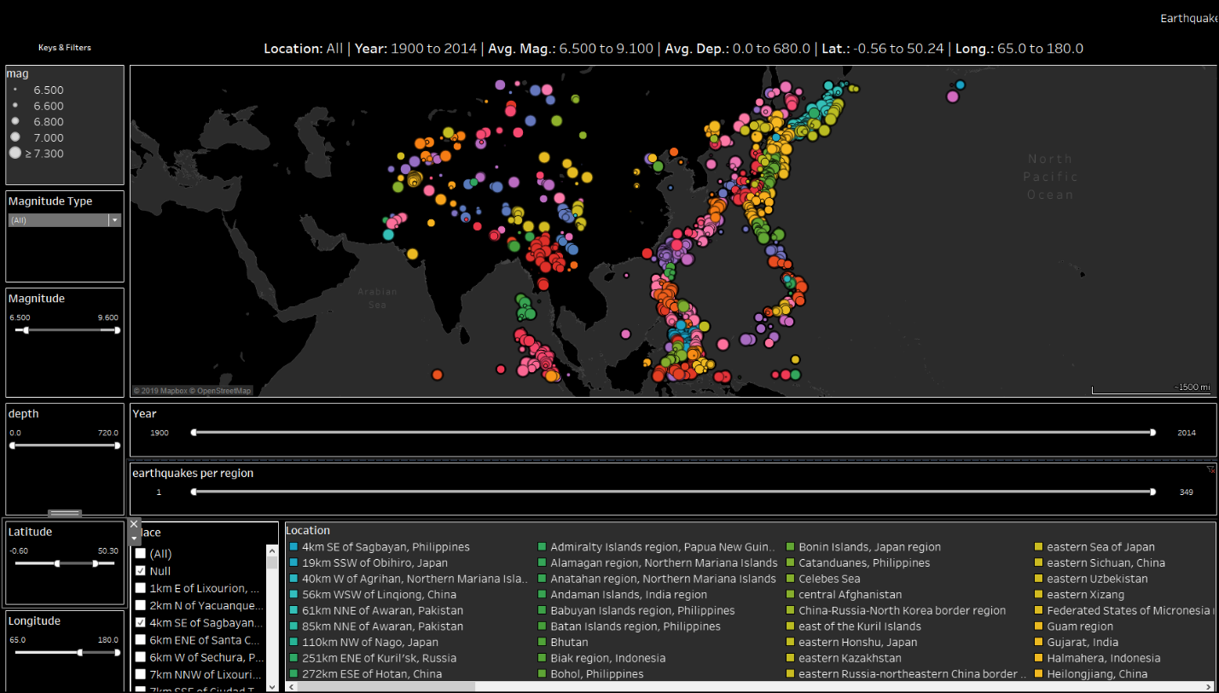

Figure . Filtering by longitude and latitude

Filtering by latitude and longitude enables users to concentrate on a specific “slice” of geographic data.

Now that we have honed in on our specified subset, we need to make a selection for analysis. Our data is well-suited for radial selection via the mouse.

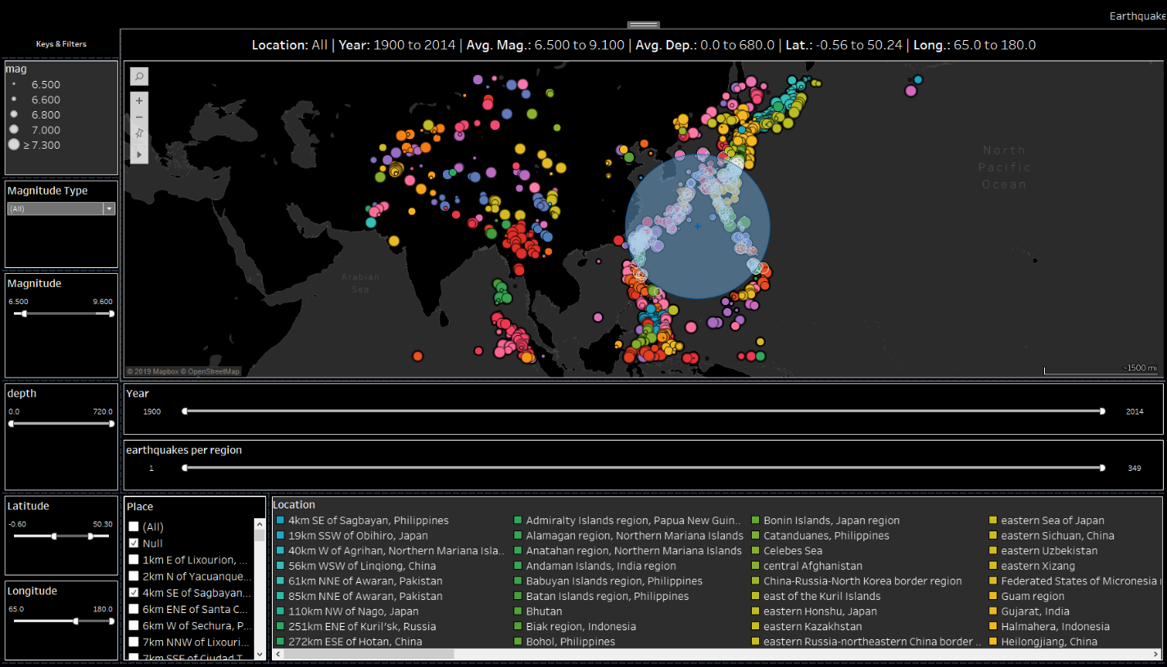

Figure . Filtering a dataset via radial selection with the mouse

Once we make a selection, a corresponding tooltip updates with relevant quake information, including place, latitude, longitude, magnitude, and depth, as shown in figure 5.

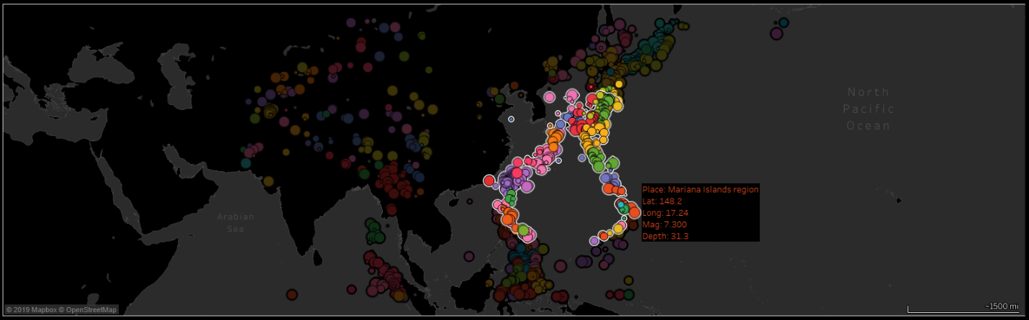

Figure . Radial selection with the corresponding tooltip

Now, we can further drill-down into our subset using the **Location Drill-Down** display, depicted in Figure 6.

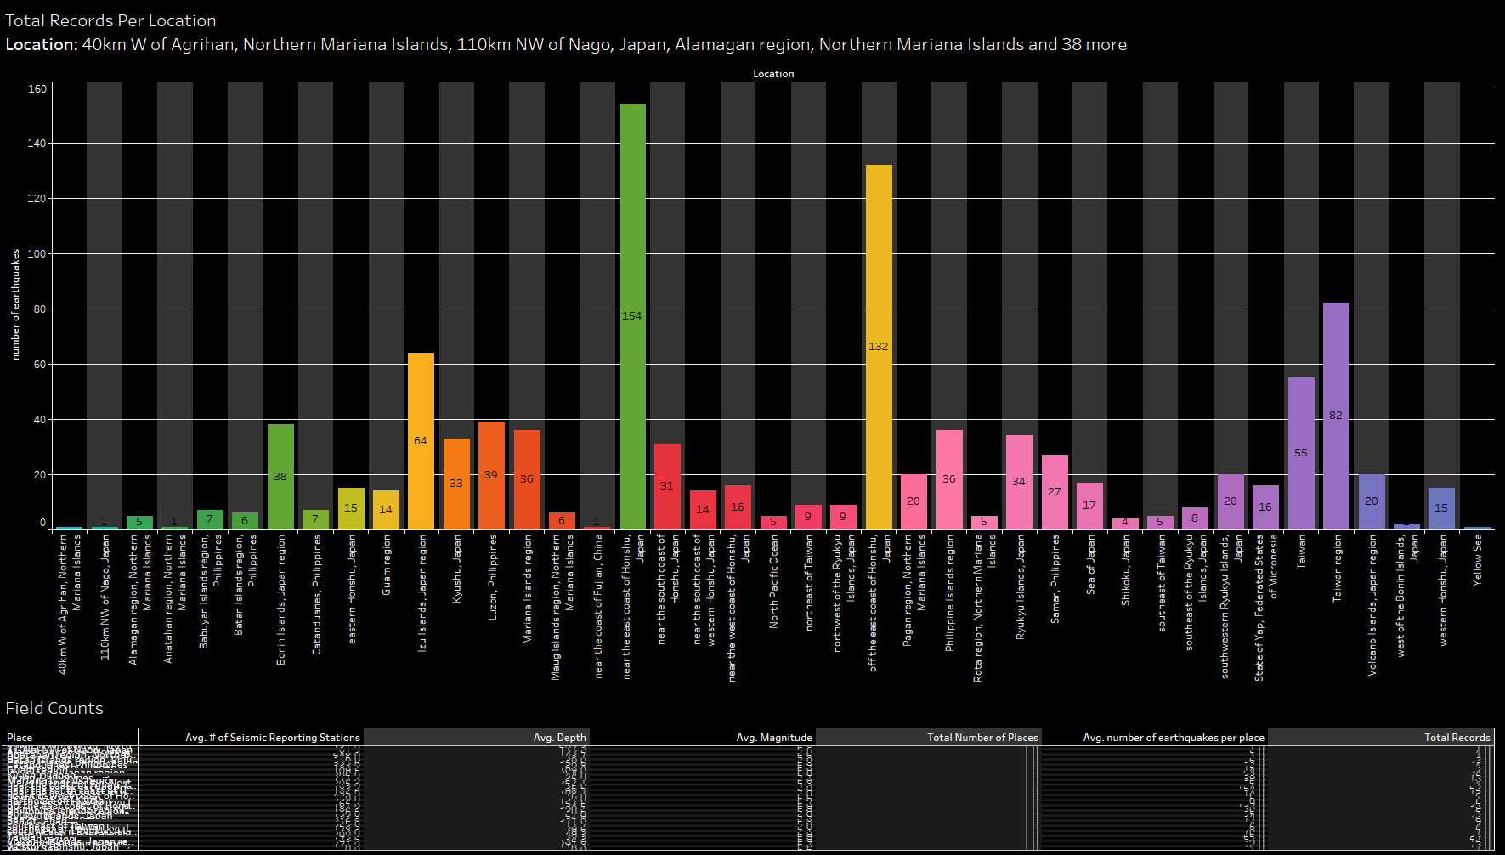

Figure . Location Drill-Down display w/ Statistical Analyses Table below

The **Location Drill-Down** display presents us with the total number of quakes per region for our selection. A glance at this display tells us which locations house the most earthquakes. Below the Drill-Down display, we see the results of the **Statistical Analyses Table**. Because we have yet to zoom in on a specific location, the Statistical Analyses Table is still unreadable. Clicking on a specific location in the Drill-Down display will update the Statistical Analyses Table, as well as enable us to glean more information from the other displays. For example, let’s select the yellow region in Figure 6 labeled “off the east coast of Honshu, Japan,” where we can see 132 earthquakes with a magnitude of 6+ or greater have occurred between 1900 and 2013. Figure 7 displays this selection.

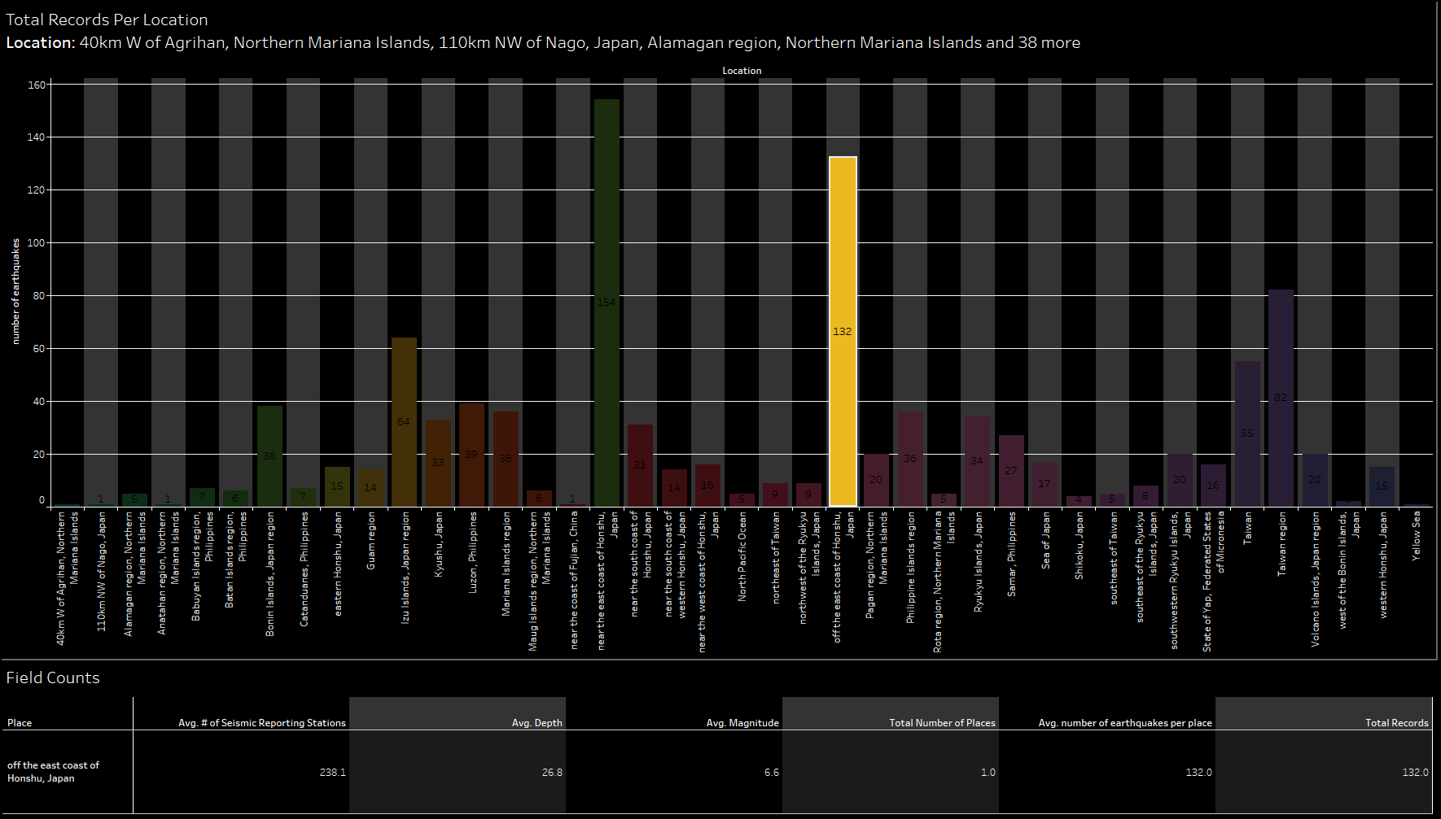

Figure . Selecting “off the east coast of Honshu, Japan” from the Drill-Down display

Notice how after making this selection, the **Statistical Analyses Table** automatically updates to display relevant information for this region, including the average number of seismic stations reporting the quakes, the average magnitudes of the quakes, and the average depths of the quakes (“ComCat Documentation—Event Terms,” n.d.).

Making this selection will update both the **Magnitude and Depth by Year Dual-Axis Display** and the **Time-Series Heatmap Display**. These displays allow end-users to interpret results overtime, make future predictions, and drill-down into the specific year by location analyses. Figure 8 presents the results of the Magnitude and Depth by Year Dual-Axis Display.

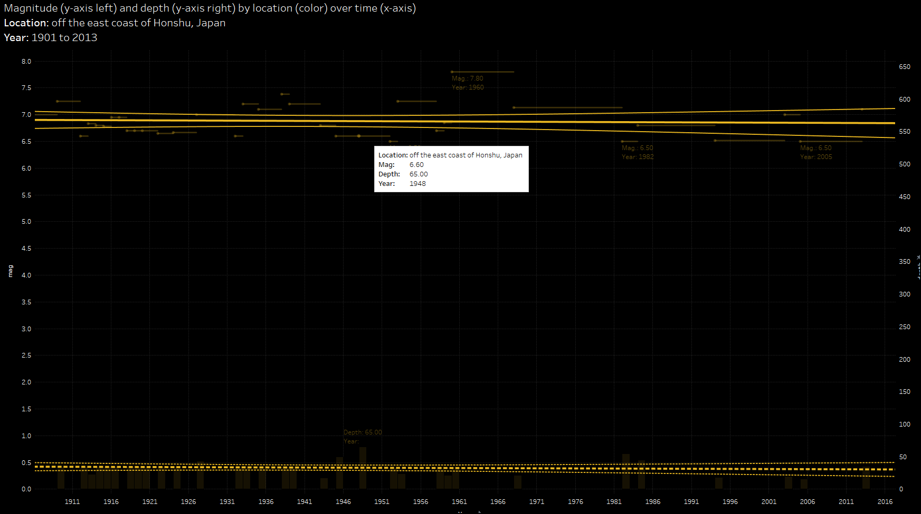

Figure . The Magnitude and Depth by Year Dual-Axis Display

The Magnitude and Depth by Year Dual-Axis Display presents us with the magnitudes and depths of our corresponding selection plotted by year on a dual-axis graph, along with corresponding linear regression lines and confidence limits for each axis. We represent the depth over time via a bar graph and the magnitude over time via line plots. A solid line displays the linear regression model and confidence limits for magnitude by year, while a dashed line displays the linear regression model and confidence limits for depth by year. We display the minimum and maximum values for each axis on the graph via label and tooltip information. We can see the trends of these quakes—the depth appears consistent and shallow, while the magnitude appears to remain stable, slightly below a magnitude of 7.0 mj.

The last display in our dashboard, **The Time-Series Heatmap Display**, presents us with a time-series heatmap for our specified selection.

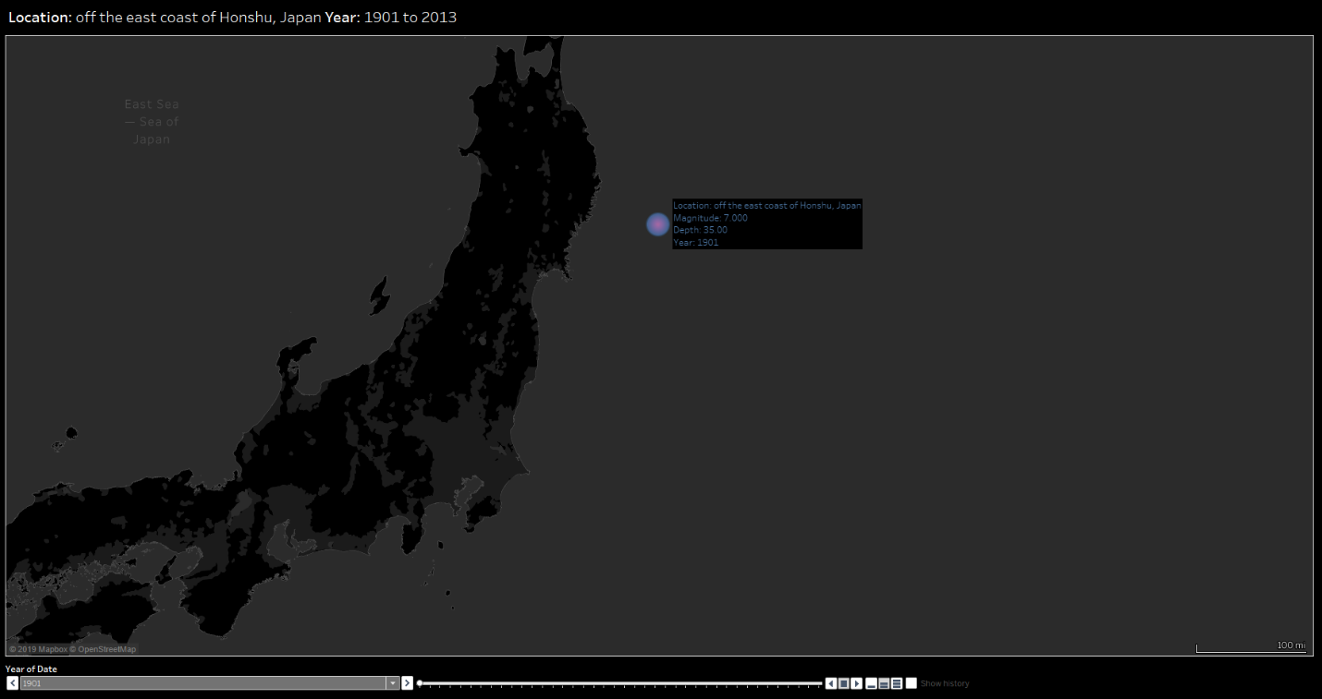

Figure . The Time-Series Heatmap Display

The **Time-Series Heatmap Display** allows us to view the occurrences of earthquakes by year for our specified selection on a geographical map. We can use the toolbar below the display to select a year via a drop-down list or slide-bar. We can also use the playback tools to start, stop, and loop playback as well as adjust the playback speed. Figure 10 presents us with a picture of the heatmap display where we have honed in on the year 1915. Here, we see the depth and magnitude of each quake that occurred that year via tooltip and label information.

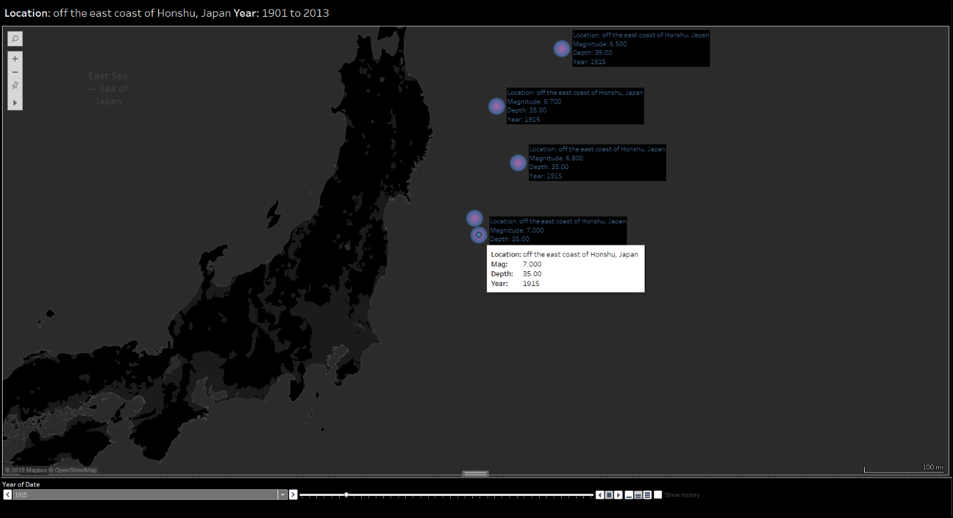

Figure . A Heatmap display of earthquakes occurring off the east coast of Honshu Japan in the year 1915

Figure 11 presents us with an overview of the dashboard, where all panels of the display are visible at once—the screen an end-user would view when first logging into the dashboard.

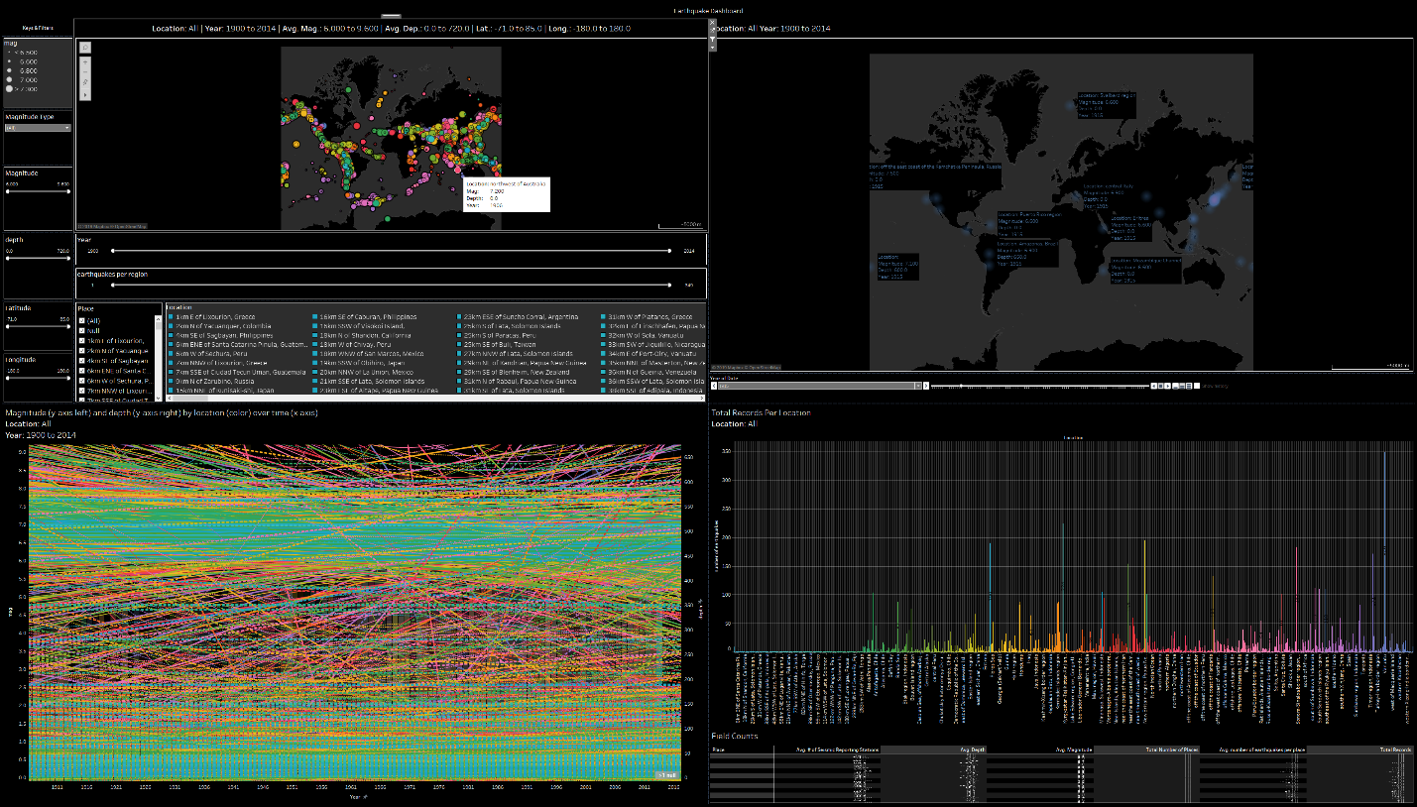

Figure . Dashboard overview before making a specified selection

If we were to filter our view so that only one quake was visible per location, we could see the result in Figure 12.

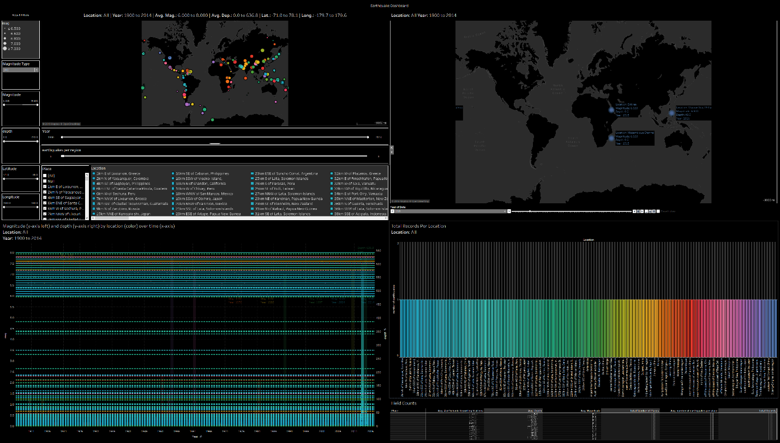

Figure . Filtering by one earthquake per location

Such filtering does not offer much in the way of analyses, as only one data point is made available per location, filling our dual-axis graph with a series of straight lines. We can further examine the result of this subset by selecting a specific location from the Drill-Down display in the bottom right-hand corner of the dashboard.

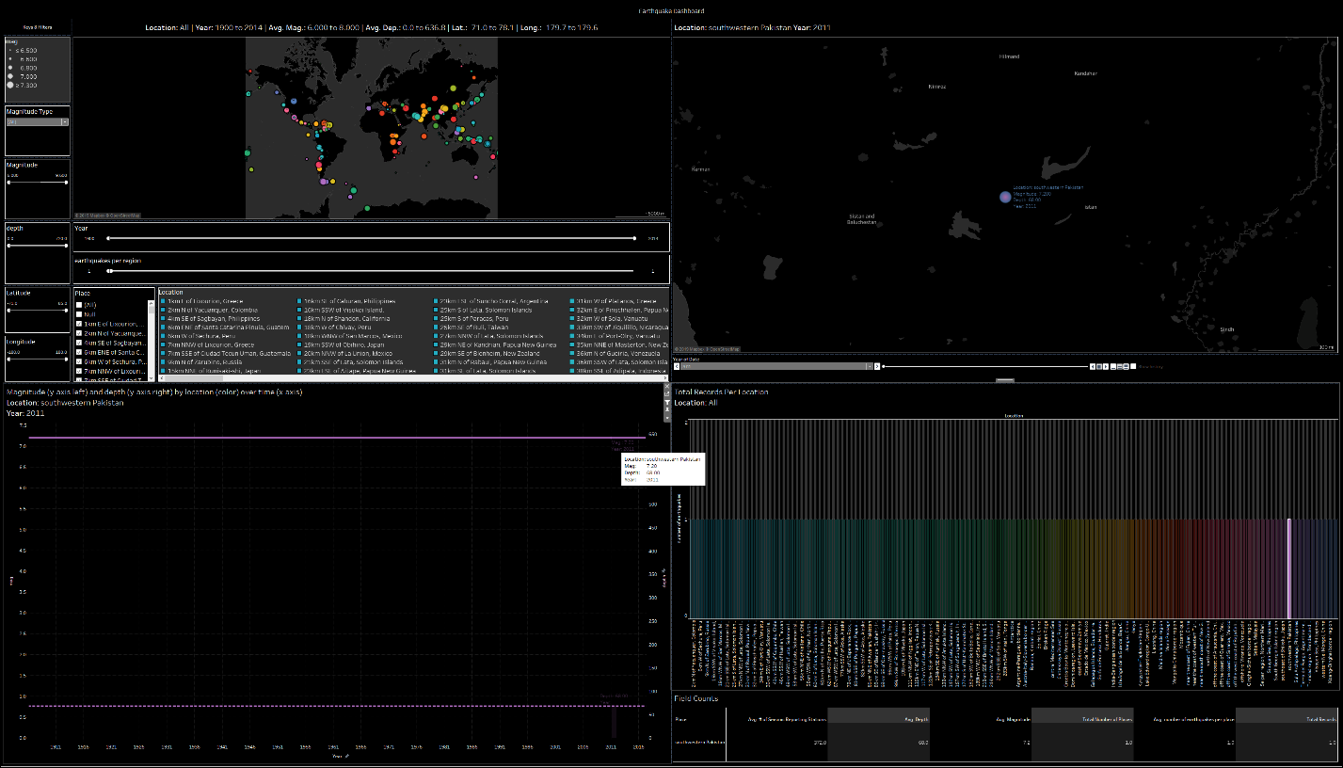

Figure . The result of zooming in on a single plot point

Here, we see one earthquake that occurred in southwestern Pakistan in 2011. The corresponding magnitude information and depth information is displayed as 7.2 and 68.00, respectively. The dashboard synchronizes all measures of this display between views. Much more interesting, however, is when we view multiple quakes that have occurred for a given location over time.

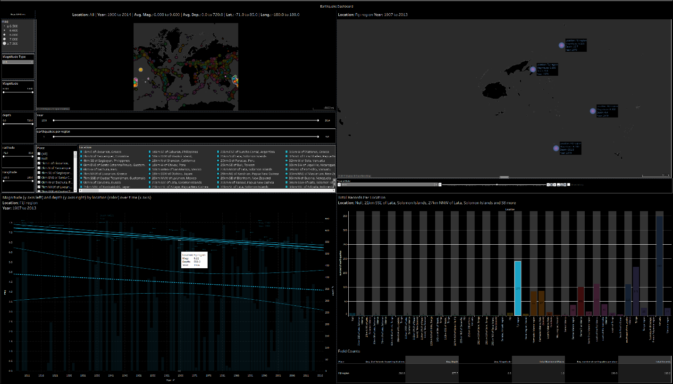

Figure . Earthquake analysis in the Figi region

By selecting the 190 earthquakes that occurred in the Figi region between 1900 and 2013, we can view the corresponding depths and magnitudes of each quake that occurred on the dual-axis display. We are able to view the extreme accuracy with which we can predict the magnitude of the quakes in this region (based on the solid linear regression model at the top of display), and we see, in the wider range of distance that occurs between the dashed lines at the bottom of the graph, the lesser extent to which we can predict the depth of the quakes—as these lines represent the confidence limits of the linear regression model for depth over time. Nevertheless, these models appear to show accurate and relevant trends that exist in the data for the Figi region. We can see, for instance, that both magnitude and depth are trending downwards over time.

**Conclusion**

Tableau is a sophisticated and powerful software that enables users to create stunning interactive visualizations for large datasets with relative ease. The dashboard created in this example uses a dataset available from USGS, containing all earthquakes with a magnitude of 6 or greater that occurred between the years 1900 and 2013. The dashboard offers sophisticated geographical mapping, filtering, and analysis capabilities that enable end-users to zoom in on a specified subset of data quickly. As such, we can see the sheer visualization power of the Tableau software.

References

ComCat Documentation—Event Terms. (n.d.). Retrieved November 17, 2019, from <https://earthquake.usgs.gov/data/comcat/data-eventterms.php>

Resources | Tableau Public. (n.d.). Retrieved November 11, 2019, from <https://public.tableau.com/en-us/s/resources>

Seismic magnitude scales. (2019). In *Wikipedia*. Retrieved from <https://en.wikipedia.org/w/index.php?title=Seismic_magnitude_scales&oldid=925286617>