Manufacturing BI Use Case: Single Integrated BI Solution

Scott Miner

Colorado State University – Global Campus

**Part A: Manufacturing BI Use Case: Single Integrated BI Solution**

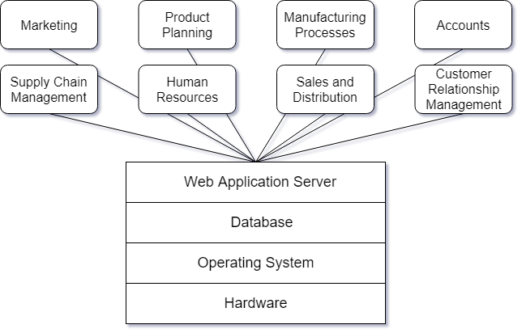One example of a single-solution framework is what is known as an Enterprise Resource Planning (ERP) system. An ERP system integrates all business resources into one. Examples of business resources include manufacturing processes, financial resources, human resources, marketing resources, customer resources, and sales.

Figure 1. Separate application modules accessing an ERP solution

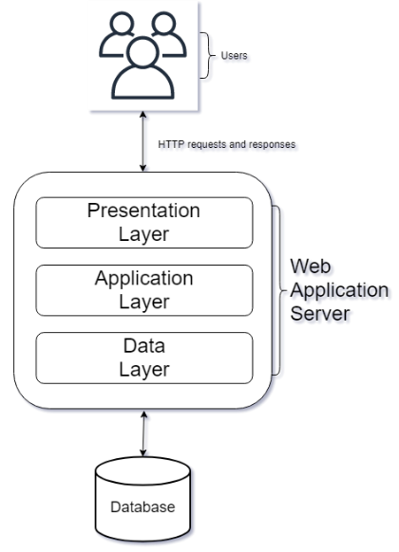 Figure 1 shows several different divisions accessing a trusted data source via a Web Application Server. All company information resides on one trusted data source; multiple divisions access that data source via the application layer. We install the database on hardware running an operating system. The SAS HANA operating system allows for all company data to be available in real-time (“[Canadian College for Higher Studies],” 2014).

Figure 2. Three-tiered client/server architecture

Figure 2 shows a three-tiered client/server architecture. In this architecture, the client sends HTTP requests from the presentation layer to the application layer. The application layer handles security checks and requests information from the database layer. The database layer retrieves the necessary information and returns it to the user in the correct format. This set-up allows us to incorporate single sign-on (SSO) so that all users have access to the correct information. A common application that incorporates SSO into an SAS installation is SAP NetWeaver (“SAP NetWeaver Single Sign-On,” n.d.). Additionally, user profiles can be created on the database so that users can be assigned a correct profile based on their job description, further easing and enabling security tasks (“[Canadian College for Higher Studies],” 2014).

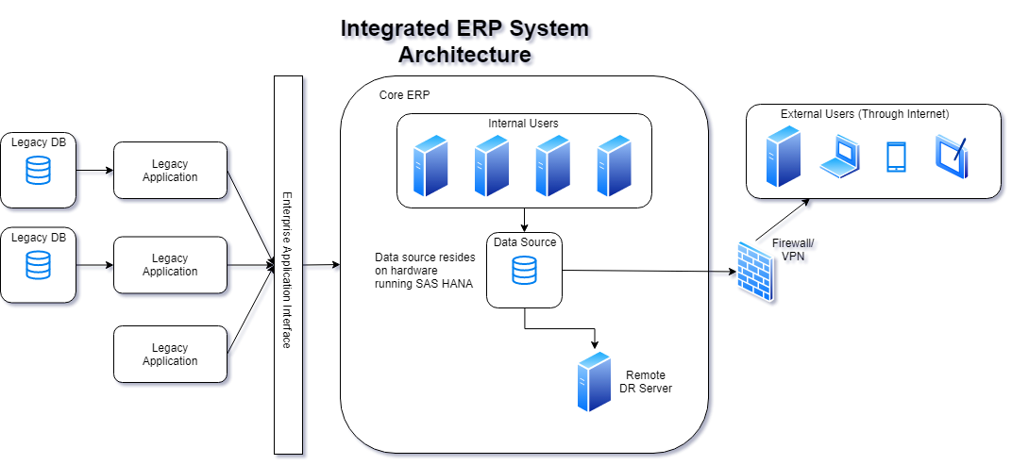

Figure . Integrated ERP System Architecture

Figure 3 presents us with the entire integrated architecture of the new ERP system.

**Secure Access from Multiple Divisions**

In the middle of Figure 3, we see how internal users can access the data source via the intranet. These internal users represent individuals from all departments, including human resources, marketing, accounting, manufacturing, and so on. All internal users have access to the one trusted data source.

**Secure Access from Multiple Regions and Self-Service Capabilities**

Similarly, at the top right of figure 3, we see how external users can access the system securely over a Virtual Private Network (VPN). A VPN manages authorizations, protects the network from damage (even from infected laptops), enforces access policies, and restricts access to certain applications and files (“A VPN implementation checklist,” 2008). Similarly, a firewall sits between two networks and controls the traffic from one network to the next. Douglas Blansit (2009) writes, “by preventing certain types of network traffic, [a firewall] hopefully slows the spread of unwanted or malicious activity from one network to another” (p. 261).

The system also supports self-service capabilities. Self-Service capabilities in a data-management environment include integrating data from a variety of sources, cleansing data, analyzing data for better governance, and sharing data with others to promote collaboration. (“Self-Service Data Preparation in SAS® Viya®,” n.d.)

**Multiple Use Purpose Within the Organization**

The new ERP architecture offers a variety of useful purposes within the organization. One such purpose, for instance, would be for an executive from a corporate office in the states to view and affect production planning at an international facility, via a dashboard. There would be no delay in monitoring and influencing such logistic activities, besides the delay of milliseconds in transmittal times (Palaniswamy & Frank, 2000).

Another function of the new system would be for a customer to contact only one location to place an order because all the divisions within the organization are now interconnected. Previously, when the system was disjointed and unintegrated, the customer would have to call two or more places to place an order. Customer service representatives can now view up-to-date information on product availability and product pricing via any linked terminal (Palaniswamy & Frank, 2000).

Additional uses of the new ERP system include reductions in cost, reductions in inventory, enhanced visibility, and reduced overhead and paperwork. Before the new ERP implementation, sales managers may have had to fax in orders, which could take several days to complete. The new architecture automates this process by keeping databases current and allowing data to be available in real-time. (Palaniswamy & Frank, 2000).

**Integration with Legacy Systems**

We can easily integrate this new ERP system with legacy systems via an Application Programming Interface (API). In this way, if a customer calls to place an order, and the customer database resides in the core ERP system, while the inventory database resides in the legacy system, we update the legacy system from the core ERP system via the Application Programming Interface (API). Slowly, the data from the legacy systems can be extracted, cleansed, and loaded into the core ERP system, eventually eliminating the legacy systems.

Ramco Cements Limited (RCL) is one such organization that successfully integrated an ERP system with a legacy system. On the first attempt, the implementation failed due to a lack of employee training regarding how to use the ERP system to enhance decision making. To overcome this challenge, RCL educated employees on the benefits of the new system and allowed IT to eliminate the legacy system from users’ computers. The second attempt to implement the ERP system succeeded (Dutta & Bose, 2015). This example demonstrates the necessity of educating users on the benefits of the new system.

**Integrated with Corporate Data Governance and Security Policies**

In the new ERP system, we handle all security checks through the application layer, as discussed earlier. Additionally, users are assigned user roles based on a profile set up in the database. This way, users from human resources only have access to the necessary human resources information, and users from financials only have access to their needed information. Operating via the least access rights model minimizes any potential damage that could occur if an employee has access to too much information (Architect, 2019).

Our ERP system also supports the use of Single Sign-On (SSO). As mentioned previously, a common SSO product used in SAS installations is SAP NetWeaver. SSO “provides strong encryption, secure communication, and single sign-on between a wide variety of … components” (“SAP NetWeaver Single Sign-On,” n.d.). This way, if a user is running complex analytical queries on the database, the user only needs to sign on once through the front-end GUI. SSO handles the login functionality between systems so that a user has access to the customer information, production information, and pricing information he needs, only needing to sign on one time (“SAP NetWeaver Single Sign-On,” n.d.).

**Salable and High Performance**

Finally, we see this alternative presents us with a salable and high-performance solution. SAS is the market leader when it comes to implementing ERP software solutions. In 1994, SAS had over 3 million users in 120 countries. In 1993, SAS recorded record sales of over $420.3 million. Today, the software is installed in over 27,000 businesses, universities, and government agencies worldwide (“Sas Institute Inc | Encyclopedia.com,” n.d.). Notable manufacturing corporations that have incorporated SAS ERP software solutions into their systems include Owens Corning, a fiberglass company, and Viskase, a food packaging company. Both companies experienced improved manufacturing benefits, including greater integration, greater connectivity, less paperwork, and a reduction in inventory (Palaniswamy & Frank, 2000). In effect, we can see the numerous benefits offered by implementing a SAS ERP software solution.

**Part B: Getting Started with SAS**

**SAS Code**

**DATA EXAMPLE;**  
**INPUT AGE @@;**  
**DATALINES;**  
**12 11 12 12 9 11 8 8 7 11 12 14 9 10 7 13**  
**6 11 12 4 11 9 13 6 9 7 13 9 13 12 10 13**  
**11 8 11 15 12 14 10 10 13 13 10 8 12 7 13**  
**11 9 12**  
**;**  
**PROC MEANS;**  
**VAR AGE;**  
**RUN;**

**SAS Output**

Figure . File Explorer w/ code and output

Figure . Output data w/ log results

References

A VPN implementation checklist. (2008). NetworkWorld Asia, 4(5), 20–20.

Architect, C. G.-S. (2019, August 22). Complete SAP Security Basics Guide: What You Need to Know. Retrieved December 15, 2019, from Symmetry website: <https://symmetrycorp.com/blog/sap-security-basics-what-you-need-to-know/>

[Canadian College for Higher Studies]. (2014 Oct 2). Introduction to ERP & SAP – 10. [Video file]. Retrieved from https://www.youtube.com/watch?v=4hpNZQw2FyQ

Douglas Blansit, B. (2009). Firewalls: Basic Principles and Some Implications. Journal of Electronic Resources in Medical Libraries, 6(3), 260–269. <https://doi.org/10.1080/15424060903167377>

Dutta, D., & Bose, I. (2015). Managing a Big Data project: The case of Ramco Cements Limited. *International Journal of Production Economics*, *165*, 293–306. <https://doi.org/10.1016/j.ijpe.2014.12.032>

Palaniswamy, R., & Frank, T. (2000). Enhancing Manufacturing Performance with Erp Systems. *Information Systems Management*, *17*(3), 43. <https://doi.org/10.1201/1078/43192.17.3.20000601/31240.7>

SAP NetWeaver Single Sign-On. (n.d.). Retrieved December 15, 2019, from <https://help.sap.com/doc/saphelp_snc_uiaddon_10/1.0/en-US/89/d115110d444d85a94dff7ffd0e2b7f/content.htm?no_cache=true>

Sas Institute Inc | Encyclopedia.com. (n.d.). Retrieved December 15, 2019, from https://www.encyclopedia.com/social-sciences-and-law/economics-business-and-labor/businesses-and-occupations/sas-institute-inc

Self-Service Data Preparation in SAS® Viya®. (n.d.). Retrieved December 15, 2019, from Acclaim website: https://www.youracclaim.com/badge_templates/7bba01ce-bc95-4977-ac3b-38a2d538ae8c

Simonson, S. (2017, September 11). *ERP 101 - What is Enterprise Resource Planning Software & How Can Small Businesses Benefit From It*. [Video file]. Retrieved from

https://www.youtube.com/watch?v=hKX7MnOljOc&t=691s