Healthcare BI Use Case – Single Integrated BI Solution

Scott Miner

Colorado State University – Global Campus

**Part A: Healthcare BI Use Case: Single Integrated BI Solution**

In this scenario, there is a large healthcare company, with 30,000 employees and 24 mobile units operating in over 15 countries. It is my job to consolidate the data processing effort by providing a single-solution business intelligence (BI) framework (“Module 2: Critical Thinking,” n.d.). Khanna and Narula (2016) describe a mobile medical unit as a commercial coach that provides medical services to patients in underserved areas who need cost-effective treatments. I am suggesting a single-solution BI framework that makes use of the time-driven nature of the Internet of Things (IoT), fog computing, and cloud computing.

**Device Layer**

In this BI ecosystem, sensors in mobile medical units collect real-time patient data, including patients’ body temperature, heart rate, blood pressure, and glucose levels. Medical equipment provides data in the form of high-resolution images (Rahmani et al., 2018). Once collected, we transfer data from sensors in the Wireless Local Area Network (WLAN) to a hosting layer comprised of smart devices (e.g., smartphones, tablets, and laptops) via wired or wireless protocols (e.g., Bluetooth, WiFi, or 6LoWPAN) (Hindia, Rahman, Ojukwu, Hanafi, & Fattouh, 2016). Bluetooth-enabled sensors should operate in non-discoverable mode and encrypt the payload using standard encryption algorithms such as AES to provide enhanced security (Mare & Kotz, 2010). Once the aggregated data has arrived in the hosting layer, we transmit the data from smart devices to local hospitals via the Wide Area Network (WAN). The standards for wireless communication over the WAN are 3G and Long Term Evolution (LTE), both of which are available everywhere, including third-world countries (Talari et al., 2017).

**Fog Layer**

At local hospitals, the data now resides in what we term the fog or edge layer. This layer enables the ecosystem to support load balancing, scalability, mobility, and low-latency responses. Rahmani et al. (2018), describes the fog layer as built from a network of smart e-Health gateways. The fog layer performs protocol conversions, data aggregations, filtering, and dimensionality reductions. This layer provides robust and complex noise filtering capabilities. Sensors accumulate noises due to interferences from electrical devices or improper use by patients. The fog layer reduces this noise. Furthermore, the fog layer provides the necessary processing power to perform complex lossless data compression algorithms in real-time, offloading this burden from the device layer (Rahmani et al., 2018).

**Data fusion capabilities.**

The fog layer also provides for data fusion. Data fusion consists of three classes, including complementary, competitive, and cooperative fusion. An example of complementary data fusion would be combining body temperature data with environmental data to determine the severity of temperature anomalies. The fog layer handles competitive fusion by collecting data for a single parameter from several sources. In this way, we strive to ensure data accuracy and reliability in case of sensor failures. Lastly, cooperative fusion can provide comprehensive information, such as a patient’s medical state, based on an analysis of heterogeneous data sources, including vital signs (Rahmani et al., 2018).

**Edge analytics.**

From this, we enhance the sensitivity of our BI ecosystem by performing data analytics at the edge layer. By performing data analytics here, our system is more responsive to patient emergencies. We no longer have to wait for our cloud server to return our response. The fog layer offers real-time emergency responses, which are critical in detecting elderly falls, seizures, or heart attacks. Moreover, by performing high-level analytics in the fog layer, we reduce processing latencies. Encrypted local storage systems can act as caches to ensure the continuous flow of data throughout the network since the speed to transmit data from the gateway to the cloud is constrained by bandwidth. Local encrypted storage in the fog layer allows us to keep a secure, reliable system operational, even in cases of internet unavailability. We can later synchronize local storage with the Cloud (Rahmani et al., 2018).

**Cloud Layer**

The final layer in the system architecture, the cloud layer, is arguably the most important. The cloud layer comprises three key components: data storage, analytics, and visualizations. The primary purpose of the cloud layer is storage, consolidating data from local storage systems (Clim, Zota, & Tinica, 2019). This layer is accessible both by headquarters and mobile care units alike, providing easy and secure access to patient information from multiple locations. To ensure security, we make use of a Virtual Private Network (VPN), allowing us to mask IP addresses of remote devices by routing traffic through intermediary servers. All traffic flowing through a VPN is encrypted (Writer, 2018). Furthermore, Kruse et al. (as cited in Ravi & Nair, 2019), lists cloud computing with data protection and hardware redundancy as one of the most common strategies for preventing cyber attacks.

**Multi-tiered architecture.**

We further protect patient privacy and ubiquitous data access in the cloud platform by using multi-tenant data storage. Multi-tenant storage enhances data security by isolating data. An isolated database offers the highest security, and a shared database with isolated data tables offers a compromise between data security and access. Our multi-tenant cloud architecture utilizes a two-level infrastructure. The first level comprises healthcare providers. Each tenant at this level belongs to a specific healthcare provider. We use an isolated database to secure healthcare data between agencies, providing secure access for authorized users. In the second level of the multi-tenant cloud architecture, we use shared tables to store data linked to individual patients. This architecture allows for quicker access by authorized personnel (Xu et al., 2017). Corporate headquarters has access to all consolidated databases in the cloud.

**Analytic Capabilities**

The analytical capabilities of this single-solution BI framework are immense. We can deploy machine learning algorithms to enhance treatment personalizations, enable early detections of diseases, and reduce healthcare costs (Clim et al., 2019). We can examine patients exhibiting similar symptoms to improve diagnostic accuracies and obtain treatment plans from historical examples (Xu et al., 2017). By collecting and analyzing patient data in real-time, we can send emergency medical services when needed in cases of heart attacks or seizures. We can then send this data to deep learning modules in the cloud, where health professionals will view the results via web-based applications to make decisions more cost-effectively (Alhussein et al., 2018). As we see, this single-solution BI framework offers an easy and secure way to transfer data between sensors, mobile units, hospitals, and corporate offices utilizing an IoT event-based architecture comprising a three-layered approach: a device layer, a fog layer, and a cloud layer.

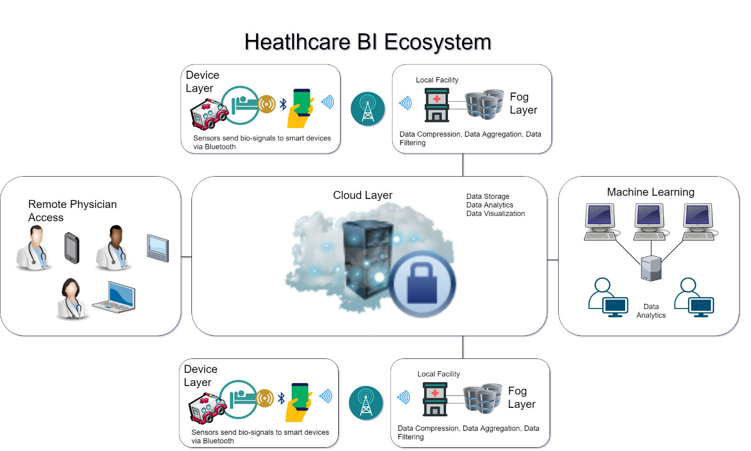

Figure . Single-solution healthcare BI ecosystem w/ device, fog, and cloud layers

**Part B: SAS Code for Statistical Analysis Test**

The following code demonstrates a two-sample t-Test using SAS. The example dataset contains 200 test scores from 91 males and 109 females in five different subjects, including social studies, science, math, reading, and writing. An analysis of the results shows that only the writing test scores demonstrated statistical significance between groups. Females received significantly higher test scores than males in writing. We contrast writing test scores with reading test scores, where we found no statistical differences between groups. Further, when analyzing the results, we do not assume the populations' variances to be equal when examining writing test scores. When examining reading test scores, on the other hand, we can assume the population variances to be equal, based on the p-value of the F-Statistic (Elliott & Woodward, 2016).

**SAS Code**

DATA testScores;

SET MYSASLIB.hsb2;

RENAME female=Gender socst=SocialStudies science=Science

math=Math write=Writing read=Reading;

RUN;

PROC FORMAT;

VALUE genderFmt 0=’Male’ 1=’Female’;

RUN;

PROC TTEST DATA=testScores;

CLASS Gender;

VAR Writing Reading;

FORMAT Gender genderFmt.;

TITLE ‘Two Sample t-Test (Gender x Test Scores) Reading & Writing’;

RUN;

**SAS Output**

**Two Sample t-Test (Gender x Test Scores) Reading & Writing**

**The TTEST Procedure**

**Variable: Writing**

| **Gender** | **Method** | **N** | **Mean** | **Std Dev** | **Std Err** | **Minimum** | **Maximum** |
| --- | --- | --- | --- | --- | --- | --- | --- |
| **Male** |  | 91 | 50.1209 | 10.3052 | 1.0803 | 31.0000 | 67.0000 |
| **Female** |  | 109 | 54.9908 | 8.1337 | 0.7791 | 35.0000 | 67.0000 |
| **Diff (1-2)** | **Pooled** |  | -4.8699 | 9.1846 | 1.3042 |  |  |
| **Diff (1-2)** | **Satterthwaite** |  | -4.8699 |  | 1.3319 |  |  |

| **Gender** | **Method** | **Mean** | **95% CL Mean** | | **Std Dev** | **95% CL Std Dev** | |
| --- | --- | --- | --- | --- | --- | --- | --- |
| **Male** |  | 50.1209 | 47.9747 | 52.2670 | 10.3052 | 8.9947 | 12.0662 |
| **Female** |  | 54.9908 | 53.4466 | 56.5351 | 8.1337 | 7.1786 | 9.3843 |
| **Diff (1-2)** | **Pooled** | -4.8699 | -7.4418 | -2.2981 | 9.1846 | 8.3622 | 10.1878 |
| **Diff (1-2)** | **Satterthwaite** | -4.8699 | -7.4992 | -2.2407 |  |  |  |

| **Method** | **Variances** | **DF** | **t Value** | **Pr > |t|** |
| --- | --- | --- | --- | --- |
| **Pooled** | Equal | 198 | -3.73 | 0.0002 |
| **Satterthwaite** | Unequal | 169.71 | -3.66 | 0.0003 |

| **Equality of Variances** | | | | |
| --- | --- | --- | --- | --- |
| **Method** | **Num DF** | **Den DF** | **F Value** | **Pr > F** |
| **Folded F** | 90 | 108 | 1.61 | 0.0187 |



|  |
| --- |
| ***Variable: Reading*** |

| **Gender** | **Method** | **N** | **Mean** | **Std Dev** | **Std Err** | **Minimum** | **Maximum** |
| --- | --- | --- | --- | --- | --- | --- | --- |
| **Male** |  | 91 | 52.8242 | 10.5067 | 1.1014 | 31.0000 | 76.0000 |
| **Female** |  | 109 | 51.7339 | 10.0578 | 0.9634 | 28.0000 | 76.0000 |
| **Diff (1-2)** | **Pooled** |  | 1.0902 | 10.2643 | 1.4575 |  |  |
| **Diff (1-2)** | **Satterthwaite** |  | 1.0902 |  | 1.4633 |  |  |

| **Gender** | **Method** | **Mean** | **95% CL Mean** | | **Std Dev** | **95% CL Std Dev** | |
| --- | --- | --- | --- | --- | --- | --- | --- |
| **Male** |  | 52.8242 | 50.6360 | 55.0123 | 10.5067 | 9.1706 | 12.3022 |
| **Female** |  | 51.7339 | 49.8244 | 53.6435 | 10.0578 | 8.8768 | 11.6043 |
| **Diff (1-2)** | **Pooled** | 1.0902 | -1.7840 | 3.9645 | 10.2643 | 9.3452 | 11.3855 |
| **Diff (1-2)** | **Satterthwaite** | 1.0902 | -1.7963 | 3.9767 |  |  |  |

| **Method** | **Variances** | **DF** | **t Value** | **Pr > |t|** |
| --- | --- | --- | --- | --- |
| **Pooled** | Equal | 198 | 0.75 | 0.4553 |
| **Satterthwaite** | Unequal | 188.46 | 0.75 | 0.4572 |

| **Equality of Variances** | | | | |
| --- | --- | --- | --- | --- |
| **Method** | **Num DF** | **Den DF** | **F Value** | **Pr > F** |
| **Folded F** | 90 | 108 | 1.09 | 0.6613 |



References

Alhussein, M., Muhammad, G., Hossain, M. S., & Amin, S. U. (2018). Cognitive IoT-Cloud Integration for Smart Healthcare: Case Study for Epileptic Seizure Detection and Monitoring. Mobile Networks and Applications; New York, 23(6), 1624–1635. <http://dx.doi.org.csuglobal.idm.oclc.org/10.1007/s11036-018-1113-0>

Clim, A., Zota, R. D., & Tinica, G. (2019). Big Data in home healthcare: A new frontier in personalized medicine. Medical emergency services and prediction of hypertension risks. International Journal of Healthcare Management, 12(3), 241–249. <https://doi.org/10.1080/20479700.2018.1548158>

Elliott, A. C., & Woodward, W. A. (2016). SAS essentials: Mastering SAS for data analytics (Second edition). Hoboken, New Jersey: John Wiley and Sons, Inc.

Hindia, M. N., Rahman, T. A., Ojukwu, H., Hanafi, E. B., & Fattouh, A. (2016). Enabling Remote Health-Caring Utilizing IoT Concept over LTE-Femtocell Networks. PLoS ONE, 11(5), 1–17. https://doi.org/10.1371/journal.pone.0155077

Khanna, A. B., & Narula, S. A. (2016). Mobile health units: Mobilizing healthcare to reach unreachable. International Journal of Healthcare Management, 9(1), 58–66. https://doi.org/10.1080/20479700.2015.1101915

Mare, S., & Kotz, D. (2010). Is Bluetooth the right technology for mHealth?

Module 2: Critical Thinking. (n.d.). Retrieved December 22, 2019, from https://csuglobal.instructure.com/courses/16501/assignments/332789

Rahmani, A. M., Gia, T. N., Negash, B., Anzanpour, A., Azimi, I., Jiang, M., & Liljeberg, P. (2018). Exploiting smart e-Health gateways at the edge of healthcare Internet-of-Things: A fog computing approach. Future Generation Computer Systems, 78, 641–658. <https://doi.org/10.1016/j.future.2017.02.014>

Ravi, A. R., & Nair, R. R. (2019). Cybersecurity Threats and Solutions in the Current E-Healthcare Environment: A Situational Analysis. Medico-Legal Update, 19(2), 141–144. https://doi.org/10.5958/0974-1283.2019.00161.0

Talari, S., Shafie-khah, M., Siano, P., Loia, V., Tommasetti, A., & Catalão, J. P. S. (2017). A Review of Smart Cities Based on the Internet of Things Concept. Energies; Basel, 10(4), 421. <http://dx.doi.org.csuglobal.idm.oclc.org/10.3390/en10040421>

Writer, G. (2018, September 25). How to Secure Your IoT Devices With a VPN. Retrieved December 17, 2019, from IoT For All website: <https://www.iotforall.com/secure-iot-devices-vpn/>

Xu, B., Xu, L., Cai, H., Jiang, L., Luo, Y., & Gu, Y. (2017). The design of an m-Health monitoring system based on a cloud computing platform. Enterprise Information Systems, 11(1), 17–36. https://doi.org/10.1080/17517575.2015.1053416