Step 1: Start the server

Cmd

cd C:\Users\scott\Desktop\USC WORK IN PROGRESS\final project\Previous Project

workon finalproject

setprojectdir .

python plot.py

Step 2: Start the browser

In the browser, type the url: <http://127.0.0.1:5000/>

It will display following 2 graphs:

* Age vs Cholesterol
* Age vs Chest Pain

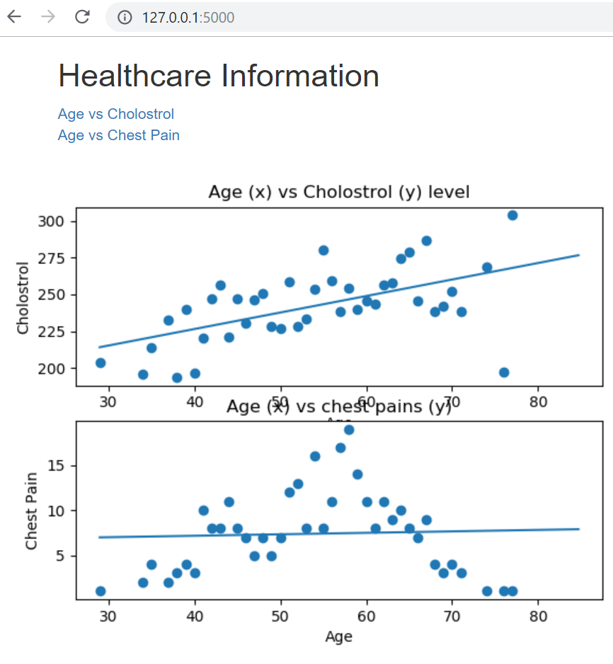

Used the following for the project:

* SciKit-Learn
* pandas
* matplotlib/seaborn
* Flask
* HTML/CSS/Bootstrap

Database: SqlLite (Healthcare_data.db)

DataSource:

https://www.kaggle.com/ronitf/heart-disease-uci#heart.csv