|  |  |
| --- | --- |
|  |  |

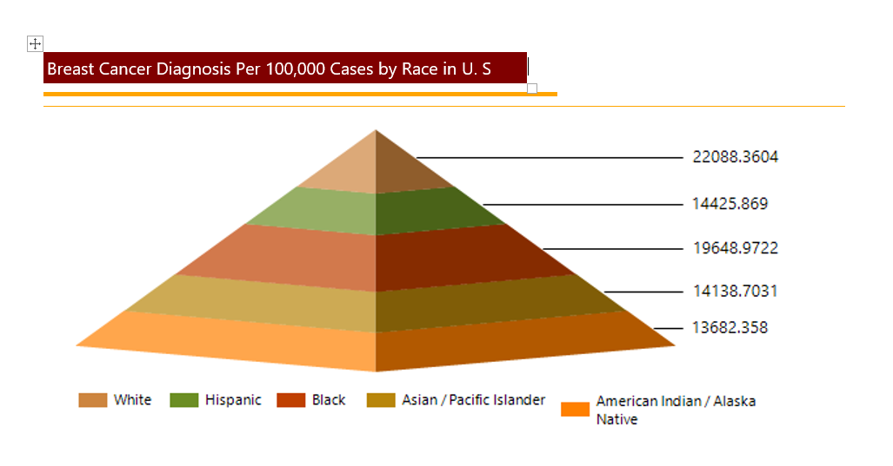

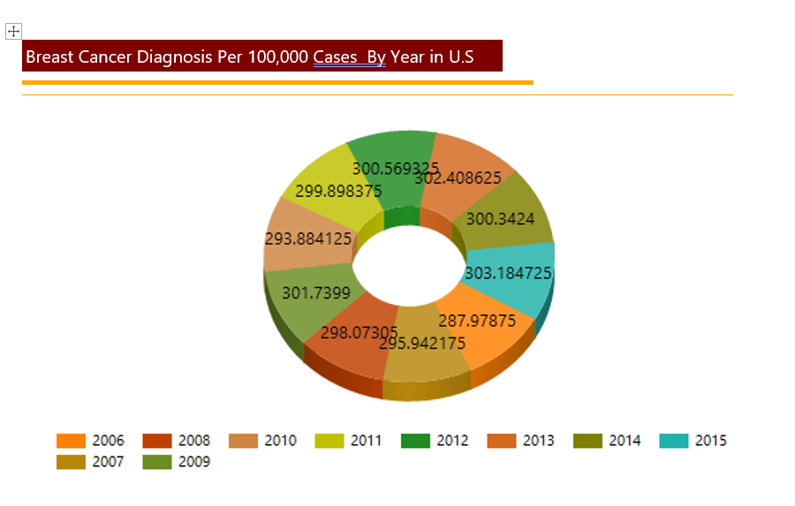

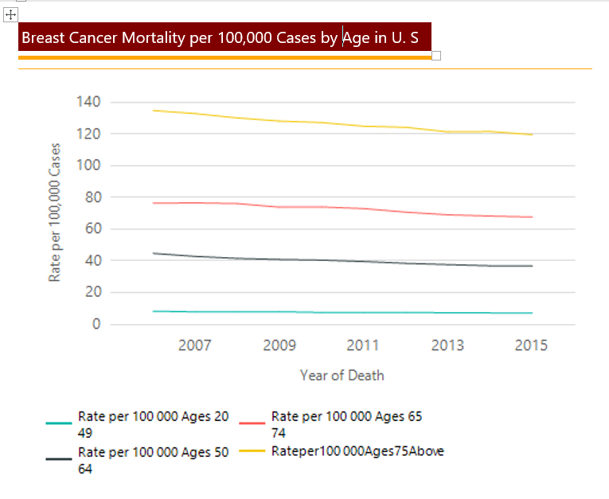

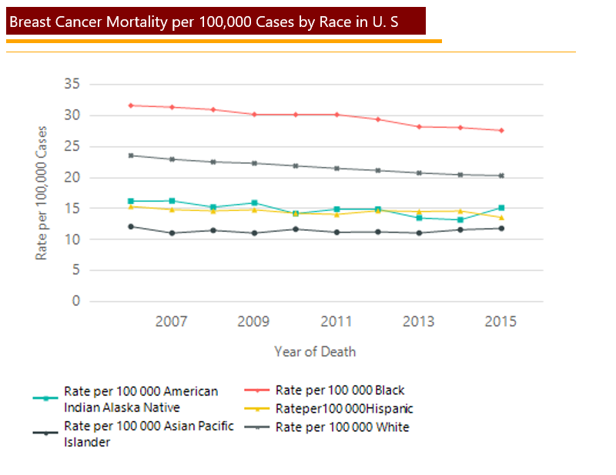

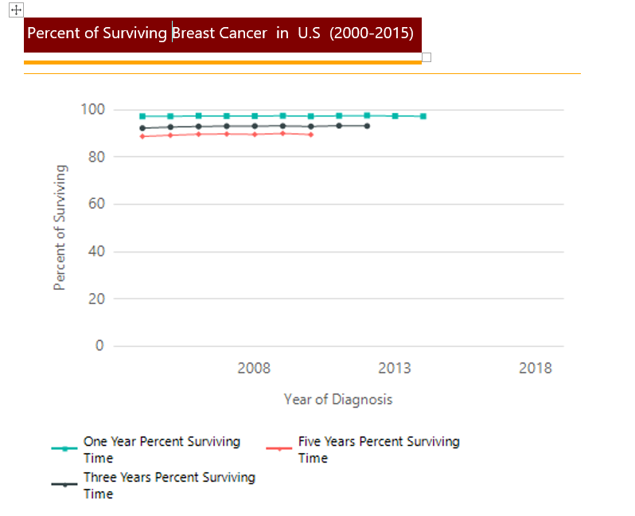



Data Source:

<https://seer.cancer.gov/explorer/application.php?site=55&data_type=1&graph_type=2&compareBy=race&chk_sex_3=3&chk_race_5=5&chk_race_4=4&chk_race_3=3&chk_race_6=6&chk_race_8=8&chk_age_range_1=1&chk_data_type_1=1&advopt_precision=2&advopt_display=1&showDataFor=sex_3_and_age_range_1_and_data_type_1>