**3.0 Background**

**3.1 Mammogram**

Mammograms is an early screening tool used in detecting early breast cancer in women with no indication of a condition or disease. It can also be used in detecting and diagnosing breast cancer in women with a known condition such as a lump, skin dimpling and nipple discharge. The mammography exam is referred to as the mammogram. Mammography can be divided into two types the screening mammography and the diagnostic mammography. The screening mammography shows early detection of breast cancers and show changes in the breast for up to two years before the patient or doctor can feel it. The U.S. Department of Health Services (HHS) and the American College of Radiology (ACR) as recommended screening for women at age 40 annually [1]. These annual mammograms have saved a lot of women life through early detection of breast cancers when is most curable. The National Cancer Institute (NCI) have stated that women with cancer, and those with family history of breast cancer should seek medical advice on whether to start early screening before the age of 40 [1]. Women who are at risk of breast cancer may need to obtain a breast Magnetic Resonance Imaging (MRI) in addition to their annual mammogram. The Diagnostic Mammography is used to examine women with abnormal findings like breast lump or nipple discharge. It is done after an abnormal screening mammogram to review the area of concern on the mammogram image.

Mammography is a medical technique that is used in detecting and diagnosing early cancer by taking images of the breast tissue using a low-dose x-ray [1]. The low- dose x-ray is referred to as the radiograph. The radiograph is non- invasive, and it aids physician in detecting and treating early stage of breast cancer in women. Women ages 40 to 44 have the choice to begin a mammogram annually, ages 45 to 54 are required to take a mammogram every year, ages 50 and above are required to take the mammogram every two years [2]. Mammography has evolved over the years, and the three recent mammography are the digital mammography, computer-aided detection and the breast tomosynthesis [3]. The digital mammography also referred to as the Full-Field Digital Mammography (FFDM). The FFDM system can be compared to a digital camera which enables it to take better images of breast tissue using a lower radiation dose. The images of the breast tissue are loaded into the computer to be stored and reviewed by the radiologist. Computer-aided detection also referred to as the CAD, search the breast tissue for abnormal areas of density, mass, calcification that may show the presence of cancer. These areas are further reviewed by the radiologist for better assessment. The breast tomosynthesis is also referred to as the three-dimensional (3-D) mammography and the digital breast tomosynthesis (DBT), it is a more advanced system of taking multiple images of the breast tissue from different angles in 3- dimensional image. Studies have shown that the DBT screening as a better and improved detection of breast cancer and a lesser rate of patient call-backs due to potential abnormal findings [3]. The DBT gives a better accuracy in showing the shape, size, and the location of breast abnormalities. It shows a clearer image of the abnormalities within the dense breast tissue and detecting multiple breast tumors.

The American Cancer Society (ACS) recommends that patients’ going in for their mammogram should not wear deodorant and lotion has these can show on the mammogram as calcium spots [3]. Mammogram should not be scheduled when you are pregnant because there is possibility of the baby developing cancer due to excessive exposure to radiation. The screening should not be scheduled a week before the menstrual period has the breasts is tender during this period. The best time to schedule a mammogram should be a week after the menstrual period.

**3.2 Normal and Abnormal Mammogram**

**3.21 Normal Mammogram**

What does a normal mammogram look like? A mammogram will mostly be gray with white areas showing healthy tissue. The small white specks image on the mammogram shows no health problem. The denser tissue, the connective tissue, and the glands shows white on the mammogram [4]. A whiter speck on the mammogram usually does not indicate a health issue. However, not all normal mammogram is cancer free. About 20 percent of breast cancers are not detected on a mammogram [4]. This percentage is apparent for women with denser breast tissue. Some cancer is overlooked on a mammogram especially those cancer that do not result in a mass. MRI is recommended to get a deeper detail of an area of concern on mammogram and for women that are at high risk with denser breast tissue. If a mammogram shows an area of concern the MRI provides an accurate information. However, MRI are more expensive than a mammogram and are mostly used to diagnose abnormal tissue or high-risk developing breast cancer.

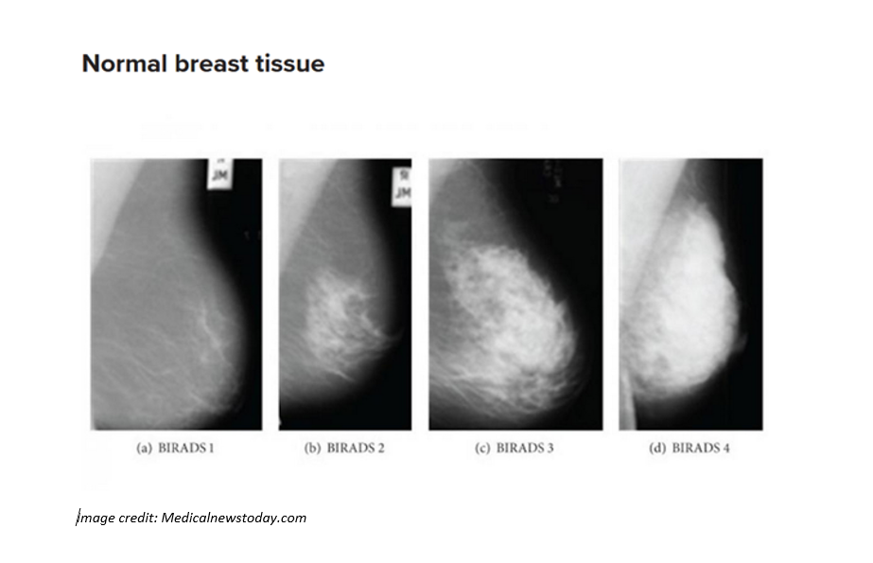

**Figure 1.** Normal breast tissue showing different categories of BIRADS.

**3.22 Abnormal Mammogram**

Women with a dense breast are at higher risk of breast cancer. The denser the breast the more difficult it is to find abnormalities on a mammogram. If a mammogram results shows abnormalities, a follow up is necessary to check if it is breast cancer. An abnormal mammogram most often does not indicate breast cancer. A follow-up is needed to confirm if it breasts cancer or not. Most abnormal mammogram is a benign breast condition or just a normal breast tissue. Some abnormalities found in the breast include cysts, calcifications, fibroadenomas, and scar tissue [4]. A cyst is a small filled sac, most often is not cancerous but needs further check-up to determine if it is cancerous or not. Calcifications is a deposit of calcium, often due to old age. Depending on the appearance further checkup is needed to test for cancer. Fibroadenomas is a round-like benign tumors in the breast and can occur at any age. Scar tissue appears white on the mammogram, your doctor should be aware of any scar on your breast at the earliest.

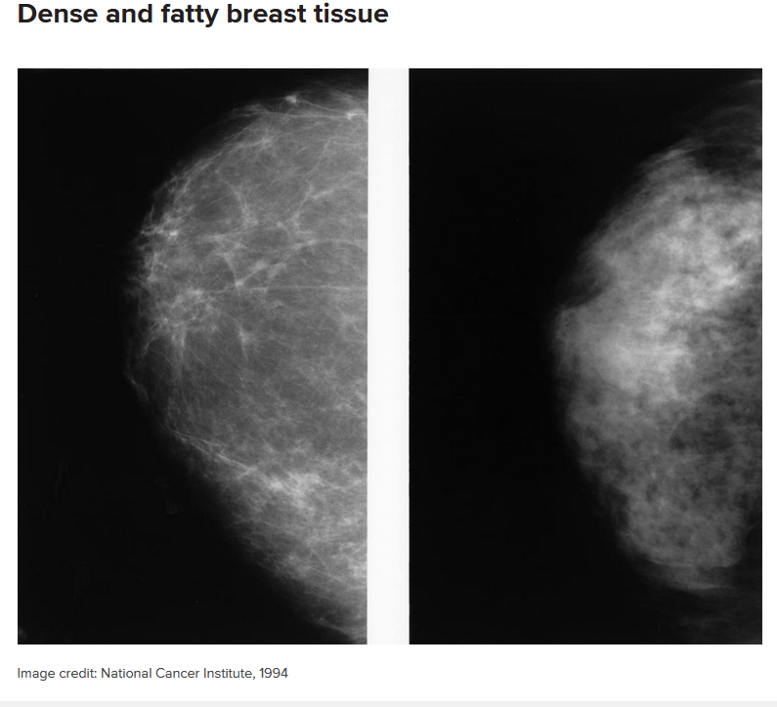

**Figure 2.** Dense and Fatty breast tissue becomes less dense as the age progresses.

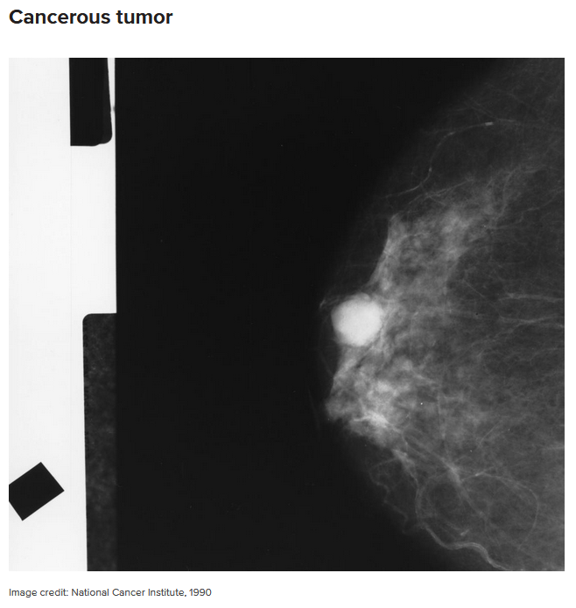

**Figure 3.** Breast tissue showing a cancerous tumor.

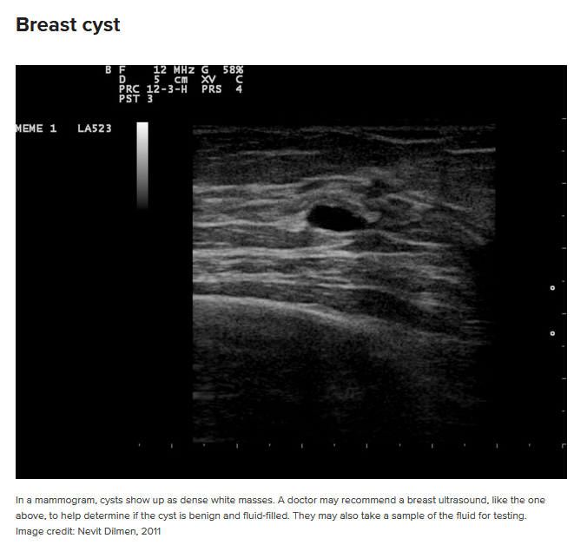

**Figure 4.** A breast cyst appears as dense white masses, further check-up is needed to determine if it is benign and fluid-filled.

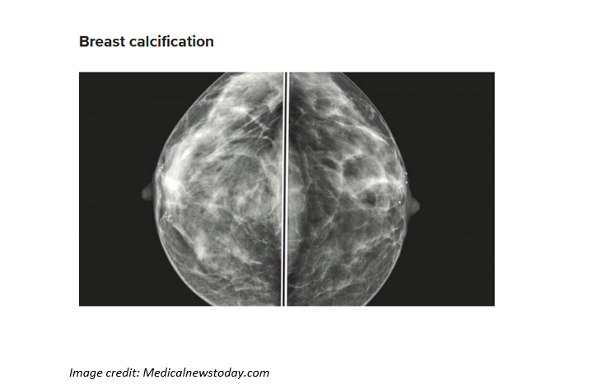

**Figure 5.** Breast calcification often due to old age showing deposit of calcium.

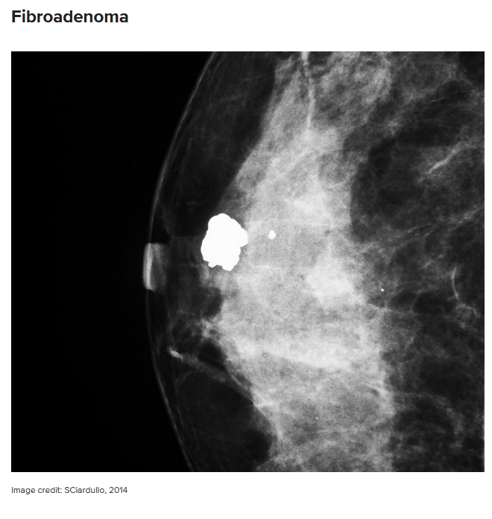

**Figure 6.** Fibroadenoma appears as a a round-like benign tumors in the breast and can occur at any age.

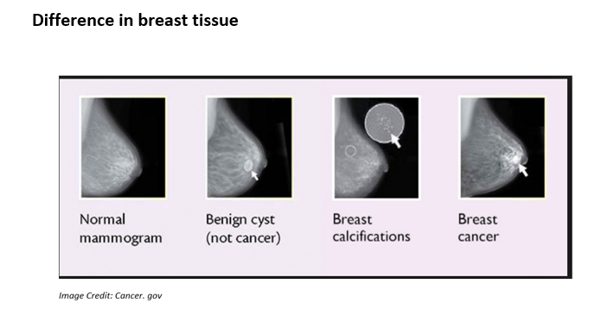

**Figure 7.** The difference in breast tissue showing a normal breast tissue, benign cyst, calcifications, and breast cancer image.

**3.3 Interpreting the Mammogram**

The standard system for reporting a mammogram result is called the Breast Imaging-Reporting and Data System (BI-RADS). The BI-RADS category ranges from the number 0 to 6. The doctors across the United States adhere strictly to the BI-RADS system. The table below shows how to understand a mammogram result.

|  |  |
| --- | --- |
| **Category** | **Interpretation** |
| 0 | Result unclear needs further test, and previous mammogram comparison |
| 1 | Abnormalities absent |
| 2 | No cancer but presence of abnormalities like benign calcifications |
| 3 | Abnormalities like benign present needs follow-up |
| 4 | Abnormalities present could be cancerous, may need biopsy |
| 5 | Abnormalities present likely to be cancerous, requires biopsy |
| 6 | Presence of cancer requires a mammogram for progress. |

**Table 1. Interpreting a Mammogram**

The result of a mammogram is clearly explained by a medical practitioner to a patient after the result comes in. Further check-up is then required if there are abnormalities on the mammogram.

Mammograms is the most important method out there for detecting breast cancer and checking the respond to treatment of breast cancer. However, mammograms are not perfect for checking abnormalities, especially women with dense breasts. There is no standard for abnormal and normal mammogram out there. Mammograms appears different for every patient. White areas on the mammograms may need follow-up, but most often do not result to cancer.

**3.4 Benefits and Risks of a Mammogram**

|  |  |
| --- | --- |
| **Benefits** | **Risks** |
| Early detection of breast cancer like small tumors gives the patient more treatment options. | There is possibility of small exposure to radiation after mammogram, but the benefits outweigh the risk. |
| Mammogram is used to detect all types of breast cancer such as ductal and invasive lobular cancer. | About 5 to 15 percent of screening mammograms needs retesting. Most cases turn out to be false-positive mammogram. This means the result is a normal mammogram. |
| Special care is taken during x-ray exam to use the lowest dose of radiation. No radiation is left behind in the patient’s body after the x-ray exam. | It is not advisable to take a screening mammogram if you are pregnant. The baby stands the risk of possible exposure to radiation. |

**Table 2. Benefits and Risks of a Mammogram**

**3.5 Convolutional Neural Network**

Classification on the breast images was performed using a Convolutional Neural Network (CNN). CNN is a processing machine learning tool that uses deep learning, artificial neural network mostly used in analyzing visual imagery [5]. One of the advantages of CNN is that It requires little or minimal preprocessing and uses a variation of multilayer perceptron. CNN inspired by Hubel and Wiesel work in the 1950’s and 1960’s which shows the biological process that the connectivity pattern between neurons resembles the organization of the animal visual cortex [5]. CNN includes an input, output layer and a multiple hidden layer. The hidden layers include the convolutional layers, pooling layers, connected layers and the normalization layers. Compared to other Image classification algorithms CNN uses very little preprocessing time and fewer connections and parameters, which makes it easier to train. This project uses the CNN for detection and classification of mass and calcification in detecting breast cancer in mammograms.

**References**

<https://www.radiologyinfo.org/en/info.cfm?pg=mammo> [1]

<https://www.cancer.org/cancer/breast-cancer/screening-tests-and-early-detection/american-cancer-society-recommendations-for-the-early-detection-of-breast-cancer.html> [2]

<https://www.radiologyinfo.org/en/info.cfm?pg=mammo> [3]

<https://www.medicalnewstoday.com/articles/322068.php> [4]

<http://deeplearning.net/tutorial/lenet.html> [5]