The Simultaneous Detection and Classification of Mass and Calcification Leading to Breast Cancer in Mammograms
Scott Gozdzialski, Ireti Fasere, Alex Stern
1 Master of Science in Data Science, Southern Methodist University,
Dallas, TX 75275 USA
sgozkzialski@smu.edu
ifasere@smu.edu
kastern@smu.edu
Abstract. In this paper, we will be detecting and classifying breast cancer calcification and masses in a single step. We tackle this problem by training a Convolution Neural Network (CNN) to classify different cropped images of the types of breast cancer. We are then building a sliding window detector to break apart full mammogram images into sub-images, and classifying the sub-images. We receive multiple probabilities for each sub-image for the different classification. We then rank the sub-images, displaying the coordinates of the highest ranked sub-images for each classification. The results of this process are that we detect 46% of cancer within the mammograms, and properly classify 64%.
.
1 Introduction
Breast cancer is the second leading cause of death among women. The chance of a women dying of breast cancer is 1 in 37 or 2.7 percent [4]. 40 thousand women are estimated to die from breast cancer in 2017 alone [4]. It is important that we understand the effect breast cancer has upon those around us, that we can diagnose it easily, and that we have a treatment path for the disease. Awareness and early screening are crucial in reducing the risk of breast cancer. Early detection of cancer can save the patient’s life. If the cancer is not detected on time and treated it can lead to death. There are three main types of tools used to diagnose breast cancer. The first is a physical breast exam. This is completed by a physician of as a self-exam. The second way is with imaging. Imaging is sub-divided into a mammogram, ultrasound and MRI scan [4]. Each one of the imaging tests has a different purpose. Mammograms are used to detect lumps within the tissue. Ultrasounds determine the difference between a solid mass and a cyst. The MRI is used to determine how invasive the cancer has become. The final test is the biopsy. In a biopsy, they remove some tissue and test it in the lab, identifying if the cells are cancerous and the type of cancer. Each step taken to aid in the proper detection of breast cancer can make a vast improvement in the lives of women and those around them.
We are looking to detect and classify breast cancer within a mammogram in one step using a CNN. The biggest issues to overcome is the ambiguity of the data itself, cancer can be obscured by the nature of the tissue around it. This can be resolved with different views of the breast tissue, the most common are CC, overhead, and MLO, at a 45-degree angle. Also, the differences between malignant and benign cells cannot be easily distinguished on a mammogram. This is displayed by the fact that doctors have three pathologies for possible cancer found on a mammogram, benign without callback, benign, and malignant. Benign indicates that the doctor could not determine the pathology of the cancer by reading the mammogram alone and further tests. With 38% of our training data is marked benign we can see that even medical providers have a difficulty classifying breast cancer with a mammogram alone. The final issue we encounter is our ignorance on the subject itself. When our detector picks a section of the mammogram as important and it looks like the text book answer to the classification picked, we cannot explain why it is not cancerous and instead it is a false positive.
The first step we utilized to solve this problem is to build an image classifier to differentiate between benign and malignant, calcifications and masses found within mammograms, by classifying cropped images of the different pathologies of breast cancer. We utilize this method because the nature of our data and limit of our computing power. Our dataset contains full mammograms and cropped images of the different pathology. By using the cropped images, we must use less compression on the images to load them in our memory. We have a finite amount of memory, 8Gbs of main memory and 3Gbs of video memory to use for training and testing our CNN.
Finally, we use the model built by the image classifier to build a sliding window image detector. We pull sections of the of the full mammogram into our model one piece at a time and run them through the classifier, predicting the possibility of the sub-image belonging to a different class of cancer. We record the different sub-images probabilities and coordinates. Finally, we display the highest ranked of each sub-category of cancer.
If the known area of cancerous tissue is detected and classified properly and displayed in the highest ranked of its subcategory, our system works and there are no false positives. If the known are of cancerous tissue is detected and classifies properly, but not displayed in the ranked area, we have a false positive elsewhere within the mammogram. If we detect the tissue but misclassify the tissue, we know the detector is working by the pathology is obscure and more analysis is needed.
Utilizing the detector and the method above, we detected 32% of the cancer within the mammograms and properly classified 68% of the cancer we discovered. Only 50% of the cancer detected, or 15% overall, was detected as the most important anomaly on the mammogram. This leaves a large group of false positives, with most of the false positives being outside of the breast tissue completely or within the black outside of the mammogram.
After completing this process of building the classifier to feed into the sliding window detector for the purpose of detecting and classifying breast cancer within a mammogram we can conclude this is a solvable problem but will need a serious effort to bring to a solid solution. Many studies, with good results, have focused on a part of this solution. But to bring it to a single step will be hard work.
2 Background
2.1 Mammogram
Mammograms are an early screening tool used in detecting early breast cancer in women with no indication of a condition or disease. They can also be used in detecting and diagnosing breast cancer in women with a known condition such as a lump, skin dimpling and nipple discharge. Mammography can be divided into two types the screening mammography and the diagnostic mammography. The screening mammography shows early detection of breast cancers and show changes in the breast for up to two years before the patient or doctor can feel it. The U.S. Department of Health Services (HHS) and the American College of Radiology (ACR) as recommended screening for women at age 40 annually [1]. These annual mammograms have saved a lot of women’s lives through early detection of breast cancer when it is most curable. The National Cancer Institute (NCI) has stated that women with cancer, and those with family history of breast cancer, should seek medical advice on whether to start early screening before the age of 40 [1]. Women who are at risk of breast cancer may need to obtain a breast Magnetic Resonance Imaging (MRI) in addition to their annual mammogram. The Diagnostic Mammography is used to examine women with abnormal findings like breast lump or nipple discharge. It is done after an abnormal screening mammogram to review the area of concern on the mammogram image.
Mammography is a medical technique that is used in detecting and diagnosing early cancer by taking images of the breast tissue using a low-dose x-ray [1]. The low- dose x-ray is referred to as the radiograph. The radiograph is non- invasive, and it aids physician in detecting and treating early stage of breast cancer in women. Women ages 40 to 44 have the choice to begin a mammogram annually, ages 45 to 54 are required to take a mammogram every year, and ages 50 and above are required to take the mammogram every two years [2]. Mammography has evolved over the years, and the three recent mammography are the digital mammography, computer-aided detection and the breast tomosynthesis [3]. The digital mammography also referred to as the Full-Field Digital Mammography (FFDM). The FFDM system can be compared to a digital camera which enables it to take better images of breast tissue using a lower radiation dose. The images of the breast tissue are loaded into the computer to be stored and reviewed by the radiologist. Computer-aided detection also referred to as the CAD, search the breast tissue for abnormal areas of density, mass, calcification that may show the presence of cancer. These areas are further reviewed by the radiologist for better assessment. The breast tomosynthesis is also referred to as the three-dimensional (3-D) mammography and the digital breast tomosynthesis (DBT) is a more advanced system of taking multiple images of the breast tissue from different angles in a 3-dimensional image. Studies have shown that the DBT screening is an improved method of detection of breast cancer with a lesser rate of patient call-backs due to potential abnormal findings [3]. The DBT gives a better accuracy in showing the shape, size, and the location of breast abnormalities. It shows a clearer image of the abnormalities within the dense breast tissue and detecting multiple breast tumors.
The American Cancer Society (ACS) recommends that patients going in for their mammogram should not wear deodorant and lotion has these can show on the mammogram as calcium spots [3]. A mammogram should not be scheduled when you are pregnant because there is possibility of the baby developing cancer due to excessive exposure to radiation. The screening should not be scheduled a week before the menstrual period has the breasts is tender during this period. The best time to schedule a mammogram should be a week after the menstrual period.

2.2 Normal and Abnormal Mammogram
2.21 Normal Mammogram

What does a normal mammogram look like? A mammogram will mostly be gray with white areas showing healthy tissue. The small white specks image on the mammogram show no health problem. The denser tissue, the connective tissue, and the glands shows white on the mammogram [4]. A whiter speck on the mammogram usually does not indicate a health issue. However, not all normal mammograms are cancer free. About 20 percent of breast cancers are not detected on a mammogram [4]. This percentage is apparent for women with denser breast tissue. Some cancer is overlooked on a mammogram especially those cancer that do not result in a mass. An MRI is recommended to get a deeper detail of an area of concern on mammogram and for women that are at high risk with denser breast tissue. If a mammogram shows an area of concern, the MRI provides an accurate information. However, MRIs are more expensive than a mammogram and are mostly used to diagnose abnormal tissue or high-risk developing breast cancer.

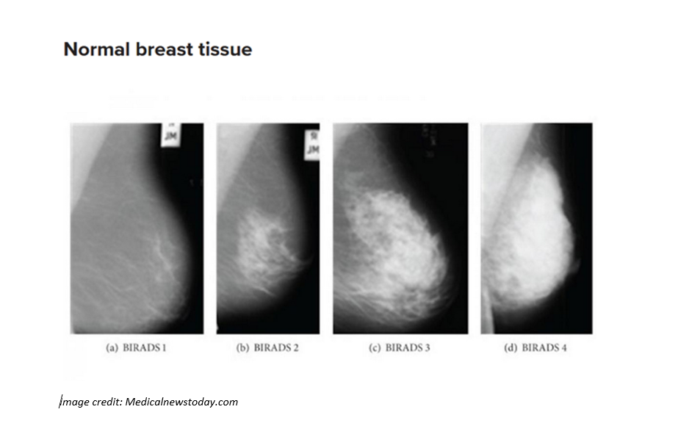
Figure 1. Normal breast tissue showing different categories of BIRADS.

2.22 Abnormal Mammogram

Women with denser breasts are at higher risk of breast cancer. The denser the breast, the more difficult it is to find abnormalities on a mammogram. If mammogram results show abnormalities, a follow-up is necessary to check if it is breast cancer. An abnormal mammogram most often does not indicate breast cancer. Most abnormal mammograms are due to a benign breast condition or just a normal breast tissue. Some abnormalities found in the breast include cysts, calcifications, fibroadenomas, and scar tissue [4]. A cyst is a small filled sac, and most often is not cancerous but needs further check-up to determine if it is cancerous or not. Calcifications are deposits of calcium, often due to old age. Depending on the appearance further checkup is needed to test for cancer. Fibroadenomas is a round-like benign tumors in the breast and can occur at any age. Scar tissue appears white on the mammogram, your doctor should be aware of any scar on your breast at the earliest.

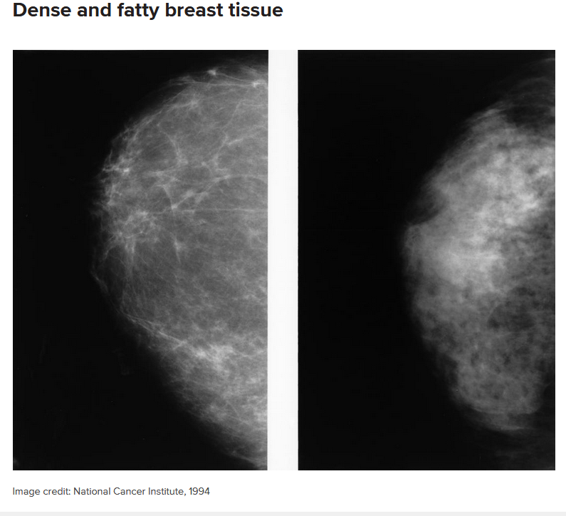
Figure 2. Dense and Fatty breast tissue becomes less dense as the age progresses.

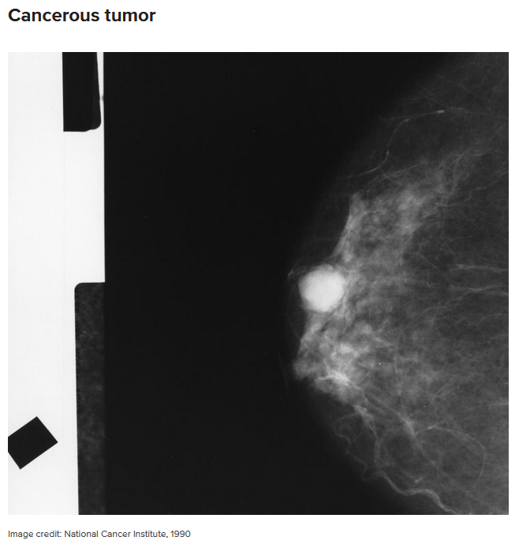
Figure 3. Breast tissue showing a cancerous tumor.

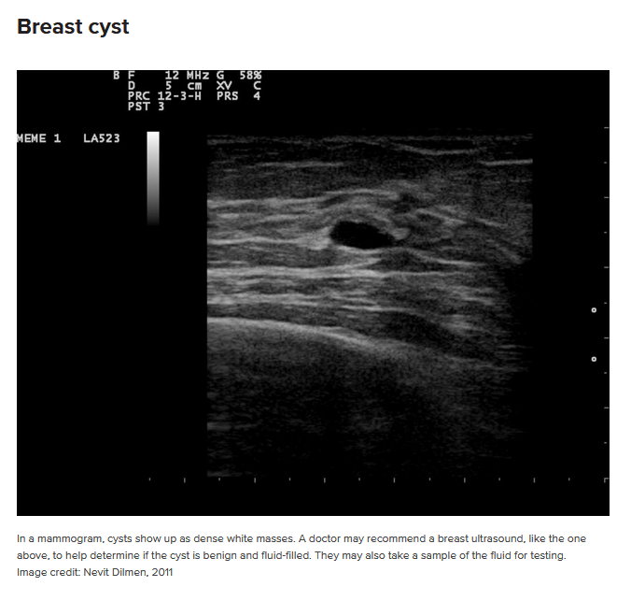
Figure 4. A breast cyst appears as dense white masses, further check-up is needed to determine if it is benign and fluid-filled.

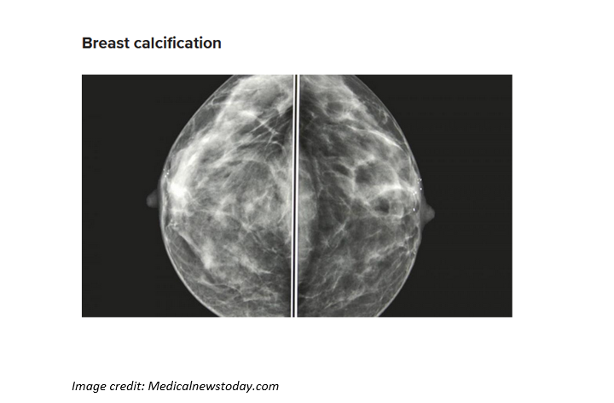
Figure 5. Breast calcification often due to old age showing deposit of calcium.

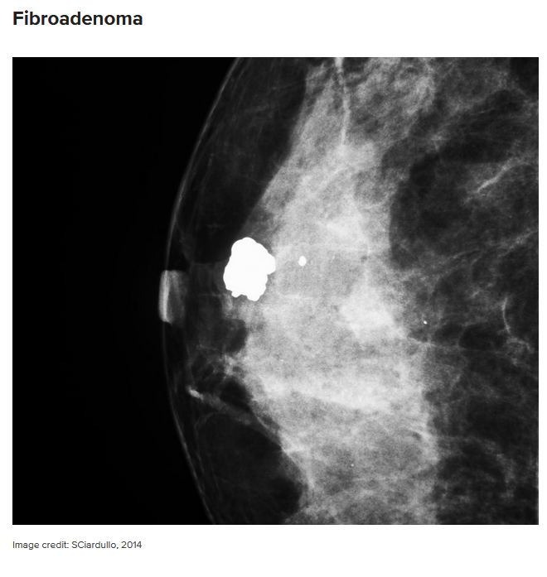
Figure 6. Fibroadenoma appears as a round-like benign tumors in the breast and can occur at any age.

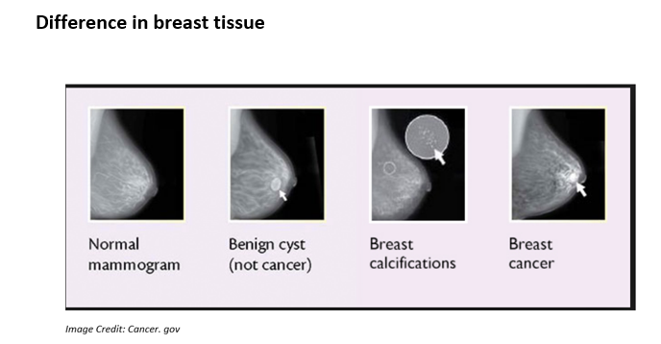
Figure 7. The difference in breast tissue showing a normal breast tissue, benign cyst, calcifications, and breast cancer image.

2.3 Interpreting the Mammogram

The standard system for reporting a mammogram result is called the Breast Imaging-Reporting and Data System (BI-RADS). The BI-RADS category ranges from the number 0 to 6. The doctors across the United States adhere strictly to the BI-RADS system. The table below shows how to understand a mammogram result.

Table 1. Interpreting a Mammogram
Category | Interpretation
0 | Result unclear, needs further test, and previous mammogram comparison
1 | Abnormalities absent
2 | No cancer but presence of abnormalities like benign calcifications
3 | Abnormalities like benign present needs follow-up
4 | Abnormalities present could be cancerous, may need biopsy
5 | Abnormalities present likely to be cancerous, requires biopsy
6 | Presence of cancer requires a mammogram for progress.

The result of a mammogram is clearly explained by a medical practitioner to a patient after the result comes in. Further check-up is then required if there are abnormalities on the mammogram.
Mammography is the most important method out there for detecting breast cancer and checking the respond to treatment of breast cancer. However, mammograms are not perfect for checking abnormalities, especially women with dense breasts. There is no standard for abnormal and normal mammogram out there. Mammograms appears different for every patient. White areas on the mammograms may need follow-up, but most often do not result to cancer.

2.4 Benefits and Risks of a Mammogram
Table 2. Benefits and Risks of a Mammogram
Benefits | Risks
Early detection of breast cancer like small tumors gives the patient more treatment options. | There is possibility of small exposure to radiation after mammogram, but the benefits outweigh the risk.
Mammogram is used to detect all types of breast cancer such as ductal and invasive lobular cancer. | About 5 to 15 percent of screening mammograms needs retesting. Most cases turn out to be false-positive mammogram. This means the result is a normal mammogram.
Special care is taken during x-ray exam to use the lowest dose of radiation. No radiation is left behind in the patient’s body after the x-ray exam. | It is not advisable to take a screening mammogram if you are pregnant. The baby stands the risk of possible exposure to radiation.

2.5 Neural Networks
Neural networks have a long history in the machine learning realm. In 1958, Frank Rosenblatt theorized the perceptron to mathematically model a neuron in the human brain, Figure 2.2.1. In his theory, the neuron takes multiple inputs and multiplies the input by a weighted value. The neuron then sums all the inputs and weights, and if the sum is above a threshold, the neuron is activated. If the sum is below the threshold, the neuron stays dormant.
Figure x.1. Perceptron
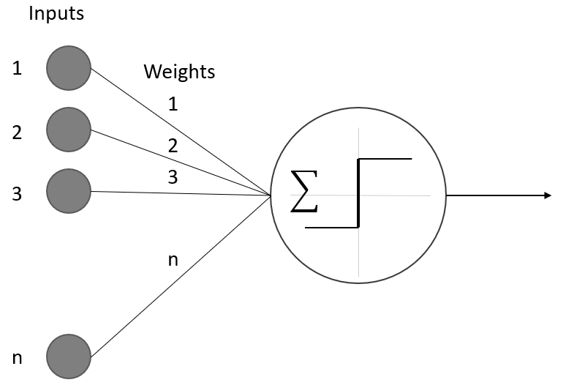
Over time, the perceptron was shown to be able to handle some simple functions, but more complex problems need more than one perceptron to calculate the solution. The next step was to build networks of perceptrons to work in conjunction, call neural networks. The first neural networks we made up of only a single input layer and a single output layer, this was caused by the need for multiple outputs for a simple problem. An example of the would be if you wanted to classify a picture of a vehicle as a truck, a car, or motorcycle; then, you could have multiple inputs of the images, but a single perceptron could only output one response. For this example, we would need three different outputs, one for truck, one for car, and one for motorcycle.
Neural networks continued to become more and more complex as the problems increased in difficulty. We learned that having a single layer of neurons is needed to have hidden layers, Figure 2.2.2. The hidden layers are fully connected to the neurons in the previous layer and the next layer, but they do not have an input or output connection outside of the neural network.

Figure 2.2.2. Hidden Layer

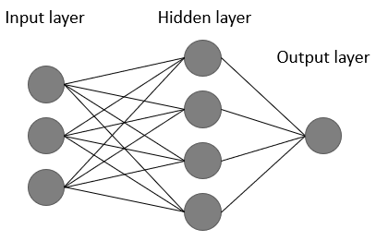

As the layers of neural networks grew to include hidden layers, the way we trained the models had to change. Since the output did not have a direct connection to the output layer, we had to find a way to push the corrections to the weights of the connections of layers further back. The way we achieve this is with backpropagation, Figure 2.2.3. As the network is trained, it outputs the results, then the results are calculated for an error. From the error, we build a correction to the weights of the neurons. We backpropagate those corrections through the network adjusting the weights until the loss is minimized within the loss function, giving us the best results.

Figure 2.2.3. Backpropagation
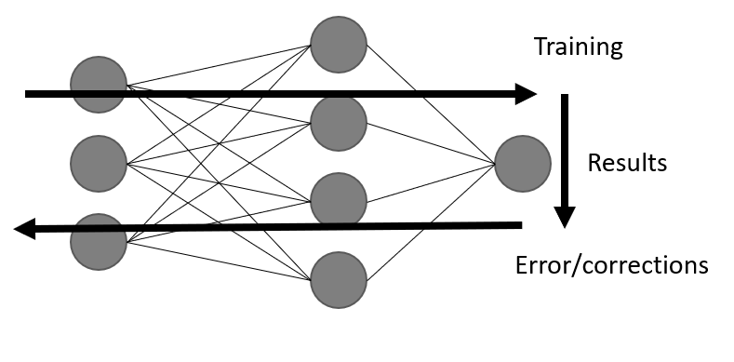

2.5.1 Convolutional Neural Networks

The convolutional neural network (CNN) is a neural network used to identify images. It does this on a high leave by examining the pixel of the image with filters and identifying different features of the image structure. It then compiles the different features extracted and builds a model of the object with in the image. After the model has been properly built an unknown image can be feed into the model and a probability of the object in the image belonging to the different classifications trained in model can be output.
A CNN is made up of different layers performing different functions, Figure 2.2.1.1. The first type of layer is the convolution layer itself, which applies a filter to the image extracting the features from the image. The next type of layer is the pooling layer, which reduces the size of the previous layers cutting the computational complexity of the problem. The final type of layer is the fully connected layer which is responsible to transform the outputs from the other layers into the final output.
Figure 2.2.1.1. CNN example
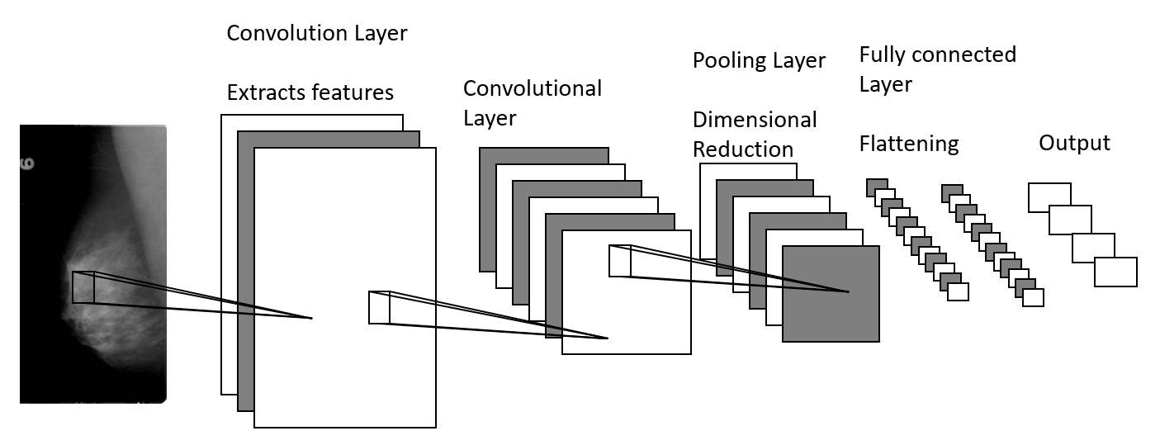
The first type of layer of a CNN is the Convolutional layer. This layer applies a convolutional filter to the image. The filter is used to learn different features and relationships of the image. It will look for structural or gradient on each different channel of the image. The different channels can be three for each color in the red, green, blue image or one on a greyscale image. These filters take the pixels within the filter size and apply a different linear algebra function to them to extract the feature from that section of the image. They then travel around the entire image, mapping the entire image. Each of the filters produces different maps of the image.
With the different filters creating the unique maps on each channel of the image we need to reduce the amount of data we are using. The pooling layer of the CCN is used to reduce the size of the data needed to process. The pooling layer completes this by taking a piece of the filtered image and using a function to combine the properties of the piece, while maintaining the integrity of the information contained within.
After multiple convolutional and pooling layers have been applied to the image, we need to send the information to the output layer. Until now, we have not talked about the dimensions of the CNN, but each of the convolutional and pooling steps change the shape of the information. The original image may be 100 x 100 x 3 pixels for the RGB channels, and after the first convolutional layer with 10 filters, it can be 100 x 100 x 3 x 10. Even with pooling it will not be reduced to a perfect shape to feed the output. The flattening layer is responsible for reducing the response from the previous layers into a single stream of bits. This stream of bits is fed into the output layer to get the probability results.
Each CNN uses a different number of each layer in different orders to achieve their results.

2.5.2 Object Detection

Utilizing the CNN built above, we can develop a way to detect objects within an image and highlights it location. There are three main ways to do this sliding window, "You Only Look Once, YOLO" and the "Single Shot Multiple Box Detector." The different ways to detect an object have some similarities and a few key differences, but fundamentality they all work the same. They all work by first dividing the image into smaller sub-images. Then, they run the image classification model we described above on the sub-images. A probability is retrieved from the image classifier and recorded with the location within the image. If the probability is above a certain threshold, then that section of the image is highlighted in some fashion.
3 Data
The data set we used for our paper was put together by the Cancer Imaging Archive [13] for public use. It was made from the Digital Database for Screening Mammography. The dataset consists of 10,239 images made up of full MLO (mediolateral oblique, angled) images, CC (Cranial-Caudal, top-down) images, Region of Interest masks, and cropped images. The images are split into 704 test images and 5324 training images. We pull 100 images from the test and training sets before the model is made for validation of the object detector. The images chosen for the object detector are chosen because there is only one image from that patient, removing a chance they could have been looked at before the final validation, skewing the results.
The data is stored in separate folders for each patient and each image type (MLO, CC) and each breast (left, right). These folders have subfolders by the day the image was taken. The next subfolder is used to explain the type of image contained (full mammogram, cropped, ROI). Finally, the images are located within these subfolders named either 000000.dcm or 000001.dcm based on how many images are located within the folder (fig ##).

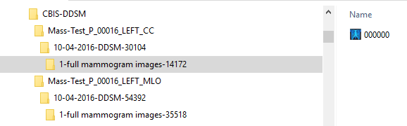
Fig 1

The first step in processing the images we brought them into individual folders used for training and testing of the convolutional neural network. Next, we identify the individual files used for this study. We converted all the DICOM files into lossless JPEG files to be used by the CNN for detection and classification.
4 Methods
In order to detect and classify breast cancer within mammograms, we utilized CNNs to do the heavy lifting. Using a Keras front end with a Tensorflow working in the back ground, we build a 4-layer deep learning image classifier to differentiate between the four states of the cancer we are looking to detect, calcification benign, calcification malignant, mass benign, and mass malignant. We used the checkpoint from the image classifier to load into the sliding window detector and retrieve the final detection and classification of anomalies in the mammograms.
The building of the image classifier is broken down into four fully connected layers: one flattening layer and three dropout layers using relu activation on the first two and softmax on the final flattening layer. It then uses an adam optimizer looking at categorical response. The four fully connected layers start with 10 filters working up to 80 layer per image, with a shrinking kernel size at the filters increase. After flattening the results, the four drop layers are utilized, bringing the results down to the final four categories. We run 75 epochs validating after each epoch saving the best weights of the epochs to be used by the image classifier. We train our model on only the images with pathologies of "benign-with no call back" and "malignant" to remove the middle ground with an unclear pathology even for the doctors reading the mammograms. We still validate the classifier and test detector with all three pathology types. Removing the "benign" pathology gave an immediate validation accuracy of 11% in classification with no other changes. We achieve a peak validation accuracy of 68% as shown in figure, we load these weights into our object detector.
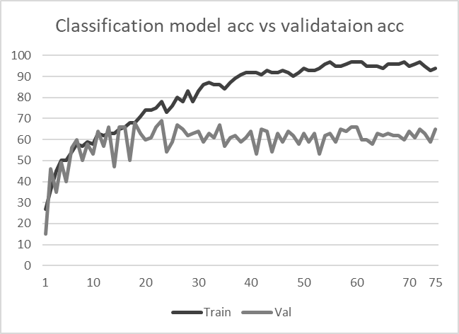

We then build a sliding window object detector to pull pieces of a full mammogram ranging from 215x512 pixels to 1024x1024 pixels, the images are shrunk to 512x512 sub-images. The different sub-images are run through the image classifier predictor one at time saving the results and x, y coordinates. We then look through the results observing any spikes in the predictions indicating the presence of cancerous tissue. Then the different classifications for the area of interest are compared to see which classification of caner type and pathology are determined by the CNN.
5 Results
Using the methods above we achieved a detection accuracy of 46% and classification percentage of 64%. We utilized 25 full mammograms of each type of cancer and pathology for our final validation of our cancer detector and classifier. Our best category for detection is malignant masses, we detected 16 out of 25 or 64% of this type of cancer. Our best category for classification is malignant calcifications, we properly classified 12 out or 13, or 92% of the detected cancer. Typically, improper classifications where only a change of pathology, only 4% were classified as a mass verse calcification and vice versa.

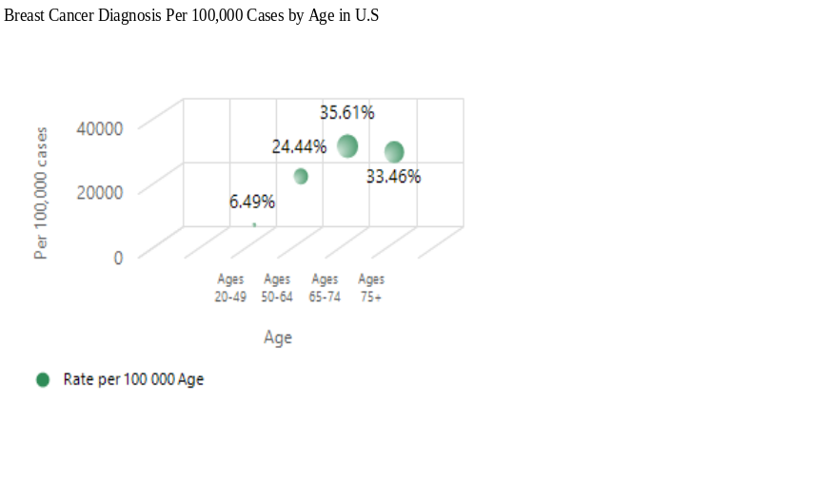

Figure 5.1. Scatter plot per 100,000 cases in breast cancer diagnosis (y-axis) at each
changes to age at time of diagnosis with 20 -75+ years of age (x-axis)

The scatter plot of 100,000 cases in breast cancer diagnosis by age shows percentages per age of diagnosis with age range 65-74 years recording the highest at 35.6% while the age range 20-49 years recorded the lowest at 6.49%. Ages 75 and above and 50-64 years recorded 33.46% and 24.44% respectively as shown in figure 5.1 above.
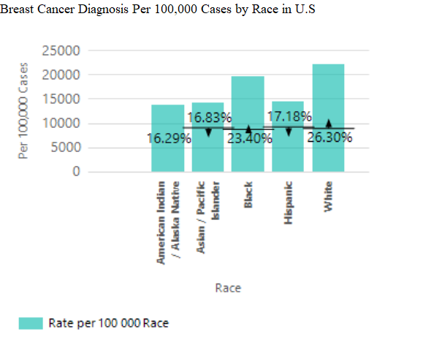

Figure 5.2. Bar chart per 100,000 cases in breast cancer diagnosis to the percentage by race in breast cancer diagnosis

The Pie chart of 100,000 cases in breast cancer diagnosis by race shows percentages per race at time of diagnosis with White recording the highest at 26.30%, followed by Black with 23.40%, while American Indian/Alaska recorded the lowest at 16.29%. Hispanic and Asian/Pacific Islander recorded 17.18% and 16.83% respectively as shown in figure 5.2 above.

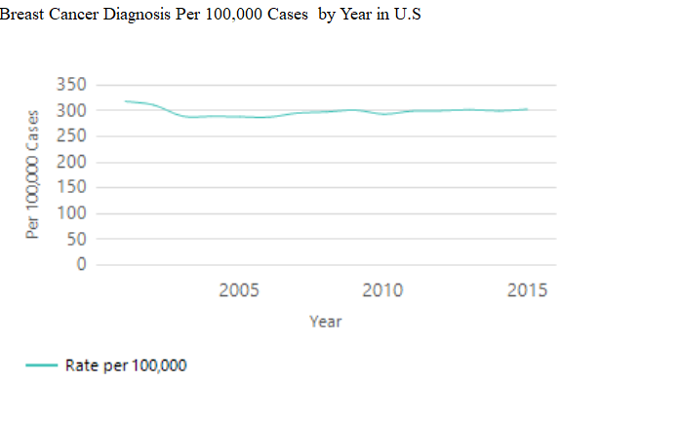

Figure 5.3. Line plot per 100,000 cases in breast cancer diagnosis by year (2001 - 2015) in breast cancer diagnosis

The line plot of 100,000 cases in breast cancer diagnosis per year at time of diagnosis with year 2001 recording the highest with a significant decrease yearly and slight increase every other year. Year 2015 shows a significant decrease from 2001 as shown in figure 5.3 above.

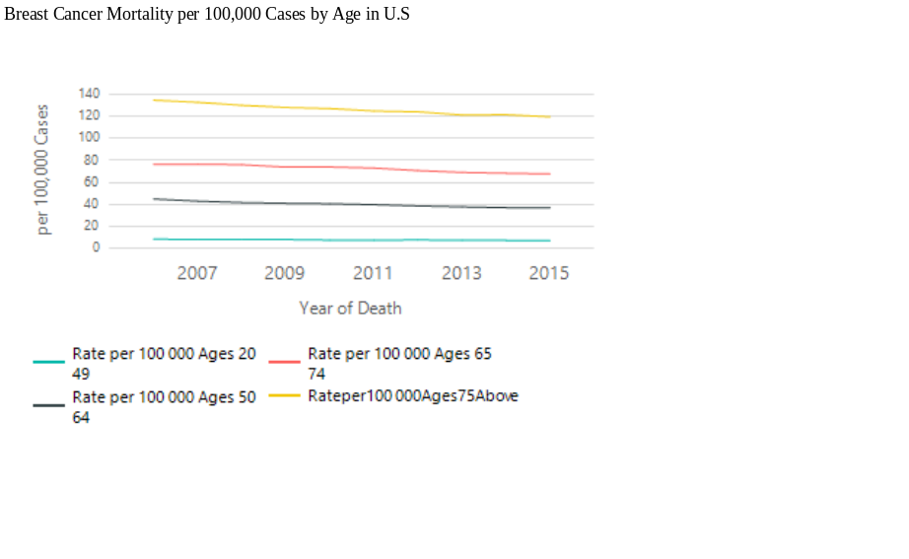

Figure 5.4. Line plot per 100,000 cases by age in breast cancer diagnosis (y-axis) at each change to year at time of death (x-axis) with 20 -75+ years of age

The Line plot of 100,000 cases in breast cancer diagnosis per year at time of death by age with ages 75 and above recording the highest mortality rate, followed by ages 65 -74 years and 50 - 64 respectively. Ages 20 - 49 recorded the lowest mortality rate as shown in figure 5.4 above.

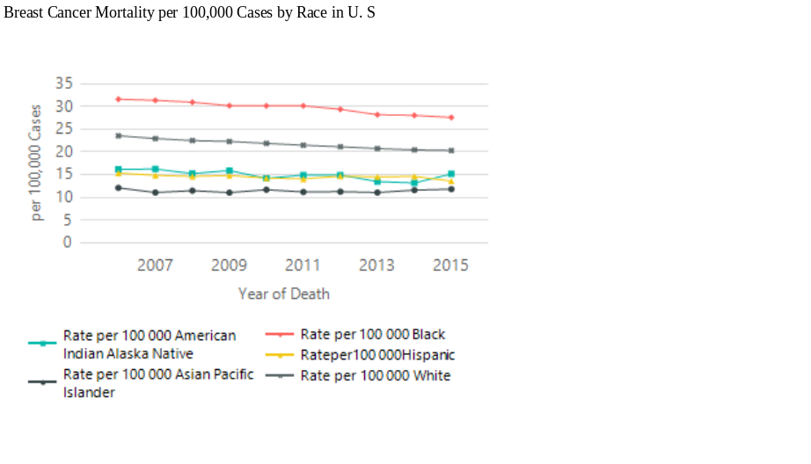

Figure 5.5. Line plot per 100,000 cases by race in breast cancer diagnosis (y-axis) at each
changes to year at time of death (x-axis) per race

The Line plot of 100,000 cases in breast cancer diagnosis per year at time of death by race with Black recording the highest mortality rate, followed by White and American Indian/Alaska Native respectively. Hispanic and Asian Pacific Islander recorded the lowest mortality rate respectively as shown in figure 5.5 above.

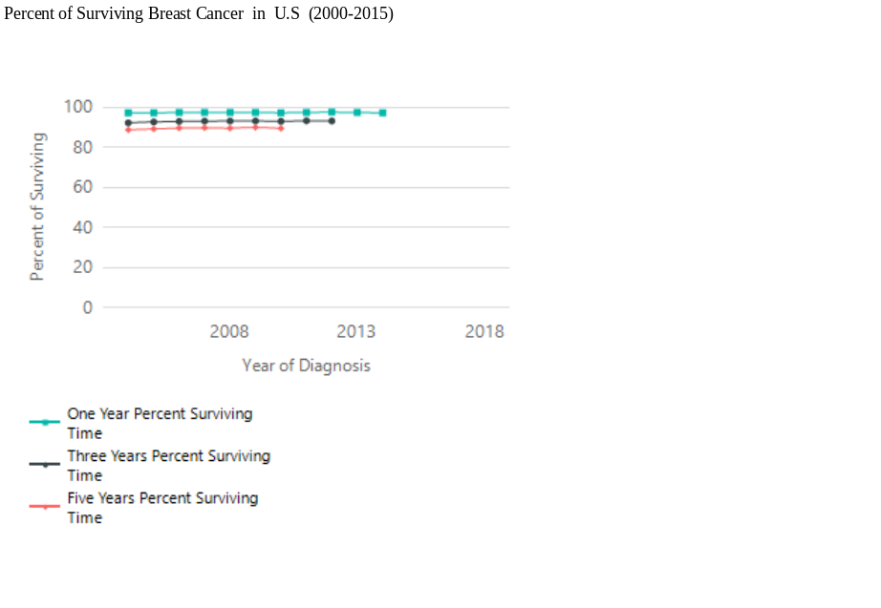
Figure 5.6. Line plot per 100,000 cases by percentage of surviving breast cancer from time of diagnosis (y-axis) at each change to year at the time of diagnosing breast cancer (x-axis) per one-year percent surviving, per three- years percent surviving, and per five-years percent surviving

The Line plot of 100,000 cases in breast cancer diagnosis per year at time of diagnosis by surviving time with percentage of one year of surviving breast cancer recording the highest surviving rate at 97.61%, followed by three years of surviving breast cancer recording 93.21% surviving rate. Five years of surviving breast cancer recorded 90.07% surviving rate, the lowest surviving rate as shown in figure 5.6 above.

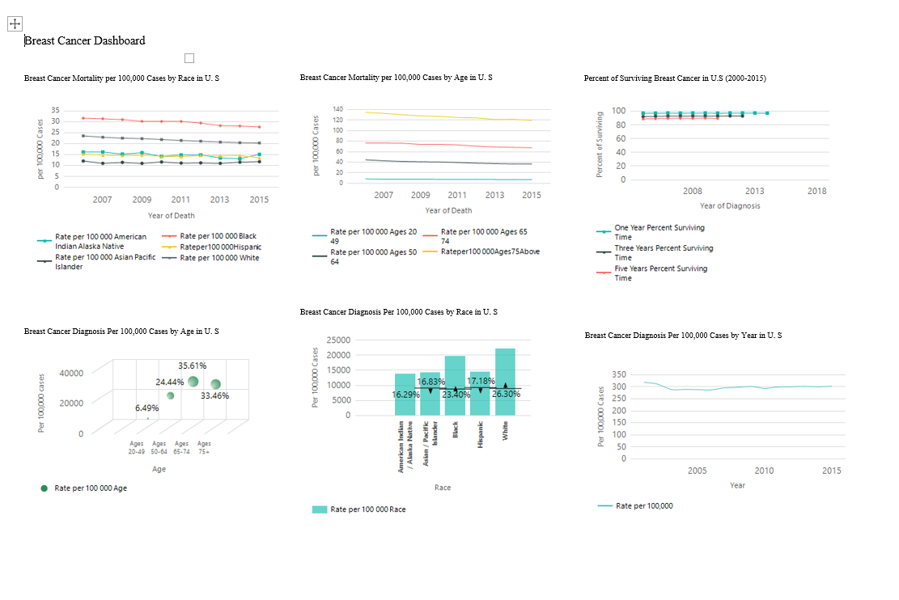

Figure 5.7. Breast Cancer dashboard by race, age, year, mortality rate by race, mortality
rate by age and surviving time per 100,000 cases in U.S

6 Analysis of Results.
6.1 Convolutional Neural Network Classification and Validation Analysis.

From our result removing the benign pathology, we got a validation accuracy of 11% in the classification and a validation accuracy of 68%. We loaded these weights into our object detector and then build a sliding window object detector to pull pieces of a full mammogram. Using these methods, we achieved a detection accuracy of 46% and classification of 64%. After we utilize 25 mammograms of each type of cancer and pathology for our final validation of our cancer detector and classifier. Our best category for detection is the malignant masses. We detected 16 out of 25 or 64% of this type of cancer. Our best category for classification is malignant calcifications. We classified 12 out of 13 or 92% of the detected cancer.

6.2 Breast Cancer Observed Rates by Age and Race

Figure 5.1 observed 100,000 cases in breast cancer diagnosis by age and indicates percentages per age of diagnosis with age range 65-74 years recording the highest at 35.6% while the age range 20-49 years recorded the lowest at 6.49%. Ages 75 and above and 50-64 years recorded 33.46% and 24.44% respectively.
However, Figure 5.2 observed 100,000 cases in breast cancer diagnosis by race and indicates percentages per race at time of diagnosis with White recording the highest at 26.30%, followed by Black with 23.40%, while American Indian/Alaska recorded the lowest at 16.29%. Hispanic and Asian/Pacific Islander recorded 17.18% and 16.83% respectively.
An interpretation from the variable age indicates that the highest observed age ranged 65-74 years recorded a 35.6% while age range 20 - 49 years recorded the lowest at 6.4%. The scatterplot in Figure 5.1 depicts this analysis. Furthermore, the variable race indicates that the White race recorded the highest at 26.30% while the American Indian/Alaska recorded the lowest at 16.29%. The bar chart in Figure 5.2 depicts the analysis.
Further analysis will be required to determine why the age range 65-74 years recorded the highest breast cancer observed rate. And why the White race recorded the highest observed rate.
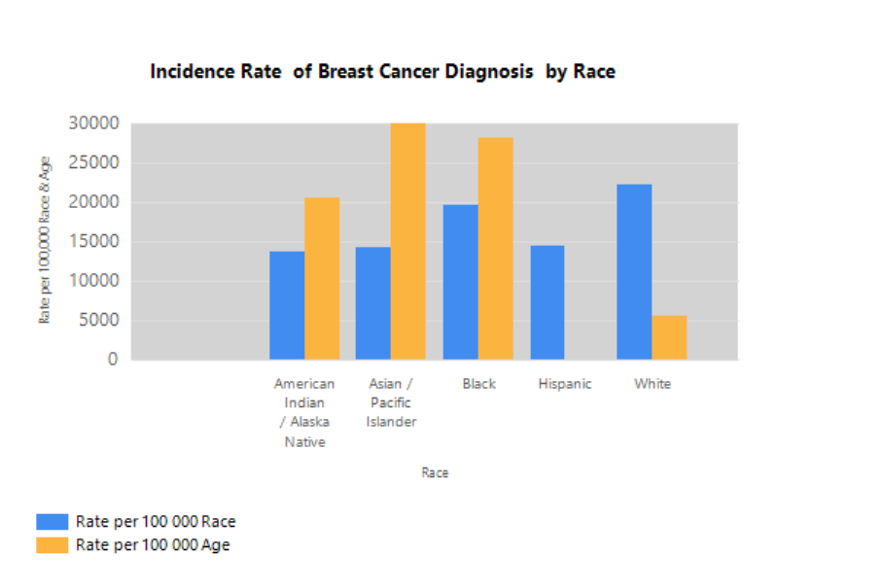
Figure 5.8. Bar plot per 100,000 cases of Race and Age by Race.

6.3 Breast Cancer Observed Rates by Mortality and Survival

Figure 5.5 observed 100,000 cases in breast cancer diagnosis per year at time of death by race with Black recording the highest mortality rate, followed by White and American Indian/Alaska Native respectively. Hispanic and Asian Pacific Islander recorded the lowest mortality rate respectively.
However, Figure 5.6 observed 100,000 cases in breast cancer diagnosis per year at time of diagnosis by surviving time with percentage of one year of surviving breast cancer recording the highest surviving rate at 97.61% followed by three years of surviving breast cancer recording 93.21% surviving rate. Five years of surviving breast cancer recorded 90.07% surviving rate, the lowest surviving rate.
Our analysis from the variable mortality indicates that the highest observed death by race is Black recording the highest mortality rate while Hispanic and Asian Pacific Islander recorded the lowest mortality rate. The line plot in Figure 5.5 depicts the analysis.
Furthermore, the variable survival indicates that the highest surviving rate is a one year of surviving breast cancer at 97.61%. With a five year of surviving breast cancer recording the lowest at 90.07%. The line plot in Figure 5.6 depicts the analysis.
From Figure 5.2 the White race recorded the highest observed rate breast cancer diagnosis at time of diagnosis. However, from Figure 5.5 the Black race recorded the highest mortality rate. Further analysis will be required to determine why the Black race recorded the highest mortality observed rate.
Whether the White race recording the highest observed rate of breast cancer diagnosis is reflecting some certain factors such as certain genetic variation or some other factors. Or the Black race recording the highest mortality rate is reflecting some certain factors such as low- income, poverty, or genetic variation cannot truly be known at this stage. Further analyses are required to determine all these factors.

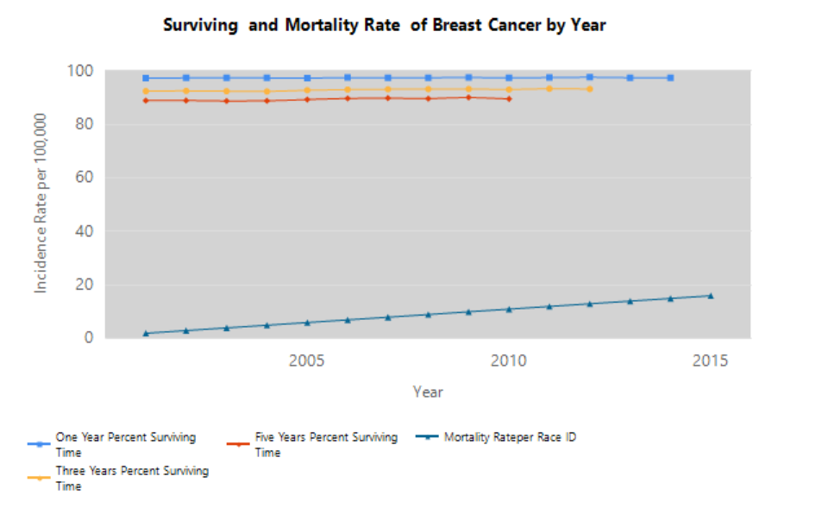
Figure 5.9. Line plot per 100,000 cases of surviving and mortality rate of breast cancer from time of diagnosis (y-axis) at each change to year at the time of diagnosing breast cancer (x-axis)

7 Ethics
All innovators must bear the consequences of their creations. Not all discoveries and new developments are used for the better, even when it was not what their creators intended. However, good intentions do not absolve anyone of their ethical responsibility. For example, those who worked on the Manhattan project were ethically responsible to consider the consequences of creating the atomic bomb, and the lives it could destroy. This does not mean they murdered everyone who died at Hiroshima and Nagasaki, but the possibility of these deaths was something they were obligated to consider when making an ethical decision whether or not to create the bomb. It is not different for us as data scientists. While we may not believe our creations will have nearly as large of consequences, we must still consider them.
As data scientists, we must understand how the methods we create to analyze data will be used, and factor that into our decision to release our findings. Once we share our methods of analysis, or even just the results we have found, we cannot control how others will use them. Therefore, we must think about all possible ways our results can be used, and which are most likely. While we can never anticipate every possibility, we can do our best to understand the nature of our creation.
In this paper, we create a way to detect masses in breast tissue based on mammogram images, and then classify the type of mass. Our intention is to detect breast cancer early, which can in turn help save the lives of breast cancer victims that may have otherwise died due to failure to treat the cancer early enough. However, we also must consider the possibility that our method could end up costing lives rather than saving them.
Our method ran a success rate of --%, which leaves the possibility the other --% could die to the lack of detection. Our intention is that doctors will still catch the cancer in the same patients they would have prior to our method. However, it is possible that doctors could become too reliant on the automatic detection, and then would fail to identify the cancer in other patients they would have normally found. If this were to be the case, we could potentially be doing more harm than good with our methods and would be better off keeping it to ourselves until we could ensure a higher success rate than current doctors.
Even if we were to get our success rate high enough that we are clearly saving more lives than we could possibly be losing, there are still ethical issues to consider. Utilitarian ethics would dictate that the use of our detection would be a positive force since we save more lives than we would lose. However, the fact that we are now changing who lives and who dies puts our method under much more scrutiny. We may find out that our method has a lower success rate in people of a certain age, race, or sex, which would mean that it could be considered discriminatory. Is it fair to give certain groups of people a lower chance at survival if it means more lives are saved overall? This is an ethical question we would have to consider in this situation.
These ethical questions arise if we were to produce false negatives in our method, failing to detect some breast cancer that could result in a patient’s death. However, we also need to consider the implications of producing false positives, where our method could create panic in a patient that is completely healthy. We could be held responsible for a patient overreacting to bad news, or even simply the grief they feel before they learn that they are healthy. Is it unethical to create false panic in more patients to avoid more false negatives? The answer to this again stems from the way our model is used. If the use is made clear that the results simply indicate an increased risk, and that the patient should be examined further by a doctor, then our model should be justified. However, as said before, we can never guarantee how our model will be used if we were to make it used widespread, so we would need to consider the implications. There could even be a scenario where the results of our model are too accepted by doctors, and a patient receives treatment they do not need, which could prove harmful if not just expensive and uncomfortable.
Another ethical concern is the potential for invasion of privacy through the use of our dataset. Medical records are supposed to be private in our country, but we are using them to train our model. While the images are anonymous, there is still a question if we have the right to use these images without the consent of the patients. Are the medical images the property of the patient, or does the hospital own the images, and is simply ethically obligated to withhold the identity of the patient? If we determined the latter was true, we could assume that the hospital provided these images, and we would have not ethical concerns in using the dataset. The former would be more complex. First of all, we do not know if the patients gave consent for their images to be released by the database where we found our dataset. If they did not, then there is clearly a violation of privacy by the entity that released the information. We could argue that the data is already be publicly available, so our use of it would not result in any further invasion of privacy. However, our participation in the use of the potentially unlawfully procured images would most likely be considered unethical.
7 Future Works
Our works is a small step towards the detection and classification of breast cancer types and pathologies. There is still work to be done in this field. First, an evaluation of different object detectors should be done to determine if you only look once or single shot multi-box detector have better results. Next, an evaluation of different forms of images pre-processing and their improvement. Also, being able to directly feed the images as DICOM format could yield strong improvements. Finally, our lack of knowledge about mammograms was our biggest weakness, a multi-disciple team could not only find ways to improve the accuracy of the CNN in detection and classification of mammograms but make a model ready for real word use.
8 Conclusion
An initial look at our results indicate there is still plenty of work to get done before a cancer detector and classifier will be viable for real world applications. Other studies [references] have achieved solid result by limiting themselves to focusing on the detection of a single type of cancer, masses or calcifications, without classifying the pathology. Indicating focusing on detection only is the best way forward for the time being. This will yield the best results in the short term. But a deeper look at our results also, shows a strong start into building a combined detector and classifier for breast cancer.

References
Appendix

