6 Analysis
Looking further into our results we can see the strengths and weaknesses in our process. We looking into our method, comparing its strength and weaknesses. In comparing our results to other studies and doctors results we can see how it stands up to the current systems. Finally, looking into our data, its characteristics, and how it effects our results we can see what limitations it has imposed upon our study.
Our method of using a CNN has a few advantages and weaknesses. The biggest advantage of using a CNN is its strength in image classification. The ImageNet competition was the gold standard for computer vision. It started in 2010 and featured over a million images in over 1 thousand different classes. For many years many models won the competition with an error rate of 26%, until 2012. Then a CNN call AlexNet won with an error rate of 16.4% [1]. Since that year CNNs continued to win with decreasing error rates [2]. Neural networks are also, very good at dealing with large datasets, at a certain point older algorithms stop improving with an increase of data while neural networks continue to grow. Another strength is they build their own algorithm on the data. Some of the weakness for us to use CNNs is they need a large amount of data to work properly, even with over 3 thousand images we are on the lower end of what is needed to properly build a CNN. On top of this they are a black box, we do not know exactly what is happening on the inside of our model, we cannot make changes and if we add data, we have to start the whole training process over again [3].
To truly understand the accomplishment of our model we have to compare the results to other studies and doctors. When it comes to detection, we have a rate of 46%. When compared to doctors, who detect 87% of breast cancer [4], it does not look that good. Other studies have also looked into the detection of breast cancer in mammograms with detection rates from 80% [5] to 94% [6]. If you compare it to random chance if is a great improvement. Each mammogram is 3000x16000 pixels on average. We break this up into 512x512 pieces and feed them to our classifier. The probability of picking the right location at random is 1 in 192 or 0.005% chance. These studies have focused on only the detection of masses within mammograms, without looking into the classification side of the equation.
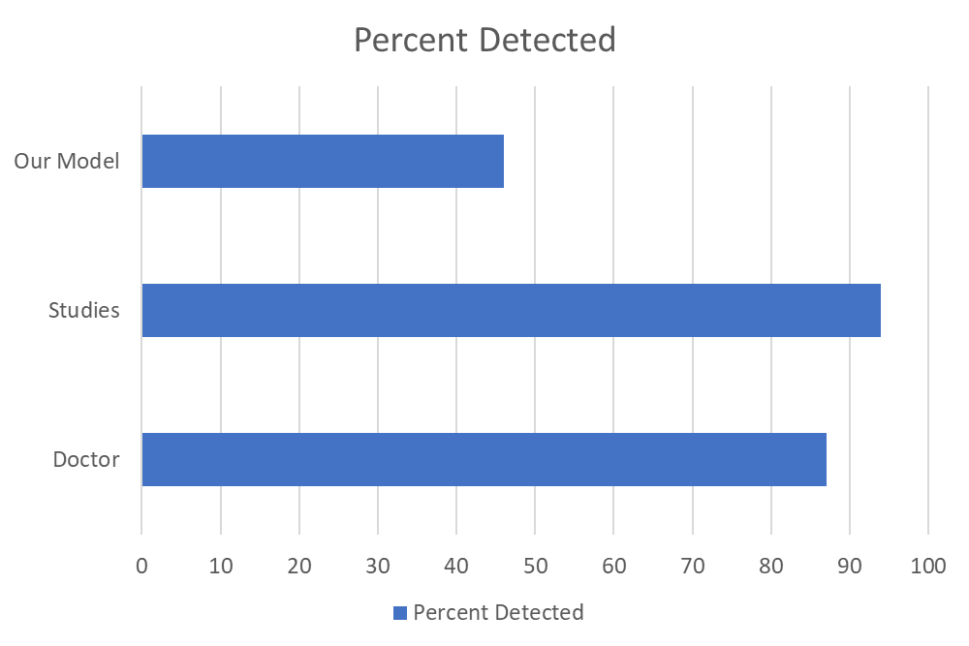
While we add the additional step of classification to our model, increasing its complexity. Less research has been completed on the classification of breast cancer in mammography. The other research we found [7] achieved a proper classification rate of 86% on the proper classification of masses only. Our research has a proper classification rate on masses only of 52%.
Finally looking into our dataset is very biased with all our images contain one form or another of cancer. Using this for both our training and validation sets skews our results. It greatly enhances our chances of properly classifying any detected cancer because the CNN does not know what healthy breast tissue looks like. While, it greatly reduces our chances to detect breast cancer within the full mammogram, for the same reasons.

References

[1]https://hackernoon.com/a-brief-history-of-computer-vision-and-convolutional-neural-networks-8fe8aacc79f3

[2]https://www.scnsoft.com/blog/imagenet-challenge-2017-expectations

[3]https://towardsdatascience.com/hype-disadvantages-of-neural-networks-6af04904ba5b

[4] https://ww5.komen.org/BreastCancer/AccuracyofMammograms.html

[5] https://www.sciencedirect.com/science/article/pii/S0010482511001132?via%3Dihub

[6] https://cs.adelaide.edu.au/~carneiro/publications/mass_classification_miccai.pdf

[7] https://www.ncbi.nlm.nih.gov/pmc/articles/PMC4992049/

Using the methods above we achieved a detection accuracy of 46% and classification percentage of 64%. We utilized 25 full mammograms of each type of cancer and pathology for our final validation of our cancer detector and classifier. Of the different detection rate of cancer type, Mass or Calcification, Mass had a slight edge with 65% those detected while Calcification makes up the remaining 35%.

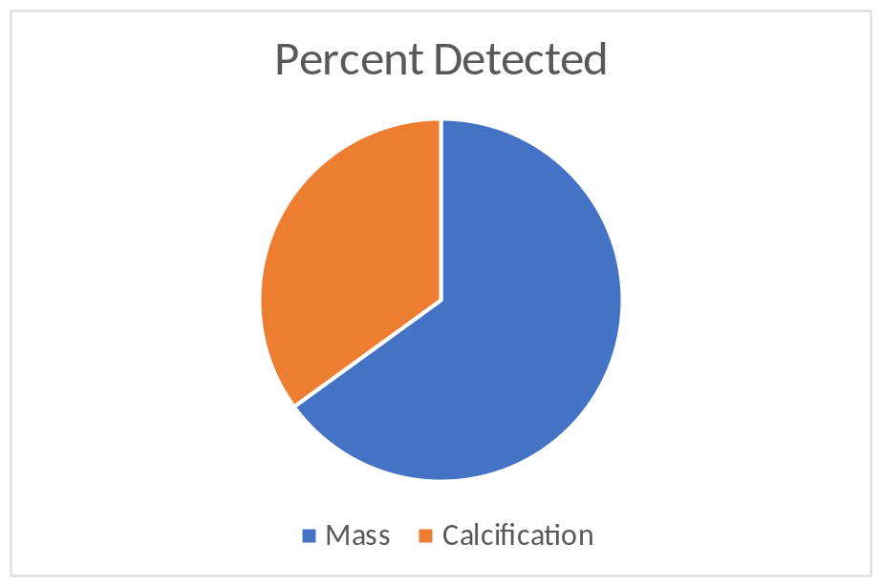

Of the pathology, Malignant of Benign, Malignant was 58% of the detected cancer and benign we 42%.

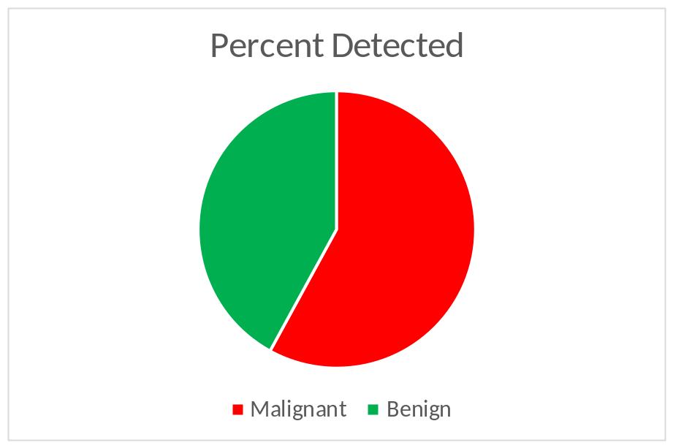
Breaking the results down further into individual combinations of type and pathology we can see rur best category for detection is malignant masses, we detected 16 out of 25 or 64% of this type of cancer.
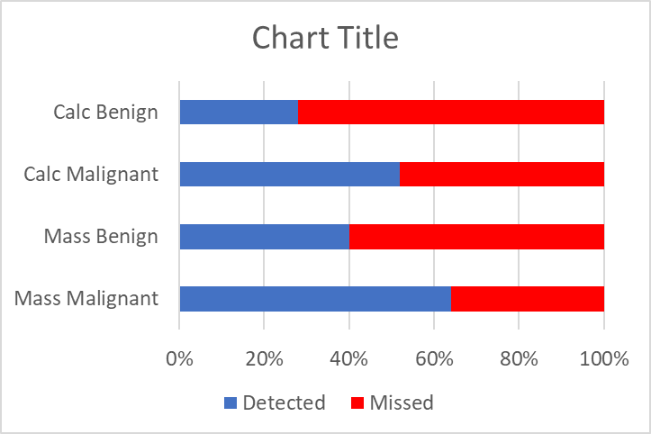
When it comes to classification of the detected cancer, we proper classified 64% of the detected cancer properly. We had two that we improperly classified as the wrong type of cancer. When we it comes to improper classification of the pathology there are some interesting results.
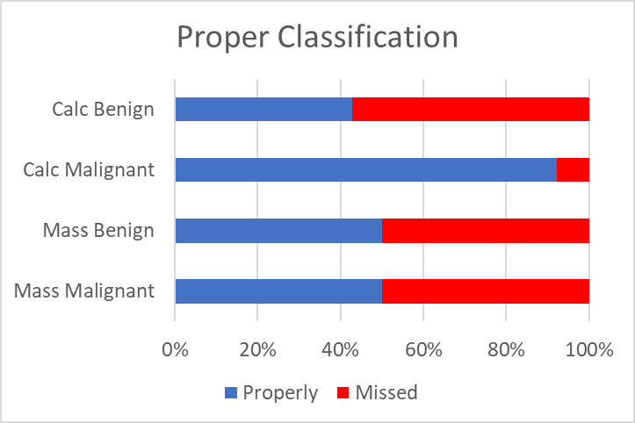
Malignant calcification was classified very well, with only one miss classification. While with masses, both malignant and benign, we properly classified 50%. Finally, benign calcification was miss classified over half the time, but only 7 cases we detected.

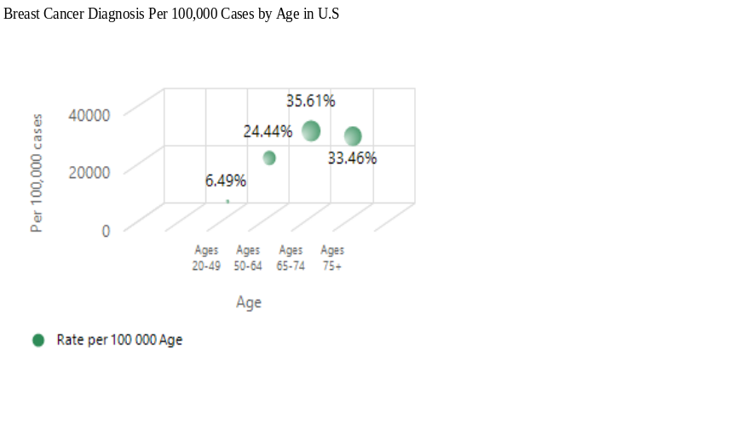

Figure 5.1. Scatter plot per 100,000 cases in breast cancer diagnosis (y-axis) at each
changes to age at time of diagnosis with 20 -75+ years of age (x-axis)

The scatter plot of 100,000 cases in breast cancer diagnosis by age shows percentages per age of diagnosis with age range 65-74 years recording the highest at 35.6% while the age range 20-49 years recorded the lowest at 6.49%. Ages 75 and above and 50-64 years recorded 33.46% and 24.44% respectively as shown in figure 5.1 above.
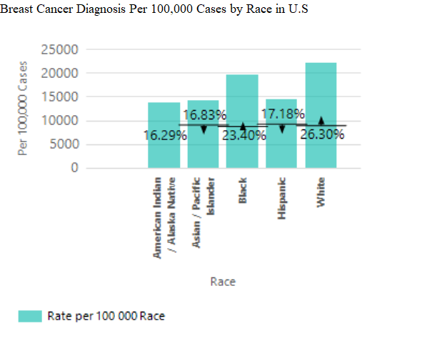

Figure 5.2. Bar chart per 100,000 cases in breast cancer diagnosis to the percentage by race in breast cancer diagnosis

The Pie chart of 100,000 cases in breast cancer diagnosis by race shows percentages per race at time of diagnosis with White recording the highest at 26.30%, followed by Black with 23.40%, while American Indian/Alaska recorded the lowest at 16.29%. Hispanic and Asian/Pacific Islander recorded 17.18% and 16.83% respectively as shown in figure 5.2 above.

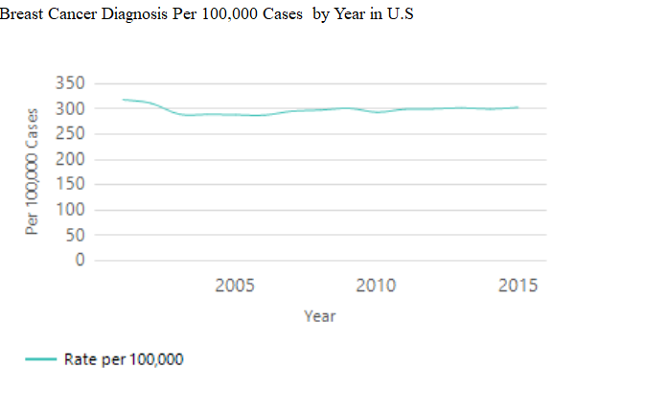

Figure 5.3. Line plot per 100,000 cases in breast cancer diagnosis by year (2001 - 2015) in breast cancer diagnosis

The line plot of 100,000 cases in breast cancer diagnosis per year at time of diagnosis with year 2001 recording the highest with a significant decrease yearly and slight increase every other year. Year 2015 shows a significant decrease from 2001 as shown in figure 5.3 above.

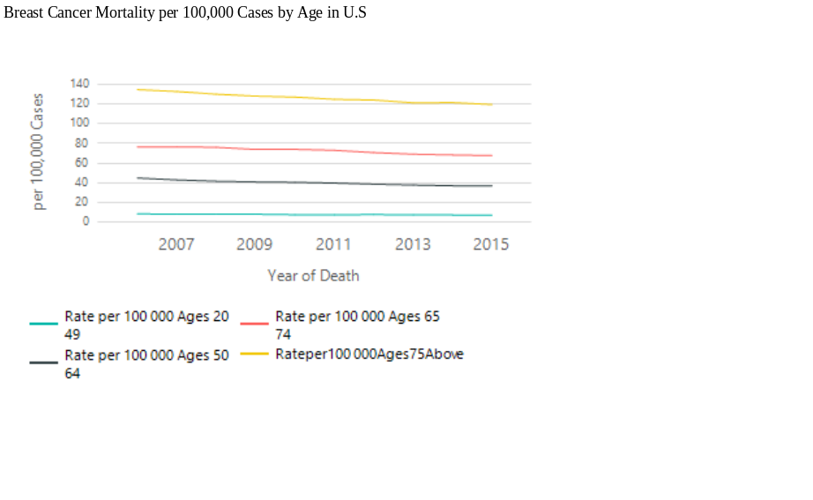

Figure 5.4. Line plot per 100,000 cases by age in breast cancer diagnosis (y-axis) at each change to year at time of death (x-axis) with 20 -75+ years of age

The Line plot of 100,000 cases in breast cancer diagnosis per year at time of death by age with ages 75 and above recording the highest mortality rate, followed by ages 65 -74 years and 50 - 64 respectively. Ages 20 - 49 recorded the lowest mortality rate as shown in figure 5.4 above.

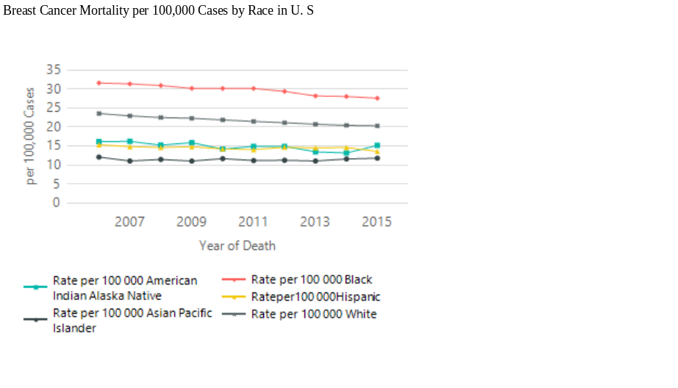

Figure 5.5. Line plot per 100,000 cases by race in breast cancer diagnosis (y-axis) at each
changes to year at time of death (x-axis) per race

The Line plot of 100,000 cases in breast cancer diagnosis per year at time of death by race with Black recording the highest mortality rate, followed by White and American Indian/Alaska Native respectively. Hispanic and Asian Pacific Islander recorded the lowest mortality rate respectively as shown in figure 5.5 above.

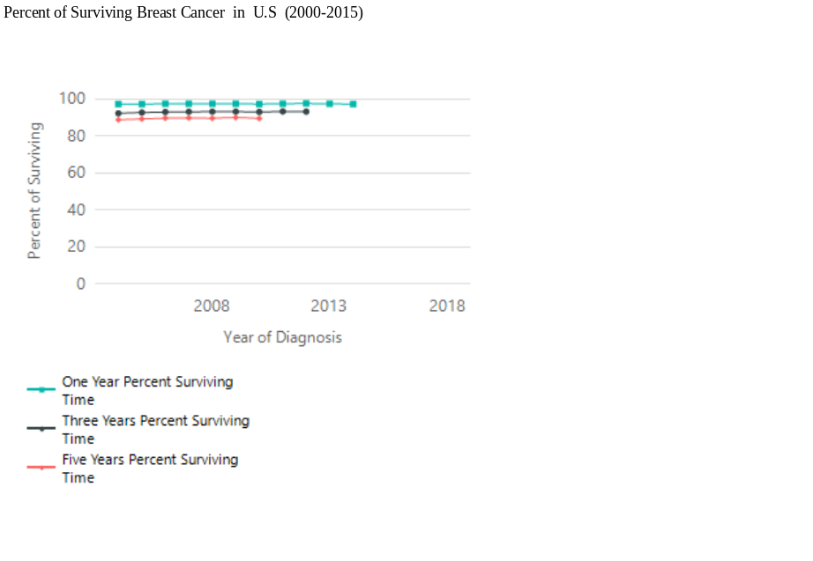
Figure 5.6. Line plot per 100,000 cases by percentage of surviving breast cancer from time of diagnosis (y-axis) at each change to year at the time of diagnosing breast cancer (x-axis) per one-year percent surviving, per three- years percent surviving, and per five-years percent surviving

The Line plot of 100,000 cases in breast cancer diagnosis per year at time of diagnosis by surviving time with percentage of one year of surviving breast cancer recording the highest surviving rate at 97.61%, followed by three years of surviving breast cancer recording 93.21% surviving rate. Five years of surviving breast cancer recorded 90.07% surviving rate, the lowest surviving rate as shown in figure 5.6 above.

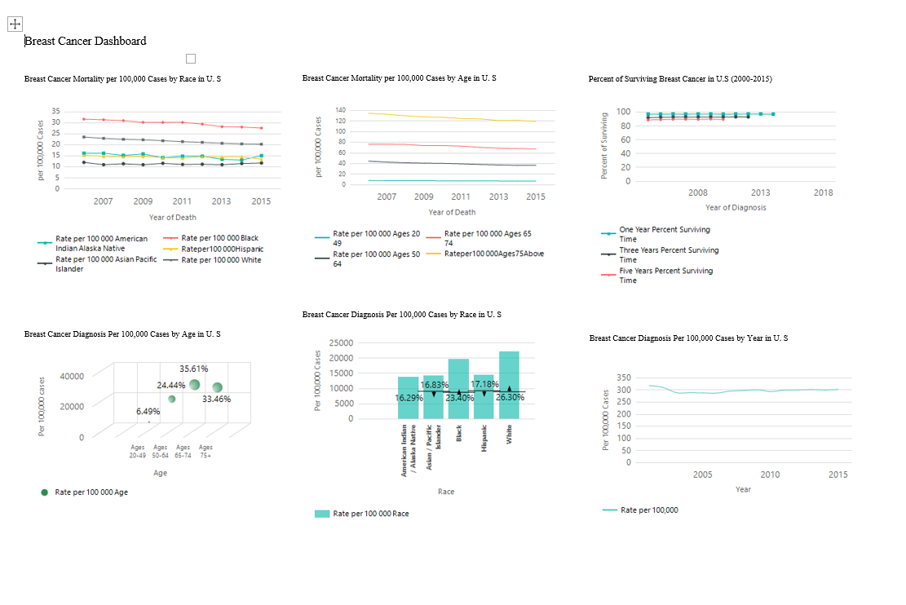

Figure 5.7. Breast Cancer dashboard by race, age, year, mortality rate by race, mortality
rate by age, and surviving time per 100,000 cases in U.S

