5 Results
Using the methods above we achieved a detection accuracy of 46% and classification percentage of 64%. We utilized 25 full mammograms of each type of cancer and pathology for our final validation of our cancer detector and classifier. Of the different detection rate of cancer type, Mass or Calcification, Mass had a slight edge with 65% those detected while Calcification makes up the remaining 35%.

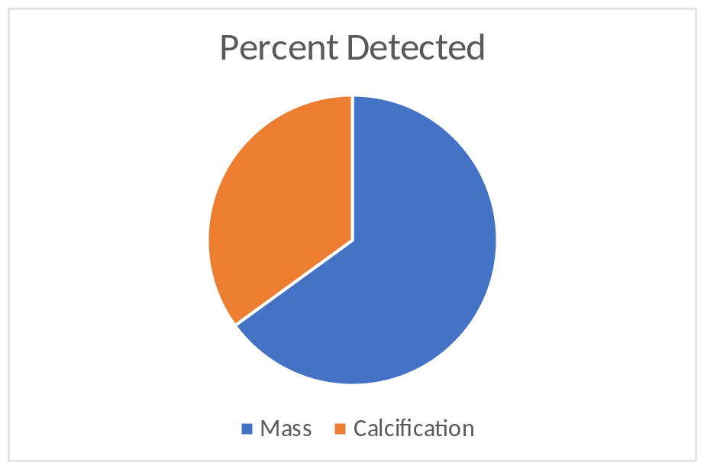

Of the pathology, Malignant of Benign, Malignant was 58% of the detected cancer and benign we 42%.

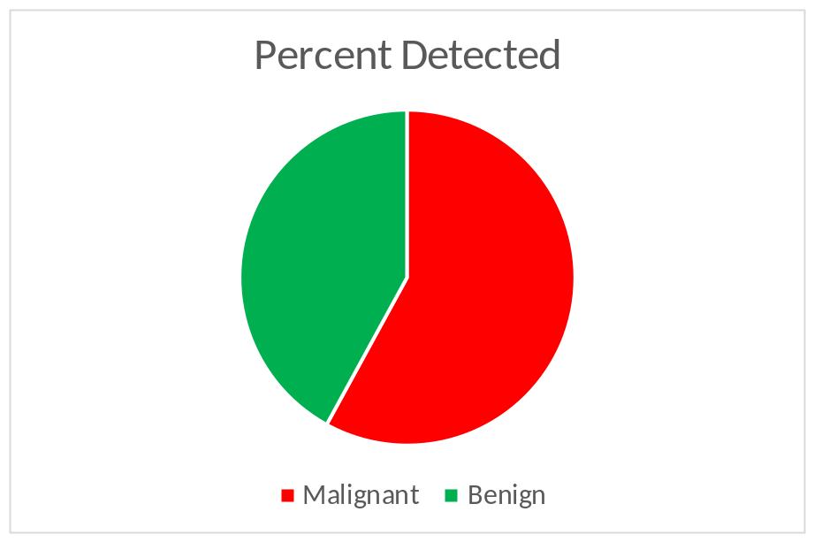
Breaking the results down further into individual combinations of type and pathology we can see rur best category for detection is malignant masses, we detected 16 out of 25 or 64% of this type of cancer.
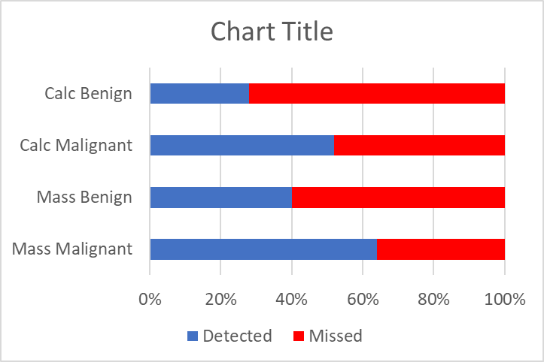
When it comes to classification of the detected cancer, we proper classified 64% of the detected cancer properly. We had two that we improperly classified as the wrong type of cancer. When we it comes to improper classification of the pathology there are some interesting results.
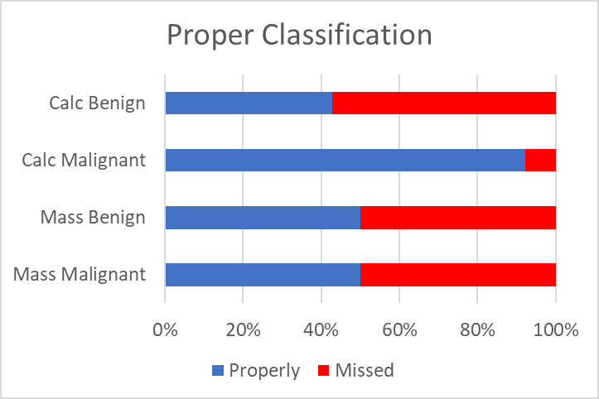
Malignant calcification was classified very well, with only one miss classification. While with masses, both malignant and benign, we properly classified 50%. Finally, benign calcification was miss classified over half the time, but only 7 cases we detected.

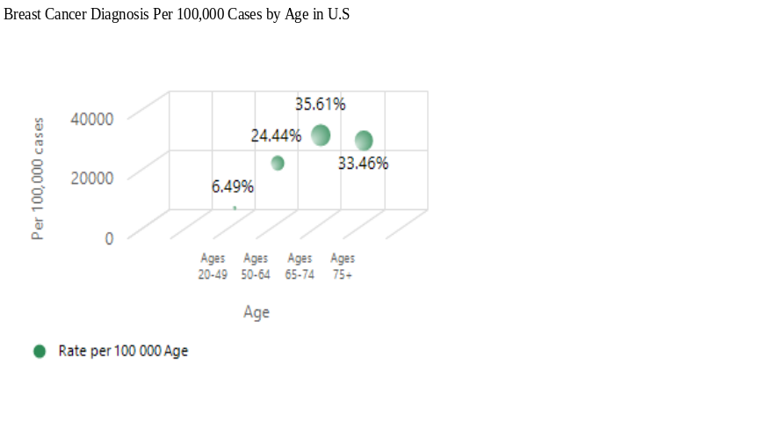

Figure 5.1. Scatter plot per 100,000 cases in breast cancer diagnosis (y-axis) at each
changes to age at time of diagnosis with 20 -75+ years of age (x-axis)

The scatter plot of 100,000 cases in breast cancer diagnosis by age shows percentages per age of diagnosis with age range 65-74 years recording the highest at 35.6% while the age range 20-49 years recorded the lowest at 6.49%. Ages 75 and above and 50-64 years recorded 33.46% and 24.44% respectively as shown in figure 5.1 above.
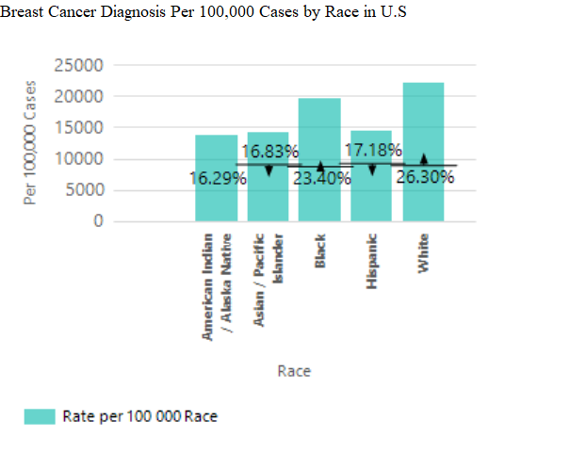

Figure 5.2. Bar chart per 100,000 cases in breast cancer diagnosis to the percentage by race in breast cancer diagnosis

The Pie chart of 100,000 cases in breast cancer diagnosis by race shows percentages per race at time of diagnosis with White recording the highest at 26.30%, followed by Black with 23.40%, while American Indian/Alaska recorded the lowest at 16.29%. Hispanic and Asian/Pacific Islander recorded 17.18% and 16.83% respectively as shown in figure 5.2 above.

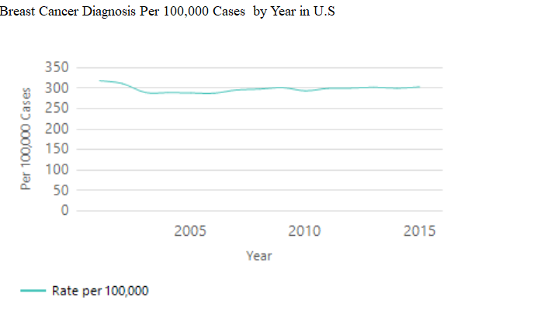

Figure 5.3. Line plot per 100,000 cases in breast cancer diagnosis by year (2001 - 2015) in breast cancer diagnosis

The line plot of 100,000 cases in breast cancer diagnosis per year at time of diagnosis with year 2001 recording the highest with a significant decrease yearly and slight increase every other year. Year 2015 shows a significant decrease from 2001 as shown in figure 5.3 above.

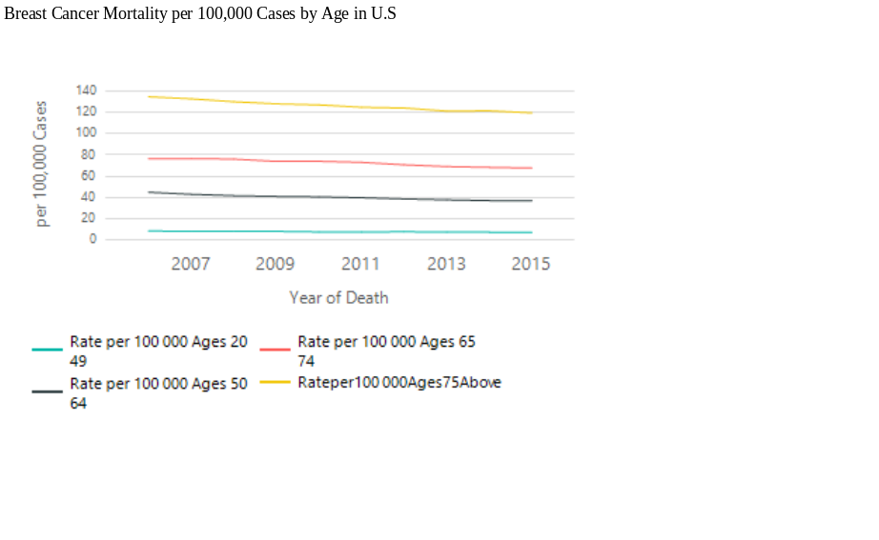

Figure 5.4. Line plot per 100,000 cases by age in breast cancer diagnosis (y-axis) at each change to year at time of death (x-axis) with 20 -75+ years of age

The Line plot of 100,000 cases in breast cancer diagnosis per year at time of death by age with ages 75 and above recording the highest mortality rate, followed by ages 65 -74 years and 50 - 64 respectively. Ages 20 - 49 recorded the lowest mortality rate as shown in figure 5.4 above.

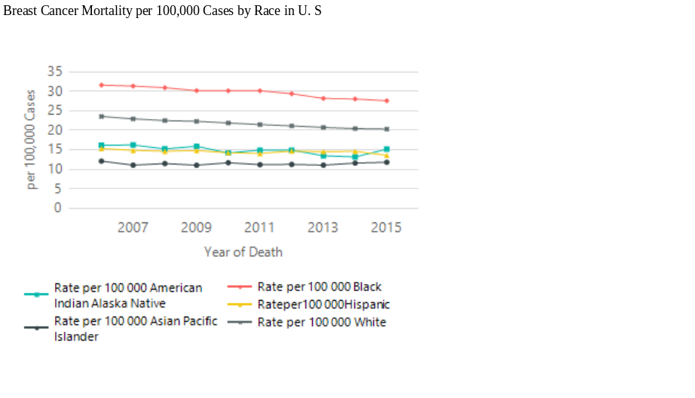

Figure 5.5. Line plot per 100,000 cases by race in breast cancer diagnosis (y-axis) at each
changes to year at time of death (x-axis) per race

The Line plot of 100,000 cases in breast cancer diagnosis per year at time of death by race with Black recording the highest mortality rate, followed by White and American Indian/Alaska Native respectively. Hispanic and Asian Pacific Islander recorded the lowest mortality rate respectively as shown in figure 5.5 above.

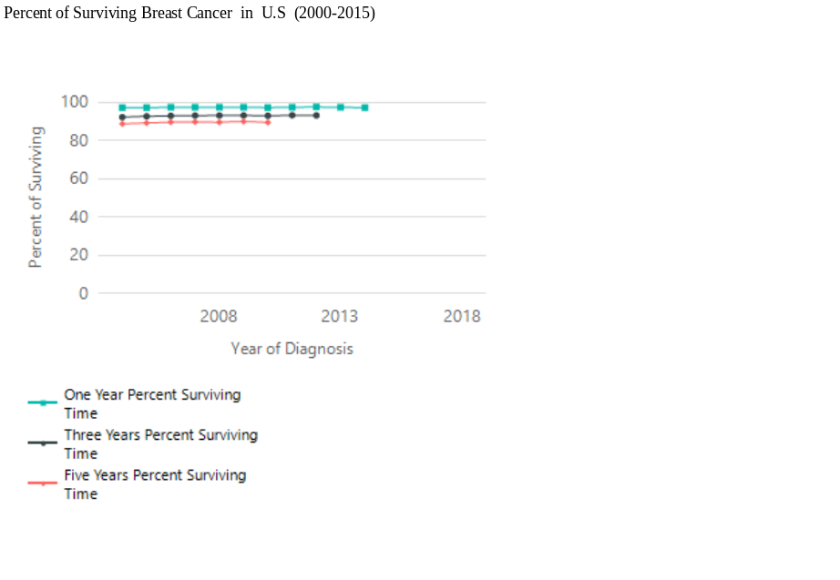
Figure 5.6. Line plot per 100,000 cases by percentage of surviving breast cancer from time of diagnosis (y-axis) at each change to year at the time of diagnosing breast cancer (x-axis) per one-year percent surviving, per three- years percent surviving, and per five-years percent surviving

The Line plot of 100,000 cases in breast cancer diagnosis per year at time of diagnosis by surviving time with percentage of one year of surviving breast cancer recording the highest surviving rate at 97.61%, followed by three years of surviving breast cancer recording 93.21% surviving rate. Five years of surviving breast cancer recorded 90.07% surviving rate, the lowest surviving rate as shown in figure 5.6 above.

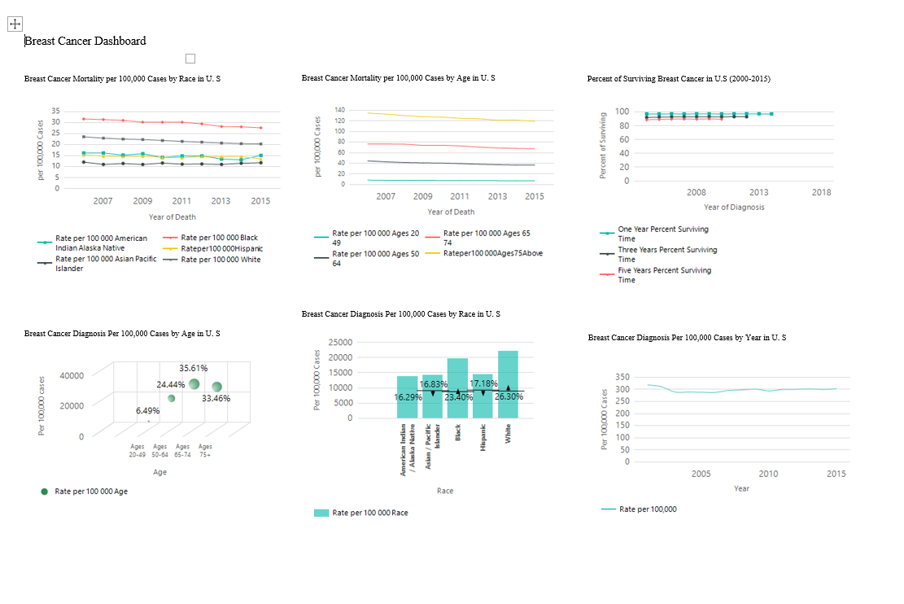

Figure 5.7. Breast Cancer dashboard by race, age, year, mortality rate by race, mortality
rate by age, and surviving time per 100,000 cases in U.S

