2.5 Neural Networks
Neural networks have a long history in the machine learning realm. In 1958, Frank Rosenblatt theorized the perceptron to mathematically model a neuron in the human brain [1], Figure 2.2.1. In his theory, the neuron takes multiple inputs and multiplies the input by a weighted value. The neuron then sums all the inputs and weights, and if the sum is above a threshold, the neuron is activated. If the sum is below the threshold, the neuron stays dormant.
Figure x.1. Perceptron
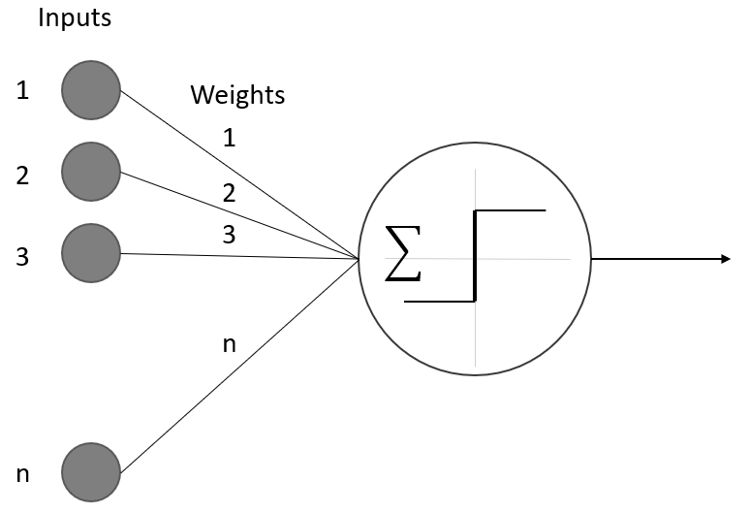
Over time, the perceptron was shown to be able to handle some simple functions, but more complex problems need more than one perceptron to calculate the solution. The next step was to build networks of perceptrons to work in conjunction, call neural networks. The first neural networks we made up of only a single input layer and a single output layer, this was caused by the need for multiple outputs for a simple problem [2]. An example of the would be if you wanted to classify a picture of a vehicle as a truck, a car, or motorcycle; then, you could have multiple inputs of the images, but a single perceptron could only output one response. For this example, we would need three different outputs, one for truck, one for car, and one for motorcycle.
Neural networks continued to become more and more complex as the problems increased in difficulty. We learned that having a single layer of neurons is needed to have hidden layers, Figure 2.2.2. The hidden layers are fully connected to the neurons in the previous layer and the next layer, but they do not have an input or output connection outside of the neural network [2].

Figure 2.2.2. Hidden Layer

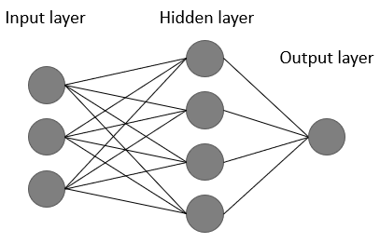

As the layers of neural networks grew to include hidden layers, the way we trained the models had to change. Since the output did not have a direct connection to the output layer, we had to find a way to push the corrections to the weights of the connections of layers further back. The way we achieve this is with backpropagation, Figure 2.2.3. As the network is trained, it outputs the results, then the results are calculated for an error. From the error, we build a correction to the weights of the neurons. We backpropagate those corrections through the network adjusting the weights until the loss is minimized within the loss function, giving us the best results [2].

Figure 2.2.3. Backpropagation
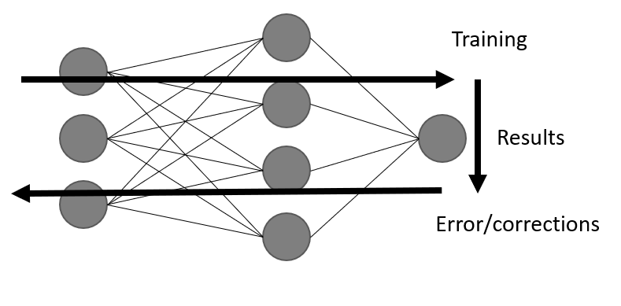

2.5.1 Convolutional Neural Networks

The convolutional neural network (CNN) is a neural network used to identify images. It does this on a high leave by examining the pixel of the image with filters and identifying different features of the image structure. It then compiles the different features extracted and builds a model of the object with in the image. After the model has been properly built an unknown image can be feed into the model and a probability of the object in the image belonging to the different classifications trained in model can be output [3].
A CNN is made up of different layers performing different functions, Figure 2.2.1.1. The first type of layer is the convolution layer itself, which applies a filter to the image extracting the features from the image. The next type of layer is the pooling layer, which reduces the size of the previous layers cutting the computational complexity of the problem. The final type of layer is the fully connected layer which is responsible to transform the outputs from the other layers into the final output [3].
Figure 2.2.1.1. CNN example
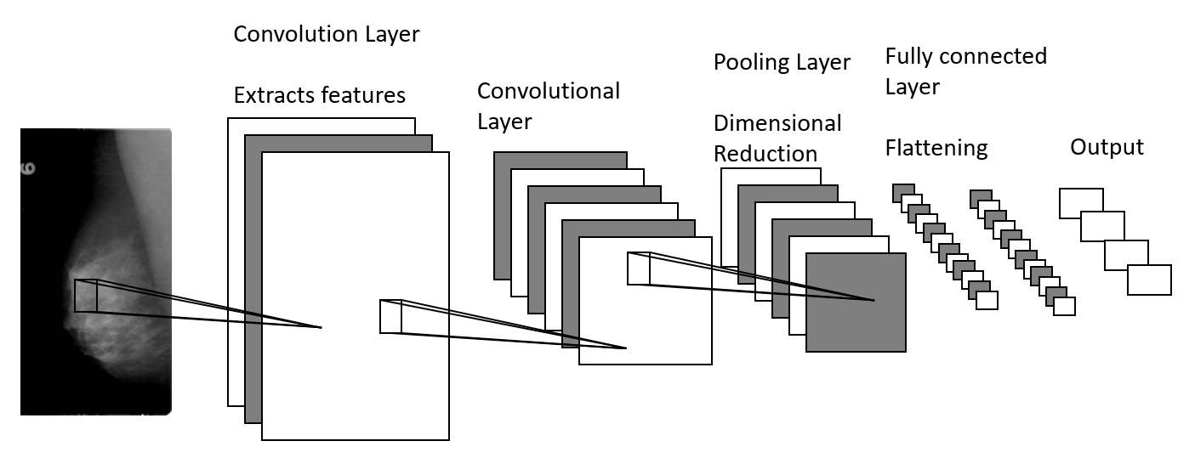
The first type of layer of a CNN is the Convolutional layer. This layer applies a convolutional filter to the image. The filter is used to learn different features and relationships of the image. It will look for structural or gradient on each different channel of the image. The different channels can be three for each color in the red, green, blue image or one on a greyscale image. These filters take the pixels within the filter size and apply a different linear algebra function to them to extract the feature from that section of the image. They then travel around the entire image, mapping the entire image. Each of the filters produces different maps of the image [3].
With the different filters creating the unique maps on each channel of the image we need to reduce the amount of data we are using. The pooling layer of the CCN is used to reduce the size of the data needed to process. The pooling layer completes this by taking a piece of the filtered image and using a function to combine the properties of the piece, while maintaining the integrity of the information contained within [3].
After multiple convolutional and pooling layers have been applied to the image, we need to send the information to the output layer. Until now, we have not talked about the dimensions of the CNN, but each of the convolutional and pooling steps change the shape of the information. The original image may be 100 x 100 x 3 pixels for the RGB channels, and after the first convolutional layer with 10 filters, it can be 100 x 100 x 3 x 10. Even with pooling it will not be reduced to a perfect shape to feed the output. The flattening layer is responsible for reducing the response from the previous layers into a single stream of bits. This stream of bits is fed into the output layer to get the probability results [3].
Each CNN uses a different number of each layer in different orders to achieve their results.

2.5.2 Object Detection

Utilizing the CNN built above, we can develop a way to detect objects within an image and highlights it location. There are three main ways to do this sliding window, "You Only Look Once, YOLO" and the "Single Shot Multiple Box Detector." The different ways to detect an object have some similarities and a few key differences, but fundamentality they all work the same. They all work by first dividing the image into smaller sub-images. Then, they run the image classification model we described above on the sub-images. A probability is retrieved from the image classifier and recorded with the location within the image. If the probability is above a certain threshold, then that section of the image is highlighted in some fashion [1].
3 Data
The data set we used for our paper was put together by the Cancer Imaging Archive [1] for public use. It was made from the Digital Database for Screening Mammography. The dataset consists of 10,239 images each containing cancer. The image set is made up of full MLO (mediolateral oblique, angled) images, CC (Cranial-Caudal, top-down) images, Region of Interest masks, and cropped images. The images are split into 704 test images and 5324 training images. We pull 100 full mammogram images from the test and training sets before the model is made for validation of the object detector. The images chosen for the object detector are chosen because there is only one image from that patient, removing a chance they could have been looked at before the final validation, skewing the results.
The data is stored in separate folders for each patient and each image type (MLO, CC) and each breast (left, right). These folders have subfolders by the day the image was taken. The next subfolder is used to explain the type of image contained (full mammogram, cropped, ROI). Finally, the images are located within these subfolders named either 000000.dcm or 000001.dcm based on how many images are located within the folder (fig ##).

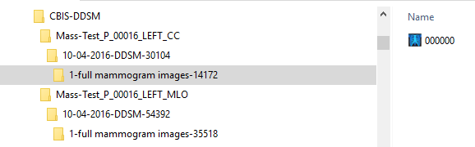
Fig 1

The first step in processing the images we brought them into individual folders used for training and testing of the convolutional neural network. Next, we identify the individual files used for this study. W converted all the DICOM files into lossless JPEG files to be used by the CNN for detection and classification.
References

Neural network
1. F. Rosenblatt.: The perceptron, a perceiving and recognizing automaton Project Para. Cornell Aeronautical Laboratory, 1957.

2. Andrey Kurenkov: A 'Brief' History of Neural nets and Depp Learning (2015) http://www.andreykurenkov.com/writing/ai/a-brief-history-of-neural-nets-and-deep-learning/

3. Ujjwlkarn.: An Intuitive Explanation of Convolutional Neural Networks. (2016) https://ujjwalkarn.me/2016/08/11/intuitive-explanation-convnets/

Object Detectors
1. Prince Grover.: Evolution of Object Detection and Localization Algotithms (2018) https://towardsdatascience.com/evolution-of-object-detection-and-localization-algotihms-e2410212d8bad

Data
1. Cancer Image Archive.: Curated Breast Imaging Subset of DDSM. (2018) https://wiki.cancerimagingarchive.net/display/Public/CBIS-DDSM#83dd9b518d554b2983368fd0d778f31b

