CV [59 x 80] at times: 49



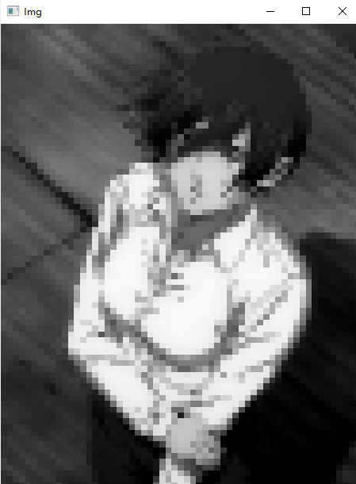

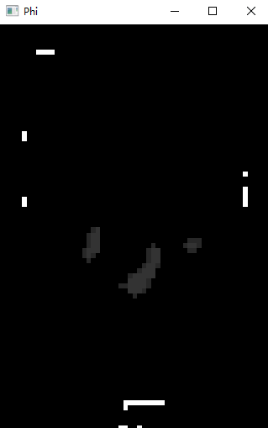



# 3

C1: 96.29 C2: 96.29

finish up to stop condition, at times: 1865

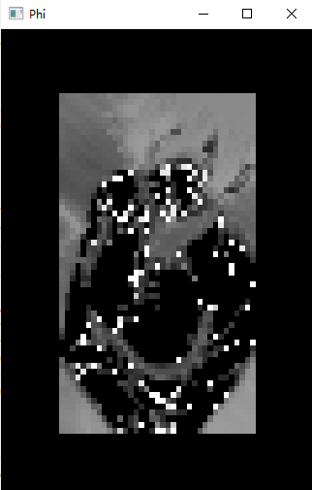

#4

C1: 95.88 C2: 96.06

finish up to stop condition, at times: 57



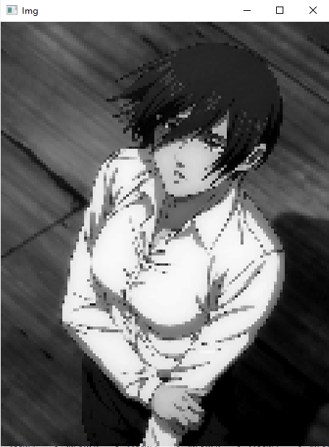

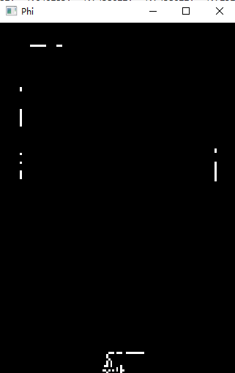



Use Heaviside to distinguish LAST Phi result:

# best result

Img size: [59 x 80]

Phi original margin: 10

C1: 96.25 C2: 96.28

finish up to stop condition, at times: 391

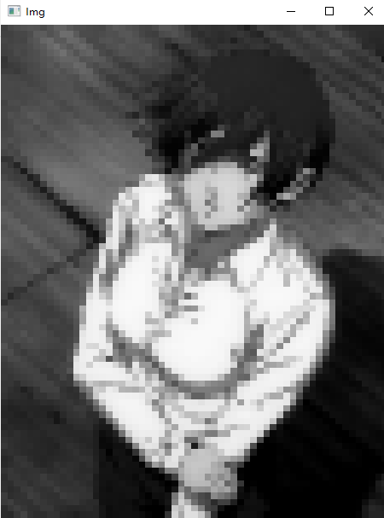



Best result, for

#2



#

Img size: [396 x 534]

Phi original margin: 50

C1: 92.86 C2: 94.47

finish up to stop condition, at times: 56

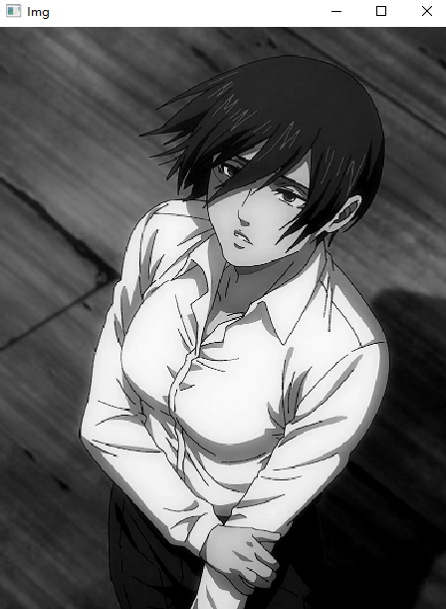

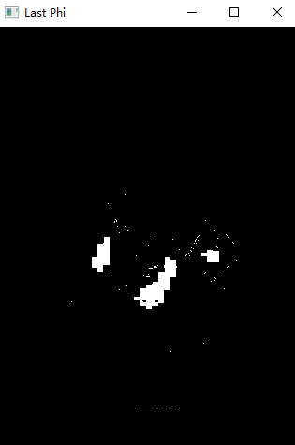

Not good using cv

#

Img size: [29 x 40]

Phi original margin: 1

C1: 109.02 C2: 46.50

finish up to stop condition, at times: 7285

