timestep尺度信贷网络SOC对照实验报告 v2
生成时间：2026-06-09 13:26:58 CST

1. 实验协议
- timestep扫描目录：results/credit_soc_timestep_scan_20260609_v2/merged
- 分析目录：results/credit_soc_timestep_scan_analysis_20260609_v2
- period_end 对照目录：/data/WYC/class/creditNet/results/credit_soc_comprehensive_scan_20260608_v1
- run 数：8000
- avalanche 事件数：4539260
- scenario 数：8000
- 每宏观期微步上限：max_period_length_steps=500
本轮保持上一轮完备扫描的场景轴：初始本金分布、收入分配、信贷增长规则、支出机制、网络拓扑和 c=0.10..0.80。区别只在事件观测尺度：原协议在 period_end 统一结算检查；本协议把一个宏观期的计划 K_t 个单位信贷尝试拆成 K_t 个微步，每个成功或失败的 credit time_step 后立即按 1/K_t 缩放结算支出/收入、检查违约，并在下一次信贷增长前完成整次 avalanche 清算。
为使 8000 个场景的全景筛查在有限时间内完成，本轮 v2 对照设置 max_period_length_steps=500：理论 K_t 仍记录为未截断指标，实际每个宏观期最多执行 500 个 credit 微步。这一上限不会改变单个微步的单位信贷规模，但会限制高 c、高支出反馈下的单期计算长度，因此本报告结论应解释为“带 500 微步上限的 timestep 快速全景对照”，不是 120-period、3-seed、无上限长时稳态最终证明。
因此，本报告里的 event_timestep_rate 是 avalanche 次数除以实际信贷尝试 time_step 数；event_period_occupancy 只是有事件的宏观期占比。SOC 快筛里的非饱和门槛使用 event_timestep_rate < 0.80，不再使用 period_end 报告中的 period 占用率。

2. 与 period_end 的总体差异
- 同场景平均大级联事件率变化：-0.321
- 同场景平均事件规模比例变化：-0.102
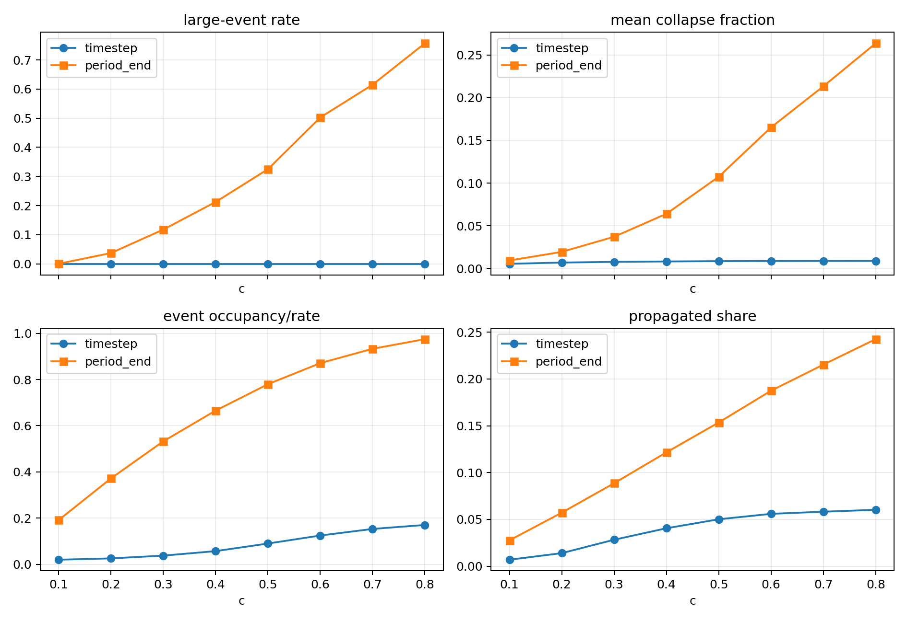
protocol_compare_by_c.png
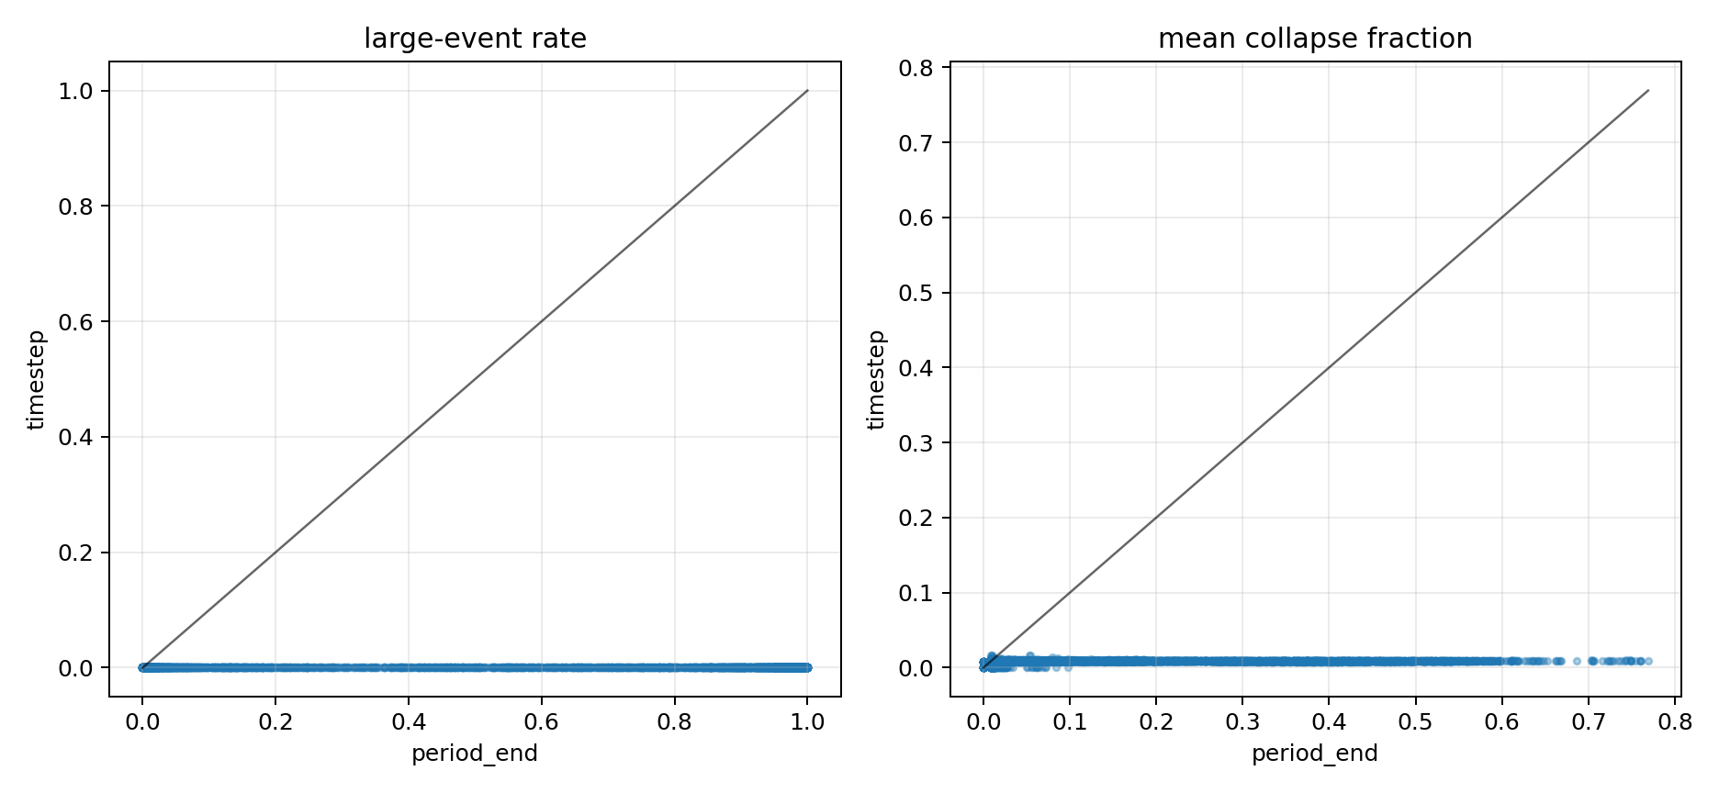
protocol_scenario_scatter.png
按 c 聚合的 timestep 结果：
c | scenarios | mean_large_event_rate | mean_event_fraction | mean_event_timestep_rate | mean_event_period_occupancy | mean_propagated_share | mean_repeat_default_share
0.1 | 1000 | 0 | 0.00551 | 0.01965 | 0.1809 | 0.006929 | 0.1415
0.2 | 1000 | 0 | 0.006963 | 0.02543 | 0.3529 | 0.01394 | 0.2115
0.3 | 1000 | 0 | 0.007784 | 0.03736 | 0.5326 | 0.02826 | 0.2968
0.4 | 1000 | 0 | 0.008263 | 0.05684 | 0.6845 | 0.04052 | 0.3795
0.5 | 1000 | 0 | 0.008621 | 0.08973 | 0.8081 | 0.05011 | 0.487
0.6 | 1000 | 0 | 0.008774 | 0.1244 | 0.8872 | 0.05592 | 0.5849
0.7 | 1000 | 0 | 0.008861 | 0.1529 | 0.9433 | 0.05821 | 0.6682
0.8 | 1000 | 0 | 0.008899 | 0.1702 | 0.9633 | 0.06024 | 0.7168

3. 级联失效相图
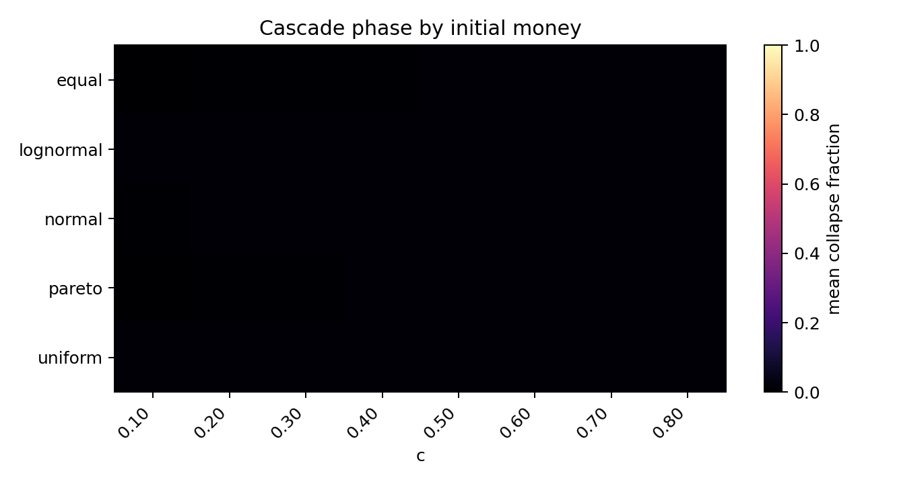
cascade_phase_by_money.png
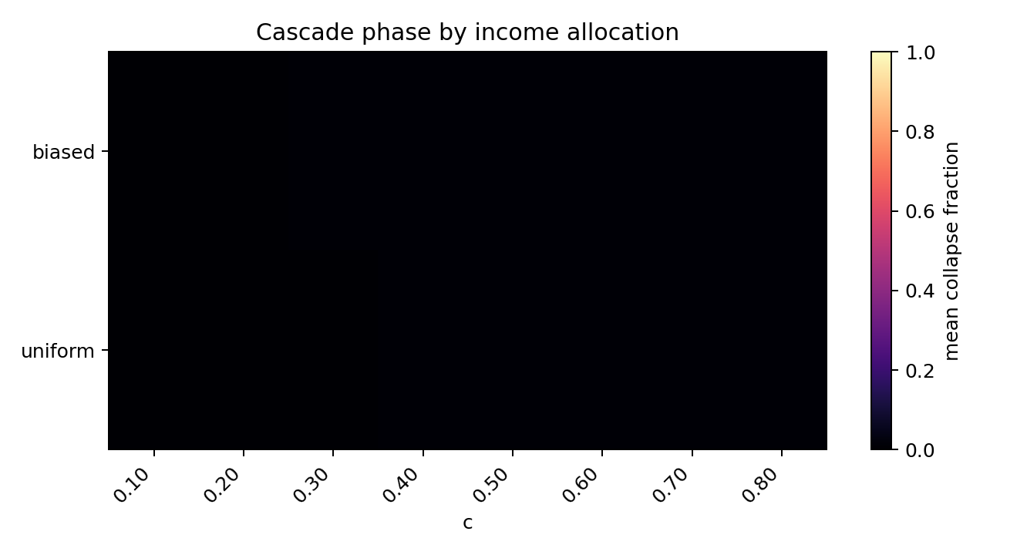
cascade_phase_by_income_rule.png
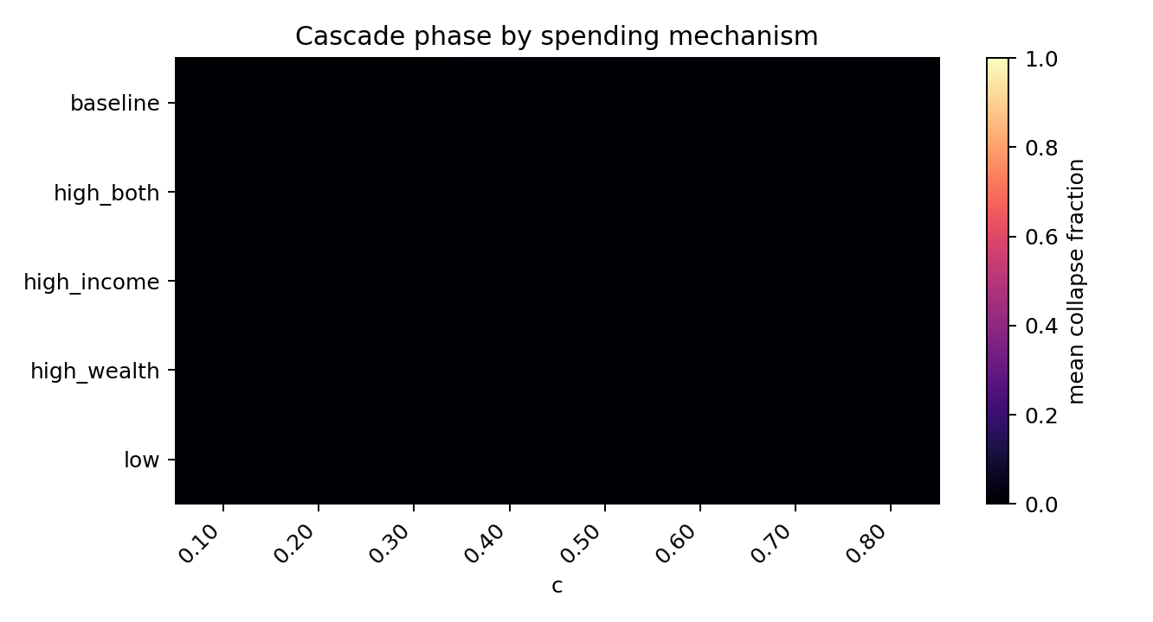
cascade_phase_by_spending.png
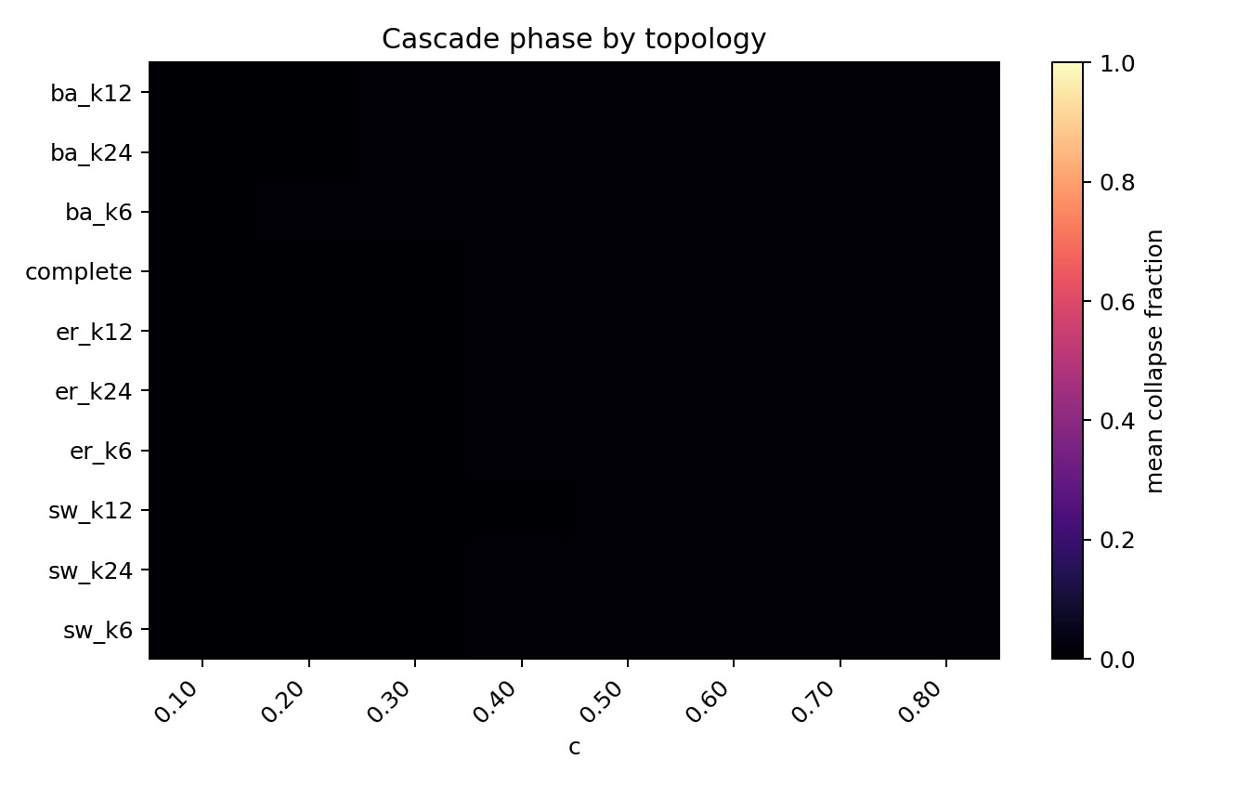
cascade_phase_by_topology.png
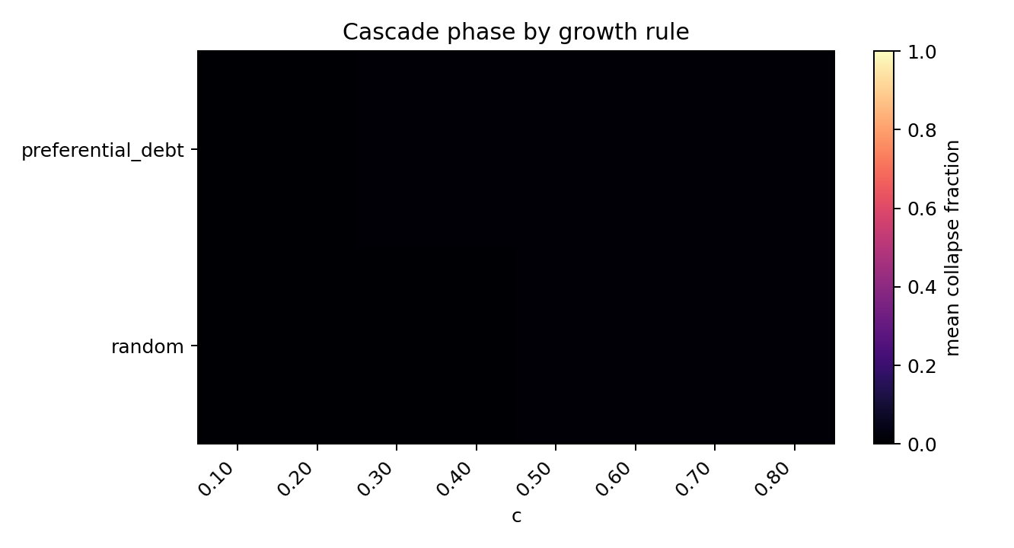
cascade_phase_by_growth_rule.png
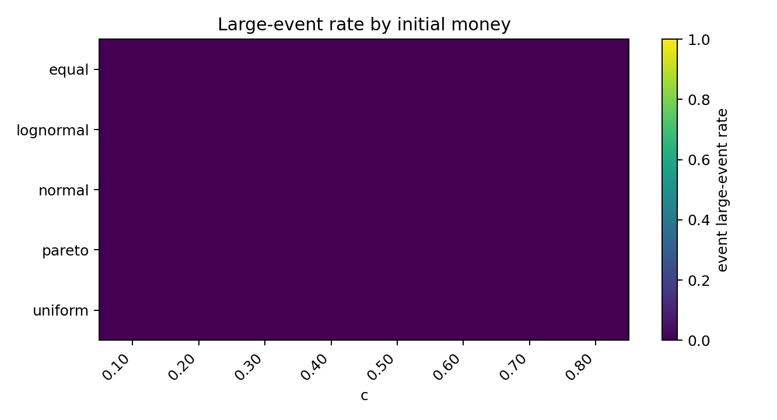
large_event_phase_by_money.png
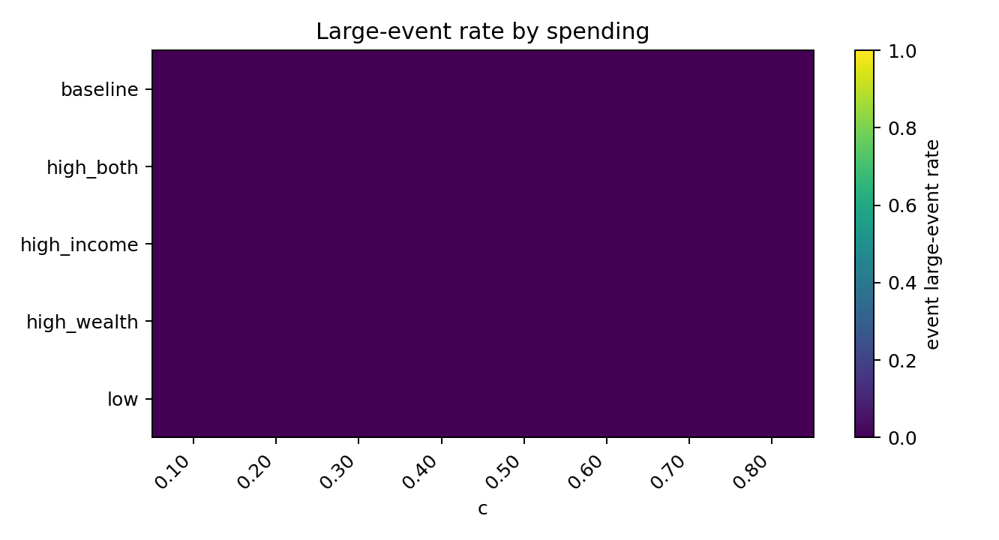
large_event_phase_by_spending.png
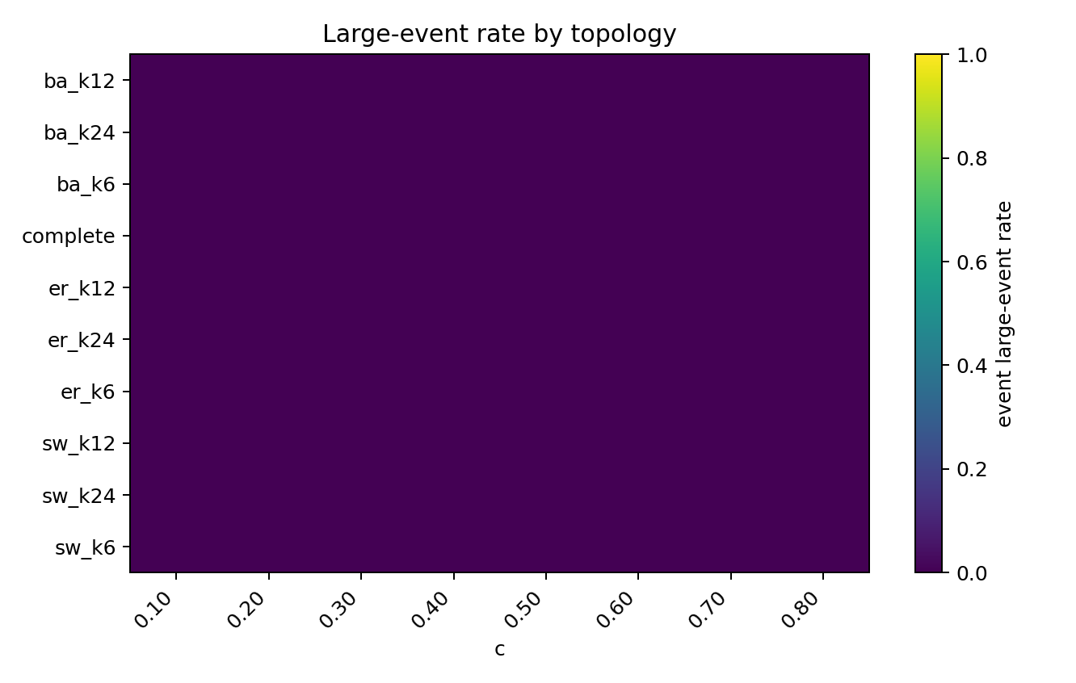
large_event_phase_by_topology.png
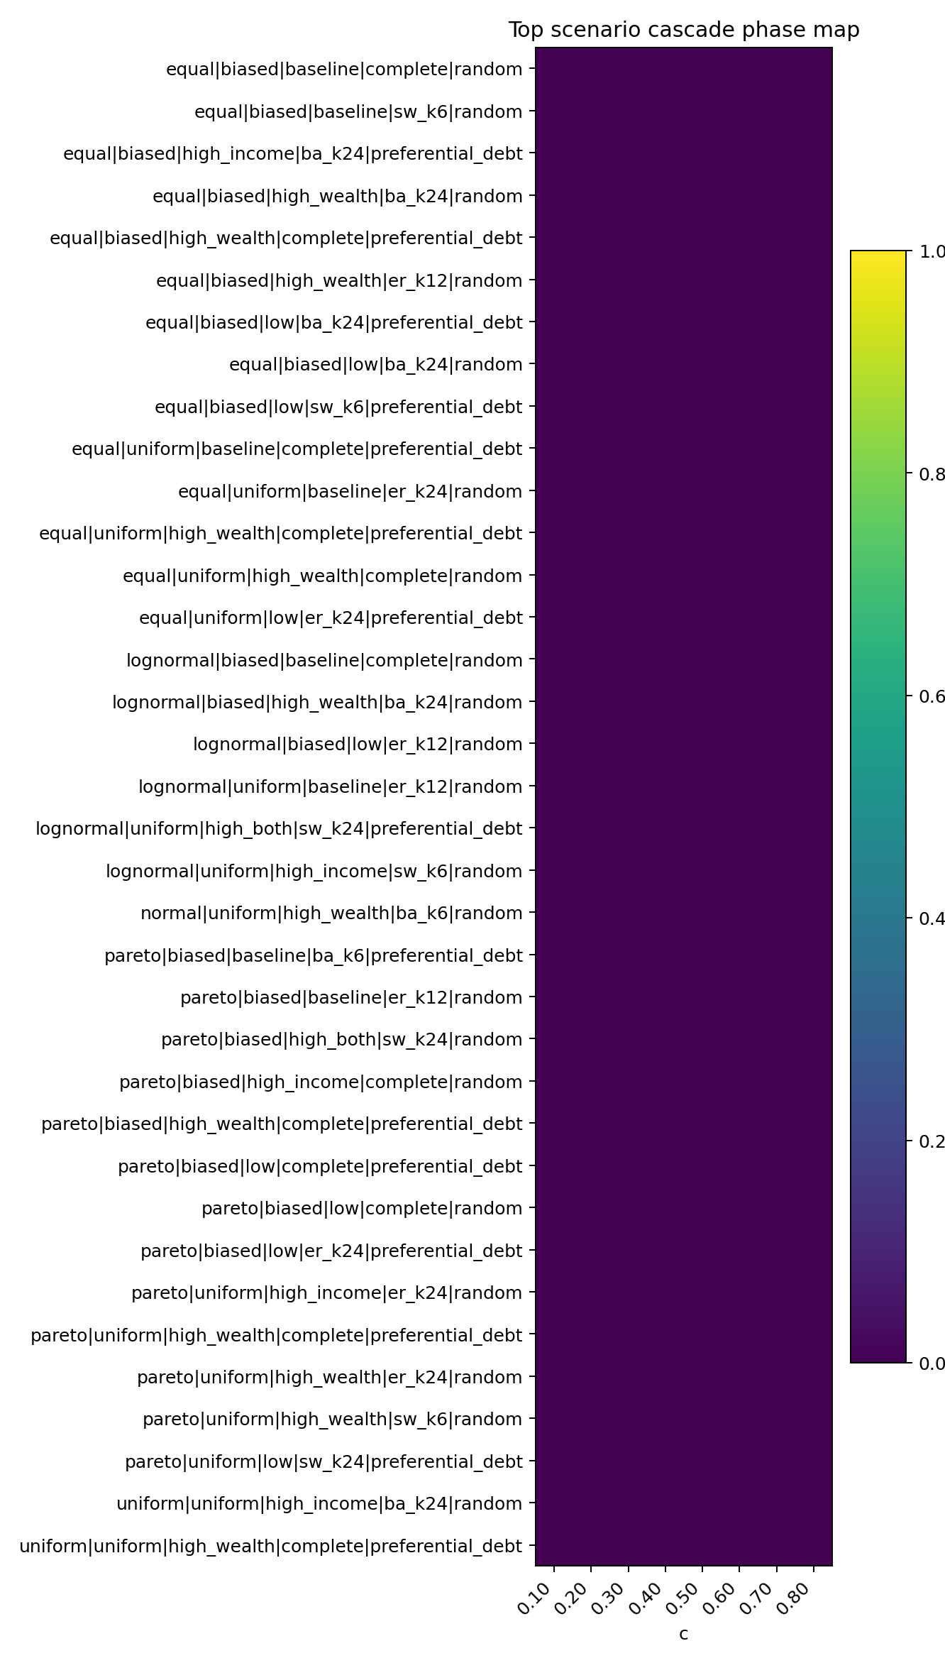
global_cascade_phase_map.png
级联规模最高的场景：
c | money_distribution | income_distribution_rule | growth_rule | spending_label | topology_label | event_large_event_rate | mean_event_fraction | event_timestep_rate | propagated_share_total | mean_repeat_default_share
0.1 | lognormal | biased | random | low | er_k12 | 0 | 0.01667 | 0.007634 | 0.5 | 0
0.1 | pareto | biased | preferential_debt | baseline | ba_k6 | 0 | 0.01667 | 0.004484 | 0.5 | 0
0.2 | pareto | uniform | preferential_debt | low | sw_k24 | 0 | 0.01667 | 0.003367 | 0.5 | 0
0.2 | pareto | biased | random | high_income | complete | 0 | 0.01667 | 0.00142 | 0.5 | 0
0.4 | equal | biased | random | baseline | sw_k6 | 0 | 0.01667 | 0.0006859 | 0.5 | 0
0.3 | pareto | biased | preferential_debt | low | complete | 0 | 0.01389 | 0.00565 | 0.4 | 0
0.6 | equal | biased | random | low | ba_k24 | 0 | 0.01364 | 0.005714 | 0.3889 | 0.05556
0.1 | equal | biased | preferential_debt | high_income | ba_k24 | 0 | 0.0125 | 0.006689 | 0.3333 | 0
0.1 | pareto | biased | preferential_debt | high_wealth | complete | 0 | 0.0125 | 0.006061 | 0.3333 | 0
0.2 | normal | uniform | random | high_wealth | ba_k6 | 0 | 0.0125 | 0.004994 | 0.3333 | 0.5
0.2 | lognormal | uniform | random | baseline | er_k12 | 0 | 0.0125 | 0.003945 | 0.3333 | 0
0.3 | equal | biased | random | high_wealth | er_k12 | 0 | 0.0125 | 0.001413 | 0.3333 | 0
0.1 | lognormal | uniform | random | high_income | sw_k6 | 0 | 0.0125 | 0.006826 | 0 | 0
0.1 | pareto | biased | random | high_both | sw_k24 | 0 | 0.0125 | 0.004283 | 0 | 0
0.8 | equal | uniform | random | high_wealth | complete | 0 | 0.01167 | 0.000501 | 0.2857 | 0
0.1 | uniform | uniform | random | high_income | ba_k24 | 0 | 0.01111 | 0.01056 | 0.25 | 0.25
0.3 | equal | biased | random | high_wealth | ba_k24 | 0 | 0.01111 | 0.006281 | 0.25 | 0
0.3 | pareto | biased | random | baseline | er_k12 | 0 | 0.01111 | 0.003344 | 0.25 | 0
0.3 | pareto | biased | preferential_debt | low | er_k24 | 0 | 0.01111 | 0.01198 | 0.25 | 0
0.4 | equal | uniform | preferential_debt | low | er_k24 | 0 | 0.01111 | 0.00361 | 0.25 | 0

4. SOC 快筛相图
- 快速候选数：0
- 小尺度尾部候选数（未达到 10%N 尺度门槛）：28
- timestep 近饱和场景数（event_timestep_rate >= 0.80）：42
gate | passed | total | pass_rate
gate_event_count | 4758 | 8000 | 0.5948
gate_not_saturated | 7958 | 8000 | 0.9948
gate_has_transition | 0 | 8000 | 0
gate_propagation | 150 | 8000 | 0.01875
gate_tail_plausible | 146 | 8000 | 0.01825
gate_alternative_not_better | 131 | 8000 | 0.01638
gate_scale_range | 0 | 8000 | 0
quick_soc_candidate | 0 | 8000 | 0
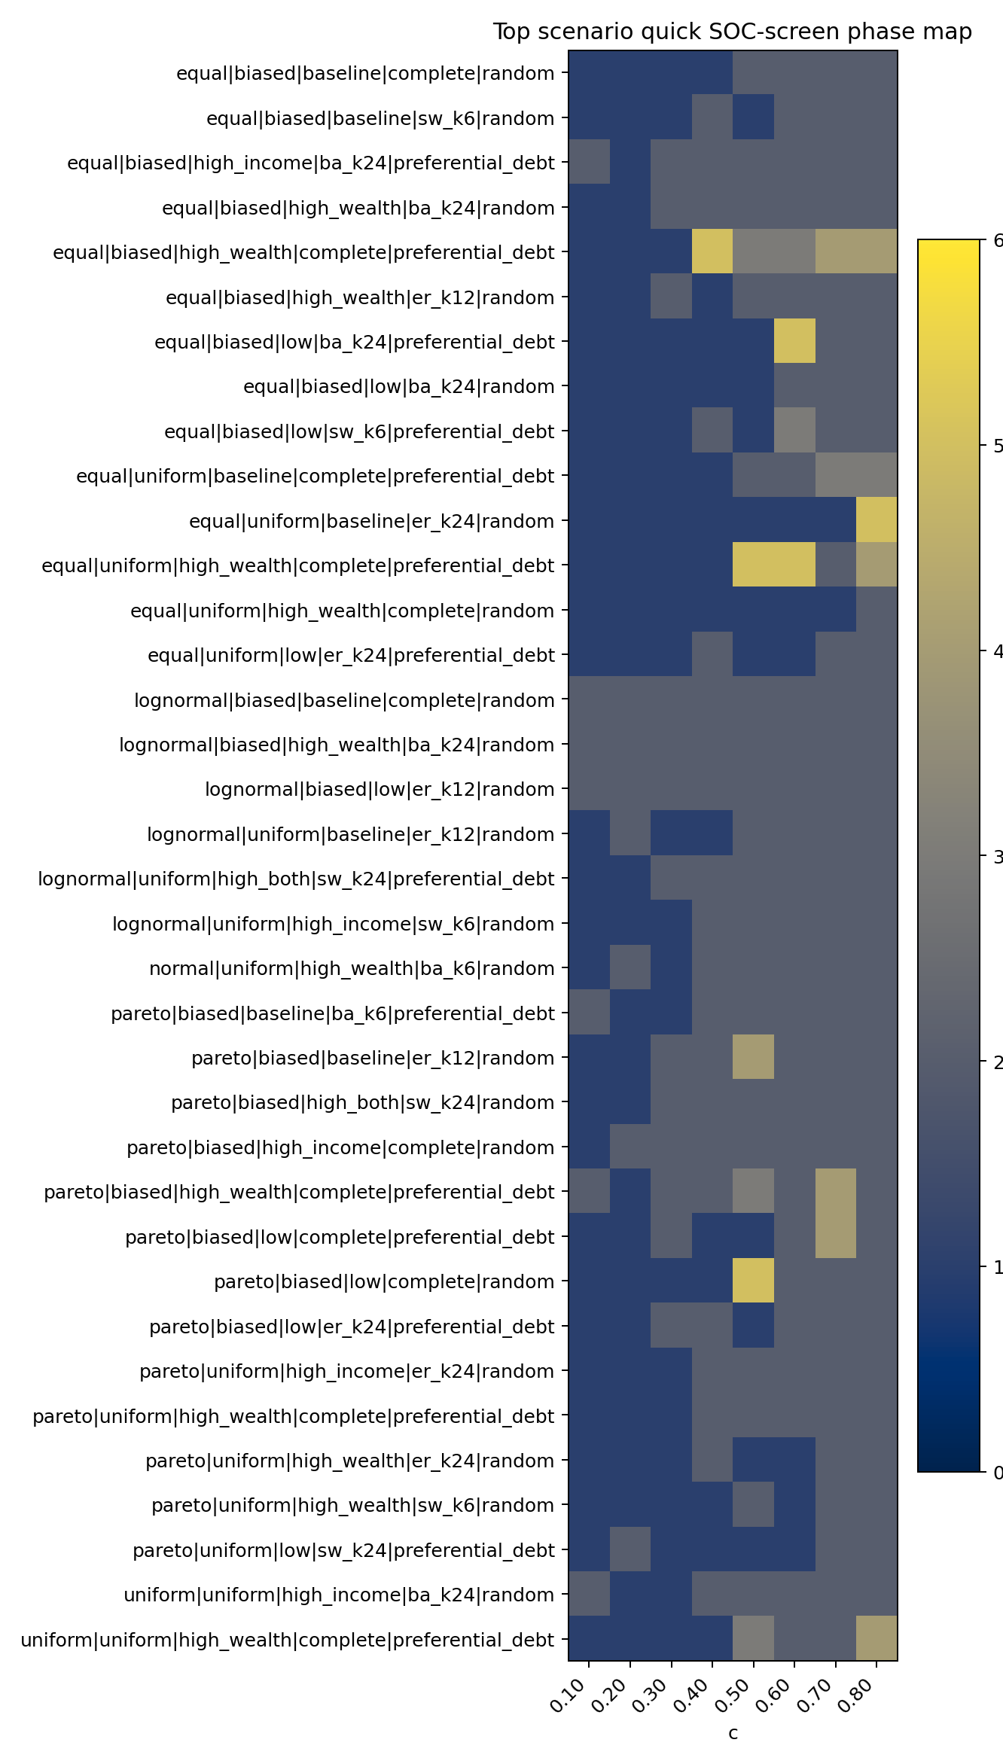
global_soc_screen_phase_map.png
SOC 快筛分数最高的场景：
soc_screen_score | quick_soc_candidate | small_tail_candidate | c | money_distribution | income_distribution_rule | growth_rule | spending_label | topology_label | event_large_event_rate | event_timestep_rate | propagated_share_total | bootstrap_p | bounded_bootstrap_p | pl_vs_lognormal_R
5 | False | True | 0.4 | equal | biased | preferential_debt | high_wealth | complete | 0 | 0.0184 | 0.25 | 0.6667 | 1 | -0.06076
5 | False | True | 0.5 | equal | uniform | preferential_debt | high_wealth | complete | 0 | 0.01347 | 0.2308 | 0.5 | 0.3636 | -0.1403
5 | False | True | 0.8 | equal | uniform | random | baseline | er_k24 | 0 | 0.004108 | 0.2264 | 0.7 | 0.6667 | -0.08617
5 | False | True | 0.6 | equal | biased | preferential_debt | low | ba_k24 | 0 | 0.0218 | 0.2105 | 0.6 | 0.6 | -0.3248
5 | False | True | 0.5 | pareto | biased | random | low | complete | 0 | 0.0253 | 0.2093 | 0.2727 | 0.2222 | -0.1862
5 | False | True | 0.5 | lognormal | uniform | preferential_debt | high_wealth | complete | 0 | 0.02312 | 0.2062 | 0.7 | 0.5455 | -0.335
5 | False | True | 0.4 | equal | biased | preferential_debt | high_both | complete | 0 | 0.02251 | 0.2051 | 0.09091 | 0.2727 | -0.1561
5 | False | True | 0.6 | equal | uniform | preferential_debt | high_wealth | complete | 0 | 0.01701 | 0.1984 | 0.7 | 0.6364 | -0.1232
5 | False | True | 0.4 | pareto | biased | preferential_debt | high_both | complete | 0 | 0.0271 | 0.1898 | 0.9091 | 0.9091 | -0.3434
5 | False | True | 0.6 | normal | uniform | preferential_debt | baseline | complete | 0 | 0.01714 | 0.1829 | 0.3636 | 0.3636 | -0.6478
5 | False | True | 0.6 | lognormal | uniform | preferential_debt | high_wealth | complete | 0 | 0.02217 | 0.1753 | 0.8182 | 0.7273 | -0.4704
5 | False | True | 0.5 | equal | biased | preferential_debt | baseline | complete | 0 | 0.01988 | 0.1724 | 0.7778 | 0.9 | -0.2656
5 | False | True | 0.8 | normal | uniform | preferential_debt | high_wealth | complete | 0 | 0.02044 | 0.17 | 0.5455 | 0.4545 | -0.9476
5 | False | True | 0.7 | lognormal | biased | preferential_debt | low | complete | 0 | 0.03699 | 0.1678 | 0.7273 | 0.7273 | -0.1948
5 | False | True | 0.3 | pareto | biased | random | high_wealth | er_k24 | 0 | 0.02117 | 0.1667 | 0.8 | 0.6667 | -0.1007
5 | False | True | 0.5 | equal | uniform | preferential_debt | high_income | complete | 0 | 0.01831 | 0.1653 | 0.4545 | 0.3636 | -0.2807
5 | False | True | 0.6 | equal | uniform | random | high_wealth | ba_k24 | 0 | 0.006833 | 0.1633 | 0.1 | 0.2857 | -0.1717
5 | False | True | 0.2 | lognormal | biased | random | baseline | ba_k24 | 0 | 0.0692 | 0.1622 | 1 | 1 | -0.05675
5 | False | True | 0.8 | normal | uniform | preferential_debt | baseline | complete | 0 | 0.01784 | 0.1604 | 0.5455 | 0.4545 | -0.7897
5 | False | True | 0.8 | lognormal | uniform | preferential_debt | high_wealth | complete | 0 | 0.01964 | 0.1588 | 0.2727 | 0.1818 | -0.9604
5 | False | True | 0.8 | equal | biased | preferential_debt | high_income | complete | 0 | 0.03016 | 0.1588 | 0.2727 | 0.1818 | -1.932
5 | False | True | 0.8 | lognormal | biased | preferential_debt | low | complete | 0 | 0.03406 | 0.1561 | 0.9091 | 1 | -0.2302
5 | False | True | 0.6 | pareto | biased | preferential_debt | baseline | ba_k24 | 0 | 0.03019 | 0.1533 | 0.6364 | 0.5455 | -0.5335
5 | False | True | 0.7 | normal | biased | preferential_debt | baseline | complete | 0 | 0.02987 | 0.153 | 0.2727 | 0.5455 | -0.6092
5 | False | True | 0.7 | normal | uniform | preferential_debt | high_both | complete | 0 | 0.02056 | 0.1523 | 0.4545 | 0.1818 | -1.008

5. 级联规模-频率关系
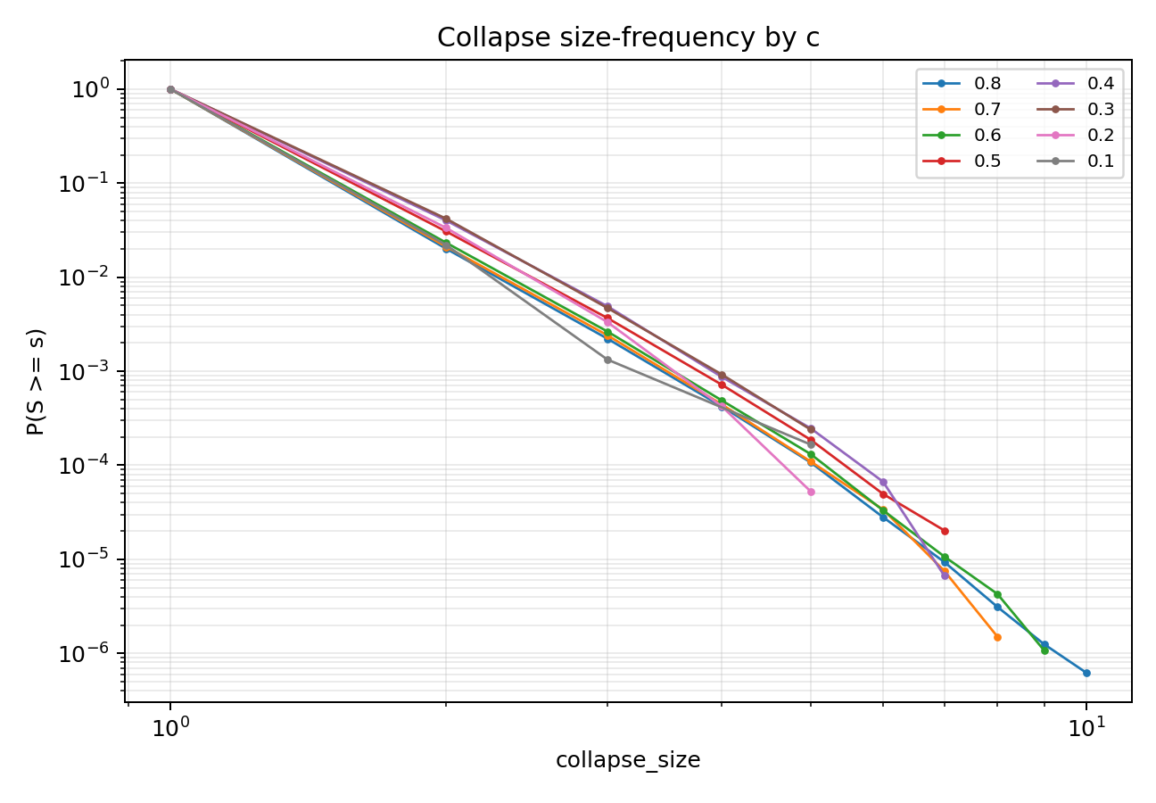
ccdf_by_c.png
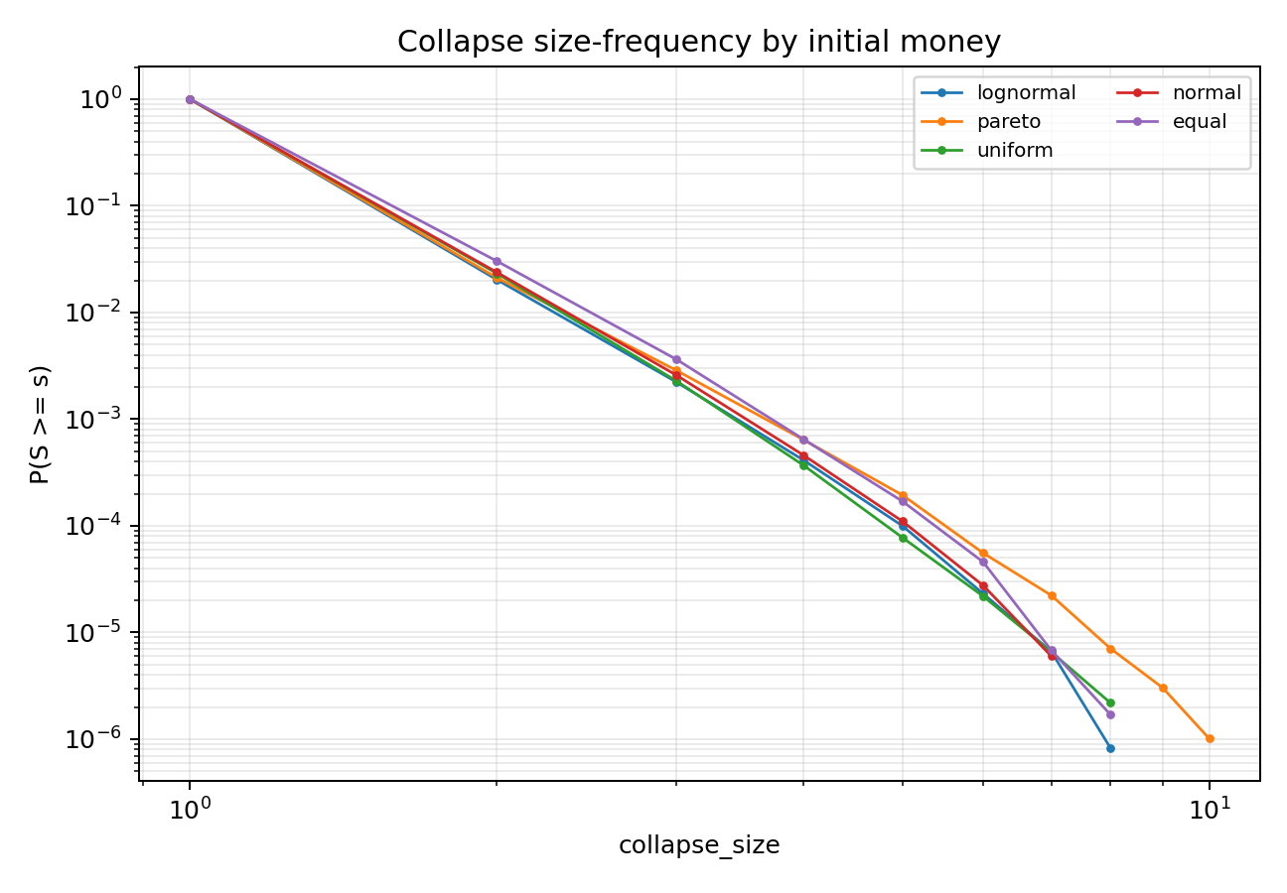
ccdf_by_money.png
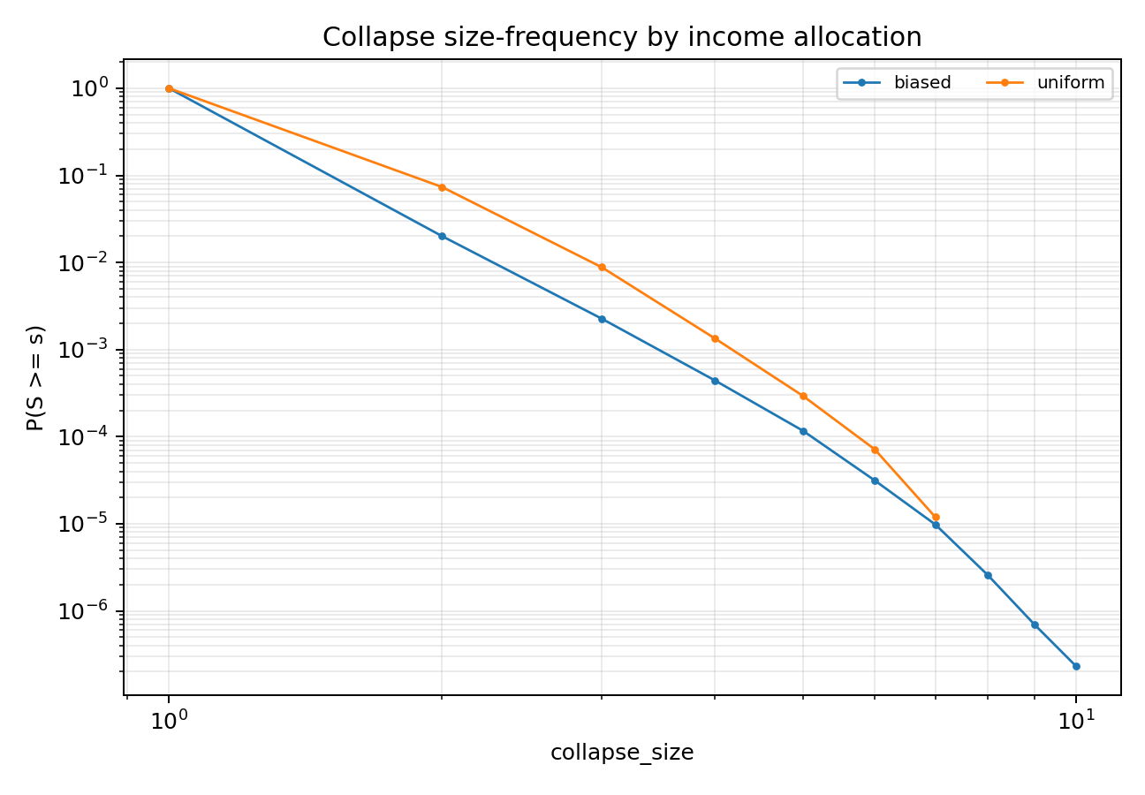
ccdf_by_income_rule.png
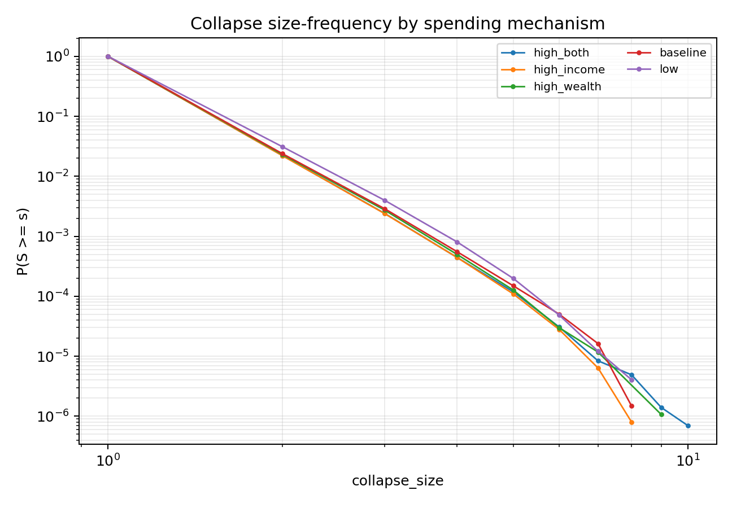
ccdf_by_spending.png
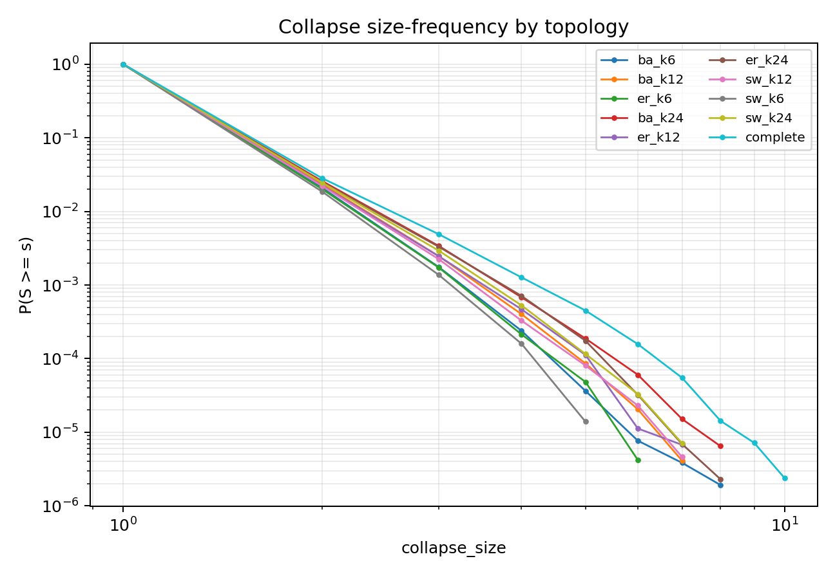
ccdf_by_topology.png
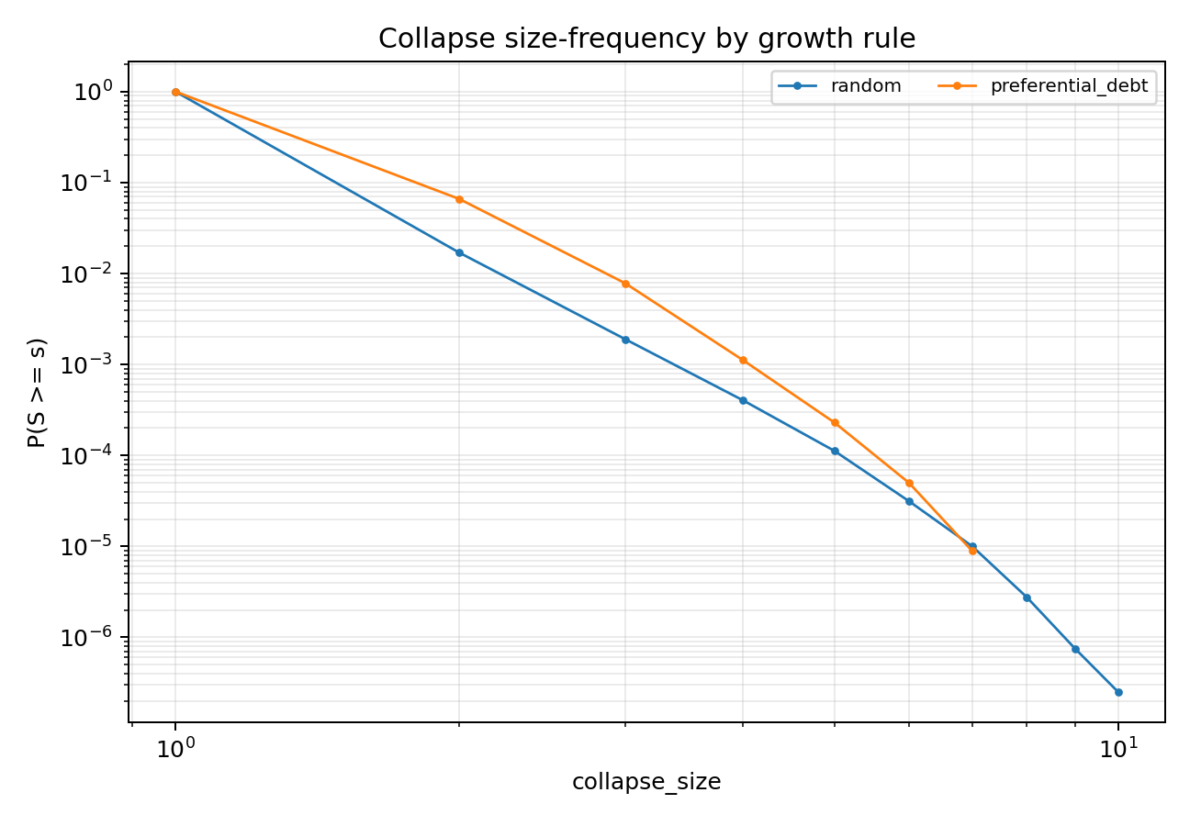
ccdf_by_growth_rule.png
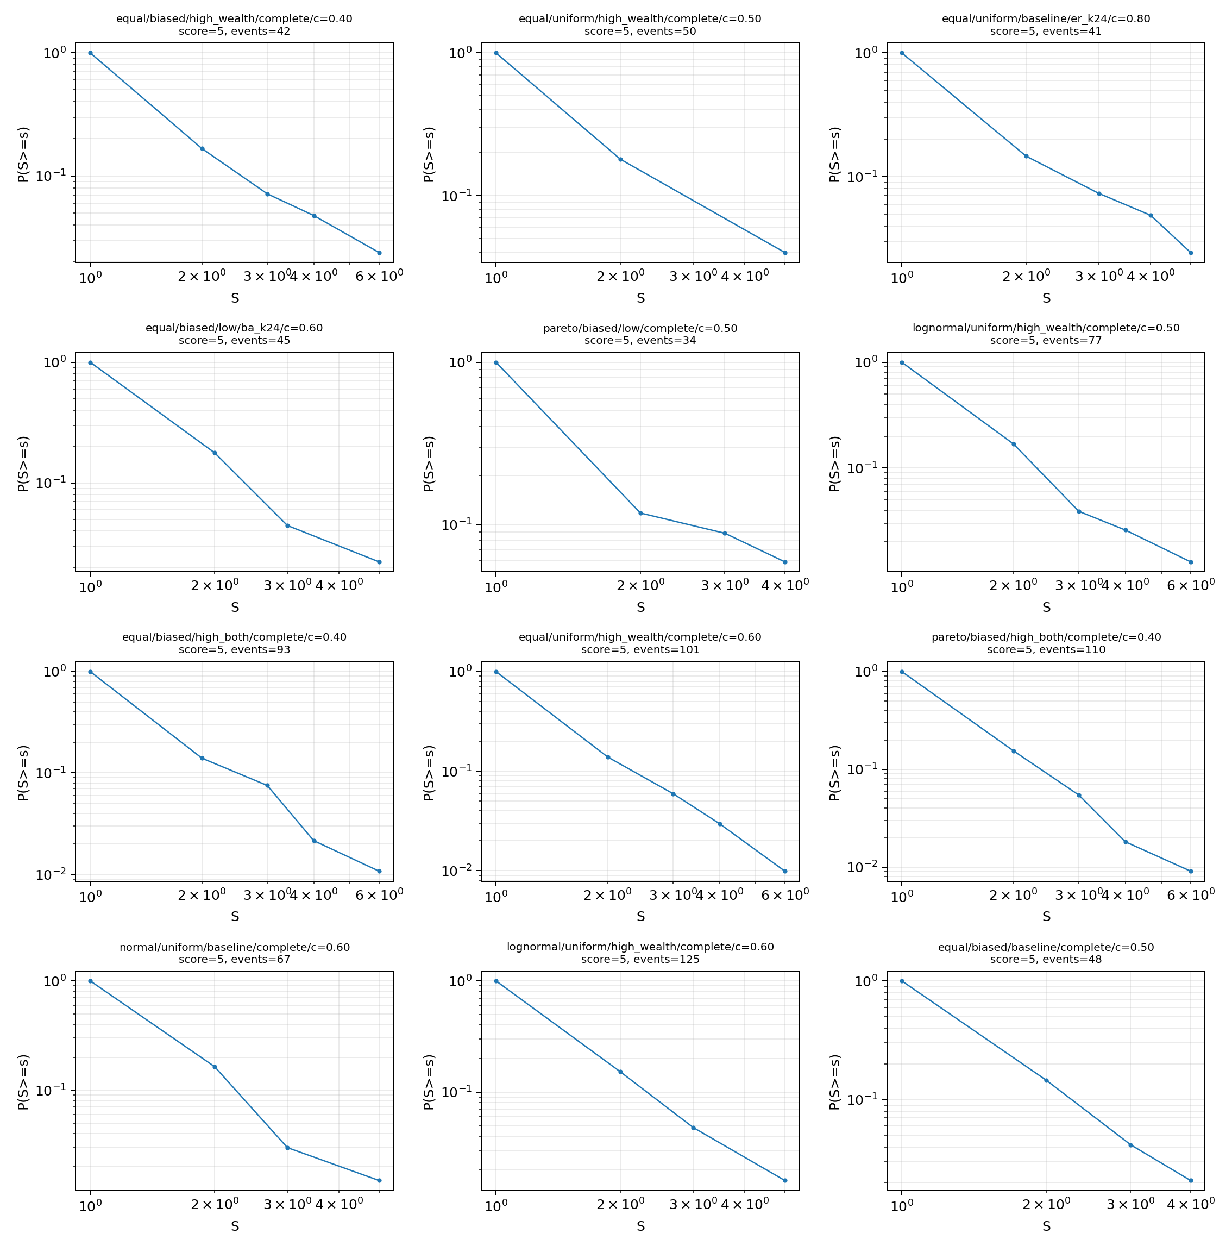
top_candidate_ccdf_grid.png

6. 尾部拟合摘要
c | money_distribution | income_distribution_rule | growth_rule | spending_label | topology_label | events | fit_status | xmin | alpha | bootstrap_p | bounded_alpha | bounded_bootstrap_p | pl_vs_exponential_R | pl_vs_lognormal_R
0.7 | equal | uniform | random | baseline | er_k12 | 34 | insufficient_tail
0.5 | equal | biased | random | high_wealth | complete | 63 | ok | 1 | 3.653 | 1 | 3.653 | 1 | 2.524 | -0.05214
0.2 | lognormal | biased | random | baseline | ba_k24 | 31 | ok | 1 | 3.387 | 1 | 3.387 | 1 | 0.591 | -0.05675
0.3 | pareto | biased | random | high_wealth | ba_k24 | 56 | ok | 1 | 3.961 | 1 | 3.961 | 0.8571 | 2.793 | -0.128
0.4 | normal | biased | preferential_debt | baseline | sw_k24 | 36 | ok | 1 | 3.787 | 1 | 3.787 | 1 | 1.317 | -0.05387
0.5 | pareto | biased | random | baseline | complete | 275 | ok | 1 | 3.65 | 1 | 3.649 | 0.5455 | 9.402 | -0.1008
0.7 | equal | biased | random | low | er_k24 | 44 | ok | 1 | 4.012 | 1 | 4.012 | 1 | 1.577 | -0.0932
0.8 | equal | uniform | random | high_wealth | er_k24 | 44 | ok | 1 | 4.012 | 1 | 4.012 | 1 | 1.577 | -0.0932
0.6 | uniform | uniform | random | high_both | ba_k12 | 187 | ok | 1 | 3.936 | 1 | 3.936 | 0.9091 | 5.178 | 0.01801
0.8 | lognormal | uniform | random | low | sw_k24 | 48 | ok | 1 | 3.858 | 1 | 3.858 | 1 | 1.206 | -0.01855
0.7 | uniform | biased | preferential_debt | high_both | complete | 376 | ok | 1 | 3.98 | 1 | 3.98 | 1 | 9.134 | -0.01188
0.8 | normal | biased | preferential_debt | low | sw_k12 | 210 | ok | 1 | 3.726 | 1 | 3.726 | 1 | 3.875 | -0.1422
0.6 | equal | uniform | preferential_debt | high_both | er_k12 | 194 | ok | 1 | 3.958 | 1 | 3.958 | 1 | 2.18 | -0.1608
0.3 | lognormal | biased | random | high_wealth | complete | 263 | ok | 1 | 4.082 | 1 | 4.082 | 1 | 4.29 | -0.03706
0.3 | lognormal | biased | random | high_income | ba_k24 | 365 | ok | 1 | 4.197 | 1 | 4.197 | 1 | 4.414 | -0.1048
0.6 | lognormal | biased | preferential_debt | high_income | complete | 568 | ok | 1 | 4.149 | 1 | 4.148 | 0.6364 | 4.461 | -0.4316
0.5 | pareto | biased | random | high_wealth | ba_k24 | 1068 | ok | 1 | 4.333 | 1 | 4.333 | 0.9091 | 9.71 | -0.3189
0.8 | equal | uniform | preferential_debt | high_wealth | complete | 198 | ok | 2 | 5.686 | 1 | 5.686 | 1 | -0.02325 | -0.06604
0.8 | lognormal | biased | preferential_debt | low | complete | 227 | ok | 1 | 3.449 | 0.9091 | 3.449 | 1 | 5.753 | -0.2302
0.6 | equal | uniform | preferential_debt | high_both | sw_k24 | 204 | ok | 1 | 4.181 | 0.9091 | 4.181 | 0.9091 | 4.626 | -0.1035
0.7 | uniform | uniform | preferential_debt | high_income | complete | 209 | ok | 1 | 3.492 | 0.9091 | 3.492 | 0.8182 | 5.205 | -0.1893
0.4 | pareto | biased | preferential_debt | high_both | complete | 110 | ok | 1 | 3.172 | 0.9091 | 3.172 | 0.9091 | 2.405 | -0.3434
0.8 | uniform | uniform | preferential_debt | high_income | complete | 222 | ok | 1 | 3.633 | 0.9091 | 3.633 | 0.9091 | 5.058 | -0.1221
0.5 | pareto | biased | preferential_debt | high_income | ba_k24 | 182 | ok | 1 | 3.949 | 0.9091 | 3.949 | 0.9091 | 4.635 | -0.07564
0.7 | pareto | biased | preferential_debt | low | complete | 93 | ok | 1 | 3.662 | 0.9091 | 3.661 | 0.6364 | 0.3486 | -0.3304

7. 当前判定
timestep 协议可以回答一个明确问题：上一轮 period_end 大崩塌是否主要来自较粗的批量结算尺度。如果 timestep 结算后大级联率、平均规模和同步 initial defaults 明显下降，就说明原大事件有相当部分由 period_end 批量聚合放大；如果仍在多个相邻 c 和多类场景中存在稳定跨尺度事件，并通过尾部、平稳性和有限尺寸门槛，才可升级为 timestep-SOC 候选。
本报告的 SOC 结论仍遵循项目层级：大级联出现 < 稳健级联转变 < 重尾 < 可信幂律 < 严格 SOC。timestep 下即使每个微步都可能触发 avalanche，也不能把高频事件本身直接等同于 SOC；必须结合规模分布、传播分量、重复违约、长期平稳和有限尺寸标度。

8. 轴效应摘要
axis | level | scenarios | mean_large_event_rate | mean_event_fraction | mean_event_timestep_rate | mean_propagated_share | mean_repeat_default_share
growth_rule | preferential_debt | 4000 | 0 | 0.00842 | 0.02831 | 0.05032 | 0.3331
growth_rule | random | 4000 | 0 | 0.007498 | 0.1408 | 0.02822 | 0.5384
income_distribution_rule | biased | 4000 | 0 | 0.008205 | 0.1568 | 0.03947 | 0.5689
income_distribution_rule | uniform | 4000 | 0 | 0.007713 | 0.01231 | 0.03906 | 0.3026
money_distribution | lognormal | 1600 | 0 | 0.008627 | 0.126 | 0.04009 | 0.5175
money_distribution | uniform | 1600 | 0 | 0.008591 | 0.09244 | 0.03494 | 0.5179
money_distribution | normal | 1600 | 0 | 0.008455 | 0.07719 | 0.03554 | 0.4899
money_distribution | pareto | 1600 | 0 | 0.007519 | 0.08281 | 0.04295 | 0.3665
money_distribution | equal | 1600 | 0 | 0.006604 | 0.04444 | 0.04282 | 0.2871
spending_label | high_both | 1600 | 0 | 0.008398 | 0.115 | 0.04333 | 0.5286
spending_label | high_income | 1600 | 0 | 0.00821 | 0.1044 | 0.04089 | 0.4992
spending_label | high_wealth | 1600 | 0 | 0.008079 | 0.08551 | 0.04321 | 0.4401
spending_label | baseline | 1600 | 0 | 0.007822 | 0.07192 | 0.0376 | 0.4023
spending_label | low | 1600 | 0 | 0.007287 | 0.04599 | 0.03129 | 0.3087
topology_label | ba_k12 | 800 | 0 | 0.008368 | 0.09257 | 0.03937 | 0.5229
topology_label | ba_k6 | 800 | 0 | 0.008362 | 0.1002 | 0.03584 | 0.5928
topology_label | ba_k24 | 800 | 0 | 0.008233 | 0.08737 | 0.04669 | 0.4594
topology_label | complete | 800 | 0 | 0.007923 | 0.07754 | 0.05611 | 0.3717
topology_label | er_k6 | 800 | 0 | 0.007918 | 0.08837 | 0.03118 | 0.4584
topology_label | er_k12 | 800 | 0 | 0.007891 | 0.08231 | 0.03869 | 0.4094
topology_label | er_k24 | 800 | 0 | 0.007847 | 0.08007 | 0.04449 | 0.386
topology_label | sw_k24 | 800 | 0 | 0.007721 | 0.07783 | 0.03975 | 0.3767
topology_label | sw_k12 | 800 | 0 | 0.007687 | 0.07987 | 0.03302 | 0.3853
topology_label | sw_k6 | 800 | 0 | 0.007643 | 0.07957 | 0.02752 | 0.3951

