Spike outcomes
Name: FileIO

Goals:
To learn how to use file IO on Android.

Personnel:
primary – Scott secondary - Rajesh

Technologies, Tools, and Resources used:
- Java 6
- Android SDK
- Eclipse ADT plugin
- Eclipse 3.6
- Android development website – Data Storage

Tasks undertaken:
Create a simple application that functions like a dictionary. The user enters a word and the meaning is displayed if it has one. If the dictionary does not contain the word then the user will be able to enter a meaning and save it to file.

What we found out:
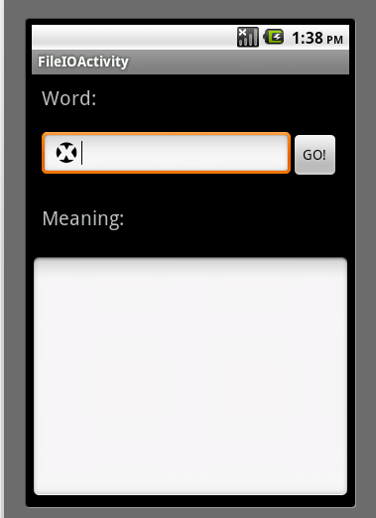
The clear Edittext had to be created and functions just like the iPhone equivalent.

There are a few options when it comes to data storage on Android. The one chosen for this application was SharedPreferences. This storage option is especially designed to cater for comma separated pairs.

SharedPreferences functions some what like a hash map and requires commit to be called once changes have been made. In order to edit the data stored in the file the SharedPreferences.Editor interface needs to be used.
Open issues/risks [Optional]:
Risk:
The data storage option used in this spike may not be suitable for a future problem. Need to carry out a spike using regular file IO.

Recommendations [Optional]:
More research needs to be done in order to see what widget has already been created to function just like the clear edittext.

