Spike Plan
Name: Form Layout

Context:
To learn to build forms and how to lay them out with Android. Need to experiment with orientation change and observe how that effects the form layout. There is also a need to learn how to develop the user friendly layouts and form elements.

Knowledge Gap:
Limited form creation experience and no familiarity with how Android is best suited to create simple forms.
Skill Gap:
Technology Gap:

At this stage the team isn't familiar with from creation on Android using the Eclipse IDE.

Goals/Deliverables:
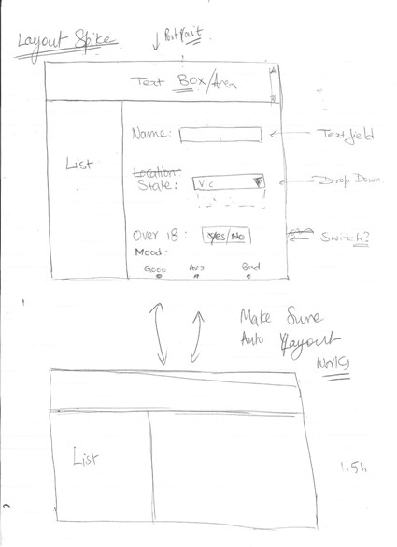
- Discover what is the best way of presenting a label and text field to the user. This will be achieved by experimenting with several different approaches.
- A completed form that includes each of the elements covered in the wire frame shown above.
- The form must be checked to work when the orientation changes. A clear method for changing the layout when the orientation changes should be found.

Planned start date: 14/12/2010
Deadline: 14/12/2010

Planning notes:
- Experiment with the standard applications that come on the Samsung Galaxy Tab and note how forms are presented. Key to observe what works and what needs to be improved.
- Briefly read through the form element APIs to get a feel for what they can do.
- Try out different elements and their attributes noting how things change.
- Read up on layouts and methods of changing the layout once screen orientation has changed.
- Create the layout to match the wire frame shown above.
- Include the form elements and ensure that layout works.
- Test out different approaches for changing the layout.

