Spike Plan
Name: FileStyle

Context:
To learn how to do simple File IO and to establish how to best style elements in Android.

Knowledge Gap:
Yet to use the simple file IO classes provided with Android and as such don't know what is available.
Skill Gap:
Technology Gap:

Plan to create a simple wire frame form to read/write to file and provide three different styles that can be applied to the application.
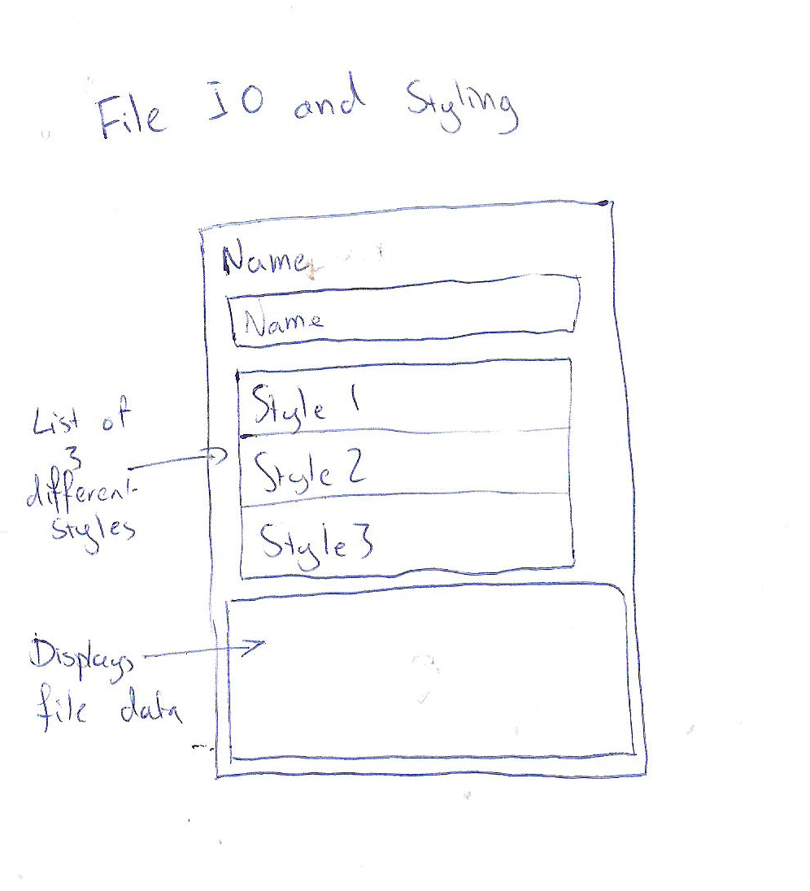
Goals/Deliverables:
A basic application that demonstrates basic file IO and to clearly display three different styles.

Planned start date: 24/12/2010
Deadline: 24/12/2010

Planning notes:
- Create the layout as outlined above.
- Ensure that the file read/write functions work.
- Research how to style applications using Android and hopefully find a simple method or jazzing up apps.

