Spike Plan
Name: SQLlite

Context:
As of yet the team has not had a chance to use SQLlite databases with Android. This spike aims to introduce SQLlite databases as well as playing youtube clips and using custom images for buttons.

Knowledge Gap:
Don't know how to use databases with Android applications.

Skill Gap:
Technology Gap:

The following wire frame will be created:
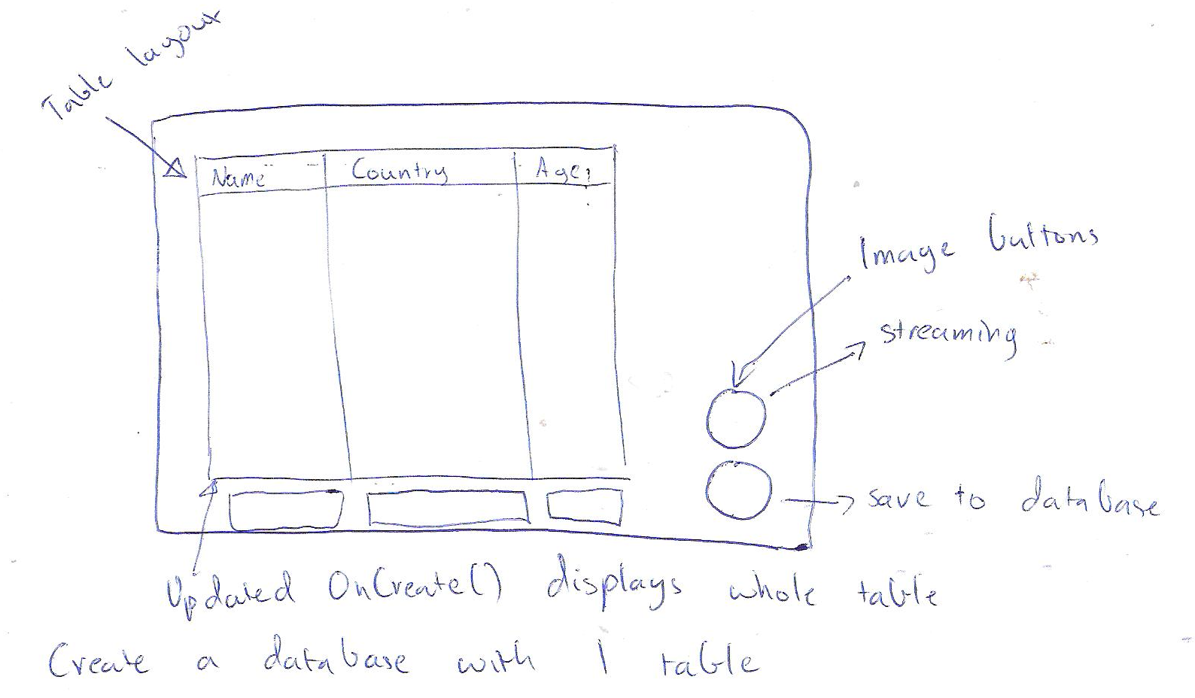
Goals/Deliverables:
- A demonstrable application that will play a youtube clip, display the contents of a table in a database to screen and to show how image buttons can be used.

Planned start date: 23/12/2010
Deadline: 24/12/2010

Planning notes:
- Find and follow a SQLlite demo on the Android development website.
- Review the form stuff section of that same site in order to become familiar with using image buttons.
- Set up the layout of the application.
- Implement the database section of the application.
- Create the images to be used as a button and implement it.
- Learn how to best show a youtube clip from a running application.

