Spike outcomes
Name: TouchDraw

Goals:
To have a figure of a person and to select/deselect body parts.

Personnel:
primary – Scott secondary - Rajesh

Technologies, Tools, and Resources used:
- Java 6
- Android SDK
- Eclipse ADT Android plugin
- Eclipse 3.6
- Android forums: http://osdir.com/ml/Android-Developers/2010-12/msg00601.html
- Blog: http://www.developer.com/ws/other/article.php/3748281/Working-with-Images-in-Googles-Android.htm
- Android-Developers website: http://developer.android.com/reference/android/graphics/drawable/Drawable.html
- Other web resources

Tasks undertaken:
- Found a Finger draw application that lets the user draw on the screen with their finger.
- Created a circle shape in xml.
- Found and modified two images of a person
Image with marked coloured hotspots. Individual arms could be selected using different colours but for simplicity they were paired.

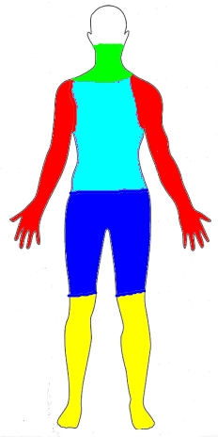

Image that is presented to the user:
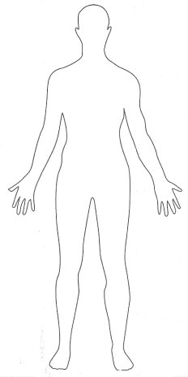
- Experimented with using canvas to draw to the screen.
- Final solution used invisible views.

What we found out:
Android has some memory issues when dealing with Bitmaps.

There is always several ways of doing something. So when looking at using what was learnt in this spike ensure that requirements are well defined.

Became familiar with setting up a layout from code. Also learnt how to position views in a layout using code.

Open issues/risks [Optional]:
Risk/Issue: Difficult to modify functionality
Due to the nature of this type of solution care needs to be taken at the start to ensure that the desired functionality is achieved. To mitigate this risk alternative solutions should be looked at more thoroughly.
Recommendations [Optional]:
Try to avoid setting up complicated layouts in code. Better to stick to using the xml files as much as possible. Invisible elements can save a lot of work.

Simple shapes can be created in xml files in Android but for anything fancy it's better to create an image file.

More work could be done to enhance this spike for instance this spike had a fixed orientation layout.

