Spike Plan
Name: ImageView

Context:
Team needs to know how to use the image slider widget as well as get familiar with loading pictures to the screen and using the grid layout.

Knowledge Gap:
Have yet to use the image slider widget or the grid layout.
Skill Gap:
Technology Gap:

Spike involves creating an application based on the following wire frame.
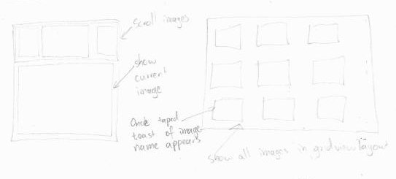
Goals/Deliverables:
- Portrait view shows a image slider and displays the image that is selected below it.
- Landscape view shows all the pictures in a grid layout and displays a toast once an image has been selected.

Planned start date: 19/12/2010
Deadline: 24/12/2010

Planning notes:
- Read up on how to use image sliders and how to display images.
- Create the portrait section of the application.
- Follow the tutorial for grid layouts on the Android development website for the landscape section.

