Spike Plan
Name: TableList

Context:
Learn how to use the table layout as well as implement a fully function list. Builds upon the FormLayout spike.

Knowledge Gap:
Yet to use the table layout and implement a working list.
Skill Gap:
Technology Gap:

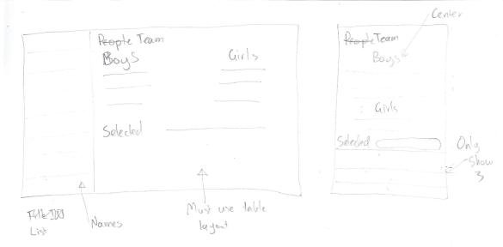

Goals/Deliverables:
- A simple application that matches the above wireframe.
- Orientation must be handled exactly as shown.

Planned start date: 16/12/2010
Deadline: 17/12/2010

Planning notes:
- Design and layout the landscape view first and read up on table layouts.
- Refer to previous spike to create listview and then implement.
- Create table layout and populate.
- Create the portrait layout.

