Spike Plan
Name: AnimationHttp

Context:
The application will need to access files stored on a web server. This process may take some time so two waiting animations will also be demonstrated in this spike.

Knowledge Gap:
Have not used Android to access files on a web server or created animations before.
Skill Gap:
Technology Gap:
The simple application will display a status bar, the waiting animation displayed on several Android applications and access files on a web server. The files data.txt and image.png will be stored at www.scottawebsite.com/. These two files will need to be loaded to the application at runtime.

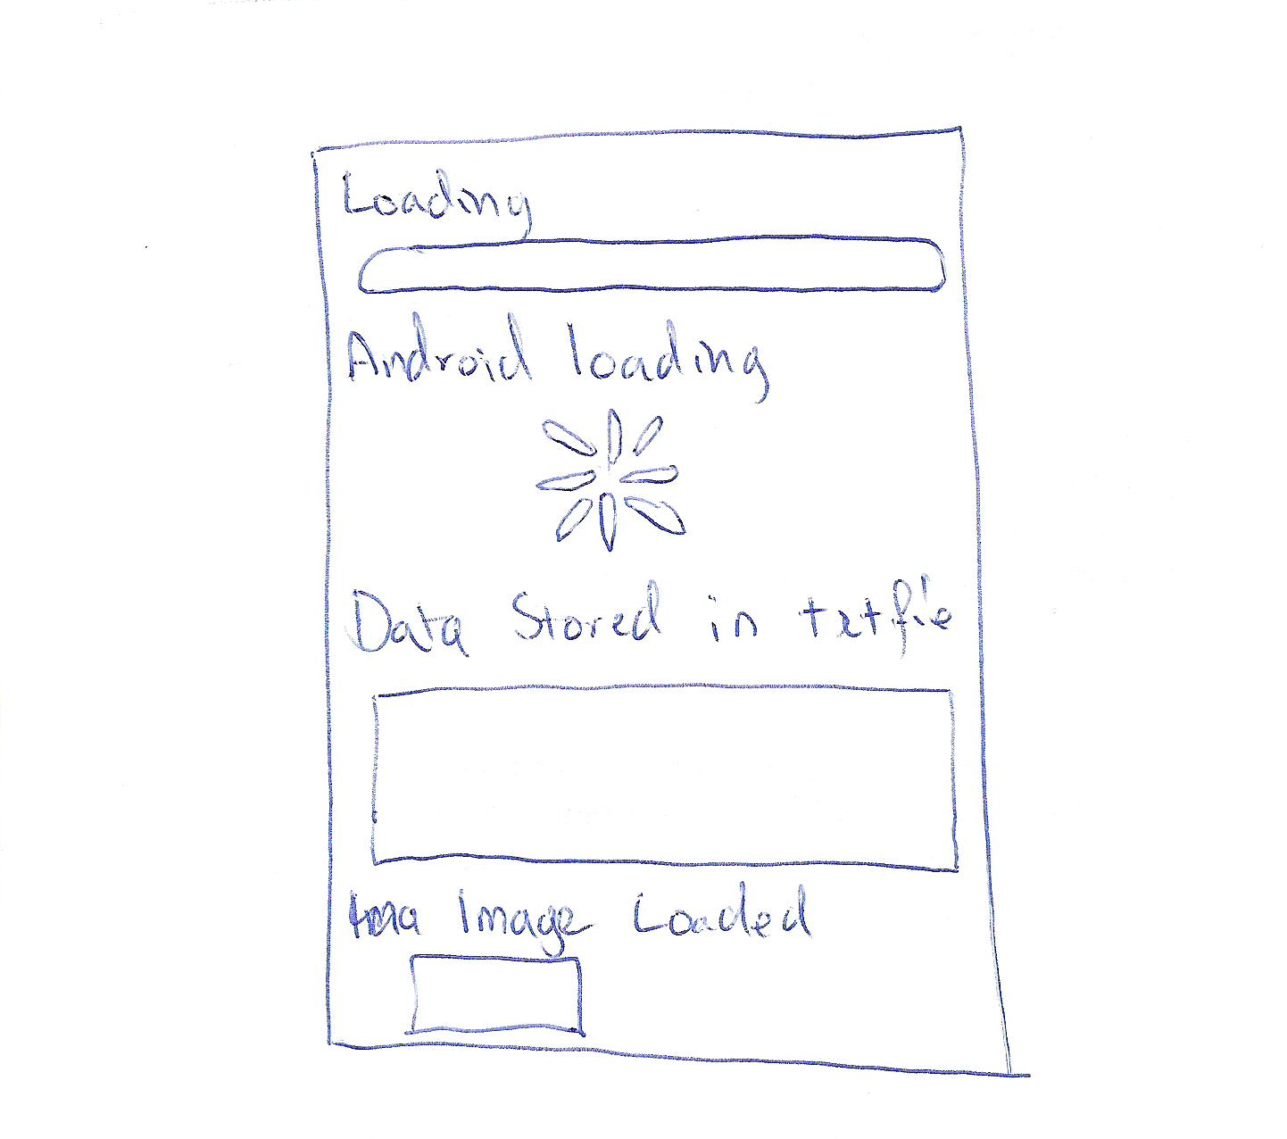
Goals/Deliverables:
- Small application that shows the 2 varieties of status bar and accesses files on the web server.

Planned start date: 27/12/2010
Deadline: 28/12/2010

Planning notes:
- Create the layout xml file for this spike.
- Research how to best present a status bar.
- Look up an appilcation that uses the Android waiting animation.
- Record some basic notes about animation in Android to be used in a later spike if needed.
- Find examples of accessing files on a web server.
- Complete spike.

