Spike outcomes
Name: Log Commands

Goals:
To understand the states of an Android application as well as learn some simple debugging techniques using Eclipse IDE.

Personnel:
primary – Scott secondary - Rajesh

Technologies, Tools, and Resources used:
- Eclipse 3.6
- LogCat from Android SDK
- Log API
http://developer.android.com/reference/android/util/Log.html

Tasks undertaken:
- Created a simple application that overrides each function representing each of the different states.
- Create a message of each type.

What we found out:
The types of messages that can be logged are as follows: verbose, debug, info, warnings and errors. The API recommends never compiling verbose messages into finished applications.

LogCat can be opened from Window->Show View->Other->Android.

When using LogCat the symbols with a circle represent which messages will be displayed:

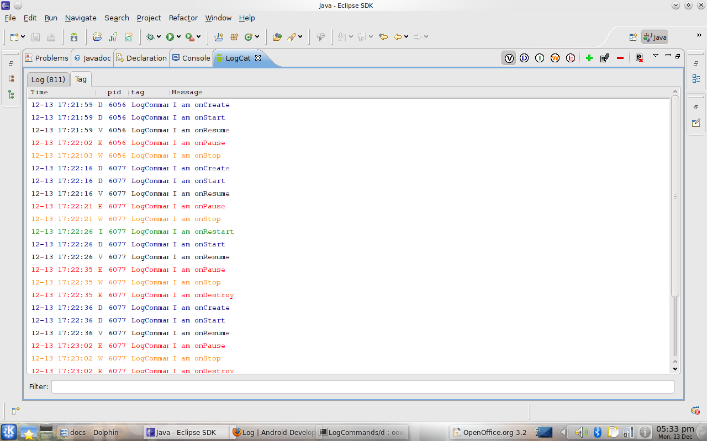
V displays all of them, D only displays errors from D to the right and so on. To view messages only you added, click the + symbol and create your own filter. Call it what you like but make sure that the by Log Tag field matches the tag that you defined in the messages.

Open issues/risks [Optional]:

Recommendations [Optional]:

