Spike Plan
Name: Log Commands

Context:
This spike is to become familiar with the states that an Android application can be in. It is also to explore the logging debug commands to be used within the Eclipse IDE and become familiar with the log viewer.
The below diagram was taken from http://developer.android.com/guide/topics/fundamentals.html
and clearly indicates the flow from state to state.
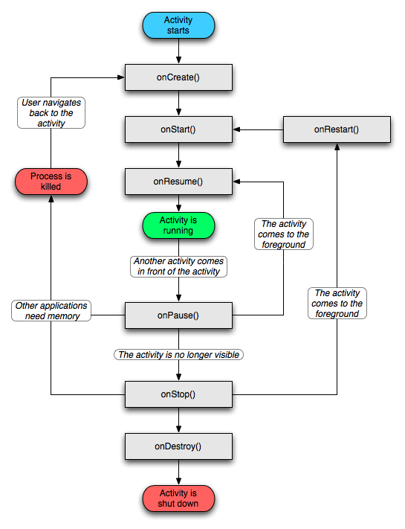

Knowledge Gap: The state flow for Android applications is all new.
Skill Gap:
Technology Gap:

Goals/Deliverables:
An application that states which state it is in by using the log command. Demonstrate simple debugging techniques with Eclipse for Android.

Planned start date: Example: 13/12/2010
Deadline: Example: 17/12/2010

Planning notes:
- Override each of the state functions in the Activity class.
- Create a static final TAG to be used with the Log class.
- Briefly read up on the debugging Log class and its functions.
- Run the application on a device and observe the log print out as the application moves from state to state.

