SE350 RTX Project Documentation

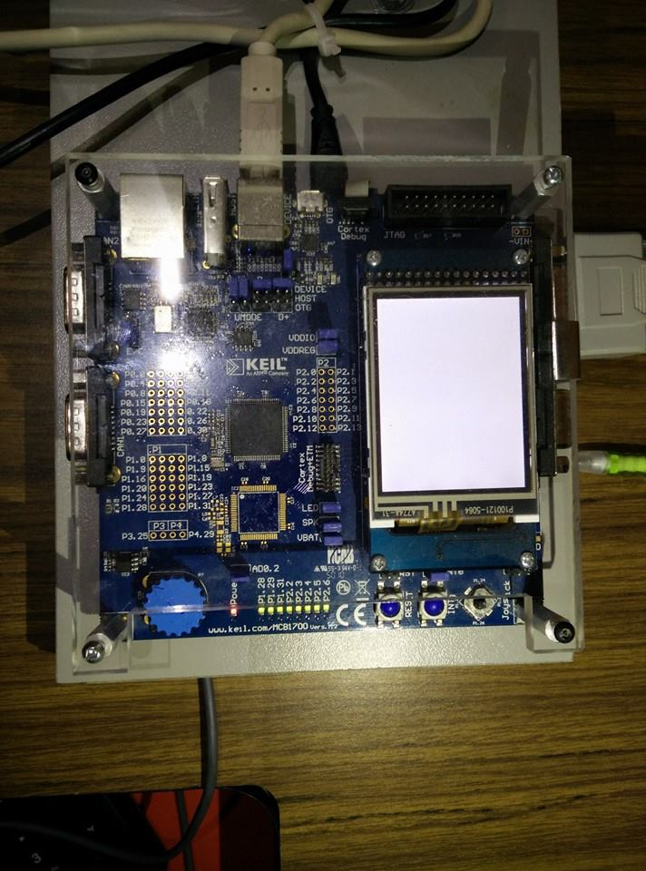

**University of Waterloo**

**3A Software Engineering**

**3/10/2015**

Angad Kashyap (20466050), Mike Wang (20465276), Tong Tong (20460179) and Vishal Bollu (20474731)

Table of Contents

Table of Contents 2

1 Introduction 4

2 Software Design Description 5

2.1 INITIALIZATION 5

2.1.1 Memory Initialization 5

2.1.2 Process Initialization 5

2.2 MEMORY MANAGEMENT 5

2.2.1 Requesting Memory 5

2.2.2 Releasing Memory 6

2.3 PROCESSOR MANAGEMENT 6

2.3.1 Scheduling 6

2.3.1 Context Switching 6

2.3.2 Process Priority 6

2.4 INTERPROCESS COMMUNICATION 7

2.4.1 Sending Messages 7

2.4.2 Receiving Messages 7

2.4.3 Non-Blocking Message Receiving 8

2.4.4 Delayed Messages 8

2.5 INTERRUPT PROCESSES 8

2.5.1 Timer I-Process 9

2.5.2 UART I-Process 9

2.5.2.1 Hotkeys 9

2.6 SYSTEM PROCESSES 9

2.6.1 Null Process 9

2.6.2 KCD Process 9

2.6.3 CRT Display Process 10

2.7 USER PROCESSES 10

2.7.1 24 Hour Wall Clock Display Process 11

2.7.2 User Tests 11

2.7.3 Stress Tests 11

3 Timing Analysis 11

4 Lessons Learned 12

1 Introduction

[Insert introduction here describing the purpose of the project, the objectives including an overview of the capabilities of the resulting RTX]

2 Software Design Description

# 2.1 INITIALIZATION

## 2.1.1 Memory Initialization

[Insert description]

**void memory_init(void);**

This method starts with placing 4 bytes of padding at the bottom of the RAM (at the lowest address). Then memory is allocated for PCB pointers and PCB node pointers. A global stack pointer is created in preparation for the call to alloc_stack. Memory is allocated for the memory blocks map. The pointer to the start of the heap is also initialized. The memory map is zero-initialized to indicate that all of the memory blocks are free.

**U32 *alloc_stack(U32 size_b);**

This method shifts the global stack pointer by the provided value (size_b). The global stack pointer is 8-byte aligned.

## 2.1.2 Process Initialization

[Insert description]

**void process_init(void);**

This method begins with placing all of the information related to user processes as well as the null process into a global process table. This information includes the PID, the priority, the stack size and the starting PC value for the process. New PCBs are created for each of the processes in the global process table. Here, stack space is allocated for the PCBs. At the same time, PCB nodes are created for each process to be used in the ready priority queue and the blocked queue. The ready priority queue and the blocked queue are both null-initialized. Then the processes' PCB nodes are enqueued in the ready priority queue according to their priorities.

# 2.2 MEMORY MANAGEMENT

## 2.2.1 Requesting Memory

**void *k_request_memory_block(void);**

This method checks whether all of the memory blocks are in use. As long as all of the memory blocks are in use, the current process is pushed into the blocked queue. The processor is released and moves onto the next process. If there are allocable memory blocks, we allocate them in the order that the processes were enqueued in the blocked queue.

## 2.2.2 Releasing Memory

**int k_release_memory_block(void *);**

This method checks the validity of the memory block pointer. If it is a valid pointer that points to the beginning of a memory block, then the block is updated with an available status.

# 2.3 PROCESSOR MANAGEMENT

## 2.3.1 Scheduling

**PCB *scheduler(void);**

This method iterates through the ready priority queue and dequeues the PCB node with the highest priority with a first-in first-out policy. The method then returns a pointer to this PCB node.

## 2.3.1 Context Switching

**int k_release_processor(void);**

This method keeps track of the current running process as the old process. If this process is not null and its state is RUN, then its state will be changed to RDY and the process' PCB will be enqueued in the appropriate ready queue. The method changes the current process pointer to the new process as returned by the scheduler method. Then process_switch is called on the old process. After the context switch, the new process' state is set to RUN.

## 2.3.2 Process Priority

**void set_priority(int pid, int priority);**

This method takes in a PID and a new priority value, and changes the priority of the process with the associated PID. If the process does not have a blocked state, the method also dequeues the process from the ready priority queue and re-inserts it back in to the appropriate queue. The method returns RTX_ERR if the process with the given PID is not found.

**int get_priority(int pid);**

This method takes in a PID and returns the priority value for the node with that PID. The method returns RTX_ERR if the process with the given PID is not found.

# 2.4 INTERPROCESS COMMUNICATION

## 2.4.1 Sending Messages

[Insert description]

int k_send_message (int targetPID, void* msgEnvelope) {

atomic (on);

newMsgEnvelope ← msgEnvelope;

get senderProcess using newMsgEnvelope.senderPID;

get targetProcess using targetPID;

enqueue newMsgEnvelope onto targetProcess.msgQueue;

if (targetProcess.state is BLOCKED_ON_RECEIVE) {

remove targetProcess from blockedOnReceiveList;

targetProcess.state ← READY;

enqueue targetProcess onto readyPriorityQueue;

if ((preemption is on) and

(targetProcess.priority >

currentProcess.priority)){

k_release_processor ();

}

}

atomic (off);

return RTX_OK;

}

## 2.4.2 Receiving Messages

void* k_receive_message (int* senderID) {

atomic (on);

get currentProcess;

while (currentProcess.msgQueue is empty) {

currentProcess.state ← BLOCKED_ON_RECEIVE;

add targetProcess to blockedOnReceiveList;

k_release_processor ();

}

msgEnvelope ← dequeue currentProcess.msgQueue;

senderID ← msgEnvelope.senderPID;

atomic (off);

return (void*) msgEnvelope;

}

## 2.4.3 Non-Blocking Message Receiving

void* k_non_block_receive_message(int destinationID){

atomic (on);

get targetProcess using destinationID;

msgEnvelope ← dequeue currentProcess.msgQueue;

atomic (off);

return (void*) msgEnvelope;

}

## 2.4.4 Delayed Messages

int k_delayed_send (int targetPID, void* msgEnvelope, int delay) {

atomic (on);

newMsgEnvelope ← msgEnvelope;

newMsgEnvelope.delay ← globalTimerCount + delay;

preemption (off);

k_send_message (TIMER_PID, newMsgEnvelope);

preemption (on);

atomic (off);

return RTX_OK;

}

# 2.5 INTERRUPT PROCESSES

[Insert description]

## 2.5.1 Timer I-Process

void timer_i_proc (void) {

preemption_flag ← false;

atomic (on);

LPC_TIM0.IR ← (1 << 0);

envelope ← k_non_blocking_receive_message (TIMER_PID);

while (envelope not NULL) {

insert envelope into timeoutQueue in sorted order by delay;

envelope ← k_non_blocking_receive_message (TIMER_PID);

}

preemption (off);

while ((timeoutQueue.head not NULL) and

(timeoutQueue.head.delay <= globalTimerCount) {

cur ← dequeue timeoutQueue;

k_send_message (cur.destination_pid, (void *) cur);

if (globalPCBs[cur.destination_pid].m_priority > globalCurrentProcess.m_priority) {

preemption_flag ← true;

}

}

preemption (on);

globalTimerCount++;

atomic (off);

if (preemption_flag) {

k_release_processor ();

}

}

## 2.5.2 UART I-Process

void uart_i_proc (void) {

pUart ← (LPC_UART_TypeDef *) LPC_UART0;

atomic (on);

uart_preemption (off);

IIRInterruptID ← (pUart.IIR) >> 1 ;

if (IIRInterruptID is in read status) {

characterRead ← pUart.RBR;

if (there is memory available) {

if (characterRead is '\r') {

display_msg ← '\n' + characterRead + '\0';

} else {

display_msg ← characterRead + '\0';

}

envelope ← (ENVELOPE*) k_request_memory_block ();

envelope.sender_pid ← UART_IPROC_PID;

envelope.destination_pid ← CRT_PID;

envelope.message_type ← MSG_CRT_DISPLAY;

envelope.message ← display_msg;

k_send_message (CRT_PID, envelope);

uart_preemption (on);

}

if (characterRead not '\r') {

globalInputBuffer[globalInputBufferIndex] ← characterRead;

globalInputBufferIndex ++;

} else {

globalInputBuffer[globalInputBufferIndex] ← '\0';

globalInputBufferIndex ++;

if (there is memory available) {

envelope ← (ENVELOPE*) k_request_memory_block ();

envelope.sender_pid ← UART_IPROC_PID;

envelope.destination_pid ← KCD_PID;

envelope.message_type ← MSG_CONSOLE_INPUT;

envelope.message ← globalInputBuffer;

k_send_message(KCD_PID, envelope);

globalInputBufferIndex ← 0;

uart_ preemption (on);

}

}

globalInputBuffer[globalInputBufferIndex] ← characterRead;

} else if (IIRInterruptID is in write status) {

if (globalCurrentEnvelope is NULL) {

globalCurrentEnvelope ←

(ENVELOPE*) k_non_block_receive_message(UART_IPROC_PID);

}

if (globalCurrentEnvelope not NULL) {

globalCurrentEnvelopeMessage ← (char*) globalCurrentEnvelope.message;

if (globalCurrentEnvelopeMessage [globalOutCharacterCounter] is not '\0') {

pUart.THR ← globalCurrentEnvelopeMessage [globalOutCharacterCounter];

globalOutCharacterCounter ++;

} else {

if (globalPCBNodes[UART_IPROC_PID].p_pcb.msgQueue.head is NULL) {

unmark pUart for output;

}

pUart.THR ← globalCurrentEnvelopeMessage [globalOutCharacterCounter];

k_non_block_release_memory_block(globalCurrentEnvelope);

globalCurrentEnvelope ← NULL;

globalOutCharacterCounter ← 0;

}

}

}

atomic (off);

}

## 2.5.2.1 Hotkeys

void k_print_ready_queue()

{

print("----- PROCESSES CURRENTLY IN READY QUEUE -----");

print("Current running process with PID " + globalCurrentProcess.m_pid);

for i ← 0 to 3 do {

if(readyPriorityQueue[i] is not empty) {

curPCBNode ← ready_priority_queue[i].head;

print("Priority " + i + ": ");

while(curPCBNode not NULL){

print("Process with PID " + curPCBNode.p_pcb.m_pid);

curPCBNode ← curPCBNode.next;

}

}

}

}

void k_print_blocked_on_memory_queue()

{

print("----- PROCESSES CURRENTLY IN BLOCKED ON MEMORY QUEUE -----");

for i ← 0 to 3 {

if(blockedOnMemoryQueue[i] is not empty) {

curPCDNode ← blockedOnMemoryQueue[i].head;

print("Priority " + i + ": ");

while(curPCDNode not NULL) {

print("Process with PID " + curPCDNode.p_pcb.m_pid);

curPCDNode ← curPCDNode.next;

}

}

}

}

void k_print_blocked_on_receive_queue_helper (int priority) {

curPCB ← blocked_on_receive_list;

while (curPCB not NULL)

{

if (curPCB.p_pcb.m_priority is priority){

break;

}

curPCB ← curPCB.next;

}

if (curPCB is NULL) return;

print ("Priority " + priority + ": ");

while(curPCB not NULL) {

if(curPCB.p_pcb.m_priority is priority){

print("Process with PID " + curPCB.p_pcb.m_pid);

}

curPCB ← curPCB.next;

}

}

void k_print_blocked_on_receive_queue()

{

print("----- PROCESSES CURRENTLY IN BLOCKED ON RECEIVE QUEUE -----");

for i ← 0 to 3 do {

k_print_blocked_on_receive_queue_helper(i);

}

}

# 2.6 SYSTEM PROCESSES

[Insert description]

2.6.1 Null Process

void null_proc (void) {

while (true) {

k_release_processor ();

}

}

## 2.6.2 KCD Process

void kcd_proc (void)

{

declare sender;

while (true) {

msgEnvelope ← receive_message (sender);

if (msgEnvelope not NULL) {

if (msgEnvelope.message_type is MSG_COMMAND_REGISTRATION) {

for i ← 0 to (KC_MAX_COMMANDS - 1) do {

if (globalKeyboardCommands[i] is available) {

globalKeyboardCommands[i].pid ← *sender;

globalKeyboardCommands[i].command ← msgEnvelope.message;

break;

}

}

} else if (msgEnvelope.message_type is MSG_CONSOLE_INPUT) {

command ← command portion from msgEnvelope.message

for j ← 0 to (KC_MAX_COMMANDS – 1) {

if (command equals globalKeyboardCommands[j].command) {

KCDMsgEnvelope ← request_memory_block();

KCDMsgEnvelope.sender_pid ← KCD_PID;

KCDMsgEnvelope.destination_pid ← globalKeyboardCommands[j].pid;

KCDMsgEnvelope.nextMsg ← NULL;

KCDMsgEnvelope.message_type ← MSG_KCD_DISPATCH;

KCDMsgEnvelope.delay ← 0;

KCDMsgEnvelope.message ← msgEnvelope.message;

send_message(KCD_PID, KCDMsgEnvelope);

break;

}

}

release_memory_block(msgEnvelope);

}

}

}

}

## 2.6.3 CRT Display Process

void crt_proc (void)

{

while (true) {

envelope ← (ENVELOPE*) receive_message (NULL);

pUart ← (LPC_UART_TypeDef *) LPC_UART0;

if (envelope.message_type is MSG_CRT_DISPLAY) {

send_message (UART_IPROC_PID, envelope);

mark pUart for output;

} else {

release_memory_block (envelope);

}

}

}

# 2.7 USER PROCESSES

## 2.7.1 24 Hour Wall Clock Display Process

void wall_clock_proc (void) {

register command "%WR" in globalKeyboardCommands;

register command "%WS" in globalKeyboardCommands;

register command "%WT" in globalKeyboardCommands;

while (true) {

receiveMsgEnvelope ← (ENVELOPE*) receive_message (NULL);

charMessage ← (char *) receiveMsgEnvelope.message;

if((receiveMsgEnvelope.message_type is MSG_WALL_CLOCK) and

(receiveMsgEnvelope.sender_pid is WALL_CLOCK_PID) and (show_wclock is true)) {

delayedMsgEnvelope ← (ENVELOPE*) request_memory_block ();

w_clock ← (ENVELOPE*) request_memory_block ();

w_clock.sender_pid ← WALL_CLOCK_PID;

w_clock.destination_pid ← CRT_PID;

w_clock.message_type ← MSG_CRT_DISPLAY;

curr_time ← g_timer_count - elapsed + base;

w_clock.message ← curr_time.hh + ":" + curr_time.mm + ":" + curr_time.ss;

send_message(CRT_PID, w_clock);

delayedMsgEnvelope.message_type ← MSG_WALL_CLOCK;

delayedMsgEnvelope.sender_pid ← WALL_CLOCK_PID;

delayedMsgEnvelope.destination_pid ← WALL_CLOCK_PID;

delayedMsgEnvelope.message ← NULL;

delayed_send(WALL_CLOCK_PID, delayedMsgEnvelope, 1000);

} else {

if (charMessage[2] is 'R') {

msgEnvelope ← (ENVELOPE *) request_memory_block ();

msgEnvelope.message_type ← MSG_WALL_CLOCK;

msgEnvelope.sender_pid ← WALL_CLOCK_PID;

msgEnvelope.destination_pid ← WALL_CLOCK_PID;

msgEnvelope.message ← NULL;

reset current time;

if (show_wclock is false) {

show_wclock ← true;

send_message(WALL_CLOCK_PID, msgEnvelope);

}

}

if (charMessage[2] is 'S') {

msgEnvelope ← (ENVELOPE *) request_memory_block ();

msgEnvelope.message_type ← MSG_WALL_CLOCK;

msgEnvelope.sender_pid ← WALL_CLOCK_PID;

msgEnvelope.destination_pid ← WALL_CLOCK_PID;

msgEnvelope.message ← NULL;

set current time to time indicated in receiveMsgEnvelope.message;

if (show_wclock is false) {

show_wclock ← true;

send_message(WALL_CLOCK_PID, msgEnvelope);

}

} else if (charMessage[2] is 'T') {

show_wclock ← false;

}

}

release_memory_block(receiveMsgEnvelope);

}

}

## 2.7.2 User Tests

## 2.7.3 Stress Tests

3 Timing Analysis

4 Lessons Learned