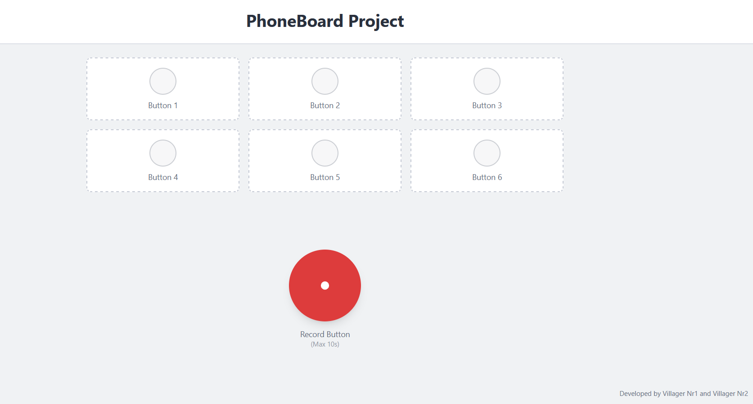
App Title
Button

Developer names
Record Button
Short description: PhoneBoard Project will be a mobile application whose purpose is to take short sound recordings( 10s max) and assign them to one of the 6 different buttons available. If a recording is assigned on a button who already had an existing recording on it, then the new recording will take its place. This application started as the theme for our Mobile systems and applications laboratory hours project.
App Title: At the top of the screen will be displayed the app title, “PhoneBoard Project”.
Button: the app has 6 similar looking buttons. At first the buttons don’t do anything if pressed. After a sound is recorded and then assigned to one of the buttons, then by pressing the specific button the recording will play.
Record Button: a round button, bigger then the rest and situated in the middle of the screen, below the 6 other buttons. Once pressed it will start sound recording for 10 seconds. After that you will have the option to press one of the 6 buttons above, in order to assign the recorded sound to one of them.
Developer names: in the lower right corner the names of the developers are to be displayed.

