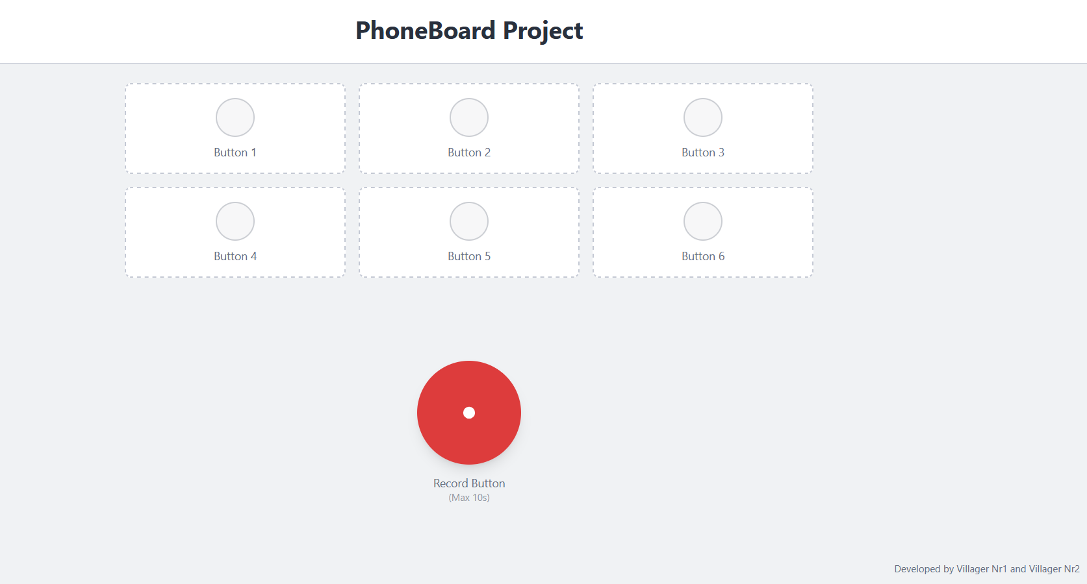

App Title

Button

Developer names

Record Button

**Short description**: PhoneBoard Project will be a mobile application whose purpose is to take short sound recordings( 10s max) and assign them to one of the 6 different buttons available. If a recording is assigned on a button who already had an existing recording on it, then the new recording will take its place. This application started as the theme for our *Mobile systems and applications* laboratory hours project.

**App Title**: At the top of the screen will be displayed the app title, “PhoneBoard Project”.

**Button**: the app has 6 similar looking buttons. At first the buttons don’t do anything if pressed. After a sound is recorded and then assigned to one of the buttons, then by pressing the specific button the recording will play.

**Record Button**: a round button, bigger then the rest and situated in the middle of the screen, below the 6 other buttons. Once pressed it will start sound recording for 10 seconds. After that you will have the option to press one of the 6 buttons above, in order to assign the recorded sound to one of them.

**Developer names**: in the lower right corner the names of the developers are to be displayed.