**Jorge Leon**

**6095718**

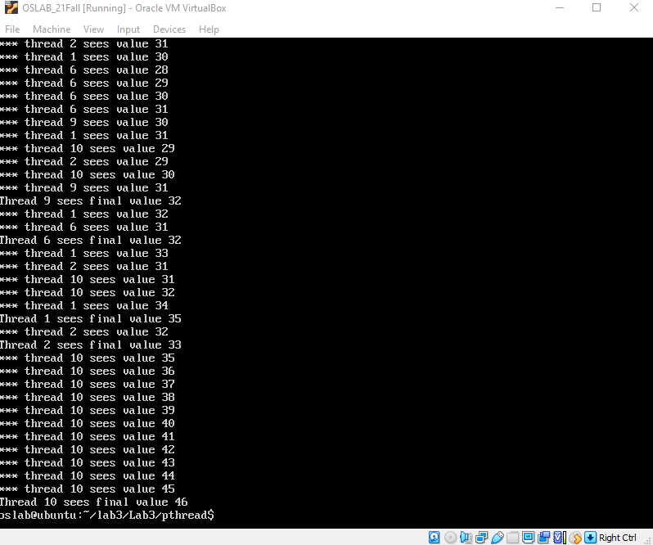**PART 1**

The unsychranised version will sometimes have a thread working on the shared value but before it can modify it will switch to a new thread. After the it’s the thread’s time again, it will then modify it. But this modification is an old value so it basically nullify anything that happen

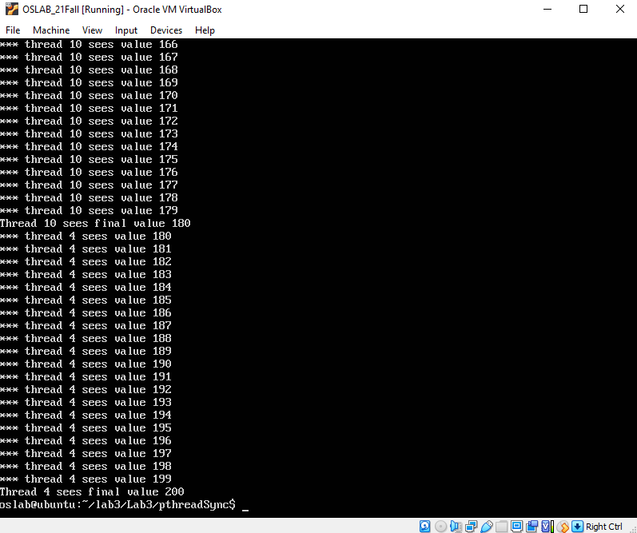**PART 2**

For the synchronized version of the code, the threads are not allowed to modify the shared value until one thread is done because of the locking function.

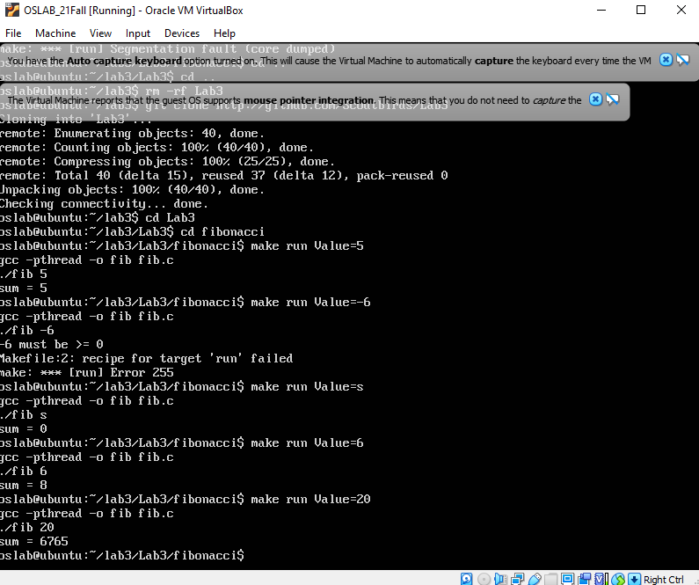**Fibonacci**

In this program when a thread is created and works on the Fibonacci sequence, a new thread will have to wait until the old thread is finished.