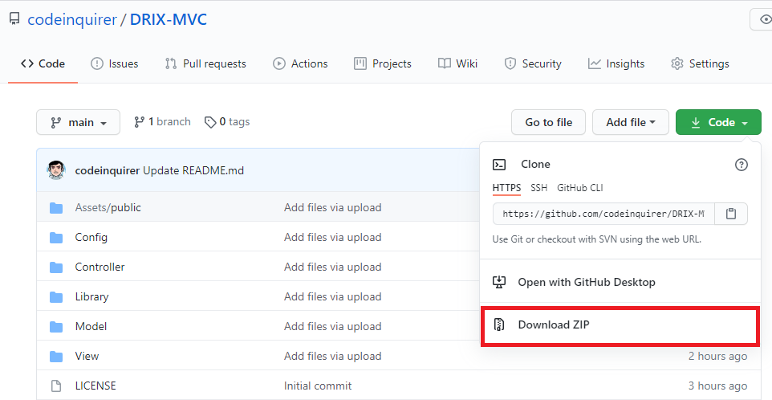**Downloading DRIX MVC from the GITHUB**

1. Click the CODE in the upper right corner.
2. Click the DOWNLOAD ZIP.

**Importing DRIX MVC to host**

1. Extract the downloaded zip to the file repository of your host.

(e.g. in localhost)

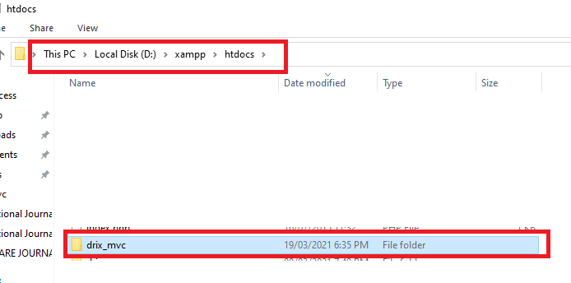

**How to create new page for you web app**

1. 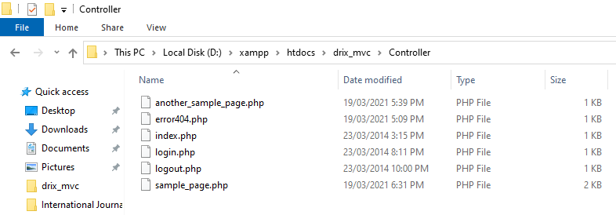Go to Controller folder.
2. Create a new file and put a code just like below. The Classname should be the same as the file name.

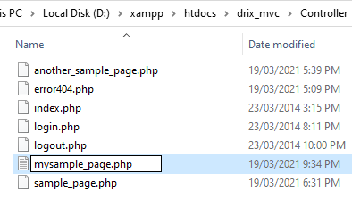

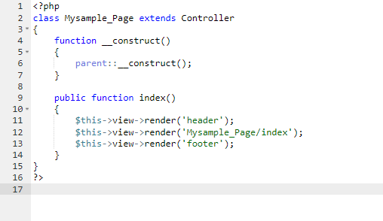

1. Go to View Folder and Create the file that you put in the paramter of

$this->view->render.

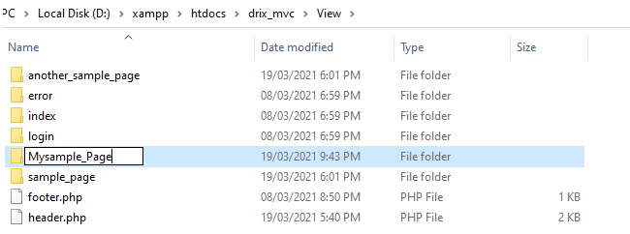

1. Create index.php inside the folder you created.

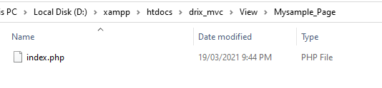

1. Open the file and anything you desire like build a content using HTML and CSS.

**How to do CRUD or ADD, EDIT, DELETE AND VIEW**

**General instruction:** You can view sample code in *Sample_Page_Model.php* under Model Folder.

1. 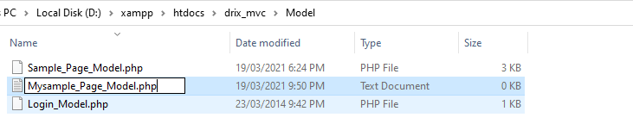Create a model file for your *mysample_page* in Model folder.
2. 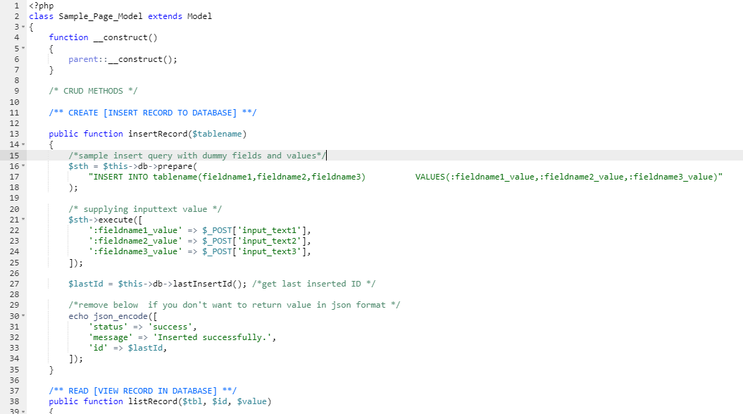You can copy the method in in *Sample_Page_Model.php* under Model Folder or create your own method.

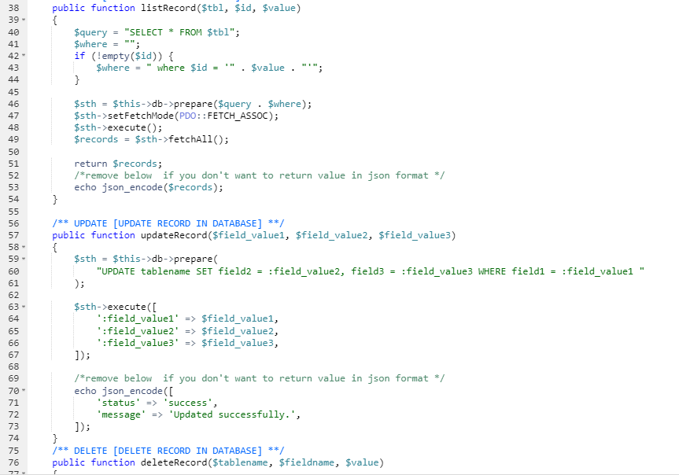

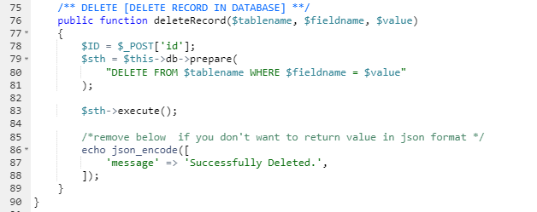

1. 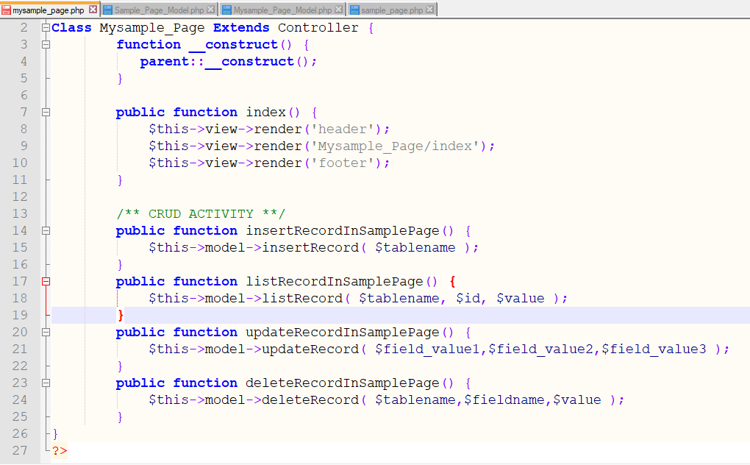Lastly, use the methods by going back to mysample_page.php under Controller and use the following code in this manner.