GCN vanilla

Cora

0.15 perturbation, w. gnnsafe

Best validation/test overall accuracy/test ind accuracy/openset detection: 0.8957/0.4643/0.8462/[0.770337182612409, 0.7977324833140695, 0.815813953488372], model saved to model.pth

0.05 perturbation, w. gnnsafe

0.05 perturbation, w/o. gnnsafe

Citeseer

Best validation/test overall accuracy/test ind accuracy/openset detection: 0.7114/0.4892/0.7023/[0.6356879599646746, 0.818730135451962, 0.9127906976744186], model saved to model.pth

GAT vanilla

0.15 perturbation

Best validation/test overall accuracy/test ind accuracy/openset detection: 0.9202/0.4597/0.8378/[0.8423892813295137, 0.8759362769272323, 0.7209302325581395], model saved to model.pth

Citeseer

Best validation/test overall accuracy/test ind accuracy/openset detection: 0.7520/0.4857/0.6972/[0.6545872828966736, 0.8261958231817259, 0.9162790697674419], model saved to model.pth

GIB-mcmc

For cora:

    parser.add_argument('--lambda_ixz', type=float, default=0.005, help='Weight for I(X;Z) loss')

    parser.add_argument('--lambda_struct', type=float, default=0.1, help='Weight for structure KL loss')

    parser.add_argument('--lambda_cons', type=float, default=0.0, help='Weight for consensual loss')

    # Training

    parser.add_argument('--lr', type=float, default=0.0005, help='Learning rate')

    parser.add_argument('--weight_decay', type=float, default=5e-7, help='Weight decay')

    parser.add_argument('--epochs', type=int, default=300, help='Number of epochs')

    parser.add_argument('--patience', type=int, default=250, help='Early stopping patience')

Best validation/test overall accuracy/test ind accuracy/openset detection: 0.9264/0.4635/0.8447/[0.9010060319211403, 0.9136041907191703, 0.4558139534883721],

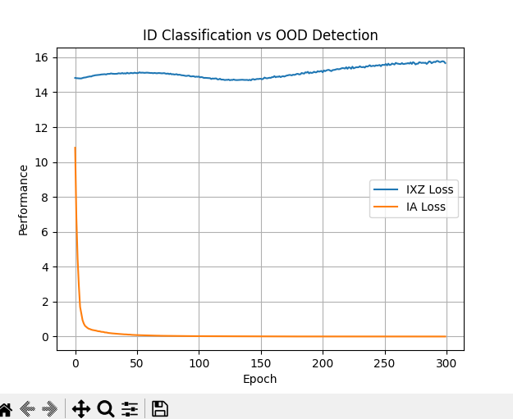

GIB

Lr=0.0005

0.001, 0.001

Best validation/test overall accuracy/test ind accuracy/openset detection: 0.9448/0.4765/0.8684/[0.8805394921798543, 0.9052256648318593, 0.6195348837209302], model saved to model.pth

0.005,0.005

Best validation/test overall accuracy/test ind accuracy/openset detection: 0.9387/0.4786/0.8722/[0.8898880802832689, 0.9136293420867324, 0.5665116279069767], model saved to model.pth

0.01,0.01

Best validation/test overall accuracy/test ind accuracy/openset detection: 0.9387/0.4757/0.8669/[0.8701553353143182, 0.8980570206413583, 0.6223255813953489], model saved to model.pth

Lr=0.001

0.005,0.005

Best validation/test overall accuracy/test ind accuracy/openset detection: 0.9448/0.4773/0.8699/[0.8702941228803758, 0.8942008587344941, 0.5869767441860465], model saved to model.pth

0.001,0.001

Best validation/test overall accuracy/test ind accuracy/openset detection: 0.9387/0.4790/0.8730/[0.8613718617106456, 0.8839845571626147, 0.586046511627907], model saved to model.pth

Citeseer

Lr=0.0005

0.001,0.001 （Bernoulli）

Best validation/test overall accuracy/test ind accuracy/openset detection: 0.7520/0.4952/0.7109/[0.7804989696791287, 0.8852479650930334, 0.8627906976744186], model saved to model.pth

Best validation/test overall accuracy/test ind accuracy/openset detection: 0.7480/0.4984/0.7154/[0.7805498969679129, 0.8694684792621595, 0.6581395348837209], model saved to model.pth

Dice-0.15

    parser.add_argument('--lambda_ixz', type=float, default=0.005, help='Weight for I(X;Z) loss')

    parser.add_argument('--lambda_struct', type=float, default=0.1, help='Weight for structure KL loss')

    parser.add_argument('--lambda_cons', type=float, default=0.0, help='Weight for consensual loss')

    # Training

    parser.add_argument('--lr', type=float, default=0.001, help='Learning rate')

Best validation/test overall accuracy/test ind accuracy/openset detection: 0.7886/0.5143/0.7382/[0.7294197821607301, 0.8554574422911424, 0.8348837209302326], model saved to model.pth

GIB

0.001,0.001

0.005， 0.005

id性能和ood性能悖论：

GIB

Citeseer lr=0.001

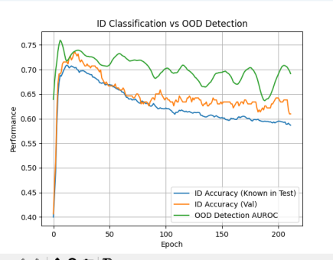

Citeseer lr=0.0005

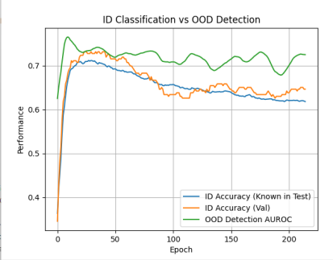

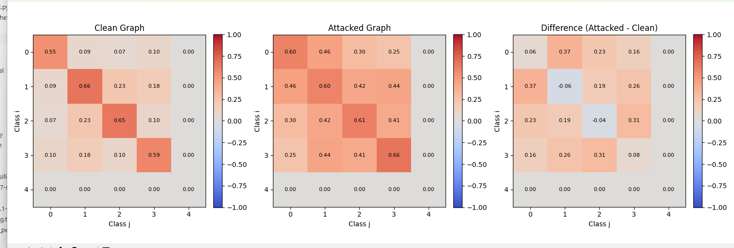

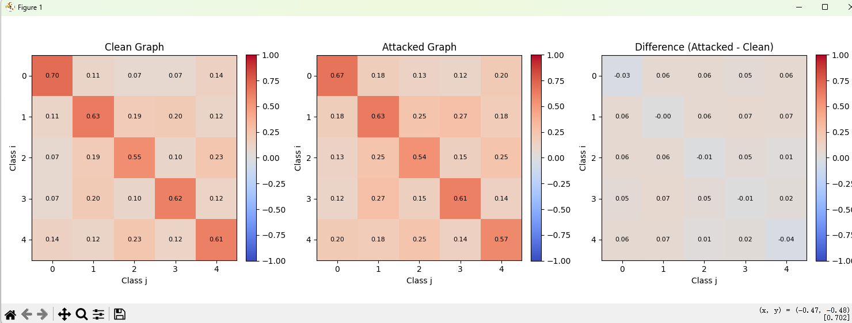

干净图

