03 VKESMD Debug Software User Manual

1. Software Startup
This software is specifically designed for debugging the VKESMD series of servo motors. Its core functions cover four major modules: servo motor motion control, status reading, parameter modification, and firmware upgrade. It is the core tool for debugging and maintaining the VKESMD series of servo motors. The software icon of VKESMD Debug is shown below. Double-click it to enter the program interface.
VKESMD_Debug Software Download
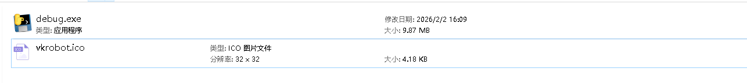
Note: When copying the software, the debug.exe and vkrobot.ico files need to be copied to the same directory; otherwise, the software may fail to open during use.
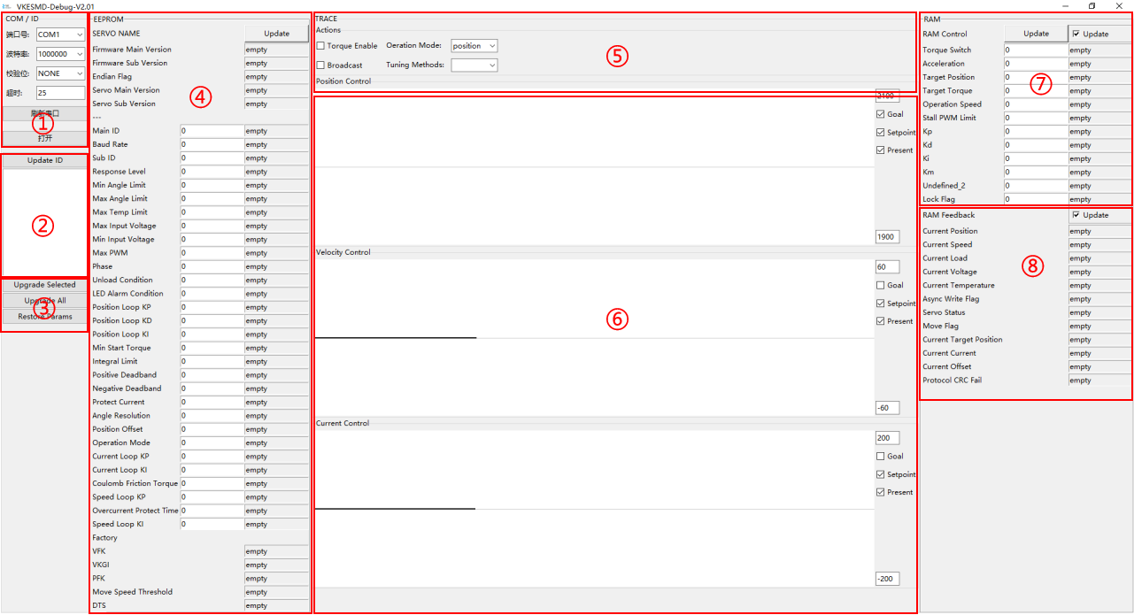
Figure Software Main Interface

2. Communication Settings and Servo Search Area
Area ① of the main interface of the software is the communication settings area, mainly used for opening/closing the communication serial port, setting the Port Number, setting the baud rate (the default baud rate for VKESSM servos is 1000000), setting the parity bit (default NONE), and setting parameters such as communication timeout (default 25); Area ② is the servo search area, mainly used for searching and displaying all servos connected in series on the bus.
When the servo driver board is plugged into the computer via the USB port and the 12V power supply of the driver board is powered on, the corresponding Port Number of the driver board can be found in the Device Manager, as shown in the following figure.
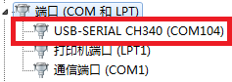
The search operation requires that the communication settings have been set up and are in the open state (displaying "Close", with the panel shown in gray). The servo search range is from ID 0 to ID 253, and the ID numbers and models of the corresponding searched servos will appear in the list in this area. By clicking on a servo in the list, you can select it. After clicking the "Update" button, the relevant parameter information and operation information of the selected servo will be displayed in the middle and right areas of the interface. Only the currently selected servo can have its relevant parameters read and operations performed.
[通信参数设置.mp4]
Note: If the ID number and model cannot be scanned, the following situations may occur: (1) Duplicate ID numbers (the ID of each servo on the bus cannot be duplicated, and the default ID of all servos at the factory is set to ID1); (2) No power supply or undervoltage for the servo (refer to the servo specification for the power supply range); (3) Incorrect selection of baud rate and serial port number (VKESSM defaults to a baud rate of 1000000); (4) Other factors (servo damage and short circuit, abnormal USB data cable, damaged signal board, abnormal contact of servo cable, etc.). In this case, please contact the manufacturer.

3. EEPROM Parameter Programming and Viewing Area
Area ④ in the main interface of the software is the EEPROM parameter programming and viewing area, mainly used for modifying servo parameters to achieve different motion effects. Since the parameters involve many algorithms, arbitrary modification may render the servo inoperable, so please modify them with caution! For the definition of parameters, please refer to 1.2 [MD Series] Memory Table.
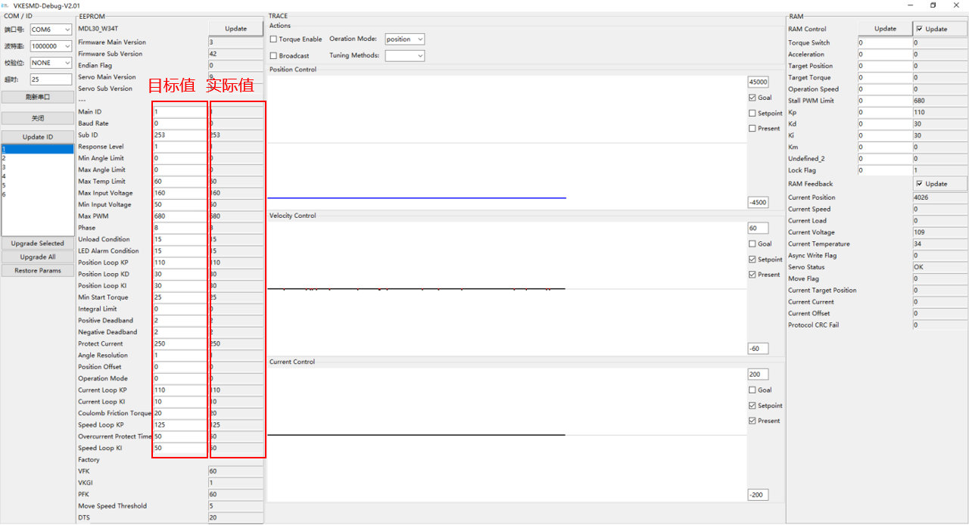
You can send a command by entering a new value in the target value input box and pressing Enter. Click the "Update" button to read the actual parameter values of the servo and display them in the actual value box to confirm whether the modification has taken effect.
[EEPROM参数设置.mp4]
Steps for power-off preservation of EEPROM parameters: ① Modify the Lock register (address: 55, 0x37), set it to 0 to close the write lock, and the value written to the EPROM address will be preserved after power-off. ② Modify the EEPROM parameters. ③ Modify the Lock register (address: 55, 0x37), set it to 1 to open the write lock, and the value written to the EPROM address will not be preserved after power-off. During the period when the write lock is closed, all modifications to the EEPROM parameters will be stored in the servo flash and preserved after power-off.
[EEPROM参数掉电保存.mp4]
Table 1 EEPROM Parameter Description
Parameter Name | Register Address | Register Length | RW Permission | Unit | Parameter Description
Firmware Main Version | 0 | 1 | R | None | Firmware Major Version
Firmware Sub Version | 1 | 1 | R | None | Firmware Subversion
Endian Flag | 2 | 1 | R | None | ByteDance
Servo Main Version | 3 | 1 | R | None | Steering Gear Main Version
Servo Sub Version | 4 | 1 | R | None | Steering Gear Sub-Version
Main ID | 5 | 1 | R/W | None | Master ID. A unique identifier on the bus. Duplicate ID numbers are not allowed on the same bus. 254 (0xfe) is the broadcast ID, and broadcasts do not return response packets.
Baud Rate | 6 | 1 | R/W | None | Baud rate.  0-11 respectively represent the following baud rates:  1000000(0), 500000(1), 250000(2), 128000(3), 115200(4), 76800(5), 57600(6), 38400(7),1500000(8),2000000(9),3000000(10),4000000(11)
Sub ID | 7 | 1 | R/W | None | Secondary ID. Secondary ID identifier (secondary identification), the secondary ID is only applicable to write instructions
Response Level | 8 | 1 | R/W | None | Response level. 0: Except for read commands and Ping commands, other commands do not return response packets; 1: All commands return response packets
Min Angle Limit | 9 | 2 | R/W | Step (0.087 degrees) | Minimum Angle Limit
Max Angle Limit | 11 | 2 | R/W | Step (0.087 degrees) | Maximum Angle Limit
Max Temp Limit | 13 | 1 | R/W | °C | Maximum Temperature Limit
Max Input Voltage | 14 | 1 | R/W | 0.1V | Maximum Input Voltage
Min Input Voltage | 15 | 1 | R/W | 0.1V | Minimum Input Voltage
Max PWM | 16 | 2 | R/W | 0.10% | Set the stall detection protection current percentage of the servo. Set 680 = 68%, stall detection protection current = 0.68 * Protect Current(28)
Phase | 18 | 1 | R/W | None | Special function ByteDance, do not modify without special requirements, see Special Byte Position Analysis for details. Currently only 2 bit positions are used.  BIT3 (8): Curve planning parameter. (0) 0 indicates that speed and acceleration are 0, (1) 0 indicates that speed and acceleration are at maximum values;  BIT4 (16): Angle feedback mode. (0) Feedback single-turn angle, (1) Feedback full angle.  BIT7 (128): Position feedback direction. (0) Forward, (1) Reverse.
Unload Condition | 19 | 1 | R/W | None | Unloading condition. 0 indicates off, 1 indicates on. Currently only 4 bits are used.  - BIT0 (1): Voltage Protection  - BIT1(2): Magnetic Encoding Protection  - BIT2 (4): Overheat Protection  - BIT3 (8): Overload Protection
LED Alarm Condition | 20 | 1 | R/W | None | Alarm condition: 0 indicates off, 1 indicates on. Currently, only 4 bits are used.  - BIT0 (1): Voltage Alarm  - BIT1(2): Magnetic Encoding Alarm  - BIT2(4): Overheat Alarm  - BIT3 (8): Overload Alarm
Position Loop KP | 21 | 1 | R/W | None | Position loop kp
Position Loop KD | 22 | 1 | R/W | None | Position loop kd
Position Loop KI | 23 | 1 | R/W | None | Position loop ki
Min Start Torque | 24 | 1 | R/W | 6.5mA | Minimum starting force in assist mode
Positive Deadband | 26 | 1 | R/W | Step (0.087 degrees) | Positive Dead Zone
Negative Deadband | 27 | 1 | R/W | Step (0.087 degrees) | Negative Dead Zone
Protect Current | 28 | 2 | R/W | 6.5mA | Protection current threshold
Position Offset | 31 | 2 | R/W | Step (0.087 degrees) | Position Deviation
Operation Mode | 33 | 1 | R/W | None | Control mode.  0: Position Servo Mode  1: Motor constant speed mode, controlled by parameter 0x2E running speed parameter, with the highest bit BIT15 as the direction bit  2: Motor constant current mode, controlled by parameter 0x2C target torque parameter, with the most significant bit BIT15 as the direction bit  3: Motor assist mode, controlled by parameter 0x18 minimum starting force and parameter 0x24 friction parameter
Current Loop KP | 34 | 1 | R/W | None | Current loop kp
Current Loop KI | 35 | 1 | R/W | None | Current loop ki
Coulomb Friction Torque | 36 | 1 | R/W | 6.5mA | Friction compensation current in assist mode
Speed Loop KP | 37 | 1 | R/W | None | Speed loop kp
Overcurrent Protect Time | 38 | 1 | R/W | 10ms | Overcurrent protection time. The maximum setting is 254 * 10ms = 2540ms
Speed Loop KI | 39 | 1 | R/W | None | Speed loop ki

4. RAM Parameter Control and Viewing Area
In the main interface of the software, areas ⑦ and ⑧ are the operation and viewing areas for servo RAM parameters, mainly used for manually controlling servo movement.
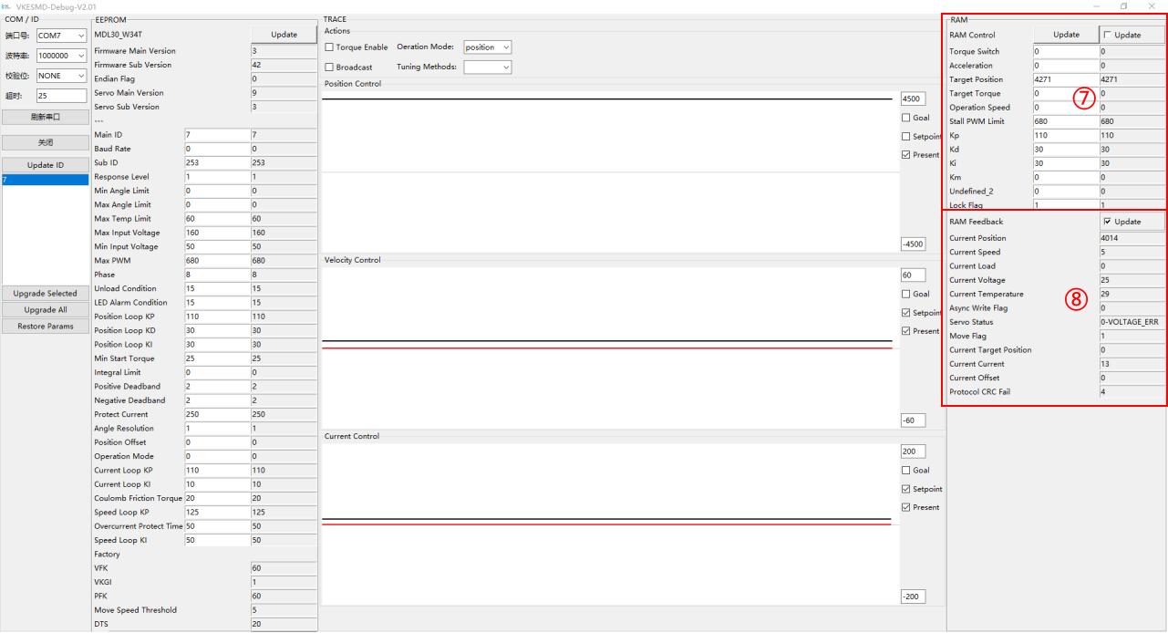
(1) Area ⑦: Readable and writable RAM parameters. Click the "Update" button to populate the target value input box on the left with the real-time value on the right. Write a new value in the target value input box and press Enter to send the command.
(2) Area ⑧: Read-only RAM parameters. After checking the "Update" checkbox, the parameter values of the servo will be displayed in real time.
Table 1 RAM Parameter Description
Parameter Name | Register Address | Register Length | RW Permission | Unit | Parameter Description
Torque Switch | 40 | 1 | R/W | None | Torque switch. Write 0: Turn off torque output; Write 1: Turn on torque output;
Acceleration | 41 | 1 | R/W | 100 steps/second² | Acceleration/Deceleration of the servo operation. If set to 10, the speed will change by 1000 steps per second
Target Position | 42 | 2 | R/W | Step (0.087 degrees) | Target position. In position control mode, the maximum value corresponds to the maximum effective angle, and BIT15 is the direction bit
Target Torque | 44 | 2 | R/W | 6.5mA | After torque enabling, it is assigned by the protection current (28), and this value can be modified to control the output of the motor's maximum operating torque; BIT15 is the current direction bit
Operation Speed | 46 | 2 | R/W | Step (0.087 degrees) | Controls the maximum operating speed of the motor. Steps per unit time (per second), 50 steps/second = 0.732 RPM (revolutions per minute)
Stall PWM Limit | 48 | 2 | R/W | 0.1% | Torque limit. The user controls the output of the maximum torque during stall by modifying this value.
Kp | 50 | 1 | R/W | None | Real-time control of the proportional coefficient of the motor position loop, which is assigned by the position loop P proportional coefficient (21) after torque enabling
Kd | 51 | 1 | R/W | None | Real-time control of the differential coefficient of the motor position loop, which is assigned by the position loop D differential coefficient (22) after torque enabling
Ki | 52 | 1 | R/W | None | Real-time control of the integral coefficient of the motor position loop, which is assigned by the position loop I integral coefficient (23) after torque enable
Lock Flag | 55 | 1 | R/W | °C | Write 0 to close the write lock, and save the value of the EPROM address after power failure  Write 1 opens the write lock, and the value written to the EPROM address is powered down and not saved
Current Position | 56 | 2 | R | Step (0.087 degrees) | In absolute position control mode, the maximum value corresponds to the maximum effective angle
Current Speed | 58 | 2 | R | Step (0.087 degrees) | Feedback the current rotational speed of the motor, i.e., the number of steps per unit time (per second)
Current Load | 60 | 2 | R | 0.001 | Voltage PWM duty cycle of the drive motor
Current Voltage | 62 | 2 | R | 0.1V | Current servo operating voltage
Current Temperature | 63 | 1 | R | °C | Current internal operating temperature of the server
Async Write Flag | 64 | 1 | R | None | When using asynchronous write instructions, the flag bit
Servo Status | 65 | 1 | R | None | - BIT0 (1): Voltage Status  - BIT1(2): Magnetic Encoding Status  - BIT2 (4): Temperature Status  - BIT3 (8): Current Status  - BIT4（16）：----  - BIT5 (32): Load Status  - BIT6（64）：----  - BIT7（128）：----
Move Flag | 66 | 1 | R | Step (0.087 degrees) | When the servo is moving, it is marked as 1; when the servo is stopped, it is marked as 0
Current Target Position | 67 | 2 | R |  | Current target position of curve planning
Current Current | 69 | 2 | R |  | Current target current for curve planning
Protocol CRC Fail |  |  | R |  | Number of CRC check errors during communication
Tip: How to quickly know the range of speed values?
A larger current can be set through the current mode for no-load operation, and by observing the maximum displayed value of the speed feedback from the servo, this value is the maximum no-load operating speed of the servo. The operating speed is stored in the SRAM area of the servo and will be cleared to 0 when power is turned off.

5. Automatic servo testing and real-time curve plotting area
(1) Area ⑤ is the automatic testing area. This area is mainly used for automatically repeating the control of servo movement. The parsing of the buttons or options in this area is as follows:
Select the operating mode: click the Operation Mode dropdown box to select the operating mode (supports torque, speed, and position modes)
Select the debugging mode: click on the Tuning Methods dropdown box and select the debugging mode (supports square wave, sine wave, and frequency sweep methods)
Turn on/off torque: Check/uncheck the Torque Enable box
After adjusting the period, amplitude, and offset, turn on the torque switch, then click Start to begin and Stop to end.
(2) Area ⑥ is the automatic curve plotting area. It is mainly used for intuitively observing the dynamic curves of various parameters of the servo, including three major boxes: (blue for target, red for planning, black for actual) position, (blue for target, black for actual) speed, and (blue for target, black for actual) torque. As the servo moves, the dynamic curves will be displayed in real time. You can set the curve display range by modifying the value in the red box and pressing Enter.
Note : This area can only observe the selected 1 rudder. The time per grid of the curve is 1000ms.
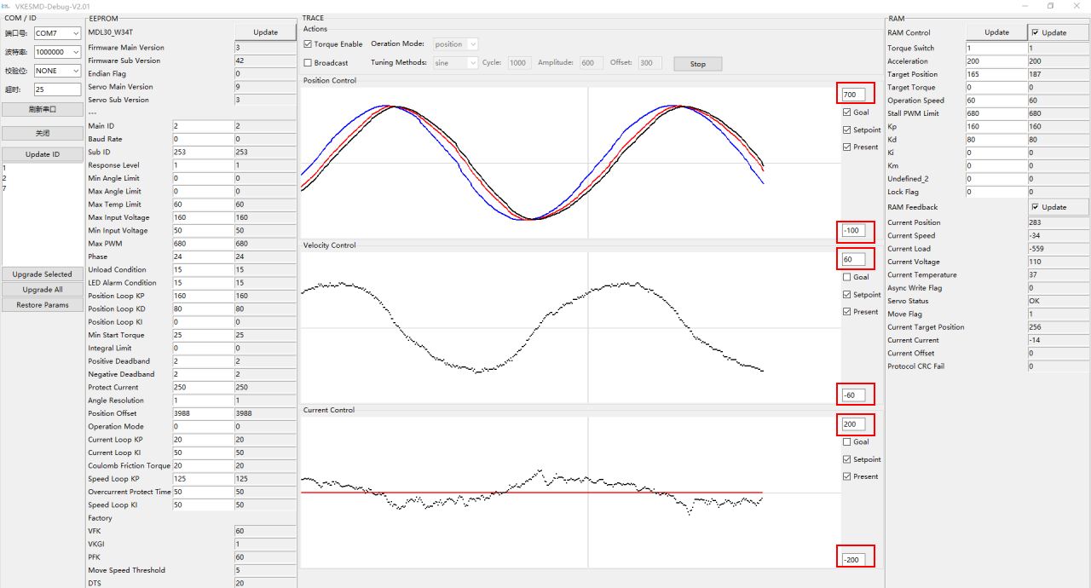
Figure Automatic Testing and Real-time Curve Plotting

[正弦与方波自动测试.mp4]

6. Firmware Upgrade and Parameter Restoration Area
In the main interface of the software, Area ③ is the servo upgrade and parameter restoration area, which is mainly used for upgrading servo firmware. It can upgrade all servos connected in series on the bus at once, and the ID remains unchanged before and after the upgrade.
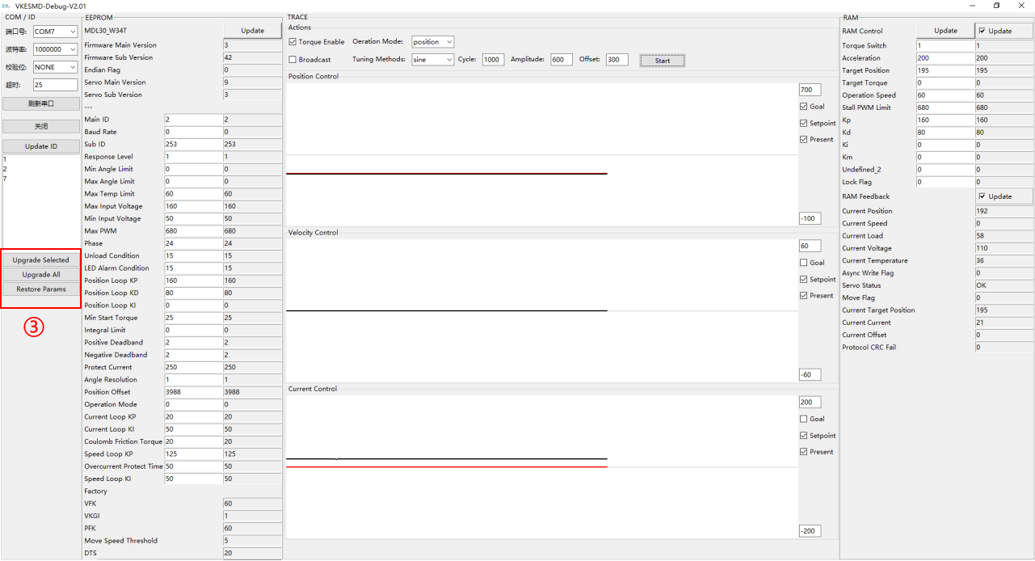
Figure Firmware Upgrade
Before upgrading, please update the ID to ensure that the ID number and model of the servo motor found appear in the device list area table. You can select a servo motor by clicking on it in the list, then click Upgrade Selected to upgrade only the selected servo motor; or click Upgrade All to upgrade all servo motors in the list of Area ②. After upgrading, you can perform parameter restoration operations one by one as needed. Except for the ID number, all other parameters will be restored to their factory default settings.
[一对一固件升级.mp4]

