PROJECT PLAN

Griffith University | 2810ICT-Software Technologies

NEW YORK RESTAURANT INSPECTION DATA ANALYSIS SOFTWARE TOOL

Ridwan M Rahman – s5236144 Dylan Horton - s5170425 Pranav Patel - S2961443

2022

Table of Contents

1.0 Introduction 3

1.1 Background 3

1.2 Scope 3

1.3 Document contents 4

2.0 Work Breakdown Structure 5

3.0 Activity Definition & Estimation 6

4.0 Gantt Chart 7

# Introduction

According to research from the Centre for Science in the Public Interest, people who dine out are twice as likely to get food poisoning than those who eat at home. This project aims to provide an intuitive data visualisation dataset analysis tool that will make it easier to analyse and understand the data on the restaurants. This document's project plan will include resources including a Project Overview, Work-Breakdown Structure, Activity Definition and Estimation, and a Gantt chart that displays the project's scheduling and progress estimation in terms of time.

## Background

Restaurant inspections are not intended to cause anxiety among company owners. On the contrary, these inspections ensure that your clients are secure. A restaurant inspection usually takes place at least once and often up to four times a year for most restaurants. Employees may be required to resign under challenging situations where many infractions occur at an establishment. In these situations, a business may be obliged to lock its doors until the situation improves, resulting in significant financial losses for the organisation. Customers and companies must be acutely aware of food safety issues' effects on the company and the damaging loss of reputation and value if these considerations are ignored.

## Scope

This project aims to provide a straightforward user interface that will enable users to quickly perform data analysis and visualize the data related to the New York Inspection results. The aim is to ensure that users can find and view the data they want to know about with moderate ease and precision. Graphs need to match their data and clearly define what they represent. The layout must be straightforward, with toggleable choices to reveal or provide a clearer view of the requested data. The ability to query and search for titles within a data search ensures that even individuals with little to no programming or specialized experience can find it simple to use this program.

The first step in understanding the scope is to analyse and research the requirements and tools needed to design and create this project. Once completed, second comes the planning stage of the project, which aims to outline the completion estimates and deadlines for each part of the project. Each task is defined and assigned to team members at this stage so that everyone always has a job to perform and a deadline for when it must be completed. Third comes the designing of the program’s UI. Questions such as where to place text, user input methods, and what makes an interface simple and easy to use.

Once design is complete, implementation of the project becomes a top priority. Each team member references the work breakdown plan for the project and begins working on their allocated tasks. From completion, tests can be conducted to ensure that everything works as intended and that the systems defined in the planning stages work effectively.

## Document contents

This project plan gives a general overview on how the team plans to schedule, give an overview of, and design a data analysis tool for New York restaurant inspection data. The project is separated into two key elements, that being the project plan document and the Software Design document. The project plan also includes a work breakdown structure for the undertaking. The sub-activities and work packages are displayed in a hierarchical format. the project Gantt chart and duration estimates created at the end of the project plan.

The following lists the contents that are found within each document:

**Project Management Plan**

⦁ Activity Chart

⦁ Project Network & Scheduling

⦁ Gantt Chart

⦁ Work Breakdown Structure

⦁ Activity Definition and Estimation

**Design Document**

⦁ System Overview

⦁ User Requirements

⦁ Software Requirements

⦁ Use Cases

⦁ System Components and Software Design

⦁ User Interface Design

# Work Breakdown Structure

This section showcases the initial breakdown of the entire development of the Data Analysis Software by breaking them down into different categories and sub-categories.

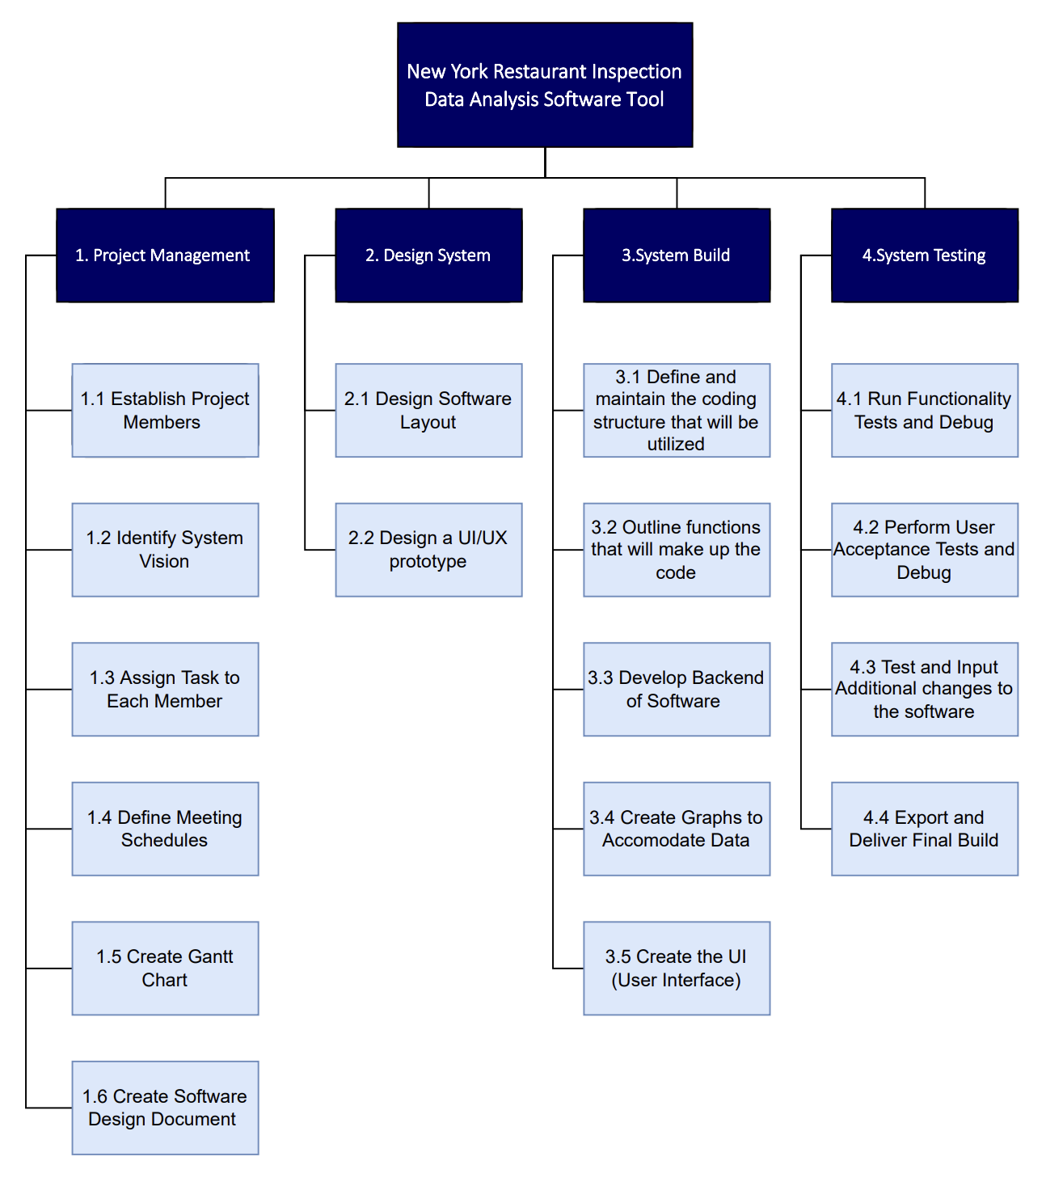

*fig. 1 Initial Work Breakdown Structure*

*Changes may be made in the final version of the document

# Activity Definition & Estimation

This section is to define and estimates the required time to complete this project from start to finish by segmenting the tasks and allocating the estimated time till completion.

|  |  |  |  |  |
| --- | --- | --- | --- | --- |
| Activity Number | Task Name | Duration | Start | Finish |
| 1.0 | **Project Management** | **10 days** |  |  |
| 1.1 | Establish Project Members | 1 | 4th Aug | 5th Aug |
| 1.2 | Identify System Vision | 2 | 5th Aug | 8th Aug |
| 1.3 | Assign Task to Each Member | 1 | 8th Aug | 9th Aug |
| 1.4 | Define Meeting Schedules | 1 | 9th Aug | 10th Aug |
| 1.5 | Create Gantt Chart | 1 | 10th Aug | 11th Aug |
| 1.6 | Create Software Design Document | 4 | 11th Aug | 17th Aug |
| 2.0 | **Design System** | **5 days** |  |  |
| 2.1 | Design Software Layout | 2 | 17th Aug | 19th Aug |
| 2.2 | Design a UI/UX Prototype | 3 | 22nd Aug | 24th Aug |
| 3.0 | **System Build** | **10 days** |  |  |
| 3.1 | Define and maintain the coding structure that will be utilized | 1 | 24th Aug | 25th Aug |
| 3.2 | Outline functions that will make up the code | 1 | 25th Aug | 26th Aug |
| 3.3 | Develop Backend of Software | 3 | 29th Aug | 31st Aug |
| 3.4 | Create Graphs to Accommodate Data | 2 | 1st Sept | 2nd Sept |
| 3.5 | Create the UI (User Interface) | 3 | 5th Sept | 7th Sept |
| 4.0 | **System Testing** | **5 days** |  |  |
| 4.1 | Run Functionality Tests and Debug | 1 | 8th Sept | 9th Sept |
| 4.2 | Perform User Acceptance Tests and Debug | 1 | 9th Sept | 12th Sept |
| 4.3 | Test and Input Additional changes to the software | 2 | 12th Sept | 14th Sept |
| 4.4 | Export and Deliver Final Build | 1 | 14th Sept | 15th Sept |

*fig. 2 Initial Activity Definition and Estimation Diagram*

*Changes may be made in the final version of the document

# Gantt Chart

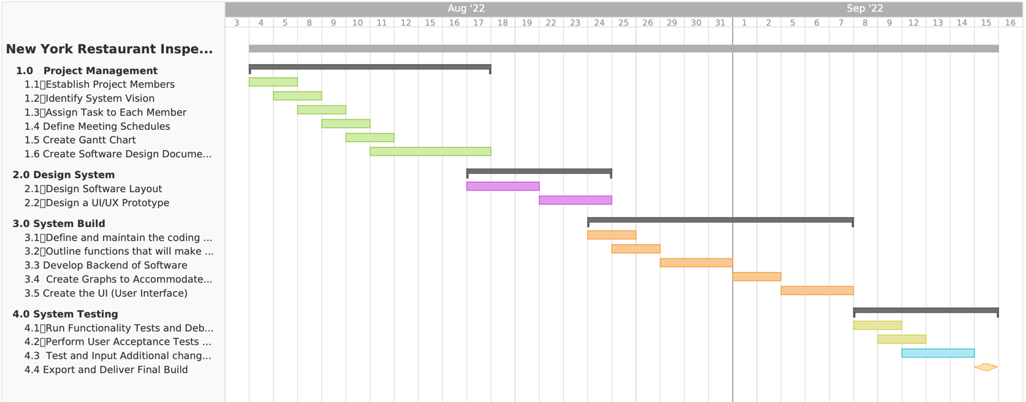This Gantt chart allows to visualize the overall progress of the project according the estimated allocation of the tasks.

*fig. 3 Initial Gantt Chart for the Project*

*Changes may be made in the final version of the document