OOP

There are a number of classes used in the program. Only 4 classes use inheritance, 1 inherits from another child class. The classes are often used as custom data structures to make the code more abstract and segregated in order to reduce complexity of the program.

Connections

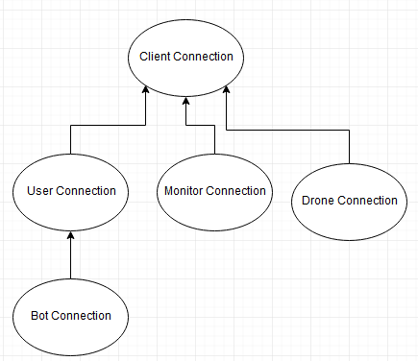
The Connection classes are used by the server to serve as an interface with which the client can communicate with. These classes manage communication, encryption and command processing and generally are quite simple, calling commands to add values to the database or logging in.

The ClientConnection class contains all the base functions needed for the child classes including instantiation, connection loops and send/receiving. The class also contains the protected variables for the current clientID, connection to DB and the crypto object. This class however cannot run without being altered by a child class as it requires the child classes CreateCommands method to set the available command dictionary.

The UserConnection object is used to interface with the User and sets the relevant commands. The most complex command is Add_Flight which sets up a flight for a drone using the A* search as well as AATC_Weather to provide an average speed estimation.

The BotConnection inherits from the UserConnection object and overrides a number of its methods in order to adapt them to the bot’s requirements. This involves altering the instantiation method as well as the send and login methods. The class also does not use the Connection_Loop method , instead using a Main method which runs only the provided command.

The MonitorConnection object is used to interface with the monitor client and provides a smaller number of commands compared to the UserConnection object as this client can mostly only observe the events and not alter them.

The DroneConnection object is used to interface with the drone client and contains a smaller number of command than the Monitor or User connection objects. It is used to communicate with the drone clients.

AATC_Astar
AATC_Astar includes two classes. The DynoGraph class is used to manage the graph stored on the disk when performing the search, acting as an abstraction to the fact that the nodes must be read from files, acting like a conventional graph. The Node class is used to store the nodes of the graph and these nodes are stored by the DynoGraph object and used in the search algorithm.

AATC_Client
AATC_Client has one class UserInterface which is used as a convenient way to manage the connection to the server for the user (here referenced as client) as well as store the functions accessible on the server to simplify programming of User software such as a text interface or automatic management.

AATC_Client_Text_UI
AATC_Client_Text_UI has one class UserTextUI which is used to produce a text UI interface to the User part of the server. This uses similar methods to the AATC_Client.UserInterface object but provides and input system to obtain the relevant information and passes this information on the UserInterface and then displays the response.

AATC_Coordinate
The AATC_Coordinate module has one class Coordinate which is used to store the information about a coordinate as well as providing the ability to use the coordinate in this form with common calculations defined with other functions in the module.

AATC_Crypto
The AATC_Crypto module is used to manage the encryption of communication between the server and the client in the form of the Crypter object which manages the exchange of the encryption keys as well as the encryption/decryption of messages.

AATC_DB
The AATC_DB module uses one class named DBConnection which acts as a simplification and segregation method to ensure that SQL is only used in this module and so only one module must be altered/checked with alterations regarding SQL as well as providing a simple way to manage the connection to the database and providing commands which are used to alter the database.

AATC_Drone
AATC_Drone can be used by drone to communicate easily with the server and other drone functions. The module contains the DroneInterface method to communicate with the server, the Waypoint object to store waypoint information, the Flight object to store flight information and the DroneInformation object to store drone information.

