AATC_Astar_Testing
TestID | Test description | Test data | Expected outcome
1 | Create a DynoGraph object. This is used to connect / manage the graph of the served section of airspace. | Instanciate a dynograph object with default parameters. | Returns a functioning dynograph object.
2 | Create Dynograph with non default parameters. This required as some configurations may have to be changed to suit the servers requirements eg change in block size depending on the storage medium used. | Create Dyno graph with ABSlots = 3 and ABSlot =1. | Check that the Folder names contains a,b,c and that the current folder name works
3 | Set the size of the graph. The size is the size of a single sector of the graph. | Enter a size of the graph. | Should setup the new sizes
4 | Get size of the graph. This returns the size of the graph, used to perform calculations in the A* algorithm. | Get the size of the graph. | Should return the size of the graph.
5 | Add a node. This is an object which represents a single point in space which is connected to it's neighbours forming a 3D mesh. | Add a node to the graph. | Node should be added to the graph
6 | Setup edges. This calculates the edges of the graph. Turns a set of points in 3D space into 3D graph. | Add some nodes to the graph and create edges | Should setup edges for each node.
7 | Calculate Neighbours. This function calculates the neighbouring NodeIDs of a node. Required for the A* search. | A node ID = 6 , Counts = 10 | Should return neighbours including 5,7,15,17,16 and higher values.
8 | Node_Cache_Hash. This is used to store Node_Cache values in blocks by deriving a key for each Node_Cache value. | Hash a number of keys , should persist over restarts. | Should return a persistant hash result
9 | Build node cache. This calculates all the Node_Cache value for the graph. The Node_Cache stores a mapping value used to find the NodeID for a given sector in O(1) time. | Build the node cache for a graph | Searching for a nodeID should return a correct result
10 | Save Node Cache. This writes the built Node_Cache to files on a disk. Number of files will vary depending on the configuration. Files will have the label NC for Node_Cache. | Save the Node Cache in the correct folder. | Should save ~430 files in folder.
11 | FindNodeID. This function uses the Node_Cache to find a NodeID for a given set of coordinates. Used to find the start and end NodeIDs. | Obtain a value from the node cache | Should return a nodeID
12 | DirectNodeID. This obtains a NodeID value for an already partly mapped coordinate set (coordinates divided by graph size). | Obtain value from node cache using hashed values | Should return a nodeID
13 | Obj find nodeID. This finds the nodeID for an object with a Coordinate attribute. | Obtain value from node cache using a coordinate object | Should reutrn a nodeID
14 | Save graph. This saves the details of the graph to secondary storage, results in large numbers of files being generated in the save folders. | Save the graph after being generated. 0,0,0->1,1,100 @ 0.01,0.01,50 | Should save all the details of the graph into folders. Size of folder should be ~25 MB for 0,0,0->1,1,100 @ 0.01,0.01,50
15 | Import graph. This loads the details of the graph from a file on the disk. | Import the graph from disk | Graph details should be imported (shown by hasattr(graph,”xSize”) being true)
16 | GetNode. This obtains the node object for the passed nodeID. | Obtain a node using its nodeID. One real , one non existant node. | Should return the node If node does not exist raise error.
17 | Save Nodes. This saves all the nodes to files in the save folder. Used to permenatly store the graph for later use. | Create graph and save nodes. | Should populate folder with many files.
18 | Evict Node. This is used to remove the node from memory if it no longer needed. | Attempt to evict one loaded and one unloaded node. | Should evict the node from memory if it is present
19 | All Node Ids. This produces a list of all NodeIDs which are used by that graph. | Call All NodeIDs | Should return a list with all nodeIDs.
20 | GetFolderNames. The obtains a list of all possible folder names used by the AB saving system. The system prevents issues caused by write locks on files and or can be used to improve storage bandwith by placing the folders via hardlinks onto different storage mediums. | Call GetFolderNames | Should show the possible folder names
21 | Current folder name. This calculates the current folder name the graph should be using in order to access/save in. | Run CurrentFolderName | Should return the current folder name.
22 | Astar2. This is used to find a path close to the optimal in a reasonable amount of time using the dynograph object and start and stop nodes. This test ensures it can find a path. | Run Astar2 with the graph and start and target Ids | Should return a path between the points.
23 | Astar2 invalid node. This test shows that the method will raise an error if invalid start or end nodes are used, i.e. if the DynoGraph object was incorrectly configured. | Run Astar2 with an invalid target or start ID | Should raise an error about the issue.
24 | Astar2 not loaded nodes. This demonstrates that the algorithm only loads the nodes relevant to the search into memory. | Check if a node far from the path is loaded | The node should not be loaded
25 | AstarPQ. This algorithm also performs the same task as Astar2, however is modified to reduce run time under specific circumstance. This test checks it also can find a path to the target. | Run AstarPQ with the graph and start and target Ids | Should return a path between the points.
26 | AstarPQ invalid node. This test shows that the algorithm will raise an error if an invalid node is accessed/set and alerts of the error. | Run AstarPQ with an invalid target or start ID | Should raise an error about the issue.
27 | AstarPQ not loaded nodes. This also shows that the nodes relevant to the search are the only nodes loaded into memory. | Check if a node far from the path is loaded | The node should not be loaded
28 | Astar2 vs AstarPQ. This test shows that the algorithm for both searches finds the correct path and that the search path is not random. | Run same start and target Ids for both searches | Both should return the same path due to using the same algorithm.
29 | Path finding with No Fly Zones. This test shows that the search will attempt to bypass no fly zones unless it is impossible to do otherwise. The path will not intersect with the no fly zone. | Add a no fly zone to 0.9,0.9,0-> 1,1,200 at level 1234 | The path may change as target of 80000 is above no fly zone, however original path may have taken a low route. Comparison to default.
30 | Attempting to use one of the points on the no fly zone This shows that the algorithm will attempt to find a shorter path to the end node , by selecting a very high value node the search attempts to find a shorter path, exploring other options. | Select node 79997 as the target | The search should take a much longer time than normal.

1.
Correctly created object. This can be used for searching the stored graph via an A* Search.

2.
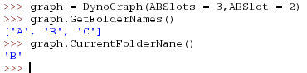
Sucessfully created non default dynograph. This shows that The Dynograph will use the changed parameters , seen by the three items in GetFolderNames compared to the default 2.

3.
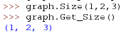
Correctly set size. This shows that the graph correctly updates it’s size when the Size command is used.

4.
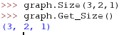
Correctly obtained size. This obtains the size of a sector in the graph (3D space allocated to a node). Same values as set above.

5.
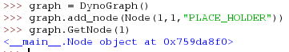
Correctly added node. These nodes are required for the graph to function.

6.
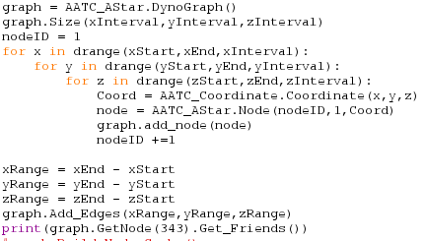
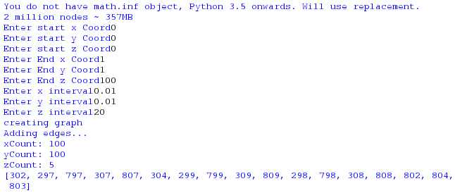
Edges (values in list, for a single edge node) correctly created. These edges are required to add arcs / edges to the graph so that the alogirthm can traverse the graph. A set of edges for a single node is shown here.

7.
Neighbouring NodeIDs generated. This shows that the neighbours are correctly created. There are fewer edges than above due to this nodeID being demonstrated being on the edge of the mesh (edge of cuboid mesh).

8.
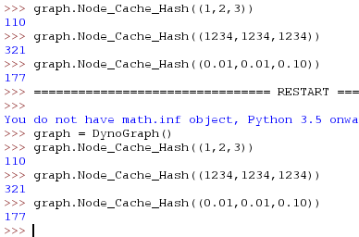
Generated persistent hashes for each key. The restart shows that the hashes remain constant over restarts of the interpreter as well as that the different keys have different outcomes.

9.
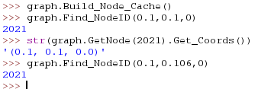
Correctly obtained correct NodeID with Node Cache. This shows that the program can load the values from persistent storage correctly for the node_cache.

10.
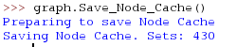
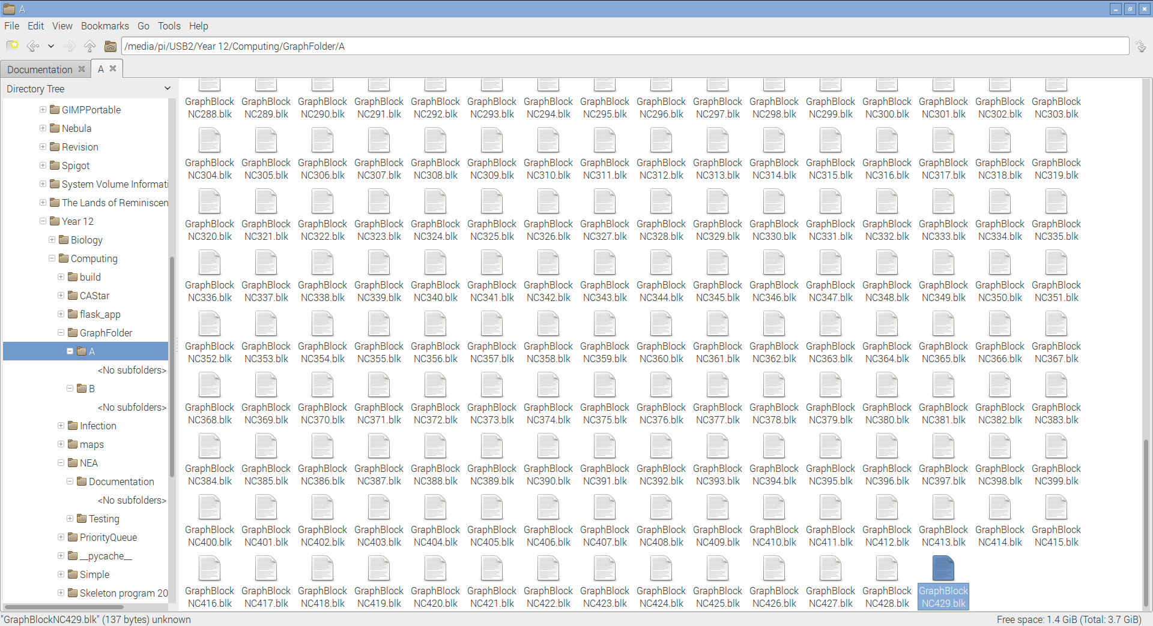
Correctly saved files. The files with NC in are used to store components of the node cache. The number of files can vary depending on the side of the node_cache and node_cache block size parameters.

11.
Sucessfully obtained the nodeID. This shows that the nodeID can be correctly obtained using a set of coordinates.

12.
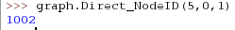
Sucessfully obtained NodeID. This shows the NodeID can be successfully obtained from already modulated values.

13.
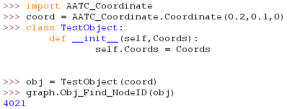
Correctly obtained nodeID. This shows and object with the Coords attribute can be used to obtain the nodeID.

14.
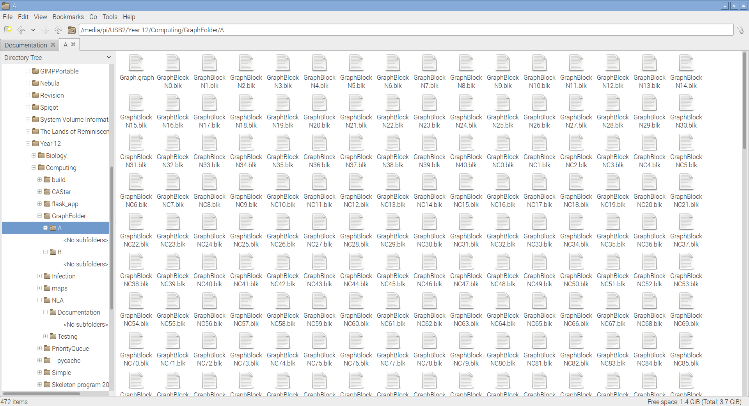
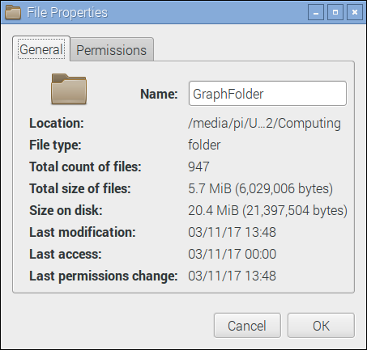

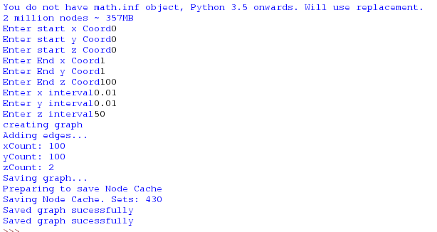
Sucessfully saved graph. This shows that the graph was correctly saved, note the file size being large, containing all the information for a 20000 node map.

15.
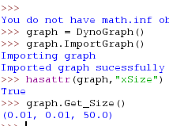
Correctly imported graph details. This shows that details of the graph such as size can be loaded from storage correctly.

16.
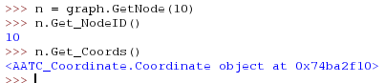
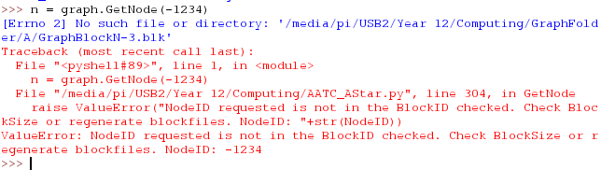
Successfully obtained node where possible. This shows that the objects can be correctly loaded from storage and a relevant error will be raised if the node is not available ( node -1234 will never exist).

17.
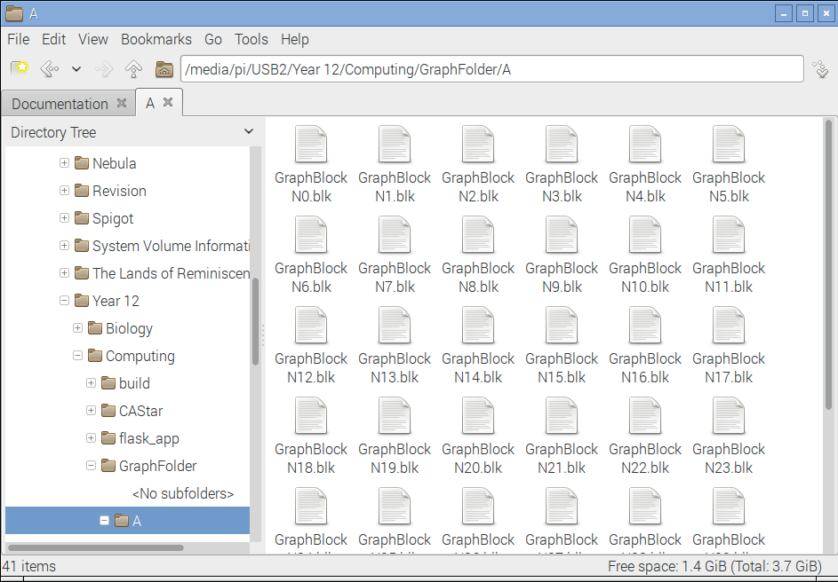
Sucessfully saved nodes. This shows the save nodes function works with all the nodes being saved. The lack of a graph.graph file shows that only the nodes were saved.

18.
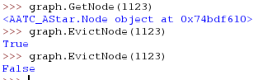
Sucessfully evicted node when in memory, correct response in both cases. This shows that the evict node function successfully evicts a node and returns a boolean value of the statement “node was in memory”, true if it was in memory, false if it was not.

19.
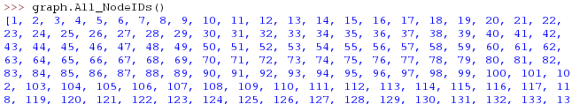
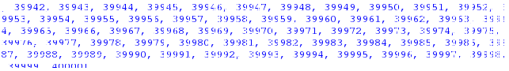
Sucessfully returned all nodeIDs. These are two extracts from calling the function on a 40000 node graph, returning a list containing all nodeIDs from 1 - > 40000.

20.
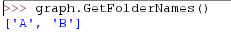
Obtained folder names correctly. This shows the function is able to return a list of all the folder names which are possible, in this case A and B.

21.
Correctly obtained the folder name. This shows the program can correctly calculate the folder it must use, in this case A.

22.
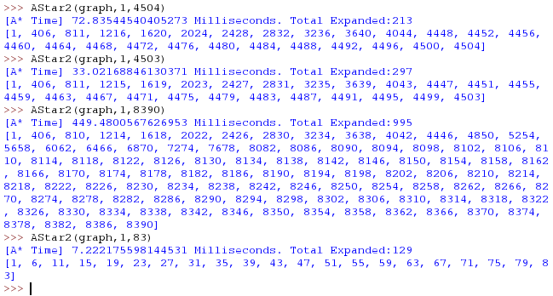
Correctly found paths with NodeIDs. This shows a couple of searches on the graph, returning a path of NodeIDs which must be followed, starting at the start NodeID and moving towards the Target NodeID.

23.
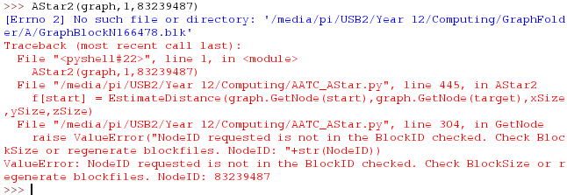
Correctly raised error. This is used to alert the server that a NodeID used is invalid.

24.
Far off node correctly not loaded into memory. This shows the program will only load nodes into memory which are relevant to the search.

25.
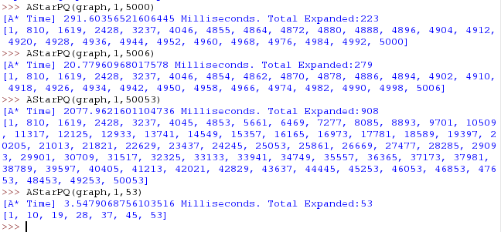
Correctly found path. This shows that the algorithm can find a path between the start and end nodes and returns this as a list of NodeIDs.

26.
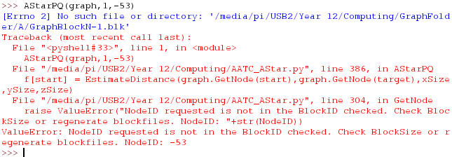
Correctly raised error. This shows that the algorithm will raise an error if an invalid node is attempted to be loaded.

27.
Far away node correctly not loaded. This also shows that the algorithm only loads nodes into memory which are required for the search.

28.
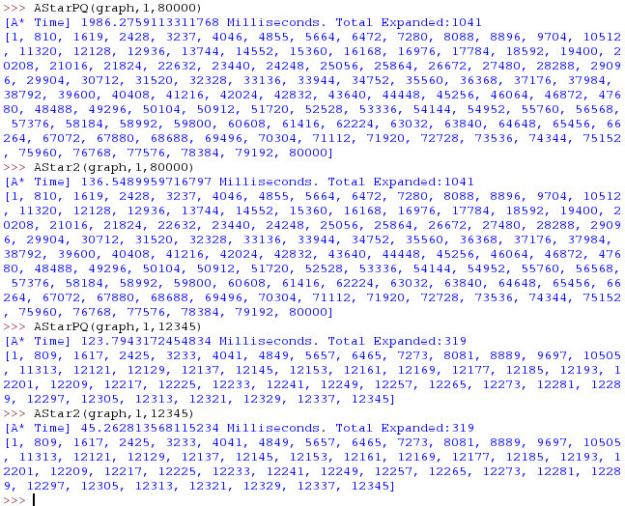
Both algorithms find the same path. This shows that the algorithms find the same path, that they are equivalent and that the search algorithm functions without random diversions ( if any form of randomness were involved the paths would have been different).

29.

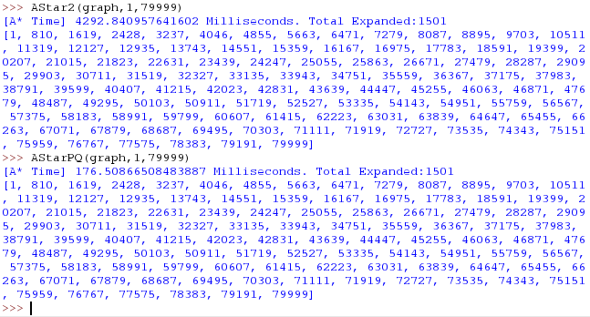

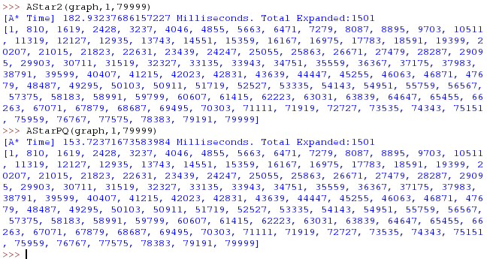
Correctly avoided any costly nodes ( in 3D NodeID 80000 is at 400m, path went over NoFlyZone at 0-200m). In this case original and No Fly zone version were the same. The algorithm found a path above the NoFlyZone.

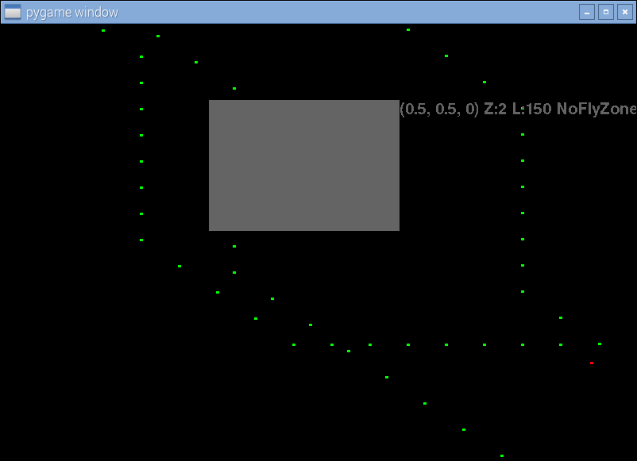
This is a demonstration of the path finding and no fly zone. The middle flight was created before the no fly zone, while the other two were created after, finding a path around the no fly zone (optimal would have been through the no fly zone). This shows that the algorithm will find a close to optimal path while avoiding NoFlyZones where possible.

30.
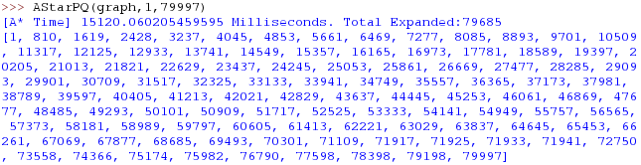
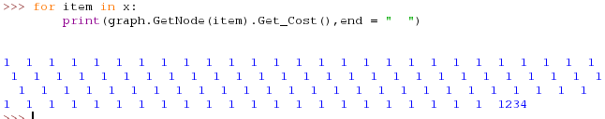
Search time was longer than normal. The path taken has a cost of 1 except the last item. The nodes expanded show that it attempted to find any better path (cost of 1000 is very high for a 100*100*4 graph). This shows that the algorithm searched a large number of nodes in order to find a shorter path , however due to the target node being the expensive node this was not possible.

